
̰ INTERNATIONAL SOCIETY FOR KRISHNA CONSCIOUSNESS
(Founder Acharya: His Divine Grace A.C Bhaktivedanta Swami Prabhupada)
A non-proﬁt charitable society registered in Bangalore, India, Registration No.S-49/78-79
Registered office : Hare Krishna Hill, Chord Road, Bangalore - 560 010, India.
(BO) D.No. 5-7-638, P.V.S Kalakunj, Kodialbail, Mangalore - 575003.
Ph : +91 88676 22108, E-Mail:donorcare.mlr@iskconmangalore.org



DONATION RECEIPT

No: {{Receipt_No}} Date: {{Date}}

To,
{{Donor_Name}}

{{Donor_Address}}
Mobile : {{Donor_Mobile_No}}
Email : {{Donor_Email}}
PAN: {{Donor_PAN}}

Dear {{Donor_Name}}

We thank you for your kind & generous donation of ₹{{Donor_Amount}}/-
(Rupees {{Donor_Amount_In_Words}} only)
through {{Donation_Payment_Type}} towards {{Seva_Type}} Donation for FY 2026-27.
ISKCON Mangalore acknowledges the receipt of your donation made on {{Date}} vide
Receipt No: {{Receipt_No}}.
For ISKCON Mangalore

Authorized Signatory
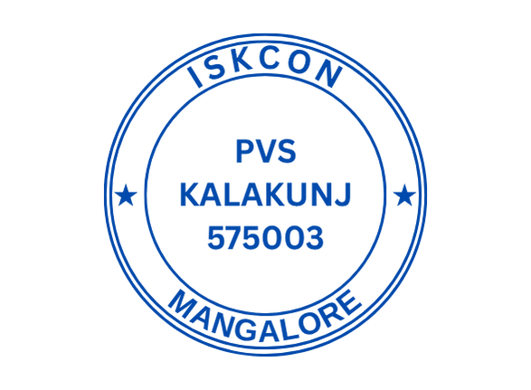
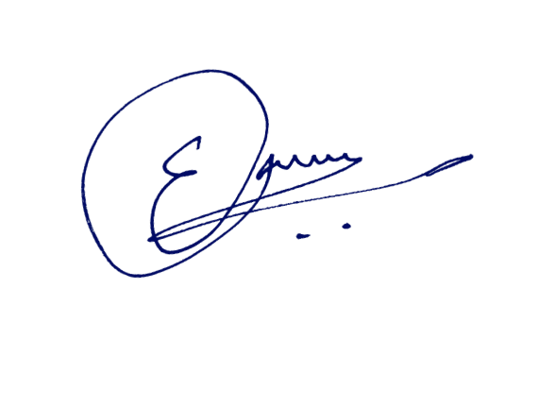
Donations to this institution are exempted u/s 80G vide No.ITA/355/2010 DT.12.01.2011
Valid from 01-04-2009
PAN : AAATI2696G

Hare Krishna Hare Krishna Krishna Krishna Hare Hare Hare Rama Hare Rama Rama Rama Hare Hare

For queries - Please contact :+91 88676 22108 Website: https://www.iskconmangalore.org

