**Advanced Software Engineering Madhire Kranthi Reddy**

**LAB 2 REPORT #12366438**

In this Lab Assignment -2, while I was on holiday, I went to pine mountains, I loved it. I wanted to develop an app for them. I have created an application that helps the user in finding way to the Pine Mountain and also displays the user with its weather conditions at any moment of time. I have used Google Maps web services and google weather web services for this application. I have created the application by making use of HTML, CSS, Javascript and JQuery Mobile.

In this application, the user has a choice to select the Directions for Pine Mountains from their current location (Kansas City, MO) or also the Weather at pine mountains. The Screenshots of the above mentioned application are presented below.

Also, as advised I have used Opera Mobile Emulator for seeing the application in a mobile interface and the screenshots of the Opera Mobile emulator are also presented below.

Screenshots:

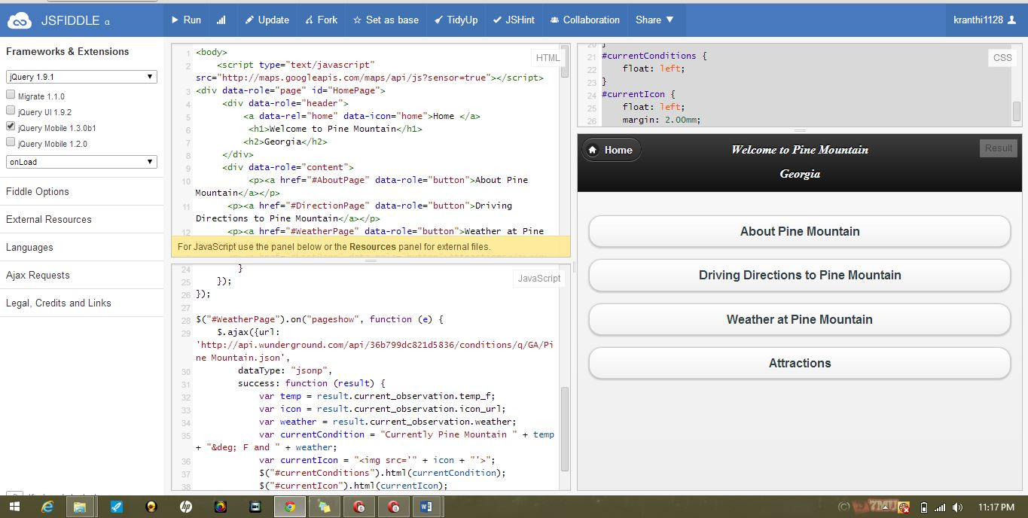

Screen Shots from Opera mobile operator:

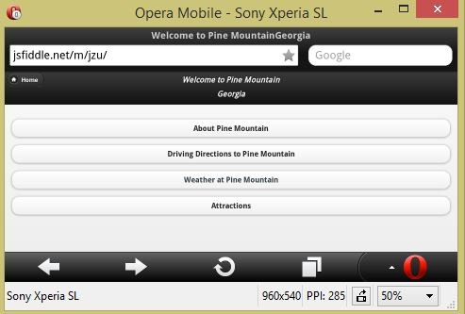

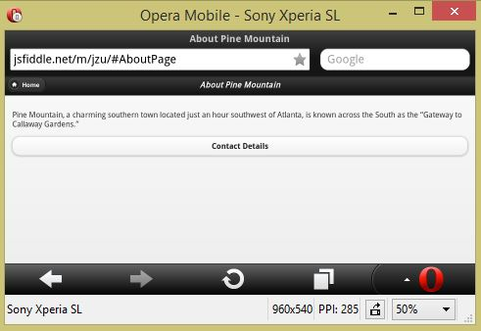

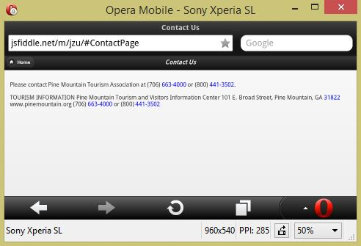

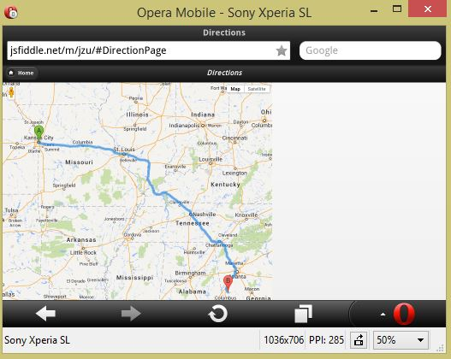

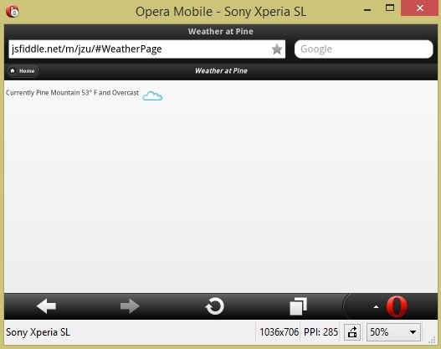

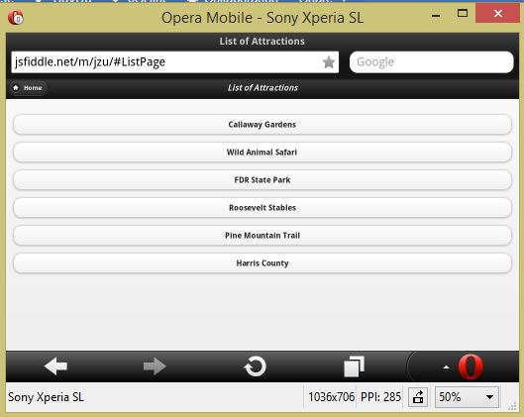

ScrumDo Tasks/Delivery:

