

Table of Content
Introduction 1
Service Mesh 2
Features 2
Components 4
Deployment Models 6
Implementations 6
Istio 6
Architecture 7
Comparison 8
Request Flow 10
Conclusion 10

Introduction


Kranthi Kumar Bitra
Associate Architect

In micro-services era, a typical application might encompass hundreds of services; each service might run in multiple instances; and each of those instances might be in a constantly-change state when they are deployed / scheduled by using an orchestrator. Currently, in an organization, a routine set successfully in making systematize pattern for packaging and deploying the services with the powerful abstractions provided by things like Docker and Kubernetes which drastically reduced the incremental operational burden to deployment. By incorporating these kinds of tools, it helped drastically in adopting micro-services
The real challenge with the micro-services type implementation is not building the services themselves, but the communication between services and different confronts arising from this inter-service communications are Load balancing, Distributed tracing, TLS encryption and mutual TLS authentication, Resiliency (Retry, Circuit Breaker), Service Versioning, even more..
Is it possible to handle all these challenges in a decentralized approach without touching the application services?
Does it practicable by offloading all of the inter-service communication requirements to a different layer by keeping service code independent as these specifications are quite generic in any micro-services implementations?
Can we undertake and provide language agnostic solution as an application service may code in different languages and communication among those might on the top of standard protocols such as HTTP1.x/2.x,gRPC, WebSocket, TCP traffic etc..?
Does it feasible to face these challenges on already deployed / on the top of micro-services network without touching it?
To address all these concerns, a “Service Mesh” is designed

Service Mesh
- To handle peer-to-peer communication in a way to ensure that those communications should be more secure, manageable, reliable and observable a committed infrastructure layer is introduced which is called a Service Mesh which also addresses all the global cross-cutting concerns.
- Just like the way that the tools – Kubernetes and Docker provided a standard way for deploying services, this layer solved in standardizing majority of the runtime operations for our
- With this design, communications among services will not be happened directly rather all the inter-service communications will take place through a component called side-car proxy which will run parallel to our application services.

Features
Common features offered from Service Mesh
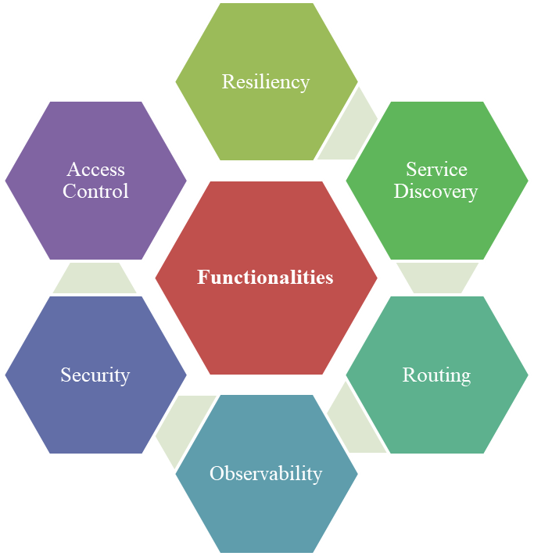

The different functionalities offered through these features are
- It enhance reliability by supporting circuit-breaking, retries and timeouts, fault injection, fault handling, load balancing and failover
- By determined registry of service, it aids in discovering the application services. Also, this provides insight by examining the messages which helps in identifying location of services. For instance, it whenever fails to reach the target services will return with an understandable errors and ensures that message passed as expected
- On the fly, primordial routing potentialities
  - If service have multiple versions then this helps in routing to particular version based on the destination rules set like route 100% traffic to v1 version / route to v2 based on the value set in the HTTP header
  - Helps in fixing the problems/bugs by incorporating fault injection rules(out of the box) in the production environment and not impacting the actual users
- It improves deep visibility by providing long-term metrics on availability of services. Also it provides capabilities like monitoring, distributed logging, distributed tracing
- Transport Level Security and key management
- Simple blacklist and whitelist based access control
- Native support for containers, Docker and Kubernetes
- It also often has more complex operational requirements, like A/B testing, canary releases

Components
In service mesh, different components involved in communicating one service with another services are
- Business Logic
  - Includes logic related to its business functions, computations
- Primitive Network Functions
  - A minimum network interactions between the application service and the side-car proxy
- Application Network Functions
  - In-depth accompany to network such as circuit breaking, timeouts, retries, client side LB etc
- Control Plane
  - A centralized plane to support capabilities like access control, observability, service discovery etc
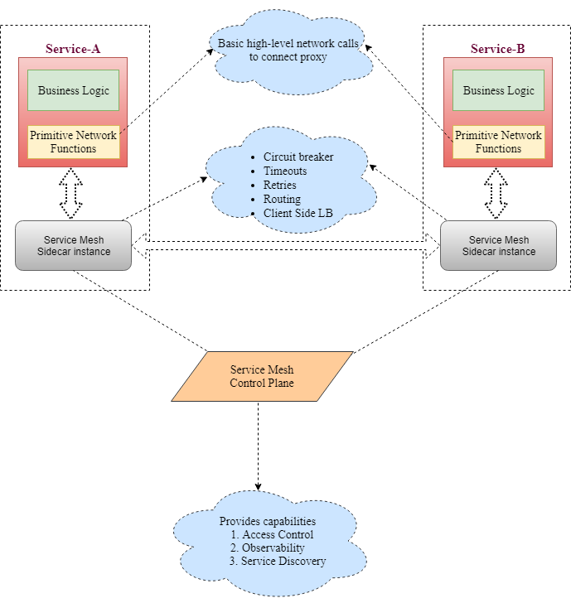

Deployment Models
It can be deployed in two different patterns
- Per-host proxy deployment
  - One proxy is deployed per host
  - A host can be virtual machine, or a physical host or a Kubernetes worker node
  - N-number of micro-service instances will run on the host
  - Traffic management will route through only with a single proxy instance on a node
  - In case of kubernetes, the proxy instance can be deployed as daemonset
- Sidecar proxy deployment
  - One proxy is deployed per instance of every service
  - In kubernetes, a service mesh sidecar container can be deployed along with application service container as a part of the kubernetes pod
  - This approach requires more instances of sidecar, hence a smaller resource profile for sidecar is usually appropriate

Implementations
Linkerd and Istio are two popular open source service mesh implementations. As both follow a similar architecture, but with different implementation mechanism, will explore more with Istio and will give insight about the features provided by these two implementations

Istio
From the official site - https://istio.io/ , it conveys without any changes in the service code, it eases creation of network of deployed services with
- Fine-grained control of traffic behavior with rich routing rules, retries, failovers, and fault injection
- Automatic load balancing for HTTP, gRPC, WebSocket, and TCP traffic
- A pluggable policy layer and configuration API supporting access controls, rate limits and quotas
- Automatic metrics, logs and traces for all traffic with in a cluster, including ingress and egress
- Secure service-to-service communication in a cluster with strong identity-based authentication and authorization

Architecture
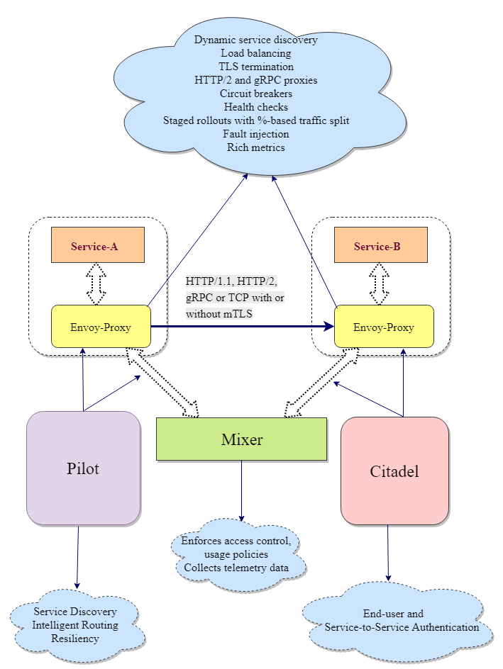

Logically split into a
- data plane
  - Touches every packet/request in the system
  - Responsible for
    - service discovery
    - health checking
    - routing
    - load balancing
    - authentication / authorization
    - observability
- control plane
  - provides policy and configuration for all the running data planes in the mesh
  - does not touch any packets / requests in the system
  - it turns all of the data planes into a distributed system

Comparison
Features | Istio | Linkerd
Proxy | Envoy | Finagle + Jetty
Circuit Breaker | Enforces at network level | Two types  - Fail Fast (session-driven)  - Failure Accrual (request-driven)
Dynamic Request Routing | To service instances by versions or environment | Service destination (service name) and the concrete destination (version and environment)
Traffic Shifting/Splitting | Yes | Yes
Service Discovery | Platform-agnostic service discovery | Namer – file based service discovery  Namer can also work with Zookeeper, Consul, Kubernetes
Load Balancing | Envoy’s load balancing algorithms  Eject unhealthy service instance from the load balancing pool | Finagle’s load balancing algorithms  Provides failure-and latency-aware load balancing
Security | Secuirng  - End-user to service  - Service-to-Service | Easy to add TLS to all service-to-service calls  Per-service/Per-environment certificates  Key management process
Access Control | Enforce simple whitelist – or blacklist-based access control  Enforce quotas and rate limits | -
Observability | Metrics(Prometheus, statsd)  Monitoring(New Relic, Stackdrive)  Logging(Application and access logs)  Distributed tracing(zipkin) | Distributed tracing (Zipkin)  Metrics(InfluxDB, Prometheus, statsd)
Deployment support | Kubernetes; Sidecar proxy | Kubernetes, Mesos, Cluster of hosts; per-host or sidecar proxy
Control Plane | Pilot, Mixer, Istio-Auth | Namerd
Service-to-Service communication | HTTP1.1 or HTTP/2, gRPC or TCP with or without TLS | HTTP1.1 or HTTP/2, gRPC or TCP with or without TLS

Request Flow
- By default, proxies handle only intra-service mesh cluster traffic – between the source (upstream) and the destination (downstream) services.
- To expose a service which is part of service mesh to outside world, it must enable ingress traffic
- Similarly, if a service depends on an external service , it requires enabling the egress traffic
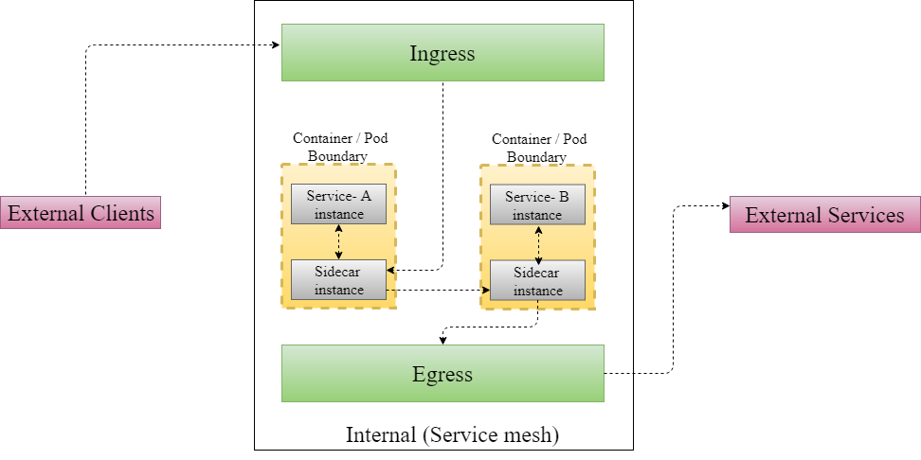

Conclusion

Hence, Service Mesh allows handling all the challenges involved in the inter-service communication in runtime without incorporating any code related to this communication in the application services which aids the developers to concentrate only on the business logic and all the network related reliability/visibility/security/observability will be taken care by running a side-car proxy parallel to the application service.

