Test Case

Website requested is [www.example.net/path/name/item.html](http://www.example.net/path/name/item.html)

This was used due to it being able to fulfill HTTP 1.0 request. (Discovered via stackoverflow)

https://stackoverflow.com/questions/14330553/c-programming-sending-http-request/14343240

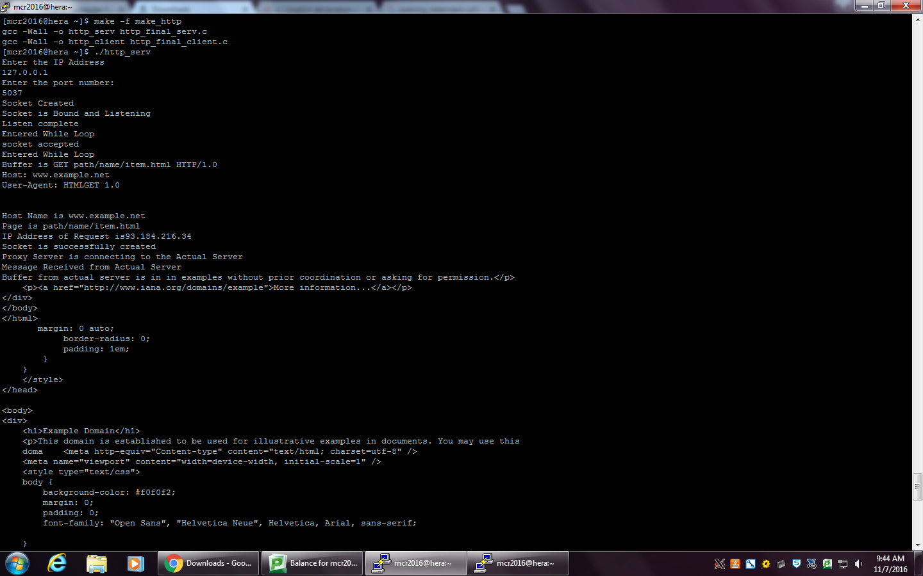

This shows the first request on the server side

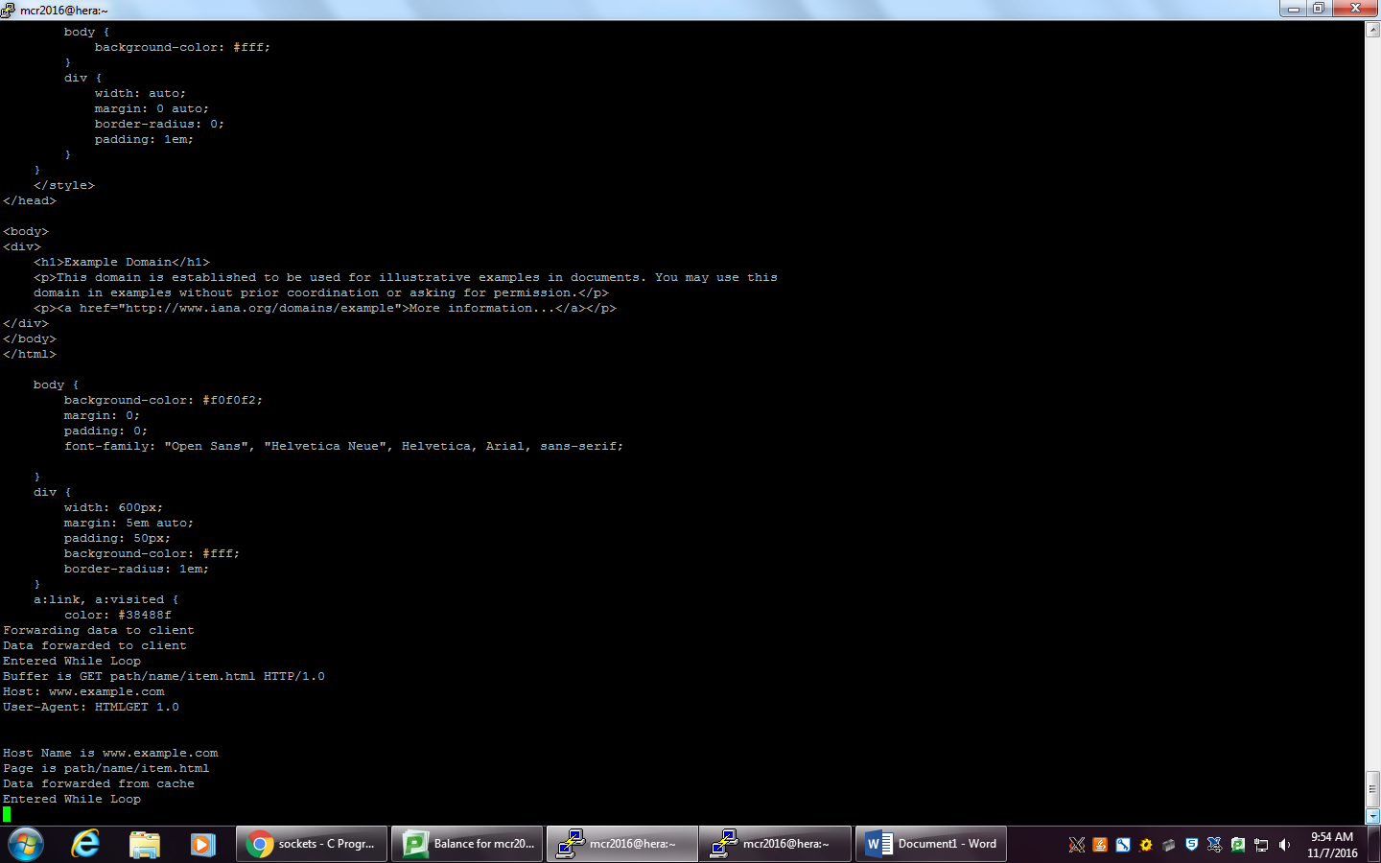

This show the second request for the same document. Notice that the data is forwarded from the cache rather than requesting from the actual server.

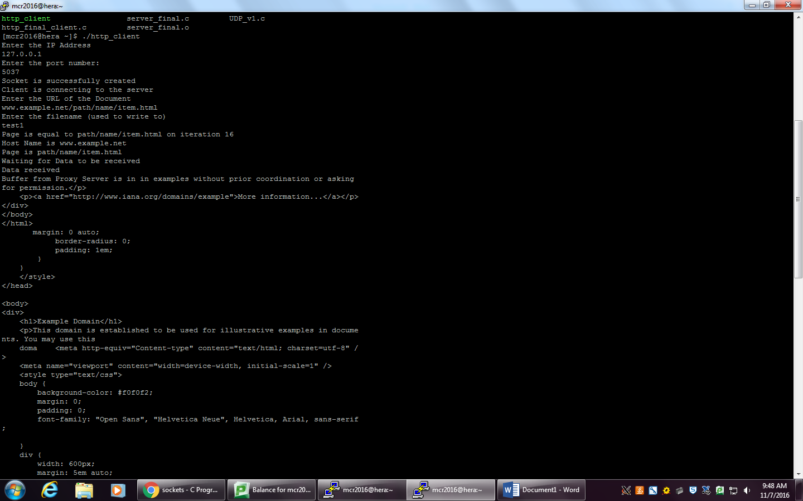

Client

Wrote copies to test1 and test2. Requested the same document so first was requested from actual server and the second was forwarded using the cache of the LRU.

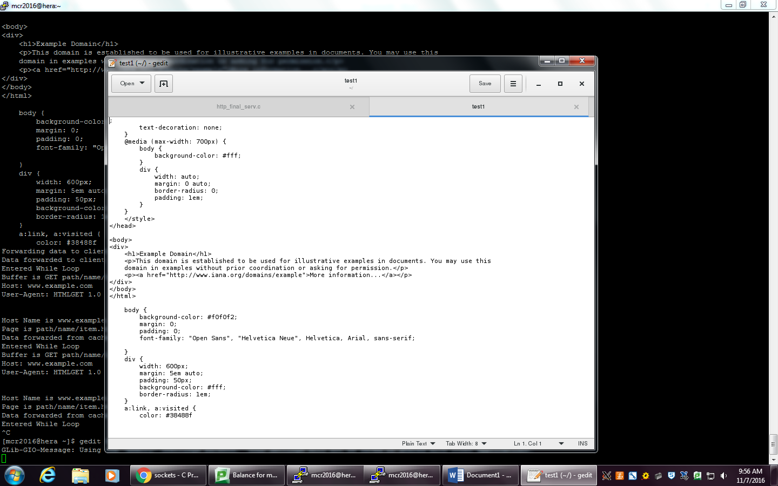

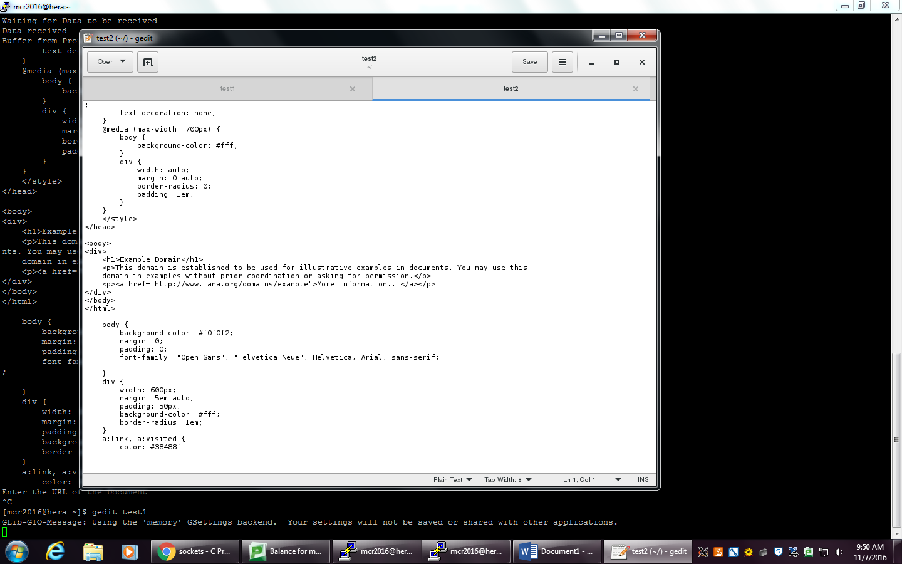

These are test1 and test 2 respectively. They are both written correctly to each file.