1. Testing for one file.

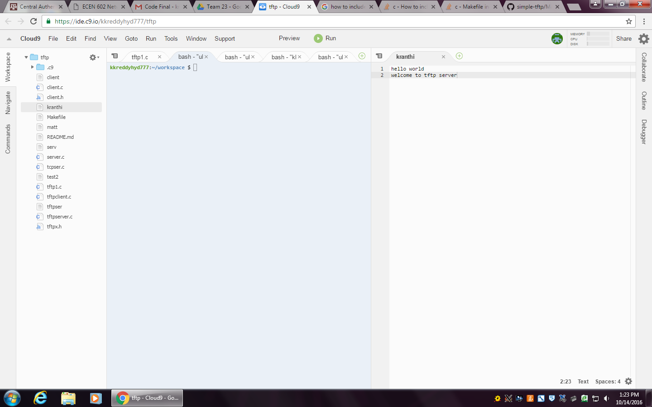 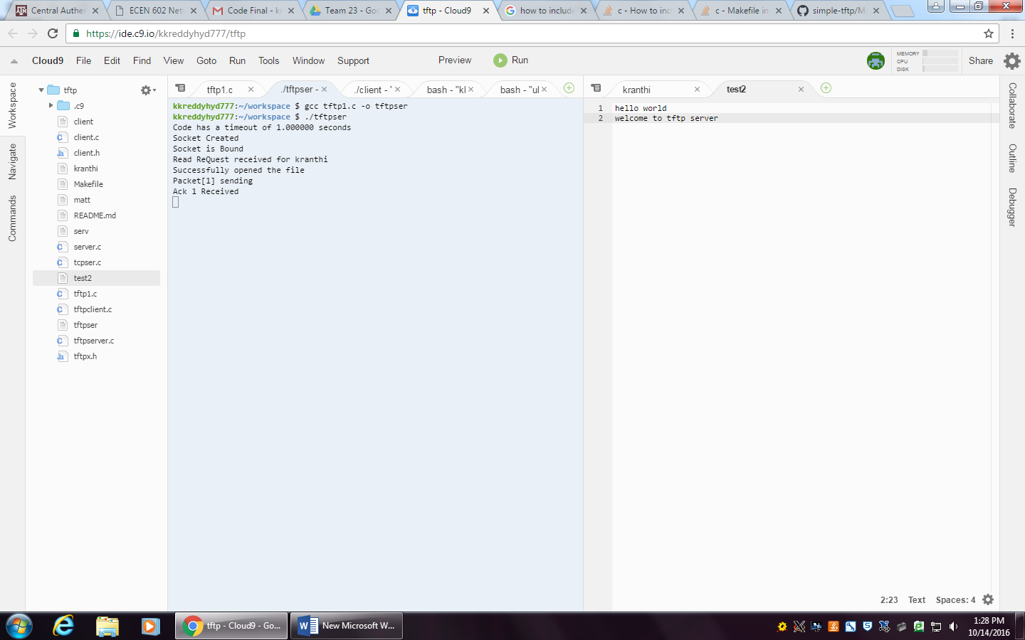

File in server File copied to client

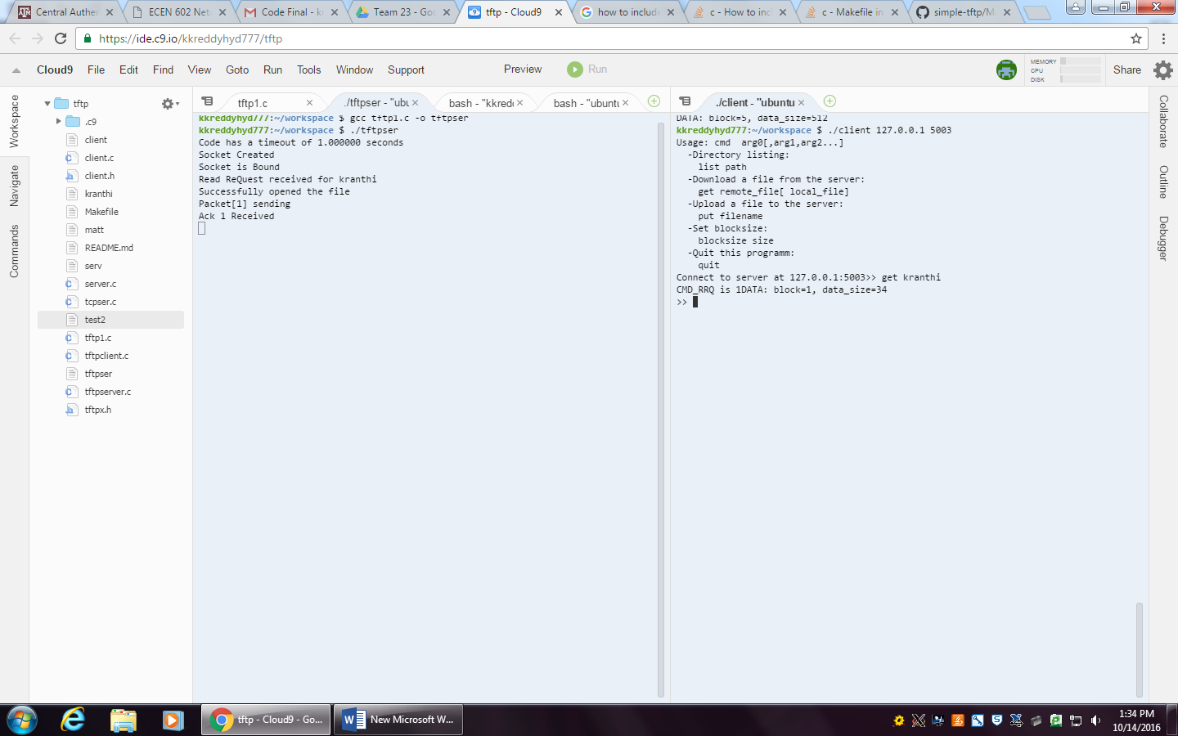



1. Testing the program for large data file.

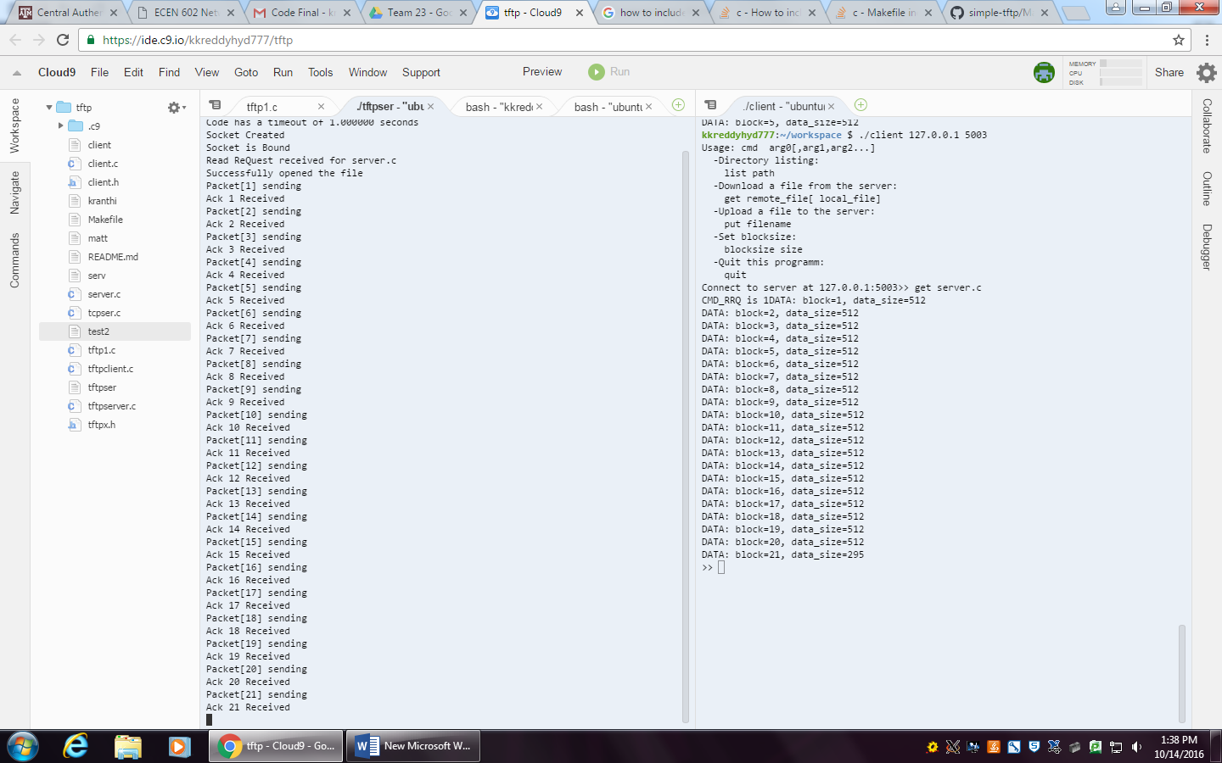 

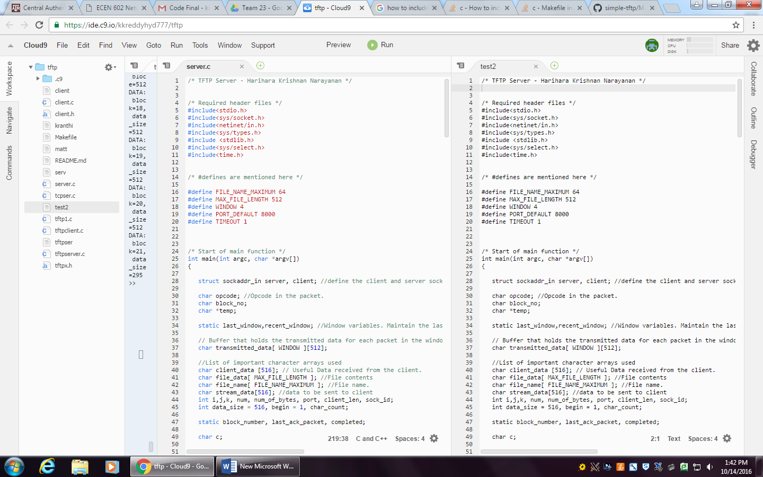

The large file server.c is also transferred to test2 which is created by the client.

1. Connecting multiple clients.

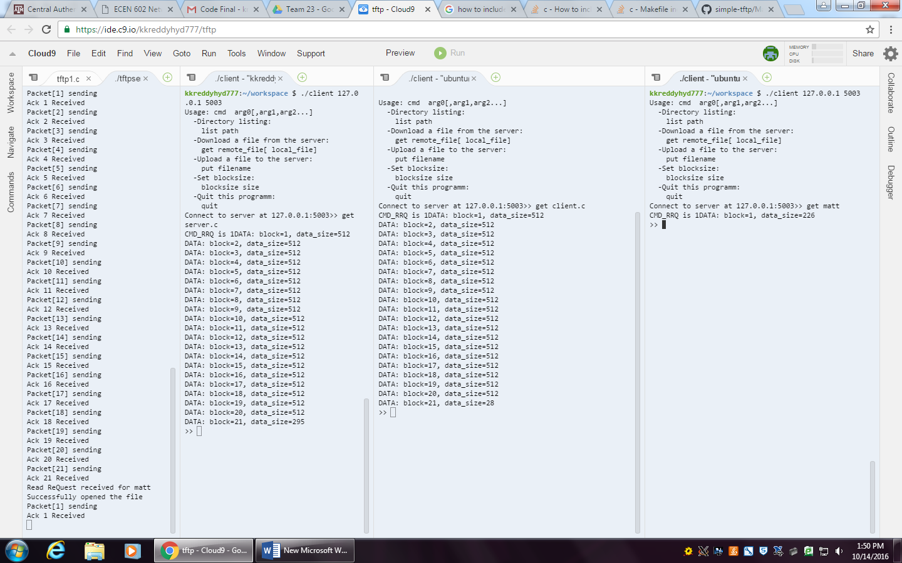

Multiple clients are connecting and able to download the files from the server.