Create LeaveType Master page in .NETCoreMVC using C# and ADO .NET for DB related in the current project. All DB related queries should call from Stored procedures/Functions and provide required DB scripts to execute in SQL server DB manually.
LeaveType Master Screen should be available along with "Add Employee", "Employees List" screen, Department Master, Section Master, Designation Master screen , 5th screen is this newly created LeaveType Master in left side menu screen modules. After successful login "Add Employee", "Employees List" screen, "Department Master screen", “Section Master screen” , “Designation Master screen” and “LeaveType Master screen” should be accessible. Follow the below left side menu screen.
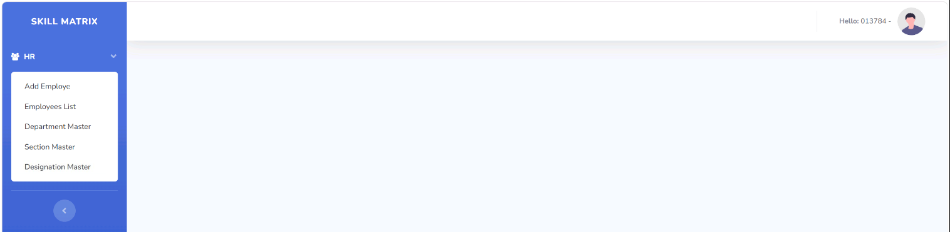
## Overview
This is a complete .NETCore MVC implementation of a Section Master module for the E-Management application. It includes all CRUD operations, advanced searching, pagination, and export functionality.
Table should create with the below columns
LeaveID, LeaveType, LeaveDescription, Created By, Created On, Edited By, Edited On, isActive
## Features need to be Implemented
LeaveType Header Details:
LeaveID: Text field
LeaveType: text field
LeaveDescription: text field
Should have Save and Exit buttons and add validation for all the fields are mandatory to enter data
### 1. Grid Display with Pagination
- Display records with customizable page size (5, 10, 25, 50, 100 records)
- Show total record count
- Display columns: Edit, Delete, LeaveID, LeaveType, LeaveDescription, Created By, Created On, Edited By, Edited On, isActive
New LeaveType master should be followed the below reference image.
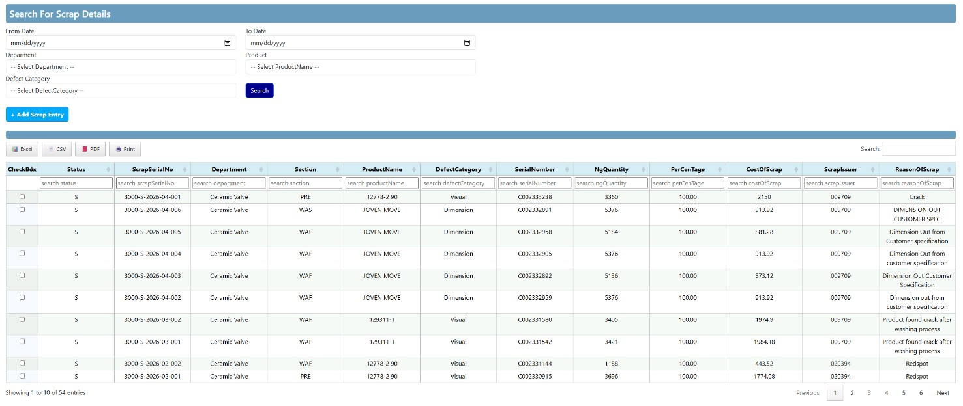
### 2. Validation
- Prevent duplicate Section code creation
- Display "LeaveType Already Exists" validation message
- All fields are mandatory
- Client-side and server-side validation
### 3. Search Functionality
- Global search across all columns
- Column-level search for each column
- Search results update grid in real-time
### 4. Sorting
- Sort by any column
- Ascending and descending order
### 5. CRUD Operations
- Create new LeaveType
- Read/View LeaveType details
- Update existing LeaveType
- Delete LeaveType (soft delete - marked as inactive)

### 6. Export Functionality
- Export to Excel (.xlsx)
- Export to CSV (.csv)
- Export to PDF (.pdf)
- Print option
### 7. User Interface
- Display loggedin Employee Number and Name before Sign Out button before “Hello” for each page

- Responsive design
- Modal form for Create/Edit operations
- After successful save, newly added record displays immediately

