Create Section Master page in .NETCoreMVC using C# and ADO .NET for DB related in the current project, based on the attached existing old VB.NET application code functionality. All DB related queries should call from Stored procedures/Functions and provide required DB scripts to execute in SQL server DB manually.
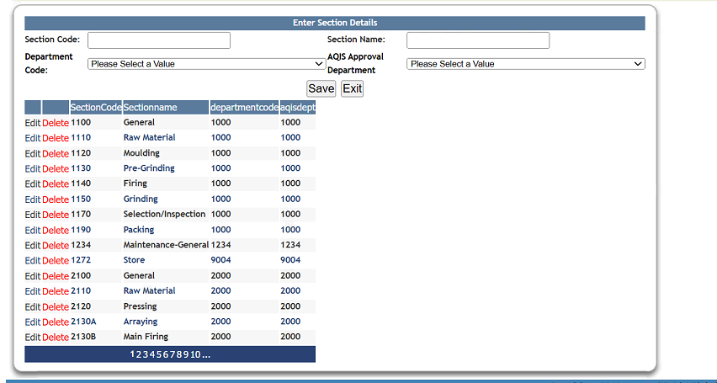
Section Master Screen should be available along with "Add Employee", "Employees List" screen, Department Master and 4th screen is this newly created Section Master screen in left side menu screen modules. After successful login "Add Employee", "Employees List" screen, "Department Master screen", “Section Master screen” should be accessible. Follow the below left side menu screen.
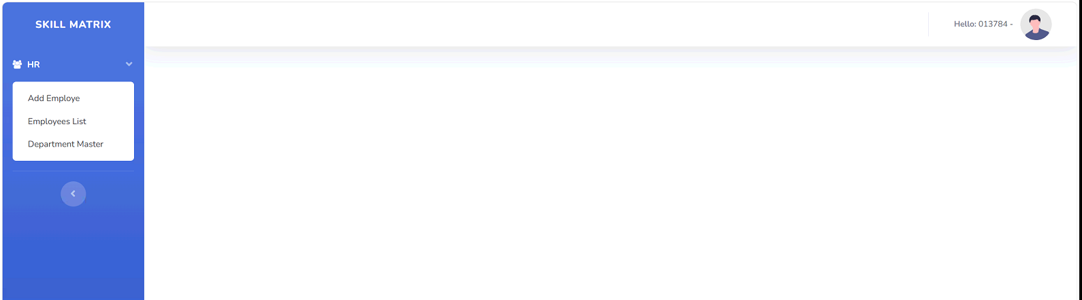
## Overview
This is a complete .NETCore MVC implementation of a Section Master module for the E-Management application. It includes all CRUD operations, advanced searching, pagination, and export functionality.
Table should create with the below columns
SectionCode, Sectionname, SectionId, Departmentcode( FK from Department Master table), SubDepartmentName, issectionActive, Created By, Created On, Edited By, Edited On
## Features need to be Implemented
Department Header Details:
Section Code: text field
Section name: text field
DepartmentCode: Dropdown filed and all the values should fetch from Department Master table
Should have Save and Exit buttons
### 1. Grid Display with Pagination
- Display records with customizable page size (5, 10, 25, 50, 100 records)
- Show total record count
- Display columns: Edit, Delete, SectionCode, Sectionname, Departmentcode, Created By, Created On, Edited By, Edited On
New Section master should be followed the below reference image.
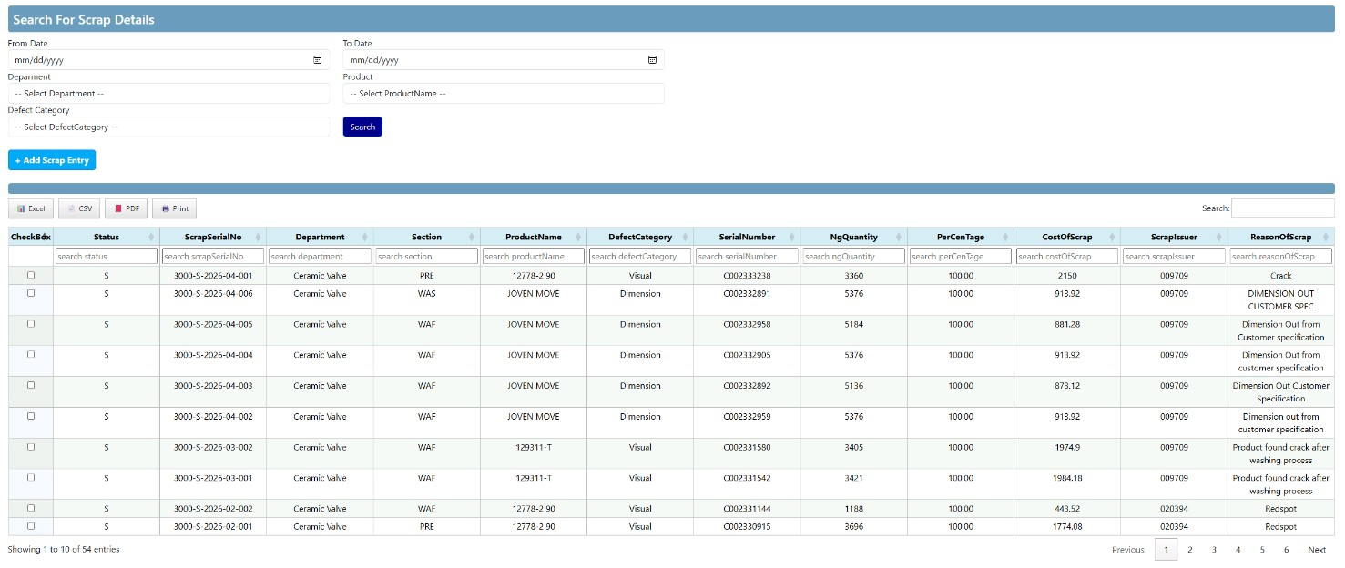

### 2. Validation
- Prevent duplicate Section code creation
- Display "Sectioncode Already Exists" validation message
- All fields are mandatory
- Client-side and server-side validation

### 3. Search Functionality
- Global search across all columns
- Column-level search for each column
- Search results update grid in real-time

### 4. Sorting
- Sort by any column
- Ascending and descending order

### 5. CRUD Operations
- Create new Section
- Read/View Section details
- Update existing Section
- Delete Section (soft delete - marked as inactive)

### 6. Export Functionality
- Export to Excel (.xlsx)
- Export to CSV (.csv)
- Export to PDF (.pdf)
- Print option

### 7. User Interface
- Display loggedin Employee Number and Name before Sign Out button before “Hello” for each page
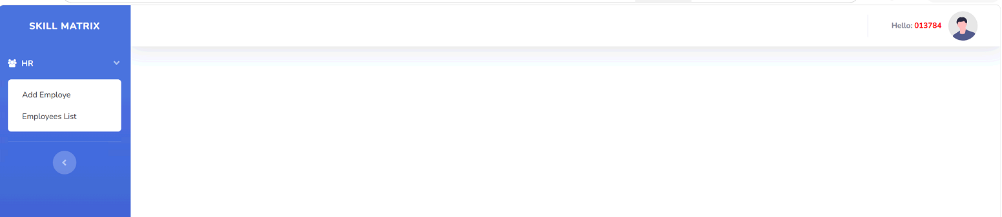
- Responsive design
- Modal form for Create/Edit operations
- After successful save, newly added record displays immediately

