Create CRUD operations as per the Requirement_Designation.docx as attached in the current .netcore MVC application attached as .Zip file with ADO .net DB and download the latest solution file. Create Designation Master Module for the same project solution and download
Create Designation Master page in .NETCoreMVC using C# and ADO .NET for DB related in the current project, based on the attached existing old VB.NET application code functionality. All DB related queries should call from Stored procedures/Functions and provide required DB scripts to execute in SQL server DB manually.
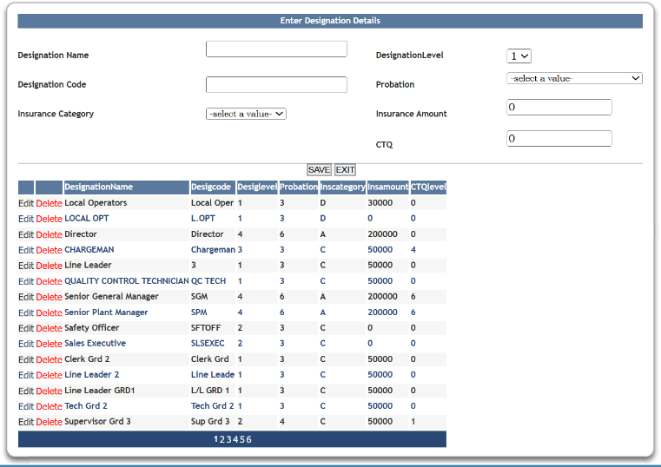
Designation Master Screen should be available along with "Add Employee", "Employees List" screen, Department Master, Section Master and 5th screen is this newly created Designation Master screen in left side menu screen modules. After successful login "Add Employee", "Employees List" screen, "Department Master screen", “Section Master screen” and “Designation Master screen” should be accessible. Follow the below left side menu screen.
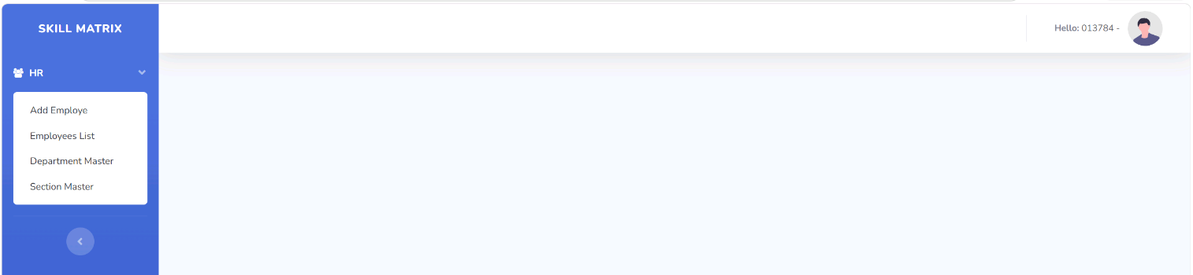
## Overview
This is a complete .NETCore MVC implementation of a Section Master module for the E-Management application. It includes all CRUD operations, advanced searching, pagination, and export functionality.
Table should create with the below columns
insCatergory,dlevel,probation,CTQLevel,kpi,positioned,insamount,designationcode,designationName, Created By, Created On, Edited By, Edited On, isActive
## Features need to be Implemented
Designation Header Details:
Designation Name: text field
Designation Code: text field
Insurance Category: Dropdown filed and all the values (A,B,C,D) should be fetched from newly created Insurance Category Master table and also should provide search
Probation: Dropdown filed and all the values (0,3,4,6) should fetch from newly created Probation Master table and also should provide search
Insurance Amount : Text Field
Should have Save and Exit buttons and add validation for all the fields are mandatory to enter data
### 1. Grid Display with Pagination
- Display records with customizable page size (5, 10, 25, 50, 100 records)
- Show total record count
- Display columns: Edit, Delete, designationcode, designationName, probation, insurance Catergory, insurance amount, Created By, Created On, Edited By, Edited On, isActive
New Section master should be followed the below reference image.
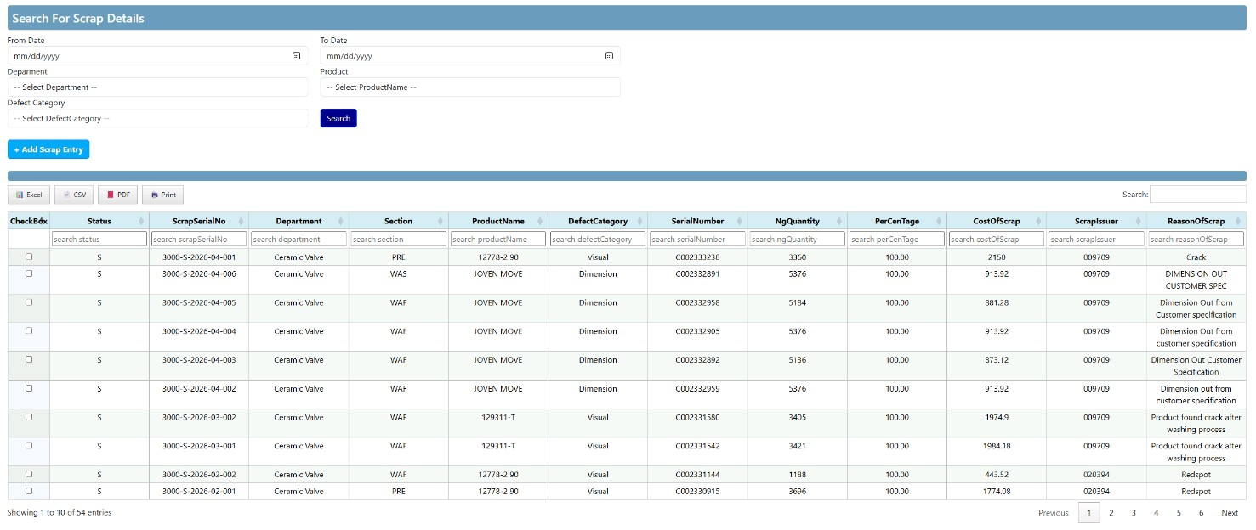
### 2. Validation
- Prevent duplicate Section code creation
- Display "Designationcode Already Exists" validation message
- All fields are mandatory
- Client-side and server-side validation
### 3. Search Functionality
- Global search across all columns
- Column-level search for each column
- Search results update grid in real-time
### 4. Sorting
- Sort by any column
- Ascending and descending order
### 5. CRUD Operations
- Create new Section
- Read/View Section details
- Update existing Section
- Delete Section (soft delete - marked as inactive)

### 6. Export Functionality
- Export to Excel (.xlsx)
- Export to CSV (.csv)
- Export to PDF (.pdf)
- Print option
### 7. User Interface
- Display loggedin Employee Number and Name before Sign Out button before “Hello” for each page

- Responsive design
- Modal form for Create/Edit operations
- After successful save, newly added record displays immediately

