**DOCUMENTATION FOR CONNECTING MONGODB WITH THE WEBSITE APPLICATION**

**Name: Kranthi Kumar Reddy Anugu**

**ID:1974268**

**GitHub Repository URL**: [**https://github.com/kranthireddy47/1974268_kranthireddy_TCSMEANSTACK.git**](https://github.com/kranthireddy47/1974268_kranthireddy_TCSMEANSTACK.git)

**Links to open the pages**

* <http://localhost:9090/>
* <http://localhost:9090/course>
* <http://localhost:9090/update.html>
* <http://localhost:9090/delete.html>
* <http://localhost:9090/fetch.html>

**Note:** I have developed Connection MongoDB with Website Application.

This application contains single 6 files.

1. expressdemo.js
2. Index.html
3. Course.html
4. delete.html
5. Update.html
6. Fetch.html

1)I have pushed all these files to GITHUB in the folder **ConnectingMongoDb** under the commit “**ConnectingMongodb With Website Application**”

2)To develop this application I have used

a) Mongoose: to insert,delete,update,fetch the document in the MongoDB collection.

b) Express module

c) Body-parser

3) You can run the file using the following command.

>>node expressdemo.js

4) After running the file you will get a web page with hyperlinks for various operations

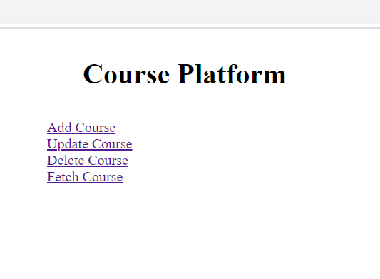

**5)** When you click on add Course a webpage will be displayed where you need to enter the details to insert the course into mogodb database.

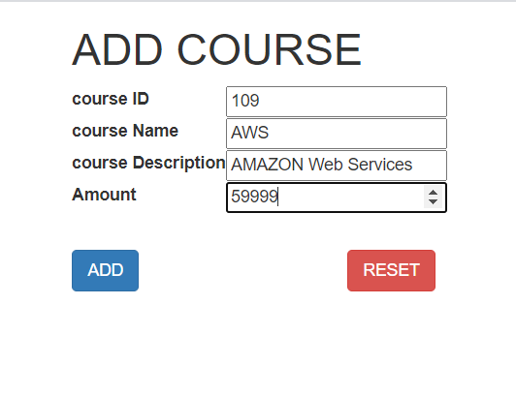

1. **When you click on update course. You have to enter the course id for which you have to update the course amount.**

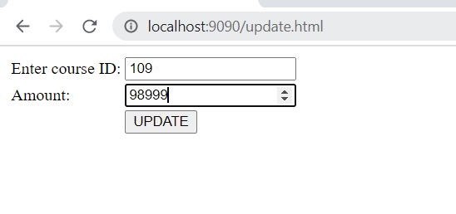

1. When you click on delete course please enter the course id which you want to delete from the mongodb collection.

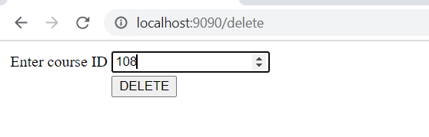

1. The final Crud operation is fetch since we have to fetch all the collection data this is how it looks.

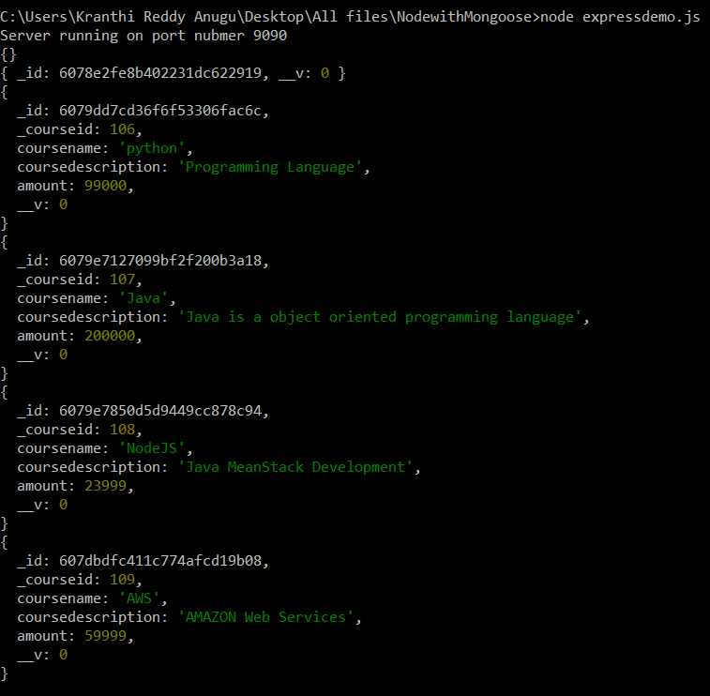

Note: After performing all the CRUD operations this is how the collection looks in the MongoDb collection.

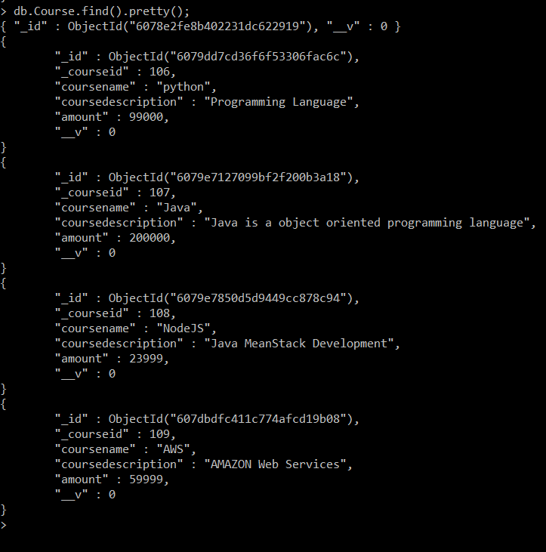

When you insert ,delete, update the course the details will be display on the console as well.

