**DOCUMENTATION FOR CREATING LOG RECORDS APPLICATION**

**Name: Kranthi Kumar Reddy Anugu**

**ID:1974268**

**GitHub Repository URL**: **https://github.com/kranthireddy47/1974268_kranthireddy_TCSMEANSTACK.git**

**Note:** I have written the code for CREATING LOG RECORDS Application.

This application contains 3 files.

1. Demoo.js
2. Main.js
3. Emp.json

I have pushed all these files to GITHUB under the commit “**Creating Log Record Application**”

1)When you run the **demoo.js** file. You have to enter the number of records you want to entre and you have to enter some basic details like

a) First Name

b) Last Name

c) Gender

d) Email ID

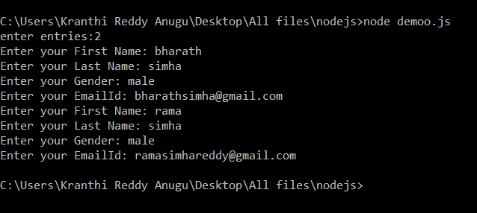

2) All these details will be pushed into the **emp.json** file along with

a) Date and b) Time

As a log. when you enter more records the records will get appended at the end of old records in the json format

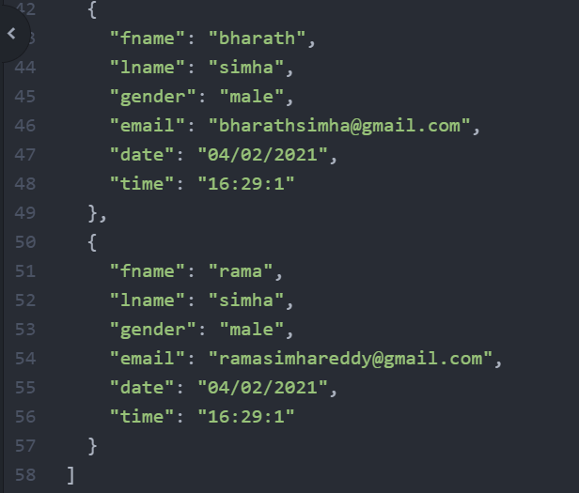

**IMPLEMENTATIOn**

1)In developing this application I used all the nodejs modules like

a) ReadLine-Sync

b) File System

c)Import

d)Export

2) I used all the fileread and filewrite operations to read the data from the json and to write the data into the json file. All these information is stored in the form of a log.

3) To get the data and time I have created an object for the data and used some of its methods like.

a) getDate()

b) getMonth()

c) getFullYear()

d) getMinutes()

e) getHours() and getSeconds();

4)Apart from all these I have used debugger to debug the code and add the break points.

5). I also created the .ignorefile and ignored the output screenshots and documentation file.

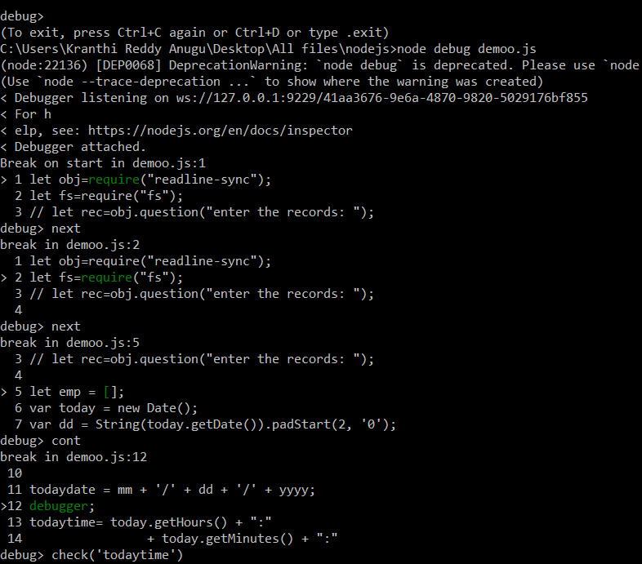

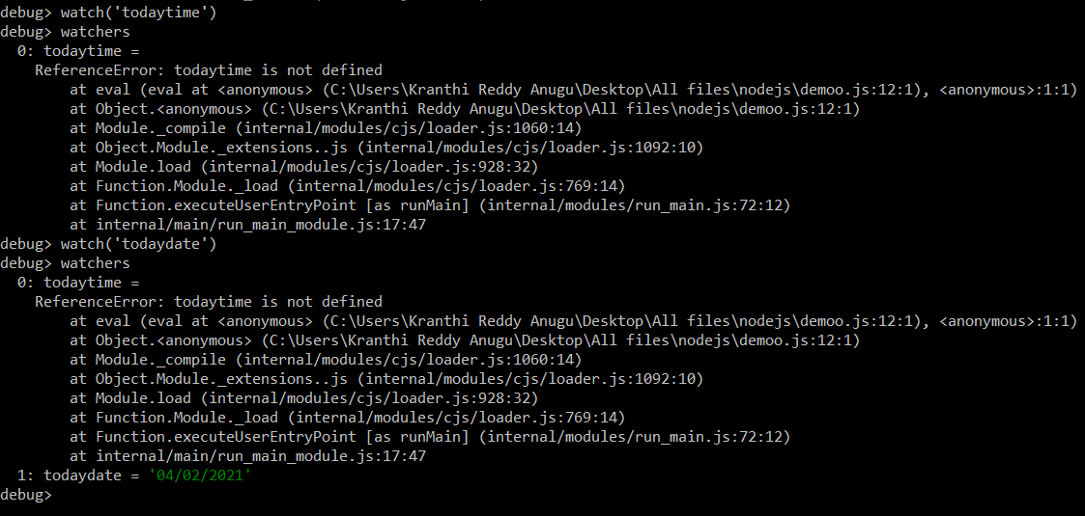

5) Finally to make application reusable I have used export module and included the required functionalities to demonstrate reusability in node applications.

