**DOCUMENTATION FOR Amazing Portfolio Project**

**Name: Kranthi Kumar Reddy Anugu**

**ID:1974268**

**GitHub Repository URL**: **https://github.com/kranthireddy47/1974268_kranthireddy_TCSMEANSTACK.git**

**Note:** I have created angular-portfolio project with the following 3 components

1)login

2)registration

3)portfolio

I have pushed all these files to GITHUB under the commit “**Amazing Portfolio Application**”

1. When you run the project in home page you can see the welcome page with all links for

a) login

b) registration

c) portfolio.

2)I have written code to integrate all the components and used HTML/CSS and bootstrap for the look and feel.

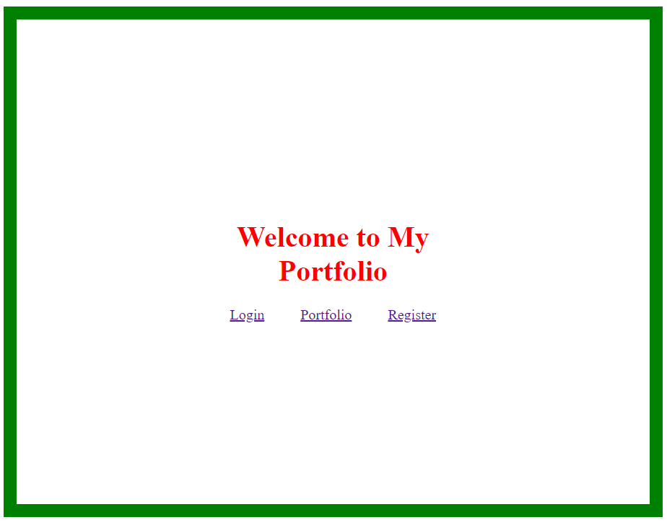

2)You can click on the registration and create an account by entering details. like

a) first name

b) last name

c) username

d) password

3)when you click on register button your account will be created and you have to login using your credentials to enter your portfolio page.

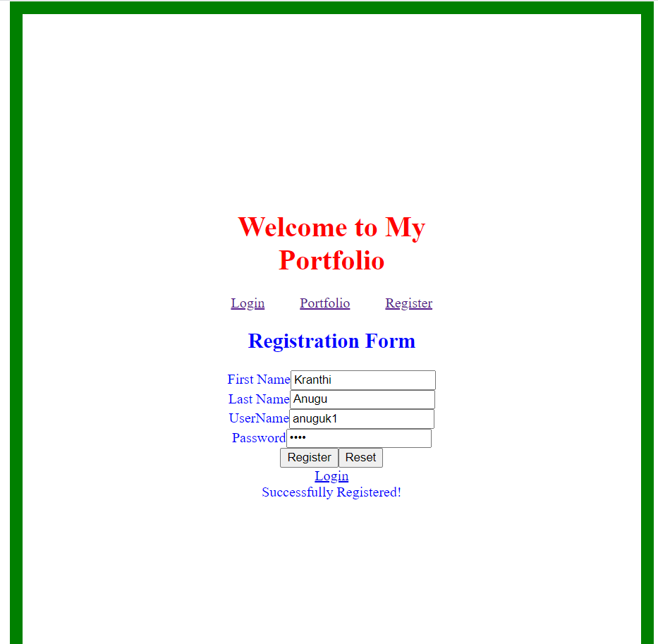

4)when you have registered, then login into your account by entering

a) Username

b) Password

Then click on login

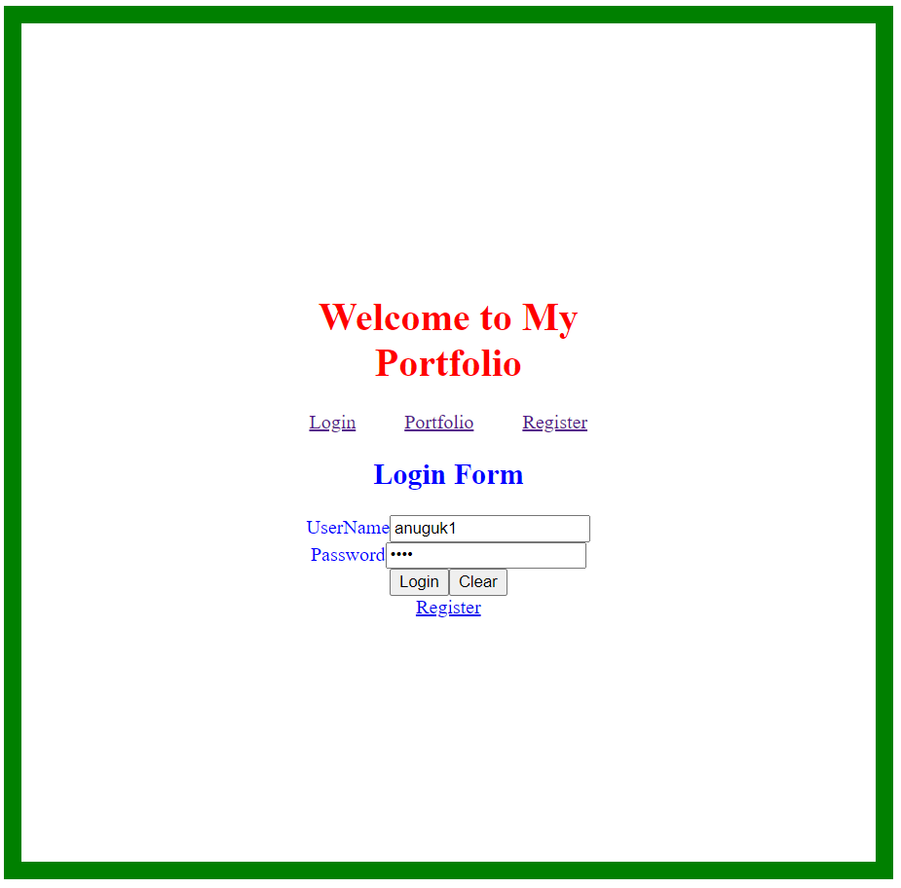

5)after login you will be redirected to your portfolio page here you have to enter your basic details like

a) Contact Name

b) Phone Number

Then click on save to save them in database you can see all those details in your portfolio in a tabular format.

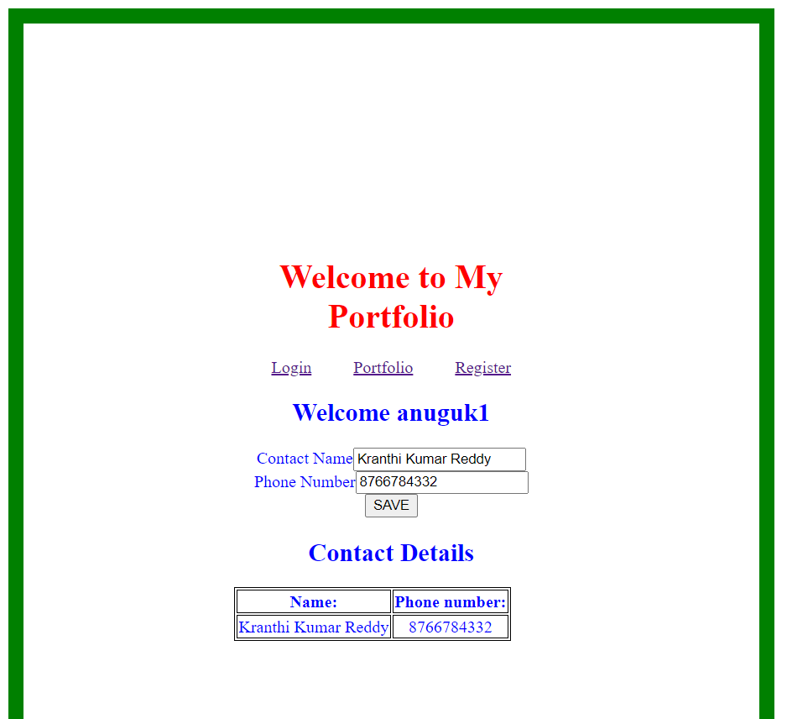a) I used Local Storage functions to save the data and display on different components

b) I wrote all the click events and functions in TYPESCRPT. I Have used the concept of forms, routing, local storage and HTML/CSS.

c). I also created the .ignorefile and ignored the output screenshots and documentation file.