**DOCUMENTATION FOR ONLINE TEST APPLICATION**

**Name: Kranthi Kumar Reddy Anugu**

**ID:1974268**

**GitHub Repository URL**: **https://github.com/kranthireddy47/1974268_kranthireddy_TCSMEANSTACK.git**

**Note:** I have developed Online Test Application. I have created One Component called quizedata-retrive

And a service quizedata.service .

I have pushed all these files to GITHUB under the commit “**Online Test Application**”

1. When you run the project in home page you can see

“WELCOME TO ONLINE TEST APPLICATION” with all the questions present.

2)You have to select the appropriate Radio-Button with the correct answer to the question.

3) When you finish answering all the questions you can click on the submit button.

4) As a result you will see what is your

a) Final Score

b) Number of Incorrect Answers

c)Number of correct Answers

5) You can also see what options you have chosen for a particular question and the correct answer for the question.

**NOTE:**

a) I used json file to retrieve the data through Http-Request and Imported all the required components and modules.

b) I wrote all the click events and functions in TYPESCRPT. I Have used the concept of forms, routing, local storage and HTML/CSS.

c). I also created the .ignorefile and ignored the output screenshots and documentation file.

d) The data is present in the quizedata.json file which is in asset folder.

Output:

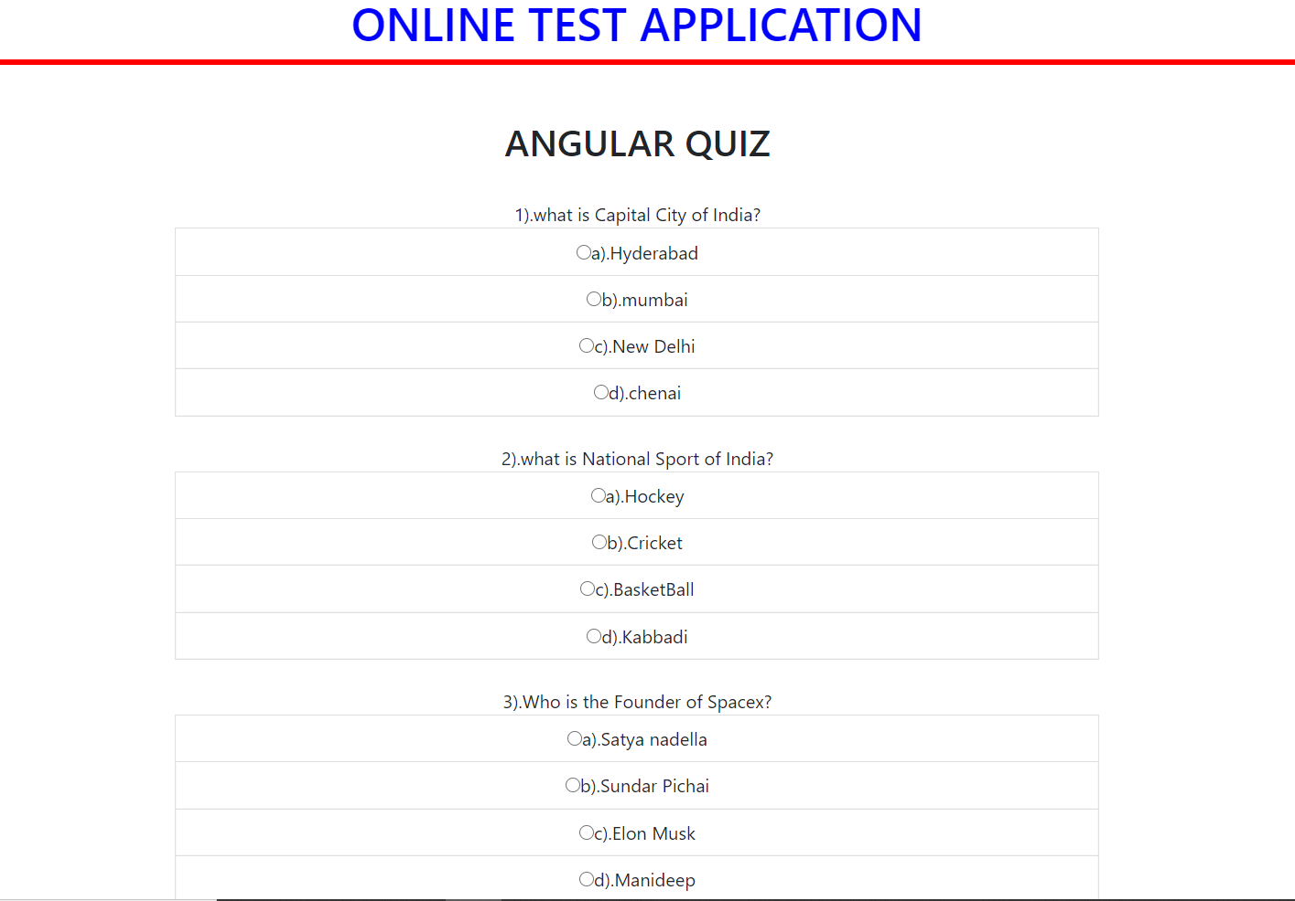

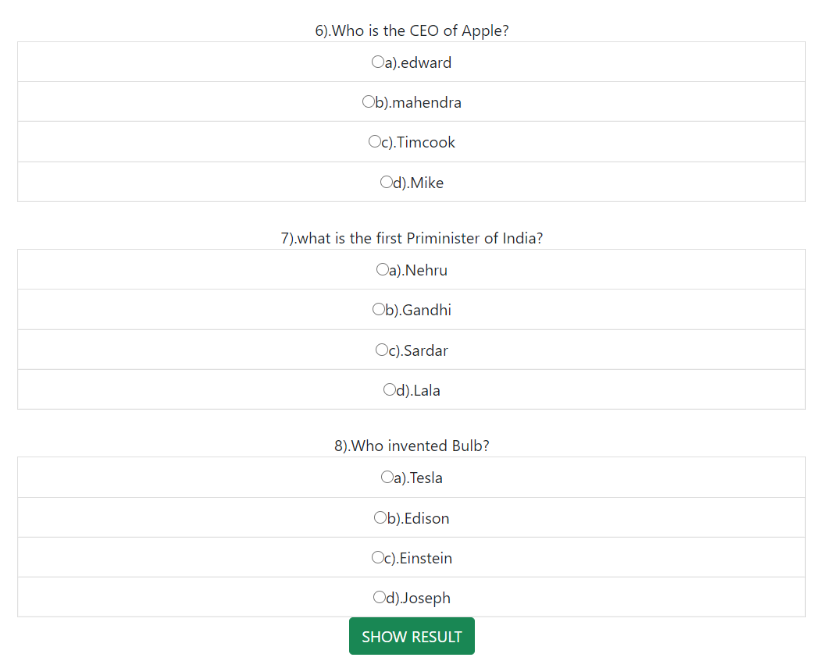

3) 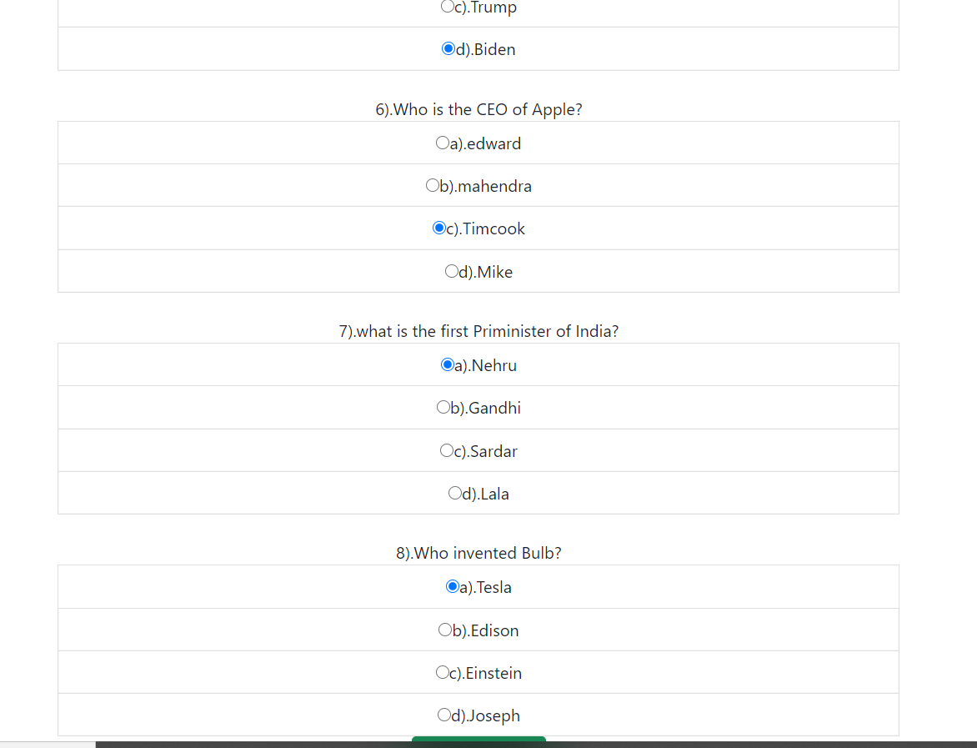

4) 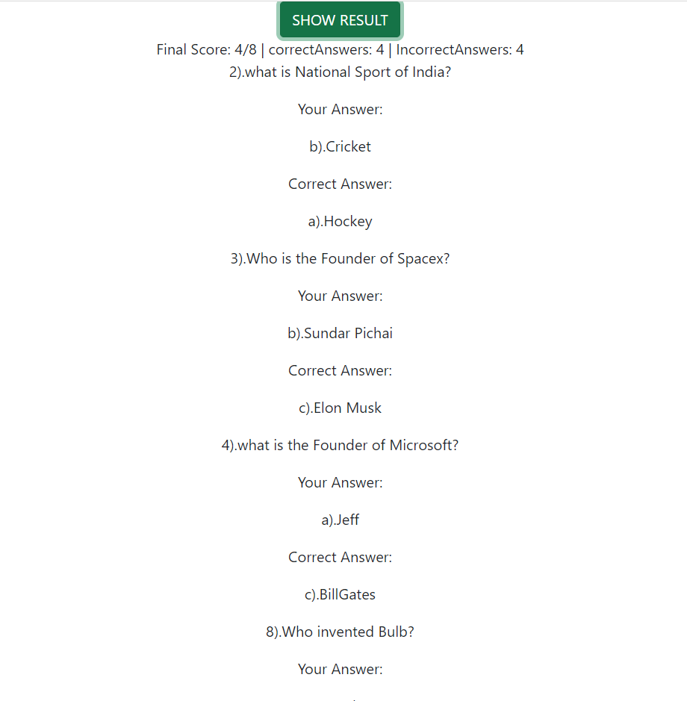

5) 