**DOCUMENTATION FOR TASK TRACKER APPLICATION**

**Name: Kranthi Kumar Reddy Anugu**

**ID:1974268**

**GitHub Repository URL**: **https://github.com/kranthireddy47/1974268_kranthireddy_TCSMEANSTACK.git**

**Note:** I have developed Task Tracker Application. Where you can add your tasks.

This application contains

1. Task component
2. Task service
3. Task model and tasklistdata.json files

And all the app component files.

I have pushed all these files to GITHUB under the commit “**Task Tracker Application**”

1)When you run the project in home page you can see

“TASK TRACKER APPLICATION” with some fields to fill in.

2)You have to fill the following details which are being displayed on the html page.

a)ID

b) NAME

c)TASK

d)DEADLINE

4) When you have entered all the details click on submit button all these details will be added to the json file and when you click on the reset button all the fields will be reset.

5)In the home page you can also see a **TO-DO-LIST** table with all the tasks with the details provided.

6)By using this table you can track all the tasks and their deadlines.

**NOTE:**

a) I used json file to retrieve /storethe data through Http-Request and Imported all the required components and modules.

b) I wrote all the click events and functions in TYPESCRPT. I Have used the concepts of

1)PWA

2)Forms

3)HTML/CSS and other technical things related to angular.

c). I also created the .ignorefile and ignored the output screenshots and documentation file.

d) The data is present in the tasklistdata.json file which is in asset folder.

Output:

1)

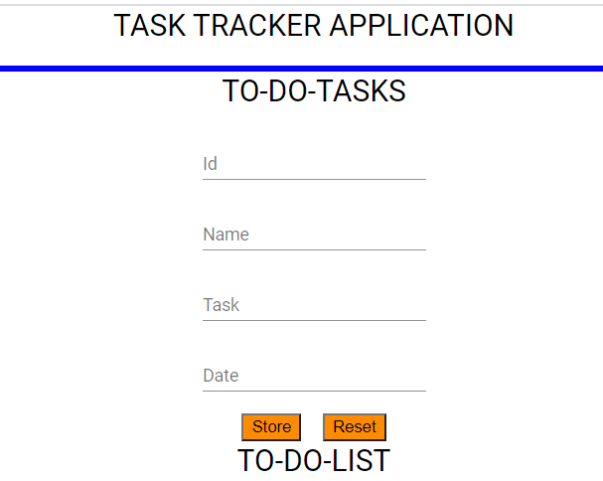

2)

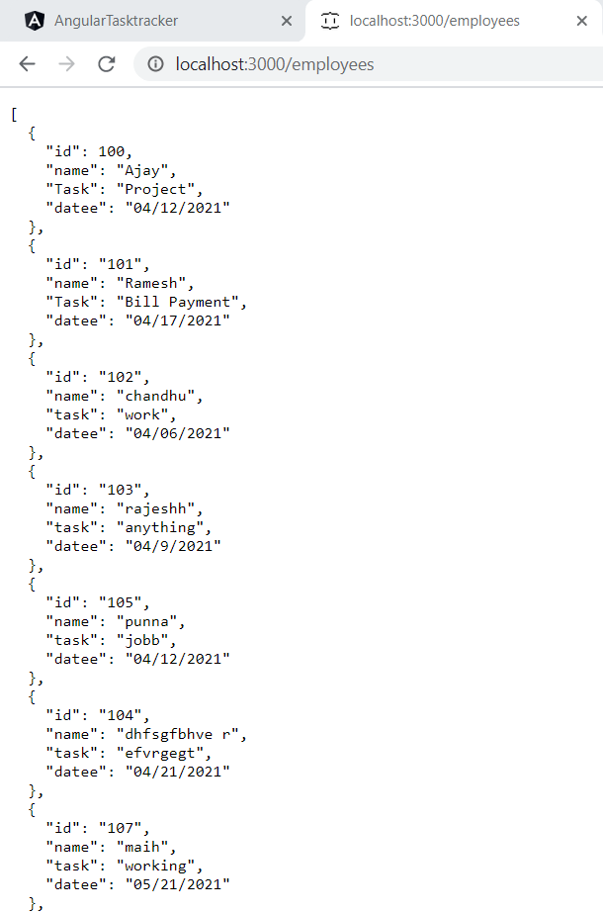

3) 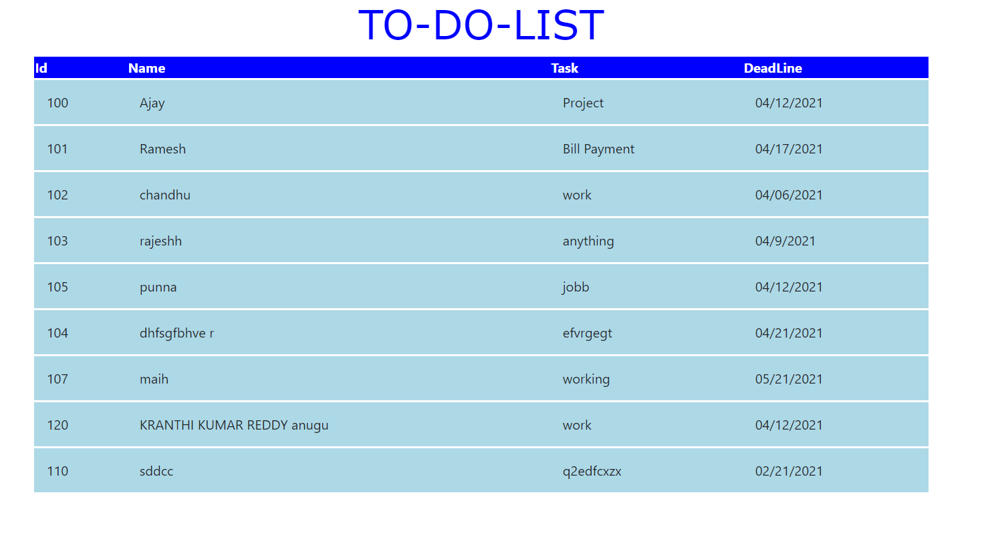

4) 