**Kranthi Kumar Reddy Anugu**

**TcsId:1974268**

**Phone:+1(937)581-4223**

**CREATING A REGISTRY USING EUREKHA AND REGISTERING Employee Service**

**GITHUB URL:** [**https://github.com/kranthireddy47/Eureka-Server.git**](https://github.com/kranthireddy47/Eureka-Server.git)

1. **CREATING A REGISTRY USING EUREKHA**

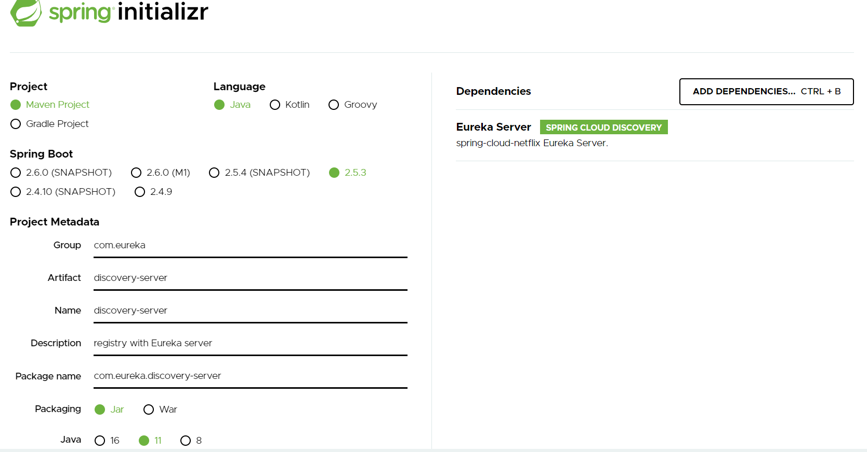

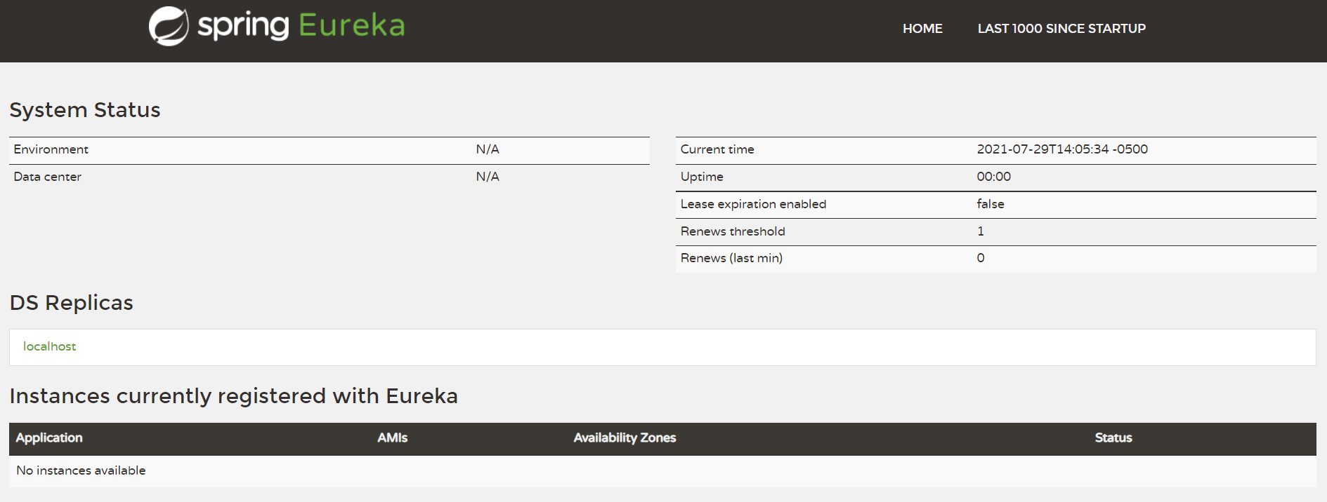

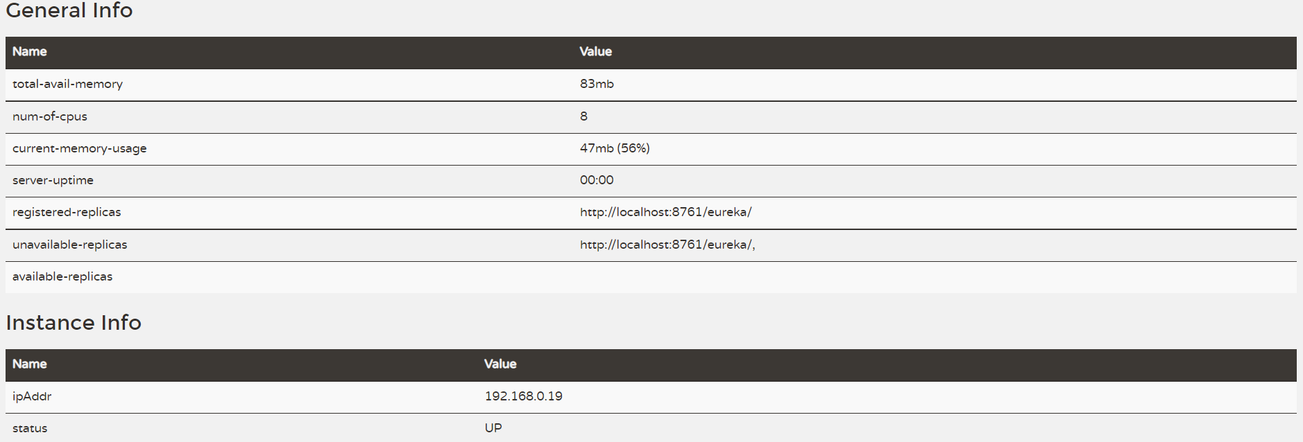

1. Registering Employee Service

