Test Scenario 1: UOM is not being checked on any of the records

UOM BEING CHECKED RECORDS:

PRICE_LIST PART_NUMBER BATCH_NUMBER

EMEA-MST-DE-EUR PV14-8LFX-M 322

PRIMARY_UOM_CODE =PC AND PRICING UOM=

IF above two are same so the flag become checked.

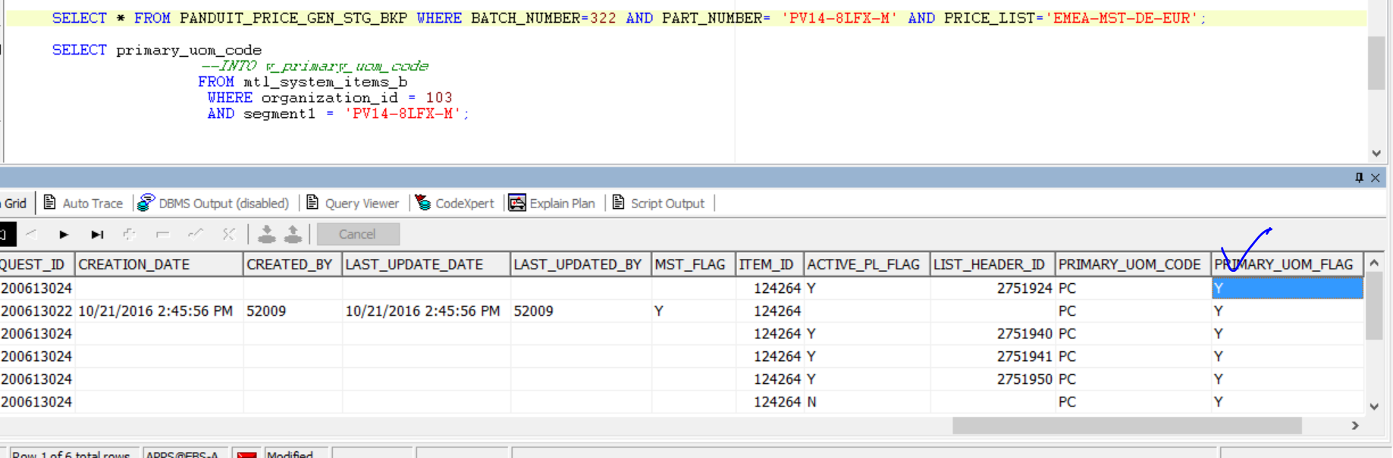

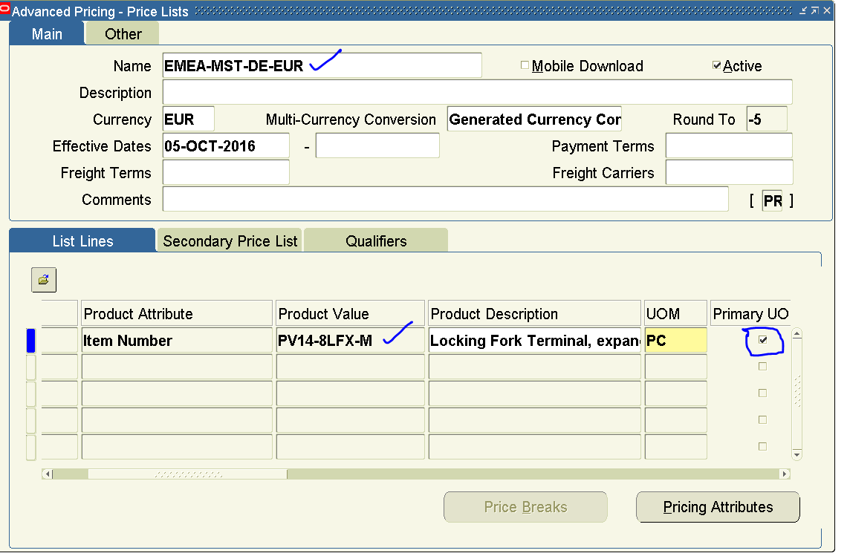

For same pricelist with different part number:

Part number: ABM100-A-C

For this part number pricing_UOM is C And primary_uom_code is PC.

PRICING UOM for above part number as below:

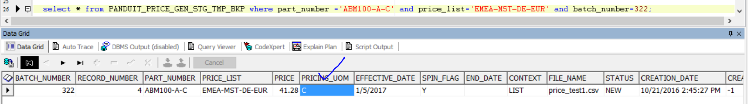

Primary_uom_code for above part number is:

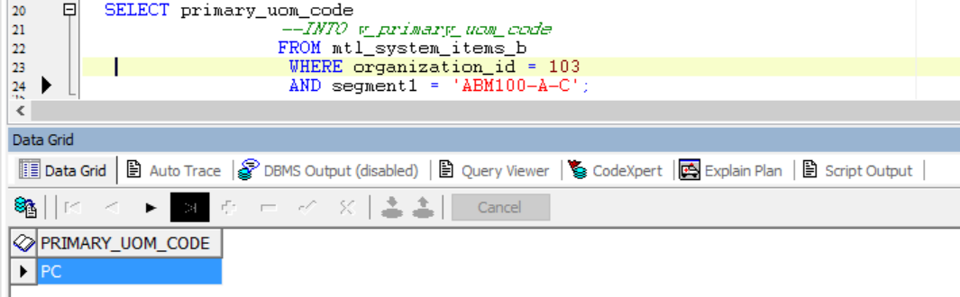

If pricing_uom and primary_uom_code not the same the primary_uom_flag should uncheck as per below screenshot:

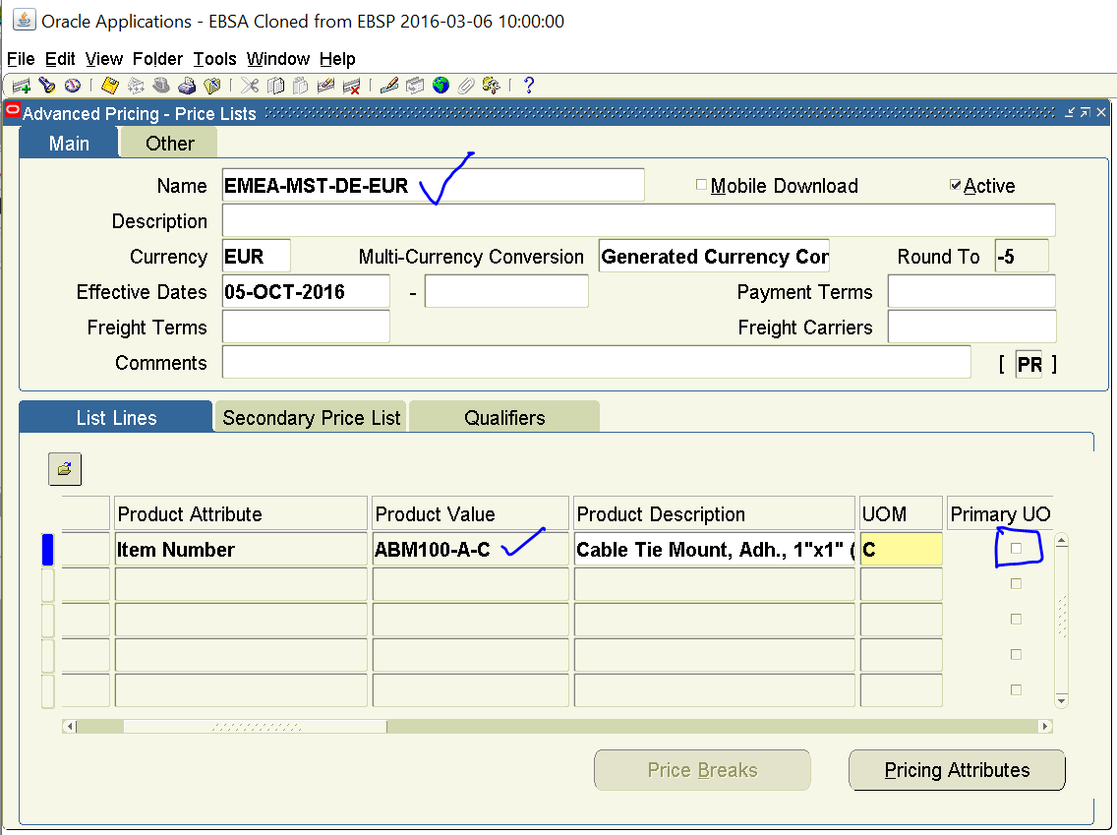

For exception tab: