Data Technician
Week 6 -
Python

Name:
Course Date:
Table of contents
Day 2: Task 1 3
Day 3: Task 1 3
Exercise 1: Loading and Exploring the Data 4
Exercise 2: Indexing and Slicing 4
Exercise 3: Data Manipulation 4
Exercise 4: Aggregation and Grouping 5
Exercise 5: Advanced Operations 5
Exercise 6: Exporting Data 6
Exercise 7: If finished early, try visualising the results 6
Day 4: Task 1 7
Day 4: Task 2 8
Course Notes 8
Additional Information 9

Day 2: Task 1

It is a common software development interview question to create the below with a certain programming language. Create the below using Python syntax, test it and past the completed syntax and output below.

FizzBuzz:

Go through the integers from 1 to 100.
If a number is divisible by 3, print "fizz."
If a number is divisible by 5, print "buzz."
If a number is both divisible by 3 and by 5, print "fizzbuzz."
Otherwise, print just the number.

Paste your completed work to the right | 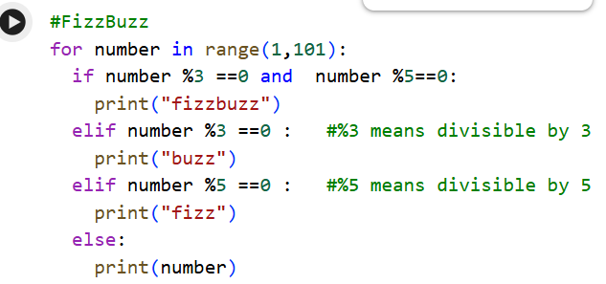  1  2  buzz  4  fizz  buzz  7  8  buzz  fizz  11  buzz  13  14  fizzbuzz  16  17  buzz  19  fizz  buzz  22  23  buzz  fizz  26  buzz  28  29  fizzbuzz  31  32  buzz  34  fizz  buzz  37  38  buzz  fizz  41  buzz  43  44  fizzbuzz  46  47  buzz  49  fizz  buzz  52  53  buzz  fizz  56  buzz  58  59  fizzbuzz  61  62  buzz  64  fizz  buzz  67  68  buzz  fizz  71  buzz  73  74  fizzbuzz  76  77  buzz  79  fizz  buzz  82  83  buzz  fizz  86  buzz  88  89  fizzbuzz  91  92  buzz  94  fizz  buzz  97  98  buzz  fizz

Day 3: Task 1

Using the ‘student.csv’, complete the following exercises as a group and paste your input and output. Although this is a group activity, everyone should have the following answered so it supports your portfolio:

Exercise 1: Loading and Exploring the Data
- Question: "Write the code to read a CSV file into a Pandas DataFrame."
- Question: "Write the code to display the first 5 rows of the DataFrame."
- Question: "Write the code to get the information about the DataFrame."
- Question: "Write the code to get summary statistics for the DataFrame."

1. from google.colab import files
import pandas as pd
uploaded = files.upload()
full_path = '/content/student.csv'
df = pd.read_csv('/content/student.csv') #enter your csv file example student.csv

2. df.head() #Dataframe is named ‘df’
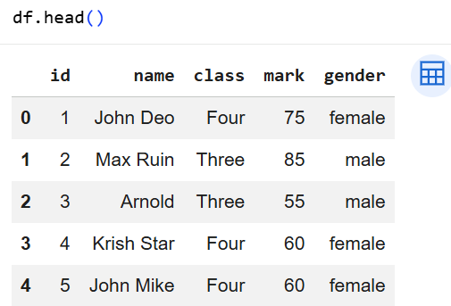

3. df.info()
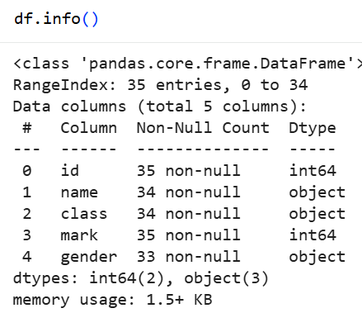

4. df.describe()
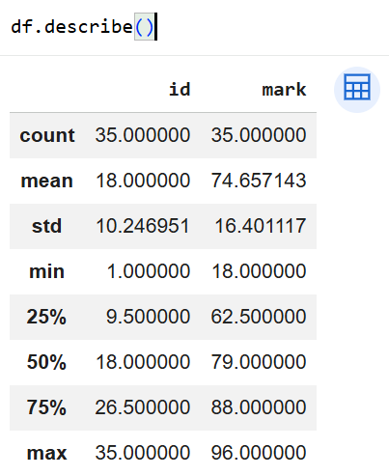

Exercise 2: Indexing and Slicing
- Question: "Write the code to select the 'name' column."
- Question: "Write the code to select the 'name' and 'mark' columns."
- Question: "Write the code to select the first 3 rows."
- Question: "Write the code to select all rows where the 'class' is 'Four'."

1. df[['name']]

2. df[['name','mark']]

3. df.loc[0:2]

4. df[df['class'] =='Four']

Exercise 3: Data Manipulation
- Question: "Write the code to add a new column 'passed' that indicates whether the student passed (mark >= 60)."
- Question: "Write the code to rename the 'mark' column to 'score'."
- Question: "Write the code to drop the 'passed' column."

1. df['passed'] = df['mark'] >= 60
print(df)

2. df = df.rename(columns={'mark': 'score'})
df.head()

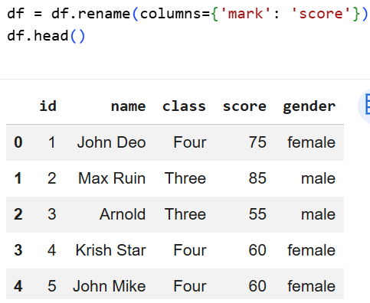
3. df = df.drop(columns=['passed'])
df.head()

Exercise 4: Aggregation and Grouping
- Question: "Write the code to group the DataFrame by the 'class' column and calculate the mean 'score’ for each group."
- Question: "Write the code to count the number of students in each class."
- Question: "Write the code to calculate the average score for each gender."

1. df['class'] = df['class'].replace('Fifth', 'Five') #replace ‘Fifth’ with ‘Five’ first
df.groupby('class')['score'].mean()
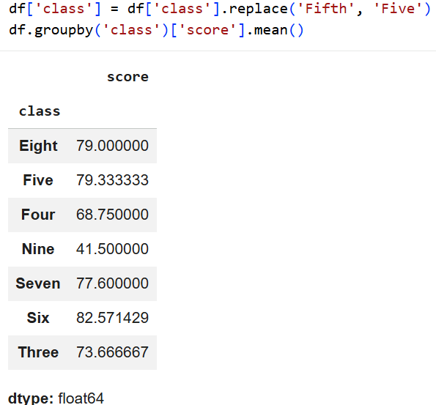

2. df['class'].value_counts()

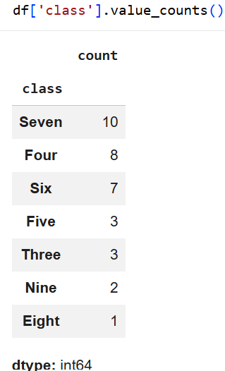

3. df.groupby('gender')['score'].mean()
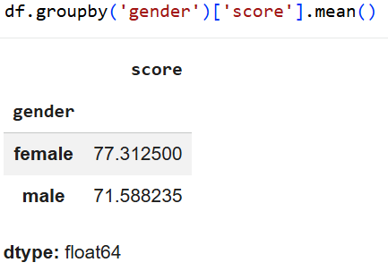

Exercise 5: Advanced Operations (optional)
- Question: "Write the code to create a pivot table with 'class' as rows, 'gender' as columns, and 'score' as values."
- Question: "Write the code to create a new column 'grade' where marks >= 85 are 'A', 70-84 are 'B', 60-69 are 'C', and below 60 are 'D'."
- Question: "Write the code to sort the DataFrame by 'score' in descending order."

1. need more time to work out this one as the score values were giving weird values
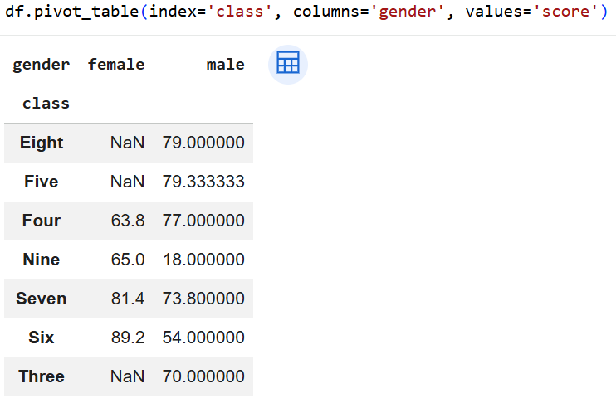

2. conditions = [
df['score'] >= 85.0,
df['score'] >= 70.0,
df['score'] >= 60.0,
]
choices = ['A', 'B', 'C']
df['grade'] = np.select(conditions, choices, default='D')

df.head()
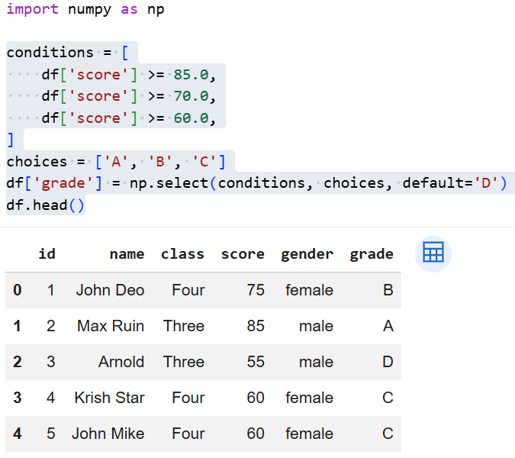

3. df = df.sort_values('score', ascending=False)
print(df)

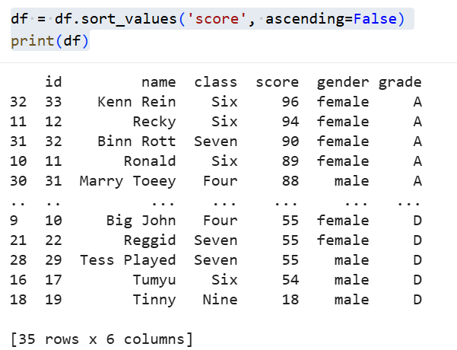

Exercise 6: Exporting Data
- Question: "Write the code to save the DataFrame with the new 'grade' column to a new CSV file."

Exercise 7: If finished early, try visualising the results

Day 4: Task 1

Using the ‘GDP (nominal) per Capita.csv’, complete the following exercises and paste your input and output. Work individually, but we will work and support each other in the room.

- Read and save the ‘GDP (nominal) per Capita’ data to a data frame called “df” in Jupyter notebook
- Print the first 10 rows
- Print the last 5 rows
- Print ‘Country/Territory’ and ‘UN_Region’ columns

First 10 rows:

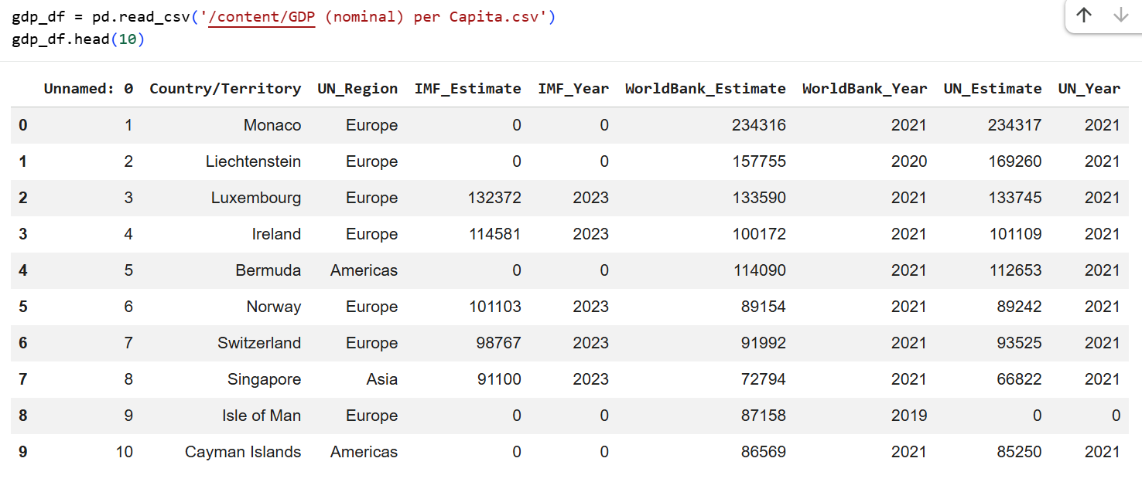

Last 5 rows:

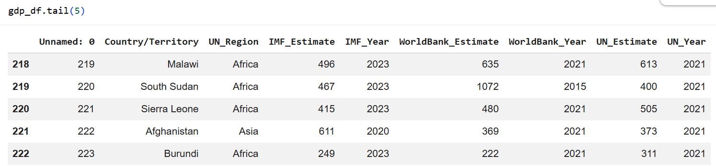

‘Country/Territory’ and ‘UN_Region’ columns:

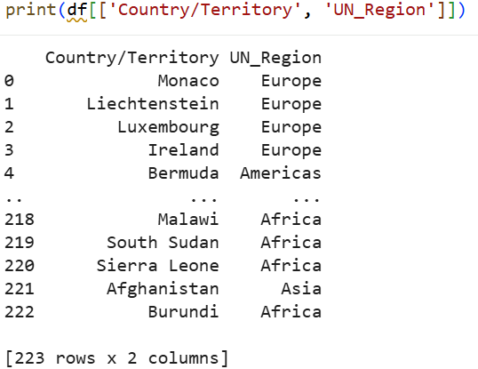

Day 4: Task 2

Upload > file > new notebook > Work through the task provided by the tutor.

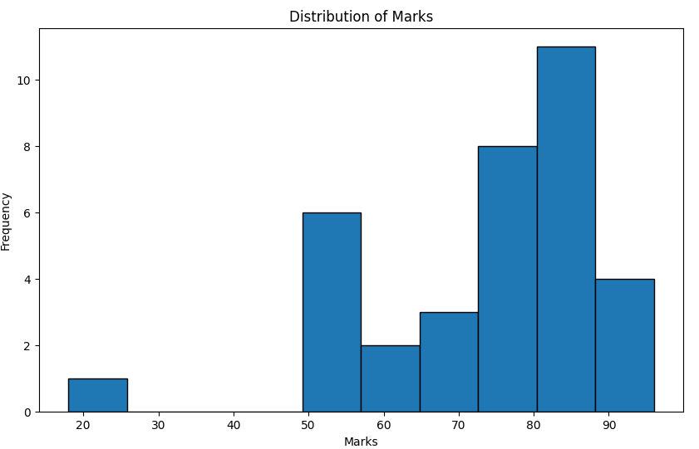

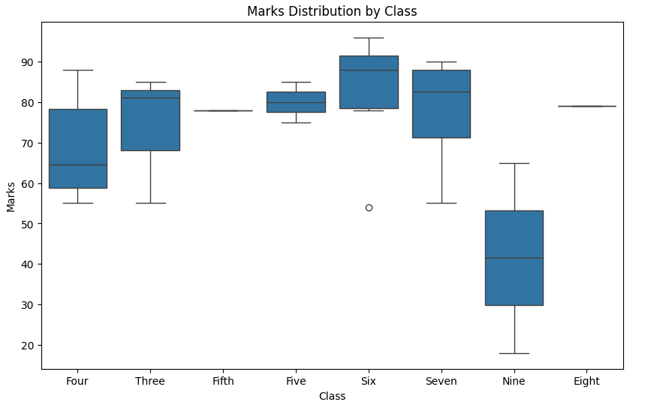

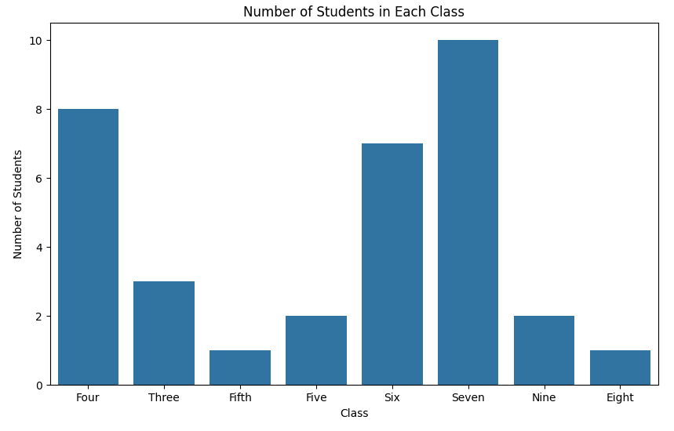

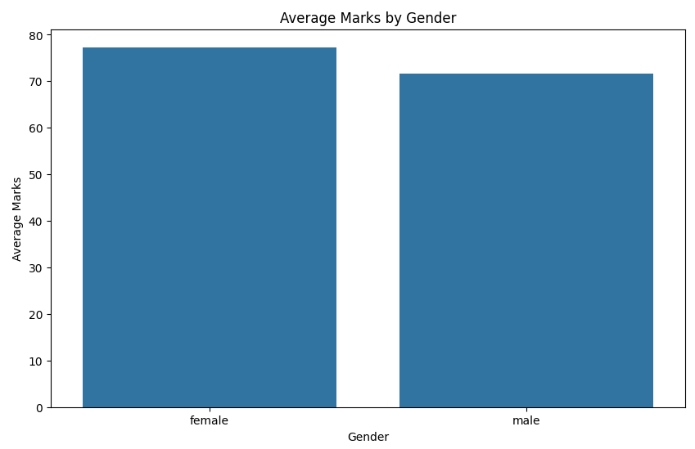

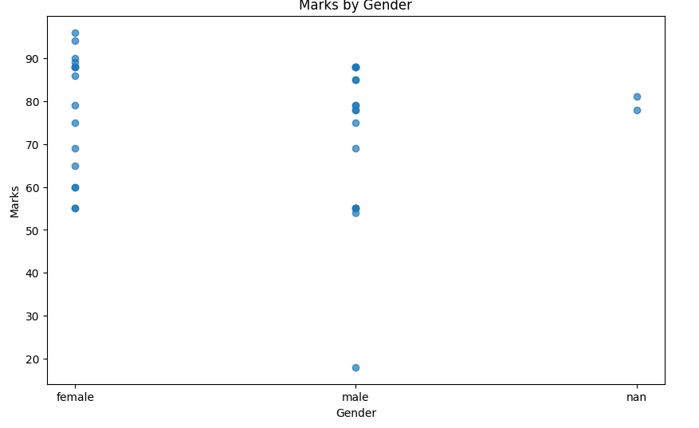

Course Notes

It is recommended to take notes from the course, use the space below to do so, or use the revision guide shared with the class:

Additional Information

We have included a range of additional links to further resources and information that you may find useful, these can be found within your revision guide.

END OF WORKBOOK

Please check through your work thoroughly before submitting and update the table of contents if required.

Please send your completed work booklet to your trainer.

