AI ASSISTED CODING :-

NAME : T.karthik
Enroll No : 2403A54089
Batch : DS – Batch : 3

Assignment 7.3 :
Task Description 1
• Paste a function with a missing colon (add(a, b)), and let AI fix the syntax error.
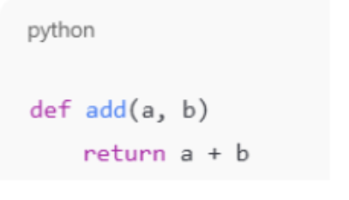

Prompt: correct the following code and input two numbers to find the sum

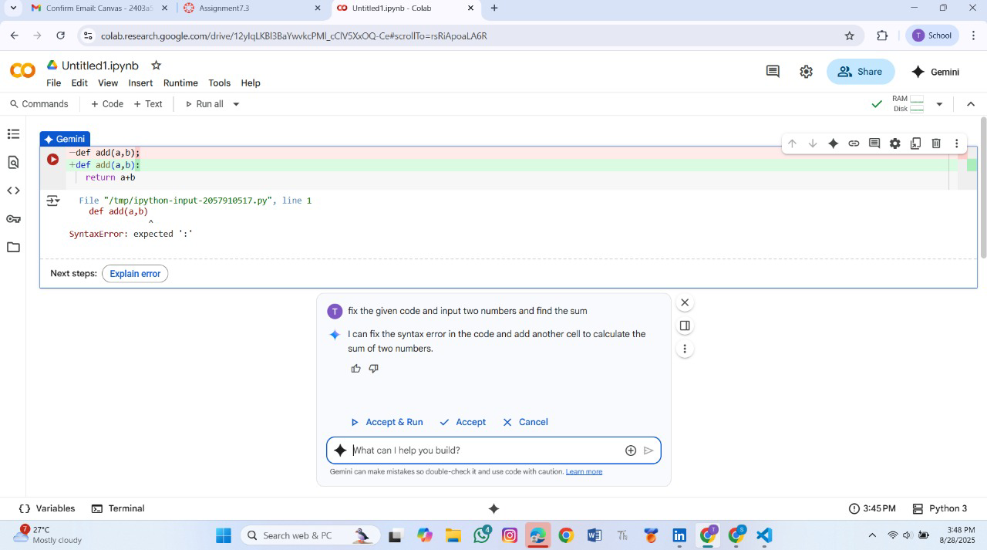
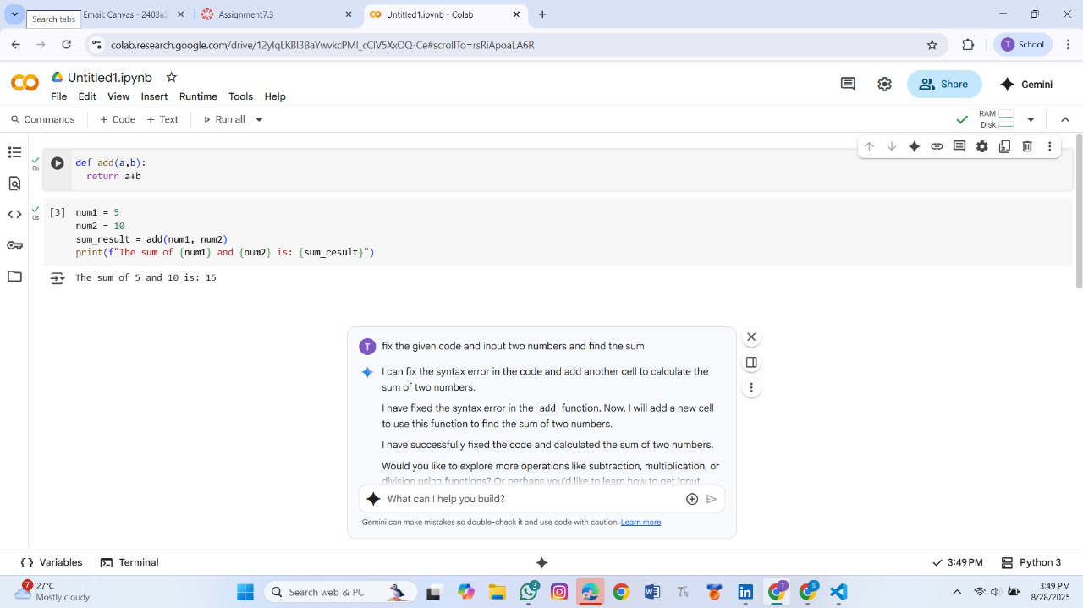

Output : Corrected function with syntax fix
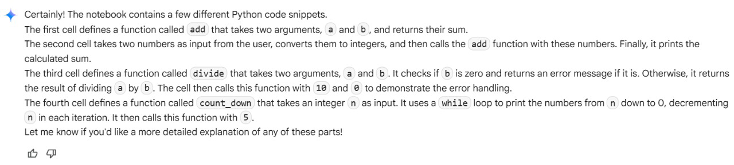

Task Description#2 (Loops)
• Identify and fix a logic error in a loop that causes infinite iteration
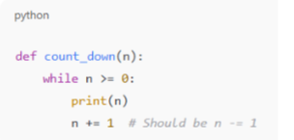
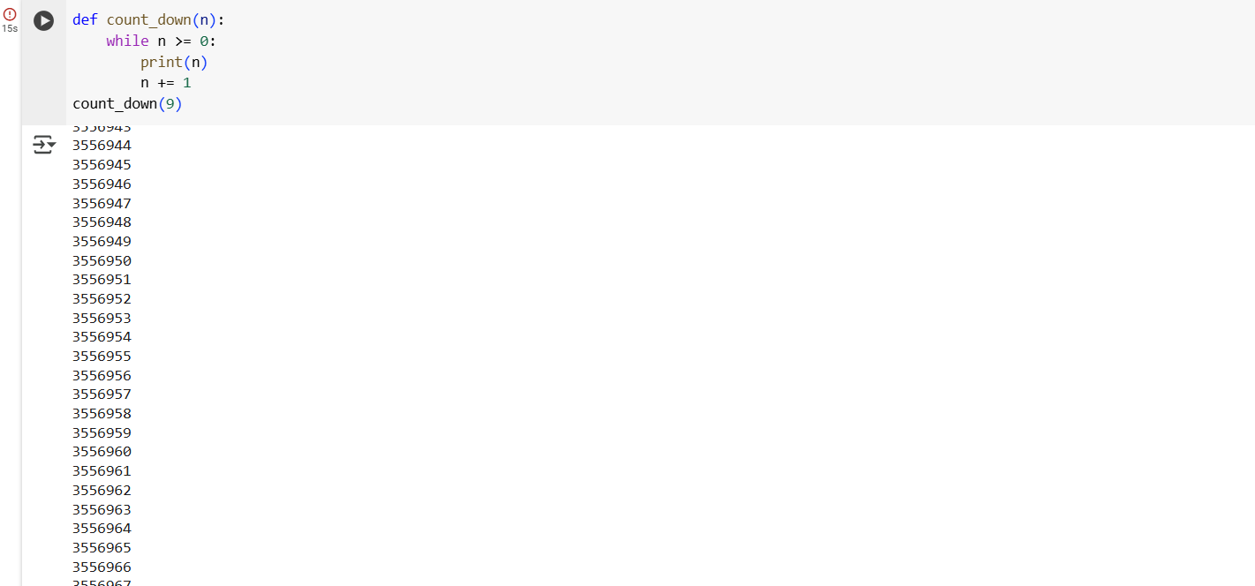
Prompt :

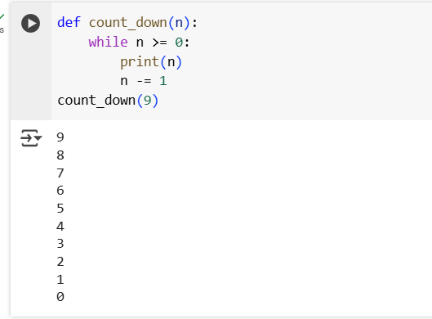
Output : AI fixes increment/decrement error
Explanation :
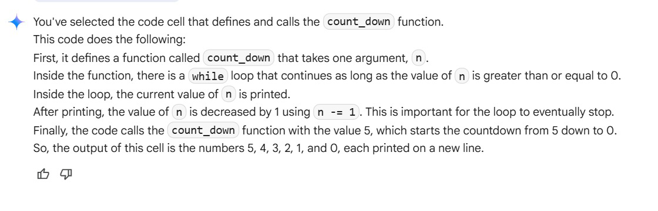
TASK 3:
Debug a runtime error caused by division by zero. Let AI insert try-except.
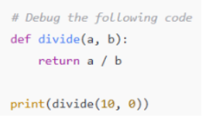
Prompt: correct the error and give the perfect input in the following code
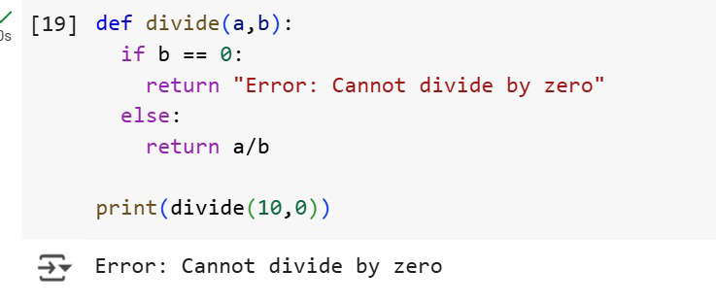
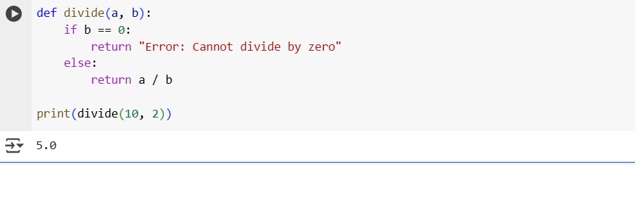
Output : Corrected function with safe error handling
Explanation :
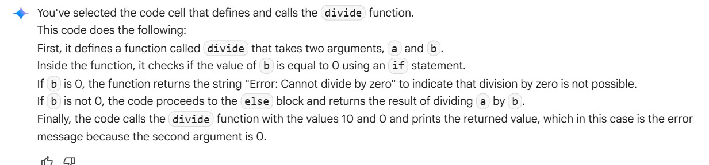
TASK 4 :
Provide a faulty class definition (missing self in parameters). Let AI fix it
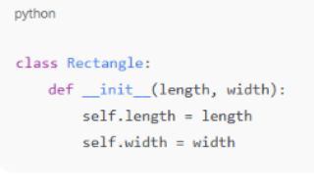
Prompt : correct the following code and give the suitable inputs
Code :
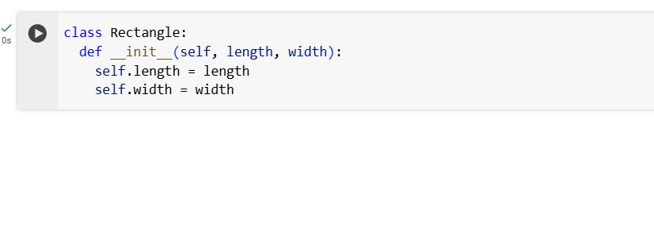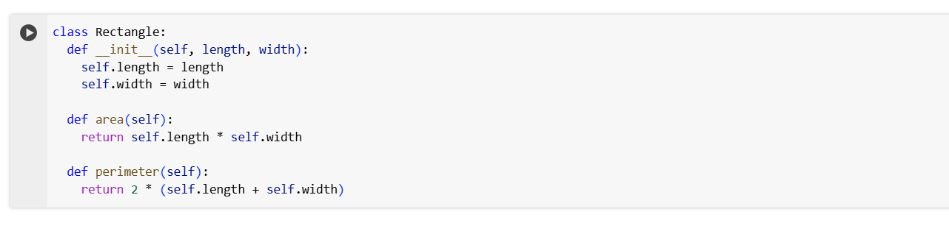
Output : Correct __init__() method and explanation
Explanation :
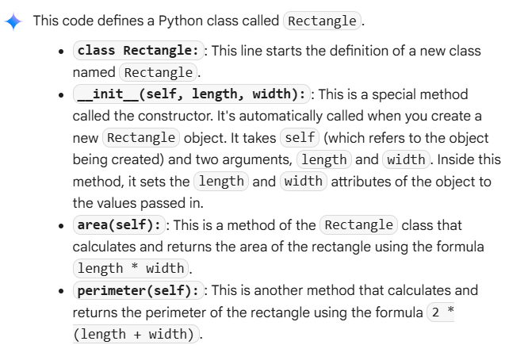
TASK 5 :
Access an invalid list index and use AI to resolve the Index Error
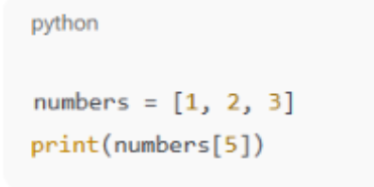
Prompt: fix the following code and explain it
Code : 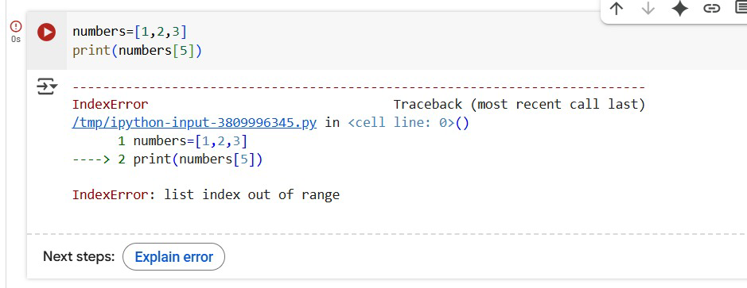

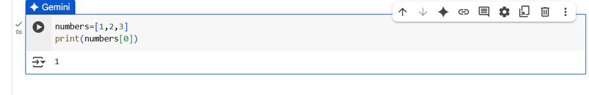
Output : AI suggests checking length or using safe access logic
Explanation :
