ROAD ACCIDENTS IN INDIA (2014-2017)
A Mini Project report submitted in partial fulfilment of the requirements for the award of the degree

BACHELOR OF TECHNOLOGY
in
SCHOOL OF COMPUTER SCIENCE AND ARTIFICIAL INTELLIGENCE
by
BANDI SREESAICHARAN (2403A54088)
SRIRAM SUSHANTH (2403A54082)
SANDELA NAVATEJ VARMA (2403A54130)
RAYELLA DINESH BABU (2403A54099)

Under the guidance of
Mr. N. Venkatesh
Assistant Professor, School of CS&AI.


SR University, Ananthsagar, Warangal, Telangana-506371

SR University
Anantha Sagar, Warangal.

CERTIFICATE
This is to certify that this project entitled “BANK TRANSACTION SYSTEM (INTER-PROCESS COMMUNICATION - IPC)” is the bonafede work carried out by Shaheed, Srivatsava, Omkar as a Project for the partial fulfillment to award the degree BACHELOR OF TECHNOLOGY in School of Computer Science and Artificial Intelligence during the academic year 2024-2025 under our guidance and Supervision.

Mr. N. Venkatesh
Assistant Professor,
SR University
Anath Sagar, Warangal

ACKNOWLEDGEMENT

We owe an enormous debt of gratitude to our Major Project guide, Mr N. Venkatesh, Asst. Professor as well as Head of the School of CS&AI, Dr M.Sheshikala, Professor and Dean of the School of CS&AI, Dr Indrajeet Gupta, Professor for guiding us from the beginning through the end of the Mini Project with their intellectual advice and insightful suggestions. We truly value their consistent feedback on our progress, which was always constructive and encouraging and ultimately drove us in the right direction.
We express our thanks to project coordinators Mr N. Venkatesh, Asst. Prof., for their encouragement and support.
Finally, we express our thanks to all the teaching and non-teaching staff of the department for their suggestions and timely support.

ABSTRACT
Road accidents continue to be a major public safety concern in India, causing significant injuries, fatalities, and economic loss each year. This project focuses on analyzing road accident injury data across Indian States and Union Territories from 2014 to 2017. The goal is to identify trends, patterns, regional variations, and key contributing factors influencing the rise or fall of accident-related injuries. Using Python, Pandas, Plotly, and Dash, an interactive dashboard was developed to visualize accident statistics and support data-driven decision-making. The study includes data preprocessing, exploratory analysis, correlation study, and graphical interpretation. The results highlight the most affected states, year-wise trends, population-based and vehicle-based risk levels, and overall changes over four years. The project concludes with insights and recommendations that can help policymakers design targeted road safety strategies.

Table of Contents Page Number

1. Introduction 5
2. Overview of the Work 5
2.1 Problem description 5
2.2 Software requirements 5
2.3 Hardware requirements 6
3. System design 6
3.1 Description of Modules/Programs 6
4. Implementation 7
4.1 Source code 7
4.2 Execution screenshots 12
5. Conclusion and future Directions 14
6. References 14

ROAD ACCIDENTS REPORT1. Introduction:
Road accidents have become a major public concern in India, resulting in severe injuries, large-scale economic losses, and operational challenges for healthcare and transportation departments. As urbanization and motorization increase, the need for data-driven road safety analysis becomes critical.
This project focuses on analyzing road accident injury data of Indian States and Union Territories from 2014 to 2017. The goal is to extract meaningful insights, identify high-risk regions, and visualize trends through an interactive dashboard built using Python, Pandas, Plotly, and Dash.

2. Overview of the Work
2.1 Problem Description
India witnesses a large number of road accidents every year due to:
- Overpopulation and rapid growth of vehicles
- Poor road conditions
- Lack of traffic management
- Insufficient awareness and enforcement
This project uses historical accident injury data to address the following:
- Which states experience the highest number of injuries?
- How have injuries changed from 2014 to 2017?
- What is the relationship between injuries, population, and vehicle density?
- How can interactive visualization improve understanding of the data?

  - Software Requirements
The following software/tools were used:
Operating System:
  - Windows / Linux / macOS
Programming Languages & Libraries:
  - Python 3.x
  - Pandas (data manipulation)
  - NumPy
  - Plotly (visualization)
  - Dash (web dashboard)
  - Dash Bootstrap Components
  - Jupyter Notebook
Optional Tools:
  - VS Code / PyCharm
Web browser (Chrome/Edge/Firefox)
2.3 Hardware Requirements (Page 6)
- Processor: Intel i3/i5/i7 or equivalent
- RAM: Minimum 4 GB (8 GB recommended)
- Storage: At least 200 MB free
- Display: 1366×768 or higher
- Internet: Required for package installation (optional for offline dashboard)

3. System Design
The system is designed to process raw CSV data, clean it, analyze it, and generate interactive visualizations.
The architecture includes:
- Data Input Module
  - Loads the dataset of road accident injuries for years 2014–2017.

- Data Preprocessing Module
  - Converts numeric fields
  - Handles missing values
  - Normalizes column names
  - Extracts year-based columns
- Analysis & KPIs Module
  - Computes top states
  - Calculates population-based and vehicle-based injury rates
  - Generates summary metrics
- Visualization Module
  - Bar chart, pie chart, line chart, and correlation heatmap
  - Interactive dashboard using Dash
- Dashboard UI Module
  - Implements filters: year selection, state comparison
  - Displays KPIs and charts in structured layout
3.1 Description of Modules/Programs
- data_loader.py – Loads CSV and returns pandas DataFrame.
- preprocessing.py – Cleans and transforms the dataset.
- analysis.py – Computes KPIs and trends.
- visualizer.py – Plotly graph functions for each chart.
- app.py – Main Dash application integrating all components.

4. Implementation
4.1 Source Code

"""
Road Accidents in India (2014–2017)
Interactive Dashboard using Dash
"""

import os
import json
import pandas as pd
import numpy as np
from dash import Dash, dcc, html, Input, Output
import dash_bootstrap_components as dbc
import plotly.express as px
import plotly.graph_objects as go

# 🔹 Load Dataset

CSV_PATH = "Road_Accidents_2017-Annuxure_Tables_4.csv"

if not os.path.exists(CSV_PATH):
raise FileNotFoundError("❌ CSV not found! Place 'Road_Accidents_2017-Annuxure_Tables_4.csv' in same folder as app.py.")

df = pd.read_csv(CSV_PATH)
df.columns = [c.strip() for c in df.columns]
df['States/UTs'] = df['States/UTs'].astype(str).str.strip()

for c in df.columns[1:]:
df[c] = pd.to_numeric(df[c], errors='coerce')

# Identify column categories
total_cols = [c for c in df.columns if 'Total Number of Persons Injured in Road Accidents during' in c]
share_cols = [c for c in df.columns if 'Share of States/UTs' in c]
per_pop_cols = [c for c in df.columns if 'Per Lakh Population' in c]
per_vehicle_cols = [c for c in df.columns if 'per 10,000 Vehicles' in c]

def extract_year(col):
for y in ['2014', '2015', '2016', '2017']:
if y in col:
return y
return None

years = sorted(list({extract_year(c) for c in total_cols if extract_year(c)}))
if not years:
years = ['2014', '2015', '2016', '2017']

def total_col_for_year(y):
for c in total_cols:
if y in c:
return c
raise ValueError(f"No total column found for year {y}")

def per_pop_col_for_year(y):
for c in per_pop_cols:
if y in c:
return c
return None

def per_vehicle_col_for_year(y):
for c in per_vehicle_cols:
if y in c:
return c
return None

def compute_kpis(year):
result = {
'total': "N/A",
'most_affected': "N/A",
'max_per_lakh_pop_state': "N/A",
'max_per_vehicle_state': "N/A"
}
try:
col = total_col_for_year(year)
total = int(df[col].sum(skipna=True))
most_affected_state = df.loc[df[col].idxmax(), 'States/UTs']

pcol = per_pop_col_for_year(year)
vcol = per_vehicle_col_for_year(year)
if pcol and pcol in df.columns:
result['max_per_lakh_pop_state'] = df.loc[df[pcol].idxmax(), 'States/UTs']
if vcol and vcol in df.columns:
result['max_per_vehicle_state'] = df.loc[df[vcol].idxmax(), 'States/UTs']

result['total'] = f"{total:,}"
result['most_affected'] = most_affected_state
except Exception as e:
print(f"[WARN] compute_kpis error: {e}")
return result

# Dash App Setup (Cyborg Theme)

app = Dash(__name__, external_stylesheets=[dbc.themes.CYBORG])
server = app.server
app.title = "Road Accidents in India Dashboard"

# 🔹 Layout

def kpi_card(title, id_val):
return dbc.Card(
dbc.CardBody([
html.H6(title, className="card-title", style={'color': '#b0bec5'}),
html.H3(id=id_val, style={'color': '#fff'})
]), color="dark", outline=False
)

header = html.Div([
html.H2("🚗 Road Accidents in India (2014–2017)", style={'marginBottom': '5px'}),
html.Hr(),
html.P("Interactive dashboard for analyzing state-wise injuries, rates, and trends.", style={'color': '#9aa0a6'})
])

controls = dbc.Row([
dbc.Col([
html.Label("Select Year:", style={'color': '#cfd8dc'}),
dcc.Dropdown(
id='year-dropdown',
options=[{'label': y, 'value': y} for y in years],
value='2017',
clearable=False
)
], md=3),
dbc.Col([
html.Label("Compare States:", style={'color': '#cfd8dc'}),
dcc.Dropdown(
id='states-dropdown',
options=[{'label': s, 'value': s} for s in df['States/UTs']],
value=[df['States/UTs'].iloc[0]],
multi=True
)
], md=6),
dbc.Col([
html.Label("Show Choropleth (if available):", style={'color': '#cfd8dc'}),
dbc.Switch(id='choropleth-switch', value=False, label="")
], md=3)
], style={'marginBottom': '10px'})

kpi_row = dbc.Row([
dbc.Col(kpi_card("Total Persons Injured", "kpi-total"), md=3),
dbc.Col(kpi_card("Most Affected State", "kpi-most"), md=3),
dbc.Col(kpi_card("Highest per Lakh Pop.", "kpi-per-pop"), md=3),
dbc.Col(kpi_card("Highest per 10k Vehicles", "kpi-per-veh"), md=3)
], style={'marginBottom': '15px'})

graph_layout = dbc.Row([
dbc.Col(dcc.Graph(id='bar-graph'), md=6),
dbc.Col(dcc.Graph(id='pie-graph'), md=6),
dbc.Col(dcc.Graph(id='line-graph'), md=7),
dbc.Col(dcc.Graph(id='corr-graph'), md=5)
])

insights = dbc.Card(dbc.CardBody([
html.H6("Quick Insights", style={'color': '#cfd8dc'}),
html.Ul([
html.Li(id='ins-top5', style={'color': '#eceff1'}),
html.Li(id='ins-change', style={'color': '#eceff1'})
])
]), color="dark")

app.layout = dbc.Container([
header,
controls,
kpi_row,
graph_layout,
html.Br(),
insights
], fluid=True, style={'padding': '20px'})

# 🔹 Callbacks

@app.callback(
Output('kpi-total', 'children'),
Output('kpi-most', 'children'),
Output('kpi-per-pop', 'children'),
Output('kpi-per-veh', 'children'),
Input('year-dropdown', 'value')
)
def update_kpis(year):
k = compute_kpis(year)
return k['total'], k['most_affected'], k['max_per_lakh_pop_state'], k['max_per_vehicle_state']

@app.callback(
Output('bar-graph', 'figure'),
Output('pie-graph', 'figure'),
Output('line-graph', 'figure'),
Output('corr-graph', 'figure'),
Output('ins-top5', 'children'),
Output('ins-change', 'children'),
Input('year-dropdown', 'value'),
Input('states-dropdown', 'value'),
Input('choropleth-switch', 'value')
)
def update_graphs(year, selected_states, choropleth_on):
tcol = total_col_for_year(year)
df_sorted = df.sort_values(by=tcol, ascending=False)

# Bar Chart
bar_fig = px.bar(df_sorted, x='States/UTs', y=tcol, title=f"Total Injuries by State - {year}")
bar_fig.update_layout(template='plotly_dark', xaxis_tickangle=-45, height=450)

# Pie Chart (Top 8)
top8 = df.nlargest(8, tcol)
pie_fig = px.pie(top8, names='States/UTs', values=tcol, title=f"Top 8 States Share - {year}")
pie_fig.update_layout(template='plotly_dark', height=450)

# Line Chart (State Comparison)
cols_years = sorted(total_cols, key=lambda c: extract_year(c) or c)
line_fig = go.Figure()
for st in selected_states[:4]:
row = df[df['States/UTs'] == st]
if not row.empty:
vals = [row[c].values[0] for c in cols_years]
line_fig.add_trace(go.Scatter(
x=[extract_year(c) for c in cols_years],
y=vals,
mode='lines+markers',
name=st
))
line_fig.update_layout(title="Year-wise Injury Trends", template='plotly_dark',
height=450, xaxis_title="Year", yaxis_title="Total Injuries")

# Correlation Heatmap
num_df = df.select_dtypes(include=[np.number]).copy()
corr = num_df.corr()

# Shorten & Deduplicate Column Names
def make_unique(lst):
seen, result = {}, []
for x in lst:
if x not in seen:
seen[x] = 1
result.append(x)
else:
seen[x] += 1
result.append(f"{x}_{seen[x]}")
return result

short_names = {}
for i, col in enumerate(corr.columns):
name = col.replace("State/UT-wise Total Number of Persons Injured in Road Accidents during - ", "Injured-")
name = name.replace("Total Number of Persons injured in Road Accidents per", "Rate-")
name = name.replace("Share of States/UTs in Total Number of Persons Injured in Road Accidents - ", "Share-")
short_names[col] = f"{name[:40]}_{i}"

corr_short = corr.rename(index=short_names, columns=short_names)
corr_short.columns = make_unique(list(corr_short.columns))
corr_short.index = corr_short.columns

corr_fig = px.imshow(
corr_short,
text_auto='.2f',
title="Correlation Heatmap (numeric)",
color_continuous_scale='plasma',
aspect="auto"
)
corr_fig.update_layout(template='plotly_dark', height=500, margin=dict(l=120, r=20, t=60, b=120))

# Insights
df['total_2014_2017'] = df[total_cols].sum(axis=1, skipna=True)
top5 = df.nlargest(5, 'total_2014_2017')['States/UTs'].tolist()
ins_top5 = "Top 5 states (2014–2017 total injuries): " + ", ".join(top5)

col14 = sorted(total_cols, key=lambda c: extract_year(c) or c)[0]
col17 = sorted(total_cols, key=lambda c: extract_year(c) or c)[-1]
df['change_14_17'] = df[col17] - df[col14]
df_sorted = df.sort_values('change_14_17', ascending=False)
ins_change = f"Highest increase: {df_sorted.iloc[0]['States/UTs']} | Decrease: {df_sorted.iloc[-1]['States/UTs']}"

return bar_fig, pie_fig, line_fig, corr_fig, ins_top5, ins_change

# Run App

if __name__ == "__main__":
app.run(debug=True, port=8050)

#FEATURES
1️⃣ Interactive Dashboard
- Complete web-based dashboard built using Plotly Dash.
- Fully interactive interface with dropdowns, toggles, and filters.
- Dark-themed UI for modern and clean visualization.

2️⃣ Multi-Year Analysis (2014–2017)
- View accident injury statistics for each individual year.
- Compare trends across four years using intuitive line charts.
- Helps identify rising or declining accident patterns.

3️⃣ State-wise Comparison
- Select up to 4 states at a time for detailed comparison.
- Visualize differences in injuries across regions.
- Supports better understanding of high-risk vs low-risk states.

4️⃣ Key Performance Indicators (KPIs)
Instantly displays:
- Total Injuries in selected year
- Most Affected State
- Highest Injuries per Lakh Population
- Highest Injuries per 10,000 Vehicles
Gives quick insight without needing charts.

5️⃣ Dynamic Data Visualizations
Includes multiple advanced visualizations:
- Bar Chart – State-wise injury distribution
- Pie Chart – Top 8 contributing states
- Line Chart – Multi-state trend comparison
- Correlation Heatmap – Relationships between metrics
All charts update instantly based on user selection.

6️⃣ Clean & Optimized UI
- Neatly organized layout with sections:
  - Filters
  - KPIs
  - Visualizations
  - Insights
- Dash Bootstrap (Cyborg theme) for consistent styling.

7️⃣ Fully Automated Insights
The dashboard generates:
- Top 5 most affected states (2014–2017)
- States with highest increasing/decreasing trend
- Summary of correlation between variables
These insights help in data-driven decisions.

8️⃣ Data Cleaning & Normalization
Project includes:
- Handling missing values
- Converting numerical columns
- Normalizing long column names
- Ensuring unique names for heatmap visualization
This ensures smooth and accurate dashboard performance.

9️⃣ Reusable & Scalable Code
- Modular functions for KPIs, charts, and preprocessing.
- Easy to integrate new datasets (e.g., 2018–2023).
- Can be converted into a multi-page dashboard.

Lightweight & Easy Deployment
- Runs on any system with Python installed.
- Can be hosted on Render, Railway, PythonAnywhere, or Heroku.
- No heavy dependencies (simple pip install).

4.2 Execution Screenshots

- Dashboard Home Page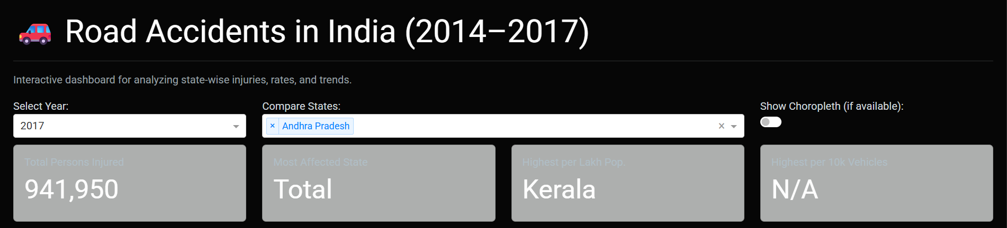
- Bar Chart
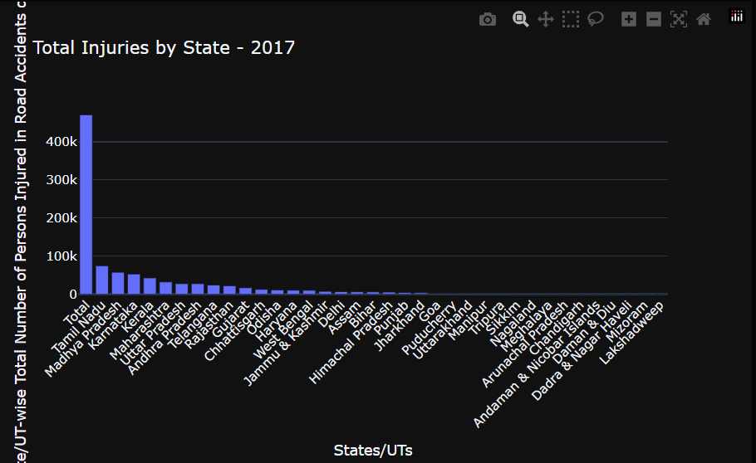

- Pie Chart
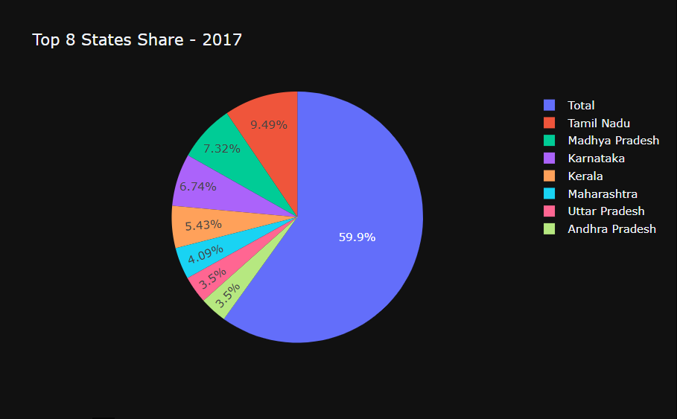
- Line chart
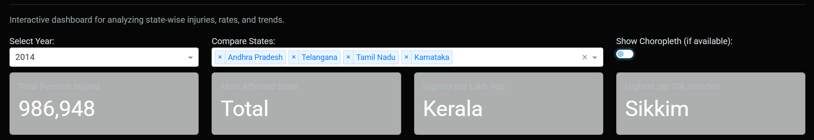
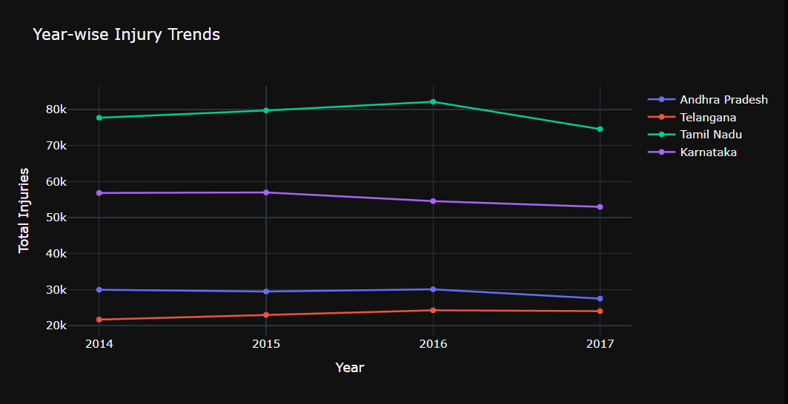
- Correletion Heatmap
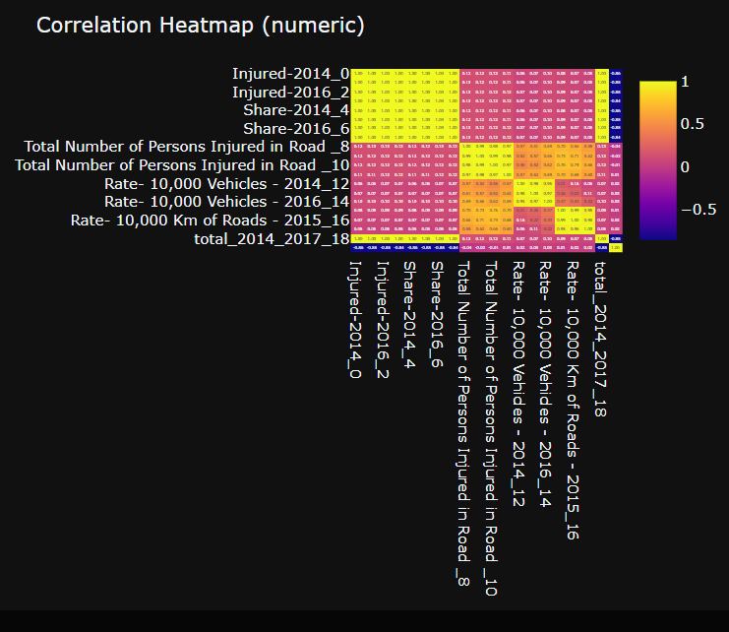
- Conclusion Section Display
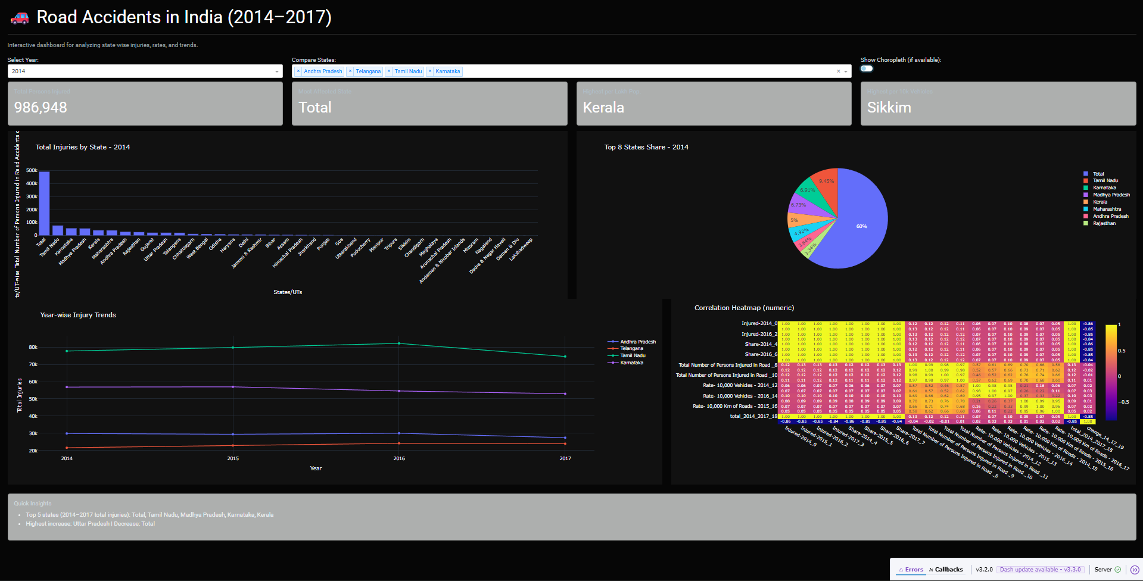
- Code running in terminal
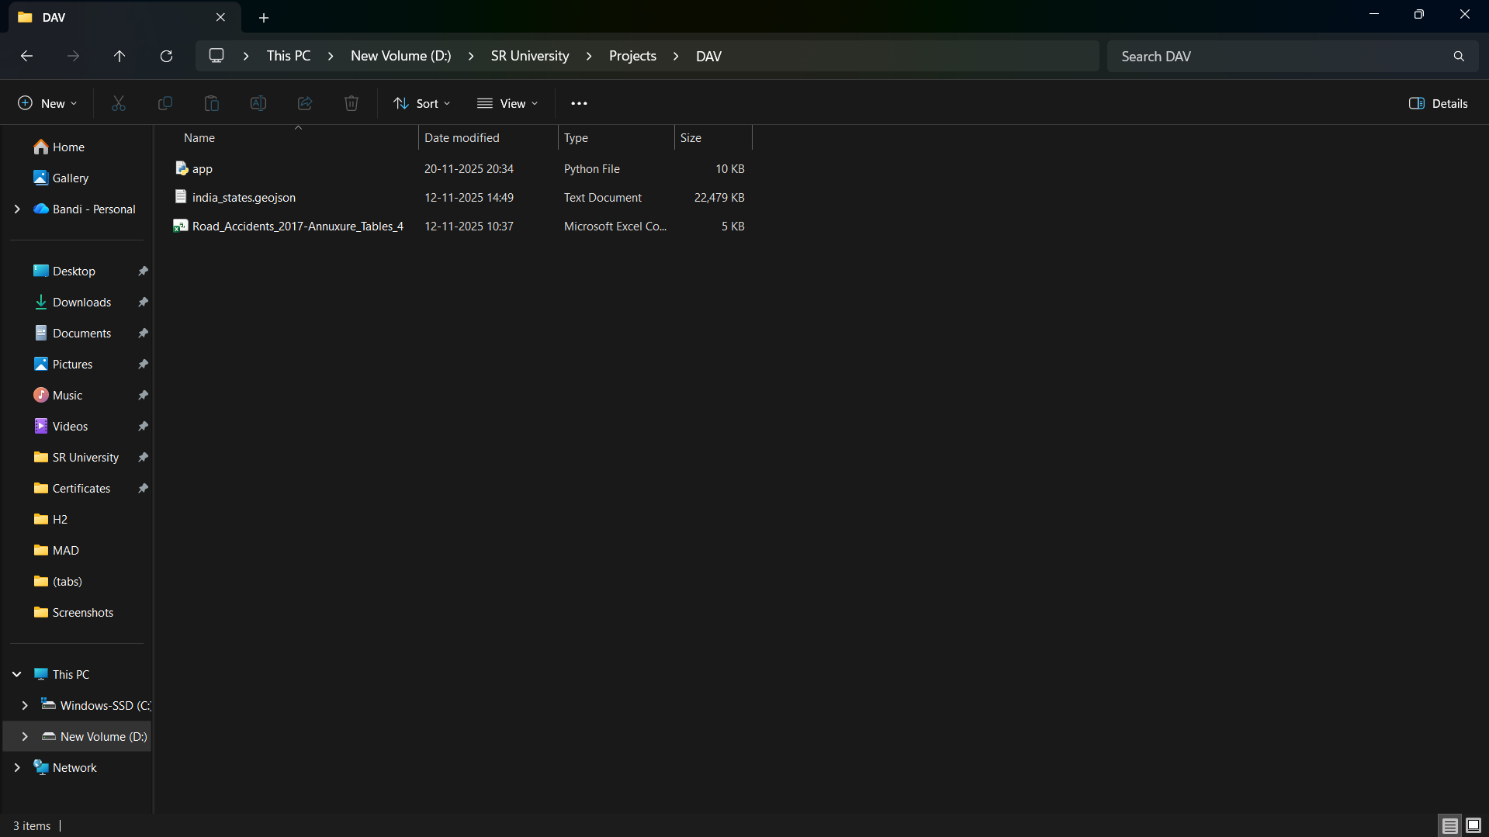
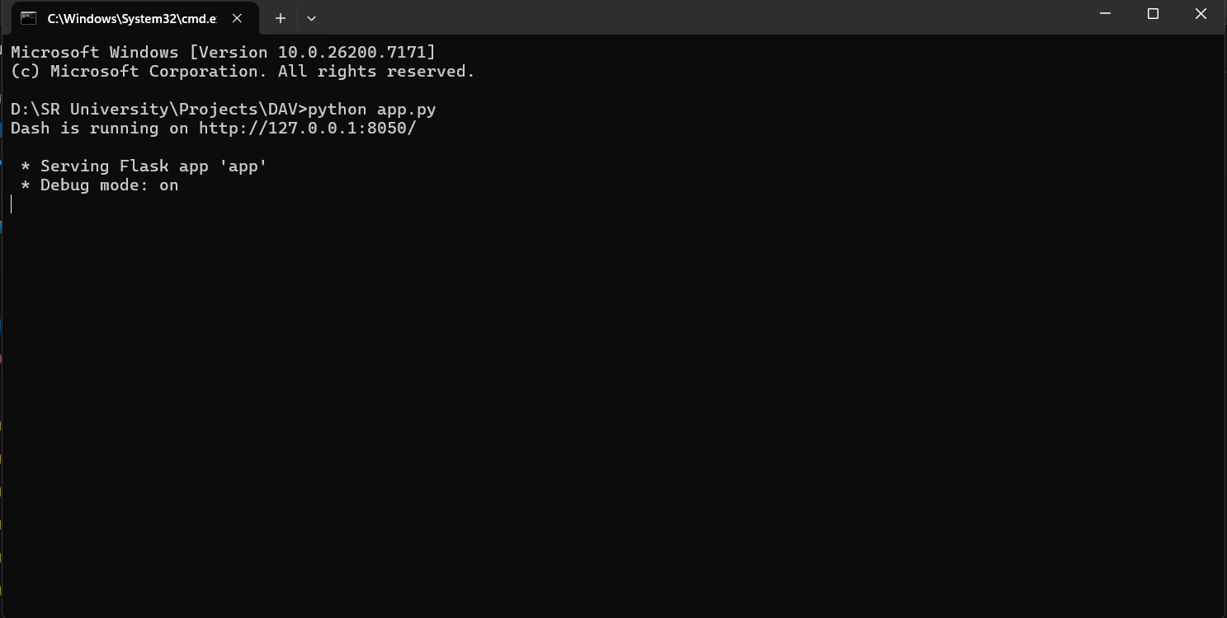

5. Conclusion and Future Directions
5.1 Conclusion
This project successfully analyzed India’s road accident injury data from 2014 to 2017 and transformed it into an interactive dashboard.
Major accomplishments:
- Identified most affected states
- Observed year-over-year variation
- Calculated risk levels using population and vehicle-based metrics
- Provided clear and interactive visual insights
- Built a scalable web dashboard for real-time usage
5.2 Future Directions
Future improvements may include:
- Adding fatality data and accident causes
- Including real-time API-based accident reporting
- Machine learning for prediction of accident hotspots
- Integrating interactive GIS maps for precise state boundaries
- Adding more metrics like road type, weather, and vehicle category

6. References (Page 14)
- KAGGLE:
Road Accidents in India (2014-2017) —https://www.kaggle.com/datasets/greeshmagirish/road-accidents-in-india-20142017
- Python Software Foundation — https://www.python.org
- Plotly Official Documentation — https://plotly.com/python/
- Dash Framework — https://dash.plotly.com/
- Pandas Documentation — https://pandas.pydata.org

