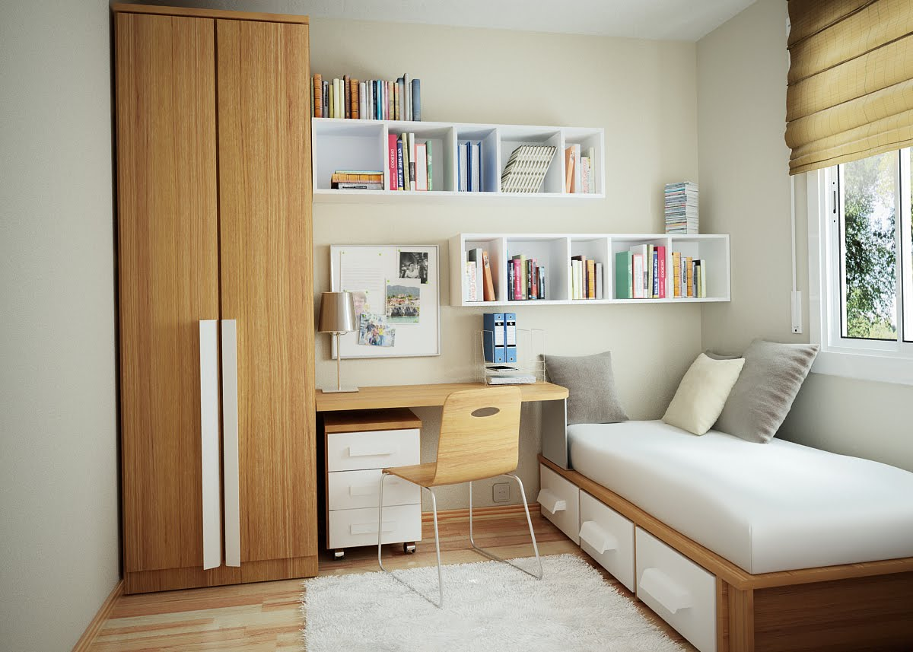

Write sentences with **There is/There are/There isn’t/There aren’t** to describe the picture above:

1. A bed / under________________________________________________
2. A chair/at __________________________________________________
3. Cushions/on ________________________________________________
4. A lamp/ on __________________________________________________
5. A computer ______________________________________________
6. A wardrobe /corner __________________________________________
7. A desk/ between _____________________________________________
8. A mirror __________________________________________________
9. A TV ____________________________________________________
10. Toys ______________________________________________________
11. Shelves / on /over ___________________________________________
12. Books /on__________________________________________________
13. A rug /on ___________________________________________________
14. A chest of drawers /under ____________________________________
15. Any flowers _______________________________________________