Choose the correct answer.

  1 | 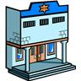  2 |   3  4 |  | 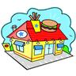  5
- school  - bank  - church | - hospital  - police station  - school | a. library  b. church  c. post office | a. office  b. butcher’s  c. doctor’s | a. fast food restaurant  b. baker’s  c. bank
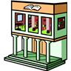  6 | 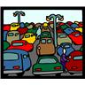  7 | 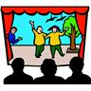  8  9 | 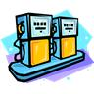 | 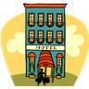  10
a. post office  b. bus station  c. library | a. petrol station  b. car park  c. cinema | a. cinema  b. hotel  c. theatre | a. petrol station  b. bus station  c. restaurant | a. bank  b. cafe  c. hotel
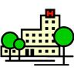  11 | 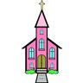  12 |   13  14 | 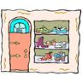  15 | 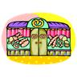
a. hospital  b. supermarket  c. bookshop | a. cinema  b. church  c. school | a. garage  b. hotel  c. cafe | a. shoe shop  b. bookshop  c. clothes shop | a. supermarket  b. café  c. baker’s
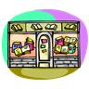  17  16 |  | 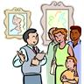  19  18 | 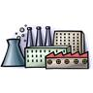  20 | 
a. shoe shop  b. bookshop  c. clothes shop  21 | a. supermarket  b. restaurant  c. factory  22 | a. library  b. sports centre  c. museum | a. hospital  b. factory  c. bank | a. school  b. cinema  c. swimming pool
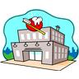 | 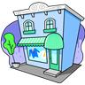 | 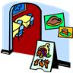  23  24 | 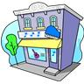 | 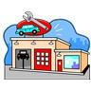  25
a. dentist’s  b. doctor’s  c. grocer’s | a. music shop  b. clothes shop  c. supermarket | a. restaurant  b. theatre  c. greengrocer’s | a. school  b. theatre  c. music shop | a. factory  b. garage  c. museum
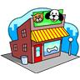  26 |   27 | 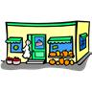  28  29 | 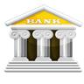  30 | 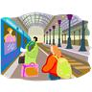
a. bookshop  b. pet shop  c. dentist’s | a. cinema  b. theatre  c. restaurant | a. supermarket  b. greengrocer’s  c. market | a. post office  b. school  c. bank | a. petrol station  b. police station  c. train station

  - a
  - b
  - c
  - b
  - a
  - c
  - b
  - c
  - a
  - c
  - a
  - b
  - c
  - a
  - c
  - b
  - a
  - c
  - b
  - c
  - a
  - b
  - a
  - c
  - b
  - b
  - a
  - b
  - c
  - c

