
WH - Questions
Question words | Meaning | Examples
Who | person | Who is this woman? She is my teacher.
When | time | When will you travel? Tomorrow evening.
Where | place | Where were you born? In Spain.
What | object | What’s the matter? I lost my keys.
What kind | description | What kind of movies do you like? I like action movies.
What time | time | What time did you sleep? Midnight.
Whose | possession | Whose is this car? It’s mine.
Whom | object of the verb | Whom did you go with to the party? My colleague.
Which | choice | Which country do you prefer? Italy.
Why | reason | Why are you sad? My pet died.
How | manner | How do you go to school? By bus.
How much | amount/price | How much sugar do you like? One spoon.
How many | quantity | How many are you in the club? Twenty.
How often | frequency | How often do you visit your uncle? Once a week.
How far | distance | How far is your home? It’s one mile far.
How long | duration / length | How long does it take to finish the exercise? 10 minutes.
How old | age | How old is your sister? She is 17.
How come | reason | How come you missed the party? I was ill.
➢Fill in the blanks with the appropriates question words.

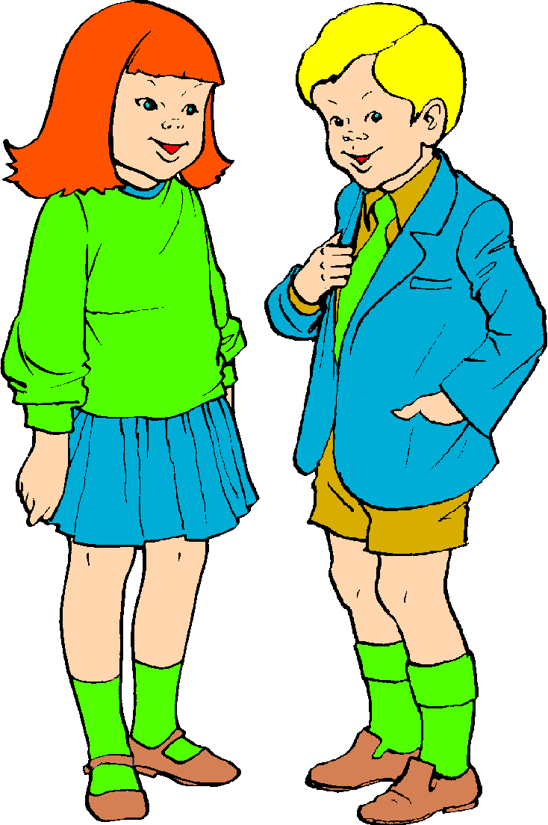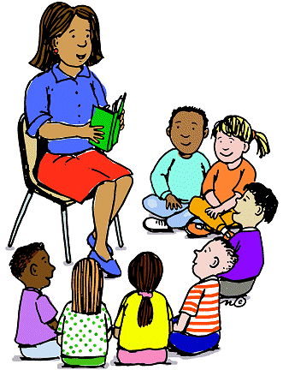
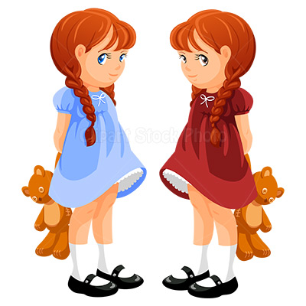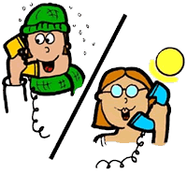

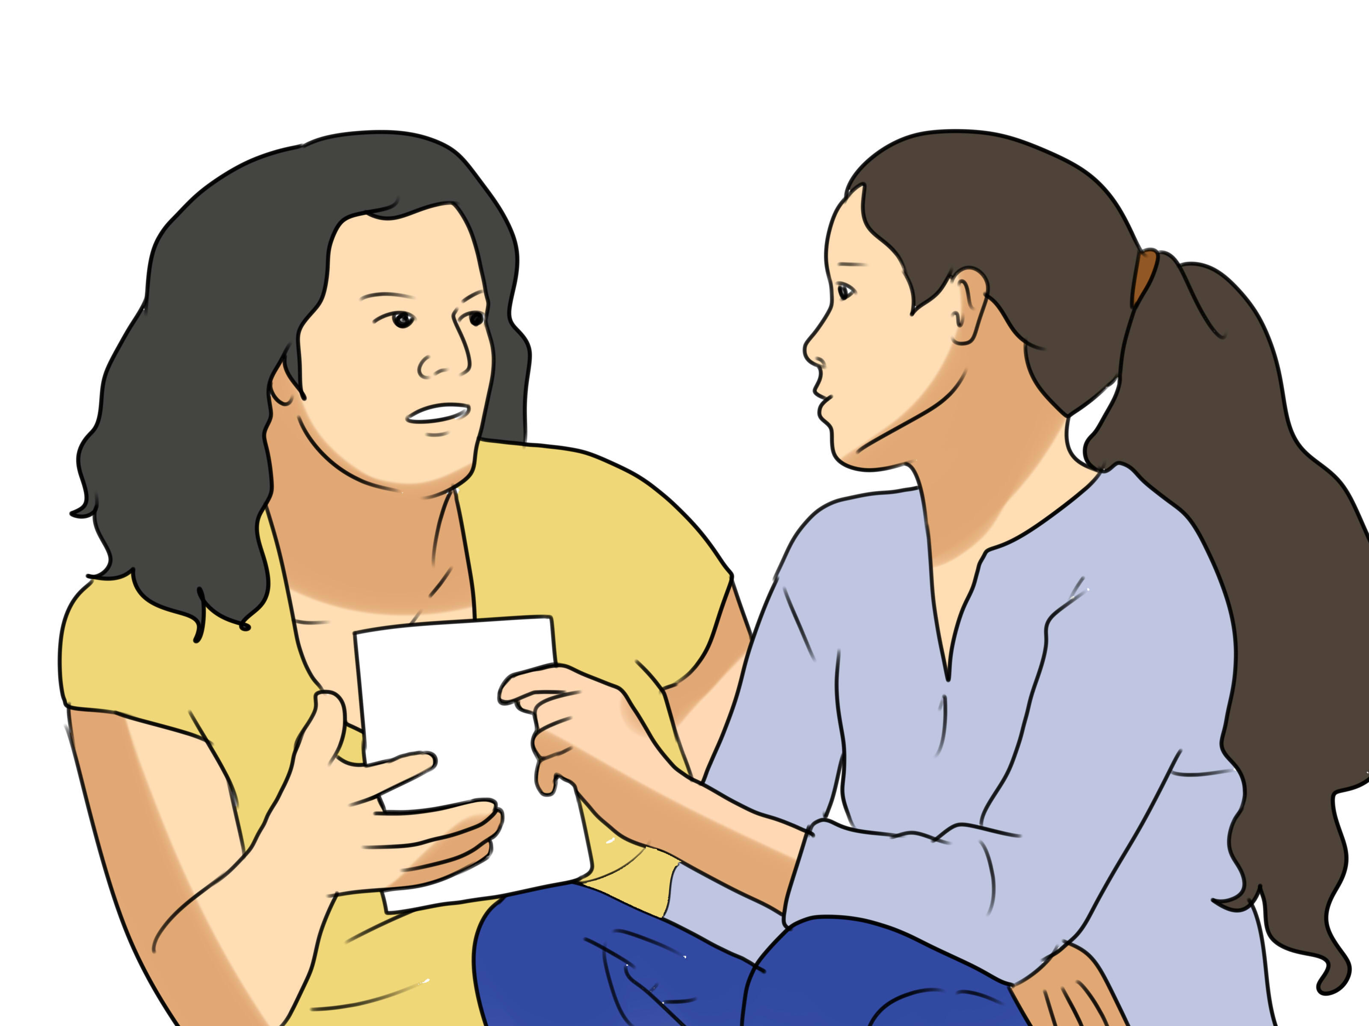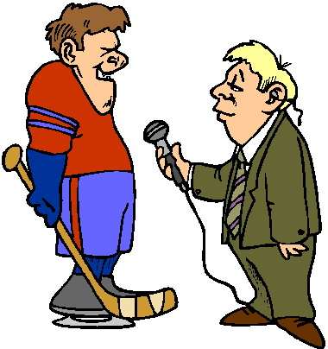
My mum.
…….…bought you this jacket ?
I have a lot.
…………. toys do you have ?
He is so tender.
………… of man is he ?
In Seychelles.
………….will you spend the honeymoon ?
……………………are you Sam ?
I’m 7 years old.
The weather is warmer here.
…………….you didn’t return back home ?
…….do you think of this project ?
We have to wait.
………………… did you save ?
100 Euros.
May be next week.
……….…will your husband come ?
………..team will win ?
Of course, mine.

