**System-level**

* Images represent resource intensive operations
* Video processing is exponentially more
* Natural domain of system level code
* https://en.wikipedia.org/wiki/Image_processing
* https://en.wikipedia.org/wiki/Facial_recognition_system

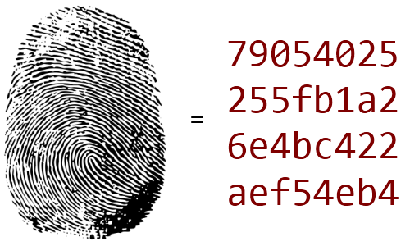

**VLC**

http://www.videolan.org/vlc/download-sources.html

<https://github.com/jteeuwen/go-vlc>

<https://github.com/jteeuwen/imghash>

Steps

* **export GOPATH=/home/ubu/golang**
* **sudo apt-get install libvlccore-dev libvlc-dev**
* **go get github.com/jteeuwen/go-vlc**

**Makefile**

**install the build-essential package**

**sudo apt-get update**

**sudo apt-get install build-essential**

**make**

this command will look for a file named makefile in your directory, and then execute

Makefile

**default:**

**go build tut.go**

**clean:**

**rm -rf *.o *.a *.[$(OS)] [$(OS)].out $(APPS)**

**Possible errors and the quick- fix**

**libvlc**

pkg-config --cflags libvlc

Package libvlc was not found in the pkg-config search path.

Perhaps you should add the directory containing `libvlc.pc'

to the PKG_CONFIG_PATH environment variable

No package 'libvlc' found

pkg-config: exit status 1

**Ubuntu**

sudo apt-get install libvlccore-dev libvlc-dev

<http://www.videolan.org/vlc/#download>

<https://wiki.videolan.org/LibVLC_Tutorial>

**VLC plugins**

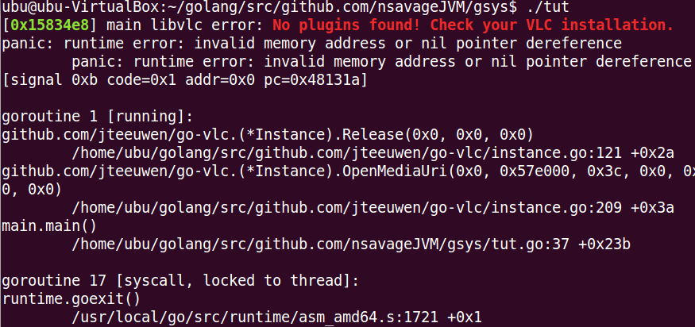

**Content to stream**

can find some content here

<http://www.vlc.eu.pn/index.php>

<http://www.videolan.org/vlc/#download> oops!!!

<https://wiki.videolan.org/LibVLC_Tutorial>

**Ubuntu**

find the necessary files (libvlc.so, libvlc.pc, header files...) in a binary package called libvlc-dev (Debian, Ubuntu...), libvlc-devel (RPM distros) or similar.

Ubuntu

sudo apt-get install libvlccore-dev libvlc-dev

**Install go-vlc**

**go get github.com/jteeuwen/go-vlc**

src/github.com/jteeuwen/go-vlc/instance.go: In function ‘_cgo_a8b54f45daf4_Cfunc_libvlc_audio_output_device_count’:

src/github.com/jteeuwen/go-vlc/instance.go:58:2: **warning**: ‘libvlc_audio_output_device_count’ is deprecated (declared at /usr/include/vlc/libvlc_media_player.h:1440) [-Wdeprecated-declarations]

// AudioDeviceCount returns the number of devices for audio output. These devices

^

src/github.com/jteeuwen/go-vlc/instance.go: In function ‘_cgo_a8b54f45daf4_Cfunc_libvlc_audio_output_device_id’:

src/github.com/jteeuwen/go-vlc/instance.go:74:2: warning: ‘libvlc_audio_output_device_id’ is deprecated (declared at /usr/include/vlc/libvlc_media_player.h:1457) [-Wdeprecated-declarations]

return "", syscall.EINVAL

^

check all this debug code is just a warning

now should have this

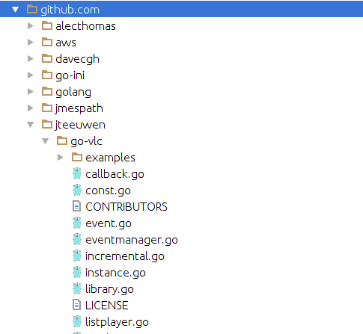

make

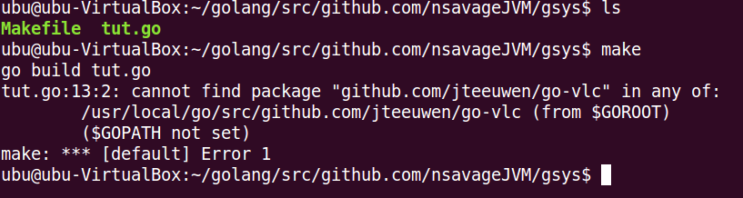

Dont forget to make sure gopath is set

**export GOPATH=/home/ubu/golang**

make



see the red error

its looking for more shared object files called ‘plugins’

so at build time it looks for libvlc

but at runtime it looks for more shared objects in the system

**Install vlc player**

now

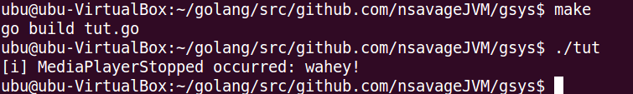

its working but there is no content at the url!!!

can find some content here

<http://www.vlc.eu.pn/index.php>

find a working url, change the uri in the code

// const uri = "http://freedownloads.last.fm/download/466248492/Aperture.mp3"

const uri = "<http://77.76.140.251:22637/udp/231.1.2.1:1234>"

rebuild and run

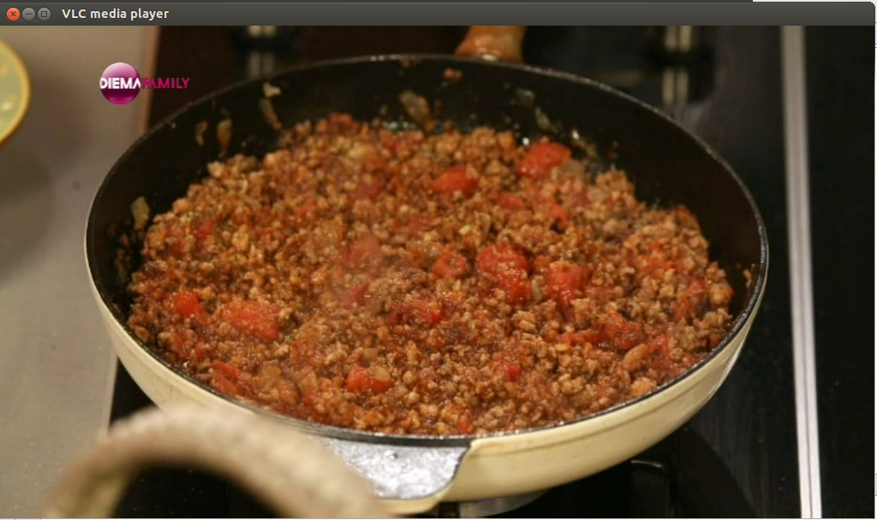

while this video plays the terminal is reporting system errors

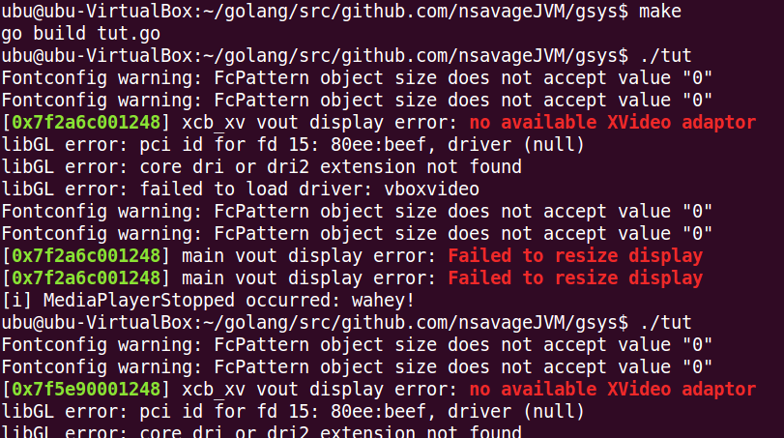

A big part of your work as a systems programmer is fixing these dynamic linking errors for platform specific object code at runtime