# Digital Signal Processing

# Matlab Final Exam

# Take Home Project – by Krashagi Gupta

1. Answer to the questions:

• What were the names of the individuals that were talking?

* Ellen and Marc

• Where were they when the bomb went off?

* Ellen – 4 blocks away from the blast
* Marc – Café a block away from the blast

• What were they doing just before the bomb exploded?

* Ellen - Walking
* Marc - Having coffee at the back of the store

• What were they going to do after they finished their conversation? Provide as many details as possible.

* They were going to head home and eat Pizza and Salad on the way.
* Pizza – Large Cheese with mushrooms and pineapples and barbecue sauce
* Salad - side garden salads with house dressing.
* Dominoes number - 2163688192

• In your judgement, were they involved in the bomb explosion at all? Explain

* In my opinion, they are not involved in the bomb explosion, because
* As they discussed, they were in faraway places when the bomb exploded.
* They just want to go home be safe, after that horrifying experience.
* They just want to go eat, which might be to calm down the nerves.
* They seem like harmless bystanders.

1. For audio sound 1 : I answered the above questions by solving the first audio,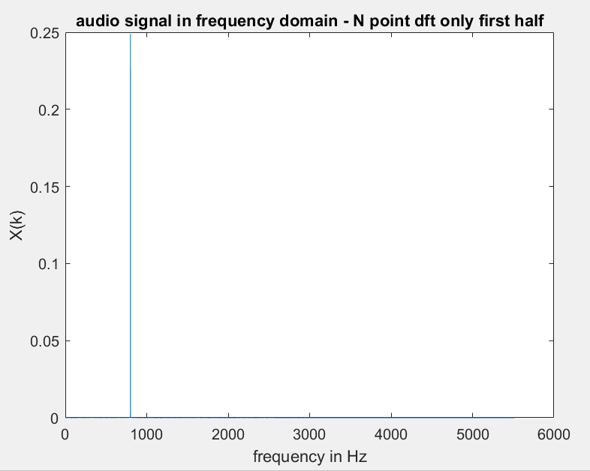

There is huge spike at 800 Hz, and thus my approach is to apply a notch filter, which I do by using the filter design tool in matlab.

This removes the amplitude at that frequency, and gives the correct audio.

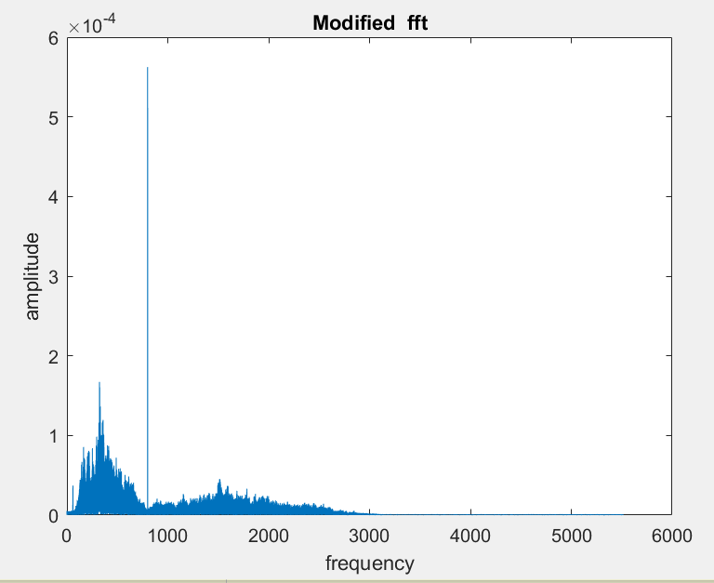

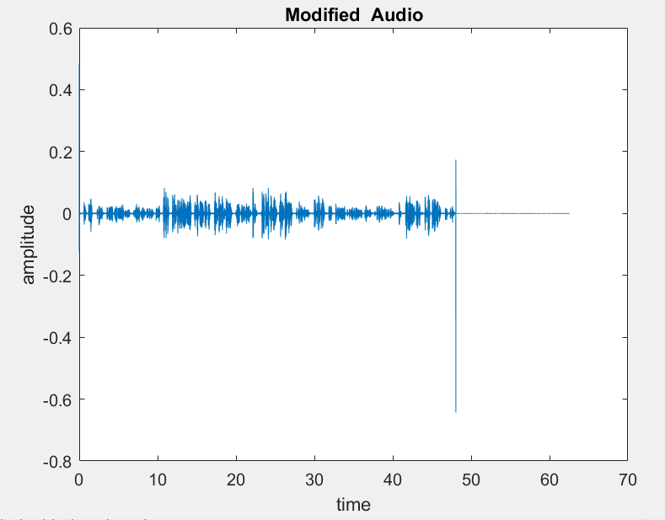

To listen: **play sol_final1.wav**

1. For audio sound 2 :

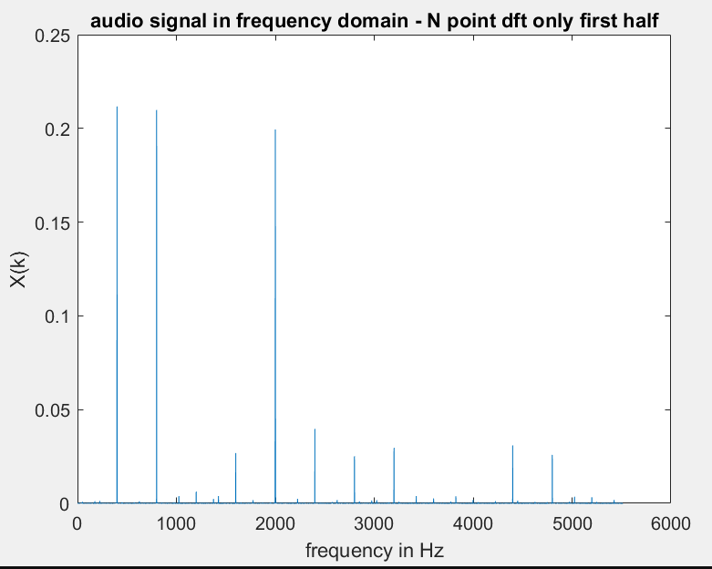

Since there are no frequencies beyond 3000 hz in the correct signal, I use a low pass filter to remove everything beyond 3000 Hz

I also notice that the peaks are at 400Hz and multiples of it. So I use comb filter at 400 Hz: test5 in code.

What I notice here, no matter how many times, I use this filter, the magnitude of those frequencies is still pretty high, compared to the actual usable signal frequencies, even though it attenuates.

Therefore, I use this filter a couple of times, until it the highest frequency reaches the same order as the highest frequency in the correct frequency form, which is the first answer solution.

My approach here is, since I am not able to remove the noise, I should be able to attenuate it enough, so that I can also hear the underlying signal with the noise.

I also notice additional harmonics emerging, so I stop at this point. I use an additional notch filter to remove a frequency at 2002 Hz

The final solution which can be heard by playing.

**Sol_final2.wav**

* 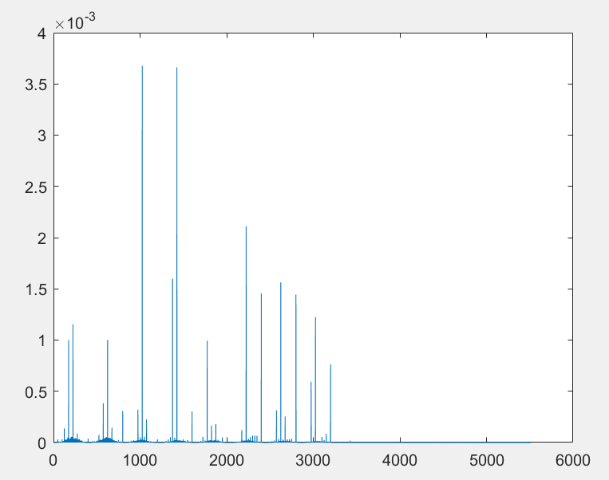

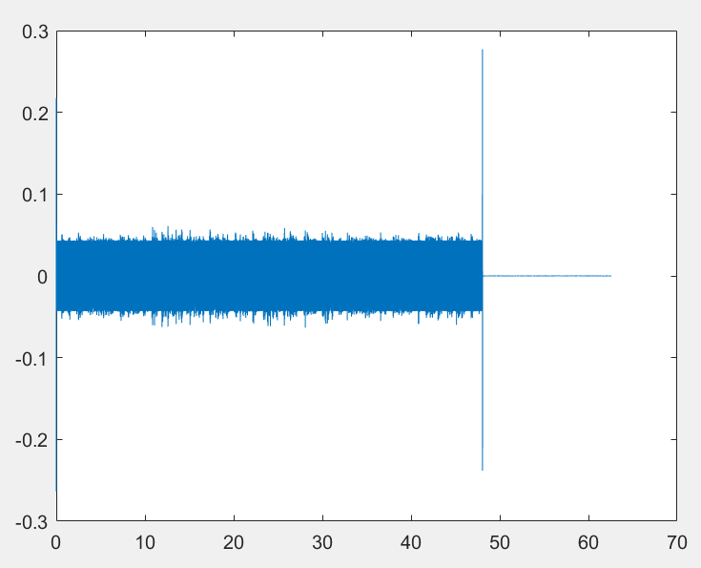

1. For audio sound 3:

The audio looks like this in time and frequency- time domain

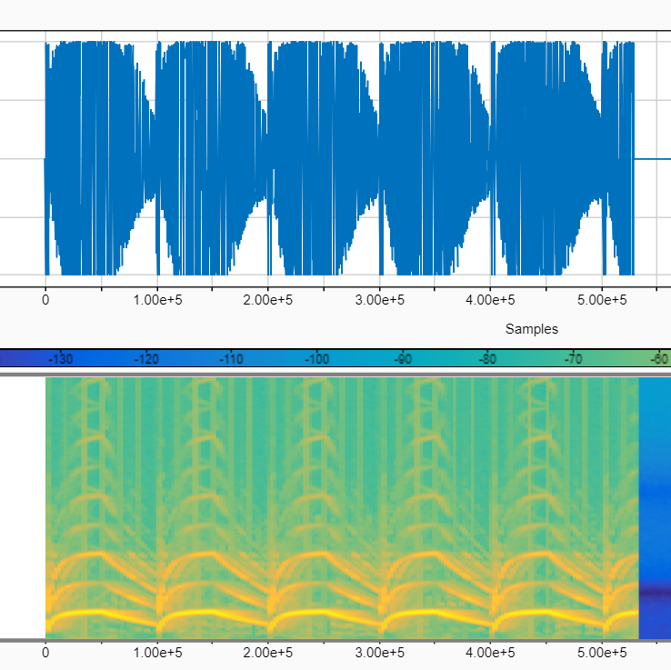

There is a cyclic nature to the high amplitude frequencies.

So I tried to look more closely to first 10 seconds, and find the distribution of frequencies which have the highest magnitude.

I observed that while the noisy signal changes in frequency, at the edges, in the middle it is quite constant, and there are 3 such frequencies. So I decided to attack and remove these frequencies.

Doing so got me the first 10 seconds of the audio, with the beginning and the end distorted but the middle clear to hear.

Thus I broke down the entire audio into 10 sec samples, and applied the same filters on them.

I stitched these filtered batches together and got the final solution.

In my final solution, in every 10 seconds the beginning and the end is distorted due to variable frequency noise.

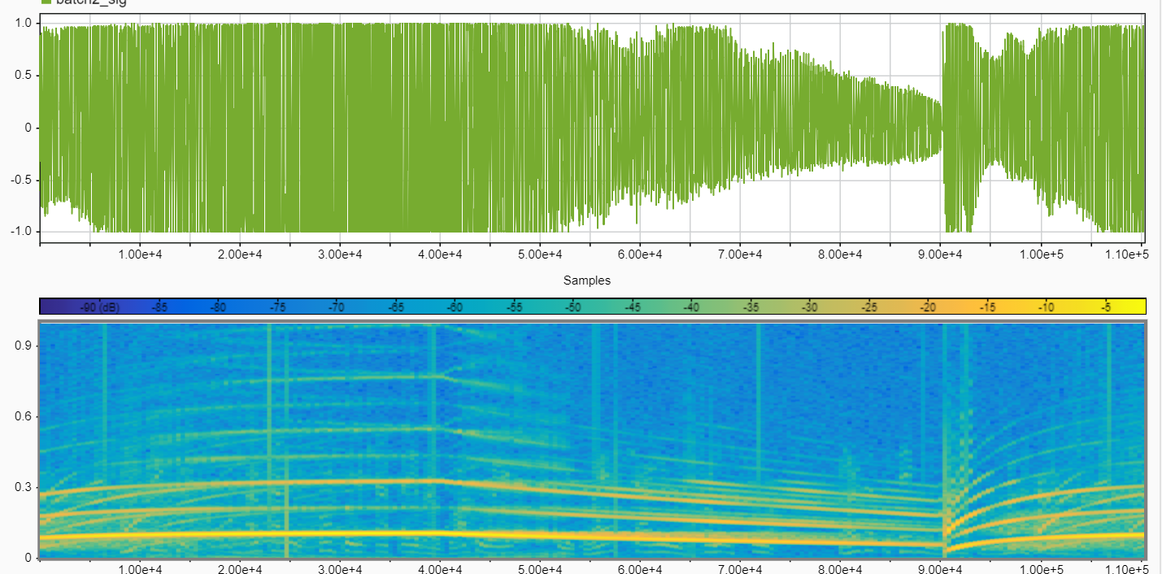

The final signal looks like this :

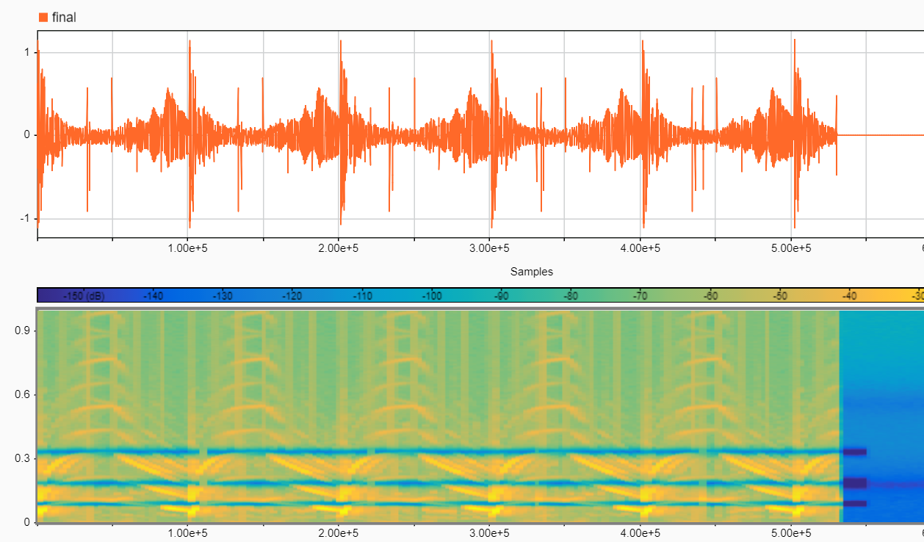

One can clearly see, that every ten seconds the noisy signals are high.

Failed attempts:

To deal with the part of the noise that changes frequency, I first tried to break each batch of 10 sec, to start, middle and end.

To apply a high pass filter at the start and end, in order to completely remove the noise there, as I do not know how to design a time varying frequency filter.

The results were not great.

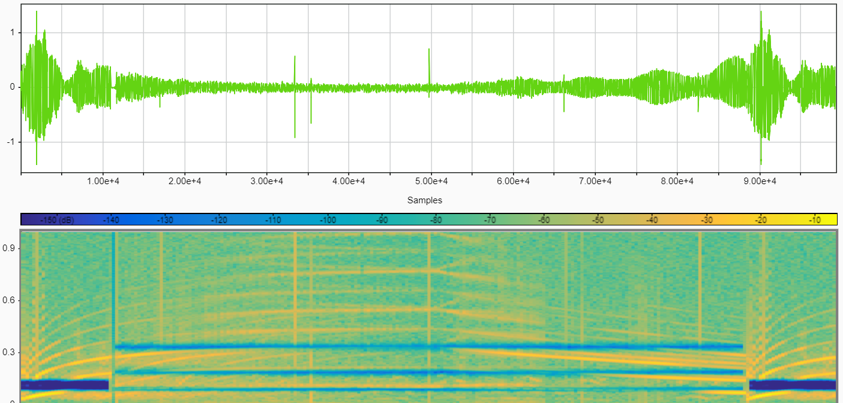

The sirens at the beginning and at the end were quiet.