All About Beer - “Beer3-Oh”

**1. Introduction**

Do you enjoy beer? If the answer is yes this website is for you. With today’s craft beer, it can be intimidating to venture out to your local watering hole and try to figure out what to order. We can help!

By browsing through this crash course before you go out will arm you with the foundation of knowledge you will need in your journey.

Our goals:

* Overview of popular beer types from light to dark, with some background information
* Help you find the tastes you like, take our online quiz!
* Food to pair with your drink
* Connect you to your local breweries
* Contact us with questions or comments

**2. Wireframe and General Layout:**

I’ve compiled a wireframe as well as an example of a contact page that I’d like my site to incorporate. See descriptions in buttons for more info. Intro page is already completed.

Index page (to get in the site):

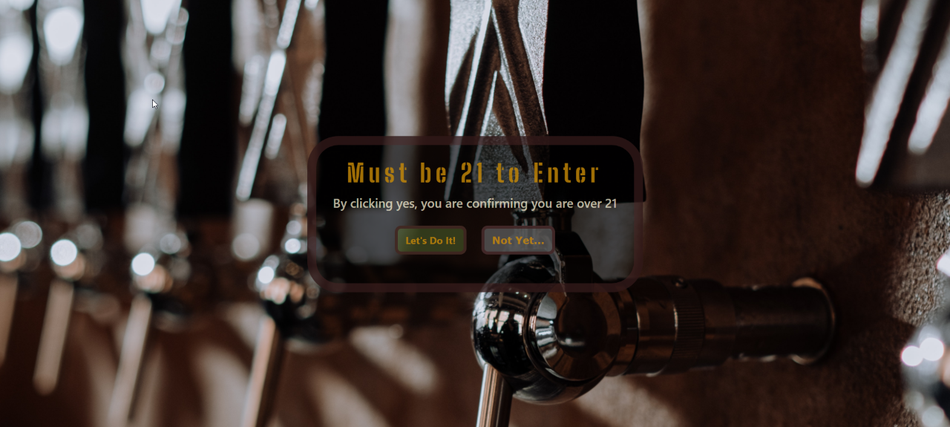

“Home” Page when you get in:

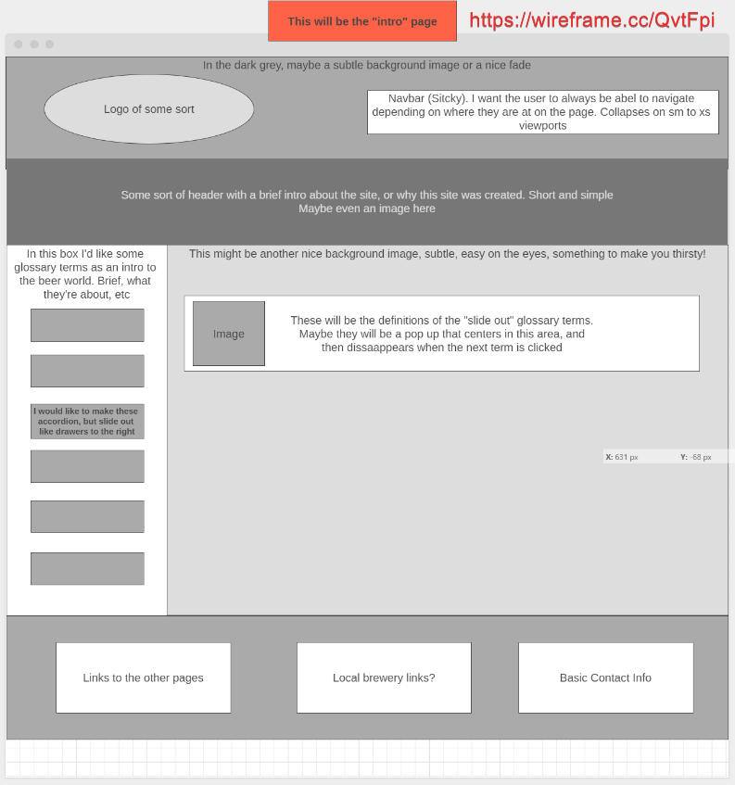

Information Page:

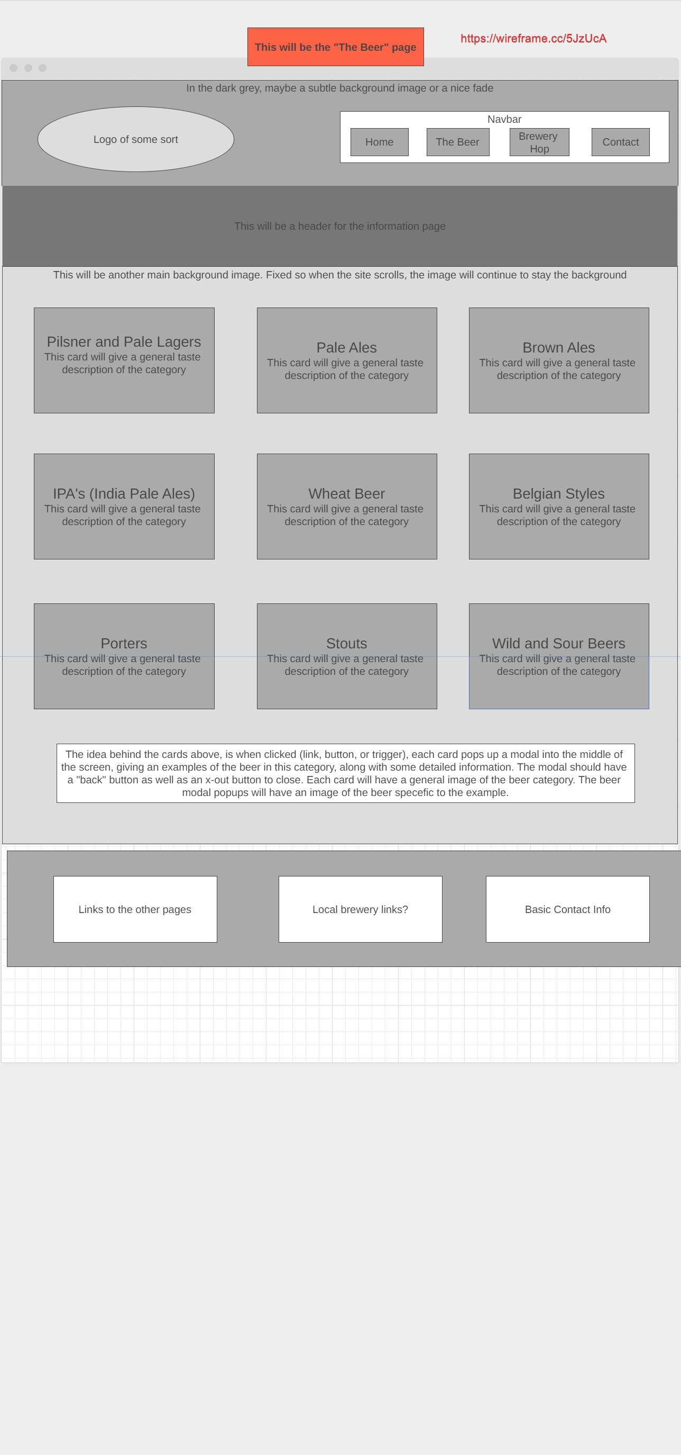

Contact Page Idea:

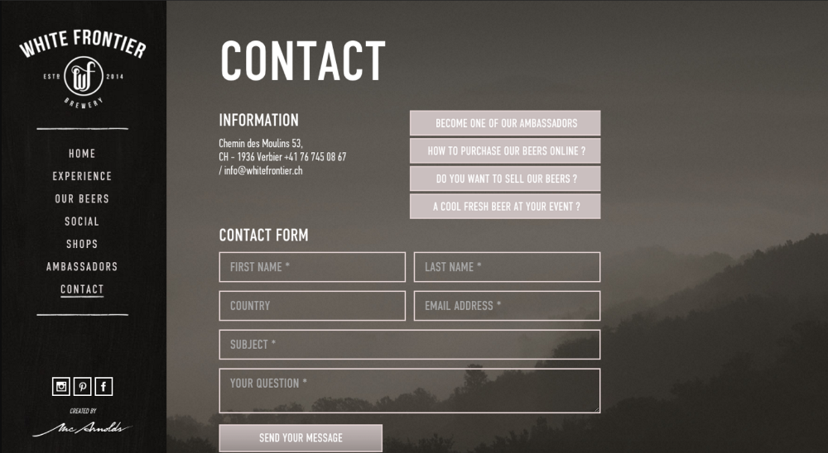

Courtesy of online Google search