1. Elevate your user access to root;

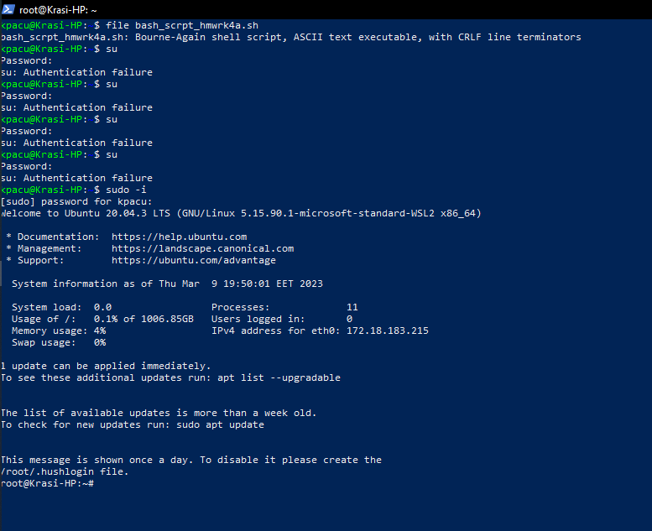

2. add a new user to your Linux OS and set a password for it;

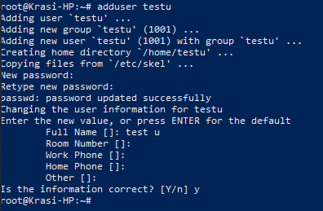

3. Test if you can log in using that user;



4. Using grep command check if the user is created;

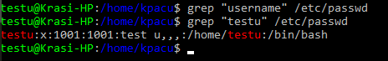

5. grep the UID of each user;

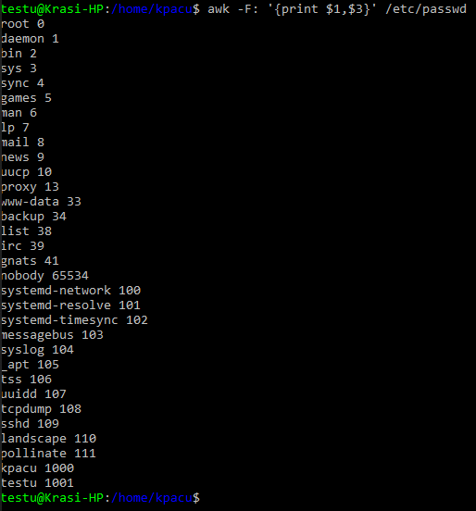

6. Find out the GID of the created user;



7. Change the password of the user and force it to change the pass on his next login;

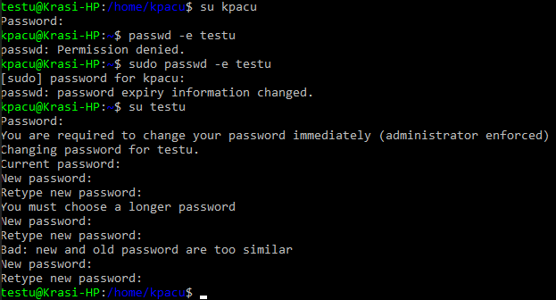

8. Add a new user and set an expiration date for it, with a five-day warning period;

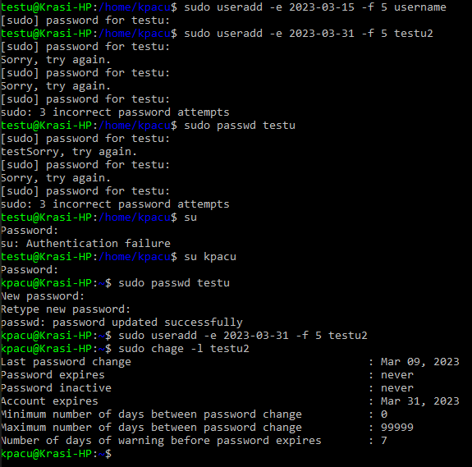

9. Create a new group; &

10. Assign the two new users to that group;

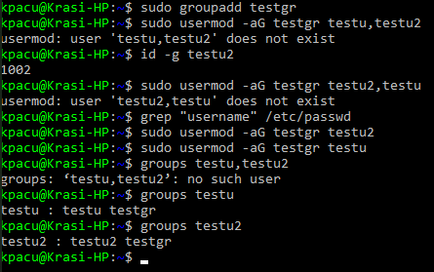

11. Lock one of the user accounts;

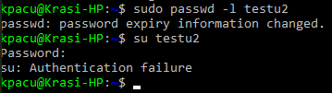

12. Change the shell of one user to tcsh;

