# Exercises: Table Relations

This document defines the **exercise assignments** for the ["Databases Basics - MSSQL" course @ Software University.](https://softuni.bg/trainings/1436/databases-basics-mssql-september-2016)

## One-To-One Relationship

Create two tables as follows. Use appropriate data types.

|  |  |  |  |  |  |  |
| --- | --- | --- | --- | --- | --- | --- |
| **Persons** | | | |  | **Passports** | |
| **PersonID** | **FirstName** | **Salary** | **PassportID** |  | **PassportID** | **PassportNumber** |
| 1 | Roberto | 43300.00 | 102 |  | 101 | N34FG21B |
| 2 | Tom | 56100.00 | 103 |  | 102 | K65LO4R7 |
| 3 | Yana | 60200.00 | 101 |  | 103 | ZE657QP2 |

Insert the data from the example above.

Alter table customers and make PersonIDa primary key. Create a foreign key between Persons and Passports by using PassportID column.

Submit your queries by using **SQL Server run skeleton run queries and check db.**

## One-To-Many Relationship

Create two tables as follows. Use appropriate data types.

|  |  |  |  |  |  |  |
| --- | --- | --- | --- | --- | --- | --- |
| **Models** | | |  | **Manufacturers** | | |
| **ModelID** | **Name** | **ManufacturerID** |  | **ManufacturerID** | **Name** | **EstablishedOn** |
| 101 | X1 | 1 |  | 1 | BMW | 07/03/1916 |
| 102 | i6 | 1 |  | 2 | Tesla | 01/01/2003 |
| 103 | Model S | 2 |  | 3 | Lada | 01/05/1966 |
| 104 | Model X | 2 |  |  | | |
| 105 | Model 3 | 2 |  |  | | |
| 106 | Nova | 3 |  |  | | |

Insert the data from the example above. Add primary keys and foreign keys.

Submit your queries by using **SQL Server run skeleton run queries and check db.**

## Many-To-Many Relationship

Create three tables as follows. Use appropriate data types.

|  |  |  |  |  |  |  |  |
| --- | --- | --- | --- | --- | --- | --- | --- |
| **Students** | |  | **Exams** | |  | **StudentsExams** | |
| **StudentID** | **Name** | **ExamID** | **Name** | **StudentID** | **ExamID** |
| 1 | Mila | 101 | SpringMVC | 1 | 101 |
| 2 | Toni | 102 | Neo4j | 1 | 102 |
| 3 | Ron | 103 | Oracle 11g | 2 | 101 |
|  | |  | | 3 | 103 |
| 2 | 102 |
| 2 | 103 |

Insert the data from the example above.  
Add primary keys and foreign keys. Have in mind that table StudentsExams should have a composite primary key.

Submit your queries by using **SQL Server run skeleton run queries and check db.**

## Self-Referencing

Create a single table as follows. Use appropriate data types.

|  |  |  |
| --- | --- | --- |
| **Teachers** | | |
| **TeacherID** | **Name** | **ManagerID** |
| 101 | John | NULL |
| 102 | Maya | 106 |
| 103 | Silvia | 106 |
| 104 | Ted | 105 |
| 105 | Mark | 101 |
| 106 | Greta | 101 |

Insert the data from the example above. Add primary keys and foreign keys. The foreign key should be between ManagerId and TeacherId.

Submit your queries by using **SQL Server run skeleton run queries and check db.**

## Online Store Database

Create a new database and design the following structure:

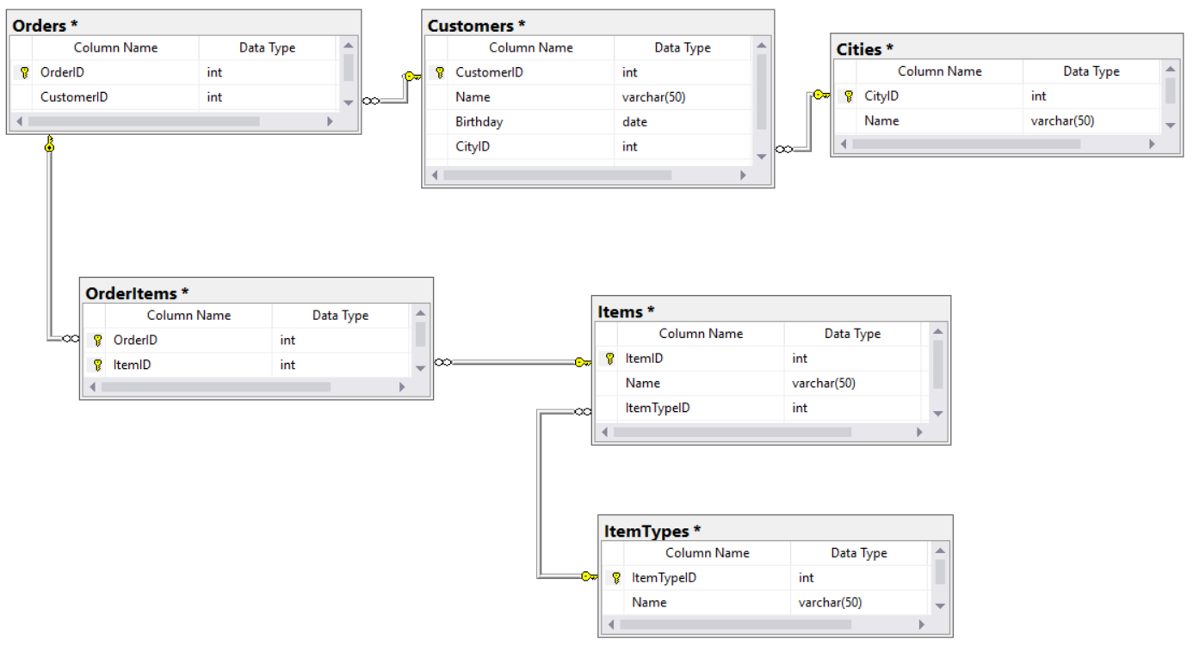

Submit your queries by using **SQL Server run skeleton run queries and check db.**

## University Database

Create a new database and design the following structure:

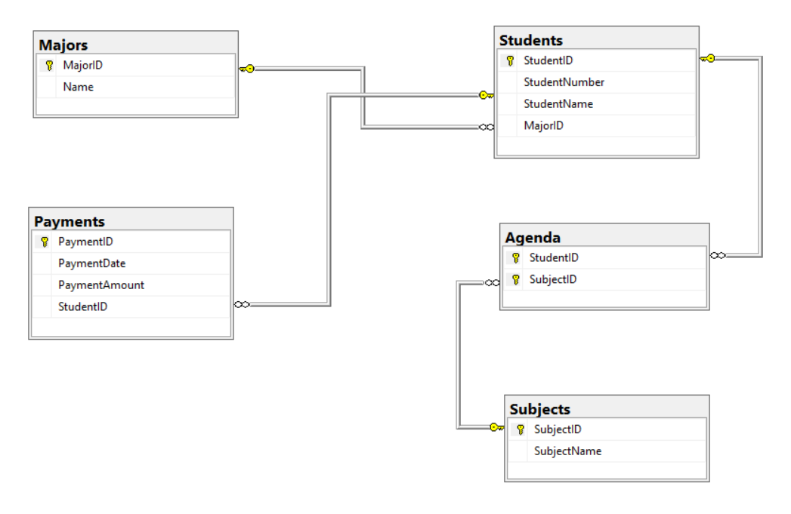

Submit your queries by using **SQL Server run skeleton run queries and check db.**

## SoftUni Design

Create an E/R Diagram of the SoftUni Database. There are some special relations you should check out: Employees are **self-referenced** (ManagerID) and Departments have **One-to-One** with the Employees (ManagerID) while the Employees have **One-to-Many** (DepartmentID). You might find it interesting how it looks on the diagram. ☺

## Geography Design

Create an E/R Diagram of the Geography Database.

## *Peaks in Rila

Display all peaks for "Rila" mountain. Include:

* MountainRange
* PeakName
* PeakElevation

Peaks should be sorted by elevation descending.

### Example

|  |  |  |
| --- | --- | --- |
| **MountainRange** | **PeakName** | **Elevation** |
| Rila | Musala | 2925 |
| … | … | … |