Comparison of data from two labs

Krista Kraskura

2024-10-02

Table of Contents

SUMMARY STATISTICS 1

FIGURES 3

STATISTICS 4

#### SUMMARY STATISTICS

A total of 20 samples were analyzed in two different labs, Vista and Eurofins.

Table 1: The list of PFAS that were tested each lab and their detection limits

|  |  |  |
| --- | --- | --- |
| Analyte | Eurofins | Vista |
| 11Cl-PF3OUdS | 2.670 | 4.2715 |
| 3:3 FTCA | 5.550 | 5.3400 |
| 4:2 FTS | 4.120 | 4.2715 |
| 5:3 FTCA | 12.300 | 5.3400 |
| 6:2 FTS | 5.140 | 4.2715 |
| 7:3 FTCA | 10.220 | 5.3400 |
| 8:2 FTS | 6.185 | 4.2715 |
| 9Cl-PF3ONS | 2.890 | 4.2715 |
| ADONA | 1.640 | 4.2715 |
| EtFOSA | 1.850 | 5.3400 |
| EtFOSAA | 1.850 | 4.2715 |
| EtFOSE | 18.500 | 4.2715 |
| HFPO-DA | 1.022 | 4.2715 |
| MeFOSA | 1.950 | 5.3400 |
| MeFOSAA | 1.230 | 4.2715 |
| MeFOSE | 10.095 | 5.3400 |
| NFDHA | 1.640 | 5.3400 |
| PFBA | 4.530 | 4.2715 |
| PFBS | 1.022 | 4.2715 |
| PFDA | 1.022 | 4.2715 |
| PFDoA | 1.022 | 4.2715 |
| PFDoS | 1.022 | 4.2715 |
| PFDS | 1.230 | 4.2715 |
| PFEESA | 3.095 | 4.2715 |
| PFHpA | 1.430 | 4.2715 |
| PFHpS | 1.022 | 4.2715 |
| PFHxA | 1.640 | 4.2715 |
| PFHxS | 11.015 | 4.2715 |
| PFMBA | 2.570 | 4.2715 |
| PFMPA | 2.570 | 4.2715 |
| PFNA | 1.850 | 4.2715 |
| PFNS | 1.022 | 4.2715 |
| PFOA | 1.950 | 4.2715 |
| PFOS | 10.635 | 4.2715 |
| PFOSA | 3.500 | 4.2715 |
| PFPeA | 1.022 | 4.2715 |
| PFPeS | 1.022 | 4.2715 |
| PFTeDA | 1.022 | 4.2715 |
| PFTrDA | 1.022 | 4.2715 |
| PFUnA | 1.022 | 4.2715 |
| 10:2 FTS | NA | 4.2715 |
| PFecHS | NA | 4.2715 |
| PFHxDA | NA | 4.2715 |
| PFODA | NA | 4.2715 |
| PFPrS | NA | 4.2715 |

Table 2: The sample size of PFAS measured above detection limit in each Lab in each Sample

|  |  |  |
| --- | --- | --- |
|  | Eurofins | Vista |
| JBA-092-SW-SPILL-042821 | 16 | 15 |
| JBA-093-SW-RIPP-042821 | 15 | 15 |
| JBA-094-SW-DOWN-042821 | 15 | 15 |
| JBA-095-SW-EXIT-042821 | 15 | 15 |
| JBA047-SW-SPILL-033021 | 15 | 14 |
| JBA048-SW-RIPP-033021 | 14 | 14 |
| JBA049-SW-DOWN-033021 | 14 | 14 |
| JBA050-SW-EXIT-033021 | 14 | 14 |
| JBA057-SW-SPILL-040721 | 16 | 15 |
| JBA058-SW-RIPP-040721 | 16 | 15 |
| JBA059-SW-DOWN-040721 | 16 | 15 |
| JBA060-SW-EXIT-040721 | 14 | 15 |
| JBA077-SW-SPILL-042221 | 16 | 15 |
| JBA078-SW-RIPP-042221 | 16 | 15 |
| JBA079-SW-DOWN-042221 | 16 | 14 |
| JBA080-SW-EXIT-042221 | 16 | 15 |
| JBA107-SW-SPILL-06232021 | 15 | 15 |
| JBA108-SW-RIPP-06232021 | 16 | 15 |
| JBA109-SW-DOWN-06232021 | 15 | 15 |
| JBA110-SW-EXIT-06232021 | 15 | 15 |

#### FIGURES

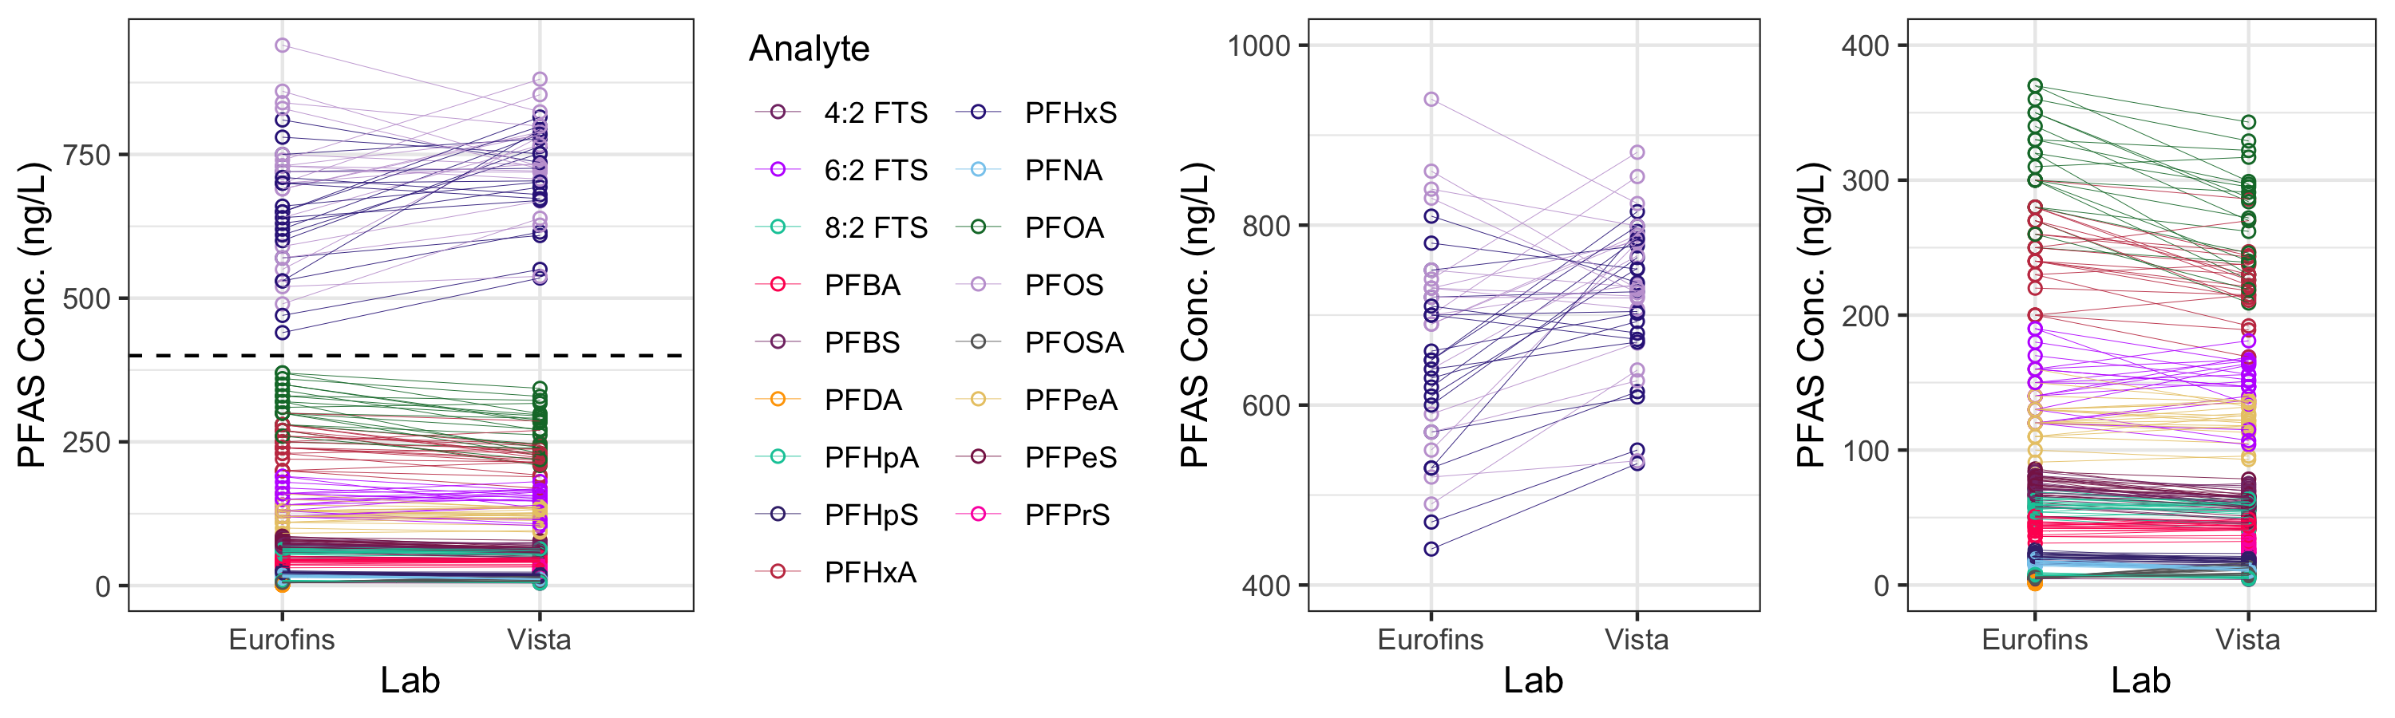

Figure 1. The comparison of each samples measured PFAS concentrations. All panels show the same data but the last two are split up at with high and low values (dashed line in most left side plot). The lines connect a distinct sample.

**Calculations**: Percent difference calculated using formula:

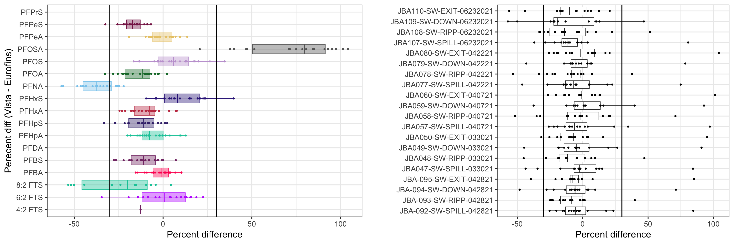

Figure 2. A percent difference between two measured values by PFAS (left) and samples (right). The vertical lines show 30% change.

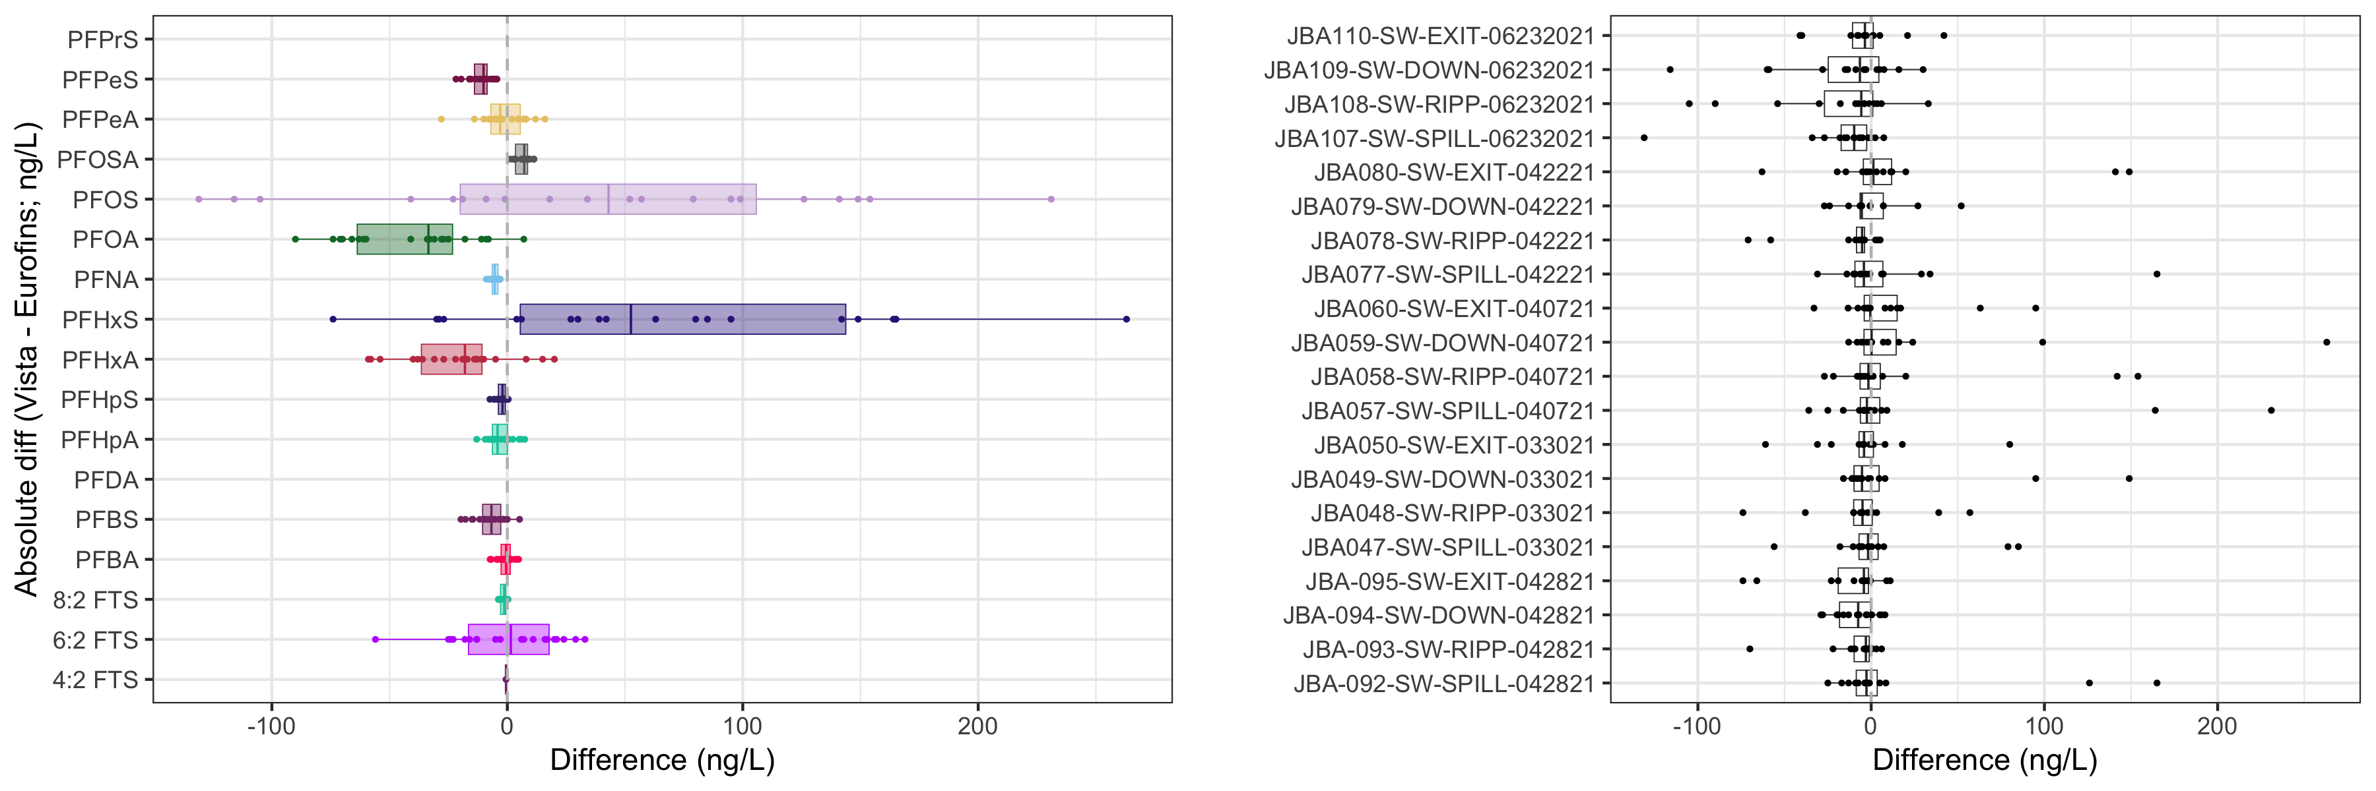

Figure 3. An absolute change in measured values by PFAS (left) and samples (right).

#### STATISTICS

1. Paired t-test results for each repeated PFAS analyte that had reported values above the lab-specific detection limits.

|  |  |  |  |
| --- | --- | --- | --- |
| PFAS | Pval | MeanDiff | n |
| 6:2 FTS | 0.9077 | -0.6 | 20 |
| 8:2 FTS | 0.00164 | -1.65667 | 12 |
| PFBA | 0.27438 | -0.82 | 20 |
| PFBS | 6e-05 | -7.27 | 20 |
| PFHpA | 0.02418 | -2.925 | 20 |
| PFHpS | 5e-05 | -2.44 | 20 |
| PFHxA | 0.00042 | -21.2 | 20 |
| PFHxS | 0.00219 | 67.95 | 20 |
| PFNA | 0 | -5.34 | 20 |
| PFOA | 0 | -40.65 | 20 |
| PFOS | 0.08586 | 39.5 | 20 |
| PFOSA | 0 | 6.6 | 20 |
| PFPeA | 0.55021 | -1.37 | 20 |
| PFPeS | 0 | -11.215 | 20 |

1. Are there differences between samples?

**Approach**: a simple one way ANOVA where the % change between two measured samples was a dependent variable and sample ID a dependent variable.

**Result**: there was no evidence that one lab would report higher values in a any given sample compared to another lab (p = 0.9236, df = 19, F = 0.5727).

mod1<-aov(percent_diff ~ `Sample ID`, data = data_wide)  
anova(mod1)

## Analysis of Variance Table  
##   
## Response: percent_diff  
## Df Sum Sq Mean Sq F value Pr(>F)  
## `Sample ID` 19 8271 435.29 0.5727 0.9236  
## Residuals 253 192298 760.07