Supplemental material:
Title: Variation in metabolic scaling reveals aerobic constraints with temperature in fishes.
Kraskura K, Jerde CL, Eliason EJ
2026-06-30
Table of Contents

General summary statistics
## The number of datapoints total: 12670
## The number of trials total: 288
## The number of studies total: 99
## The number of species total: 104
## The number of individual fish: 6042
## The number of individual fish below 1000 g: 5758
## The number of datapoints in AS data subset: 4407
## The number of trials in AS data subset: 198
## The number of studies in AS data subset: 60
## The number of species in AS data subset: 81
## The percent of tropical fish that had FAS below 3: 22.33 %
## The percent of subtropical fish that had FAS below 3: 18.49 %
## The percent of temperate fish that had FAS below 3: 11.51 %
## The percent of polar fish that had FAS below 3: 92.31 %
MMR_method | test_category3 | count
chase | optimal | 2906
chase | warm | 821
handling | optimal | 14
other | optimal | 86
other | warm | 34
stirbar-swim | optimal | 71
stirbar-swim | warm | 99
swim | optimal | 1032
swim | warm | 409
MMR | Optimal T | Warm T
Resp(L):Size(kg) (min) | 2.58 | 2.57
Resp(L):Size(kg) (max) | 3090.91 | 2138.28
Hours starved (min) | 12 | 12
Hours starved (max) | 168 | 96
Hours in chamber (min) | 0.75 | 1
Hours in chamber (max) | 48 | 48
RMR | Optimal T | Warm T
Resp(L):Size(kg) (min) | 2.58 | 2.57
Resp(L):Size(kg) (max) | 4718.88 | 3604.29
Hours starved (min) | 12 | 12
Hours starved (max) | 240 | 240
Hours in chamber (min) | 0.75 | 1
Hours in chamber (max) | 78 | 78

Phylogenetic mixed models (evolvability::Almer)
- model sets: Different random effects
  - set 1 (in R script used as #2): (1|species) +(0 + tempTest|species) + (1|species:trial) = species intercept, nested trial under species intercept, species-specific response to temperature (i.e. different size individuals of the same species, would have different sensitivity to temperature).
  - set 2 (in R script used as #4) : (1|species) +(0 + lnBWg|species) + (1|species:trial) = species intercept, nested trial under species intercept, species-specific mass scaling slopes
  - set 3 (in R script used as #5): (1|species) +(0 + lnBWg|species:trial) + (1|species:trial) = species intercept, nested trial under species intercept, nested species:trial mass scaling slopes
- model types:
  - mass and temperature affect metabolism independently
  - (int) mass and temperature affect metabolism in interaction

Abbreviations:
MMR = maximum metabolic rates RMR = resting metabolic rates AS = absolute aerobic scope FAS = factorial aerobic scope BIC = Bayesian Information Criterion (model comparison metric)

A list of libraries used for the analysis and data presentation:
- Statistics, models, and phylogenetic matrix:
  - lme4, emmeans, car, evolvability, ape, rotl, ggtree, Matrix
- Data handling and visualization:
  - pryr, viridisLite, TDbook, ggimage, ggformat2 (custom written author’s package), ggpubr, cowplot, forcats, reshape2, systemfonts, flextable, here, ggh4x, tidyverse, dplyr, colorBlindness, patchwork, weathermetrics.

Tables

BIC model selection tables

Inter-specific global scaling (adults and juveniles together) (TABLES 1 - 8)

Table S1. Selection of best fit scaling relationship of RMR in optimal temperatures using BIC comparison.
Model ID | df | BIC | delta
Phylo_RMR_model4int | 8 | 1238.05 | 0.00
Phylo_RMR_model4 | 7 | 1242.71 | 4.66
Phylo_RMR_model2 | 7 | 1307.83 | 69.78
Phylo_RMR_model2int | 8 | 1313.28 | 75.24
Phylo_RMR_model5 | 7 | 1358.11 | 120.06
Phylo_RMR_model5int | 8 | 1362.99 | 124.95
All models within ∆BIC 7 could be considered significant.

Table S2. Selection of best fit scaling relationship of RMR in warm temperatures using BIC comparison.
Model ID | df | BIC | delta
Phylo_RMR_W_model4 | 7 | 474.65 | 0.00
Phylo_RMR_W_model4int | 8 | 479.87 | 5.22
Phylo_RMR_W_model2 | 7 | 489.19 | 14.54
Phylo_RMR_W_model2int | 8 | 496.48 | 21.83
Phylo_RMR_W_model5 | 7 | 498.80 | 24.16
Phylo_RMR_W_model5int | 8 | 506.09 | 31.44
All models within ∆BIC 7 could be considered significant.

Table S3. Selection of best fit scaling relationship of MMR in optimal temperatures using BIC comparison.
Model ID | df | BIC | delta
Phylo_MMR_model4 | 7 | -431.77 | 0.00
Phylo_MMR_model4int | 8 | -424.09 | 7.68
Phylo_MMR_model5 | 7 | -359.65 | 72.12
Phylo_MMR_model5int | 8 | -353.69 | 78.09
Phylo_MMR_model2int | 8 | -164.63 | 267.14
Phylo_MMR_model2 | 7 | -153.99 | 277.78
All models within ∆BIC 7 could be considered significant.

Table S4. Selection of best fit scaling relationship of MMR in warm temperatures using BIC comparison.
Model ID | df | BIC | delta
Phylo_MMR_W_model2int | 8 | -215.27 | 0.00
Phylo_MMR_W_model4 | 7 | -208.00 | 7.27
Phylo_MMR_W_model4int | 8 | -203.56 | 11.71
Phylo_MMR_W_model2 | 7 | -191.39 | 23.88
Phylo_MMR_W_model5 | 7 | -190.34 | 24.93
Phylo_MMR_W_model5int | 8 | -188.88 | 26.38
All models within ∆BIC 7 could be considered significant.

Table S5. Selection of best fit scaling relationship of AS in optimal temperatures using BIC comparison.
Model ID | df | BIC | delta
Phylo_AS_model5int | 8 | 987.76 | 0.00
Phylo_AS_model2int | 8 | 989.29 | 1.53
Phylo_AS_model4int | 8 | 989.36 | 1.60
Phylo_AS_model4 | 7 | 1019.52 | 31.76
Phylo_AS_model5 | 7 | 1046.54 | 58.78
Phylo_AS_model2 | 7 | 1058.82 | 71.06
All models within ∆BIC 7 could be considered significant.

Table S6. Selection of best fit scaling relationship of AS in warm temperatures using BIC comparison.
Model ID | df | BIC | delta
Phylo_AS_W_model2int | 8 | 978.45 | 0.00
Phylo_AS_W_model2 | 7 | 990.19 | 11.75
Phylo_AS_W_model4 | 7 | 1012.67 | 34.22
Phylo_AS_W_model4int | 8 | 1019.52 | 41.07
Phylo_AS_W_model5 | 7 | 1019.86 | 41.41
Phylo_AS_W_model5int | 8 | 1026.33 | 47.89
All models within ∆BIC 7 could be considered significant.

Table S7. Selection of best fit scaling relationship of FAS in optimal temperatures using BIC comparison.
Model ID | df | BIC | delta
Phylo_FAS_model2int | 8 | 800.14 | 0.00
Phylo_FAS_model4int | 8 | 811.69 | 11.55
Phylo_FAS_model2 | 7 | 820.12 | 19.98
Phylo_FAS_model5int | 8 | 832.13 | 31.99
Phylo_FAS_model4 | 7 | 835.09 | 34.95
Phylo_FAS_model5 | 7 | 853.30 | 53.16
All models within ∆BIC 7 could be considered significant.

Table S8. Selection of best fit scaling relationship of FAS in warm temperatures using BIC comparison.
Model ID | df | BIC | delta
Phylo_FAS_W_model2 | 7 | 312.96 | 0.00
Phylo_FAS_W_model4 | 7 | 312.96 | 0.00
Phylo_FAS_W_model2int | 8 | 318.24 | 5.28
Phylo_FAS_W_model4int | 8 | 318.24 | 5.28
Phylo_FAS_W_model5 | 7 | 321.34 | 8.38
Phylo_FAS_W_model5int | 8 | 324.87 | 11.91
All models within ∆BIC 7 could be considered significant.

Life-stage specific scaling: juveniles only (TABLES 1.j - 8.j)

Table S1.j. Selection of best fit scaling relationship of RMR in optimal temperatures using BIC comparison.
Model ID | df | BIC | delta
Phylo_RMR_model4 | 7 | -51.87 | 0.00
Phylo_RMR_model4int | 8 | -44.94 | 6.93
Phylo_RMR_model2 | 7 | 21.42 | 73.29
Phylo_RMR_model5 | 7 | 28.74 | 80.61
Phylo_RMR_model2int | 8 | 29.60 | 81.47
Phylo_RMR_model5int | 8 | 36.71 | 88.58
All models within ∆BIC 7 could be considered significant.

Table S2.j. Selection of best fit scaling relationship of RMR in warm temperatures using BIC comparison.
Model ID | df | BIC | delta
Phylo_RMR_W_model2 | 7 | 427.38 | 0.00
Phylo_RMR_W_model2int | 8 | 433.00 | 5.62
Phylo_RMR_W_model4 | 7 | 434.91 | 7.53
Phylo_RMR_W_model5 | 7 | 435.67 | 8.29
Phylo_RMR_W_model4int | 8 | 440.32 | 12.94
Phylo_RMR_W_model5int | 8 | 441.94 | 14.56
All models within ∆BIC 7 could be considered significant.

Table S3.j. Selection of best fit scaling relationship of MMR in optimal temperatures using BIC comparison.
Model ID | df | BIC | delta
Phylo_MMR_model4int | 8 | -1095.78 | 0.00
Phylo_MMR_model5int | 8 | -1090.51 | 5.27
Phylo_MMR_model4 | 7 | -1076.67 | 19.11
Phylo_MMR_model2int | 8 | -1076.21 | 19.57
Phylo_MMR_model5 | 7 | -1064.02 | 31.75
Phylo_MMR_model2 | 7 | -1039.31 | 56.47
All models within ∆BIC 7 could be considered significant.

Table S4.j. Selection of best fit scaling relationship of MMR in warm temperatures using BIC comparison.
Model ID | df | BIC | delta
Phylo_MMR_W_model4 | 7 | -335.08 | 0.00
Phylo_MMR_W_model4int | 8 | -329.84 | 5.24
Phylo_MMR_W_model5 | 7 | -326.88 | 8.19
Phylo_MMR_W_model2 | 7 | -326.50 | 8.58
Phylo_MMR_W_model2int | 8 | -320.90 | 14.18
Phylo_MMR_W_model5int | 8 | -320.56 | 14.52
All models within ∆BIC 7 could be considered significant.

Table S5.j. Selection of best fit scaling relationship of AS in optimal temperatures using BIC comparison.
Model ID | df | BIC | delta
Phylo_AS_model2int | 8 | 241.47 | 0.00
Phylo_AS_model5int | 8 | 241.80 | 0.33
Phylo_AS_model4int | 8 | 245.89 | 4.43
Phylo_AS_model2 | 7 | 277.08 | 35.61
Phylo_AS_model4 | 7 | 280.20 | 38.73
Phylo_AS_model5 | 7 | 298.29 | 56.83
All models within ∆BIC 7 could be considered significant.

Table S6.j. Selection of best fit scaling relationship of AS in warm temperatures using BIC comparison.
Model ID | df | BIC | delta
Phylo_AS_W_model2 | 7 | 548.38 | 0.00
Phylo_AS_W_model2int | 8 | 554.98 | 6.60
Phylo_AS_W_model4int | 8 | 563.16 | 14.78
Phylo_AS_W_model5int | 8 | 565.10 | 16.72
Phylo_AS_W_model5 | 7 | 567.84 | 19.46
Phylo_AS_W_model4 | 7 | 568.60 | 20.22
All models within ∆BIC 7 could be considered significant.

Table S7.j. Selection of best fit scaling relationship of FAS in optimal temperatures using BIC comparison.
Model ID | df | BIC | delta
Phylo_FAS_model2int | 8 | -104.57 | 0.00
Phylo_FAS_model2 | 7 | -97.59 | 6.98
Phylo_FAS_model5int | 8 | -74.44 | 30.13
Phylo_FAS_model4int | 8 | -73.56 | 31.01
Phylo_FAS_model4 | 7 | -44.33 | 60.24
Phylo_FAS_model5 | 7 | -36.78 | 67.79
All models within ∆BIC 7 could be considered significant.

Table S8.j. Selection of best fit scaling relationship of FAS in warm temperatures using BIC comparison.
Model ID | df | BIC | delta
Phylo_FAS_W_model2 | 7 | 73.75 | 0.00
Phylo_FAS_W_model4 | 7 | 79.89 | 6.14
Phylo_FAS_W_model2int | 8 | 80.35 | 6.60
Phylo_FAS_W_model5 | 7 | 82.22 | 8.47
Phylo_FAS_W_model4int | 8 | 86.28 | 12.53
Phylo_FAS_W_model5int | 8 | 88.58 | 14.83
All models within ∆BIC 7 could be considered significant.

Life-stage specific scaling: adults only (TABLES 1.a - 8.a)

Table S1.a. Selection of best fit scaling relationship of RMR in optimal temperatures using BIC comparison.
Model ID | df | BIC | delta
Phylo_RMR_model4 | 7 | 977.93 | 0.00
Phylo_RMR_model4int | 8 | 981.53 | 3.60
Phylo_RMR_model2 | 7 | 997.04 | 19.11
Phylo_RMR_model2int | 8 | 1003.07 | 25.14
Phylo_RMR_model5 | 7 | 1003.08 | 25.15
Phylo_RMR_model5int | 8 | 1008.09 | 30.16
All models within ∆BIC 7 could be considered significant.

Table S2.a. Selection of best fit scaling relationship of RMR in warm temperatures using BIC comparison.
Model ID | df | BIC | delta
Phylo_RMR_W_model5 | 7 | 17.30 | 0.00
Phylo_RMR_W_model4 | 7 | 18.36 | 1.06
Phylo_RMR_W_model2 | 7 | 20.95 | 3.64
Phylo_RMR_W_model2int | 8 | 22.75 | 5.45
Phylo_RMR_W_model5int | 8 | 23.22 | 5.91
Phylo_RMR_W_model4int | 8 | 23.71 | 6.40
All models within ∆BIC 7 could be considered significant.

Table S3.a. Selection of best fit scaling relationship of MMR in optimal temperatures using BIC comparison.
Model ID | df | BIC | delta
Phylo_MMR_model4int | 8 | -30.69 | 0.00
Phylo_MMR_model4 | 7 | -20.12 | 10.57
Phylo_MMR_model5int | 8 | 7.28 | 37.97
Phylo_MMR_model5 | 7 | 10.18 | 40.87
Phylo_MMR_model2int | 8 | 10.19 | 40.88
Phylo_MMR_model2 | 7 | 11.70 | 42.39
All models within ∆BIC 7 could be considered significant.

Table S4.a. Selection of best fit scaling relationship of MMR in warm temperatures using BIC comparison.
Model ID | df | BIC | delta
Phylo_MMR_W_model5 | 7 | 78.23 | 0.00
Phylo_MMR_W_model4 | 7 | 79.90 | 1.67
Phylo_MMR_W_model5int | 8 | 84.00 | 5.76
Phylo_MMR_W_model2 | 7 | 85.48 | 7.25
Phylo_MMR_W_model4int | 8 | 85.89 | 7.65
Phylo_MMR_W_model2int | 8 | 87.23 | 9.00
All models within ∆BIC 7 could be considered significant.

Table S5.a. Selection of best fit scaling relationship of AS in optimal temperatures using BIC comparison.
Model ID | df | BIC | delta
Phylo_AS_model4 | 7 | 475.47 | 0.00
Phylo_AS_model4int | 8 | 478.48 | 3.01
Phylo_AS_model5int | 8 | 521.30 | 45.83
Phylo_AS_model2 | 7 | 524.29 | 48.83
Phylo_AS_model2int | 8 | 524.34 | 48.88
Phylo_AS_model5 | 7 | 525.06 | 49.59
All models within ∆BIC 7 could be considered significant.

Table S6.a. Selection of best fit scaling relationship of AS in warm temperatures using BIC comparison.
Model ID | df | BIC | delta
Phylo_AS_W_model5int | 8 | 337.85 | 0.00
Phylo_AS_W_model4int | 8 | 340.55 | 2.69
Phylo_AS_W_model2int | 8 | 340.55 | 2.69
Phylo_AS_W_model4 | 7 | 345.54 | 7.69
Phylo_AS_W_model2 | 7 | 345.66 | 7.81
Phylo_AS_W_model5 | 7 | 346.22 | 8.36
All models within ∆BIC 7 could be considered significant.

Table S7.a. Selection of best fit scaling relationship of FAS in optimal temperatures using BIC comparison.
Model ID | df | BIC | delta
Phylo_FAS_model2 | 7 | 637.79 | 0.00
Phylo_FAS_model4 | 7 | 637.79 | 0.00
Phylo_FAS_model5 | 7 | 641.48 | 3.69
Phylo_FAS_model4int | 8 | 642.44 | 4.64
Phylo_FAS_model2int | 8 | 642.44 | 4.64
Phylo_FAS_model5int | 8 | 646.58 | 8.79
All models within ∆BIC 7 could be considered significant.

Table S8.a. Selection of best fit scaling relationship of FAS in warm temperatures using BIC comparison.
Model ID | df | BIC | delta
Phylo_FAS_W_model5 | 7 | 137.34 | 0.00
Phylo_FAS_W_model2 | 7 | 138.45 | 1.11
Phylo_FAS_W_model4 | 7 | 138.45 | 1.11
Phylo_FAS_W_model4int | 8 | 138.52 | 1.18
Phylo_FAS_W_model5int | 8 | 140.34 | 3.00
Phylo_FAS_W_model2int | 8 | 140.74 | 3.41
All models within ∆BIC 7 could be considered significant.

Summary of the data

Table S9. Summary of sample sizes, body mass, and temperature ranges in all collated data.
MR metric | Temperature Category | N species | N studies | N trial | N datapoints | Mass (g); mean (min, max)) | Temperature (ºC; mean (min, max))
FAS | optimal | 64 | 45 | 140 | 3294 | 99.71 (0.04,3450) | 19.56 (0,31)
FAS | warm | 24 | 24 | 56 | 1115 | 163.52 (0.33,3190) | 26.13 (8,35)
AS | optimal | 64 | 45 | 140 | 3294 | 99.71 (0.04,3450) | 19.56 (0,31)
AS | warm | 24 | 24 | 56 | 1113 | 159.7 (0.33,3190) | 26.14 (8,35)
MMR | optimal | 79 | 58 | 189 | 4109 | 125.46 (0.04,7200) | 19.22 (0,31)
MMR | warm | 31 | 31 | 68 | 1363 | 286.43 (0.2,6795.93) | 25.13 (8,39)
RMR | optimal | 92 | 87 | 237 | 5733 | 187.57 (0.04,126000) | 19.31 (-1,31)
RMR | warm | 29 | 31 | 75 | 1465 | 217.56 (0.33,6350.99) | 23.68 (1,36.73)

Table S10. Factorial aerobic scopes in fish with different ecologies and morphologies.
Ecology group | Ecol. subgroups | Temperature category | FAS (min) | FAS (max) | FAS (mean) | n
BodyShapeI | elongated | optimal | 1.27 | 9.34 | 3.94 | 335
BodyShapeI | elongated | warm | 1.23 | 12.08 | 3.06 | 152
BodyShapeI | fusiform | optimal | 1.13 | 26.23 | 4.66 | 2755
BodyShapeI | fusiform | warm | 1.00 | 11.32 | 3.43 | 845
BodyShapeI | short/deep | optimal | 1.45 | 12.34 | 3.89 | 204
BodyShapeI | short/deep | warm | 1.15 | 9.12 | 3.40 | 118
Climate | Polar | optimal | 1.27 | 3.17 | 1.97 | 13
Climate | Polar | warm | 1.27 | 1.83 | 1.54 | 5
Climate | Subtropical | optimal | 1.14 | 26.23 | 4.86 | 1509
Climate | Subtropical | warm | 1.02 | 12.08 | 3.76 | 377
Climate | Temperate | optimal | 1.13 | 15.71 | 4.49 | 930
Climate | Temperate | warm | 1.00 | 6.97 | 2.86 | 214
Climate | Tropical | optimal | 1.50 | 25.42 | 4.05 | 842
Climate | Tropical | warm | 1.15 | 11.32 | 3.34 | 519
DemersPelag | benthopelagic | optimal | 1.23 | 26.23 | 4.30 | 1053
DemersPelag | benthopelagic | warm | 1.02 | 12.08 | 3.87 | 349
DemersPelag | demersal | optimal | 1.13 | 15.71 | 3.97 | 1080
DemersPelag | demersal | warm | 1.23 | 6.97 | 3.04 | 435
DemersPelag | pelagic | optimal | 3.09 | 13.75 | 6.68 | 502
DemersPelag | pelagic | warm | 1.00 | 7.80 | 3.55 | 48
DemersPelag | reef-associated | optimal | 1.79 | 10.37 | 4.22 | 659
DemersPelag | reef-associated | warm | 1.15 | 11.32 | 3.26 | 283
salintyComb | Freshwater | optimal | 1.45 | 9.93 | 3.72 | 256
salintyComb | Freshwater | warm | 1.97 | 4.32 | 2.95 | 47
salintyComb | Freshwater; brackish | optimal | 1.26 | 25.42 | 4.55 | 723
salintyComb | Freshwater; brackish | warm | 1.84 | 5.17 | 3.17 | 76
salintyComb | Marine | optimal | 1.14 | 12.34 | 3.99 | 881
salintyComb | Marine | warm | 1.15 | 11.32 | 3.12 | 328
salintyComb | Marine; brackish | optimal | 1.27 | 3.17 | 1.97 | 13
salintyComb | Marine; brackish | warm | 1.27 | 12.08 | 4.76 | 18
salintyComb | Marine; freshwater; brackish | optimal | 1.13 | 26.23 | 5.04 | 1421
salintyComb | Marine; freshwater; brackish | warm | 1.00 | 9.77 | 3.53 | 646
Colored grey are subcategories of fish which had > 100 datapoints and the body size ranges spanned at least one order of magnitude in both optimal and warm temperatures.

Table S11. Summary data of RMR dataset with sample sizes, body mass and temperature ranges in fish grouped by different ecologies and morphologies.
Ecology group | Ecol. subgroups | Temperature category | N species | N studies | N trials | N datapoints | Mass (g); mean (min, max)) | Temperature (ºC; mean (min, max))
BodyShapeI | eel-like | optimal | 1 | 1 | 2 | 48 | 292.77 (171, 507) | 20 (20, 20)
BodyShapeI | elongated | optimal | 24 | 13 | 48 | 732 | 649.19 (0.38, 126000) | 21.71 (0, 28)
BodyShapeI | elongated | warm | 5 | 5 | 9 | 158 | 10.94 (1.49, 31.01) | 26.48 (8, 32)
BodyShapeI | fusiform | optimal | 53 | 66 | 164 | 4575 | 120.05 (0.09, 11000) | 18.4 (-1, 31)
BodyShapeI | fusiform | warm | 19 | 22 | 60 | 1176 | 242.96 (0.33, 6350.99) | 22.73 (1, 36.73)
BodyShapeI | short/deep | optimal | 14 | 13 | 23 | 378 | 97.43 (0.04, 1672) | 25.57 (12, 30)
BodyShapeI | short/deep | warm | 5 | 5 | 6 | 131 | 238.73 (0.97, 1672) | 28.83 (21, 35)
Climate | Polar | optimal | 5 | 6 | 10 | 142 | 1450.74 (0.52, 126000) | 1.07 (-1, 10)
Climate | Polar | warm | 3 | 4 | 8 | 157 | 21.17 (0.52, 275) | 2.58 (1, 8)
Climate | Subtropical | optimal | 38 | 39 | 117 | 2860 | 215.92 (0.38, 11600) | 18.16 (5, 30)
Climate | Subtropical | warm | 6 | 7 | 29 | 475 | 343.89 (0.66, 6350.99) | 18.85 (8, 31)
Climate | Temperate | optimal | 27 | 22 | 56 | 1454 | 119.26 (0.16, 3450) | 16.98 (3, 30)
Climate | Temperate | warm | 7 | 7 | 14 | 237 | 406.53 (1.49, 3190) | 25.77 (11, 31)
Climate | Tropical | optimal | 22 | 24 | 54 | 1277 | 61.38 (0.04, 1672) | 26.58 (16, 31)
Climate | Tropical | warm | 13 | 15 | 24 | 596 | 93.47 (0.33, 1672) | 32.25 (21, 36.73)
DemersPelag | benthopelagic | optimal | 40 | 36 | 112 | 2665 | 136.99 (0.09, 126000) | 20.31 (3, 30)
DemersPelag | benthopelagic | warm | 7 | 8 | 30 | 478 | 265.45 (0.66, 6350.99) | 19.55 (8, 32)
DemersPelag | demersal | optimal | 30 | 34 | 69 | 1549 | 101.78 (0.45, 1672) | 19.16 (-1, 31)
DemersPelag | demersal | warm | 10 | 14 | 27 | 648 | 95.57 (0.52, 1672) | 23.79 (1, 36.73)
DemersPelag | pelagic | optimal | 7 | 10 | 28 | 766 | 685.26 (0.25, 11600) | 14.15 (9, 28)
DemersPelag | pelagic | warm | 2 | 2 | 5 | 48 | 2260.73 (1433, 3190) | 21.21 (18, 26)
DemersPelag | reef-associated | optimal | 15 | 12 | 28 | 753 | 36.74 (0.04, 602.3) | 21.33 (13, 30)
DemersPelag | reef-associated | warm | 10 | 8 | 13 | 291 | 73.53 (0.33, 700.4) | 30.61 (26.5, 35)
salintyComb | Freshwater | optimal | 26 | 9 | 34 | 499 | 15.28 (0.25, 88) | 25.19 (15, 31)
salintyComb | Freshwater | warm | 2 | 3 | 3 | 55 | 19.78 (0.97, 50.08) | 32.53 (30, 35)
salintyComb | Freshwater; brackish | optimal | 17 | 19 | 46 | 1346 | 39.65 (0.09, 882) | 22.85 (10, 30)
salintyComb | Freshwater; brackish | warm | 2 | 2 | 3 | 76 | 47.39 (2.42, 591) | 30.21 (28, 32)
salintyComb | Marine | optimal | 24 | 24 | 52 | 1290 | 71.99 (0.04, 1672) | 17.98 (-1, 30)
salintyComb | Marine | warm | 14 | 14 | 24 | 505 | 107.06 (0.33, 1672) | 20.92 (1, 35)
salintyComb | Marine; brackish | optimal | 7 | 6 | 13 | 114 | 4777.25 (0.38, 126000) | 12.68 (0, 20.8)
salintyComb | Marine; brackish | warm | 2 | 1 | 2 | 11 | 68.21 (11.4, 156.2) | 11.64 (8, 16)
salintyComb | Marine; freshwater; brackish | optimal | 18 | 32 | 92 | 2484 | 151.71 (0.16, 7200) | 17.21 (5, 30.02)
salintyComb | Marine; freshwater; brackish | warm | 9 | 12 | 43 | 818 | 316.9 (0.66, 6350.99) | 24.34 (8, 36.73)
Colored grey are subcategories of fish which had > 100 datapoints and the body size ranges spanned at least one order of magnitude in both optimal and warm temperatures.

Table S12. Summary data of MMR dataset with sample sizes, body mass and temperature ranges in fish grouped by different ecologies and morphologies.
Ecology group | Ecol. subgroups | Temperature category | N species | N studies | N trials | N datapoints | Mass (g); mean (min, max)) | Temperature (ºC; mean (min, max))
BodyShapeI | elongated | optimal | 20 | 7 | 33 | 393 | 10.75 (0.45, 52.82) | 23.67 (0, 28)
BodyShapeI | elongated | warm | 6 | 6 | 10 | 165 | 13.23 (0.38, 61.7) | 26.71 (8, 32)
BodyShapeI | fusiform | optimal | 49 | 46 | 141 | 3463 | 137.46 (0.06, 7200) | 18.33 (1.6, 31)
BodyShapeI | fusiform | warm | 20 | 21 | 52 | 1072 | 332.56 (0.2, 6795.93) | 24.41 (8, 39)
BodyShapeI | short/deep | optimal | 10 | 10 | 15 | 253 | 139.5 (0.04, 1672) | 24.53 (12, 30)
BodyShapeI | short/deep | warm | 5 | 5 | 6 | 126 | 251.74 (1.6, 1672) | 29.15 (21, 39)
Climate | Polar | optimal | 2 | 2 | 3 | 74 | 83.13 (16.1, 140.3) | 4.73 (0, 7.6)
Climate | Polar | warm | 2 | 2 | 2 | 44 | 77.73 (11.4, 123.54) | 11.6 (8, 14.8)
Climate | Subtropical | optimal | 38 | 26 | 100 | 2013 | 156.27 (0.06, 7200) | 17.39 (5, 30)
Climate | Subtropical | warm | 10 | 12 | 34 | 568 | 433.16 (0.2, 6795.93) | 19.51 (8, 39)
Climate | Temperate | optimal | 23 | 17 | 50 | 1108 | 129.56 (0.06, 3450) | 17.36 (10, 30)
Climate | Temperate | warm | 6 | 6 | 13 | 221 | 436.21 (7.1, 3190) | 25.99 (11, 31)
Climate | Tropical | optimal | 16 | 20 | 36 | 914 | 56.06 (0.04, 1672) | 26.68 (16, 31)
Climate | Tropical | warm | 13 | 14 | 19 | 530 | 84.06 (0.33, 1672) | 31.91 (21, 39)
DemersPelag | benthopelagic | optimal | 37 | 19 | 96 | 1628 | 73.34 (0.06, 7200) | 19.88 (5, 30)
DemersPelag | benthopelagic | warm | 7 | 8 | 31 | 499 | 343.84 (0.38, 6795.93) | 19.65 (8, 39)
DemersPelag | demersal | optimal | 26 | 26 | 53 | 1214 | 87.7 (0.06, 1672) | 20.15 (0, 31)
DemersPelag | demersal | warm | 11 | 13 | 18 | 499 | 102.57 (0.2, 1672) | 27.94 (8, 39)
DemersPelag | pelagic | optimal | 4 | 6 | 17 | 573 | 456.25 (5.37, 4108) | 13.76 (8.83, 28)
DemersPelag | pelagic | warm | 3 | 3 | 6 | 79 | 1853.25 (16.5, 3190) | 22.27 (17.76, 32)
DemersPelag | reef-associated | optimal | 12 | 11 | 23 | 694 | 40.66 (0.04, 602.3) | 20.58 (13, 30)
DemersPelag | reef-associated | warm | 10 | 8 | 13 | 286 | 74.29 (0.33, 700.4) | 30.57 (26.5, 35)
salintyComb | Freshwater | optimal | 25 | 6 | 30 | 315 | 16.77 (0.45, 119) | 26.13 (25, 31)
salintyComb | Freshwater | warm | 2 | 3 | 3 | 55 | 30.45 (4.62, 119) | 33.65 (31, 39)
salintyComb | Freshwater; brackish | optimal | 21 | 16 | 55 | 981 | 31.38 (0.06, 882) | 21.8 (10, 30)
salintyComb | Freshwater; brackish | warm | 3 | 3 | 4 | 84 | 48.73 (2.42, 591) | 30.96 (28, 39)
salintyComb | Marine | optimal | 15 | 15 | 32 | 921 | 80.14 (0.04, 1672) | 19.62 (12, 30)
salintyComb | Marine | warm | 11 | 10 | 16 | 332 | 152.66 (0.33, 1672) | 29.01 (21, 35)
salintyComb | Marine; brackish | optimal | 4 | 4 | 5 | 110 | 67.3 (16.1, 140.3) | 11.33 (0, 28)
salintyComb | Marine; brackish | warm | 4 | 4 | 4 | 70 | 56.33 (0.38, 123.54) | 16.76 (8, 32)
salintyComb | Marine; freshwater; brackish | optimal | 14 | 22 | 67 | 1782 | 223.48 (0.06, 7200) | 16.86 (5, 29)
salintyComb | Marine; freshwater; brackish | warm | 11 | 13 | 41 | 822 | 401.48 (0.2, 6795.93) | 23.1 (8, 35)
Colored grey are subcategories of fish which had > 100 datapoints and the body size ranges spanned at least one order of magnitude in both optimal and warm temperatures.

Table S13. Summary data of FAS dataset with sample sizes, body mass and temperature ranges in fish grouped by different ecologies and morphologies.
Ecology group | Ecol. subgroups | Temperature category | N species | N studies | N trials | N datapoints | Mass (g); mean (min, max)) | Temperature (ºC; mean (min, max))
BodyShapeI | elongated | optimal | 18 | 5 | 28 | 335 | 8.95 (0.45, 48.6) | 23.36 (0, 27)
BodyShapeI | elongated | warm | 5 | 5 | 9 | 152 | 10.98 (0.38, 31.01) | 26.26 (8, 32)
BodyShapeI | fusiform | optimal | 38 | 35 | 103 | 2755 | 105.78 (0.09, 3450) | 18.75 (5, 31)
BodyShapeI | fusiform | warm | 15 | 15 | 42 | 845 | 176.99 (0.33, 3190) | 25.77 (8, 35)
BodyShapeI | short/deep | optimal | 8 | 7 | 9 | 204 | 166.77 (0.04, 1672) | 24.24 (12, 30)
BodyShapeI | short/deep | warm | 4 | 4 | 5 | 118 | 263.61 (1.6, 1672) | 28.57 (21, 35)
Climate | Polar | optimal | 1 | 1 | 1 | 13 | 25.8 (16.1, 48.6) | 2.77 (0, 6)
Climate | Polar | warm | 1 | 1 | 1 | 5 | 18.78 (11.4, 24.9) | 8 (8, 8)
Climate | Subtropical | optimal | 30 | 18 | 73 | 1509 | 92.06 (0.46, 3011) | 17.41 (5, 30)
Climate | Subtropical | warm | 6 | 6 | 25 | 377 | 112.74 (0.38, 2595) | 18.54 (8, 31)
Climate | Temperate | optimal | 19 | 13 | 38 | 930 | 149.89 (0.45, 3450) | 16.75 (10, 30)
Climate | Temperate | warm | 5 | 5 | 12 | 214 | 447.1 (7.1, 3190) | 26.15 (11, 31)
Climate | Tropical | optimal | 14 | 16 | 28 | 842 | 59.16 (0.04, 1672) | 26.76 (16, 31)
Climate | Tropical | warm | 12 | 13 | 18 | 519 | 84.88 (0.33, 1672) | 31.82 (21, 35)
DemersPelag | benthopelagic | optimal | 27 | 12 | 62 | 1053 | 33.24 (0.09, 610) | 20.67 (5, 30)
DemersPelag | benthopelagic | warm | 4 | 4 | 23 | 349 | 15.32 (0.38, 40.9) | 18.99 (8, 32)
DemersPelag | demersal | optimal | 22 | 20 | 43 | 1080 | 88.84 (0.45, 1672) | 20.95 (0, 31)
DemersPelag | demersal | warm | 8 | 10 | 15 | 435 | 108.57 (4.62, 1672) | 29.53 (8, 35)
DemersPelag | pelagic | optimal | 3 | 5 | 16 | 502 | 338.45 (5.37, 3450) | 13.26 (9, 20)
DemersPelag | pelagic | warm | 2 | 2 | 5 | 48 | 2260.73 (1433, 3190) | 21.21 (18, 26)
DemersPelag | reef-associated | optimal | 12 | 10 | 19 | 659 | 41.89 (0.04, 602.3) | 20.28 (13, 30)
DemersPelag | reef-associated | warm | 10 | 8 | 13 | 283 | 75.05 (0.33, 700.4) | 30.56 (26.5, 35)
salintyComb | Freshwater | optimal | 21 | 4 | 22 | 256 | 17 (0.45, 81.04) | 26.36 (25, 31)
salintyComb | Freshwater | warm | 1 | 2 | 2 | 47 | 22.58 (4.62, 50.08) | 32.96 (31, 35)
salintyComb | Freshwater; brackish | optimal | 15 | 11 | 33 | 723 | 36.2 (0.09, 882) | 21.64 (10, 30)
salintyComb | Freshwater; brackish | warm | 2 | 2 | 3 | 76 | 47.39 (2.42, 591) | 30.21 (28, 32)
salintyComb | Marine | optimal | 15 | 14 | 28 | 881 | 82.69 (0.04, 1672) | 19.37 (12, 30)
salintyComb | Marine | warm | 11 | 10 | 16 | 328 | 154.47 (0.33, 1672) | 29.01 (21, 35)
salintyComb | Marine; brackish | optimal | 1 | 1 | 1 | 13 | 25.8 (16.1, 48.6) | 2.77 (0, 6)
salintyComb | Marine; brackish | warm | 2 | 2 | 2 | 18 | 5.69 (0.38, 24.9) | 15.94 (8, 19)
salintyComb | Marine; freshwater; brackish | optimal | 12 | 18 | 56 | 1421 | 158.16 (0.46, 3450) | 17.53 (5, 29)
salintyComb | Marine; freshwater; brackish | warm | 8 | 9 | 33 | 646 | 196.43 (0.66, 3190) | 23.98 (8, 35)
Colored grey are subcategories of fish which had > 100 datapoints and the body size ranges spanned at least one order of magnitude in both optimal and warm temperatures.

Best model outputs and ANOVA results for statistical significance

Inter-specific global scaling

MMR optimal temperatures
## ============================================================
## ANOVA RESULTS REPORT — lmer model (car package)
## ============================================================
##
## Model formula:
## lnAMR ~ lnBWg + tempTest + (1 | species) + (0 + lnBWg | species) +
## (1 | species:trial)
## <environment: 0xb09bd7578>
##
## ANOVA Type selected automatically: Type II
## **************** ANOVA Table ****************
## Analysis of Deviance Table (Type II Wald chisquare tests)
##
## Response: lnAMR
## Chisq Df Pr(>Chisq)
## lnBWg 7.2232 1 0.007197
## tempTest 508.1274 1 < 2.2e-16
##
## lnBWg **
## tempTest ***
## ---
## Signif. codes:
## 0 ‘***’ 0.001 ‘**’ 0.01 ‘*’
## 0.05 ‘.’ 0.1 ‘ ’ 1
##
## **************** Model Summary ****************
## Linear mixed model fit by
## maximum likelihood [lmerMod]
## Formula:
## lnAMR ~ lnBWg + tempTest + (1 | species) + (0 + lnBWg | species) +
## (1 | species:trial)
## Data: data.amrER
##
## AIC BIC logLik
## -476.0 -431.8 245.0
## -2*log(L) df.resid
## -490.0 4102
##
## Scaled residuals:
## Min 1Q Median 3Q
## -6.4740 -0.5154 0.0284 0.5508
## Max
## 6.4063
##
## Random effects:
## Groups Name
## species.trial (Intercept)
## species lnBWg
## species.1 (Intercept)
## Residual
## Variance Std.Dev.
## 0.11792 0.3434
## 0.40248 0.6344
## 0.14291 0.3780
## 0.04129 0.2032
## Number of obs: 4109, groups:
## species:trial, 189; species, 79
##
## Fixed effects:
## Estimate
## (Intercept) -1.186093
## lnBWg 0.779487
## tempTest 0.039604
## Std. Error t value
## (Intercept) 0.076360 -15.533
## lnBWg 0.290031 2.688
## tempTest 0.001757 22.542
##
## Correlation of Fixed Effects:
## (Intr) lnBWg
## lnBWg -0.037
## tempTest -0.527 0.000
## ============================================================
## ANOVA RESULTS — test null hypothesis slope = 1
## ============================================================
##
##
## Linear hypothesis test:
## lnBWg = 1
##
## Model 1: restricted model
## Model 2: lnAMR ~ lnBWg + tempTest + (1 | species) + (0 + lnBWg | species) +
## (1 | species:trial)
##
## Df Chisq Pr(>Chisq)
## 1
## 2 1 0.5781 0.4471

RMR optimal temperatures
## ============================================================
## ANOVA RESULTS REPORT — lmer model (car package)
## ============================================================
##
## Model formula:
## lnRMR ~ lnBWg * tempTest + (1 | species) + (0 + lnBWg | species) +
## (1 | species:trial)
## <environment: 0xb09bd7578>
##
## ANOVA Type selected automatically: Type III
## **************** ANOVA Table ****************
## Analysis of Deviance Table (Type III Wald chisquare tests)
##
## Response: lnRMR
## Chisq Df
## (Intercept) 990.124 1
## lnBWg 32.496 1
## tempTest 347.983 1
## lnBWg:tempTest 13.573 1
## Pr(>Chisq)
## (Intercept) < 2.2e-16 ***
## lnBWg 1.195e-08 ***
## tempTest < 2.2e-16 ***
## lnBWg:tempTest 0.0002295 ***
## ---
## Signif. codes:
## 0 ‘***’ 0.001 ‘**’ 0.01 ‘*’
## 0.05 ‘.’ 0.1 ‘ ’ 1
##
## **************** Model Summary ****************
## Linear mixed model fit by
## maximum likelihood [lmerMod]
## Formula:
## lnRMR ~ lnBWg * tempTest + (1 | species) + (0 + lnBWg | species) +
## (1 | species:trial)
## Data: data.rmrER
##
## AIC BIC logLik
## 1184.8 1238.0 -584.4
## -2*log(L) df.resid
## 1168.8 5725
##
## Scaled residuals:
## Min 1Q Median
## -13.8661 -0.4726 0.0191
## 3Q Max
## 0.5106 5.2738
##
## Random effects:
## Groups Name
## species.trial (Intercept)
## species lnBWg
## species.1 (Intercept)
## Residual
## Variance Std.Dev.
## 0.03205 0.1790
## 0.10271 0.3205
## 0.26224 0.5121
## 0.06138 0.2478
## Number of obs: 5733, groups:
## species:trial, 237; species, 92
##
## Fixed effects:
## Estimate
## (Intercept) -2.7871326
## lnBWg 0.7901360
## tempTest 0.0537949
## lnBWg:tempTest 0.0031777
## Std. Error
## (Intercept) 0.0885753
## lnBWg 0.1386080
## tempTest 0.0028838
## lnBWg:tempTest 0.0008626
## t value
## (Intercept) -31.466
## lnBWg 5.701
## tempTest 18.654
## lnBWg:tempTest 3.684
##
## Correlation of Fixed Effects:
## (Intr) lnBWg
## lnBWg -0.106
## tempTest -0.697 0.099
## lnBWg:tmpTs 0.610 -0.110
## tmpTst
## lnBWg
## tempTest
## lnBWg:tmpTs -0.884
## ============================================================
## ANOVA RESULTS — test null hypothesis slope = 1
## ============================================================
##
##
## Linear hypothesis test:
## lnBWg = 1
##
## Model 1: restricted model
## Model 2: lnAMR ~ lnBWg + tempTest + (1 | species) + (0 + lnBWg | species) +
## (1 | species:trial)
##
## Df Chisq Pr(>Chisq)
## 1
## 2 1 0.5781 0.4471

AS optimal temperatures
## ============================================================
## ANOVA RESULTS REPORT — lmer model (car package)
## ============================================================
##
## Model formula:
## lnAS ~ lnBWg * tempTest + (1 | species) + (0 + lnBWg | species:trial) +
## (1 | species:trial)
## <environment: 0xb09bd7578>
##
## ANOVA Type selected automatically: Type III
## **************** ANOVA Table ****************
## Analysis of Deviance Table (Type III Wald chisquare tests)
##
## Response: lnAS
## Chisq Df
## (Intercept) 9.5831 1
## lnBWg 1649.6474 1
## tempTest 208.0650 1
## lnBWg:tempTest 70.5640 1
## Pr(>Chisq)
## (Intercept) 0.001964 **
## lnBWg < 2.2e-16 ***
## tempTest < 2.2e-16 ***
## lnBWg:tempTest < 2.2e-16 ***
## ---
## Signif. codes:
## 0 ‘***’ 0.001 ‘**’ 0.01 ‘*’
## 0.05 ‘.’ 0.1 ‘ ’ 1
##
## **************** Model Summary ****************
## Linear mixed model fit by
## maximum likelihood [lmerMod]
## Formula:
## lnAS ~ lnBWg * tempTest + (1 | species) + (0 + lnBWg | species:trial) +
## (1 | species:trial)
## Data: data.asER
##
## AIC BIC logLik
## 939.0 987.8 -461.5
## -2*log(L) df.resid
## 923.0 3286
##
## Scaled residuals:
## Min 1Q Median 3Q
## -8.3453 -0.4716 0.0495 0.5510
## Max
## 3.5813
##
## Random effects:
## Groups Name
## species.trial (Intercept)
## species.trial.1 lnBWg
## species (Intercept)
## Residual
## Variance Std.Dev.
## 0.007213 0.08493
## 0.001285 0.03584
## 2.429175 1.55858
## 0.067829 0.26044
## Number of obs: 3294, groups:
## species:trial, 140; species, 64
##
## Fixed effects:
## Estimate
## (Intercept) -2.220137
## lnBWg 1.047634
## tempTest 0.069144
## lnBWg:tempTest -0.010012
## Std. Error
## (Intercept) 0.717176
## lnBWg 0.025794
## tempTest 0.004794
## lnBWg:tempTest 0.001192
## t value
## (Intercept) -3.096
## lnBWg 40.616
## tempTest 14.424
## lnBWg:tempTest -8.400
##
## Correlation of Fixed Effects:
## (Intr) lnBWg
## lnBWg -0.127
## tempTest -0.140 0.798
## lnBWg:tmpTs 0.120 -0.906
## tmpTst
## lnBWg
## tempTest
## lnBWg:tmpTs -0.867

FAS optimal temperatures
## ============================================================
## ANOVA RESULTS REPORT — lmer model (car package)
## ============================================================
##
## Model formula:
## log(FAS) ~ lnBWg * tempTest + (1 | species) + (0 + tempTest |
## species) + (1 | species:trial)
## <environment: 0xb09bd7578>
##
## ANOVA Type selected automatically: Type III
## **************** ANOVA Table ****************
## Analysis of Deviance Table (Type III Wald chisquare tests)
##
## Response: log(FAS)
## Chisq Df
## (Intercept) 149.6257 1
## lnBWg 29.1837 1
## tempTest 0.2985 1
## lnBWg:tempTest 28.4830 1
## Pr(>Chisq)
## (Intercept) < 2.2e-16 ***
## lnBWg 6.583e-08 ***
## tempTest 0.5848
## lnBWg:tempTest 9.452e-08 ***
## ---
## Signif. codes:
## 0 ‘***’ 0.001 ‘**’ 0.01 ‘*’
## 0.05 ‘.’ 0.1 ‘ ’ 1
##
## **************** Model Summary ****************
## Linear mixed model fit by
## maximum likelihood [lmerMod]
## Formula:
## log(FAS) ~ lnBWg * tempTest + (1 | species) + (0 + tempTest |
## species) + (1 | species:trial)
## Data: data.fasER
##
## AIC BIC logLik
## 751.3 800.1 -367.7
## -2*log(L) df.resid
## 735.3 3286
##
## Scaled residuals:
## Min 1Q Median 3Q
## -4.7157 -0.5455 -0.0048 0.5110
## Max
## 6.9163
##
## Random effects:
## Groups Name
## species.trial (Intercept)
## species tempTest
## species.1 (Intercept)
## Residual
## Variance Std.Dev.
## 0.0151236 0.1230
## 0.0001323 0.0115
## 0.0803306 0.2834
## 0.0653000 0.2555
## Number of obs: 3294, groups:
## species:trial, 140; species, 64
##
## Fixed effects:
## Estimate
## (Intercept) 1.392385
## lnBWg 0.125366
## tempTest -0.004099
## lnBWg:tempTest -0.005910
## Std. Error
## (Intercept) 0.113830
## lnBWg 0.023206
## tempTest 0.007503
## lnBWg:tempTest 0.001107
## t value
## (Intercept) 12.232
## lnBWg 5.402
## tempTest -0.546
## lnBWg:tempTest -5.337
##
## Correlation of Fixed Effects:
## (Intr) lnBWg
## lnBWg -0.755
## tempTest -0.574 0.483
## lnBWg:tmpTs 0.711 -0.932
## tmpTst
## lnBWg
## tempTest
## lnBWg:tmpTs -0.503

MMR warm temperatures
## ============================================================
## ANOVA RESULTS REPORT — lmer model (car package)
## ============================================================
##
## Model formula:
## lnAMR ~ lnBWg * tempTest + (1 | species) + (0 + tempTest | species) +
## (1 | species:trial)
## <environment: 0xb09bd7578>
##
## ANOVA Type selected automatically: Type III
## **************** ANOVA Table ****************
## Analysis of Deviance Table (Type III Wald chisquare tests)
##
## Response: lnAMR
## Chisq Df
## (Intercept) 50.9908 1
## lnBWg 882.3435 1
## tempTest 8.8971 1
## lnBWg:tempTest 37.6651 1
## Pr(>Chisq)
## (Intercept) 9.280e-13 ***
## lnBWg < 2.2e-16 ***
## tempTest 0.002856 **
## lnBWg:tempTest 8.399e-10 ***
## ---
## Signif. codes:
## 0 ‘***’ 0.001 ‘**’ 0.01 ‘*’
## 0.05 ‘.’ 0.1 ‘ ’ 1
##
## **************** Model Summary ****************
## Linear mixed model fit by
## maximum likelihood [lmerMod]
## Formula:
## lnAMR ~ lnBWg * tempTest + (1 | species) + (0 + tempTest | species) +
## (1 | species:trial)
## Data: data.amr.test
##
## AIC BIC logLik
## -257.0 -215.3 136.5
## -2*log(L) df.resid
## -273.0 1355
##
## Scaled residuals:
## Min 1Q Median 3Q
## -5.7753 -0.5056 0.0309 0.5828
## Max
## 4.5239
##
## Random effects:
## Groups Name
## species.trial (Intercept)
## species tempTest
## species.1 (Intercept)
## Residual
## Variance Std.Dev.
## 0.030940 0.17590
## 0.000746 0.02731
## 0.104767 0.32368
## 0.039299 0.19824
## Number of obs: 1363, groups:
## species:trial, 68; species, 31
##
## Fixed effects:
## Estimate
## (Intercept) -1.131249
## lnBWg 1.057698
## tempTest 0.039095
## lnBWg:tempTest -0.008190
## Std. Error
## (Intercept) 0.158421
## lnBWg 0.035608
## tempTest 0.013107
## lnBWg:tempTest 0.001334
## t value
## (Intercept) -7.141
## lnBWg 29.704
## tempTest 2.983
## lnBWg:tempTest -6.137
##
## Correlation of Fixed Effects:
## (Intr) lnBWg
## lnBWg -0.713
## tempTest -0.333 0.294
## lnBWg:tmpTs 0.656 -0.944
## tmpTst
## lnBWg
## tempTest
## lnBWg:tmpTs -0.309

RMR warm temperatures
## ============================================================
## ANOVA RESULTS REPORT — lmer model (car package)
## ============================================================
##
## Model formula:
## lnRMR ~ lnBWg + tempTest + (1 | species) + (0 + lnBWg | species) +
## (1 | species:trial)
## <environment: 0xb09bd7578>
##
## ANOVA Type selected automatically: Type II
## **************** ANOVA Table ****************
## Analysis of Deviance Table (Type II Wald chisquare tests)
##
## Response: lnRMR
## Chisq Df Pr(>Chisq)
## lnBWg 200.5 1 < 2.2e-16
## tempTest 1766.5 1 < 2.2e-16
##
## lnBWg ***
## tempTest ***
## ---
## Signif. codes:
## 0 ‘***’ 0.001 ‘**’ 0.01 ‘*’
## 0.05 ‘.’ 0.1 ‘ ’ 1
##
## **************** Model Summary ****************
## Linear mixed model fit by
## maximum likelihood [lmerMod]
## Formula:
## lnRMR ~ lnBWg + tempTest + (1 | species) + (0 + lnBWg | species) +
## (1 | species:trial)
## Data: data.rmr.test
##
## AIC BIC logLik
## 437.6 474.6 -211.8
## -2*log(L) df.resid
## 423.6 1458
##
## Scaled residuals:
## Min 1Q Median 3Q
## -6.1963 -0.4585 0.0188 0.4932
## Max
## 5.7063
##
## Random effects:
## Groups Name
## species.trial (Intercept)
## species lnBWg
## species.1 (Intercept)
## Residual
## Variance Std.Dev.
## 0.02608 0.1615
## 0.01296 0.1138
## 0.22871 0.4782
## 0.06615 0.2572
## Number of obs: 1465, groups:
## species:trial, 75; species, 29
##
## Fixed effects:
## Estimate
## (Intercept) -3.359787
## lnBWg 0.870001
## tempTest 0.082426
## Std. Error t value
## (Intercept) 0.118307 -28.40
## lnBWg 0.061441 14.16
## tempTest 0.001961 42.03
##
## Correlation of Fixed Effects:
## (Intr) lnBWg
## lnBWg -0.184
## tempTest -0.417 -0.002
## ============================================================
## ANOVA RESULTS — test null hypothesis slope = 1
## ============================================================
##
##
## Linear hypothesis test:
## lnBWg = 1
##
## Model 1: restricted model
## Model 2: lnRMR ~ lnBWg + tempTest + (1 | species) + (0 + lnBWg | species) +
## (1 | species:trial)
##
## Df Chisq Pr(>Chisq)
## 1
## 2 1 4.4767 0.03436 *
## ---
## Signif. codes:
## 0 ‘***’ 0.001 ‘**’ 0.01 ‘*’
## 0.05 ‘.’ 0.1 ‘ ’ 1

AS warm temperatures
## ============================================================
## ANOVA RESULTS REPORT — lmer model (car package)
## ============================================================
##
## Model formula:
## lnAS ~ lnBWg * tempTest + (1 | species) + (0 + tempTest | species) +
## (1 | species:trial)
## <environment: 0xb09bd7578>
##
## ANOVA Type selected automatically: Type III
## **************** ANOVA Table ****************
## Analysis of Deviance Table (Type III Wald chisquare tests)
##
## Response: lnAS
## Chisq Df
## (Intercept) 9.2037 1
## lnBWg 190.7918 1
## tempTest 0.0449 1
## lnBWg:tempTest 20.7286 1
## Pr(>Chisq)
## (Intercept) 0.002415 **
## lnBWg < 2.2e-16 ***
## tempTest 0.832256
## lnBWg:tempTest 5.292e-06 ***
## ---
## Signif. codes:
## 0 ‘***’ 0.001 ‘**’ 0.01 ‘*’
## 0.05 ‘.’ 0.1 ‘ ’ 1
##
## **************** Model Summary ****************
## Linear mixed model fit by
## maximum likelihood [lmerMod]
## Formula:
## lnAS ~ lnBWg * tempTest + (1 | species) + (0 + tempTest | species) +
## (1 | species:trial)
## Data: data.as.test
##
## AIC BIC logLik
## 938.3 978.4 -461.2
## -2*log(L) df.resid
## 922.3 1105
##
## Scaled residuals:
## Min 1Q Median
## -10.2361 -0.3703 0.0764
## 3Q Max
## 0.5620 2.6683
##
## Random effects:
## Groups Name
## species.trial (Intercept)
## species tempTest
## species.1 (Intercept)
## Residual
## Variance Std.Dev.
## 0.01508 0.1228
## 0.00360 0.0600
## 0.36040 0.6003
## 0.11357 0.3370
## Number of obs: 1113, groups:
## species:trial, 56; species, 24
##
## Fixed effects:
## Estimate
## (Intercept) -1.041130
## lnBWg 1.174409
## tempTest 0.006391
## lnBWg:tempTest -0.013835
## Std. Error
## (Intercept) 0.343181
## lnBWg 0.085024
## tempTest 0.030175
## lnBWg:tempTest 0.003039
## t value
## (Intercept) -3.034
## lnBWg 13.813
## tempTest 0.212
## lnBWg:tempTest -4.553
##
## Correlation of Fixed Effects:
## (Intr) lnBWg
## lnBWg -0.771
## tempTest -0.320 0.278
## lnBWg:tmpTs 0.721 -0.959
## tmpTst
## lnBWg
## tempTest
## lnBWg:tmpTs -0.285

FAS warm temperatures
## ============================================================
## ANOVA RESULTS REPORT — lmer model (car package)
## ============================================================
##
## Model formula:
## lnFAS ~ lnBWg + tempTest + (1 | species) + (0 + tempTest | species) +
## (1 | species:trial)
## <environment: 0xb09bd7578>
##
## ANOVA Type selected automatically: Type II
## **************** ANOVA Table ****************
## Analysis of Deviance Table (Type II Wald chisquare tests)
##
## Response: lnFAS
## Chisq Df Pr(>Chisq)
## lnBWg 8.9516 1 0.002772
## tempTest 539.4840 1 < 2.2e-16
##
## lnBWg **
## tempTest ***
## ---
## Signif. codes:
## 0 ‘***’ 0.001 ‘**’ 0.01 ‘*’
## 0.05 ‘.’ 0.1 ‘ ’ 1
##
## **************** Model Summary ****************
## Linear mixed model fit by
## maximum likelihood [lmerMod]
## Formula:
## lnFAS ~ lnBWg + tempTest + (1 | species) + (0 + tempTest | species) +
## (1 | species:trial)
## Data: data.fas.test
##
## AIC BIC logLik
## 277.8 313.0 -131.9
## -2*log(L) df.resid
## 263.8 1108
##
## Scaled residuals:
## Min 1Q Median 3Q
## -4.5965 -0.5231 0.0422 0.5094
## Max
## 4.6307
##
## Random effects:
## Groups Name
## species.trial (Intercept)
## species tempTest
## species.1 (Intercept)
## Residual
## Variance Std.Dev.
## 0.01315 0.1147
## 0.00000 0.0000
## 0.18234 0.4270
## 0.06470 0.2544
## Number of obs: 1115, groups:
## species:trial, 56; species, 24
##
## Fixed effects:
## Estimate
## (Intercept) 2.443368
## lnBWg -0.051757
## tempTest -0.045394
## Std. Error t value
## (Intercept) 0.117789 20.744
## lnBWg 0.017299 -2.992
## tempTest 0.001954 -23.227
##
## Correlation of Fixed Effects:
## (Intr) lnBWg
## lnBWg -0.475
## tempTest -0.466 0.064
### Life-stage specific scaling - juveniles only #### MMR optimal temperatures, juveniles
## ============================================================
## ANOVA RESULTS REPORT — lmer model (car package)
## ============================================================
##
## Model formula:
## lnAMR ~ lnBWg * tempTest + (1 | species) + (0 + lnBWg | species) +
## (1 | species:trial)
## <environment: 0xaeb1c8660>
##
## ANOVA Type selected automatically: Type III
## **************** ANOVA Table ****************
## Analysis of Deviance Table (Type III Wald chisquare tests)
##
## Response: lnAMR
## Chisq Df
## (Intercept) 158.2211 1
## lnBWg 9.3716 1
## tempTest 197.0104 1
## lnBWg:tempTest 28.1748 1
## Pr(>Chisq)
## (Intercept) < 2.2e-16 ***
## lnBWg 0.002204 **
## tempTest < 2.2e-16 ***
## lnBWg:tempTest 1.108e-07 ***
## ---
## Signif. codes:
## 0 ‘***’ 0.001 ‘**’ 0.01 ‘*’
## 0.05 ‘.’ 0.1 ‘ ’ 1
##
## **************** Model Summary ****************
## Linear mixed model fit by
## maximum likelihood [lmerMod]
## Formula:
## lnAMR ~ lnBWg * tempTest + (1 | species) + (0 + lnBWg | species) +
## (1 | species:trial)
## Data: data.amrER
##
## AIC BIC logLik
## -1142.3 -1095.8 579.2
## -2*log(L) df.resid
## -1158.3 2482
##
## Scaled residuals:
## Min 1Q Median 3Q
## -6.5049 -0.5502 0.0121 0.5614
## Max
## 3.5099
##
## Random effects:
## Groups Name
## species.trial (Intercept)
## species lnBWg
## species.1 (Intercept)
## Residual
## Variance Std.Dev.
## 0.08595 0.2932
## 0.42084 0.6487
## 0.14898 0.3860
## 0.02913 0.1707
## Number of obs: 2490, groups:
## species:trial, 111; species, 41
##
## Fixed effects:
## Estimate
## (Intercept) -1.730725
## lnBWg 0.924970
## tempTest 0.072283
## lnBWg:tempTest -0.008654
## Std. Error
## (Intercept) 0.137593
## lnBWg 0.302149
## tempTest 0.005150
## lnBWg:tempTest 0.001630
## t value
## (Intercept) -12.579
## lnBWg 3.061
## tempTest 14.036
## lnBWg:tempTest -5.308
##
## Correlation of Fixed Effects:
## (Intr) lnBWg
## lnBWg -0.108
## tempTest -0.801 0.100
## lnBWg:tmpTs 0.745 -0.108
## tmpTst
## lnBWg
## tempTest
## lnBWg:tmpTs -0.932

RMR optimal temperatures, juveniles
## ============================================================
## ANOVA RESULTS REPORT — lmer model (car package)
## ============================================================
##
## Model formula:
## lnRMR ~ lnBWg + tempTest + (1 | species) + (0 + lnBWg | species) +
## (1 | species:trial)
## <environment: 0xaeb1c8660>
##
## ANOVA Type selected automatically: Type II
## **************** ANOVA Table ****************
## Analysis of Deviance Table (Type II Wald chisquare tests)
##
## Response: lnRMR
## Chisq Df Pr(>Chisq)
## lnBWg 19.007 1 1.302e-05
## tempTest 1615.376 1 < 2.2e-16
##
## lnBWg ***
## tempTest ***
## ---
## Signif. codes:
## 0 ‘***’ 0.001 ‘**’ 0.01 ‘*’
## 0.05 ‘.’ 0.1 ‘ ’ 1
##
## **************** Model Summary ****************
## Linear mixed model fit by
## maximum likelihood [lmerMod]
## Formula:
## lnRMR ~ lnBWg + tempTest + (1 | species) + (0 + lnBWg | species) +
## (1 | species:trial)
## Data: data.rmrER
##
## AIC BIC logLik
## -95.2 -51.9 54.6
## -2*log(L) df.resid
## -109.2 3576
##
## Scaled residuals:
## Min 1Q Median 3Q
## -8.6152 -0.4767 0.0387 0.5180
## Max
## 3.9543
##
## Random effects:
## Groups Name
## species.trial (Intercept)
## species lnBWg
## species.1 (Intercept)
## Residual
## Variance Std.Dev.
## 0.02663 0.1632
## 0.18083 0.4252
## 0.27764 0.5269
## 0.04818 0.2195
## Number of obs: 3583, groups:
## species:trial, 144; species, 52
##
## Fixed effects:
## Estimate
## (Intercept) -3.194982
## lnBWg 0.810417
## tempTest 0.074989
## Std. Error t value
## (Intercept) 0.094569 -33.78
## lnBWg 0.185888 4.36
## tempTest 0.001866 40.19
##
## Correlation of Fixed Effects:
## (Intr) lnBWg
## lnBWg -0.047
## tempTest -0.412 0.002
## ============================================================
## ANOVA RESULTS — test null hypothesis slope = 1
## ============================================================
##
##
## Linear hypothesis test:
## lnBWg = 1
##
## Model 1: restricted model
## Model 2: lnRMR ~ lnBWg + tempTest + (1 | species) + (0 + lnBWg | species) +
## (1 | species:trial)
##
## Df Chisq Pr(>Chisq)
## 1
## 2 1 1.0401 0.3078

AS optimal temperatures, juveniles
## ============================================================
## ANOVA RESULTS REPORT — lmer model (car package)
## ============================================================
##
## Model formula:
## lnAS ~ lnBWg * tempTest + (1 | species) + (0 + tempTest | species) +
## (1 | species:trial)
## <environment: 0xaeb1c8660>
##
## ANOVA Type selected automatically: Type III
## **************** ANOVA Table ****************
## Analysis of Deviance Table (Type III Wald chisquare tests)
##
## Response: lnAS
## Chisq Df
## (Intercept) 193.950 1
## lnBWg 905.641 1
## tempTest 26.887 1
## lnBWg:tempTest 53.197 1
## Pr(>Chisq)
## (Intercept) < 2.2e-16 ***
## lnBWg < 2.2e-16 ***
## tempTest 2.158e-07 ***
## lnBWg:tempTest 3.017e-13 ***
## ---
## Signif. codes:
## 0 ‘***’ 0.001 ‘**’ 0.01 ‘*’
## 0.05 ‘.’ 0.1 ‘ ’ 1
##
## **************** Model Summary ****************
## Linear mixed model fit by
## maximum likelihood [lmerMod]
## Formula:
## lnAS ~ lnBWg * tempTest + (1 | species) + (0 + tempTest | species) +
## (1 | species:trial)
## Data: data.asER
##
## AIC BIC logLik
## 195.7 241.5 -89.9
## -2*log(L) df.resid
## 179.7 2235
##
## Scaled residuals:
## Min 1Q Median 3Q
## -8.5395 -0.4739 0.0396 0.5530
## Max
## 3.5321
##
## Random effects:
## Groups Name
## species.trial (Intercept)
## species tempTest
## species.1 (Intercept)
## Residual
## Variance Std.Dev.
## 0.0201217 0.14185
## 0.0006394 0.02529
## 0.1930250 0.43935
## 0.0556378 0.23588
## Number of obs: 2243, groups:
## species:trial, 88; species, 32
##
## Fixed effects:
## Estimate
## (Intercept) -2.309466
## lnBWg 1.127995
## tempTest 0.073440
## lnBWg:tempTest -0.013854
## Std. Error
## (Intercept) 0.165831
## lnBWg 0.037483
## tempTest 0.014163
## lnBWg:tempTest 0.001899
## t value
## (Intercept) -13.927
## lnBWg 30.094
## tempTest 5.185
## lnBWg:tempTest -7.294
##
## Correlation of Fixed Effects:
## (Intr) lnBWg
## lnBWg -0.642
## tempTest -0.410 0.350
## lnBWg:tmpTs 0.621 -0.949
## tmpTst
## lnBWg
## tempTest
## lnBWg:tmpTs -0.368

FAS optimal temperatures, juveniles
## ============================================================
## ANOVA RESULTS REPORT — lmer model (car package)
## ============================================================
##
## Model formula:
## log(FAS) ~ lnBWg * tempTest + (1 | species) + (0 + tempTest |
## species) + (1 | species:trial)
## <environment: 0xaeb1c8660>
##
## ANOVA Type selected automatically: Type III
## **************** ANOVA Table ****************
## Analysis of Deviance Table (Type III Wald chisquare tests)
##
## Response: log(FAS)
## Chisq Df
## (Intercept) 62.8753 1
## lnBWg 16.8288 1
## tempTest 0.0004 1
## lnBWg:tempTest 16.9797 1
## Pr(>Chisq)
## (Intercept) 2.202e-15 ***
## lnBWg 4.091e-05 ***
## tempTest 0.9838
## lnBWg:tempTest 3.778e-05 ***
## ---
## Signif. codes:
## 0 ‘***’ 0.001 ‘**’ 0.01 ‘*’
## 0.05 ‘.’ 0.1 ‘ ’ 1
##
## **************** Model Summary ****************
## Linear mixed model fit by
## maximum likelihood [lmerMod]
## Formula:
## log(FAS) ~ lnBWg * tempTest + (1 | species) + (0 + tempTest |
## species) + (1 | species:trial)
## Data: data.fasER
##
## AIC BIC logLik
## -150.3 -104.6 83.1
## -2*log(L) df.resid
## -166.3 2235
##
## Scaled residuals:
## Min 1Q Median 3Q
## -4.6775 -0.5770 -0.0102 0.5503
## Max
## 8.1069
##
## Random effects:
## Groups Name
## species.trial (Intercept)
## species tempTest
## species.1 (Intercept)
## Residual
## Variance Std.Dev.
## 0.014450 0.12021
## 0.001958 0.04425
## 0.192737 0.43902
## 0.047405 0.21773
## Number of obs: 2243, groups:
## species:trial, 88; species, 32
##
## Fixed effects:
## Estimate
## (Intercept) 1.3104867
## lnBWg 0.1482258
## tempTest -0.0004484
## lnBWg:tempTest -0.0075893
## Std. Error
## (Intercept) 0.1652695
## lnBWg 0.0361324
## tempTest 0.0220572
## lnBWg:tempTest 0.0018418
## t value
## (Intercept) 7.929
## lnBWg 4.102
## tempTest -0.020
## lnBWg:tempTest -4.121
##
## Correlation of Fixed Effects:
## (Intr) lnBWg
## lnBWg -0.609
## tempTest -0.258 0.213
## lnBWg:tmpTs 0.590 -0.953
## tmpTst
## lnBWg
## tempTest
## lnBWg:tmpTs -0.224

MMR warm temperatures, juveniles
## ============================================================
## ANOVA RESULTS REPORT — lmer model (car package)
## ============================================================
##
## Model formula:
## lnAMR ~ lnBWg + tempTest + (1 | species) + (0 + lnBWg | species) +
## (1 | species:trial)
## <environment: 0xaeb1c8660>
##
## ANOVA Type selected automatically: Type II
## **************** ANOVA Table ****************
## Analysis of Deviance Table (Type II Wald chisquare tests)
##
## Response: lnAMR
## Chisq Df Pr(>Chisq)
## lnBWg 20.195 1 6.993e-06
## tempTest 787.149 1 < 2.2e-16
##
## lnBWg ***
## tempTest ***
## ---
## Signif. codes:
## 0 ‘***’ 0.001 ‘**’ 0.01 ‘*’
## 0.05 ‘.’ 0.1 ‘ ’ 1
##
## **************** Model Summary ****************
## Linear mixed model fit by
## maximum likelihood [lmerMod]
## Formula:
## lnAMR ~ lnBWg + tempTest + (1 | species) + (0 + lnBWg | species) +
## (1 | species:trial)
## Data: data.amr.test
##
## AIC BIC logLik
## -368.2 -335.1 191.1
## -2*log(L) df.resid
## -382.2 832
##
## Scaled residuals:
## Min 1Q Median 3Q
## -6.7456 -0.5155 0.0300 0.5919
## Max
## 3.1944
##
## Random effects:
## Groups Name
## species.trial (Intercept)
## species lnBWg
## species.1 (Intercept)
## Residual
## Variance Std.Dev.
## 0.009412 0.09701
## 0.127067 0.35647
## 0.019844 0.14087
## 0.030956 0.17594
## Number of obs: 839, groups:
## species:trial, 43; species, 18
##
## Fixed effects:
## Estimate
## (Intercept) -1.047849
## lnBWg 0.756309
## tempTest 0.038979
## Std. Error t value
## (Intercept) 0.070684 -14.824
## lnBWg 0.168297 4.494
## tempTest 0.001389 28.056
##
## Correlation of Fixed Effects:
## (Intr) lnBWg
## lnBWg -0.065
## tempTest -0.555 0.002
## ============================================================
## ANOVA RESULTS — test null hypothesis slope = 1
## ============================================================
##
##
## Linear hypothesis test:
## lnBWg = 1
##
## Model 1: restricted model
## Model 2: lnAMR ~ lnBWg + tempTest + (1 | species) + (0 + lnBWg | species) +
## (1 | species:trial)
##
## Df Chisq Pr(>Chisq)
## 1
## 2 1 2.0966 0.1476

RMR warm temperatures, juveniles
## ============================================================
## ANOVA RESULTS REPORT — lmer model (car package)
## ============================================================
##
## Model formula:
## lnRMR ~ lnBWg + tempTest + (1 | species) + (0 + tempTest | species) +
## (1 | species:trial)
## <environment: 0xaeb1c8660>
##
## ANOVA Type selected automatically: Type II
## **************** ANOVA Table ****************
## Analysis of Deviance Table (Type II Wald chisquare tests)
##
## Response: lnRMR
## Chisq Df Pr(>Chisq)
## lnBWg 1624.009 1 < 2.2e-16
## tempTest 53.587 1 2.474e-13
##
## lnBWg ***
## tempTest ***
## ---
## Signif. codes:
## 0 ‘***’ 0.001 ‘**’ 0.01 ‘*’
## 0.05 ‘.’ 0.1 ‘ ’ 1
##
## **************** Model Summary ****************
## Linear mixed model fit by
## maximum likelihood [lmerMod]
## Formula:
## lnRMR ~ lnBWg + tempTest + (1 | species) + (0 + tempTest | species) +
## (1 | species:trial)
## Data: data.rmr.test
##
## AIC BIC logLik
## 393.3 427.4 -189.7
## -2*log(L) df.resid
## 379.3 952
##
## Scaled residuals:
## Min 1Q Median 3Q
## -5.8392 -0.4343 0.0168 0.4769
## Max
## 5.3670
##
## Random effects:
## Groups Name
## species.trial (Intercept)
## species tempTest
## species.1 (Intercept)
## Residual
## Variance Std.Dev.
## 0.030025 0.17328
## 0.000247 0.01572
## 0.217367 0.46623
## 0.074520 0.27298
## Number of obs: 959, groups:
## species:trial, 49; species, 15
##
## Fixed effects:
## Estimate
## (Intercept) -2.713030
## lnBWg 0.822722
## tempTest 0.067451
## Std. Error t value
## (Intercept) 0.179745 -15.09
## lnBWg 0.020415 40.30
## tempTest 0.009214 7.32
##
## Correlation of Fixed Effects:
## (Intr) lnBWg
## lnBWg -0.316
## tempTest -0.296 0.005
## ============================================================
## ANOVA RESULTS — test null hypothesis slope = 1
## ============================================================
##
##
## Linear hypothesis test:
## lnBWg = 1
##
## Model 1: restricted model
## Model 2: lnRMR ~ lnBWg + tempTest + (1 | species) + (0 + tempTest | species) +
## (1 | species:trial)
##
## Df Chisq Pr(>Chisq)
## 1
## 2 1 75.404 < 2.2e-16 ***
## ---
## Signif. codes:
## 0 ‘***’ 0.001 ‘**’ 0.01 ‘*’
## 0.05 ‘.’ 0.1 ‘ ’ 1

AS warm temperatures, juveniles
## ============================================================
## ANOVA RESULTS REPORT — lmer model (car package)
## ============================================================
##
## Model formula:
## lnAS ~ lnBWg + tempTest + (1 | species) + (0 + tempTest | species) +
## (1 | species:trial)
## <environment: 0xaeb1c8660>
##
## ANOVA Type selected automatically: Type II
## **************** ANOVA Table ****************
## Analysis of Deviance Table (Type II Wald chisquare tests)
##
## Response: lnAS
## Chisq Df Pr(>Chisq)
## lnBWg 835.0739 1 <2e-16
## tempTest 0.4743 1 0.491
##
## lnBWg ***
## tempTest
## ---
## Signif. codes:
## 0 ‘***’ 0.001 ‘**’ 0.01 ‘*’
## 0.05 ‘.’ 0.1 ‘ ’ 1
##
## **************** Model Summary ****************
## Linear mixed model fit by
## maximum likelihood [lmerMod]
## Formula:
## lnAS ~ lnBWg + tempTest + (1 | species) + (0 + tempTest | species) +
## (1 | species:trial)
## Data: data.as.test
##
## AIC BIC logLik
## 516.1 548.4 -251.1
## -2*log(L) df.resid
## 502.1 732
##
## Scaled residuals:
## Min 1Q Median
## -10.8400 -0.3945 0.0721
## 3Q Max
## 0.5584 2.7976
##
## Random effects:
## Groups Name
## species.trial (Intercept)
## species tempTest
## species.1 (Intercept)
## Residual
## Variance Std.Dev.
## 1.285e-02 1.134e-01
## 2.723e-03 5.218e-02
## 2.179e-10 1.476e-05
## 1.017e-01 3.190e-01
## Number of obs: 739, groups:
## species:trial, 36; species, 12
##
## Fixed effects:
## Estimate Std. Error
## (Intercept) -0.69637 0.09693
## lnBWg 0.79007 0.02734
## tempTest -0.01832 0.02660
## t value
## (Intercept) -7.184
## lnBWg 28.898
## tempTest -0.689
##
## Correlation of Fixed Effects:
## (Intr) lnBWg
## lnBWg -0.826
## tempTest -0.065 0.017
## ============================================================
## ANOVA RESULTS — test null hypothesis slope = 1
## ============================================================
##
##
## Linear hypothesis test:
## lnBWg = 1
##
## Model 1: restricted model
## Model 2: lnAS ~ lnBWg + tempTest + (1 | species) + (0 + tempTest | species) +
## (1 | species:trial)
##
## Df Chisq Pr(>Chisq)
## 1
## 2 1 58.956 1.612e-14 ***
## ---
## Signif. codes:
## 0 ‘***’ 0.001 ‘**’ 0.01 ‘*’
## 0.05 ‘.’ 0.1 ‘ ’ 1

FAS warm temperatures, juveniles
## ============================================================
## ANOVA RESULTS REPORT — lmer model (car package)
## ============================================================
##
## Model formula:
## lnFAS ~ lnBWg + tempTest + (1 | species) + (0 + tempTest | species) +
## (1 | species:trial)
## <environment: 0xaeb1c8660>
##
## ANOVA Type selected automatically: Type II
## **************** ANOVA Table ****************
## Analysis of Deviance Table (Type II Wald chisquare tests)
##
## Response: lnFAS
## Chisq Df Pr(>Chisq)
## lnBWg 2.1884 1 0.1391
## tempTest 39.0720 1 4.085e-10
##
## lnBWg
## tempTest ***
## ---
## Signif. codes:
## 0 ‘***’ 0.001 ‘**’ 0.01 ‘*’
## 0.05 ‘.’ 0.1 ‘ ’ 1
##
## **************** Model Summary ****************
## Linear mixed model fit by
## maximum likelihood [lmerMod]
## Formula:
## lnFAS ~ lnBWg + tempTest + (1 | species) + (0 + tempTest | species) +
## (1 | species:trial)
## Data: data.fas.test
##
## AIC BIC logLik
## 41.5 73.8 -13.8
## -2*log(L) df.resid
## 27.5 732
##
## Scaled residuals:
## Min 1Q Median 3Q
## -3.9227 -0.5276 0.0308 0.4864
## Max
## 4.0511
##
## Random effects:
## Groups Name
## species.trial (Intercept)
## species tempTest
## species.1 (Intercept)
## Residual
## Variance Std.Dev.
## 0.0101217 0.100607
## 0.0000861 0.009279
## 0.1743274 0.417525
## 0.0532118 0.230677
## Number of obs: 739, groups:
## species:trial, 36; species, 12
##
## Fixed effects:
## Estimate
## (Intercept) 1.876098
## lnBWg -0.032555
## tempTest -0.038182
## Std. Error t value
## (Intercept) 0.173852 10.791
## lnBWg 0.022006 -1.479
## tempTest 0.006108 -6.251
##
## Correlation of Fixed Effects:
## (Intr) lnBWg
## lnBWg -0.337
## tempTest -0.346 0.038
### Life-stage specific scaling - adults only #### MMR optimal temperatures, adults
## ============================================================
## ANOVA RESULTS REPORT — lmer model (car package)
## ============================================================
##
## Model formula:
## lnAMR ~ lnBWg * tempTest + (1 | species) + (0 + lnBWg | species) +
## (1 | species:trial)
## <environment: 0xaead23508>
##
## ANOVA Type selected automatically: Type III
## **************** ANOVA Table ****************
## Analysis of Deviance Table (Type III Wald chisquare tests)
##
## Response: lnAMR
## Chisq Df
## (Intercept) 6.8450 1
## lnBWg 9.3266 1
## tempTest 1.3210 1
## lnBWg:tempTest 17.8923 1
## Pr(>Chisq)
## (Intercept) 0.008889 **
## lnBWg 0.002258 **
## tempTest 0.250420
## lnBWg:tempTest 2.338e-05 ***
## ---
## Signif. codes:
## 0 ‘***’ 0.001 ‘**’ 0.01 ‘*’
## 0.05 ‘.’ 0.1 ‘ ’ 1
##
## **************** Model Summary ****************
## Linear mixed model fit by
## maximum likelihood [lmerMod]
## Formula:
## lnAMR ~ lnBWg * tempTest + (1 | species) + (0 + lnBWg | species) +
## (1 | species:trial)
## Data: data.amrER
##
## AIC BIC logLik
## -71.0 -30.7 43.5
## -2*log(L) df.resid
## -87.0 1135
##
## Scaled residuals:
## Min 1Q Median 3Q
## -4.9597 -0.5580 0.0526 0.5972
## Max
## 3.4336
##
## Random effects:
## Groups Name
## species.trial (Intercept)
## species lnBWg
## species.1 (Intercept)
## Residual
## Variance Std.Dev.
## 0.02691 0.1640
## 0.26828 0.5180
## 2.15410 1.4677
## 0.04296 0.2073
## Number of obs: 1143, groups:
## species:trial, 49; species, 22
##
## Fixed effects:
## Estimate
## (Intercept) -0.948360
## lnBWg 0.879230
## tempTest 0.006511
## lnBWg:tempTest 0.004940
## Std. Error
## (Intercept) 0.362481
## lnBWg 0.287899
## tempTest 0.005665
## lnBWg:tempTest 0.001168
## t value
## (Intercept) -2.616
## lnBWg 3.054
## tempTest 1.149
## lnBWg:tempTest 4.230
##
## Correlation of Fixed Effects:
## (Intr) lnBWg
## lnBWg -0.058
## tempTest -0.314 0.065
## lnBWg:tmpTs 0.247 -0.073
## tmpTst
## lnBWg
## tempTest
## lnBWg:tmpTs -0.843

RMR optimal temperatures, adults
## ============================================================
## ANOVA RESULTS REPORT — lmer model (car package)
## ============================================================
##
## Model formula:
## lnRMR ~ lnBWg + tempTest + (1 | species) + (0 + lnBWg | species) +
## (1 | species:trial)
## <environment: 0xaead23508>
##
## ANOVA Type selected automatically: Type II
## **************** ANOVA Table ****************
## Analysis of Deviance Table (Type II Wald chisquare tests)
##
## Response: lnRMR
## Chisq Df Pr(>Chisq)
## lnBWg 111.41 1 < 2.2e-16
## tempTest 586.30 1 < 2.2e-16
##
## lnBWg ***
## tempTest ***
## ---
## Signif. codes:
## 0 ‘***’ 0.001 ‘**’ 0.01 ‘*’
## 0.05 ‘.’ 0.1 ‘ ’ 1
##
## **************** Model Summary ****************
## Linear mixed model fit by
## maximum likelihood [lmerMod]
## Formula:
## lnRMR ~ lnBWg + tempTest + (1 | species) + (0 + lnBWg | species) +
## (1 | species:trial)
## Data: data.rmrER
##
## AIC BIC logLik
## 940.1 977.9 -463.0
## -2*log(L) df.resid
## 926.1 1638
##
## Scaled residuals:
## Min 1Q Median
## -11.5602 -0.4729 -0.0022
## 3Q Max
## 0.5108 4.3666
##
## Random effects:
## Groups Name
## species.trial (Intercept)
## species lnBWg
## species.1 (Intercept)
## Residual
## Variance Std.Dev.
## 0.03208 0.1791
## 0.02276 0.1509
## 0.26147 0.5113
## 0.08894 0.2982
## Number of obs: 1645, groups:
## species:trial, 70; species, 29
##
## Fixed effects:
## Estimate
## (Intercept) -2.684172
## lnBWg 0.825212
## tempTest 0.053792
## Std. Error t value
## (Intercept) 0.142249 -18.87
## lnBWg 0.078182 10.55
## tempTest 0.002222 24.21
##
## Correlation of Fixed Effects:
## (Intr) lnBWg
## lnBWg -0.185
## tempTest -0.327 0.011
## ============================================================
## ANOVA RESULTS — test null hypothesis slope = 1
## ============================================================
##
##
## Linear hypothesis test:
## lnBWg = 1
##
## Model 1: restricted model
## Model 2: lnRMR ~ lnBWg + tempTest + (1 | species) + (0 + lnBWg | species) +
## (1 | species:trial)
##
## Df Chisq Pr(>Chisq)
## 1
## 2 1 4.9981 0.02537 *
## ---
## Signif. codes:
## 0 ‘***’ 0.001 ‘**’ 0.01 ‘*’
## 0.05 ‘.’ 0.1 ‘ ’ 1

AS optimal temperatures, adults
## ============================================================
## ANOVA RESULTS REPORT — lmer model (car package)
## ============================================================
##
## Model formula:
## lnAS ~ lnBWg + tempTest + (1 | species) + (0 + lnBWg | species) +
## (1 | species:trial)
## <environment: 0xaead23508>
##
## ANOVA Type selected automatically: Type II
## **************** ANOVA Table ****************
## Analysis of Deviance Table (Type II Wald chisquare tests)
##
## Response: lnAS
## Chisq Df Pr(>Chisq)
## lnBWg 3.0608 1 0.0802
## tempTest 35.7576 1 2.235e-09
##
## lnBWg .
## tempTest ***
## ---
## Signif. codes:
## 0 ‘***’ 0.001 ‘**’ 0.01 ‘*’
## 0.05 ‘.’ 0.1 ‘ ’ 1
##
## **************** Model Summary ****************
## Linear mixed model fit by
## maximum likelihood [lmerMod]
## Formula:
## lnAS ~ lnBWg + tempTest + (1 | species) + (0 + lnBWg | species) +
## (1 | species:trial)
## Data: data.asER
##
## AIC BIC logLik
## 443.1 475.5 -214.6
## -2*log(L) df.resid
## 429.1 744
##
## Scaled residuals:
## Min 1Q Median 3Q
## -4.8221 -0.4909 0.0936 0.6174
## Max
## 3.1132
##
## Random effects:
## Groups Name
## species.trial (Intercept)
## species lnBWg
## species.1 (Intercept)
## Residual
## Variance Std.Dev.
## 0.01919 0.1385
## 1.12373 1.0601
## 10.76056 3.2803
## 0.07870 0.2805
## Number of obs: 751, groups:
## species:trial, 33; species, 17
##
## Fixed effects:
## Estimate
## (Intercept) -2.666529
## lnBWg 1.001469
## tempTest 0.031242
## Std. Error t value
## (Intercept) 0.851666 -3.131
## lnBWg 0.572426 1.750
## tempTest 0.005225 5.980
##
## Correlation of Fixed Effects:
## (Intr) lnBWg
## lnBWg -0.026
## tempTest -0.147 0.005
## ============================================================
## ANOVA RESULTS — test null hypothesis slope = 1
## ============================================================
##
##
## Linear hypothesis test:
## lnBWg = 1
##
## Model 1: restricted model
## Model 2: lnAS ~ lnBWg + tempTest + (1 | species) + (0 + lnBWg | species) +
## (1 | species:trial)
##
## Df Chisq Pr(>Chisq)
## 1
## 2 1 0 0.998

FAS optimal temperatures, adults
## ============================================================
## ANOVA RESULTS REPORT — lmer model (car package)
## ============================================================
##
## Model formula:
## log(FAS) ~ lnBWg + tempTest + (1 | species) + (0 + tempTest |
## species) + (1 | species:trial)
## <environment: 0xaead23508>
##
## ANOVA Type selected automatically: Type II
## **************** ANOVA Table ****************
## Analysis of Deviance Table (Type II Wald chisquare tests)
##
## Response: log(FAS)
## Chisq Df Pr(>Chisq)
## lnBWg 1.2758 1 0.2587
## tempTest 32.1090 1 1.458e-08
##
## lnBWg
## tempTest ***
## ---
## Signif. codes:
## 0 ‘***’ 0.001 ‘**’ 0.01 ‘*’
## 0.05 ‘.’ 0.1 ‘ ’ 1
##
## **************** Model Summary ****************
## Linear mixed model fit by
## maximum likelihood [lmerMod]
## Formula:
## log(FAS) ~ lnBWg + tempTest + (1 | species) + (0 + tempTest |
## species) + (1 | species:trial)
## Data: data.fasER
##
## AIC BIC logLik
## 605.4 637.8 -295.7
## -2*log(L) df.resid
## 591.4 744
##
## Scaled residuals:
## Min 1Q Median 3Q
## -3.5103 -0.5029 0.0188 0.4732
## Max
## 4.8797
##
## Random effects:
## Groups Name
## species.trial (Intercept)
## species tempTest
## species.1 (Intercept)
## Residual
## Variance Std.Dev.
## 0.01372 0.1171
## 0.00000 0.0000
## 0.05413 0.2327
## 0.11796 0.3435
## Number of obs: 751, groups:
## species:trial, 33; species, 17
##
## Fixed effects:
## Estimate
## (Intercept) 2.137524
## lnBWg -0.022669
## tempTest -0.031706
## Std. Error t value
## (Intercept) 0.164496 12.994
## lnBWg 0.020070 -1.130
## tempTest 0.005595 -5.666
##
## Correlation of Fixed Effects:
## (Intr) lnBWg
## lnBWg -0.644
## tempTest -0.806 0.272

MMR warm temperatures, adults
## ============================================================
## ANOVA RESULTS REPORT — lmer model (car package)
## ============================================================
##
## Model formula:
## lnAMR ~ lnBWg + tempTest + (1 | species) + (0 + lnBWg | species:trial) +
## (1 | species:trial)
## <environment: 0xaead23508>
##
## ANOVA Type selected automatically: Type II
## **************** ANOVA Table ****************
## Analysis of Deviance Table (Type II Wald chisquare tests)
##
## Response: lnAMR
## Chisq Df
## lnBWg 1472.9999 1
## tempTest 4.9608 1
## Pr(>Chisq)
## lnBWg < 2e-16 ***
## tempTest 0.02593 *
## ---
## Signif. codes:
## 0 ‘***’ 0.001 ‘**’ 0.01 ‘*’
## 0.05 ‘.’ 0.1 ‘ ’ 1
##
## **************** Model Summary ****************
## Linear mixed model fit by
## maximum likelihood [lmerMod]
## Formula:
## lnAMR ~ lnBWg + tempTest + (1 | species) + (0 + lnBWg | species:trial) +
## (1 | species:trial)
## Data: data.amr.test
##
## AIC BIC logLik
## 50.1 78.2 -18.1
## -2*log(L) df.resid
## 36.1 402
##
## Scaled residuals:
## Min 1Q Median 3Q
## -4.2038 -0.5812 0.0759 0.6543
## Max
## 3.5731
##
## Random effects:
## Groups Name
## species.trial (Intercept)
## species.trial.1 lnBWg
## species (Intercept)
## Residual
## Variance Std.Dev.
## 5.916e-03 0.076915
## 8.546e-05 0.009245
## 8.763e-02 0.296030
## 5.699e-02 0.238728
## Number of obs: 409, groups:
## species:trial, 20; species, 11
##
## Fixed effects:
## Estimate
## (Intercept) 0.629893
## lnBWg 0.844347
## tempTest -0.017403
## Std. Error t value
## (Intercept) 0.274446 2.295
## lnBWg 0.022000 38.380
## tempTest 0.007814 -2.227
##
## Correlation of Fixed Effects:
## (Intr) lnBWg
## lnBWg -0.328
## tempTest -0.663 -0.120
## ============================================================
## ANOVA RESULTS — test null hypothesis slope = 1
## ============================================================
##
##
## Linear hypothesis test:
## lnBWg = 1
##
## Model 1: restricted model
## Model 2: lnAMR ~ lnBWg + tempTest + (1 | species) + (0 + lnBWg | species:trial) +
## (1 | species:trial)
##
## Df Chisq Pr(>Chisq)
## 1
## 2 1 50.058 1.493e-12 ***
## ---
## Signif. codes:
## 0 ‘***’ 0.001 ‘**’ 0.01 ‘*’
## 0.05 ‘.’ 0.1 ‘ ’ 1

RMR warm temperatures, adults
## ============================================================
## ANOVA RESULTS REPORT — lmer model (car package)
## ============================================================
##
## Model formula:
## lnRMR ~ lnBWg + tempTest + (1 | species) + (0 + lnBWg | species:trial) +
## (1 | species:trial)
## <environment: 0xaead23508>
##
## ANOVA Type selected automatically: Type II
## **************** ANOVA Table ****************
## Analysis of Deviance Table (Type II Wald chisquare tests)
##
## Response: lnRMR
## Chisq Df Pr(>Chisq)
## lnBWg 737.078 1 < 2.2e-16
## tempTest 81.417 1 < 2.2e-16
##
## lnBWg ***
## tempTest ***
## ---
## Signif. codes:
## 0 ‘***’ 0.001 ‘**’ 0.01 ‘*’
## 0.05 ‘.’ 0.1 ‘ ’ 1
##
## **************** Model Summary ****************
## Linear mixed model fit by
## maximum likelihood [lmerMod]
## Formula:
## lnRMR ~ lnBWg + tempTest + (1 | species) + (0 + lnBWg | species:trial) +
## (1 | species:trial)
## Data: data.rmr.test
##
## AIC BIC logLik
## -10.7 17.3 12.4
## -2*log(L) df.resid
## -24.7 398
##
## Scaled residuals:
## Min 1Q Median 3Q
## -3.7470 -0.5789 -0.0158 0.5007
## Max
## 3.4165
##
## Random effects:
## Groups Name
## species.trial (Intercept)
## species.trial.1 lnBWg
## species (Intercept)
## Residual
## Variance Std.Dev.
## 0.000e+00 0.000000
## 7.102e-05 0.008427
## 7.920e-01 0.889971
## 4.634e-02 0.215262
## Number of obs: 405, groups:
## species:trial, 22; species, 13
##
## Fixed effects:
## Estimate
## (Intercept) -2.801917
## lnBWg 0.808672
## tempTest 0.081128
## Std. Error t value
## (Intercept) 0.561431 -4.991
## lnBWg 0.029786 27.149
## tempTest 0.008991 9.023
##
## Correlation of Fixed Effects:
## (Intr) lnBWg
## lnBWg -0.233
## tempTest -0.380 -0.069
## ============================================================
## ANOVA RESULTS — test null hypothesis slope = 1
## ============================================================
##
##
## Linear hypothesis test:
## lnBWg = 1
##
## Model 1: restricted model
## Model 2: lnRMR ~ lnBWg + tempTest + (1 | species) + (0 + lnBWg | species:trial) +
## (1 | species:trial)
##
## Df Chisq Pr(>Chisq)
## 1
## 2 1 41.26 1.333e-10 ***
## ---
## Signif. codes:
## 0 ‘***’ 0.001 ‘**’ 0.01 ‘*’
## 0.05 ‘.’ 0.1 ‘ ’ 1

AS warm temperatures, adults
## ============================================================
## ANOVA RESULTS REPORT — lmer model (car package)
## ============================================================
##
## Model formula:
## lnAS ~ lnBWg * tempTest + (1 | species) + (0 + lnBWg | species:trial) +
## (1 | species:trial)
## <environment: 0xaead23508>
##
## ANOVA Type selected automatically: Type III
## **************** ANOVA Table ****************
## Analysis of Deviance Table (Type III Wald chisquare tests)
##
## Response: lnAS
## Chisq Df
## (Intercept) 2.1954 1
## lnBWg 67.4696 1
## tempTest 1.1576 1
## lnBWg:tempTest 16.6583 1
## Pr(>Chisq)
## (Intercept) 0.1384
## lnBWg < 2.2e-16 ***
## tempTest 0.2820
## lnBWg:tempTest 4.475e-05 ***
## ---
## Signif. codes:
## 0 ‘***’ 0.001 ‘**’ 0.01 ‘*’
## 0.05 ‘.’ 0.1 ‘ ’ 1
##
## **************** Model Summary ****************
## Linear mixed model fit by
## maximum likelihood [lmerMod]
## Formula:
## lnAS ~ lnBWg * tempTest + (1 | species) + (0 + lnBWg | species:trial) +
## (1 | species:trial)
## Data: data.as.test
##
## AIC BIC logLik
## 309.3 337.9 -146.7
## -2*log(L) df.resid
## 293.3 254
##
## Scaled residuals:
## Min 1Q Median 3Q
## -5.4560 -0.3772 0.1038 0.5561
## Max
## 2.1431
##
## Random effects:
## Groups Name
## species.trial (Intercept)
## species.trial.1 lnBWg
## species (Intercept)
## Residual
## Variance Std.Dev.
## 0.000000 0.0000
## 0.001672 0.0409
## 0.000000 0.0000
## 0.163937 0.4049
## Number of obs: 262, groups:
## species:trial, 15; species, 9
##
## Fixed effects:
## Estimate
## (Intercept) -1.758599
## lnBWg 1.564057
## tempTest 0.040690
## lnBWg:tempTest -0.026235
## Std. Error
## (Intercept) 1.186889
## lnBWg 0.190414
## tempTest 0.037819
## lnBWg:tempTest 0.006428
## t value
## (Intercept) -1.482
## lnBWg 8.214
## tempTest 1.076
## lnBWg:tempTest -4.081
##
## Correlation of Fixed Effects:
## (Intr) lnBWg
## lnBWg -0.931
## tempTest -0.996 0.941
## lnBWg:tmpTs 0.878 -0.985
## tmpTst
## lnBWg
## tempTest
## lnBWg:tmpTs -0.901

FAS warm temperatures, adults
## ============================================================
## ANOVA RESULTS REPORT — lmer model (car package)
## ============================================================
##
## Model formula:
## lnFAS ~ lnBWg + tempTest + (1 | species) + (0 + lnBWg | species:trial) +
## (1 | species:trial)
## <environment: 0xaead23508>
##
## ANOVA Type selected automatically: Type II
## **************** ANOVA Table ****************
## Analysis of Deviance Table (Type II Wald chisquare tests)
##
## Response: lnFAS
## Chisq Df Pr(>Chisq)
## lnBWg 59.263 1 1.38e-14
## tempTest 75.866 1 < 2.2e-16
##
## lnBWg ***
## tempTest ***
## ---
## Signif. codes:
## 0 ‘***’ 0.001 ‘**’ 0.01 ‘*’
## 0.05 ‘.’ 0.1 ‘ ’ 1
##
## **************** Model Summary ****************
## Linear mixed model fit by
## maximum likelihood [lmerMod]
## Formula:
## lnFAS ~ lnBWg + tempTest + (1 | species) + (0 + lnBWg | species:trial) +
## (1 | species:trial)
## Data: data.fas.test
##
## AIC BIC logLik
## 112.3 137.3 -49.2
## -2*log(L) df.resid
## 98.3 257
##
## Scaled residuals:
## Min 1Q Median 3Q
## -3.575 -0.556 0.106 0.652
## Max
## 2.621
##
## Random effects:
## Groups Name
## species.trial (Intercept)
## species.trial.1 lnBWg
## species (Intercept)
## Residual
## Variance Std.Dev.
## 0.0000000 0.00000
## 0.0006176 0.02485
## 0.0000000 0.00000
## 0.0784532 0.28009
## Number of obs: 264, groups:
## species:trial, 15; species, 9
##
## Fixed effects:
## Estimate Std. Error
## (Intercept) 4.43322 0.37754
## lnBWg -0.16409 0.02132
## tempTest -0.09476 0.01088
## t value
## (Intercept) 11.743
## lnBWg -7.698
## tempTest -8.710
##
## Correlation of Fixed Effects:
## (Intr) lnBWg
## lnBWg -0.819
## tempTest -0.987 0.736

Inter-specific global scaling

Table S15. Confidence intervals for each model parameter.
MR metric | Temperature category | Parameter | CI 5% | CI 95%
MMR | optimal | (Intercept) | -1.336 | -1.036
MMR | optimal | lnBWg | 0.211 | 1.348
MMR | optimal | tempTest | 0.036 | 0.043
RMR | optimal | (Intercept) | -2.961 | -2.614
RMR | optimal | lnBWg | 0.518 | 1.062
RMR | optimal | tempTest | 0.048 | 0.059
RMR | optimal | lnBWg:tempTest | 0.001 | 0.005
FAS | optimal | (Intercept) | 1.169 | 1.615
FAS | optimal | lnBWg | 0.080 | 0.171
FAS | optimal | tempTest | -0.019 | 0.011
FAS | optimal | lnBWg:tempTest | -0.008 | -0.004
AS | optimal | (Intercept) | -3.626 | -0.814
AS | optimal | lnBWg | 0.997 | 1.098
AS | optimal | tempTest | 0.060 | 0.079
AS | optimal | lnBWg:tempTest | -0.012 | -0.008
MMR | warm | (Intercept) | -1.442 | -0.821
MMR | warm | lnBWg | 0.988 | 1.127
MMR | warm | tempTest | 0.013 | 0.065
MMR | warm | lnBWg:tempTest | -0.011 | -0.006
RMR | warm | (Intercept) | -3.592 | -3.128
RMR | warm | lnBWg | 0.750 | 0.990
RMR | warm | tempTest | 0.079 | 0.086
FAS | warm | (Intercept) | 2.213 | 2.674
FAS | warm | lnBWg | -0.086 | -0.018
FAS | warm | tempTest | -0.049 | -0.042
AS | warm | (Intercept) | -1.714 | -0.369
AS | warm | lnBWg | 1.008 | 1.341
AS | warm | tempTest | -0.053 | 0.066
AS | warm | lnBWg:tempTest | -0.020 | -0.008

Table S16. MMR scaling relationship estimates and 95% confidence interval in fish sharing similar ecologies and morphologies. The temperature and body mass ranges, and n-values for each category are in Table S12.
Ecology group | Ecol. subgroup | Temperature category | Slope value (b) | Slope CI 2.5% | Slope CI 97.5% | Intercept (a)
BodyShapeI | elongated | optimal | 1.18 | 1.13 | 1.24 | -1.99
BodyShapeI | elongated | warm | 0.85 | 0.75 | 0.95 | -0.48
BodyShapeI | fusiform | optimal | 0.90 | 0.89 | 0.91 | -0.53
BodyShapeI | fusiform | warm | 0.93 | 0.92 | 0.94 | -0.83
BodyShapeI | short/deep | optimal | 0.74 | 0.72 | 0.76 | 0.28
BodyShapeI | short/deep | warm | 0.91 | 0.88 | 0.95 | -0.79
Climate | Polar | optimal | 0.76 | 0.69 | 0.84 | -1.01
Climate | Polar | warm | 0.77 | 0.65 | 0.90 | -0.72
Climate | Subtropical | optimal | 0.92 | 0.91 | 0.93 | -0.22
Climate | Subtropical | warm | 0.97 | 0.95 | 0.98 | -1.12
Climate | Temperate | optimal | 0.91 | 0.89 | 0.92 | -0.68
Climate | Temperate | warm | 0.95 | 0.92 | 0.97 | -0.24
Climate | Tropical | optimal | 0.80 | 0.79 | 0.81 | -1.01
Climate | Tropical | warm | 0.91 | 0.89 | 0.93 | -1.35
DemersPelag | benthopelagic | optimal | 0.89 | 0.87 | 0.90 | -0.17
DemersPelag | benthopelagic | warm | 0.96 | 0.95 | 0.98 | -0.93
DemersPelag | demersal | optimal | 0.80 | 0.79 | 0.81 | -0.82
DemersPelag | demersal | warm | 0.79 | 0.78 | 0.81 | -0.98
DemersPelag | pelagic | optimal | 1.02 | 1.01 | 1.02 | -1.05
DemersPelag | pelagic | warm | 0.74 | 0.66 | 0.81 | 2.10
DemersPelag | reef-associated | optimal | 0.78 | 0.77 | 0.79 | -1.13
DemersPelag | reef-associated | warm | 0.84 | 0.82 | 0.87 | -1.16
salintyComb | Freshwater | optimal | 1.06 | 1.01 | 1.12 | 0.27
salintyComb | Freshwater | warm | 0.77 | 0.71 | 0.84 | -0.97
salintyComb | Freshwater; brackish | optimal | 0.82 | 0.81 | 0.84 | -0.51
salintyComb | Freshwater; brackish | warm | 0.96 | 0.92 | 0.99 | -2.52
salintyComb | Marine | optimal | 0.81 | 0.80 | 0.82 | -1.10
salintyComb | Marine | warm | 0.84 | 0.82 | 0.86 | 0.10
salintyComb | Marine; brackish | optimal | 0.67 | 0.60 | 0.75 | -0.88
salintyComb | Marine; brackish | warm | 0.73 | 0.69 | 0.76 | -1.68
salintyComb | Marine; freshwater; brackish | optimal | 0.93 | 0.92 | 0.94 | -0.29
salintyComb | Marine; freshwater; brackish | warm | 0.97 | 0.96 | 0.98 | -0.70

Table S17. RMR scaling relationship estimates and 95% confidence interval in fish sharing similar ecologies and morphologies. The temperature and body mass ranges, and n-values for each category are in Table S11.
Ecology group | Ecol. subgroup | Temperature category | Slope value (b) | Slope CI 2.5% | Slope CI 97.5% | Intercept (a)
BodyShapeI | eel-like | optimal | 1.24 | 0.91 | 1.56 | -4.85
BodyShapeI | elongated | optimal | 0.96 | 0.93 | 0.99 | -2.33
BodyShapeI | elongated | warm | 1.00 | 0.86 | 1.13 | -1.93
BodyShapeI | fusiform | optimal | 0.93 | 0.92 | 0.94 | -2.80
BodyShapeI | fusiform | warm | 0.93 | 0.92 | 0.95 | -2.86
BodyShapeI | short/deep | optimal | 0.82 | 0.79 | 0.86 | -2.52
BodyShapeI | short/deep | warm | 0.99 | 0.94 | 1.05 | -2.89
Climate | Polar | optimal | 0.83 | 0.78 | 0.88 | -2.89
Climate | Polar | warm | 0.73 | 0.68 | 0.78 | -3.40
Climate | Subtropical | optimal | 0.91 | 0.90 | 0.92 | -2.62
Climate | Subtropical | warm | 0.99 | 0.98 | 1.00 | -3.29
Climate | Temperate | optimal | 0.94 | 0.93 | 0.96 | -3.19
Climate | Temperate | warm | 0.97 | 0.94 | 1.00 | -2.17
Climate | Tropical | optimal | 0.87 | 0.85 | 0.88 | -3.25
Climate | Tropical | warm | 0.91 | 0.90 | 0.93 | -2.36
DemersPelag | benthopelagic | optimal | 0.96 | 0.95 | 0.97 | -2.86
DemersPelag | benthopelagic | warm | 1.00 | 0.99 | 1.02 | -2.97
DemersPelag | demersal | optimal | 0.83 | 0.82 | 0.85 | -2.65
DemersPelag | demersal | warm | 0.82 | 0.80 | 0.85 | -2.92
DemersPelag | pelagic | optimal | 1.03 | 1.03 | 1.04 | -2.94
DemersPelag | pelagic | warm | 1.25 | 0.82 | 1.68 | -6.06
DemersPelag | reef-associated | optimal | 0.81 | 0.80 | 0.82 | -2.71
DemersPelag | reef-associated | warm | 0.90 | 0.87 | 0.93 | -3.08
salintyComb | Freshwater | optimal | 0.97 | 0.92 | 1.01 | -3.72
salintyComb | Freshwater | warm | 0.76 | 0.70 | 0.82 | -0.89
salintyComb | Freshwater; brackish | optimal | 0.82 | 0.81 | 0.83 | -2.77
salintyComb | Freshwater; brackish | warm | 0.87 | 0.82 | 0.91 | 0.08
salintyComb | Marine | optimal | 0.86 | 0.85 | 0.88 | -2.87
salintyComb | Marine | warm | 0.90 | 0.88 | 0.92 | -3.18
salintyComb | Marine; brackish | optimal | 0.95 | 0.92 | 0.99 | -3.06
salintyComb | Marine; brackish | warm | 1.04 | 0.60 | 1.47 | -1.77
salintyComb | Marine; freshwater; brackish | optimal | 0.95 | 0.94 | 0.96 | -2.72
salintyComb | Marine; freshwater; brackish | warm | 0.96 | 0.95 | 0.98 | -2.32
Data were not available for dorsoventrally flattened and eel-like fish in warm temperatures

Table S18. FAS scaling relationship estimates and 95% confidence interval in fish sharing similar ecologies and morphologies. The temperature and body mass ranges, and n-values for each category are in Table S14.
Ecology group | Ecol. subgroup | Temperature category | Slope value (b) | Slope CI 2.5% | Slope CI 97.5% | Intercept (a)
BodyShapeI | elongated | optimal | 0.05 | 0.01 | 0.09 | 0.69
BodyShapeI | elongated | warm | -0.25 | -0.30 | -0.20 | 1.75
BodyShapeI | fusiform | optimal | -0.01 | -0.02 | 0.00 | 1.84
BodyShapeI | fusiform | warm | 0.01 | -0.01 | 0.02 | 1.54
BodyShapeI | short/deep | optimal | -0.04 | -0.06 | -0.02 | 2.71
BodyShapeI | short/deep | warm | -0.31 | -0.36 | -0.26 | 5.85
Climate | Polar | optimal | 0.15 | -0.47 | 0.78 | 0.06
Climate | Polar | warm | 0.05 | -0.86 | 0.96 | 0.29
Climate | Subtropical | optimal | 0.02 | 0.00 | 0.03 | 1.97
Climate | Subtropical | warm | 0.01 | -0.02 | 0.03 | 1.99
Climate | Temperate | optimal | 0.00 | -0.01 | 0.01 | 1.83
Climate | Temperate | warm | -0.01 | -0.04 | 0.01 | 1.79
Climate | Tropical | optimal | -0.02 | -0.03 | -0.01 | 1.87
Climate | Tropical | warm | -0.03 | -0.05 | -0.01 | 1.39
DemersPelag | benthopelagic | optimal | -0.04 | -0.05 | -0.02 | 1.71
DemersPelag | benthopelagic | warm | 0.00 | -0.03 | 0.03 | 1.85
DemersPelag | demersal | optimal | -0.02 | -0.04 | 0.00 | 1.44
DemersPelag | demersal | warm | 0.05 | 0.03 | 0.08 | 0.44
DemersPelag | pelagic | optimal | 0.01 | 0.00 | 0.02 | 1.83
DemersPelag | pelagic | warm | -0.06 | -0.74 | 0.63 | 4.80
DemersPelag | reef-associated | optimal | 0.00 | -0.01 | 0.01 | 1.59
DemersPelag | reef-associated | warm | -0.06 | -0.08 | -0.04 | 2.11
salintyComb | Freshwater | optimal | 0.02 | -0.02 | 0.05 | 3.39
salintyComb | Freshwater | warm | -0.05 | -0.14 | 0.03 | 1.33
salintyComb | Freshwater; brackish | optimal | -0.04 | -0.05 | -0.02 | 1.78
salintyComb | Freshwater; brackish | warm | -0.07 | -0.12 | -0.01 | 1.57
salintyComb | Marine | optimal | -0.02 | -0.03 | -0.01 | 1.48
salintyComb | Marine | warm | -0.02 | -0.04 | 0.01 | 0.59
salintyComb | Marine; brackish | optimal | 0.15 | -0.47 | 0.78 | 0.06
salintyComb | Marine; brackish | warm | -0.65 | -1.24 | -0.05 | 2.96
salintyComb | Marine; freshwater; brackish | optimal | 0.02 | 0.01 | 0.03 | 1.96
salintyComb | Marine; freshwater; brackish | warm | 0.04 | 0.02 | 0.06 | 1.52
Colored grey are subcategories of fish which had > 100 datapoints and the body size ranges spanned at least one order of magnitude in both optimal and warm temperatures. These were used for scaling slope comparisons.

Figures

Data coverage and patterns
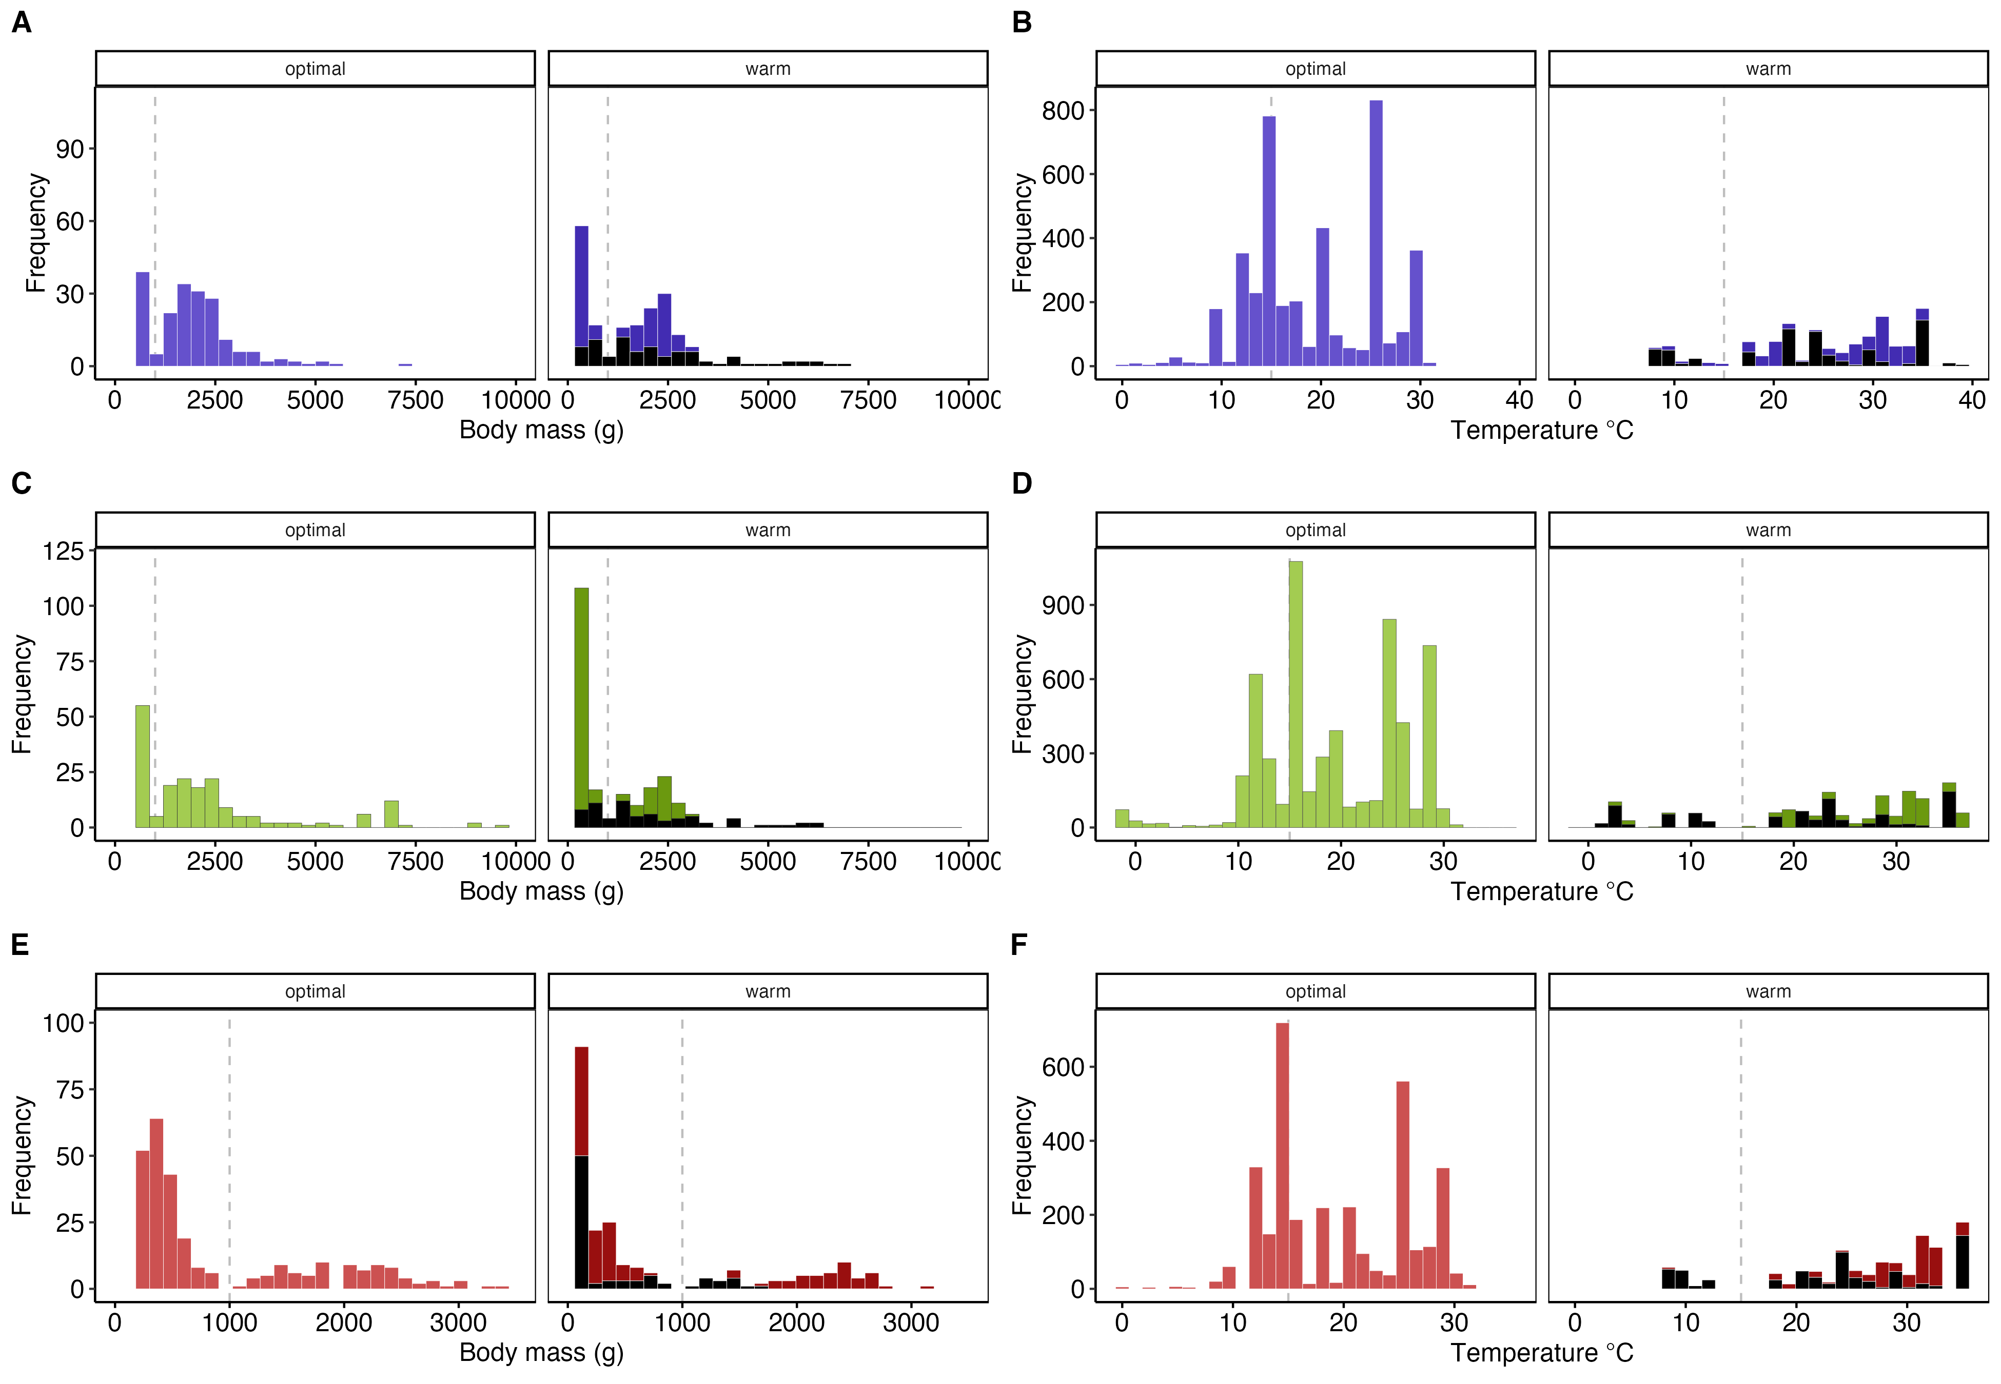

Figure S1. Histograms of body size (A, C, E) and temperature (B, D, F) for maximum metabolic rates (MMR; A,B), resting metabolic rate (RMR; C,D), and aerobic scopes (FAS and AS; E, F). Black bars are fish exposed to supra-optimal (warm) temperatures acutely. The dashed vertical lines show body mass at 1000 g (1kg), and 15ºC.
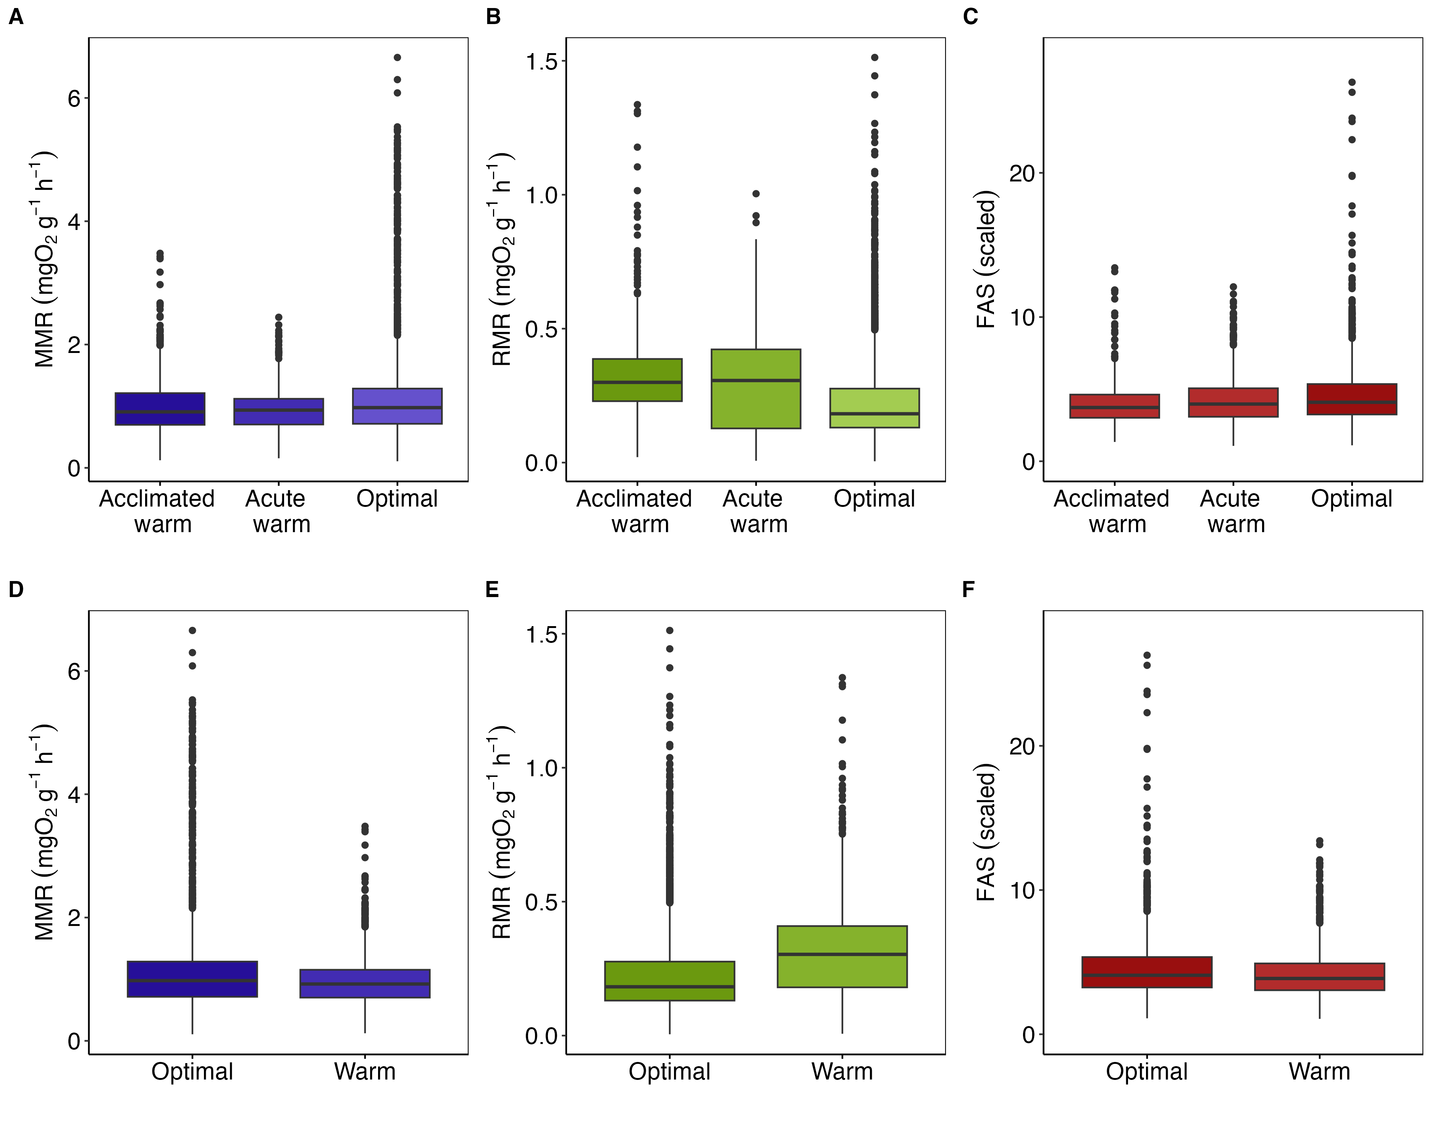

Figure S2. Comparison of mass-specific individual aerobic performances in warm temperatures (acute and acclimated exposures separated in top panels). Maximum metabolic rates (MMR; panels A,D), resting metabolic rate (RMR; B, E), factorial aerobic scopes (FAS; C, F). The values were mass-corrected using scaling exponents from the best fish global scaling models. FAS is not mass corrected.
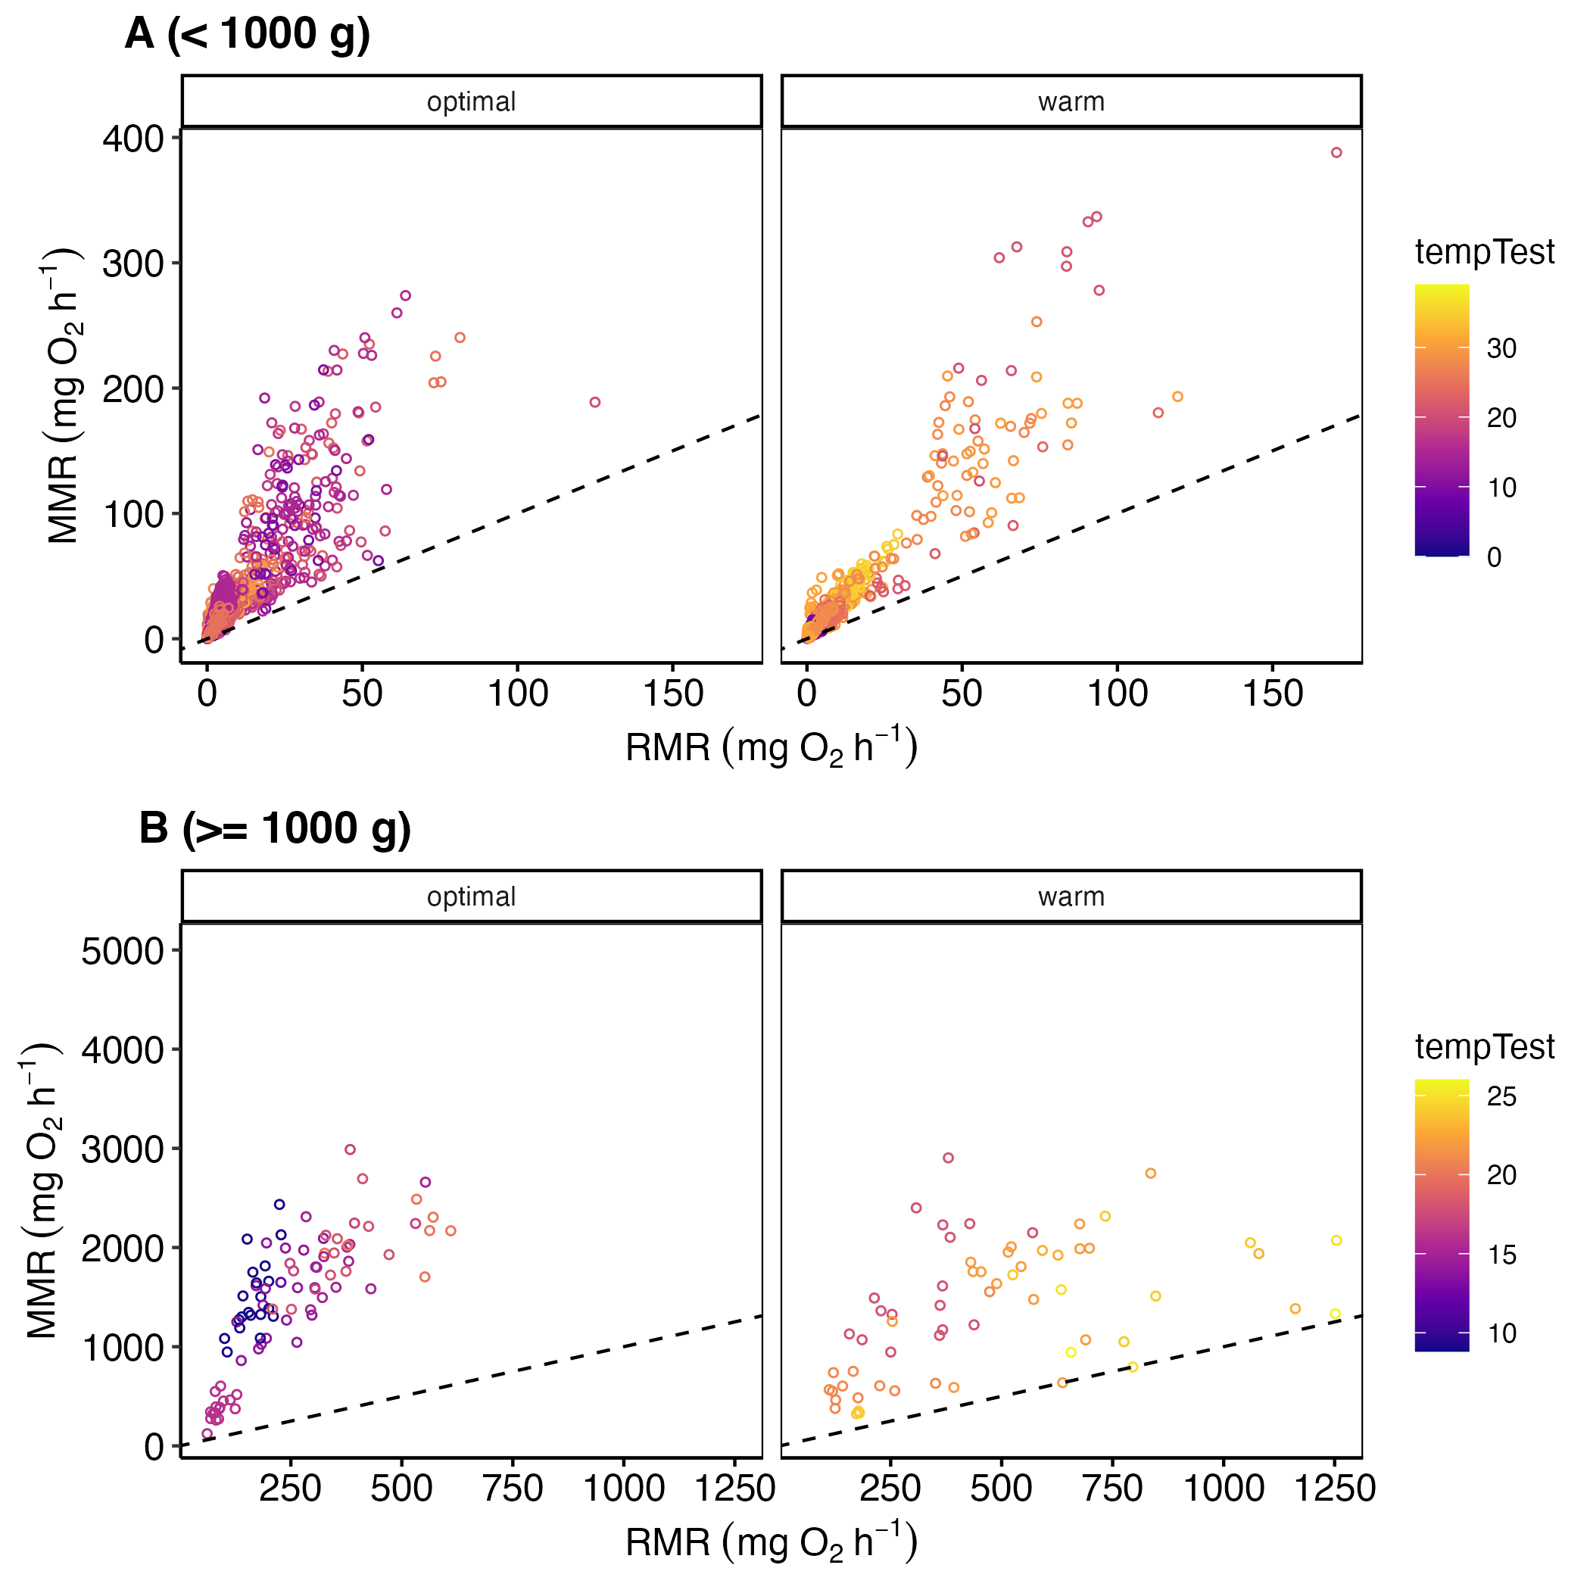

Figure S3. Correlation between resting metabolic rate (RMR) and maximum metabolic rate (MMR). The panels are divided by fish body size to improve visual quality. The dots on in diamond are Somniosus microcephalus, the largest species in the dataset.
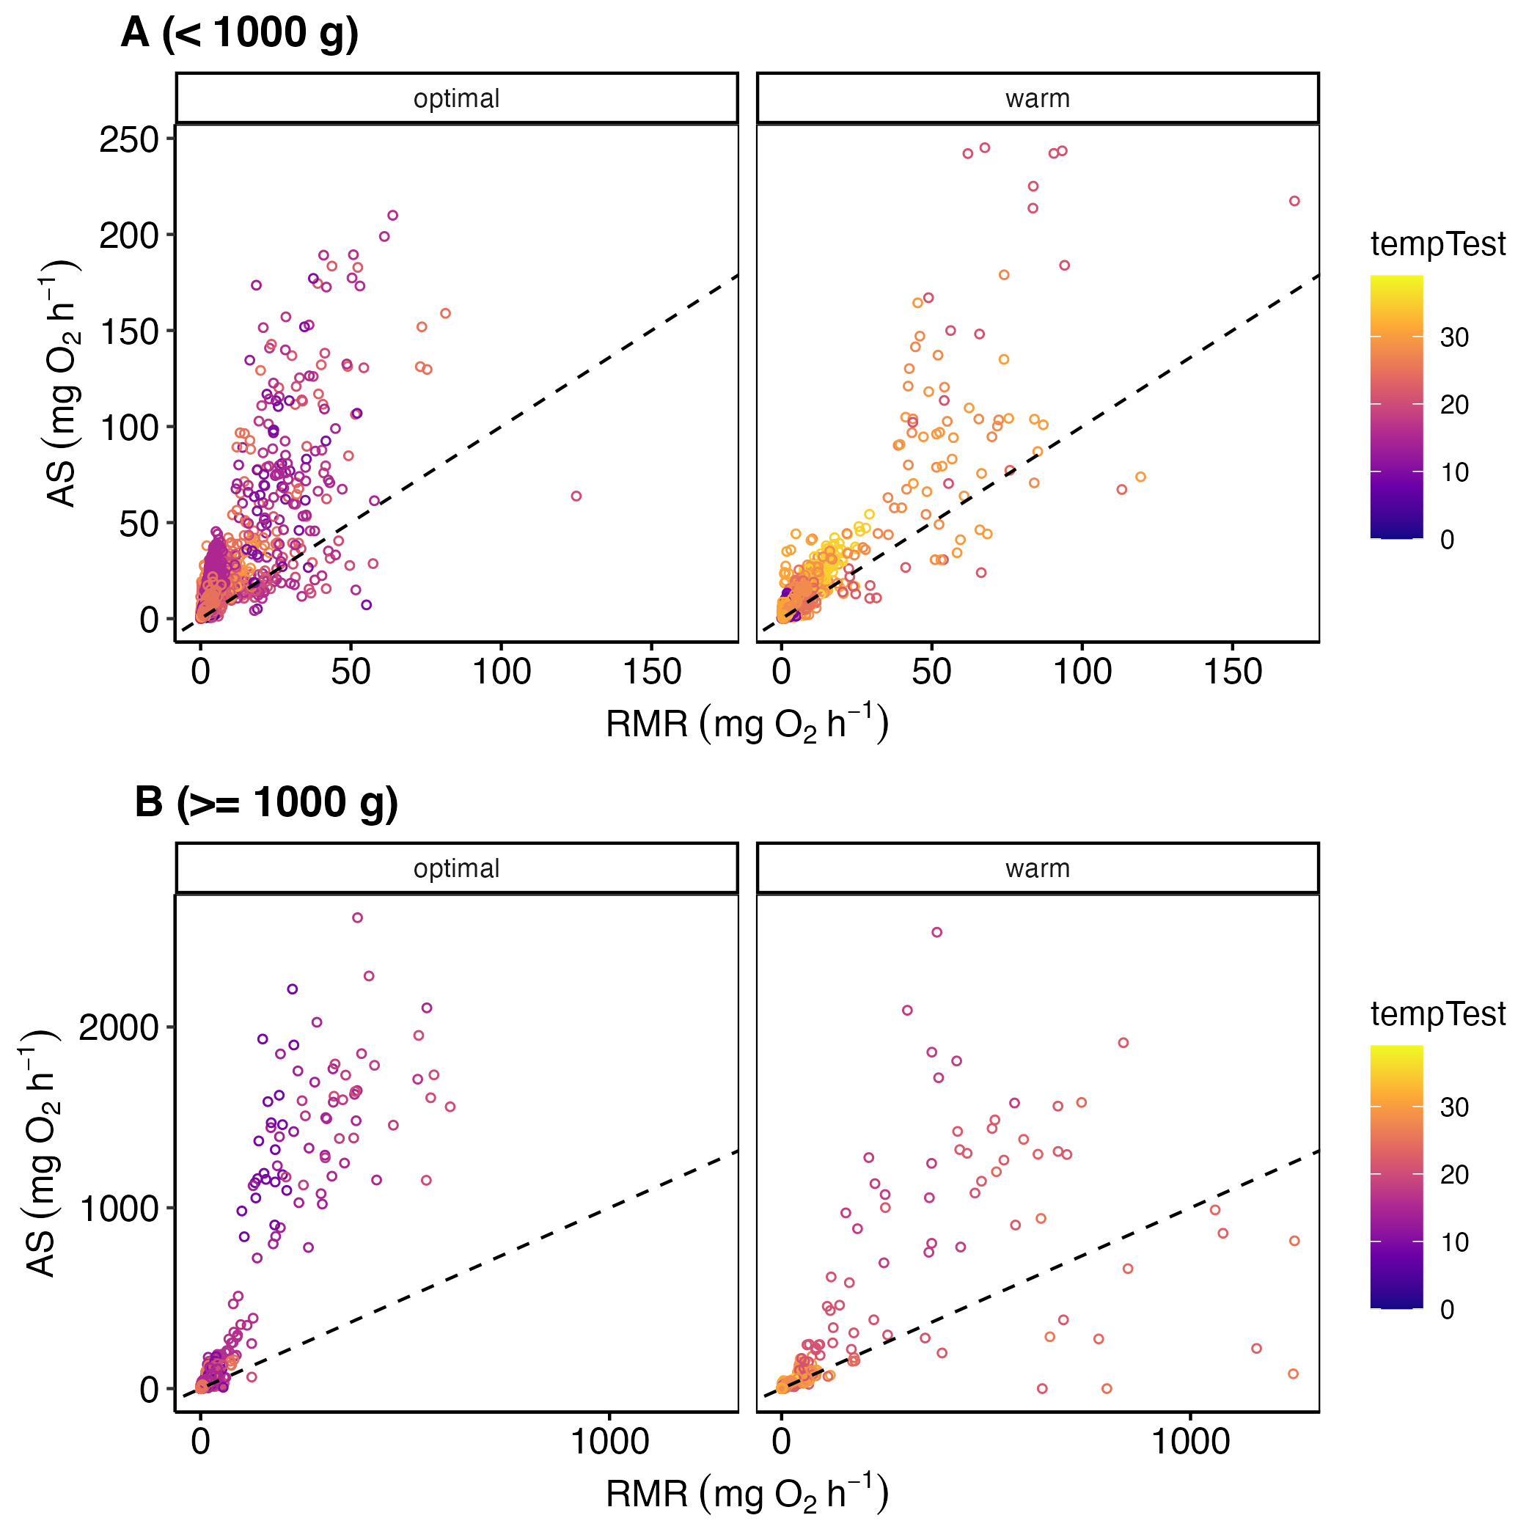

Figure S4. Correlation between resting metabolic rate (RMR) and aerobic scope (AS). The panels are divided by fish body size to improve visual quality. The dots on in diamond are Somniosus microcephalus, the largest species in the dataset.
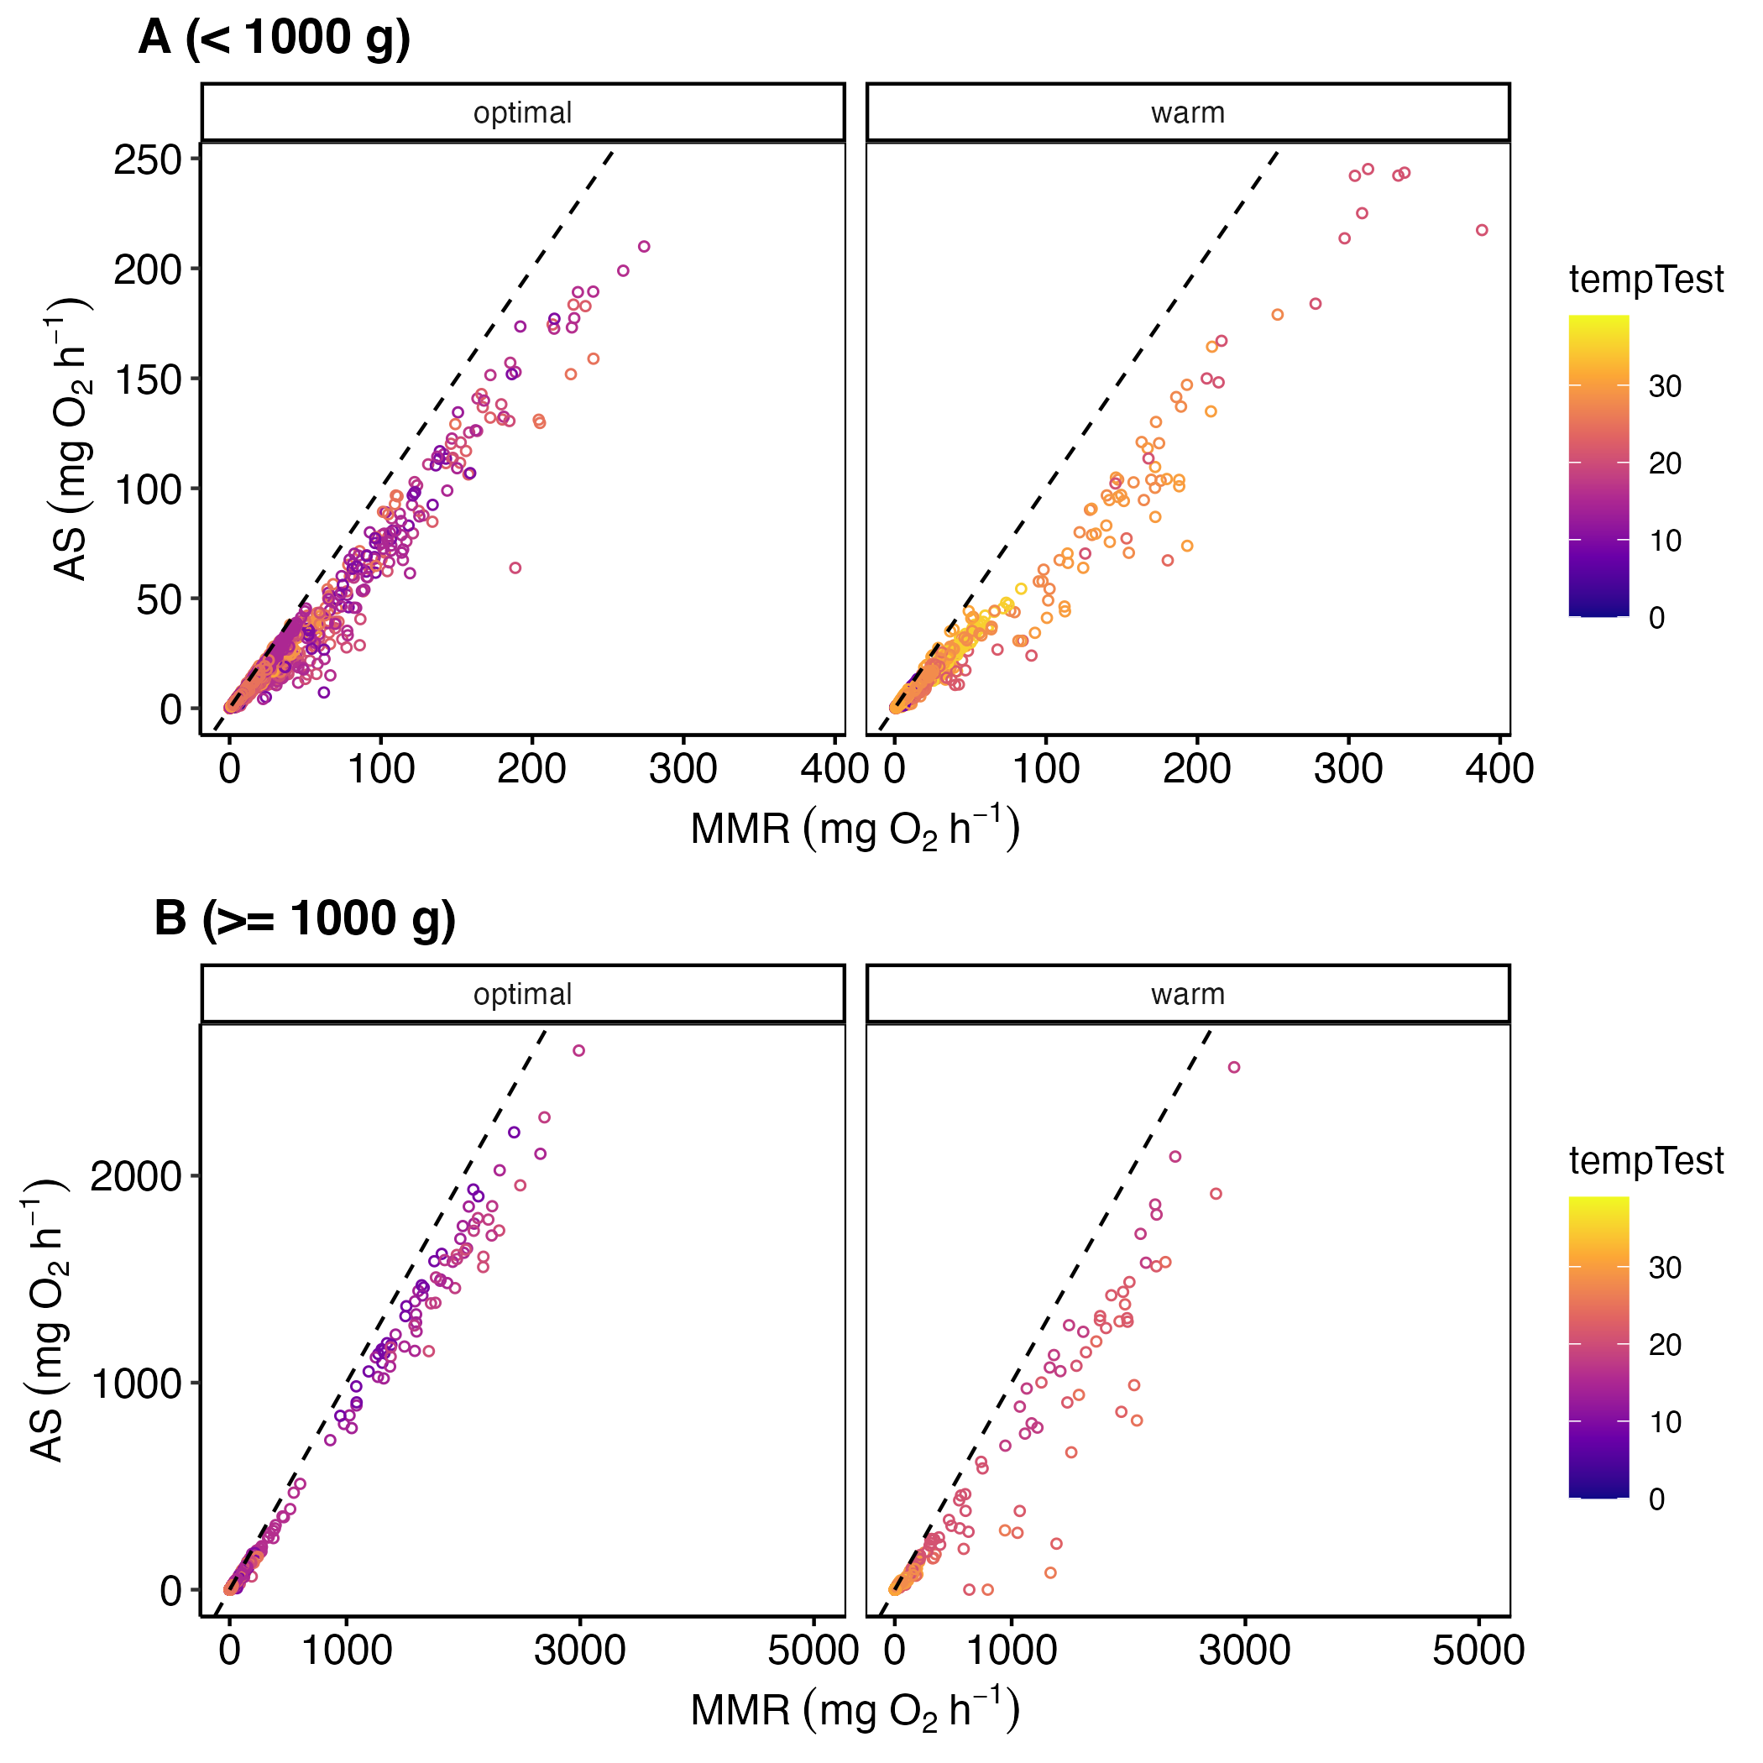

Figure S5. Correlation between maximum metabolic rate (MMR) and aerobic scope (AS). The panels are divided by fish body size to improve visual quality. The dots on in diamond are Somniosus microcephalus, the largest species in the dataset.

Species-specific scaling slopes
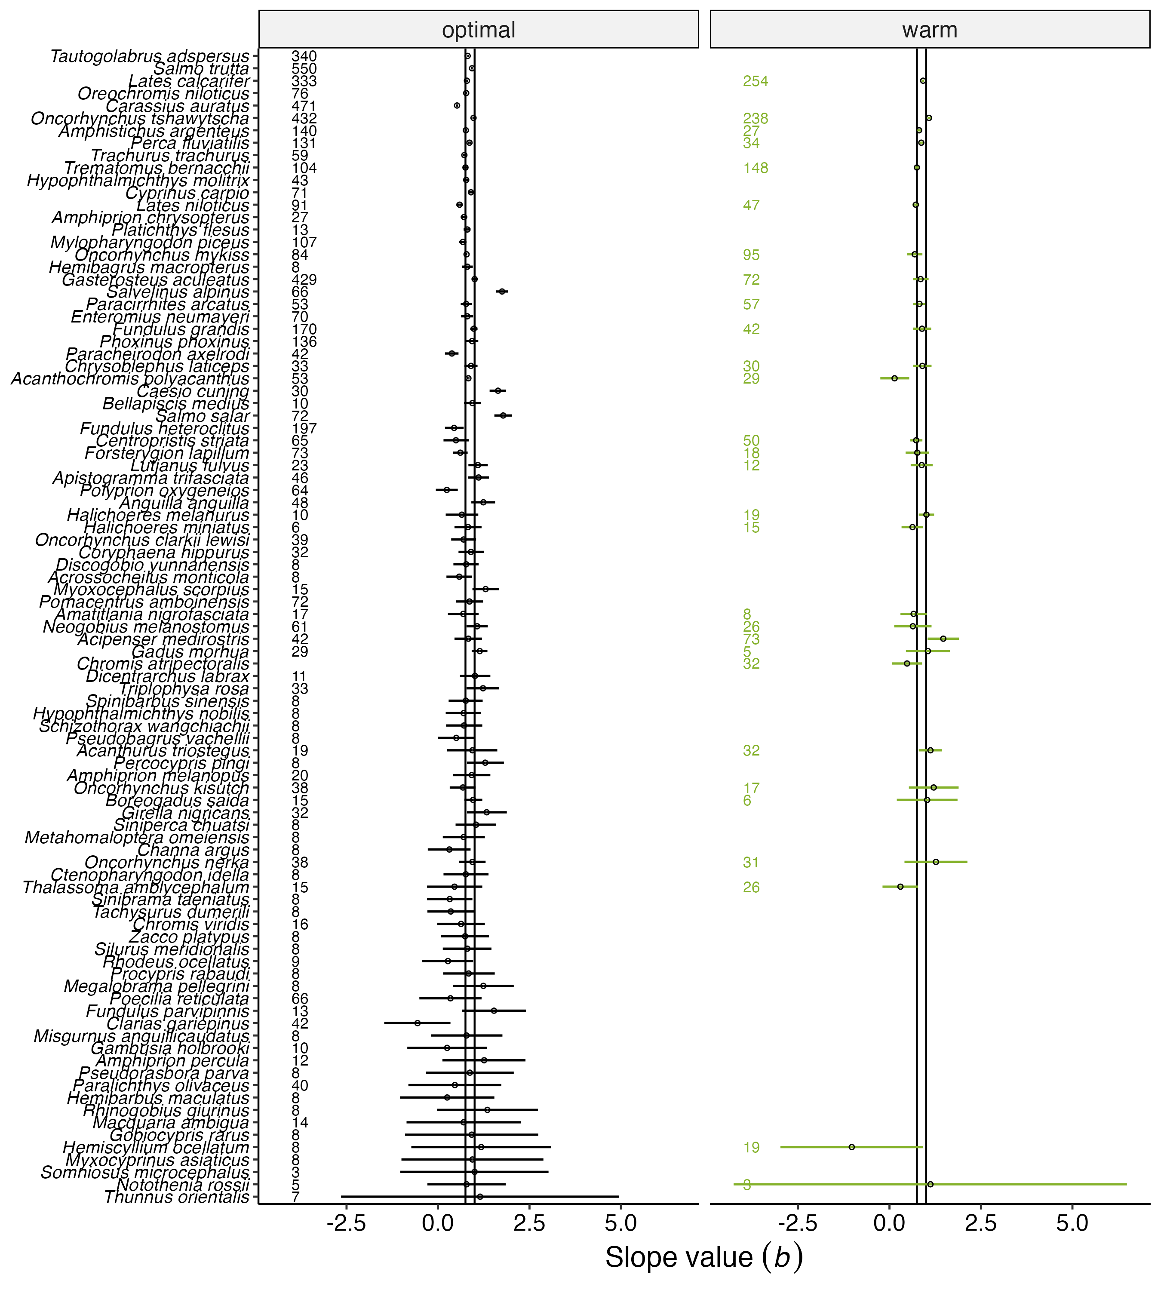

Figure S6.Species-specific scaling slope values (dots) of resting metabolic rates with its 95% confidence interval (CI, the error bar). All slopes were developed using simple linear models. The number in the panel is sample size and all species are ordered by the width of the confidence interval (top, smallest CI range; bottom = largest CI range).
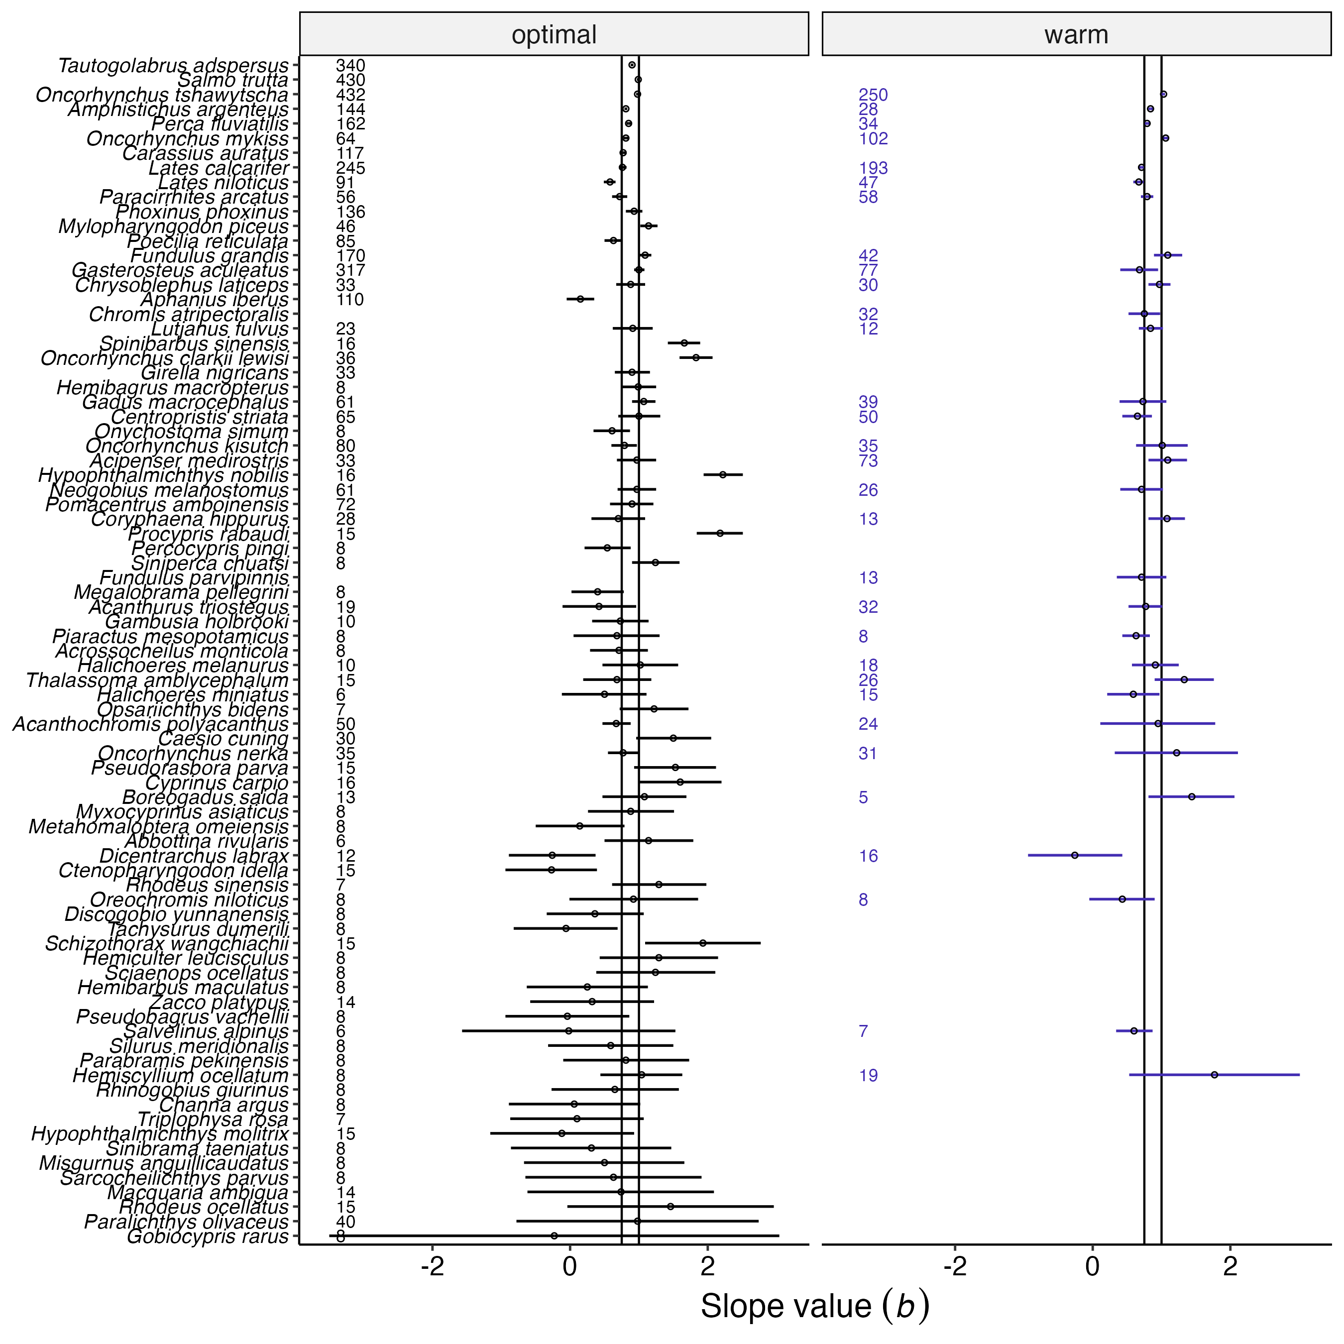

Figure S7. Species-specific scaling slope values (dots) of maximum metabolic rates with its 95% confidence interval (CI, the error bar). All slopes were developed using simple linear models. The number in the panel is sample size and all species are ordered by the width of the confidence interval (top, smallest CI range; bottom = largest CI range).
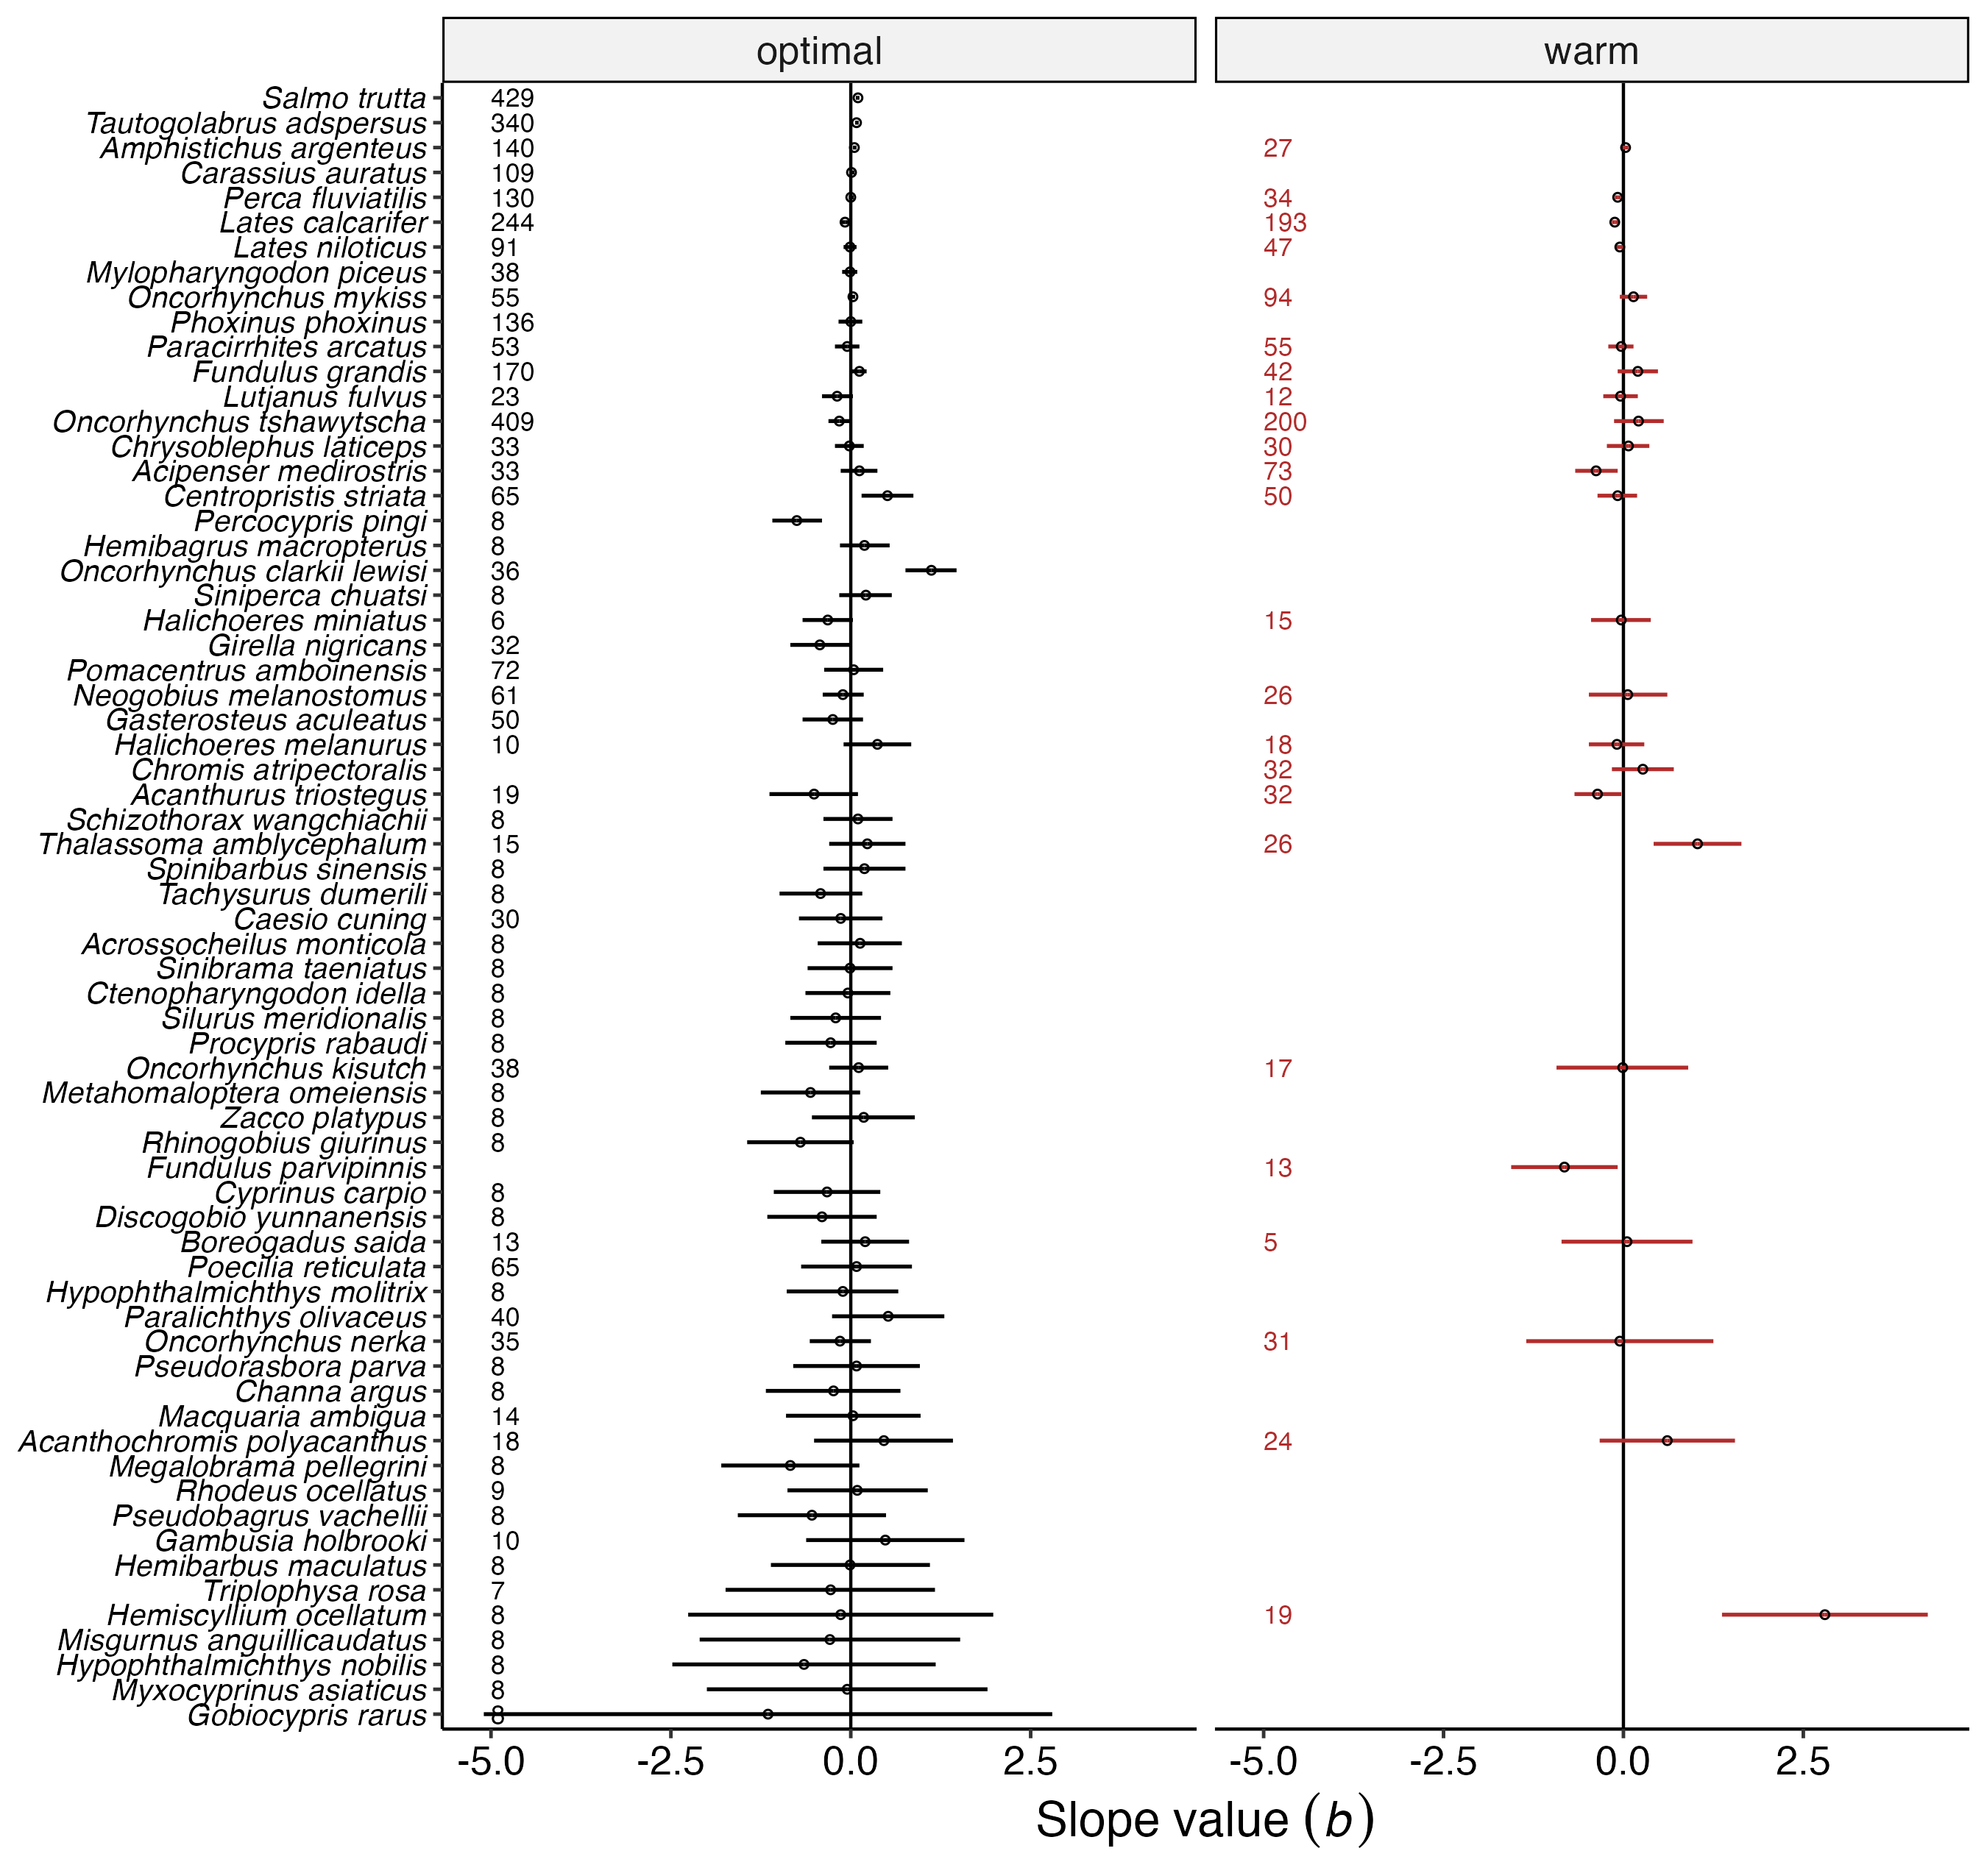

Figure S8. Species-specific scaling slope values (dots) of factorial aerobic scopes with its 95% confidence interval (CI, the error bar). All slopes were developed using simple linear models. The number in the panel is sample size and all species are ordered by the width of the confidence interval (top, smallest CI range; bottom = largest CI range).

Histograms of all scaling slopes
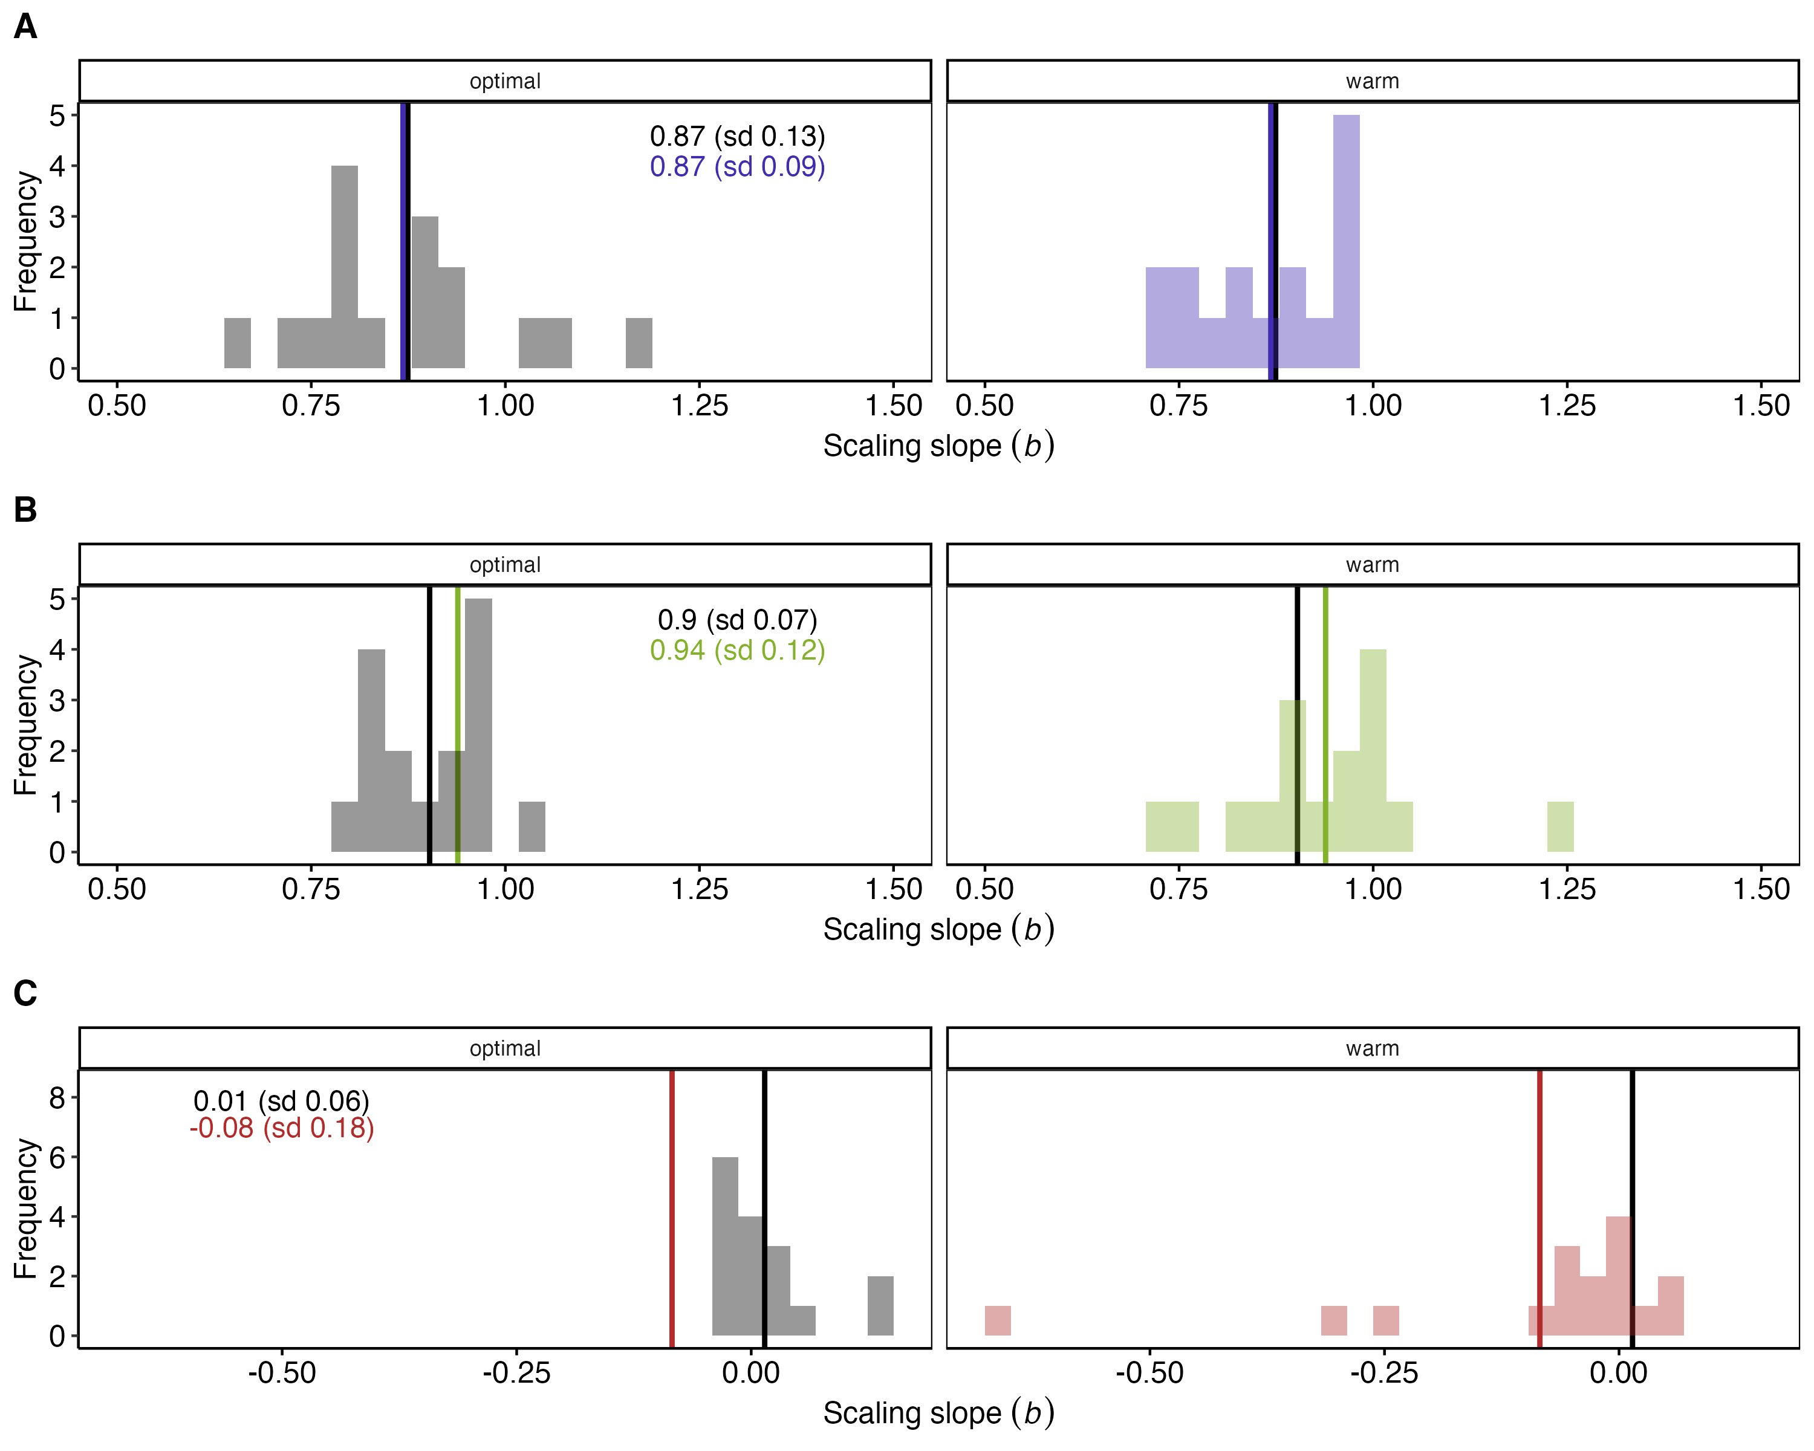

Figure S9. The histogram of all scaling slopes for fish grouped by their ecological and morphological characteristics.(A) Maximum metabolic rates, (B) resting metabolic rates, (C) factorial aerobic scopes. The vertical lines are the mean of all slopes for each temperature condition (optimal = grey-scale, and warm = colored).
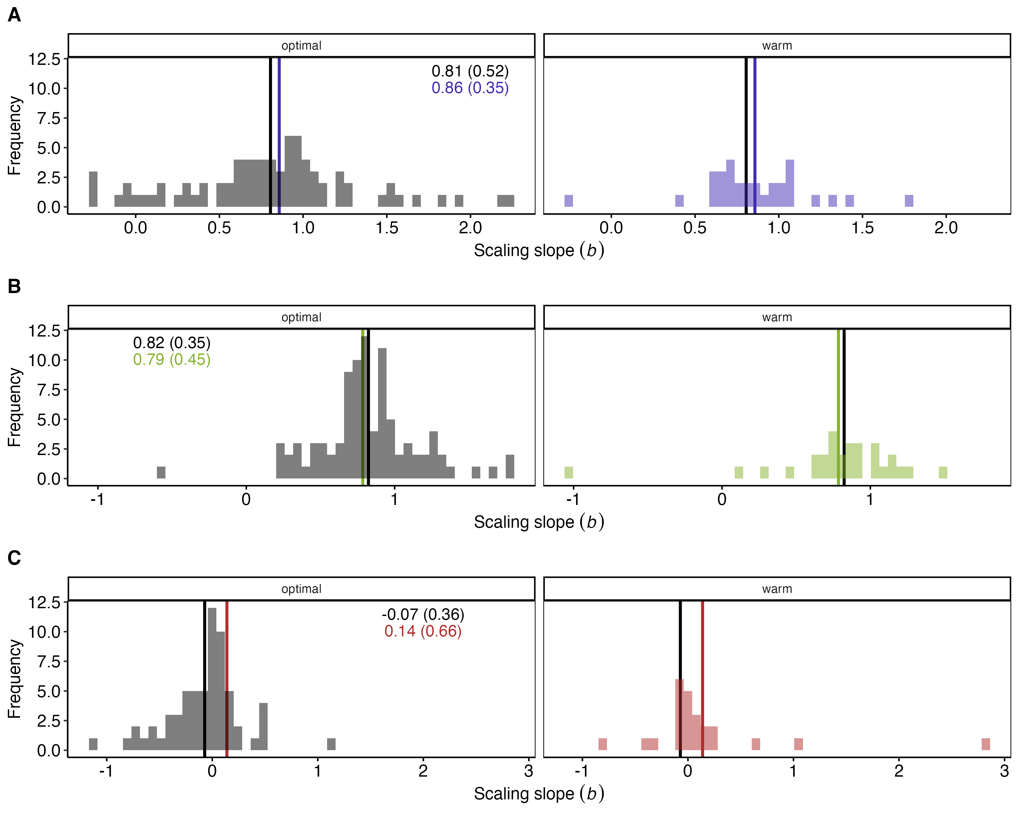

Figure S10. The histogram of all scaling slopes for all fish species included in the dataset. (A) Maximum metabolic rates, (B) resting metabolic rates, (C) factorial aerobic scopes. The vertical lines are the mean of all slopes for each temperature condition (optimal = grey-scale, and warm = colored).

Phylogenetic trees (Inter-specific global scaling models only)
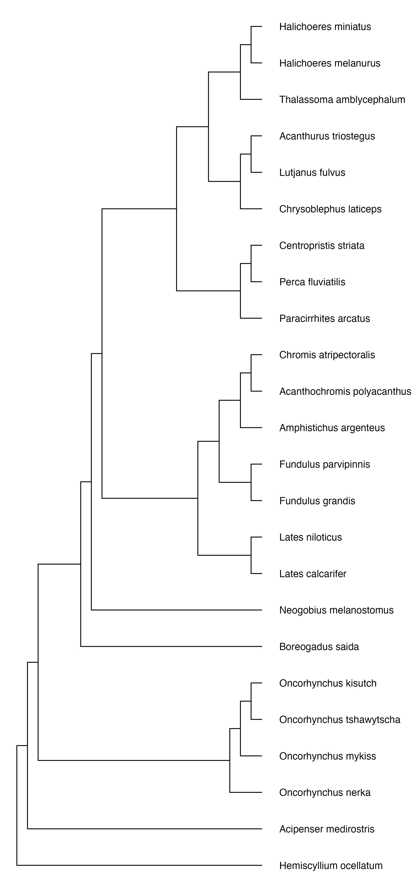

Figure S12.The phylogenetic tree representing species included in the dataset to analyze scaling relationships of factorial aerobic scopes (FAS) in warm temperatures.
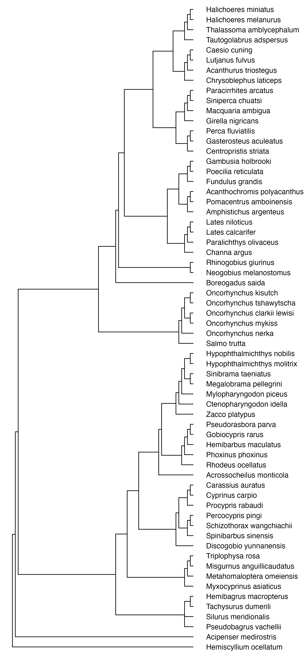

Figure S13. The phylogenetic tree representing species included in the dataset to analyze scaling relationships of factorial aerobic scopes (FAS) in optimal temperatures.

Figure S14. The phylogenetic tree representing species included in the dataset to analyze scaling relationships of aerobic scopes (AS) in warm temperatures.

Figure S15. The phylogenetic tree representing species included in the dataset to analyze scaling relationships of aerobic scopes (AS) in optimal temperatures.
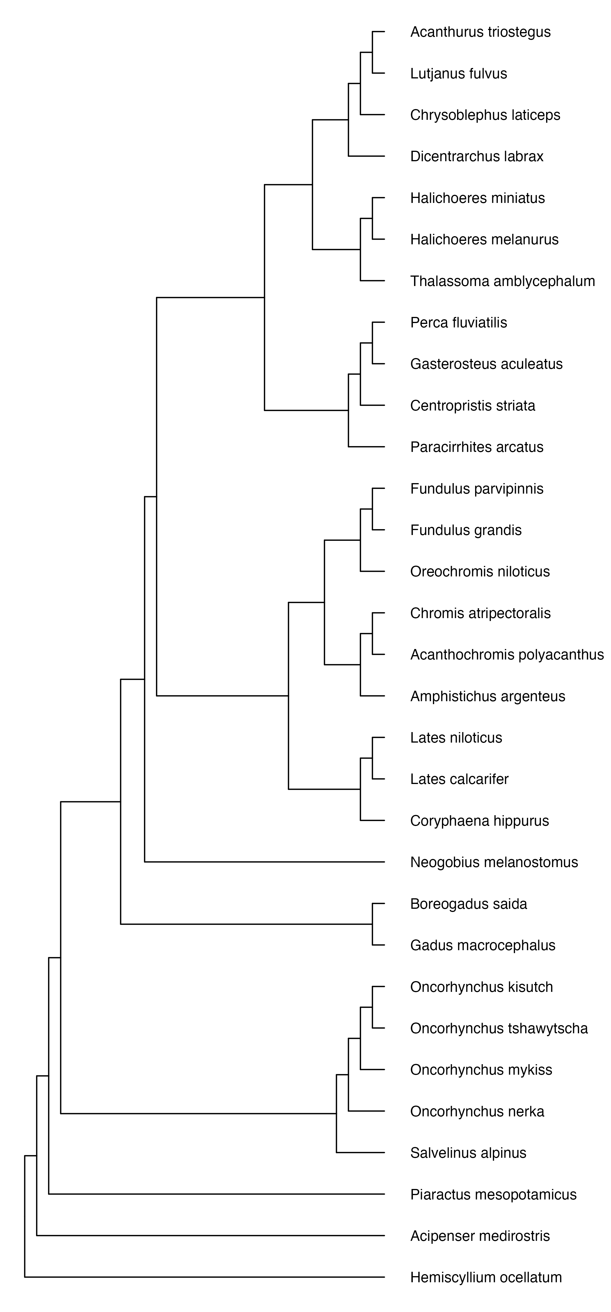

Figure S16. The phylogenetic tree representing species included in the dataset to analyze scaling relationships of maximum metabolic rates (MMR) in warm temperatures.
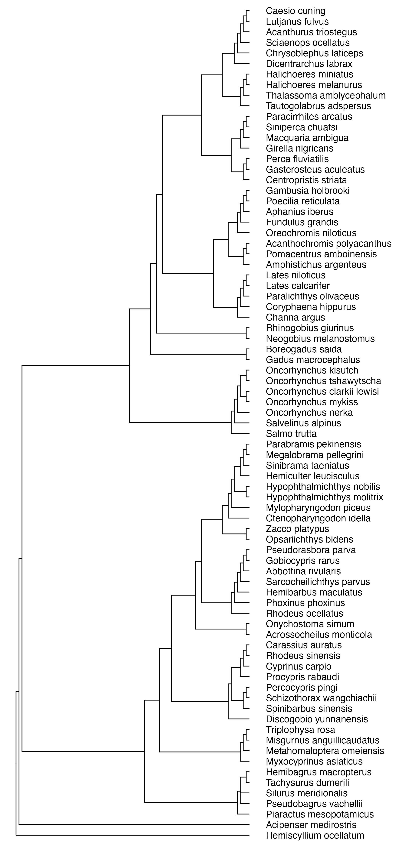

Figure S17. The phylogenetic tree representing species included in the dataset to analyze scaling relationships of maximum metabolic rates (MMR) in optimal temperatures.
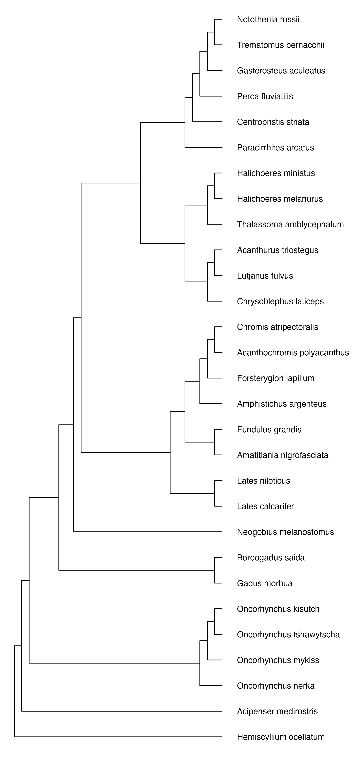

Figure S18. The phylogenetic tree representing species included in the dataset to analyze scaling relationships of resting metabolic rates (RMR) in warm temperatures.
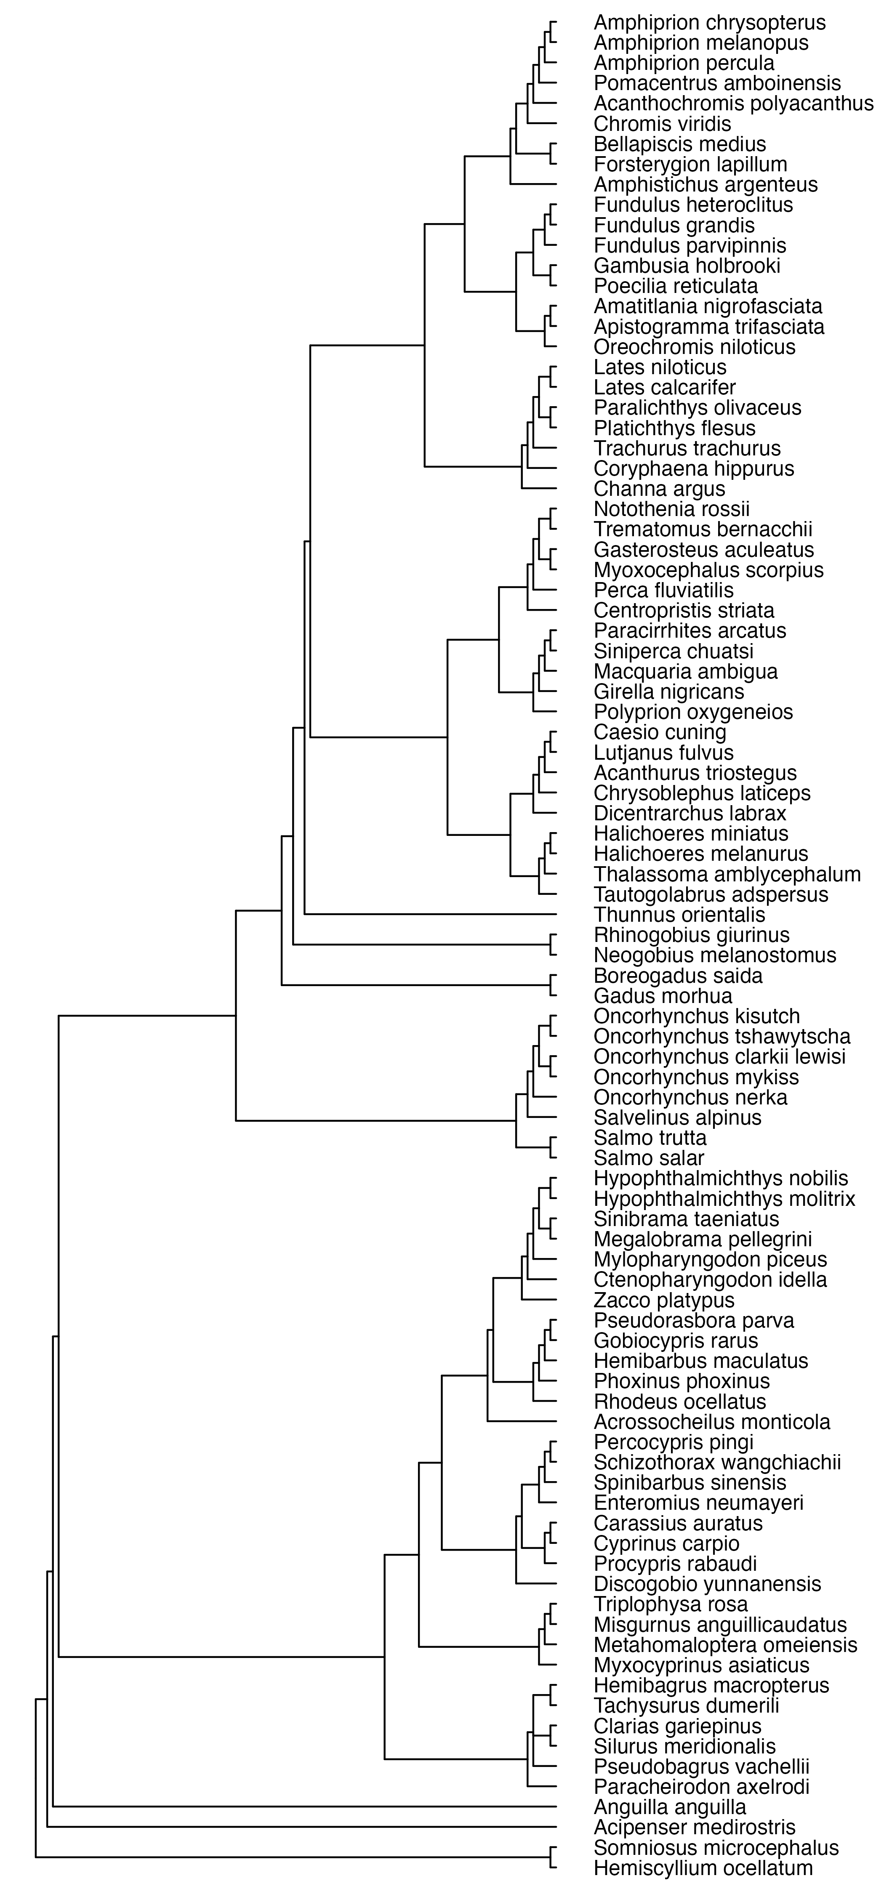

Figure S19. The phylogenetic tree representing species included in the dataset to analyze scaling relationships of resting metabolic rates (RMR) in optimal temperatures.

Detailed reference list of included studies

