Supplemental material:
Title: Variation in metabolic scaling reveals aerobic constraints with temperature in fishes.
Kraskura K, Jerde CL, Eliason EJ
2026-06-30
Table of Contents
1. General summary statistics 6
2. Phylogenetic mixed models (evolvability::Almer) 7
3. Abbreviations: 8
4. A list of libraries used for the analysis and data presentation: 8
5. Tables 8
5.1. BIC model selection tables 8
5.2. Inter-specific global scaling (adults and juveniles together) (TABLES 1 - 8) 8
5.2.1.1. Table S1. Selection of best fit scaling relationship of RMR in optimal temperatures using BIC comparison. 8
5.2.1.2. Table S2. Selection of best fit scaling relationship of RMR in warm temperatures using BIC comparison. 9
5.2.1.3. Table S3. Selection of best fit scaling relationship of MMR in optimal temperatures using BIC comparison. 9
5.2.1.4. Table S4. Selection of best fit scaling relationship of MMR in warm temperatures using BIC comparison. 10
5.2.1.5. Table S5. Selection of best fit scaling relationship of AS in optimal temperatures using BIC comparison. 10
5.2.1.6. Table S6. Selection of best fit scaling relationship of AS in warm temperatures using BIC comparison. 11
5.2.1.7. Table S7. Selection of best fit scaling relationship of FAS in optimal temperatures using BIC comparison. 11
5.2.1.8. Table S8. Selection of best fit scaling relationship of FAS in warm temperatures using BIC comparison. 11
5.3. Life-stage specific scaling: juveniles only (TABLES 1.j - 8.j) 12
5.3.1.1. Table S1.j. Selection of best fit scaling relationship of RMR in optimal temperatures using BIC comparison. 12
5.3.1.2. Table S2.j. Selection of best fit scaling relationship of RMR in warm temperatures using BIC comparison. 12
5.3.1.3. Table S3.j. Selection of best fit scaling relationship of MMR in optimal temperatures using BIC comparison. 13
5.3.1.4. Table S4.j. Selection of best fit scaling relationship of MMR in warm temperatures using BIC comparison. 13
5.3.1.5. Table S5.j. Selection of best fit scaling relationship of AS in optimal temperatures using BIC comparison. 14
5.3.1.6. Table S6.j. Selection of best fit scaling relationship of AS in warm temperatures using BIC comparison. 14
5.3.1.7. Table S7.j. Selection of best fit scaling relationship of FAS in optimal temperatures using BIC comparison. 15
5.3.1.8. Table S8.j. Selection of best fit scaling relationship of FAS in warm temperatures using BIC comparison. 15
5.4. Life-stage specific scaling: adults only (TABLES 1.a - 8.a) 16
5.4.1.1. Table S1.a. Selection of best fit scaling relationship of RMR in optimal temperatures using BIC comparison. 16
5.4.1.2. Table S2.a. Selection of best fit scaling relationship of RMR in warm temperatures using BIC comparison. 16
5.4.1.3. Table S3.a. Selection of best fit scaling relationship of MMR in optimal temperatures using BIC comparison. 17
5.4.1.4. Table S4.a. Selection of best fit scaling relationship of MMR in warm temperatures using BIC comparison. 17
5.4.1.5. Table S5.a. Selection of best fit scaling relationship of AS in optimal temperatures using BIC comparison. 18
5.4.1.6. Table S6.a. Selection of best fit scaling relationship of AS in warm temperatures using BIC comparison. 18
5.4.1.7. Table S7.a. Selection of best fit scaling relationship of FAS in optimal temperatures using BIC comparison. 18
5.4.1.8. Table S8.a. Selection of best fit scaling relationship of FAS in warm temperatures using BIC comparison. 19
5.5. Summary of the data 19
5.5.1.1. Table S9. Summary of sample sizes, body mass, and temperature ranges in all collated data. 19
5.5.1.2. Table S10. Factorial aerobic scopes in fish with different ecologies and morphologies. 20
5.5.1.3. Table S11. Summary data of RMR dataset with sample sizes, body mass and temperature ranges in fish grouped by different ecologies and morphologies. 21
5.5.1.4. Table S12. Summary data of MMR dataset with sample sizes, body mass and temperature ranges in fish grouped by different ecologies and morphologies. 24
5.5.1.5. Table S13. Summary data of FAS dataset with sample sizes, body mass and temperature ranges in fish grouped by different ecologies and morphologies. 26
5.6. Best model outputs and ANOVA results for statistical significance 28
5.6.1. Inter-specific global scaling 28
5.6.1.1. MMR optimal temperatures 28
5.6.1.2. RMR optimal temperatures 30
5.6.1.3. AS optimal temperatures 32
5.6.1.4. FAS optimal temperatures 34
5.6.1.5. MMR warm temperatures 36
5.6.1.6. RMR warm temperatures 37
5.6.1.7. AS warm temperatures 39
5.6.1.8. FAS warm temperatures 41
5.6.1.9. RMR optimal temperatures, juveniles 44
5.6.1.10. AS optimal temperatures, juveniles 46
5.6.1.11. FAS optimal temperatures, juveniles 48
5.6.1.12. MMR warm temperatures, juveniles 50
5.6.1.13. RMR warm temperatures, juveniles 52
5.6.1.14. AS warm temperatures, juveniles 53
5.6.1.15. FAS warm temperatures, juveniles 55
5.6.1.16. RMR optimal temperatures, adults 59
5.6.1.17. AS optimal temperatures, adults 61
5.6.1.18. FAS optimal temperatures, adults 62
5.6.1.19. MMR warm temperatures, adults 64
5.6.1.20. RMR warm temperatures, adults 66
5.6.1.21. AS warm temperatures, adults 68
5.6.1.22. FAS warm temperatures, adults 69
5.6.2. Inter-specific global scaling 71
5.6.2.1. Table S15. Confidence intervals for each model parameter. 71
5.6.2.2. Table S16. MMR scaling relationship estimates and 95% confidence interval in fish sharing similar ecologies and morphologies. The temperature and body mass ranges, and n-values for each category are in Table S12. 72
5.6.2.3. Table S17. RMR scaling relationship estimates and 95% confidence interval in fish sharing similar ecologies and morphologies. The temperature and body mass ranges, and n-values for each category are in Table S11. 73
5.6.2.4. Table S18. FAS scaling relationship estimates and 95% confidence interval in fish sharing similar ecologies and morphologies. The temperature and body mass ranges, and n-values for each category are in Table S14. 75
6. Figures 77
6.1. Data coverage and patterns 77
6.1.1.1. Figure S1. Histograms of body size (A, C, E) and temperature (B, D, F) for maximum metabolic rates (MMR; A,B), resting metabolic rate (RMR; C,D), and aerobic scopes (FAS and AS; E, F). Black bars are fish exposed to supra-optimal (warm) temperatures acutely. The dashed vertical lines show body mass at 1000 g (1kg), and 15ºC. 77
6.1.1.2. Figure S2. Comparison of mass-specific individual aerobic performances in warm temperatures (acute and acclimated exposures separated in top panels). Maximum metabolic rates (MMR; panels A,D), resting metabolic rate (RMR; B, E), factorial aerobic scopes (FAS; C, F). The values were mass-corrected using scaling exponents from the best fish global scaling models. FAS is not mass corrected. 78
6.1.1.3. Figure S3. Correlation between resting metabolic rate (RMR) and maximum metabolic rate (MMR). The panels are divided by fish body size to improve visual quality. The dots on in diamond are Somniosus microcephalus, the largest species in the dataset. 79
6.1.1.4. Figure S4. Correlation between resting metabolic rate (RMR) and aerobic scope (AS). The panels are divided by fish body size to improve visual quality. The dots on in diamond are Somniosus microcephalus, the largest species in the dataset. 79
6.1.1.5. Figure S5. Correlation between maximum metabolic rate (MMR) and aerobic scope (AS). The panels are divided by fish body size to improve visual quality. The dots on in diamond are Somniosus microcephalus, the largest species in the dataset. 80
6.2. Species-specific scaling slopes 80
6.2.1.1. Figure S6.Species-specific scaling slope values (dots) of resting metabolic rates with its 95% confidence interval (CI, the error bar). All slopes were developed using simple linear models. The number in the panel is sample size and all species are ordered by the width of the confidence interval (top, smallest CI range; bottom = largest CI range). 81
6.2.1.2. Figure S7. Species-specific scaling slope values (dots) of maximum metabolic rates with its 95% confidence interval (CI, the error bar). All slopes were developed using simple linear models. The number in the panel is sample size and all species are ordered by the width of the confidence interval (top, smallest CI range; bottom = largest CI range). 82
6.2.1.3. Figure S8. Species-specific scaling slope values (dots) of factorial aerobic scopes with its 95% confidence interval (CI, the error bar). All slopes were developed using simple linear models. The number in the panel is sample size and all species are ordered by the width of the confidence interval (top, smallest CI range; bottom = largest CI range). 83
6.3. Histograms of all scaling slopes 83
6.3.1.1. Figure S9. The histogram of all scaling slopes for fish grouped by their ecological and morphological characteristics.(A) Maximum metabolic rates, (B) resting metabolic rates, (C) factorial aerobic scopes. The vertical lines are the mean of all slopes for each temperature condition (optimal = grey-scale, and warm = colored). 84
6.3.1.2. Figure S10. The histogram of all scaling slopes for all fish species included in the dataset. (A) Maximum metabolic rates, (B) resting metabolic rates, (C) factorial aerobic scopes. The vertical lines are the mean of all slopes for each temperature condition (optimal = grey-scale, and warm = colored). 85
6.4. Phylogenetic trees (Inter-specific global scaling models only) 85
6.4.1.1. Figure S12.The phylogenetic tree representing species included in the dataset to analyze scaling relationships of factorial aerobic scopes (FAS) in warm temperatures. 86
6.4.1.2. Figure S13. The phylogenetic tree representing species included in the dataset to analyze scaling relationships of factorial aerobic scopes (FAS) in optimal temperatures. 87
6.4.1.3. Figure S14. The phylogenetic tree representing species included in the dataset to analyze scaling relationships of aerobic scopes (AS) in warm temperatures. 87
6.4.1.4. Figure S15. The phylogenetic tree representing species included in the dataset to analyze scaling relationships of aerobic scopes (AS) in optimal temperatures. 88
6.4.1.5. Figure S16. The phylogenetic tree representing species included in the dataset to analyze scaling relationships of maximum metabolic rates (MMR) in warm temperatures. 89
6.4.1.6. Figure S17. The phylogenetic tree representing species included in the dataset to analyze scaling relationships of maximum metabolic rates (MMR) in optimal temperatures. 89
6.4.1.7. Figure S18. The phylogenetic tree representing species included in the dataset to analyze scaling relationships of resting metabolic rates (RMR) in warm temperatures. 90
6.4.1.8. Figure S19. The phylogenetic tree representing species included in the dataset to analyze scaling relationships of resting metabolic rates (RMR) in optimal temperatures. 91
7. Detailed reference list of included studies 91

General summary statistics
- The number of datapoints total: 12670
- The number of trials total: 288
- The number of studies total: 99
- The number of species total: 104
- The number of individual fish: 6042
- The number of individual fish below 1000 g in RMR dataset: 6941 (proportion: 0.964)
- The number of individual fish below 1000 g in MMR dataset: 5188 (proportion: 0.948)
- The number of datapoints in AS data subset: 4407
- The number of trials in AS data subset: 198
- The number of studies in AS data subset: 60
- The number of species in AS data subset: 81
- The percent of tropical fish that had FAS below 3: 22.33 %
- The percent of subtropical fish that had FAS below 3: 18.49 %
- The percent of temperate fish that had FAS below 3: 11.51 %
- The percent of polar fish that had FAS below 3: 92.31 %

MMR_method | test_category | count
chase | optimal | 2906
chase | warm | 821
handling | optimal | 14
other | optimal | 86
other | warm | 34
stirbar-swim | optimal | 71
stirbar-swim | warm | 99
swim | optimal | 1032
swim | warm | 409
MMR | Optimal T | Warm T
Resp(L):Size(kg) (min) | 2.58 | 2.57
Resp(L):Size(kg) (max) | 3090.91 | 2138.28
Hours starved (min) | 12 | 12
Hours starved (max) | 168 | 96
Hours in chamber (min) | 0.75 | 1
Hours in chamber (max) | 48 | 48
RMR | Optimal T | Warm T
Resp(L):Size(kg) (min) | 2.58 | 2.57
Resp(L):Size(kg) (max) | 4718.88 | 3604.29
Hours starved (min) | 12 | 12
Hours starved (max) | 240 | 240
Hours in chamber (min) | 0.75 | 1
Hours in chamber (max) | 78 | 78

Phylogenetic mixed models (evolvability::Almer)
- model sets: Different random effects
  - set 1 (in R script used as #2): (1|species) +(0 + tempTest|species) + (1|species:trial) = species intercept, nested trial under species intercept, species-specific response to temperature (i.e. different size individuals of the same species, would have different sensitivity to temperature).
  - set 2 (in R script used as #4) : (1|species) +(0 + lnBWg|species) + (1|species:trial) = species intercept, nested trial under species intercept, species-specific mass scaling slopes
  - set 3 (in R script used as #5): (1|species) +(0 + lnBWg|species:trial) + (1|species:trial) = species intercept, nested trial under species intercept, nested species:trial mass scaling slopes
- model types:
  - mass and temperature affect metabolism independently
  - (int) mass and temperature affect metabolism in interaction

Abbreviations:
MMR = maximum metabolic rates
RMR = resting metabolic rates
AS = absolute aerobic scope
FAS = factorial aerobic scope
BIC = Bayesian Information Criterion (model comparison metric)

A list of libraries used for the analysis and data presentation:
- Statistics, models, and phylogenetic matrix:
  - lme4, emmeans, car, evolvability, ape, rotl, ggtree, Matrix
- Data handling and visualization:
  - pryr, viridisLite, TDbook, ggimage, ggformat2 (custom written author’s package), ggpubr, cowplot, forcats, reshape2, systemfonts, flextable, here, ggh4x, tidyverse, dplyr, colorBlindness, patchwork, weathermetrics.

Tables

BIC model selection tables

Inter-specific global scaling (adults and juveniles together) (TABLES 1 - 8)

Table S1. Selection of best fit scaling relationship of RMR in optimal temperatures using BIC comparison.
Model ID | df | BIC | delta
Phylo_RMR_model4int | 8 | 1238.05 | 0.00
Phylo_RMR_model4 | 7 | 1242.71 | 4.66
Phylo_RMR_model2 | 7 | 1307.83 | 69.78
Phylo_RMR_model2int | 8 | 1313.28 | 75.24
Phylo_RMR_model5 | 7 | 1358.11 | 120.06
Phylo_RMR_model5int | 8 | 1362.99 | 124.95
All models ∆BIC < 7 could be considered significant.

Table S2. Selection of best fit scaling relationship of RMR in warm temperatures using BIC comparison.
Model ID | df | BIC | delta
Phylo_RMR_W_model4 | 7 | 474.65 | 0.00
Phylo_RMR_W_model4int | 8 | 479.87 | 5.22
Phylo_RMR_W_model2 | 7 | 489.19 | 14.54
Phylo_RMR_W_model2int | 8 | 496.48 | 21.83
Phylo_RMR_W_model5 | 7 | 498.80 | 24.16
Phylo_RMR_W_model5int | 8 | 506.09 | 31.44
All models ∆BIC < 7 could be considered significant.

Table S3. Selection of best fit scaling relationship of MMR in optimal temperatures using BIC comparison.
Model ID | df | BIC | delta
Phylo_MMR_model4 | 7 | -431.77 | 0.00
Phylo_MMR_model4int | 8 | -424.09 | 7.68
Phylo_MMR_model5 | 7 | -359.65 | 72.12
Phylo_MMR_model5int | 8 | -353.69 | 78.09
Phylo_MMR_model2int | 8 | -164.63 | 267.14
Phylo_MMR_model2 | 7 | -153.99 | 277.78
All models ∆BIC < 7 could be considered significant.

Table S4. Selection of best fit scaling relationship of MMR in warm temperatures using BIC comparison.
Model ID | df | BIC | delta
Phylo_MMR_W_model2int | 8 | -215.27 | 0.00
Phylo_MMR_W_model4 | 7 | -208.00 | 7.27
Phylo_MMR_W_model4int | 8 | -203.56 | 11.71
Phylo_MMR_W_model2 | 7 | -191.39 | 23.88
Phylo_MMR_W_model5 | 7 | -190.34 | 24.93
Phylo_MMR_W_model5int | 8 | -188.88 | 26.38
All models ∆BIC < 7 could be considered significant.

Table S5. Selection of best fit scaling relationship of AS in optimal temperatures using BIC comparison.
Model ID | df | BIC | delta
Phylo_AS_model5int | 8 | 987.76 | 0.00
Phylo_AS_model2int | 8 | 989.29 | 1.53
Phylo_AS_model4int | 8 | 989.36 | 1.60
Phylo_AS_model4 | 7 | 1019.52 | 31.76
Phylo_AS_model5 | 7 | 1046.54 | 58.78
Phylo_AS_model2 | 7 | 1058.82 | 71.06
All models ∆BIC < 7 could be considered significant.

Table S6. Selection of best fit scaling relationship of AS in warm temperatures using BIC comparison.
Model ID | df | BIC | delta
Phylo_AS_W_model2int | 8 | 978.45 | 0.00
Phylo_AS_W_model2 | 7 | 990.19 | 11.75
Phylo_AS_W_model4 | 7 | 1012.67 | 34.22
Phylo_AS_W_model4int | 8 | 1019.52 | 41.07
Phylo_AS_W_model5 | 7 | 1019.86 | 41.41
Phylo_AS_W_model5int | 8 | 1026.33 | 47.89
All models ∆BIC < 7 could be considered significant.

Table S7. Selection of best fit scaling relationship of FAS in optimal temperatures using BIC comparison.
Model ID | df | BIC | delta
Phylo_FAS_model2int | 8 | 800.14 | 0.00
Phylo_FAS_model4int | 8 | 811.69 | 11.55
Phylo_FAS_model2 | 7 | 820.12 | 19.98
Phylo_FAS_model5int | 8 | 832.13 | 31.99
Phylo_FAS_model4 | 7 | 835.09 | 34.95
Phylo_FAS_model5 | 7 | 853.30 | 53.16
All models ∆BIC < 7 could be considered significant.

Table S8. Selection of best fit scaling relationship of FAS in warm temperatures using BIC comparison.
Model ID | df | BIC | delta
Phylo_FAS_W_model2 | 7 | 312.96 | 0.00
Phylo_FAS_W_model4 | 7 | 312.96 | 0.00
Phylo_FAS_W_model2int | 8 | 318.24 | 5.28
Phylo_FAS_W_model4int | 8 | 318.24 | 5.28
Phylo_FAS_W_model5 | 7 | 321.34 | 8.38
Phylo_FAS_W_model5int | 8 | 324.87 | 11.91
All models ∆BIC < 7 could be considered significant.

Life-stage specific scaling: juveniles only (TABLES 1.j - 8.j)

Table S1.j. Selection of best fit scaling relationship of RMR in optimal temperatures using BIC comparison.
Model ID | df | BIC | delta
Phylo_RMR_model4 | 7 | -51.87 | 0.00
Phylo_RMR_model4int | 8 | -44.94 | 6.93
Phylo_RMR_model2 | 7 | 21.42 | 73.29
Phylo_RMR_model5 | 7 | 28.74 | 80.61
Phylo_RMR_model2int | 8 | 29.60 | 81.47
Phylo_RMR_model5int | 8 | 36.71 | 88.58
All models ∆BIC < 7 could be considered significant.

Table S2.j. Selection of best fit scaling relationship of RMR in warm temperatures using BIC comparison.
Model ID | df | BIC | delta
Phylo_RMR_W_model2 | 7 | 427.38 | 0.00
Phylo_RMR_W_model2int | 8 | 433.00 | 5.62
Phylo_RMR_W_model4 | 7 | 434.91 | 7.53
Phylo_RMR_W_model5 | 7 | 435.67 | 8.29
Phylo_RMR_W_model4int | 8 | 440.32 | 12.94
Phylo_RMR_W_model5int | 8 | 441.94 | 14.56
All models ∆BIC < 7 could be considered significant.

Table S3.j. Selection of best fit scaling relationship of MMR in optimal temperatures using BIC comparison.
Model ID | df | BIC | delta
Phylo_MMR_model4int | 8 | -1095.78 | 0.00
Phylo_MMR_model5int | 8 | -1090.51 | 5.27
Phylo_MMR_model4 | 7 | -1076.67 | 19.11
Phylo_MMR_model2int | 8 | -1076.21 | 19.57
Phylo_MMR_model5 | 7 | -1064.02 | 31.75
Phylo_MMR_model2 | 7 | -1039.31 | 56.47
All models ∆BIC < 7 could be considered significant.

Table S4.j. Selection of best fit scaling relationship of MMR in warm temperatures using BIC comparison.
Model ID | df | BIC | delta
Phylo_MMR_W_model4 | 7 | -335.08 | 0.00
Phylo_MMR_W_model4int | 8 | -329.84 | 5.24
Phylo_MMR_W_model5 | 7 | -326.88 | 8.19
Phylo_MMR_W_model2 | 7 | -326.50 | 8.58
Phylo_MMR_W_model2int | 8 | -320.90 | 14.18
Phylo_MMR_W_model5int | 8 | -320.56 | 14.52
All models ∆BIC < 7 could be considered significant.

Table S5.j. Selection of best fit scaling relationship of AS in optimal temperatures using BIC comparison.
Model ID | df | BIC | delta
Phylo_AS_model2int | 8 | 241.47 | 0.00
Phylo_AS_model5int | 8 | 241.80 | 0.33
Phylo_AS_model4int | 8 | 245.89 | 4.43
Phylo_AS_model2 | 7 | 277.08 | 35.61
Phylo_AS_model4 | 7 | 280.20 | 38.73
Phylo_AS_model5 | 7 | 298.29 | 56.83
All models ∆BIC < 7 could be considered significant.

Table S6.j. Selection of best fit scaling relationship of AS in warm temperatures using BIC comparison.
Model ID | df | BIC | delta
Phylo_AS_W_model2 | 7 | 548.38 | 0.00
Phylo_AS_W_model2int | 8 | 554.98 | 6.60
Phylo_AS_W_model4int | 8 | 563.16 | 14.78
Phylo_AS_W_model5int | 8 | 565.10 | 16.72
Phylo_AS_W_model5 | 7 | 567.84 | 19.46
Phylo_AS_W_model4 | 7 | 568.60 | 20.22
All models ∆BIC < 7 could be considered significant.

Table S7.j. Selection of best fit scaling relationship of FAS in optimal temperatures using BIC comparison.
Model ID | df | BIC | delta
Phylo_FAS_model2int | 8 | -104.57 | 0.00
Phylo_FAS_model2 | 7 | -97.59 | 6.98
Phylo_FAS_model5int | 8 | -74.44 | 30.13
Phylo_FAS_model4int | 8 | -73.56 | 31.01
Phylo_FAS_model4 | 7 | -44.33 | 60.24
Phylo_FAS_model5 | 7 | -36.78 | 67.79
All models ∆BIC < 7 could be considered significant.

Table S8.j. Selection of best fit scaling relationship of FAS in warm temperatures using BIC comparison.
Model ID | df | BIC | delta
Phylo_FAS_W_model2 | 7 | 73.75 | 0.00
Phylo_FAS_W_model4 | 7 | 79.89 | 6.14
Phylo_FAS_W_model2int | 8 | 80.35 | 6.60
Phylo_FAS_W_model5 | 7 | 82.22 | 8.47
Phylo_FAS_W_model4int | 8 | 86.28 | 12.53
Phylo_FAS_W_model5int | 8 | 88.58 | 14.83
All models ∆BIC < 7 could be considered significant.

Life-stage specific scaling: adults only (TABLES 1.a - 8.a)

Table S1.a. Selection of best fit scaling relationship of RMR in optimal temperatures using BIC comparison.
Model ID | df | BIC | delta
Phylo_RMR_model4 | 7 | 977.93 | 0.00
Phylo_RMR_model4int | 8 | 981.53 | 3.60
Phylo_RMR_model2 | 7 | 997.04 | 19.11
Phylo_RMR_model2int | 8 | 1003.07 | 25.14
Phylo_RMR_model5 | 7 | 1003.08 | 25.15
Phylo_RMR_model5int | 8 | 1008.09 | 30.16
All models ∆BIC < 7 could be considered significant.

Table S2.a. Selection of best fit scaling relationship of RMR in warm temperatures using BIC comparison.
Model ID | df | BIC | delta
Phylo_RMR_W_model5 | 7 | 17.30 | 0.00
Phylo_RMR_W_model4 | 7 | 18.36 | 1.06
Phylo_RMR_W_model2 | 7 | 20.95 | 3.64
Phylo_RMR_W_model2int | 8 | 22.75 | 5.45
Phylo_RMR_W_model5int | 8 | 23.22 | 5.91
Phylo_RMR_W_model4int | 8 | 23.71 | 6.40
All models ∆BIC < 7 could be considered significant.

Table S3.a. Selection of best fit scaling relationship of MMR in optimal temperatures using BIC comparison.
Model ID | df | BIC | delta
Phylo_MMR_model4int | 8 | -30.69 | 0.00
Phylo_MMR_model4 | 7 | -20.12 | 10.57
Phylo_MMR_model5int | 8 | 7.28 | 37.97
Phylo_MMR_model5 | 7 | 10.18 | 40.87
Phylo_MMR_model2int | 8 | 10.19 | 40.88
Phylo_MMR_model2 | 7 | 11.70 | 42.39
All models ∆BIC < 7 could be considered significant.

Table S4.a. Selection of best fit scaling relationship of MMR in warm temperatures using BIC comparison.
Model ID | df | BIC | delta
Phylo_MMR_W_model5 | 7 | 78.23 | 0.00
Phylo_MMR_W_model4 | 7 | 79.90 | 1.67
Phylo_MMR_W_model5int | 8 | 84.00 | 5.76
Phylo_MMR_W_model2 | 7 | 85.48 | 7.25
Phylo_MMR_W_model4int | 8 | 85.89 | 7.65
Phylo_MMR_W_model2int | 8 | 87.23 | 9.00
All models ∆BIC < 7 could be considered significant.

Table S5.a. Selection of best fit scaling relationship of AS in optimal temperatures using BIC comparison.
Model ID | df | BIC | delta
Phylo_AS_model4 | 7 | 475.47 | 0.00
Phylo_AS_model4int | 8 | 478.48 | 3.01
Phylo_AS_model5int | 8 | 521.30 | 45.83
Phylo_AS_model2 | 7 | 524.29 | 48.83
Phylo_AS_model2int | 8 | 524.34 | 48.88
Phylo_AS_model5 | 7 | 525.06 | 49.59
All models ∆BIC < 7 could be considered significant.

Table S6.a. Selection of best fit scaling relationship of AS in warm temperatures using BIC comparison.
Model ID | df | BIC | delta
Phylo_AS_W_model5int | 8 | 337.85 | 0.00
Phylo_AS_W_model4int | 8 | 340.55 | 2.69
Phylo_AS_W_model2int | 8 | 340.55 | 2.69
Phylo_AS_W_model4 | 7 | 345.54 | 7.69
Phylo_AS_W_model2 | 7 | 345.66 | 7.81
Phylo_AS_W_model5 | 7 | 346.22 | 8.36
All models ∆BIC < 7 could be considered significant.

Table S7.a. Selection of best fit scaling relationship of FAS in optimal temperatures using BIC comparison.
Model ID | df | BIC | delta
Phylo_FAS_model2 | 7 | 637.79 | 0.00
Phylo_FAS_model4 | 7 | 637.79 | 0.00
Phylo_FAS_model5 | 7 | 641.48 | 3.69
Phylo_FAS_model4int | 8 | 642.44 | 4.64
Phylo_FAS_model2int | 8 | 642.44 | 4.64
Phylo_FAS_model5int | 8 | 646.58 | 8.79
All models ∆BIC < 7 could be considered significant.

Table S8.a. Selection of best fit scaling relationship of FAS in warm temperatures using BIC comparison.
Model ID | df | BIC | delta
Phylo_FAS_W_model5 | 7 | 137.34 | 0.00
Phylo_FAS_W_model2 | 7 | 138.45 | 1.11
Phylo_FAS_W_model4 | 7 | 138.45 | 1.11
Phylo_FAS_W_model4int | 8 | 138.52 | 1.18
Phylo_FAS_W_model5int | 8 | 140.34 | 3.00
Phylo_FAS_W_model2int | 8 | 140.74 | 3.41
All models ∆BIC < 7 could be considered significant.

Summary of the data

Table S9. Summary of sample sizes, body mass, and temperature ranges in all collated data.
MR metric | Temperature Category | N species | N studies | N trial | N datapoints | Mass (g); mean (min, max)) | Temperature (ºC; mean (min, max))
FAS | optimal | 64 | 45 | 140 | 3294 | 99.71 (0.04,3450) | 19.56 (0,31)
FAS | warm | 24 | 24 | 56 | 1115 | 163.52 (0.33,3190) | 26.13 (8,35)
AS | optimal | 64 | 45 | 140 | 3294 | 99.71 (0.04,3450) | 19.56 (0,31)
AS | warm | 24 | 24 | 56 | 1113 | 159.7 (0.33,3190) | 26.14 (8,35)
MMR | optimal | 79 | 58 | 189 | 4109 | 125.46 (0.04,7200) | 19.22 (0,31)
MMR | warm | 31 | 31 | 68 | 1363 | 286.43 (0.2,6795.93) | 25.13 (8,39)
RMR | optimal | 92 | 87 | 237 | 5733 | 187.57 (0.04,126000) | 19.31 (-1,31)
RMR | warm | 29 | 31 | 75 | 1465 | 217.56 (0.33,6350.99) | 23.68 (1,36.73)

Table S10. Factorial aerobic scopes in fish with different ecologies and morphologies.
Ecology group | Ecol. subgroups | Temperature category | FAS (min) | FAS (max) | FAS (mean) | n
Body Shape | elongated | optimal | 1.27 | 9.34 | 3.94 | 335
Body Shape | elongated | warm | 1.23 | 12.08 | 3.06 | 152
Body Shape | fusiform | optimal | 1.13 | 26.23 | 4.66 | 2755
Body Shape | fusiform | warm | 1.00 | 11.32 | 3.43 | 845
Body Shape | short/deep | optimal | 1.45 | 12.34 | 3.89 | 204
Body Shape | short/deep | warm | 1.15 | 9.12 | 3.40 | 118
Climate | Polar | optimal | 1.27 | 3.17 | 1.97 | 13
Climate | Polar | warm | 1.27 | 1.83 | 1.54 | 5
Climate | Subtropical | optimal | 1.14 | 26.23 | 4.86 | 1509
Climate | Subtropical | warm | 1.02 | 12.08 | 3.76 | 377
Climate | Temperate | optimal | 1.13 | 15.71 | 4.49 | 930
Climate | Temperate | warm | 1.00 | 6.97 | 2.86 | 214
Climate | Tropical | optimal | 1.50 | 25.42 | 4.05 | 842
Climate | Tropical | warm | 1.15 | 11.32 | 3.34 | 519
Lifestyle | benthopelagic | optimal | 1.23 | 26.23 | 4.30 | 1053
Lifestyle | benthopelagic | warm | 1.02 | 12.08 | 3.87 | 349
Lifestyle | demersal | optimal | 1.13 | 15.71 | 3.97 | 1080
Lifestyle | demersal | warm | 1.23 | 6.97 | 3.04 | 435
Lifestyle | pelagic | optimal | 3.09 | 13.75 | 6.68 | 502
Lifestyle | pelagic | warm | 1.00 | 7.80 | 3.55 | 48
Lifestyle | reef-associated | optimal | 1.79 | 10.37 | 4.22 | 659
Lifestyle | reef-associated | warm | 1.15 | 11.32 | 3.26 | 283
Salinity | Freshwater | optimal | 1.45 | 9.93 | 3.72 | 256
Salinity | Freshwater | warm | 1.97 | 4.32 | 2.95 | 47
Salinity | Freshwater; brackish | optimal | 1.26 | 25.42 | 4.55 | 723
Salinity | Freshwater; brackish | warm | 1.84 | 5.17 | 3.17 | 76
Salinity | Marine | optimal | 1.14 | 12.34 | 3.99 | 881
Salinity | Marine | warm | 1.15 | 11.32 | 3.12 | 328
Salinity | Marine; brackish | optimal | 1.27 | 3.17 | 1.97 | 13
Salinity | Marine; brackish | warm | 1.27 | 12.08 | 4.76 | 18
Salinity | Marine; freshwater; brackish | optimal | 1.13 | 26.23 | 5.04 | 1421
Salinity | Marine; freshwater; brackish | warm | 1.00 | 9.77 | 3.53 | 646
Colored grey are subcategories of fish which had > 100 datapoints and the body size ranges spanned at least one order of magnitude in both optimal and warm temperatures.

Table S11. Summary data of RMR dataset with sample sizes, body mass and temperature ranges in fish grouped by different ecologies and morphologies.
Ecology group | Ecol. subgroups | Temperature category | N species | N studies | N trials | N datapoints | Mass (g); mean (min, max)) | Temperature (ºC; mean (min, max))
Body Shape | eel-like | optimal | 1 | 1 | 2 | 48 | 292.77 (171, 507) | 20 (20, 20)
Body Shape | elongated | optimal | 24 | 13 | 48 | 732 | 649.19 (0.38, 126000) | 21.71 (0, 28)
Body Shape | elongated | warm | 5 | 5 | 9 | 158 | 10.94 (1.49, 31.01) | 26.48 (8, 32)
Body Shape | fusiform | optimal | 53 | 66 | 164 | 4575 | 120.05 (0.09, 11000) | 18.4 (-1, 31)
Body Shape | fusiform | warm | 19 | 22 | 60 | 1176 | 242.96 (0.33, 6350.99) | 22.73 (1, 36.73)
Body Shape | short/deep | optimal | 14 | 13 | 23 | 378 | 97.43 (0.04, 1672) | 25.57 (12, 30)
Body Shape | short/deep | warm | 5 | 5 | 6 | 131 | 238.73 (0.97, 1672) | 28.83 (21, 35)
Climate | Polar | optimal | 5 | 6 | 10 | 142 | 1450.74 (0.52, 126000) | 1.07 (-1, 10)
Climate | Polar | warm | 3 | 4 | 8 | 157 | 21.17 (0.52, 275) | 2.58 (1, 8)
Climate | Subtropical | optimal | 38 | 39 | 117 | 2860 | 215.92 (0.38, 11600) | 18.16 (5, 30)
Climate | Subtropical | warm | 6 | 7 | 29 | 475 | 343.89 (0.66, 6350.99) | 18.85 (8, 31)
Climate | Temperate | optimal | 27 | 22 | 56 | 1454 | 119.26 (0.16, 3450) | 16.98 (3, 30)
Climate | Temperate | warm | 7 | 7 | 14 | 237 | 406.53 (1.49, 3190) | 25.77 (11, 31)
Climate | Tropical | optimal | 22 | 24 | 54 | 1277 | 61.38 (0.04, 1672) | 26.58 (16, 31)
Climate | Tropical | warm | 13 | 15 | 24 | 596 | 93.47 (0.33, 1672) | 32.25 (21, 36.73)
Lifestyle | benthopelagic | optimal | 40 | 36 | 112 | 2665 | 136.99 (0.09, 126000) | 20.31 (3, 30)
Lifestyle | benthopelagic | warm | 7 | 8 | 30 | 478 | 265.45 (0.66, 6350.99) | 19.55 (8, 32)
Lifestyle | demersal | optimal | 30 | 34 | 69 | 1549 | 101.78 (0.45, 1672) | 19.16 (-1, 31)
Lifestyle | demersal | warm | 10 | 14 | 27 | 648 | 95.57 (0.52, 1672) | 23.79 (1, 36.73)
Lifestyle | pelagic | optimal | 7 | 10 | 28 | 766 | 685.26 (0.25, 11600) | 14.15 (9, 28)
Lifestyle | pelagic | warm | 2 | 2 | 5 | 48 | 2260.73 (1433, 3190) | 21.21 (18, 26)
Lifestyle | reef-associated | optimal | 15 | 12 | 28 | 753 | 36.74 (0.04, 602.3) | 21.33 (13, 30)
Lifestyle | reef-associated | warm | 10 | 8 | 13 | 291 | 73.53 (0.33, 700.4) | 30.61 (26.5, 35)
Salinity | Freshwater | optimal | 26 | 9 | 34 | 499 | 15.28 (0.25, 88) | 25.19 (15, 31)
Salinity | Freshwater | warm | 2 | 3 | 3 | 55 | 19.78 (0.97, 50.08) | 32.53 (30, 35)
Salinity | Freshwater; brackish | optimal | 17 | 19 | 46 | 1346 | 39.65 (0.09, 882) | 22.85 (10, 30)
Salinity | Freshwater; brackish | warm | 2 | 2 | 3 | 76 | 47.39 (2.42, 591) | 30.21 (28, 32)
Salinity | Marine | optimal | 24 | 24 | 52 | 1290 | 71.99 (0.04, 1672) | 17.98 (-1, 30)
Salinity | Marine | warm | 14 | 14 | 24 | 505 | 107.06 (0.33, 1672) | 20.92 (1, 35)
Salinity | Marine; brackish | optimal | 7 | 6 | 13 | 114 | 4777.25 (0.38, 126000) | 12.68 (0, 20.8)
Salinity | Marine; brackish | warm | 2 | 1 | 2 | 11 | 68.21 (11.4, 156.2) | 11.64 (8, 16)
Salinity | Marine; freshwater; brackish | optimal | 18 | 32 | 92 | 2484 | 151.71 (0.16, 7200) | 17.21 (5, 30.02)
Salinity | Marine; freshwater; brackish | warm | 9 | 12 | 43 | 818 | 316.9 (0.66, 6350.99) | 24.34 (8, 36.73)
Colored grey are subcategories of fish which had > 100 datapoints and the body size ranges spanned at least one order of magnitude in both optimal and warm temperatures.

Table S12. Summary data of MMR dataset with sample sizes, body mass and temperature ranges in fish grouped by different ecologies and morphologies.
Ecology group | Ecol. subgroups | Temperature category | N species | N studies | N trials | N datapoints | Mass (g); mean (min, max)) | Temperature (ºC; mean (min, max))
Body Shape | elongated | optimal | 20 | 7 | 33 | 393 | 10.75 (0.45, 52.82) | 23.67 (0, 28)
Body Shape | elongated | warm | 6 | 6 | 10 | 165 | 13.23 (0.38, 61.7) | 26.71 (8, 32)
Body Shape | fusiform | optimal | 49 | 46 | 141 | 3463 | 137.46 (0.06, 7200) | 18.33 (1.6, 31)
Body Shape | fusiform | warm | 20 | 21 | 52 | 1072 | 332.56 (0.2, 6795.93) | 24.41 (8, 39)
Body Shape | short/deep | optimal | 10 | 10 | 15 | 253 | 139.5 (0.04, 1672) | 24.53 (12, 30)
Body Shape | short/deep | warm | 5 | 5 | 6 | 126 | 251.74 (1.6, 1672) | 29.15 (21, 39)
Climate | Polar | optimal | 2 | 2 | 3 | 74 | 83.13 (16.1, 140.3) | 4.73 (0, 7.6)
Climate | Polar | warm | 2 | 2 | 2 | 44 | 77.73 (11.4, 123.54) | 11.6 (8, 14.8)
Climate | Subtropical | optimal | 38 | 26 | 100 | 2013 | 156.27 (0.06, 7200) | 17.39 (5, 30)
Climate | Subtropical | warm | 10 | 12 | 34 | 568 | 433.16 (0.2, 6795.93) | 19.51 (8, 39)
Climate | Temperate | optimal | 23 | 17 | 50 | 1108 | 129.56 (0.06, 3450) | 17.36 (10, 30)
Climate | Temperate | warm | 6 | 6 | 13 | 221 | 436.21 (7.1, 3190) | 25.99 (11, 31)
Climate | Tropical | optimal | 16 | 20 | 36 | 914 | 56.06 (0.04, 1672) | 26.68 (16, 31)
Climate | Tropical | warm | 13 | 14 | 19 | 530 | 84.06 (0.33, 1672) | 31.91 (21, 39)
Lifestyle | benthopelagic | optimal | 37 | 19 | 96 | 1628 | 73.34 (0.06, 7200) | 19.88 (5, 30)
Lifestyle | benthopelagic | warm | 7 | 8 | 31 | 499 | 343.84 (0.38, 6795.93) | 19.65 (8, 39)
Lifestyle | demersal | optimal | 26 | 26 | 53 | 1214 | 87.7 (0.06, 1672) | 20.15 (0, 31)
Lifestyle | demersal | warm | 11 | 13 | 18 | 499 | 102.57 (0.2, 1672) | 27.94 (8, 39)
Lifestyle | pelagic | optimal | 4 | 6 | 17 | 573 | 456.25 (5.37, 4108) | 13.76 (8.83, 28)
Lifestyle | pelagic | warm | 3 | 3 | 6 | 79 | 1853.25 (16.5, 3190) | 22.27 (17.76, 32)
Lifestyle | reef-associated | optimal | 12 | 11 | 23 | 694 | 40.66 (0.04, 602.3) | 20.58 (13, 30)
Lifestyle | reef-associated | warm | 10 | 8 | 13 | 286 | 74.29 (0.33, 700.4) | 30.57 (26.5, 35)
Salinity | Freshwater | optimal | 25 | 6 | 30 | 315 | 16.77 (0.45, 119) | 26.13 (25, 31)
Salinity | Freshwater | warm | 2 | 3 | 3 | 55 | 30.45 (4.62, 119) | 33.65 (31, 39)
Salinity | Freshwater; brackish | optimal | 21 | 16 | 55 | 981 | 31.38 (0.06, 882) | 21.8 (10, 30)
Salinity | Freshwater; brackish | warm | 3 | 3 | 4 | 84 | 48.73 (2.42, 591) | 30.96 (28, 39)
Salinity | Marine | optimal | 15 | 15 | 32 | 921 | 80.14 (0.04, 1672) | 19.62 (12, 30)
Salinity | Marine | warm | 11 | 10 | 16 | 332 | 152.66 (0.33, 1672) | 29.01 (21, 35)
Salinity | Marine; brackish | optimal | 4 | 4 | 5 | 110 | 67.3 (16.1, 140.3) | 11.33 (0, 28)
Salinity | Marine; brackish | warm | 4 | 4 | 4 | 70 | 56.33 (0.38, 123.54) | 16.76 (8, 32)
Salinity | Marine; freshwater; brackish | optimal | 14 | 22 | 67 | 1782 | 223.48 (0.06, 7200) | 16.86 (5, 29)
Salinity | Marine; freshwater; brackish | warm | 11 | 13 | 41 | 822 | 401.48 (0.2, 6795.93) | 23.1 (8, 35)
Colored grey are subcategories of fish which had > 100 datapoints and the body size ranges spanned at least one order of magnitude in both optimal and warm temperatures.

Table S13. Summary data of FAS dataset with sample sizes, body mass and temperature ranges in fish grouped by different ecologies and morphologies.
Ecology group | Ecol. subgroups | Temperature category | N species | N studies | N trials | N datapoints | Mass (g); mean (min, max)) | Temperature (ºC; mean (min, max))
Body Shape | elongated | optimal | 18 | 5 | 28 | 335 | 8.95 (0.45, 48.6) | 23.36 (0, 27)
Body Shape | elongated | warm | 5 | 5 | 9 | 152 | 10.98 (0.38, 31.01) | 26.26 (8, 32)
Body Shape | fusiform | optimal | 38 | 35 | 103 | 2755 | 105.78 (0.09, 3450) | 18.75 (5, 31)
Body Shape | fusiform | warm | 15 | 15 | 42 | 845 | 176.99 (0.33, 3190) | 25.77 (8, 35)
Body Shape | short/deep | optimal | 8 | 7 | 9 | 204 | 166.77 (0.04, 1672) | 24.24 (12, 30)
Body Shape | short/deep | warm | 4 | 4 | 5 | 118 | 263.61 (1.6, 1672) | 28.57 (21, 35)
Climate | Polar | optimal | 1 | 1 | 1 | 13 | 25.8 (16.1, 48.6) | 2.77 (0, 6)
Climate | Polar | warm | 1 | 1 | 1 | 5 | 18.78 (11.4, 24.9) | 8 (8, 8)
Climate | Subtropical | optimal | 30 | 18 | 73 | 1509 | 92.06 (0.46, 3011) | 17.41 (5, 30)
Climate | Subtropical | warm | 6 | 6 | 25 | 377 | 112.74 (0.38, 2595) | 18.54 (8, 31)
Climate | Temperate | optimal | 19 | 13 | 38 | 930 | 149.89 (0.45, 3450) | 16.75 (10, 30)
Climate | Temperate | warm | 5 | 5 | 12 | 214 | 447.1 (7.1, 3190) | 26.15 (11, 31)
Climate | Tropical | optimal | 14 | 16 | 28 | 842 | 59.16 (0.04, 1672) | 26.76 (16, 31)
Climate | Tropical | warm | 12 | 13 | 18 | 519 | 84.88 (0.33, 1672) | 31.82 (21, 35)
Lifestyle | benthopelagic | optimal | 27 | 12 | 62 | 1053 | 33.24 (0.09, 610) | 20.67 (5, 30)
Lifestyle | benthopelagic | warm | 4 | 4 | 23 | 349 | 15.32 (0.38, 40.9) | 18.99 (8, 32)
Lifestyle | demersal | optimal | 22 | 20 | 43 | 1080 | 88.84 (0.45, 1672) | 20.95 (0, 31)
Lifestyle | demersal | warm | 8 | 10 | 15 | 435 | 108.57 (4.62, 1672) | 29.53 (8, 35)
Lifestyle | pelagic | optimal | 3 | 5 | 16 | 502 | 338.45 (5.37, 3450) | 13.26 (9, 20)
Lifestyle | pelagic | warm | 2 | 2 | 5 | 48 | 2260.73 (1433, 3190) | 21.21 (18, 26)
Lifestyle | reef-associated | optimal | 12 | 10 | 19 | 659 | 41.89 (0.04, 602.3) | 20.28 (13, 30)
Lifestyle | reef-associated | warm | 10 | 8 | 13 | 283 | 75.05 (0.33, 700.4) | 30.56 (26.5, 35)
Salinity | Freshwater | optimal | 21 | 4 | 22 | 256 | 17 (0.45, 81.04) | 26.36 (25, 31)
Salinity | Freshwater | warm | 1 | 2 | 2 | 47 | 22.58 (4.62, 50.08) | 32.96 (31, 35)
Salinity | Freshwater; brackish | optimal | 15 | 11 | 33 | 723 | 36.2 (0.09, 882) | 21.64 (10, 30)
Salinity | Freshwater; brackish | warm | 2 | 2 | 3 | 76 | 47.39 (2.42, 591) | 30.21 (28, 32)
Salinity | Marine | optimal | 15 | 14 | 28 | 881 | 82.69 (0.04, 1672) | 19.37 (12, 30)
Salinity | Marine | warm | 11 | 10 | 16 | 328 | 154.47 (0.33, 1672) | 29.01 (21, 35)
Salinity | Marine; brackish | optimal | 1 | 1 | 1 | 13 | 25.8 (16.1, 48.6) | 2.77 (0, 6)
Salinity | Marine; brackish | warm | 2 | 2 | 2 | 18 | 5.69 (0.38, 24.9) | 15.94 (8, 19)
Salinity | Marine; freshwater; brackish | optimal | 12 | 18 | 56 | 1421 | 158.16 (0.46, 3450) | 17.53 (5, 29)
Salinity | Marine; freshwater; brackish | warm | 8 | 9 | 33 | 646 | 196.43 (0.66, 3190) | 23.98 (8, 35)
Colored grey are subcategories of fish which had > 100 datapoints and the body size ranges spanned at least one order of magnitude in both optimal and warm temperatures.

Best model outputs and ANOVA results for statistical significance

Inter-specific global scaling

MMR optimal temperatures
## ============================================================
## ANOVA RESULTS REPORT — lmer model (car package)
## ============================================================
##
## Model formula:
## lnAMR ~ lnBWg + tempTest + (1 | species) + (0 + lnBWg | species) +
## (1 | species:trial)
## <environment: 0xb09bd7578>
##
## ANOVA Type selected automatically: Type II
## **************** ANOVA Table ****************
## Analysis of Deviance Table (Type II Wald chisquare tests)
##
## Response: lnAMR
## Chisq Df Pr(>Chisq)
## lnBWg 7.2232 1 0.007197
## tempTest 508.1274 1 < 2.2e-16
##
## lnBWg **
## tempTest ***
## ---
## Signif. codes:
## 0 ‘***’ 0.001 ‘**’ 0.01 ‘*’
## 0.05 ‘.’ 0.1 ‘ ’ 1
##
## **************** Model Summary ****************
## Linear mixed model fit by
## maximum likelihood [lmerMod]
## Formula:
## lnAMR ~ lnBWg + tempTest + (1 | species) + (0 + lnBWg | species) +
## (1 | species:trial)
## Data: data.amrER
##
## AIC BIC logLik
## -476.0 -431.8 245.0
## -2*log(L) df.resid
## -490.0 4102
##
## Scaled residuals:
## Min 1Q Median 3Q
## -6.4740 -0.5154 0.0284 0.5508
## Max
## 6.4063
##
## Random effects:
## Groups Name
## species.trial (Intercept)
## species lnBWg
## species.1 (Intercept)
## Residual
## Variance Std.Dev.
## 0.11792 0.3434
## 0.40248 0.6344
## 0.14291 0.3780
## 0.04129 0.2032
## Number of obs: 4109, groups:
## species:trial, 189; species, 79
##
## Fixed effects:
## Estimate
## (Intercept) -1.186093
## lnBWg 0.779487
## tempTest 0.039604
## Std. Error t value
## (Intercept) 0.076360 -15.533
## lnBWg 0.290031 2.688
## tempTest 0.001757 22.542
##
## Correlation of Fixed Effects:
## (Intr) lnBWg
## lnBWg -0.037
## tempTest -0.527 0.000
## ============================================================
## ANOVA RESULTS — test null hypothesis slope = 1
## ============================================================
##
##
## Linear hypothesis test:
## lnBWg = 1
##
## Model 1: restricted model
## Model 2: lnAMR ~ lnBWg + tempTest + (1 | species) + (0 + lnBWg | species) +
## (1 | species:trial)
##
## Df Chisq Pr(>Chisq)
## 1
## 2 1 0.5781 0.4471

RMR optimal temperatures
## ============================================================
## ANOVA RESULTS REPORT — lmer model (car package)
## ============================================================
##
## Model formula:
## lnRMR ~ lnBWg * tempTest + (1 | species) + (0 + lnBWg | species) +
## (1 | species:trial)
## <environment: 0xb09bd7578>
##
## ANOVA Type selected automatically: Type III
## **************** ANOVA Table ****************
## Analysis of Deviance Table (Type III Wald chisquare tests)
##
## Response: lnRMR
## Chisq Df
## (Intercept) 990.124 1
## lnBWg 32.496 1
## tempTest 347.983 1
## lnBWg:tempTest 13.573 1
## Pr(>Chisq)
## (Intercept) < 2.2e-16 ***
## lnBWg 1.195e-08 ***
## tempTest < 2.2e-16 ***
## lnBWg:tempTest 0.0002295 ***
## ---
## Signif. codes:
## 0 ‘***’ 0.001 ‘**’ 0.01 ‘*’
## 0.05 ‘.’ 0.1 ‘ ’ 1
##
## **************** Model Summary ****************
## Linear mixed model fit by
## maximum likelihood [lmerMod]
## Formula:
## lnRMR ~ lnBWg * tempTest + (1 | species) + (0 + lnBWg | species) +
## (1 | species:trial)
## Data: data.rmrER
##
## AIC BIC logLik
## 1184.8 1238.0 -584.4
## -2*log(L) df.resid
## 1168.8 5725
##
## Scaled residuals:
## Min 1Q Median
## -13.8661 -0.4726 0.0191
## 3Q Max
## 0.5106 5.2738
##
## Random effects:
## Groups Name
## species.trial (Intercept)
## species lnBWg
## species.1 (Intercept)
## Residual
## Variance Std.Dev.
## 0.03205 0.1790
## 0.10271 0.3205
## 0.26224 0.5121
## 0.06138 0.2478
## Number of obs: 5733, groups:
## species:trial, 237; species, 92
##
## Fixed effects:
## Estimate
## (Intercept) -2.7871326
## lnBWg 0.7901360
## tempTest 0.0537949
## lnBWg:tempTest 0.0031777
## Std. Error
## (Intercept) 0.0885753
## lnBWg 0.1386080
## tempTest 0.0028838
## lnBWg:tempTest 0.0008626
## t value
## (Intercept) -31.466
## lnBWg 5.701
## tempTest 18.654
## lnBWg:tempTest 3.684
##
## Correlation of Fixed Effects:
## (Intr) lnBWg
## lnBWg -0.106
## tempTest -0.697 0.099
## lnBWg:tmpTs 0.610 -0.110
## tmpTst
## lnBWg
## tempTest
## lnBWg:tmpTs -0.884
## ============================================================
## ANOVA RESULTS — test null hypothesis slope = 1
## ============================================================
##
##
## Linear hypothesis test:
## lnBWg = 1
##
## Model 1: restricted model
## Model 2: lnAMR ~ lnBWg + tempTest + (1 | species) + (0 + lnBWg | species) +
## (1 | species:trial)
##
## Df Chisq Pr(>Chisq)
## 1
## 2 1 0.5781 0.4471

AS optimal temperatures
## ============================================================
## ANOVA RESULTS REPORT — lmer model (car package)
## ============================================================
##
## Model formula:
## lnAS ~ lnBWg * tempTest + (1 | species) + (0 + lnBWg | species:trial) +
## (1 | species:trial)
## <environment: 0xb09bd7578>
##
## ANOVA Type selected automatically: Type III
## **************** ANOVA Table ****************
## Analysis of Deviance Table (Type III Wald chisquare tests)
##
## Response: lnAS
## Chisq Df
## (Intercept) 9.5831 1
## lnBWg 1649.6474 1
## tempTest 208.0650 1
## lnBWg:tempTest 70.5640 1
## Pr(>Chisq)
## (Intercept) 0.001964 **
## lnBWg < 2.2e-16 ***
## tempTest < 2.2e-16 ***
## lnBWg:tempTest < 2.2e-16 ***
## ---
## Signif. codes:
## 0 ‘***’ 0.001 ‘**’ 0.01 ‘*’
## 0.05 ‘.’ 0.1 ‘ ’ 1
##
## **************** Model Summary ****************
## Linear mixed model fit by
## maximum likelihood [lmerMod]
## Formula:
## lnAS ~ lnBWg * tempTest + (1 | species) + (0 + lnBWg | species:trial) +
## (1 | species:trial)
## Data: data.asER
##
## AIC BIC logLik
## 939.0 987.8 -461.5
## -2*log(L) df.resid
## 923.0 3286
##
## Scaled residuals:
## Min 1Q Median 3Q
## -8.3453 -0.4716 0.0495 0.5510
## Max
## 3.5813
##
## Random effects:
## Groups Name
## species.trial (Intercept)
## species.trial.1 lnBWg
## species (Intercept)
## Residual
## Variance Std.Dev.
## 0.007213 0.08493
## 0.001285 0.03584
## 2.429175 1.55858
## 0.067829 0.26044
## Number of obs: 3294, groups:
## species:trial, 140; species, 64
##
## Fixed effects:
## Estimate
## (Intercept) -2.220137
## lnBWg 1.047634
## tempTest 0.069144
## lnBWg:tempTest -0.010012
## Std. Error
## (Intercept) 0.717176
## lnBWg 0.025794
## tempTest 0.004794
## lnBWg:tempTest 0.001192
## t value
## (Intercept) -3.096
## lnBWg 40.616
## tempTest 14.424
## lnBWg:tempTest -8.400
##
## Correlation of Fixed Effects:
## (Intr) lnBWg
## lnBWg -0.127
## tempTest -0.140 0.798
## lnBWg:tmpTs 0.120 -0.906
## tmpTst
## lnBWg
## tempTest
## lnBWg:tmpTs -0.867

FAS optimal temperatures
## ============================================================
## ANOVA RESULTS REPORT — lmer model (car package)
## ============================================================
##
## Model formula:
## log(FAS) ~ lnBWg * tempTest + (1 | species) + (0 + tempTest |
## species) + (1 | species:trial)
## <environment: 0xb09bd7578>
##
## ANOVA Type selected automatically: Type III
## **************** ANOVA Table ****************
## Analysis of Deviance Table (Type III Wald chisquare tests)
##
## Response: log(FAS)
## Chisq Df
## (Intercept) 149.6257 1
## lnBWg 29.1837 1
## tempTest 0.2985 1
## lnBWg:tempTest 28.4830 1
## Pr(>Chisq)
## (Intercept) < 2.2e-16 ***
## lnBWg 6.583e-08 ***
## tempTest 0.5848
## lnBWg:tempTest 9.452e-08 ***
## ---
## Signif. codes:
## 0 ‘***’ 0.001 ‘**’ 0.01 ‘*’
## 0.05 ‘.’ 0.1 ‘ ’ 1
##
## **************** Model Summary ****************
## Linear mixed model fit by
## maximum likelihood [lmerMod]
## Formula:
## log(FAS) ~ lnBWg * tempTest + (1 | species) + (0 + tempTest |
## species) + (1 | species:trial)
## Data: data.fasER
##
## AIC BIC logLik
## 751.3 800.1 -367.7
## -2*log(L) df.resid
## 735.3 3286
##
## Scaled residuals:
## Min 1Q Median 3Q
## -4.7157 -0.5455 -0.0048 0.5110
## Max
## 6.9163
##
## Random effects:
## Groups Name
## species.trial (Intercept)
## species tempTest
## species.1 (Intercept)
## Residual
## Variance Std.Dev.
## 0.0151236 0.1230
## 0.0001323 0.0115
## 0.0803306 0.2834
## 0.0653000 0.2555
## Number of obs: 3294, groups:
## species:trial, 140; species, 64
##
## Fixed effects:
## Estimate
## (Intercept) 1.392385
## lnBWg 0.125366
## tempTest -0.004099
## lnBWg:tempTest -0.005910
## Std. Error
## (Intercept) 0.113830
## lnBWg 0.023206
## tempTest 0.007503
## lnBWg:tempTest 0.001107
## t value
## (Intercept) 12.232
## lnBWg 5.402
## tempTest -0.546
## lnBWg:tempTest -5.337
##
## Correlation of Fixed Effects:
## (Intr) lnBWg
## lnBWg -0.755
## tempTest -0.574 0.483
## lnBWg:tmpTs 0.711 -0.932
## tmpTst
## lnBWg
## tempTest
## lnBWg:tmpTs -0.503

MMR warm temperatures
## ============================================================
## ANOVA RESULTS REPORT — lmer model (car package)
## ============================================================
##
## Model formula:
## lnAMR ~ lnBWg * tempTest + (1 | species) + (0 + tempTest | species) +
## (1 | species:trial)
## <environment: 0xb09bd7578>
##
## ANOVA Type selected automatically: Type III
## **************** ANOVA Table ****************
## Analysis of Deviance Table (Type III Wald chisquare tests)
##
## Response: lnAMR
## Chisq Df
## (Intercept) 50.9908 1
## lnBWg 882.3435 1
## tempTest 8.8971 1
## lnBWg:tempTest 37.6651 1
## Pr(>Chisq)
## (Intercept) 9.280e-13 ***
## lnBWg < 2.2e-16 ***
## tempTest 0.002856 **
## lnBWg:tempTest 8.399e-10 ***
## ---
## Signif. codes:
## 0 ‘***’ 0.001 ‘**’ 0.01 ‘*’
## 0.05 ‘.’ 0.1 ‘ ’ 1
##
## **************** Model Summary ****************
## Linear mixed model fit by
## maximum likelihood [lmerMod]
## Formula:
## lnAMR ~ lnBWg * tempTest + (1 | species) + (0 + tempTest | species) +
## (1 | species:trial)
## Data: data.amr.test
##
## AIC BIC logLik
## -257.0 -215.3 136.5
## -2*log(L) df.resid
## -273.0 1355
##
## Scaled residuals:
## Min 1Q Median 3Q
## -5.7753 -0.5056 0.0309 0.5828
## Max
## 4.5239
##
## Random effects:
## Groups Name
## species.trial (Intercept)
## species tempTest
## species.1 (Intercept)
## Residual
## Variance Std.Dev.
## 0.030940 0.17590
## 0.000746 0.02731
## 0.104767 0.32368
## 0.039299 0.19824
## Number of obs: 1363, groups:
## species:trial, 68; species, 31
##
## Fixed effects:
## Estimate
## (Intercept) -1.131249
## lnBWg 1.057698
## tempTest 0.039095
## lnBWg:tempTest -0.008190
## Std. Error
## (Intercept) 0.158421
## lnBWg 0.035608
## tempTest 0.013107
## lnBWg:tempTest 0.001334
## t value
## (Intercept) -7.141
## lnBWg 29.704
## tempTest 2.983
## lnBWg:tempTest -6.137
##
## Correlation of Fixed Effects:
## (Intr) lnBWg
## lnBWg -0.713
## tempTest -0.333 0.294
## lnBWg:tmpTs 0.656 -0.944
## tmpTst
## lnBWg
## tempTest
## lnBWg:tmpTs -0.309

RMR warm temperatures
## ============================================================
## ANOVA RESULTS REPORT — lmer model (car package)
## ============================================================
##
## Model formula:
## lnRMR ~ lnBWg + tempTest + (1 | species) + (0 + lnBWg | species) +
## (1 | species:trial)
## <environment: 0xb09bd7578>
##
## ANOVA Type selected automatically: Type II
## **************** ANOVA Table ****************
## Analysis of Deviance Table (Type II Wald chisquare tests)
##
## Response: lnRMR
## Chisq Df Pr(>Chisq)
## lnBWg 200.5 1 < 2.2e-16
## tempTest 1766.5 1 < 2.2e-16
##
## lnBWg ***
## tempTest ***
## ---
## Signif. codes:
## 0 ‘***’ 0.001 ‘**’ 0.01 ‘*’
## 0.05 ‘.’ 0.1 ‘ ’ 1
##
## **************** Model Summary ****************
## Linear mixed model fit by
## maximum likelihood [lmerMod]
## Formula:
## lnRMR ~ lnBWg + tempTest + (1 | species) + (0 + lnBWg | species) +
## (1 | species:trial)
## Data: data.rmr.test
##
## AIC BIC logLik
## 437.6 474.6 -211.8
## -2*log(L) df.resid
## 423.6 1458
##
## Scaled residuals:
## Min 1Q Median 3Q
## -6.1963 -0.4585 0.0188 0.4932
## Max
## 5.7063
##
## Random effects:
## Groups Name
## species.trial (Intercept)
## species lnBWg
## species.1 (Intercept)
## Residual
## Variance Std.Dev.
## 0.02608 0.1615
## 0.01296 0.1138
## 0.22871 0.4782
## 0.06615 0.2572
## Number of obs: 1465, groups:
## species:trial, 75; species, 29
##
## Fixed effects:
## Estimate
## (Intercept) -3.359787
## lnBWg 0.870001
## tempTest 0.082426
## Std. Error t value
## (Intercept) 0.118307 -28.40
## lnBWg 0.061441 14.16
## tempTest 0.001961 42.03
##
## Correlation of Fixed Effects:
## (Intr) lnBWg
## lnBWg -0.184
## tempTest -0.417 -0.002
## ============================================================
## ANOVA RESULTS — test null hypothesis slope = 1
## ============================================================
##
##
## Linear hypothesis test:
## lnBWg = 1
##
## Model 1: restricted model
## Model 2: lnRMR ~ lnBWg + tempTest + (1 | species) + (0 + lnBWg | species) +
## (1 | species:trial)
##
## Df Chisq Pr(>Chisq)
## 1
## 2 1 4.4767 0.03436 *
## ---
## Signif. codes:
## 0 ‘***’ 0.001 ‘**’ 0.01 ‘*’
## 0.05 ‘.’ 0.1 ‘ ’ 1

AS warm temperatures
## ============================================================
## ANOVA RESULTS REPORT — lmer model (car package)
## ============================================================
##
## Model formula:
## lnAS ~ lnBWg * tempTest + (1 | species) + (0 + tempTest | species) +
## (1 | species:trial)
## <environment: 0xb09bd7578>
##
## ANOVA Type selected automatically: Type III
## **************** ANOVA Table ****************
## Analysis of Deviance Table (Type III Wald chisquare tests)
##
## Response: lnAS
## Chisq Df
## (Intercept) 9.2037 1
## lnBWg 190.7918 1
## tempTest 0.0449 1
## lnBWg:tempTest 20.7286 1
## Pr(>Chisq)
## (Intercept) 0.002415 **
## lnBWg < 2.2e-16 ***
## tempTest 0.832256
## lnBWg:tempTest 5.292e-06 ***
## ---
## Signif. codes:
## 0 ‘***’ 0.001 ‘**’ 0.01 ‘*’
## 0.05 ‘.’ 0.1 ‘ ’ 1
##
## **************** Model Summary ****************
## Linear mixed model fit by
## maximum likelihood [lmerMod]
## Formula:
## lnAS ~ lnBWg * tempTest + (1 | species) + (0 + tempTest | species) +
## (1 | species:trial)
## Data: data.as.test
##
## AIC BIC logLik
## 938.3 978.4 -461.2
## -2*log(L) df.resid
## 922.3 1105
##
## Scaled residuals:
## Min 1Q Median
## -10.2361 -0.3703 0.0764
## 3Q Max
## 0.5620 2.6683
##
## Random effects:
## Groups Name
## species.trial (Intercept)
## species tempTest
## species.1 (Intercept)
## Residual
## Variance Std.Dev.
## 0.01508 0.1228
## 0.00360 0.0600
## 0.36040 0.6003
## 0.11357 0.3370
## Number of obs: 1113, groups:
## species:trial, 56; species, 24
##
## Fixed effects:
## Estimate
## (Intercept) -1.041130
## lnBWg 1.174409
## tempTest 0.006391
## lnBWg:tempTest -0.013835
## Std. Error
## (Intercept) 0.343181
## lnBWg 0.085024
## tempTest 0.030175
## lnBWg:tempTest 0.003039
## t value
## (Intercept) -3.034
## lnBWg 13.813
## tempTest 0.212
## lnBWg:tempTest -4.553
##
## Correlation of Fixed Effects:
## (Intr) lnBWg
## lnBWg -0.771
## tempTest -0.320 0.278
## lnBWg:tmpTs 0.721 -0.959
## tmpTst
## lnBWg
## tempTest
## lnBWg:tmpTs -0.285

FAS warm temperatures
## ============================================================
## ANOVA RESULTS REPORT — lmer model (car package)
## ============================================================
##
## Model formula:
## lnFAS ~ lnBWg + tempTest + (1 | species) + (0 + tempTest | species) +
## (1 | species:trial)
## <environment: 0xb09bd7578>
##
## ANOVA Type selected automatically: Type II
## **************** ANOVA Table ****************
## Analysis of Deviance Table (Type II Wald chisquare tests)
##
## Response: lnFAS
## Chisq Df Pr(>Chisq)
## lnBWg 8.9516 1 0.002772
## tempTest 539.4840 1 < 2.2e-16
##
## lnBWg **
## tempTest ***
## ---
## Signif. codes:
## 0 ‘***’ 0.001 ‘**’ 0.01 ‘*’
## 0.05 ‘.’ 0.1 ‘ ’ 1
##
## **************** Model Summary ****************
## Linear mixed model fit by
## maximum likelihood [lmerMod]
## Formula:
## lnFAS ~ lnBWg + tempTest + (1 | species) + (0 + tempTest | species) +
## (1 | species:trial)
## Data: data.fas.test
##
## AIC BIC logLik
## 277.8 313.0 -131.9
## -2*log(L) df.resid
## 263.8 1108
##
## Scaled residuals:
## Min 1Q Median 3Q
## -4.5965 -0.5231 0.0422 0.5094
## Max
## 4.6307
##
## Random effects:
## Groups Name
## species.trial (Intercept)
## species tempTest
## species.1 (Intercept)
## Residual
## Variance Std.Dev.
## 0.01315 0.1147
## 0.00000 0.0000
## 0.18234 0.4270
## 0.06470 0.2544
## Number of obs: 1115, groups:
## species:trial, 56; species, 24
##
## Fixed effects:
## Estimate
## (Intercept) 2.443368
## lnBWg -0.051757
## tempTest -0.045394
## Std. Error t value
## (Intercept) 0.117789 20.744
## lnBWg 0.017299 -2.992
## tempTest 0.001954 -23.227
##
## Correlation of Fixed Effects:
## (Intr) lnBWg
## lnBWg -0.475
## tempTest -0.466 0.064
### Life-stage specific scaling - juveniles only #### MMR optimal temperatures, juveniles
## ============================================================
## ANOVA RESULTS REPORT — lmer model (car package)
## ============================================================
##
## Model formula:
## lnAMR ~ lnBWg * tempTest + (1 | species) + (0 + lnBWg | species) +
## (1 | species:trial)
## <environment: 0xaeb1c8660>
##
## ANOVA Type selected automatically: Type III
## **************** ANOVA Table ****************
## Analysis of Deviance Table (Type III Wald chisquare tests)
##
## Response: lnAMR
## Chisq Df
## (Intercept) 158.2211 1
## lnBWg 9.3716 1
## tempTest 197.0104 1
## lnBWg:tempTest 28.1748 1
## Pr(>Chisq)
## (Intercept) < 2.2e-16 ***
## lnBWg 0.002204 **
## tempTest < 2.2e-16 ***
## lnBWg:tempTest 1.108e-07 ***
## ---
## Signif. codes:
## 0 ‘***’ 0.001 ‘**’ 0.01 ‘*’
## 0.05 ‘.’ 0.1 ‘ ’ 1
##
## **************** Model Summary ****************
## Linear mixed model fit by
## maximum likelihood [lmerMod]
## Formula:
## lnAMR ~ lnBWg * tempTest + (1 | species) + (0 + lnBWg | species) +
## (1 | species:trial)
## Data: data.amrER
##
## AIC BIC logLik
## -1142.3 -1095.8 579.2
## -2*log(L) df.resid
## -1158.3 2482
##
## Scaled residuals:
## Min 1Q Median 3Q
## -6.5049 -0.5502 0.0121 0.5614
## Max
## 3.5099
##
## Random effects:
## Groups Name
## species.trial (Intercept)
## species lnBWg
## species.1 (Intercept)
## Residual
## Variance Std.Dev.
## 0.08595 0.2932
## 0.42084 0.6487
## 0.14898 0.3860
## 0.02913 0.1707
## Number of obs: 2490, groups:
## species:trial, 111; species, 41
##
## Fixed effects:
## Estimate
## (Intercept) -1.730725
## lnBWg 0.924970
## tempTest 0.072283
## lnBWg:tempTest -0.008654
## Std. Error
## (Intercept) 0.137593
## lnBWg 0.302149
## tempTest 0.005150
## lnBWg:tempTest 0.001630
## t value
## (Intercept) -12.579
## lnBWg 3.061
## tempTest 14.036
## lnBWg:tempTest -5.308
##
## Correlation of Fixed Effects:
## (Intr) lnBWg
## lnBWg -0.108
## tempTest -0.801 0.100
## lnBWg:tmpTs 0.745 -0.108
## tmpTst
## lnBWg
## tempTest
## lnBWg:tmpTs -0.932

RMR optimal temperatures, juveniles
## ============================================================
## ANOVA RESULTS REPORT — lmer model (car package)
## ============================================================
##
## Model formula:
## lnRMR ~ lnBWg + tempTest + (1 | species) + (0 + lnBWg | species) +
## (1 | species:trial)
## <environment: 0xaeb1c8660>
##
## ANOVA Type selected automatically: Type II
## **************** ANOVA Table ****************
## Analysis of Deviance Table (Type II Wald chisquare tests)
##
## Response: lnRMR
## Chisq Df Pr(>Chisq)
## lnBWg 19.007 1 1.302e-05
## tempTest 1615.376 1 < 2.2e-16
##
## lnBWg ***
## tempTest ***
## ---
## Signif. codes:
## 0 ‘***’ 0.001 ‘**’ 0.01 ‘*’
## 0.05 ‘.’ 0.1 ‘ ’ 1
##
## **************** Model Summary ****************
## Linear mixed model fit by
## maximum likelihood [lmerMod]
## Formula:
## lnRMR ~ lnBWg + tempTest + (1 | species) + (0 + lnBWg | species) +
## (1 | species:trial)
## Data: data.rmrER
##
## AIC BIC logLik
## -95.2 -51.9 54.6
## -2*log(L) df.resid
## -109.2 3576
##
## Scaled residuals:
## Min 1Q Median 3Q
## -8.6152 -0.4767 0.0387 0.5180
## Max
## 3.9543
##
## Random effects:
## Groups Name
## species.trial (Intercept)
## species lnBWg
## species.1 (Intercept)
## Residual
## Variance Std.Dev.
## 0.02663 0.1632
## 0.18083 0.4252
## 0.27764 0.5269
## 0.04818 0.2195
## Number of obs: 3583, groups:
## species:trial, 144; species, 52
##
## Fixed effects:
## Estimate
## (Intercept) -3.194982
## lnBWg 0.810417
## tempTest 0.074989
## Std. Error t value
## (Intercept) 0.094569 -33.78
## lnBWg 0.185888 4.36
## tempTest 0.001866 40.19
##
## Correlation of Fixed Effects:
## (Intr) lnBWg
## lnBWg -0.047
## tempTest -0.412 0.002
## ============================================================
## ANOVA RESULTS — test null hypothesis slope = 1
## ============================================================
##
##
## Linear hypothesis test:
## lnBWg = 1
##
## Model 1: restricted model
## Model 2: lnRMR ~ lnBWg + tempTest + (1 | species) + (0 + lnBWg | species) +
## (1 | species:trial)
##
## Df Chisq Pr(>Chisq)
## 1
## 2 1 1.0401 0.3078

AS optimal temperatures, juveniles
## ============================================================
## ANOVA RESULTS REPORT — lmer model (car package)
## ============================================================
##
## Model formula:
## lnAS ~ lnBWg * tempTest + (1 | species) + (0 + tempTest | species) +
## (1 | species:trial)
## <environment: 0xaeb1c8660>
##
## ANOVA Type selected automatically: Type III
## **************** ANOVA Table ****************
## Analysis of Deviance Table (Type III Wald chisquare tests)
##
## Response: lnAS
## Chisq Df
## (Intercept) 193.950 1
## lnBWg 905.641 1
## tempTest 26.887 1
## lnBWg:tempTest 53.197 1
## Pr(>Chisq)
## (Intercept) < 2.2e-16 ***
## lnBWg < 2.2e-16 ***
## tempTest 2.158e-07 ***
## lnBWg:tempTest 3.017e-13 ***
## ---
## Signif. codes:
## 0 ‘***’ 0.001 ‘**’ 0.01 ‘*’
## 0.05 ‘.’ 0.1 ‘ ’ 1
##
## **************** Model Summary ****************
## Linear mixed model fit by
## maximum likelihood [lmerMod]
## Formula:
## lnAS ~ lnBWg * tempTest + (1 | species) + (0 + tempTest | species) +
## (1 | species:trial)
## Data: data.asER
##
## AIC BIC logLik
## 195.7 241.5 -89.9
## -2*log(L) df.resid
## 179.7 2235
##
## Scaled residuals:
## Min 1Q Median 3Q
## -8.5395 -0.4739 0.0396 0.5530
## Max
## 3.5321
##
## Random effects:
## Groups Name
## species.trial (Intercept)
## species tempTest
## species.1 (Intercept)
## Residual
## Variance Std.Dev.
## 0.0201217 0.14185
## 0.0006394 0.02529
## 0.1930250 0.43935
## 0.0556378 0.23588
## Number of obs: 2243, groups:
## species:trial, 88; species, 32
##
## Fixed effects:
## Estimate
## (Intercept) -2.309466
## lnBWg 1.127995
## tempTest 0.073440
## lnBWg:tempTest -0.013854
## Std. Error
## (Intercept) 0.165831
## lnBWg 0.037483
## tempTest 0.014163
## lnBWg:tempTest 0.001899
## t value
## (Intercept) -13.927
## lnBWg 30.094
## tempTest 5.185
## lnBWg:tempTest -7.294
##
## Correlation of Fixed Effects:
## (Intr) lnBWg
## lnBWg -0.642
## tempTest -0.410 0.350
## lnBWg:tmpTs 0.621 -0.949
## tmpTst
## lnBWg
## tempTest
## lnBWg:tmpTs -0.368

FAS optimal temperatures, juveniles
## ============================================================
## ANOVA RESULTS REPORT — lmer model (car package)
## ============================================================
##
## Model formula:
## log(FAS) ~ lnBWg * tempTest + (1 | species) + (0 + tempTest |
## species) + (1 | species:trial)
## <environment: 0xaeb1c8660>
##
## ANOVA Type selected automatically: Type III
## **************** ANOVA Table ****************
## Analysis of Deviance Table (Type III Wald chisquare tests)
##
## Response: log(FAS)
## Chisq Df
## (Intercept) 62.8753 1
## lnBWg 16.8288 1
## tempTest 0.0004 1
## lnBWg:tempTest 16.9797 1
## Pr(>Chisq)
## (Intercept) 2.202e-15 ***
## lnBWg 4.091e-05 ***
## tempTest 0.9838
## lnBWg:tempTest 3.778e-05 ***
## ---
## Signif. codes:
## 0 ‘***’ 0.001 ‘**’ 0.01 ‘*’
## 0.05 ‘.’ 0.1 ‘ ’ 1
##
## **************** Model Summary ****************
## Linear mixed model fit by
## maximum likelihood [lmerMod]
## Formula:
## log(FAS) ~ lnBWg * tempTest + (1 | species) + (0 + tempTest |
## species) + (1 | species:trial)
## Data: data.fasER
##
## AIC BIC logLik
## -150.3 -104.6 83.1
## -2*log(L) df.resid
## -166.3 2235
##
## Scaled residuals:
## Min 1Q Median 3Q
## -4.6775 -0.5770 -0.0102 0.5503
## Max
## 8.1069
##
## Random effects:
## Groups Name
## species.trial (Intercept)
## species tempTest
## species.1 (Intercept)
## Residual
## Variance Std.Dev.
## 0.014450 0.12021
## 0.001958 0.04425
## 0.192737 0.43902
## 0.047405 0.21773
## Number of obs: 2243, groups:
## species:trial, 88; species, 32
##
## Fixed effects:
## Estimate
## (Intercept) 1.3104867
## lnBWg 0.1482258
## tempTest -0.0004484
## lnBWg:tempTest -0.0075893
## Std. Error
## (Intercept) 0.1652695
## lnBWg 0.0361324
## tempTest 0.0220572
## lnBWg:tempTest 0.0018418
## t value
## (Intercept) 7.929
## lnBWg 4.102
## tempTest -0.020
## lnBWg:tempTest -4.121
##
## Correlation of Fixed Effects:
## (Intr) lnBWg
## lnBWg -0.609
## tempTest -0.258 0.213
## lnBWg:tmpTs 0.590 -0.953
## tmpTst
## lnBWg
## tempTest
## lnBWg:tmpTs -0.224

MMR warm temperatures, juveniles
## ============================================================
## ANOVA RESULTS REPORT — lmer model (car package)
## ============================================================
##
## Model formula:
## lnAMR ~ lnBWg + tempTest + (1 | species) + (0 + lnBWg | species) +
## (1 | species:trial)
## <environment: 0xaeb1c8660>
##
## ANOVA Type selected automatically: Type II
## **************** ANOVA Table ****************
## Analysis of Deviance Table (Type II Wald chisquare tests)
##
## Response: lnAMR
## Chisq Df Pr(>Chisq)
## lnBWg 20.195 1 6.993e-06
## tempTest 787.149 1 < 2.2e-16
##
## lnBWg ***
## tempTest ***
## ---
## Signif. codes:
## 0 ‘***’ 0.001 ‘**’ 0.01 ‘*’
## 0.05 ‘.’ 0.1 ‘ ’ 1
##
## **************** Model Summary ****************
## Linear mixed model fit by
## maximum likelihood [lmerMod]
## Formula:
## lnAMR ~ lnBWg + tempTest + (1 | species) + (0 + lnBWg | species) +
## (1 | species:trial)
## Data: data.amr.test
##
## AIC BIC logLik
## -368.2 -335.1 191.1
## -2*log(L) df.resid
## -382.2 832
##
## Scaled residuals:
## Min 1Q Median 3Q
## -6.7456 -0.5155 0.0300 0.5919
## Max
## 3.1944
##
## Random effects:
## Groups Name
## species.trial (Intercept)
## species lnBWg
## species.1 (Intercept)
## Residual
## Variance Std.Dev.
## 0.009412 0.09701
## 0.127067 0.35647
## 0.019844 0.14087
## 0.030956 0.17594
## Number of obs: 839, groups:
## species:trial, 43; species, 18
##
## Fixed effects:
## Estimate
## (Intercept) -1.047849
## lnBWg 0.756309
## tempTest 0.038979
## Std. Error t value
## (Intercept) 0.070684 -14.824
## lnBWg 0.168297 4.494
## tempTest 0.001389 28.056
##
## Correlation of Fixed Effects:
## (Intr) lnBWg
## lnBWg -0.065
## tempTest -0.555 0.002
## ============================================================
## ANOVA RESULTS — test null hypothesis slope = 1
## ============================================================
##
##
## Linear hypothesis test:
## lnBWg = 1
##
## Model 1: restricted model
## Model 2: lnAMR ~ lnBWg + tempTest + (1 | species) + (0 + lnBWg | species) +
## (1 | species:trial)
##
## Df Chisq Pr(>Chisq)
## 1
## 2 1 2.0966 0.1476

RMR warm temperatures, juveniles
## ============================================================
## ANOVA RESULTS REPORT — lmer model (car package)
## ============================================================
##
## Model formula:
## lnRMR ~ lnBWg + tempTest + (1 | species) + (0 + tempTest | species) +
## (1 | species:trial)
## <environment: 0xaeb1c8660>
##
## ANOVA Type selected automatically: Type II
## **************** ANOVA Table ****************
## Analysis of Deviance Table (Type II Wald chisquare tests)
##
## Response: lnRMR
## Chisq Df Pr(>Chisq)
## lnBWg 1624.009 1 < 2.2e-16
## tempTest 53.587 1 2.474e-13
##
## lnBWg ***
## tempTest ***
## ---
## Signif. codes:
## 0 ‘***’ 0.001 ‘**’ 0.01 ‘*’
## 0.05 ‘.’ 0.1 ‘ ’ 1
##
## **************** Model Summary ****************
## Linear mixed model fit by
## maximum likelihood [lmerMod]
## Formula:
## lnRMR ~ lnBWg + tempTest + (1 | species) + (0 + tempTest | species) +
## (1 | species:trial)
## Data: data.rmr.test
##
## AIC BIC logLik
## 393.3 427.4 -189.7
## -2*log(L) df.resid
## 379.3 952
##
## Scaled residuals:
## Min 1Q Median 3Q
## -5.8392 -0.4343 0.0168 0.4769
## Max
## 5.3670
##
## Random effects:
## Groups Name
## species.trial (Intercept)
## species tempTest
## species.1 (Intercept)
## Residual
## Variance Std.Dev.
## 0.030025 0.17328
## 0.000247 0.01572
## 0.217367 0.46623
## 0.074520 0.27298
## Number of obs: 959, groups:
## species:trial, 49; species, 15
##
## Fixed effects:
## Estimate
## (Intercept) -2.713030
## lnBWg 0.822722
## tempTest 0.067451
## Std. Error t value
## (Intercept) 0.179745 -15.09
## lnBWg 0.020415 40.30
## tempTest 0.009214 7.32
##
## Correlation of Fixed Effects:
## (Intr) lnBWg
## lnBWg -0.316
## tempTest -0.296 0.005
## ============================================================
## ANOVA RESULTS — test null hypothesis slope = 1
## ============================================================
##
##
## Linear hypothesis test:
## lnBWg = 1
##
## Model 1: restricted model
## Model 2: lnRMR ~ lnBWg + tempTest + (1 | species) + (0 + tempTest | species) +
## (1 | species:trial)
##
## Df Chisq Pr(>Chisq)
## 1
## 2 1 75.404 < 2.2e-16 ***
## ---
## Signif. codes:
## 0 ‘***’ 0.001 ‘**’ 0.01 ‘*’
## 0.05 ‘.’ 0.1 ‘ ’ 1

AS warm temperatures, juveniles
## ============================================================
## ANOVA RESULTS REPORT — lmer model (car package)
## ============================================================
##
## Model formula:
## lnAS ~ lnBWg + tempTest + (1 | species) + (0 + tempTest | species) +
## (1 | species:trial)
## <environment: 0xaeb1c8660>
##
## ANOVA Type selected automatically: Type II
## **************** ANOVA Table ****************
## Analysis of Deviance Table (Type II Wald chisquare tests)
##
## Response: lnAS
## Chisq Df Pr(>Chisq)
## lnBWg 835.0739 1 <2e-16
## tempTest 0.4743 1 0.491
##
## lnBWg ***
## tempTest
## ---
## Signif. codes:
## 0 ‘***’ 0.001 ‘**’ 0.01 ‘*’
## 0.05 ‘.’ 0.1 ‘ ’ 1
##
## **************** Model Summary ****************
## Linear mixed model fit by
## maximum likelihood [lmerMod]
## Formula:
## lnAS ~ lnBWg + tempTest + (1 | species) + (0 + tempTest | species) +
## (1 | species:trial)
## Data: data.as.test
##
## AIC BIC logLik
## 516.1 548.4 -251.1
## -2*log(L) df.resid
## 502.1 732
##
## Scaled residuals:
## Min 1Q Median
## -10.8400 -0.3945 0.0721
## 3Q Max
## 0.5584 2.7976
##
## Random effects:
## Groups Name
## species.trial (Intercept)
## species tempTest
## species.1 (Intercept)
## Residual
## Variance Std.Dev.
## 1.285e-02 1.134e-01
## 2.723e-03 5.218e-02
## 2.179e-10 1.476e-05
## 1.017e-01 3.190e-01
## Number of obs: 739, groups:
## species:trial, 36; species, 12
##
## Fixed effects:
## Estimate Std. Error
## (Intercept) -0.69637 0.09693
## lnBWg 0.79007 0.02734
## tempTest -0.01832 0.02660
## t value
## (Intercept) -7.184
## lnBWg 28.898
## tempTest -0.689
##
## Correlation of Fixed Effects:
## (Intr) lnBWg
## lnBWg -0.826
## tempTest -0.065 0.017
## ============================================================
## ANOVA RESULTS — test null hypothesis slope = 1
## ============================================================
##
##
## Linear hypothesis test:
## lnBWg = 1
##
## Model 1: restricted model
## Model 2: lnAS ~ lnBWg + tempTest + (1 | species) + (0 + tempTest | species) +
## (1 | species:trial)
##
## Df Chisq Pr(>Chisq)
## 1
## 2 1 58.956 1.612e-14 ***
## ---
## Signif. codes:
## 0 ‘***’ 0.001 ‘**’ 0.01 ‘*’
## 0.05 ‘.’ 0.1 ‘ ’ 1

FAS warm temperatures, juveniles
## ============================================================
## ANOVA RESULTS REPORT — lmer model (car package)
## ============================================================
##
## Model formula:
## lnFAS ~ lnBWg + tempTest + (1 | species) + (0 + tempTest | species) +
## (1 | species:trial)
## <environment: 0xaeb1c8660>
##
## ANOVA Type selected automatically: Type II
## **************** ANOVA Table ****************
## Analysis of Deviance Table (Type II Wald chisquare tests)
##
## Response: lnFAS
## Chisq Df Pr(>Chisq)
## lnBWg 2.1884 1 0.1391
## tempTest 39.0720 1 4.085e-10
##
## lnBWg
## tempTest ***
## ---
## Signif. codes:
## 0 ‘***’ 0.001 ‘**’ 0.01 ‘*’
## 0.05 ‘.’ 0.1 ‘ ’ 1
##
## **************** Model Summary ****************
## Linear mixed model fit by
## maximum likelihood [lmerMod]
## Formula:
## lnFAS ~ lnBWg + tempTest + (1 | species) + (0 + tempTest | species) +
## (1 | species:trial)
## Data: data.fas.test
##
## AIC BIC logLik
## 41.5 73.8 -13.8
## -2*log(L) df.resid
## 27.5 732
##
## Scaled residuals:
## Min 1Q Median 3Q
## -3.9227 -0.5276 0.0308 0.4864
## Max
## 4.0511
##
## Random effects:
## Groups Name
## species.trial (Intercept)
## species tempTest
## species.1 (Intercept)
## Residual
## Variance Std.Dev.
## 0.0101217 0.100607
## 0.0000861 0.009279
## 0.1743274 0.417525
## 0.0532118 0.230677
## Number of obs: 739, groups:
## species:trial, 36; species, 12
##
## Fixed effects:
## Estimate
## (Intercept) 1.876098
## lnBWg -0.032555
## tempTest -0.038182
## Std. Error t value
## (Intercept) 0.173852 10.791
## lnBWg 0.022006 -1.479
## tempTest 0.006108 -6.251
##
## Correlation of Fixed Effects:
## (Intr) lnBWg
## lnBWg -0.337
## tempTest -0.346 0.038
### Life-stage specific scaling - adults only #### MMR optimal temperatures, adults
## ============================================================
## ANOVA RESULTS REPORT — lmer model (car package)
## ============================================================
##
## Model formula:
## lnAMR ~ lnBWg * tempTest + (1 | species) + (0 + lnBWg | species) +
## (1 | species:trial)
## <environment: 0xaead23508>
##
## ANOVA Type selected automatically: Type III
## **************** ANOVA Table ****************
## Analysis of Deviance Table (Type III Wald chisquare tests)
##
## Response: lnAMR
## Chisq Df
## (Intercept) 6.8450 1
## lnBWg 9.3266 1
## tempTest 1.3210 1
## lnBWg:tempTest 17.8923 1
## Pr(>Chisq)
## (Intercept) 0.008889 **
## lnBWg 0.002258 **
## tempTest 0.250420
## lnBWg:tempTest 2.338e-05 ***
## ---
## Signif. codes:
## 0 ‘***’ 0.001 ‘**’ 0.01 ‘*’
## 0.05 ‘.’ 0.1 ‘ ’ 1
##
## **************** Model Summary ****************
## Linear mixed model fit by
## maximum likelihood [lmerMod]
## Formula:
## lnAMR ~ lnBWg * tempTest + (1 | species) + (0 + lnBWg | species) +
## (1 | species:trial)
## Data: data.amrER
##
## AIC BIC logLik
## -71.0 -30.7 43.5
## -2*log(L) df.resid
## -87.0 1135
##
## Scaled residuals:
## Min 1Q Median 3Q
## -4.9597 -0.5580 0.0526 0.5972
## Max
## 3.4336
##
## Random effects:
## Groups Name
## species.trial (Intercept)
## species lnBWg
## species.1 (Intercept)
## Residual
## Variance Std.Dev.
## 0.02691 0.1640
## 0.26828 0.5180
## 2.15410 1.4677
## 0.04296 0.2073
## Number of obs: 1143, groups:
## species:trial, 49; species, 22
##
## Fixed effects:
## Estimate
## (Intercept) -0.948360
## lnBWg 0.879230
## tempTest 0.006511
## lnBWg:tempTest 0.004940
## Std. Error
## (Intercept) 0.362481
## lnBWg 0.287899
## tempTest 0.005665
## lnBWg:tempTest 0.001168
## t value
## (Intercept) -2.616
## lnBWg 3.054
## tempTest 1.149
## lnBWg:tempTest 4.230
##
## Correlation of Fixed Effects:
## (Intr) lnBWg
## lnBWg -0.058
## tempTest -0.314 0.065
## lnBWg:tmpTs 0.247 -0.073
## tmpTst
## lnBWg
## tempTest
## lnBWg:tmpTs -0.843

RMR optimal temperatures, adults
## ============================================================
## ANOVA RESULTS REPORT — lmer model (car package)
## ============================================================
##
## Model formula:
## lnRMR ~ lnBWg + tempTest + (1 | species) + (0 + lnBWg | species) +
## (1 | species:trial)
## <environment: 0xaead23508>
##
## ANOVA Type selected automatically: Type II
## **************** ANOVA Table ****************
## Analysis of Deviance Table (Type II Wald chisquare tests)
##
## Response: lnRMR
## Chisq Df Pr(>Chisq)
## lnBWg 111.41 1 < 2.2e-16
## tempTest 586.30 1 < 2.2e-16
##
## lnBWg ***
## tempTest ***
## ---
## Signif. codes:
## 0 ‘***’ 0.001 ‘**’ 0.01 ‘*’
## 0.05 ‘.’ 0.1 ‘ ’ 1
##
## **************** Model Summary ****************
## Linear mixed model fit by
## maximum likelihood [lmerMod]
## Formula:
## lnRMR ~ lnBWg + tempTest + (1 | species) + (0 + lnBWg | species) +
## (1 | species:trial)
## Data: data.rmrER
##
## AIC BIC logLik
## 940.1 977.9 -463.0
## -2*log(L) df.resid
## 926.1 1638
##
## Scaled residuals:
## Min 1Q Median
## -11.5602 -0.4729 -0.0022
## 3Q Max
## 0.5108 4.3666
##
## Random effects:
## Groups Name
## species.trial (Intercept)
## species lnBWg
## species.1 (Intercept)
## Residual
## Variance Std.Dev.
## 0.03208 0.1791
## 0.02276 0.1509
## 0.26147 0.5113
## 0.08894 0.2982
## Number of obs: 1645, groups:
## species:trial, 70; species, 29
##
## Fixed effects:
## Estimate
## (Intercept) -2.684172
## lnBWg 0.825212
## tempTest 0.053792
## Std. Error t value
## (Intercept) 0.142249 -18.87
## lnBWg 0.078182 10.55
## tempTest 0.002222 24.21
##
## Correlation of Fixed Effects:
## (Intr) lnBWg
## lnBWg -0.185
## tempTest -0.327 0.011
## ============================================================
## ANOVA RESULTS — test null hypothesis slope = 1
## ============================================================
##
##
## Linear hypothesis test:
## lnBWg = 1
##
## Model 1: restricted model
## Model 2: lnRMR ~ lnBWg + tempTest + (1 | species) + (0 + lnBWg | species) +
## (1 | species:trial)
##
## Df Chisq Pr(>Chisq)
## 1
## 2 1 4.9981 0.02537 *
## ---
## Signif. codes:
## 0 ‘***’ 0.001 ‘**’ 0.01 ‘*’
## 0.05 ‘.’ 0.1 ‘ ’ 1

AS optimal temperatures, adults
## ============================================================
## ANOVA RESULTS REPORT — lmer model (car package)
## ============================================================
##
## Model formula:
## lnAS ~ lnBWg + tempTest + (1 | species) + (0 + lnBWg | species) +
## (1 | species:trial)
## <environment: 0xaead23508>
##
## ANOVA Type selected automatically: Type II
## **************** ANOVA Table ****************
## Analysis of Deviance Table (Type II Wald chisquare tests)
##
## Response: lnAS
## Chisq Df Pr(>Chisq)
## lnBWg 3.0608 1 0.0802
## tempTest 35.7576 1 2.235e-09
##
## lnBWg .
## tempTest ***
## ---
## Signif. codes:
## 0 ‘***’ 0.001 ‘**’ 0.01 ‘*’
## 0.05 ‘.’ 0.1 ‘ ’ 1
##
## **************** Model Summary ****************
## Linear mixed model fit by
## maximum likelihood [lmerMod]
## Formula:
## lnAS ~ lnBWg + tempTest + (1 | species) + (0 + lnBWg | species) +
## (1 | species:trial)
## Data: data.asER
##
## AIC BIC logLik
## 443.1 475.5 -214.6
## -2*log(L) df.resid
## 429.1 744
##
## Scaled residuals:
## Min 1Q Median 3Q
## -4.8221 -0.4909 0.0936 0.6174
## Max
## 3.1132
##
## Random effects:
## Groups Name
## species.trial (Intercept)
## species lnBWg
## species.1 (Intercept)
## Residual
## Variance Std.Dev.
## 0.01919 0.1385
## 1.12373 1.0601
## 10.76056 3.2803
## 0.07870 0.2805
## Number of obs: 751, groups:
## species:trial, 33; species, 17
##
## Fixed effects:
## Estimate
## (Intercept) -2.666529
## lnBWg 1.001469
## tempTest 0.031242
## Std. Error t value
## (Intercept) 0.851666 -3.131
## lnBWg 0.572426 1.750
## tempTest 0.005225 5.980
##
## Correlation of Fixed Effects:
## (Intr) lnBWg
## lnBWg -0.026
## tempTest -0.147 0.005
## ============================================================
## ANOVA RESULTS — test null hypothesis slope = 1
## ============================================================
##
##
## Linear hypothesis test:
## lnBWg = 1
##
## Model 1: restricted model
## Model 2: lnAS ~ lnBWg + tempTest + (1 | species) + (0 + lnBWg | species) +
## (1 | species:trial)
##
## Df Chisq Pr(>Chisq)
## 1
## 2 1 0 0.998

FAS optimal temperatures, adults
## ============================================================
## ANOVA RESULTS REPORT — lmer model (car package)
## ============================================================
##
## Model formula:
## log(FAS) ~ lnBWg + tempTest + (1 | species) + (0 + tempTest |
## species) + (1 | species:trial)
## <environment: 0xaead23508>
##
## ANOVA Type selected automatically: Type II
## **************** ANOVA Table ****************
## Analysis of Deviance Table (Type II Wald chisquare tests)
##
## Response: log(FAS)
## Chisq Df Pr(>Chisq)
## lnBWg 1.2758 1 0.2587
## tempTest 32.1090 1 1.458e-08
##
## lnBWg
## tempTest ***
## ---
## Signif. codes:
## 0 ‘***’ 0.001 ‘**’ 0.01 ‘*’
## 0.05 ‘.’ 0.1 ‘ ’ 1
##
## **************** Model Summary ****************
## Linear mixed model fit by
## maximum likelihood [lmerMod]
## Formula:
## log(FAS) ~ lnBWg + tempTest + (1 | species) + (0 + tempTest |
## species) + (1 | species:trial)
## Data: data.fasER
##
## AIC BIC logLik
## 605.4 637.8 -295.7
## -2*log(L) df.resid
## 591.4 744
##
## Scaled residuals:
## Min 1Q Median 3Q
## -3.5103 -0.5029 0.0188 0.4732
## Max
## 4.8797
##
## Random effects:
## Groups Name
## species.trial (Intercept)
## species tempTest
## species.1 (Intercept)
## Residual
## Variance Std.Dev.
## 0.01372 0.1171
## 0.00000 0.0000
## 0.05413 0.2327
## 0.11796 0.3435
## Number of obs: 751, groups:
## species:trial, 33; species, 17
##
## Fixed effects:
## Estimate
## (Intercept) 2.137524
## lnBWg -0.022669
## tempTest -0.031706
## Std. Error t value
## (Intercept) 0.164496 12.994
## lnBWg 0.020070 -1.130
## tempTest 0.005595 -5.666
##
## Correlation of Fixed Effects:
## (Intr) lnBWg
## lnBWg -0.644
## tempTest -0.806 0.272

MMR warm temperatures, adults
## ============================================================
## ANOVA RESULTS REPORT — lmer model (car package)
## ============================================================
##
## Model formula:
## lnAMR ~ lnBWg + tempTest + (1 | species) + (0 + lnBWg | species:trial) +
## (1 | species:trial)
## <environment: 0xaead23508>
##
## ANOVA Type selected automatically: Type II
## **************** ANOVA Table ****************
## Analysis of Deviance Table (Type II Wald chisquare tests)
##
## Response: lnAMR
## Chisq Df
## lnBWg 1472.9999 1
## tempTest 4.9608 1
## Pr(>Chisq)
## lnBWg < 2e-16 ***
## tempTest 0.02593 *
## ---
## Signif. codes:
## 0 ‘***’ 0.001 ‘**’ 0.01 ‘*’
## 0.05 ‘.’ 0.1 ‘ ’ 1
##
## **************** Model Summary ****************
## Linear mixed model fit by
## maximum likelihood [lmerMod]
## Formula:
## lnAMR ~ lnBWg + tempTest + (1 | species) + (0 + lnBWg | species:trial) +
## (1 | species:trial)
## Data: data.amr.test
##
## AIC BIC logLik
## 50.1 78.2 -18.1
## -2*log(L) df.resid
## 36.1 402
##
## Scaled residuals:
## Min 1Q Median 3Q
## -4.2038 -0.5812 0.0759 0.6543
## Max
## 3.5731
##
## Random effects:
## Groups Name
## species.trial (Intercept)
## species.trial.1 lnBWg
## species (Intercept)
## Residual
## Variance Std.Dev.
## 5.916e-03 0.076915
## 8.546e-05 0.009245
## 8.763e-02 0.296030
## 5.699e-02 0.238728
## Number of obs: 409, groups:
## species:trial, 20; species, 11
##
## Fixed effects:
## Estimate
## (Intercept) 0.629893
## lnBWg 0.844347
## tempTest -0.017403
## Std. Error t value
## (Intercept) 0.274446 2.295
## lnBWg 0.022000 38.380
## tempTest 0.007814 -2.227
##
## Correlation of Fixed Effects:
## (Intr) lnBWg
## lnBWg -0.328
## tempTest -0.663 -0.120
## ============================================================
## ANOVA RESULTS — test null hypothesis slope = 1
## ============================================================
##
##
## Linear hypothesis test:
## lnBWg = 1
##
## Model 1: restricted model
## Model 2: lnAMR ~ lnBWg + tempTest + (1 | species) + (0 + lnBWg | species:trial) +
## (1 | species:trial)
##
## Df Chisq Pr(>Chisq)
## 1
## 2 1 50.058 1.493e-12 ***
## ---
## Signif. codes:
## 0 ‘***’ 0.001 ‘**’ 0.01 ‘*’
## 0.05 ‘.’ 0.1 ‘ ’ 1

RMR warm temperatures, adults
## ============================================================
## ANOVA RESULTS REPORT — lmer model (car package)
## ============================================================
##
## Model formula:
## lnRMR ~ lnBWg + tempTest + (1 | species) + (0 + lnBWg | species:trial) +
## (1 | species:trial)
## <environment: 0xaead23508>
##
## ANOVA Type selected automatically: Type II
## **************** ANOVA Table ****************
## Analysis of Deviance Table (Type II Wald chisquare tests)
##
## Response: lnRMR
## Chisq Df Pr(>Chisq)
## lnBWg 737.078 1 < 2.2e-16
## tempTest 81.417 1 < 2.2e-16
##
## lnBWg ***
## tempTest ***
## ---
## Signif. codes:
## 0 ‘***’ 0.001 ‘**’ 0.01 ‘*’
## 0.05 ‘.’ 0.1 ‘ ’ 1
##
## **************** Model Summary ****************
## Linear mixed model fit by
## maximum likelihood [lmerMod]
## Formula:
## lnRMR ~ lnBWg + tempTest + (1 | species) + (0 + lnBWg | species:trial) +
## (1 | species:trial)
## Data: data.rmr.test
##
## AIC BIC logLik
## -10.7 17.3 12.4
## -2*log(L) df.resid
## -24.7 398
##
## Scaled residuals:
## Min 1Q Median 3Q
## -3.7470 -0.5789 -0.0158 0.5007
## Max
## 3.4165
##
## Random effects:
## Groups Name
## species.trial (Intercept)
## species.trial.1 lnBWg
## species (Intercept)
## Residual
## Variance Std.Dev.
## 0.000e+00 0.000000
## 7.102e-05 0.008427
## 7.920e-01 0.889971
## 4.634e-02 0.215262
## Number of obs: 405, groups:
## species:trial, 22; species, 13
##
## Fixed effects:
## Estimate
## (Intercept) -2.801917
## lnBWg 0.808672
## tempTest 0.081128
## Std. Error t value
## (Intercept) 0.561431 -4.991
## lnBWg 0.029786 27.149
## tempTest 0.008991 9.023
##
## Correlation of Fixed Effects:
## (Intr) lnBWg
## lnBWg -0.233
## tempTest -0.380 -0.069
## ============================================================
## ANOVA RESULTS — test null hypothesis slope = 1
## ============================================================
##
##
## Linear hypothesis test:
## lnBWg = 1
##
## Model 1: restricted model
## Model 2: lnRMR ~ lnBWg + tempTest + (1 | species) + (0 + lnBWg | species:trial) +
## (1 | species:trial)
##
## Df Chisq Pr(>Chisq)
## 1
## 2 1 41.26 1.333e-10 ***
## ---
## Signif. codes:
## 0 ‘***’ 0.001 ‘**’ 0.01 ‘*’
## 0.05 ‘.’ 0.1 ‘ ’ 1

AS warm temperatures, adults
## ============================================================
## ANOVA RESULTS REPORT — lmer model (car package)
## ============================================================
##
## Model formula:
## lnAS ~ lnBWg * tempTest + (1 | species) + (0 + lnBWg | species:trial) +
## (1 | species:trial)
## <environment: 0xaead23508>
##
## ANOVA Type selected automatically: Type III
## **************** ANOVA Table ****************
## Analysis of Deviance Table (Type III Wald chisquare tests)
##
## Response: lnAS
## Chisq Df
## (Intercept) 2.1954 1
## lnBWg 67.4696 1
## tempTest 1.1576 1
## lnBWg:tempTest 16.6583 1
## Pr(>Chisq)
## (Intercept) 0.1384
## lnBWg < 2.2e-16 ***
## tempTest 0.2820
## lnBWg:tempTest 4.475e-05 ***
## ---
## Signif. codes:
## 0 ‘***’ 0.001 ‘**’ 0.01 ‘*’
## 0.05 ‘.’ 0.1 ‘ ’ 1
##
## **************** Model Summary ****************
## Linear mixed model fit by
## maximum likelihood [lmerMod]
## Formula:
## lnAS ~ lnBWg * tempTest + (1 | species) + (0 + lnBWg | species:trial) +
## (1 | species:trial)
## Data: data.as.test
##
## AIC BIC logLik
## 309.3 337.9 -146.7
## -2*log(L) df.resid
## 293.3 254
##
## Scaled residuals:
## Min 1Q Median 3Q
## -5.4560 -0.3772 0.1038 0.5561
## Max
## 2.1431
##
## Random effects:
## Groups Name
## species.trial (Intercept)
## species.trial.1 lnBWg
## species (Intercept)
## Residual
## Variance Std.Dev.
## 0.000000 0.0000
## 0.001672 0.0409
## 0.000000 0.0000
## 0.163937 0.4049
## Number of obs: 262, groups:
## species:trial, 15; species, 9
##
## Fixed effects:
## Estimate
## (Intercept) -1.758599
## lnBWg 1.564057
## tempTest 0.040690
## lnBWg:tempTest -0.026235
## Std. Error
## (Intercept) 1.186889
## lnBWg 0.190414
## tempTest 0.037819
## lnBWg:tempTest 0.006428
## t value
## (Intercept) -1.482
## lnBWg 8.214
## tempTest 1.076
## lnBWg:tempTest -4.081
##
## Correlation of Fixed Effects:
## (Intr) lnBWg
## lnBWg -0.931
## tempTest -0.996 0.941
## lnBWg:tmpTs 0.878 -0.985
## tmpTst
## lnBWg
## tempTest
## lnBWg:tmpTs -0.901

FAS warm temperatures, adults
## ============================================================
## ANOVA RESULTS REPORT — lmer model (car package)
## ============================================================
##
## Model formula:
## lnFAS ~ lnBWg + tempTest + (1 | species) + (0 + lnBWg | species:trial) +
## (1 | species:trial)
## <environment: 0xaead23508>
##
## ANOVA Type selected automatically: Type II
## **************** ANOVA Table ****************
## Analysis of Deviance Table (Type II Wald chisquare tests)
##
## Response: lnFAS
## Chisq Df Pr(>Chisq)
## lnBWg 59.263 1 1.38e-14
## tempTest 75.866 1 < 2.2e-16
##
## lnBWg ***
## tempTest ***
## ---
## Signif. codes:
## 0 ‘***’ 0.001 ‘**’ 0.01 ‘*’
## 0.05 ‘.’ 0.1 ‘ ’ 1
##
## **************** Model Summary ****************
## Linear mixed model fit by
## maximum likelihood [lmerMod]
## Formula:
## lnFAS ~ lnBWg + tempTest + (1 | species) + (0 + lnBWg | species:trial) +
## (1 | species:trial)
## Data: data.fas.test
##
## AIC BIC logLik
## 112.3 137.3 -49.2
## -2*log(L) df.resid
## 98.3 257
##
## Scaled residuals:
## Min 1Q Median 3Q
## -3.575 -0.556 0.106 0.652
## Max
## 2.621
##
## Random effects:
## Groups Name
## species.trial (Intercept)
## species.trial.1 lnBWg
## species (Intercept)
## Residual
## Variance Std.Dev.
## 0.0000000 0.00000
## 0.0006176 0.02485
## 0.0000000 0.00000
## 0.0784532 0.28009
## Number of obs: 264, groups:
## species:trial, 15; species, 9
##
## Fixed effects:
## Estimate Std. Error
## (Intercept) 4.43322 0.37754
## lnBWg -0.16409 0.02132
## tempTest -0.09476 0.01088
## t value
## (Intercept) 11.743
## lnBWg -7.698
## tempTest -8.710
##
## Correlation of Fixed Effects:
## (Intr) lnBWg
## lnBWg -0.819
## tempTest -0.987 0.736

Inter-specific global scaling

Table S15. Confidence intervals for each model parameter.
MR metric | Temperature category | Parameter | CI 5% | CI 95%
MMR | optimal | (Intercept) | -1.336 | -1.036
MMR | optimal | lnBWg | 0.211 | 1.348
MMR | optimal | tempTest | 0.036 | 0.043
RMR | optimal | (Intercept) | -2.961 | -2.614
RMR | optimal | lnBWg | 0.518 | 1.062
RMR | optimal | tempTest | 0.048 | 0.059
RMR | optimal | lnBWg:tempTest | 0.001 | 0.005
FAS | optimal | (Intercept) | 1.169 | 1.615
FAS | optimal | lnBWg | 0.080 | 0.171
FAS | optimal | tempTest | -0.019 | 0.011
FAS | optimal | lnBWg:tempTest | -0.008 | -0.004
AS | optimal | (Intercept) | -3.626 | -0.814
AS | optimal | lnBWg | 0.997 | 1.098
AS | optimal | tempTest | 0.060 | 0.079
AS | optimal | lnBWg:tempTest | -0.012 | -0.008
MMR | warm | (Intercept) | -1.442 | -0.821
MMR | warm | lnBWg | 0.988 | 1.127
MMR | warm | tempTest | 0.013 | 0.065
MMR | warm | lnBWg:tempTest | -0.011 | -0.006
RMR | warm | (Intercept) | -3.592 | -3.128
RMR | warm | lnBWg | 0.750 | 0.990
RMR | warm | tempTest | 0.079 | 0.086
FAS | warm | (Intercept) | 2.213 | 2.674
FAS | warm | lnBWg | -0.086 | -0.018
FAS | warm | tempTest | -0.049 | -0.042
AS | warm | (Intercept) | -1.714 | -0.369
AS | warm | lnBWg | 1.008 | 1.341
AS | warm | tempTest | -0.053 | 0.066
AS | warm | lnBWg:tempTest | -0.020 | -0.008

Table S16. MMR scaling relationship estimates and 95% confidence interval in fish sharing similar ecologies and morphologies. The temperature and body mass ranges, and n-values for each category are in Table S12.
Ecology group | Ecol. subgroup | Temperature category | Slope value (b) | Slope CI 2.5% | Slope CI 97.5% | Intercept (a)
Body Shape | elongated | optimal | 1.18 | 1.13 | 1.24 | -1.99
Body Shape | elongated | warm | 0.85 | 0.75 | 0.95 | -0.48
Body Shape | fusiform | optimal | 0.90 | 0.89 | 0.91 | -0.53
Body Shape | fusiform | warm | 0.93 | 0.92 | 0.94 | -0.83
Body Shape | short/deep | optimal | 0.74 | 0.72 | 0.76 | 0.28
Body Shape | short/deep | warm | 0.91 | 0.88 | 0.95 | -0.79
Climate | Polar | optimal | 0.76 | 0.69 | 0.84 | -1.01
Climate | Polar | warm | 0.77 | 0.65 | 0.90 | -0.72
Climate | Subtropical | optimal | 0.92 | 0.91 | 0.93 | -0.22
Climate | Subtropical | warm | 0.97 | 0.95 | 0.98 | -1.12
Climate | Temperate | optimal | 0.91 | 0.89 | 0.92 | -0.68
Climate | Temperate | warm | 0.95 | 0.92 | 0.97 | -0.24
Climate | Tropical | optimal | 0.80 | 0.79 | 0.81 | -1.01
Climate | Tropical | warm | 0.91 | 0.89 | 0.93 | -1.35
Lifestyle | benthopelagic | optimal | 0.89 | 0.87 | 0.90 | -0.17
Lifestyle | benthopelagic | warm | 0.96 | 0.95 | 0.98 | -0.93
Lifestyle | demersal | optimal | 0.80 | 0.79 | 0.81 | -0.82
Lifestyle | demersal | warm | 0.79 | 0.78 | 0.81 | -0.98
Lifestyle | pelagic | optimal | 1.02 | 1.01 | 1.02 | -1.05
Lifestyle | pelagic | warm | 0.74 | 0.66 | 0.81 | 2.10
Lifestyle | reef-associated | optimal | 0.78 | 0.77 | 0.79 | -1.13
Lifestyle | reef-associated | warm | 0.84 | 0.82 | 0.87 | -1.16
Salinity | Freshwater | optimal | 1.06 | 1.01 | 1.12 | 0.27
Salinity | Freshwater | warm | 0.77 | 0.71 | 0.84 | -0.97
Salinity | Freshwater; brackish | optimal | 0.82 | 0.81 | 0.84 | -0.51
Salinity | Freshwater; brackish | warm | 0.96 | 0.92 | 0.99 | -2.52
Salinity | Marine | optimal | 0.81 | 0.80 | 0.82 | -1.10
Salinity | Marine | warm | 0.84 | 0.82 | 0.86 | 0.10
Salinity | Marine; brackish | optimal | 0.67 | 0.60 | 0.75 | -0.88
Salinity | Marine; brackish | warm | 0.73 | 0.69 | 0.76 | -1.68
Salinity | Marine; freshwater; brackish | optimal | 0.93 | 0.92 | 0.94 | -0.29
Salinity | Marine; freshwater; brackish | warm | 0.97 | 0.96 | 0.98 | -0.70

Table S17. RMR scaling relationship estimates and 95% confidence interval in fish sharing similar ecologies and morphologies. The temperature and body mass ranges, and n-values for each category are in Table S11.
Ecology group | Ecol. subgroup | Temperature category | Slope value (b) | Slope CI 2.5% | Slope CI 97.5% | Intercept (a)
Body Shape | eel-like | optimal | 1.24 | 0.91 | 1.56 | -4.85
Body Shape | elongated | optimal | 0.96 | 0.93 | 0.99 | -2.33
Body Shape | elongated | warm | 1.00 | 0.86 | 1.13 | -1.93
Body Shape | fusiform | optimal | 0.93 | 0.92 | 0.94 | -2.80
Body Shape | fusiform | warm | 0.93 | 0.92 | 0.95 | -2.86
Body Shape | short/deep | optimal | 0.82 | 0.79 | 0.86 | -2.52
Body Shape | short/deep | warm | 0.99 | 0.94 | 1.05 | -2.89
Climate | Polar | optimal | 0.83 | 0.78 | 0.88 | -2.89
Climate | Polar | warm | 0.73 | 0.68 | 0.78 | -3.40
Climate | Subtropical | optimal | 0.91 | 0.90 | 0.92 | -2.62
Climate | Subtropical | warm | 0.99 | 0.98 | 1.00 | -3.29
Climate | Temperate | optimal | 0.94 | 0.93 | 0.96 | -3.19
Climate | Temperate | warm | 0.97 | 0.94 | 1.00 | -2.17
Climate | Tropical | optimal | 0.87 | 0.85 | 0.88 | -3.25
Climate | Tropical | warm | 0.91 | 0.90 | 0.93 | -2.36
Lifestyle | benthopelagic | optimal | 0.96 | 0.95 | 0.97 | -2.86
Lifestyle | benthopelagic | warm | 1.00 | 0.99 | 1.02 | -2.97
Lifestyle | demersal | optimal | 0.83 | 0.82 | 0.85 | -2.65
Lifestyle | demersal | warm | 0.82 | 0.80 | 0.85 | -2.92
Lifestyle | pelagic | optimal | 1.03 | 1.03 | 1.04 | -2.94
Lifestyle | pelagic | warm | 1.25 | 0.82 | 1.68 | -6.06
Lifestyle | reef-associated | optimal | 0.81 | 0.80 | 0.82 | -2.71
Lifestyle | reef-associated | warm | 0.90 | 0.87 | 0.93 | -3.08
Salinity | Freshwater | optimal | 0.97 | 0.92 | 1.01 | -3.72
Salinity | Freshwater | warm | 0.76 | 0.70 | 0.82 | -0.89
Salinity | Freshwater; brackish | optimal | 0.82 | 0.81 | 0.83 | -2.77
Salinity | Freshwater; brackish | warm | 0.87 | 0.82 | 0.91 | 0.08
Salinity | Marine | optimal | 0.86 | 0.85 | 0.88 | -2.87
Salinity | Marine | warm | 0.90 | 0.88 | 0.92 | -3.18
Salinity | Marine; brackish | optimal | 0.95 | 0.92 | 0.99 | -3.06
Salinity | Marine; brackish | warm | 1.04 | 0.60 | 1.47 | -1.77
Salinity | Marine; freshwater; brackish | optimal | 0.95 | 0.94 | 0.96 | -2.72
Salinity | Marine; freshwater; brackish | warm | 0.96 | 0.95 | 0.98 | -2.32
Data were not available for dorsoventrally flattened and eel-like fish in warm temperatures

Table S18. FAS scaling relationship estimates and 95% confidence interval in fish sharing similar ecologies and morphologies. The temperature and body mass ranges, and n-values for each category are in Table S14.
Ecology group | Ecol. subgroup | Temperature category | Slope value (b) | Slope CI 2.5% | Slope CI 97.5% | Intercept (a)
Body Shape | elongated | optimal | 0.05 | 0.01 | 0.09 | 0.69
Body Shape | elongated | warm | -0.25 | -0.30 | -0.20 | 1.75
Body Shape | fusiform | optimal | -0.01 | -0.02 | 0.00 | 1.84
Body Shape | fusiform | warm | 0.01 | -0.01 | 0.02 | 1.54
Body Shape | short/deep | optimal | -0.04 | -0.06 | -0.02 | 2.71
Body Shape | short/deep | warm | -0.31 | -0.36 | -0.26 | 5.85
Climate | Polar | optimal | 0.15 | -0.47 | 0.78 | 0.06
Climate | Polar | warm | 0.05 | -0.86 | 0.96 | 0.29
Climate | Subtropical | optimal | 0.02 | 0.00 | 0.03 | 1.97
Climate | Subtropical | warm | 0.01 | -0.02 | 0.03 | 1.99
Climate | Temperate | optimal | 0.00 | -0.01 | 0.01 | 1.83
Climate | Temperate | warm | -0.01 | -0.04 | 0.01 | 1.79
Climate | Tropical | optimal | -0.02 | -0.03 | -0.01 | 1.87
Climate | Tropical | warm | -0.03 | -0.05 | -0.01 | 1.39
Lifestyle | benthopelagic | optimal | -0.04 | -0.05 | -0.02 | 1.71
Lifestyle | benthopelagic | warm | 0.00 | -0.03 | 0.03 | 1.85
Lifestyle | demersal | optimal | -0.02 | -0.04 | 0.00 | 1.44
Lifestyle | demersal | warm | 0.05 | 0.03 | 0.08 | 0.44
Lifestyle | pelagic | optimal | 0.01 | 0.00 | 0.02 | 1.83
Lifestyle | pelagic | warm | -0.06 | -0.74 | 0.63 | 4.80
Lifestyle | reef-associated | optimal | 0.00 | -0.01 | 0.01 | 1.59
Lifestyle | reef-associated | warm | -0.06 | -0.08 | -0.04 | 2.11
Salinity | Freshwater | optimal | 0.02 | -0.02 | 0.05 | 3.39
Salinity | Freshwater | warm | -0.05 | -0.14 | 0.03 | 1.33
Salinity | Freshwater; brackish | optimal | -0.04 | -0.05 | -0.02 | 1.78
Salinity | Freshwater; brackish | warm | -0.07 | -0.12 | -0.01 | 1.57
Salinity | Marine | optimal | -0.02 | -0.03 | -0.01 | 1.48
Salinity | Marine | warm | -0.02 | -0.04 | 0.01 | 0.59
Salinity | Marine; brackish | optimal | 0.15 | -0.47 | 0.78 | 0.06
Salinity | Marine; brackish | warm | -0.65 | -1.24 | -0.05 | 2.96
Salinity | Marine; freshwater; brackish | optimal | 0.02 | 0.01 | 0.03 | 1.96
Salinity | Marine; freshwater; brackish | warm | 0.04 | 0.02 | 0.06 | 1.52
Colored grey are subcategories of fish which had > 100 datapoints and the body size ranges spanned at least one order of magnitude in both optimal and warm temperatures. These were used for scaling slope comparisons.

Figures

Data coverage and patterns
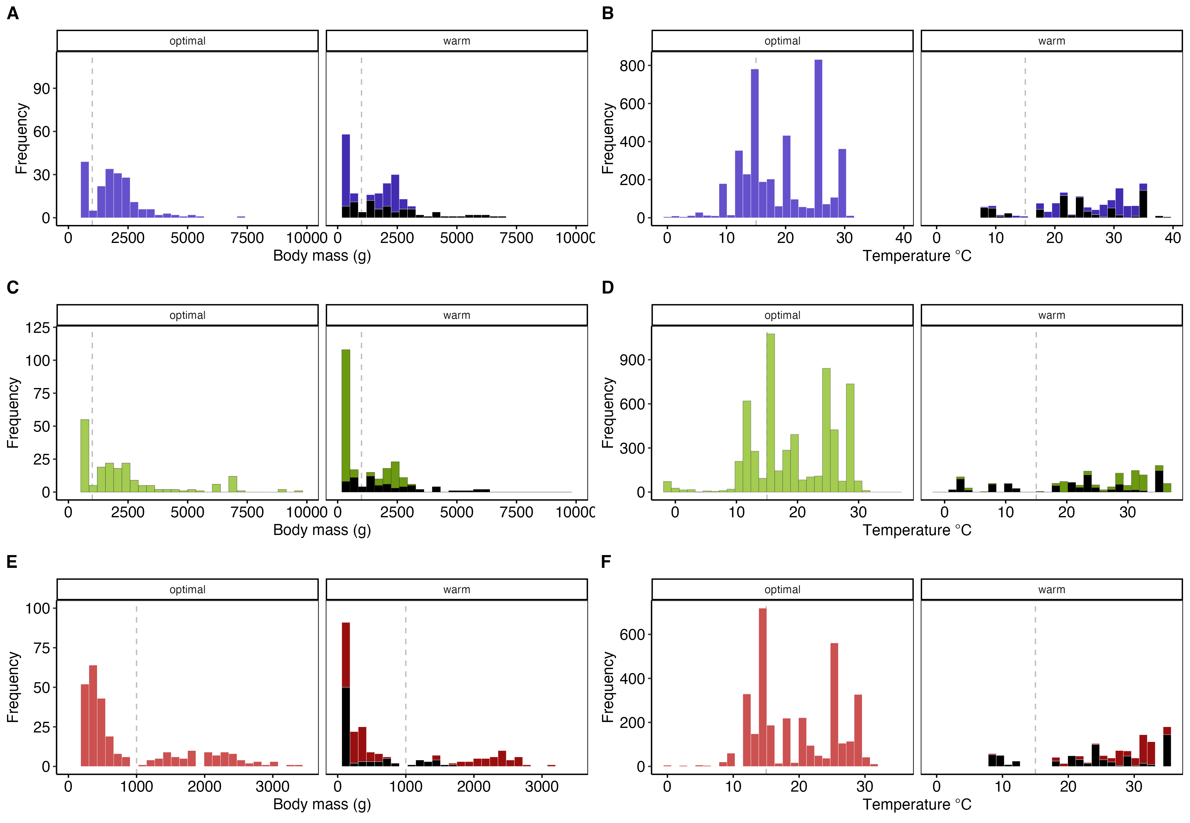

Figure S1. Histograms of body size (A, C, E) and temperature (B, D, F) for maximum metabolic rates (MMR; A,B), resting metabolic rate (RMR; C,D), and aerobic scopes (FAS and AS; E, F). Black bars are fish exposed to supra-optimal (warm) temperatures acutely. The dashed vertical lines show body mass at 1000 g (1kg), and 15ºC.
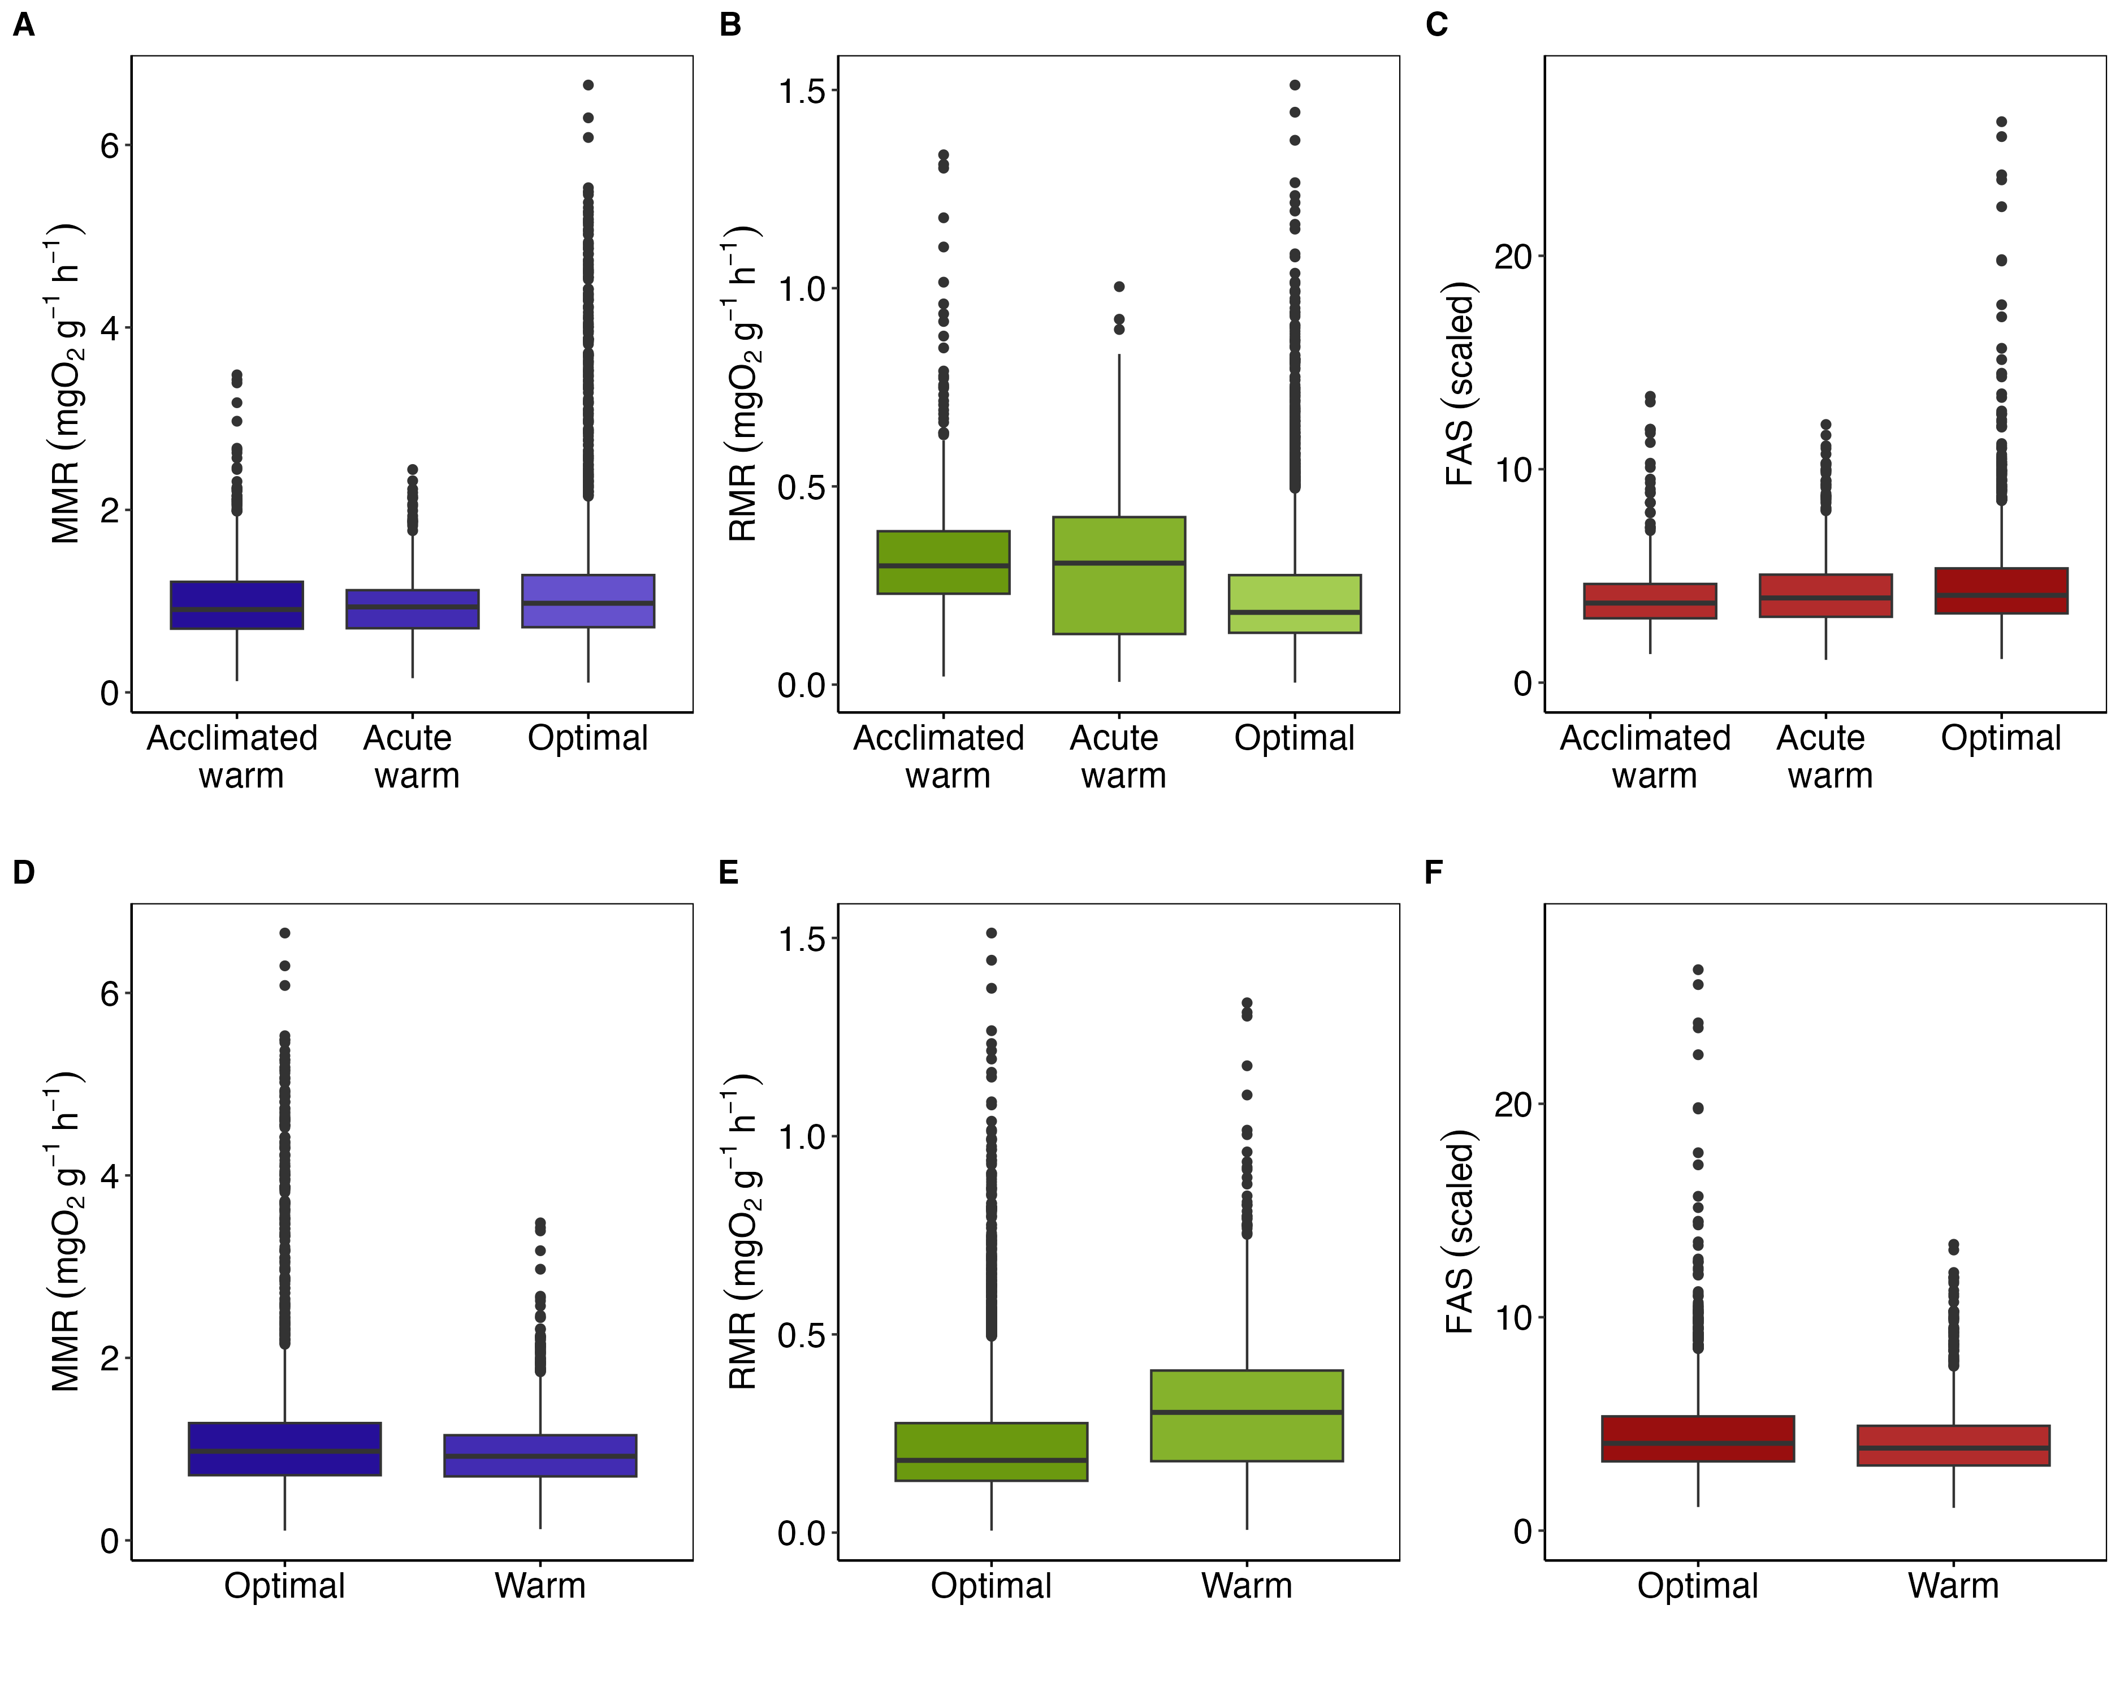

Figure S2. Comparison of mass-specific individual aerobic performances in warm temperatures (acute and acclimated exposures separated in top panels). Maximum metabolic rates (MMR; panels A,D), resting metabolic rate (RMR; B, E), factorial aerobic scopes (FAS; C, F). The values were mass-corrected using scaling exponents from the best fish global scaling models. FAS is not mass corrected.
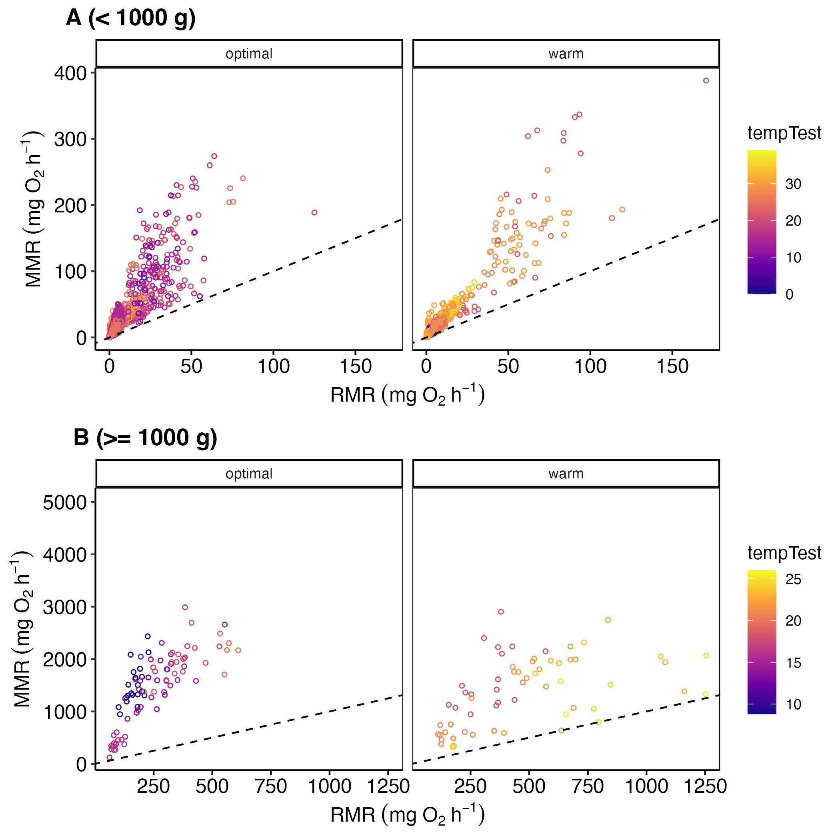

Figure S3. Correlation between resting metabolic rate (RMR) and maximum metabolic rate (MMR). The panels are divided by fish body size to improve visual quality. The dots on in diamond are Somniosus microcephalus, the largest species in the dataset.
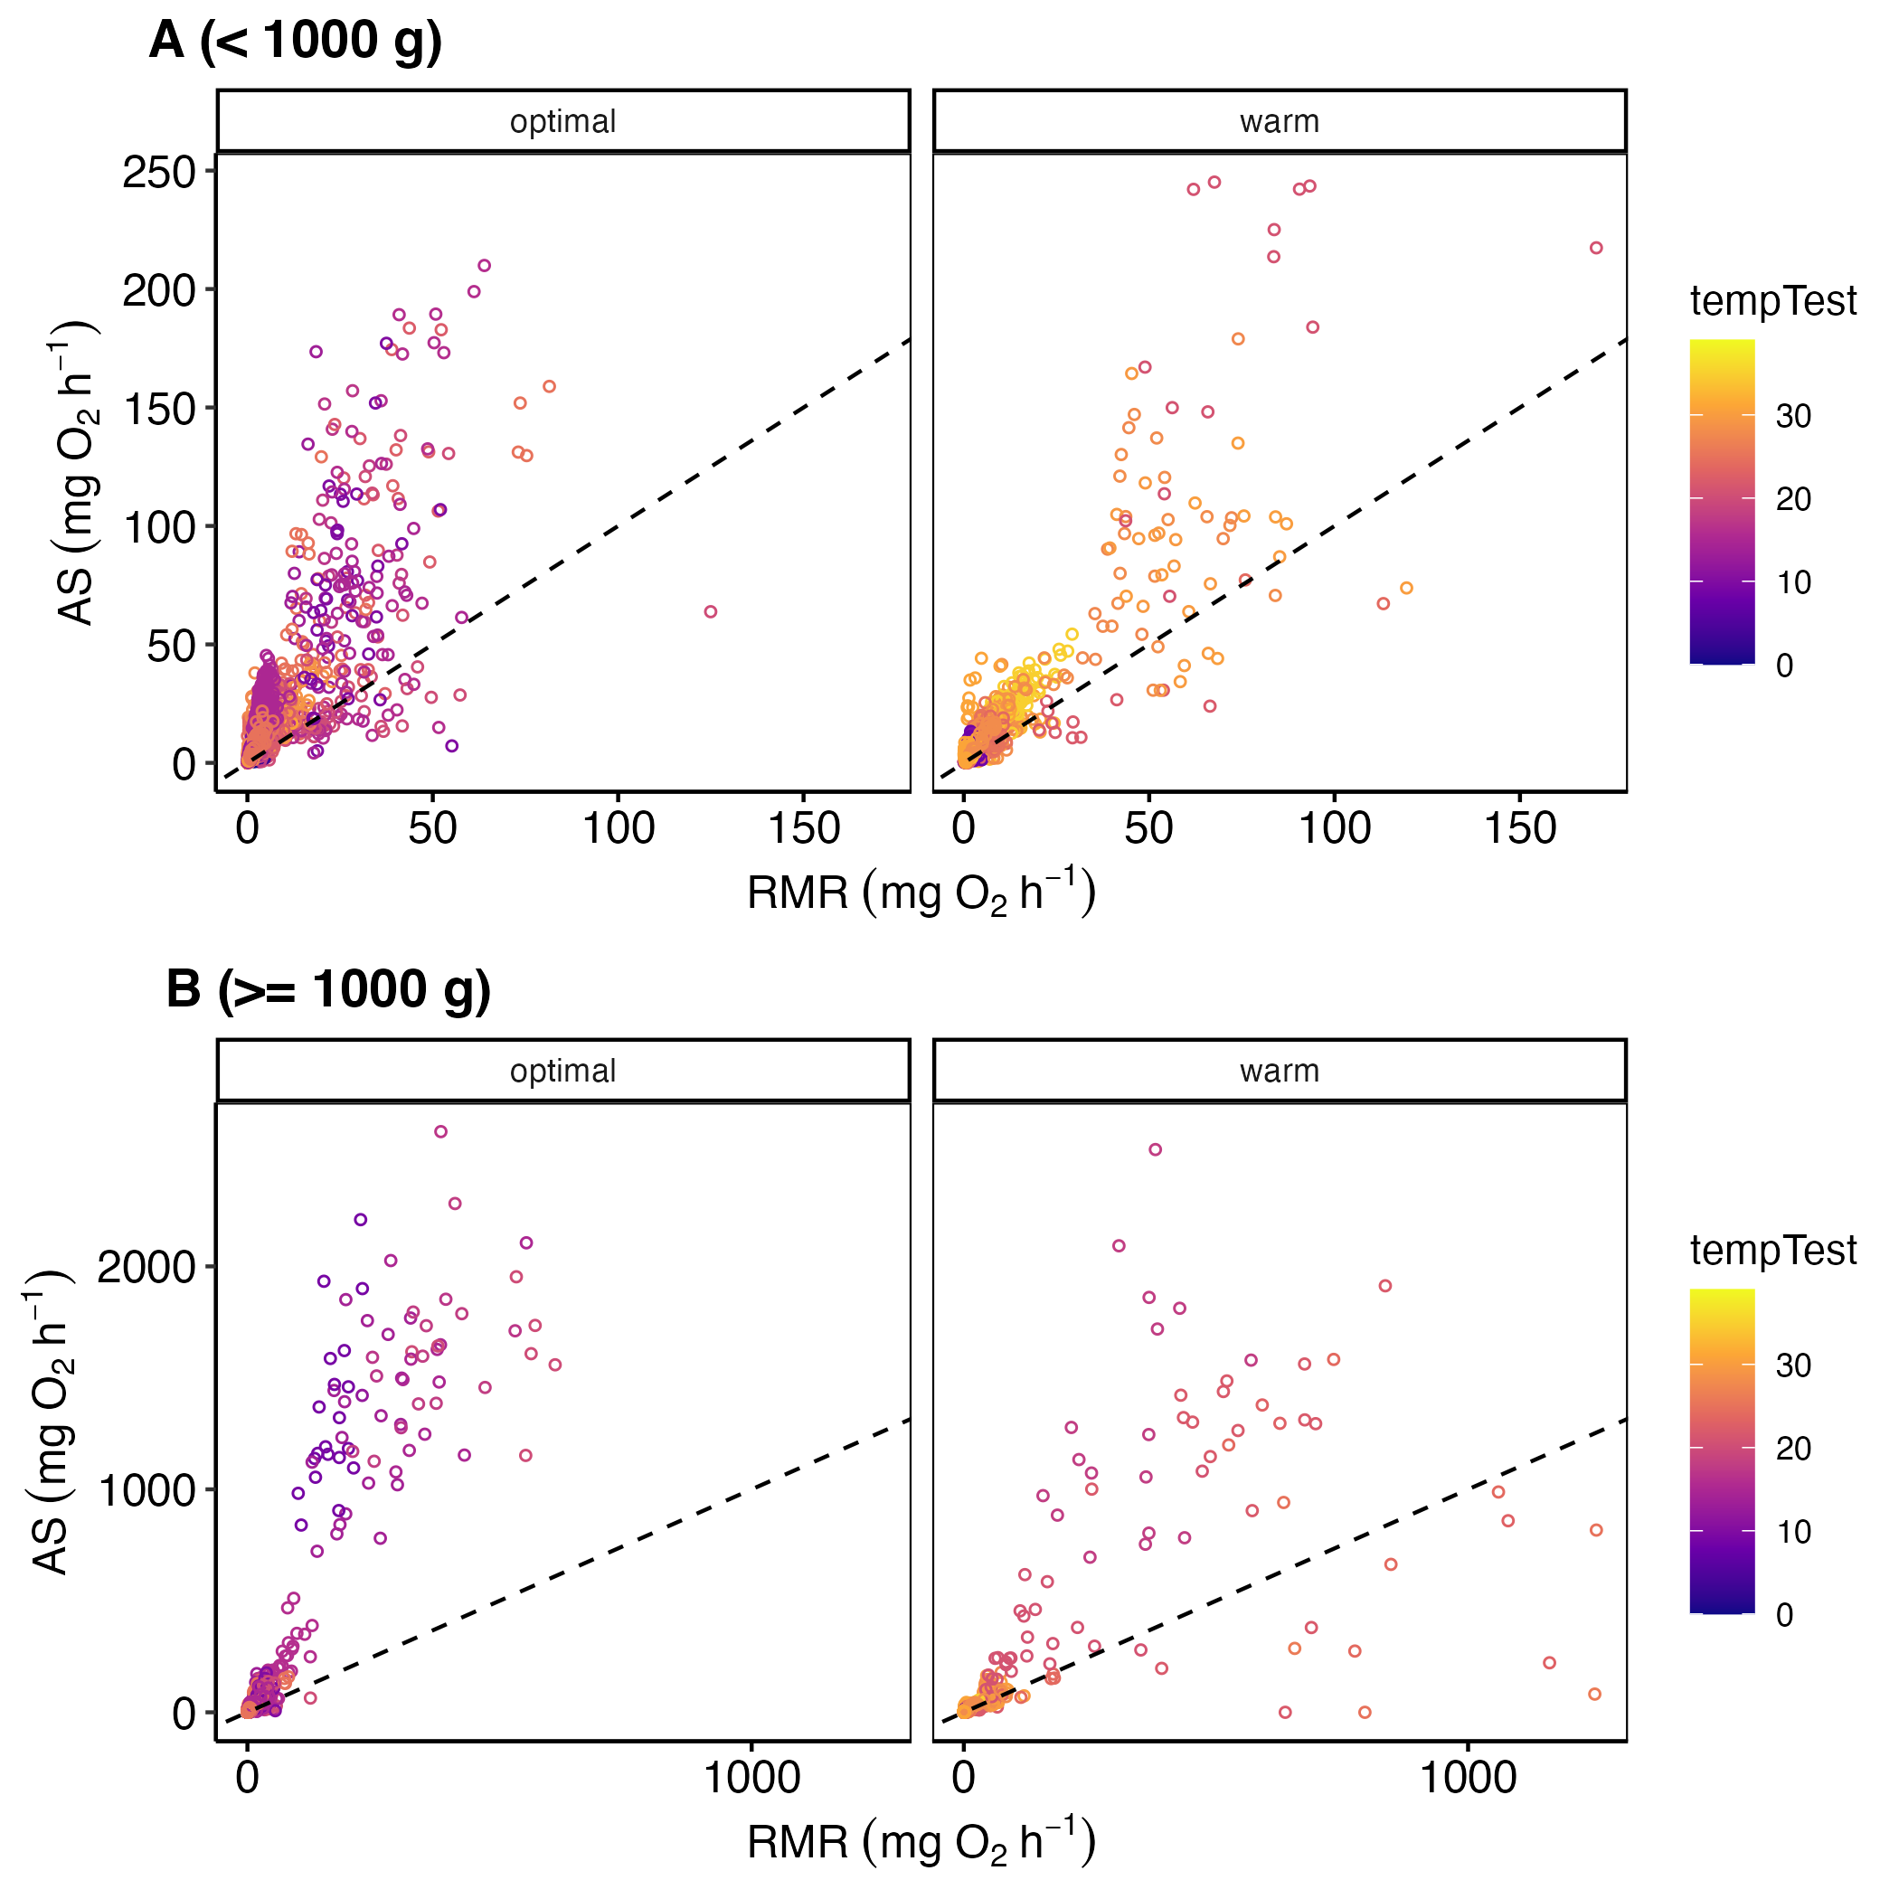

Figure S4. Correlation between resting metabolic rate (RMR) and aerobic scope (AS). The panels are divided by fish body size to improve visual quality. The dots on in diamond are Somniosus microcephalus, the largest species in the dataset.
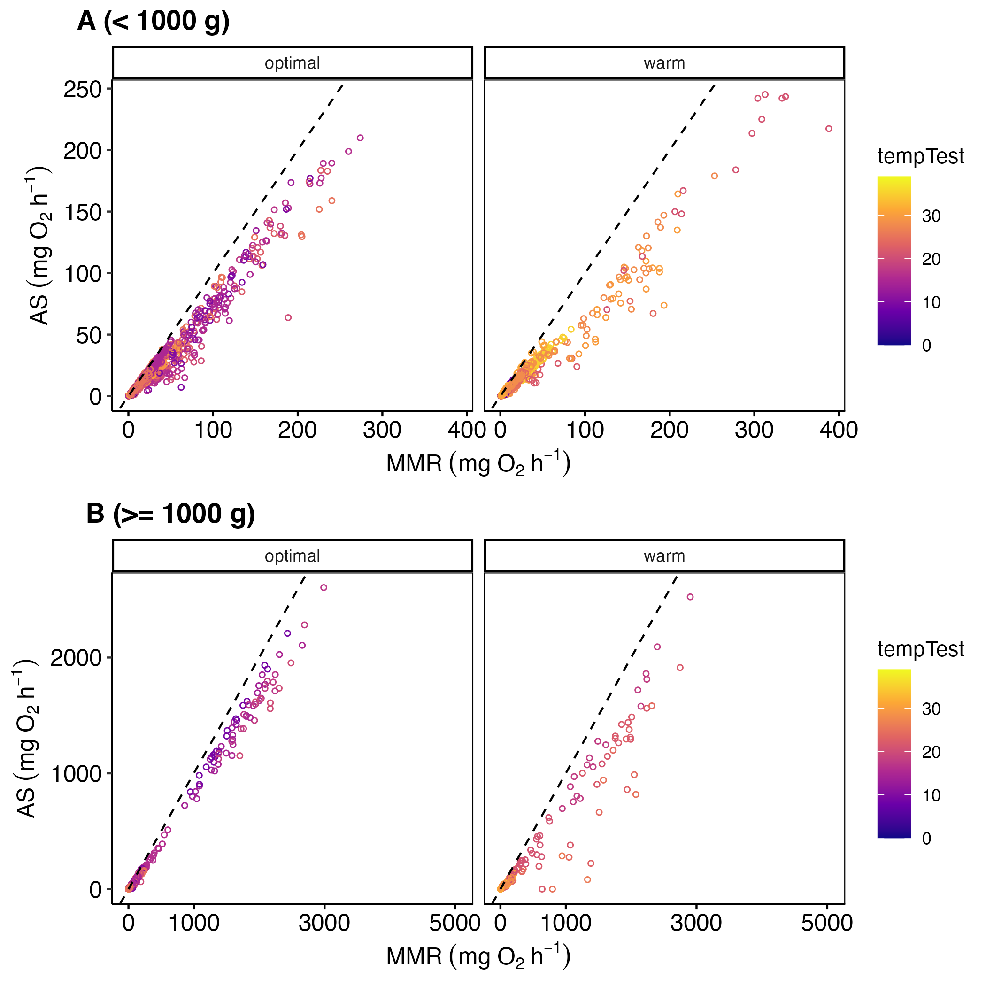

Figure S5. Correlation between maximum metabolic rate (MMR) and aerobic scope (AS). The panels are divided by fish body size to improve visual quality. The dots on in diamond are Somniosus microcephalus, the largest species in the dataset.

Species-specific scaling slopes
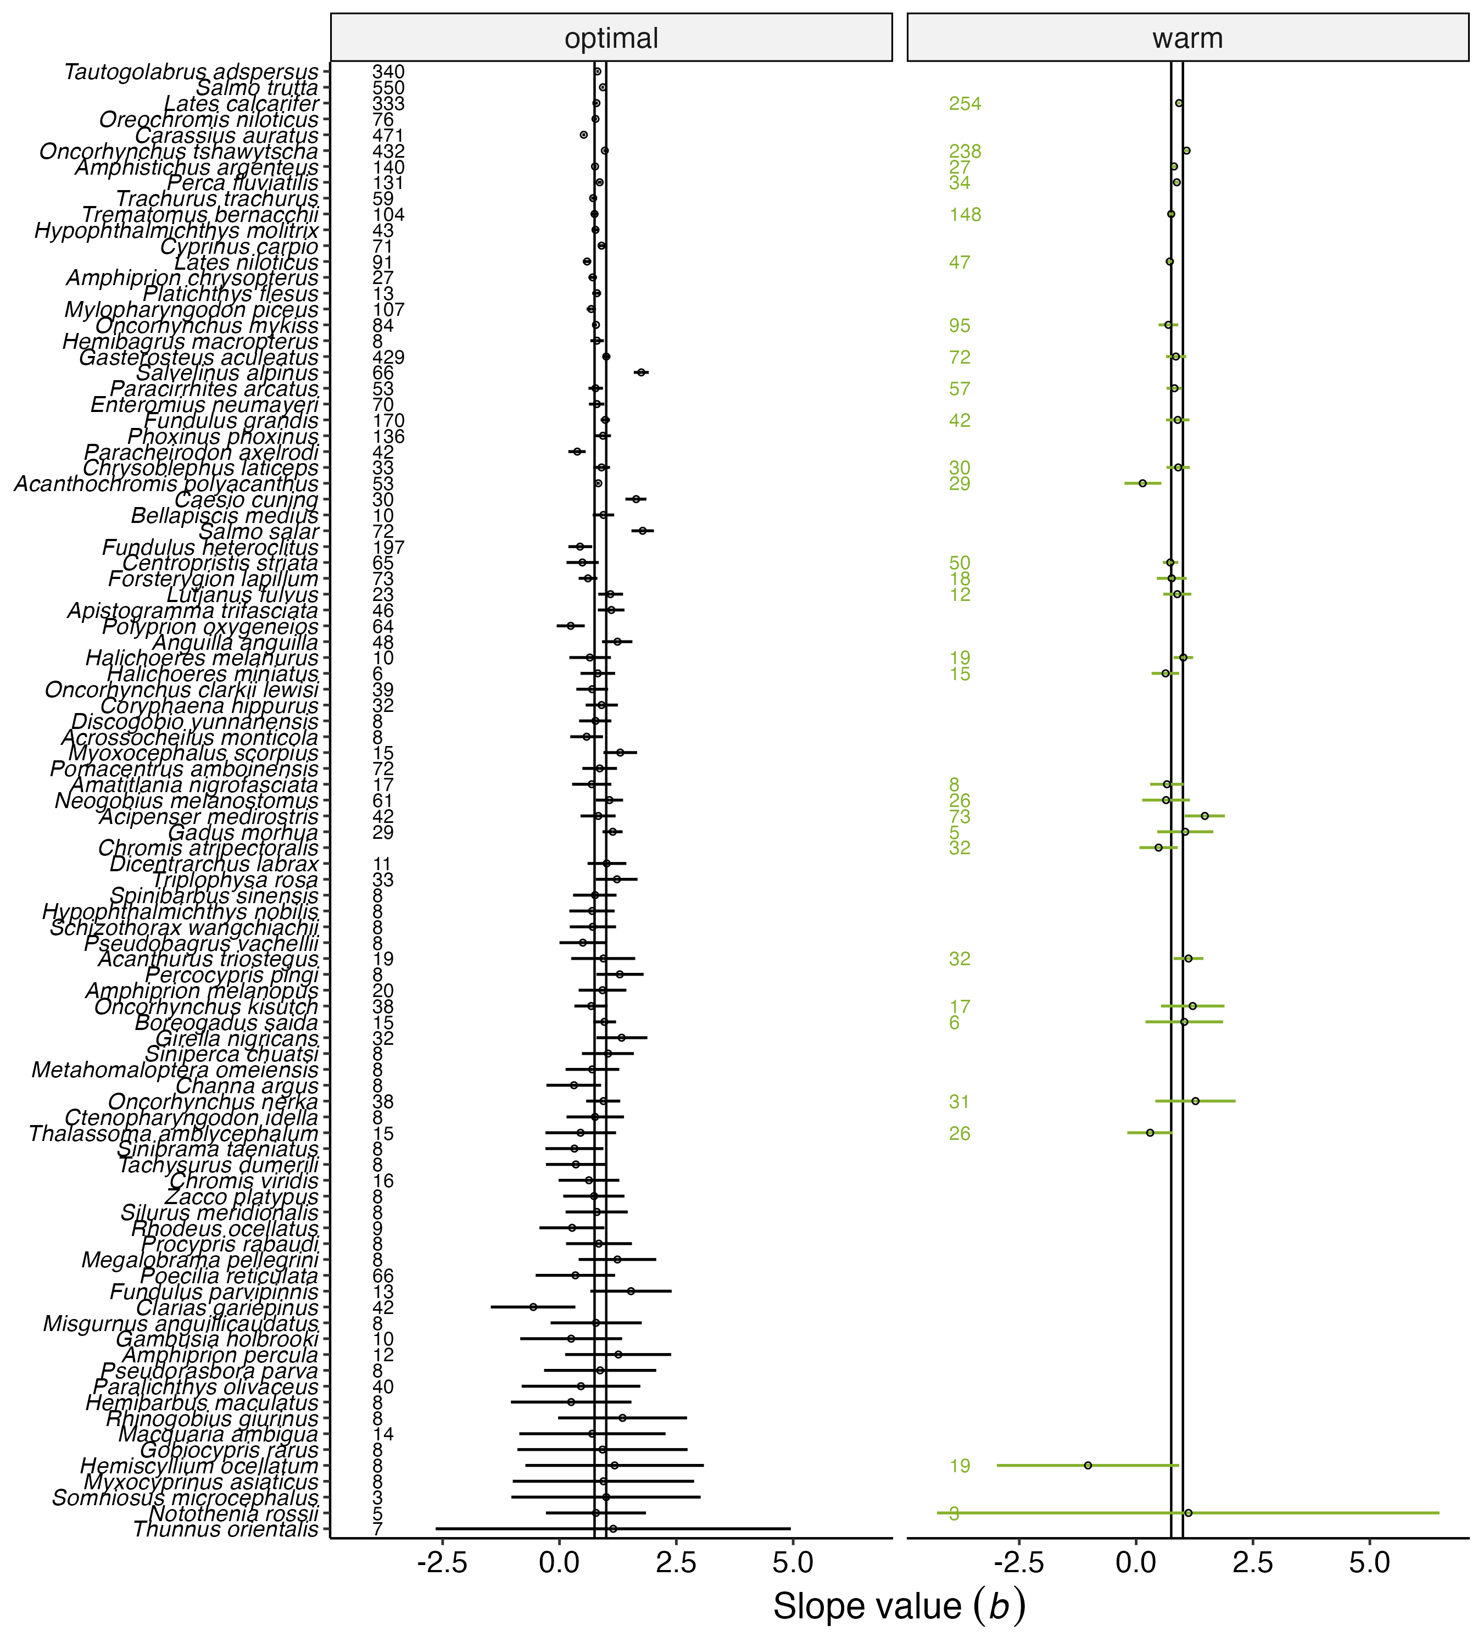

Figure S6.Species-specific scaling slope values (dots) of resting metabolic rates with its 95% confidence interval (CI, the error bar). All slopes were developed using simple linear models. The number in the panel is sample size and all species are ordered by the width of the confidence interval (top, smallest CI range; bottom = largest CI range).
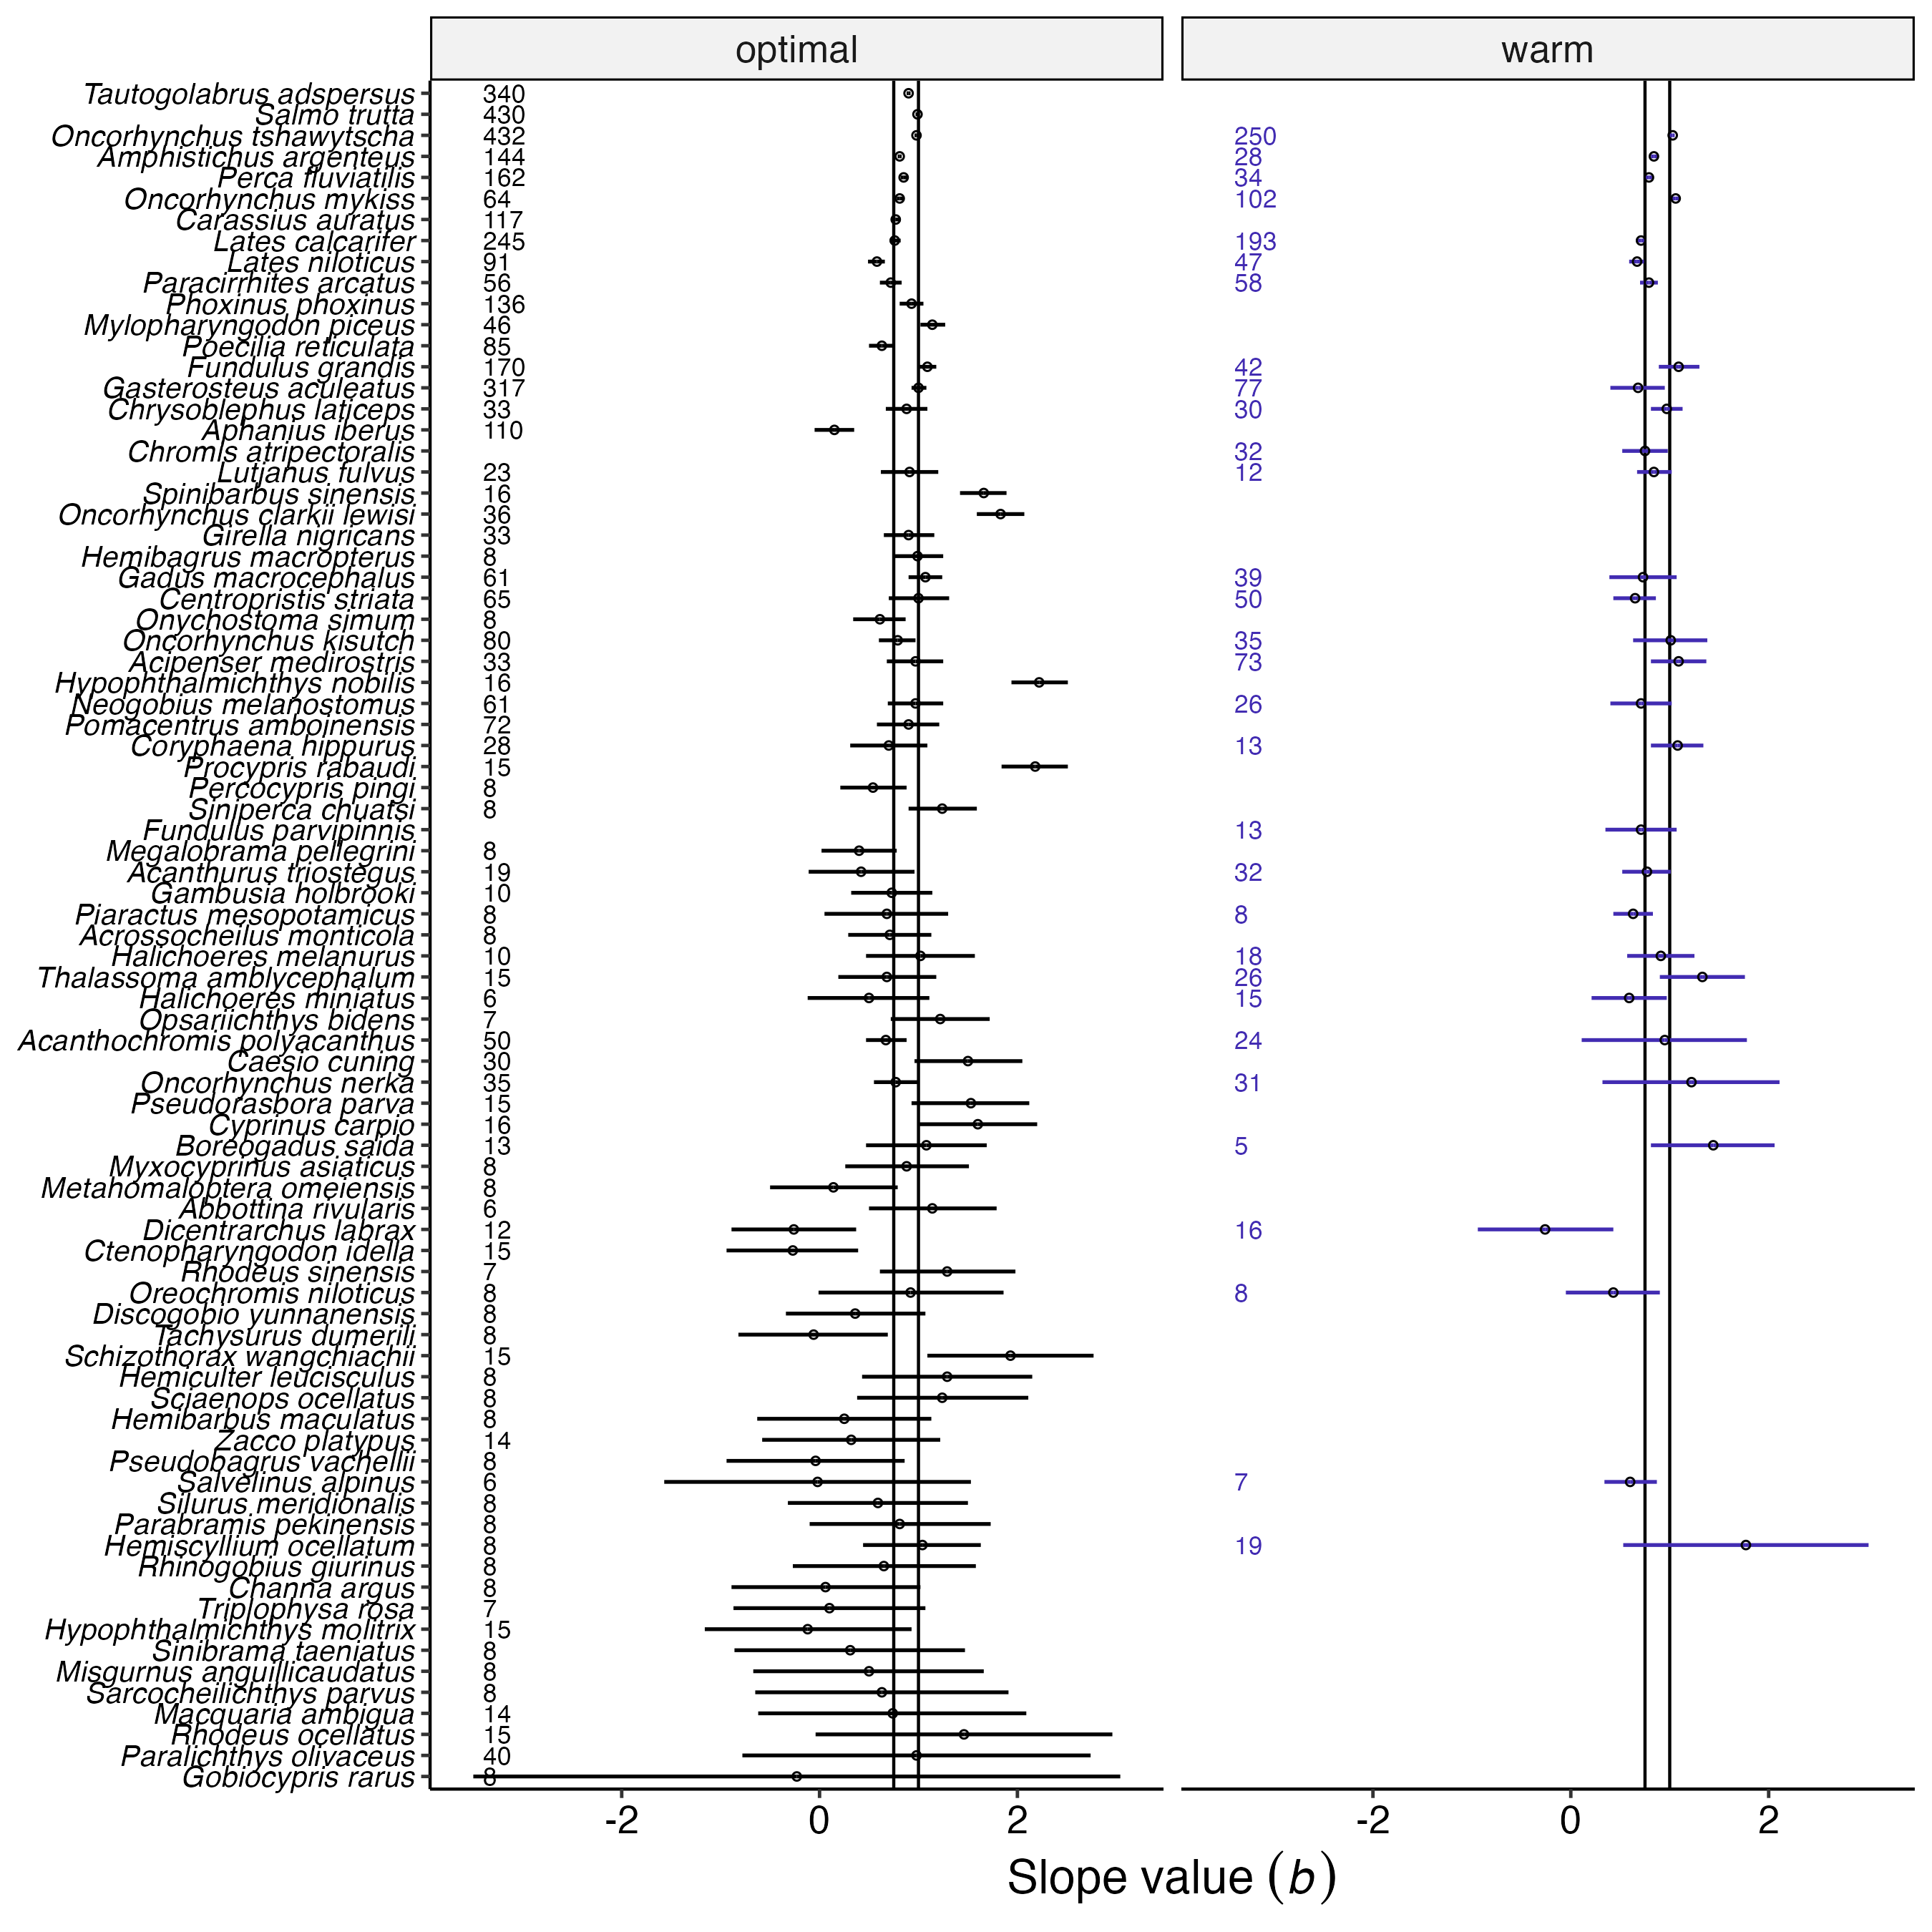

Figure S7. Species-specific scaling slope values (dots) of maximum metabolic rates with its 95% confidence interval (CI, the error bar). All slopes were developed using simple linear models. The number in the panel is sample size and all species are ordered by the width of the confidence interval (top, smallest CI range; bottom = largest CI range).
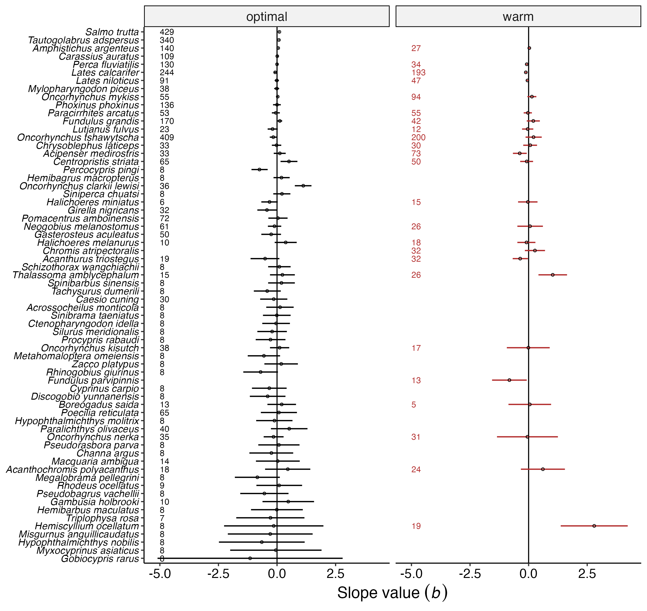

Figure S8. Species-specific scaling slope values (dots) of factorial aerobic scopes with its 95% confidence interval (CI, the error bar). All slopes were developed using simple linear models. The number in the panel is sample size and all species are ordered by the width of the confidence interval (top, smallest CI range; bottom = largest CI range).

Histograms of all scaling slopes
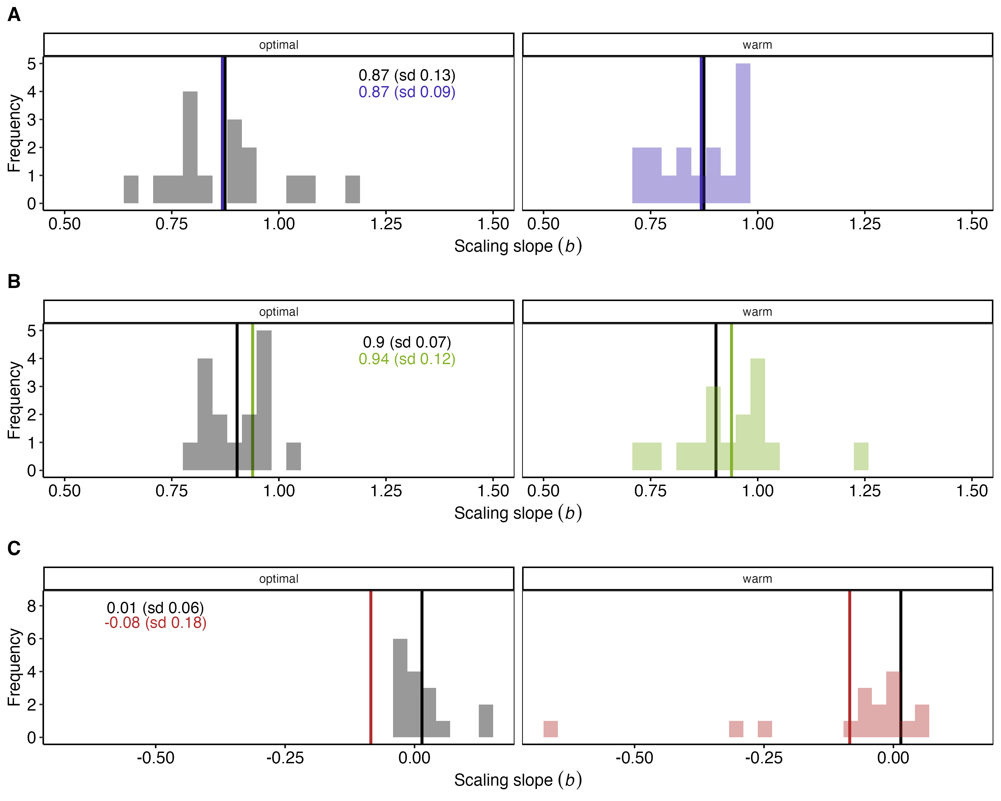

Figure S9. The histogram of all scaling slopes for fish grouped by their ecological and morphological characteristics.(A) Maximum metabolic rates, (B) resting metabolic rates, (C) factorial aerobic scopes. The vertical lines are the mean of all slopes for each temperature condition (optimal = grey-scale, and warm = colored).
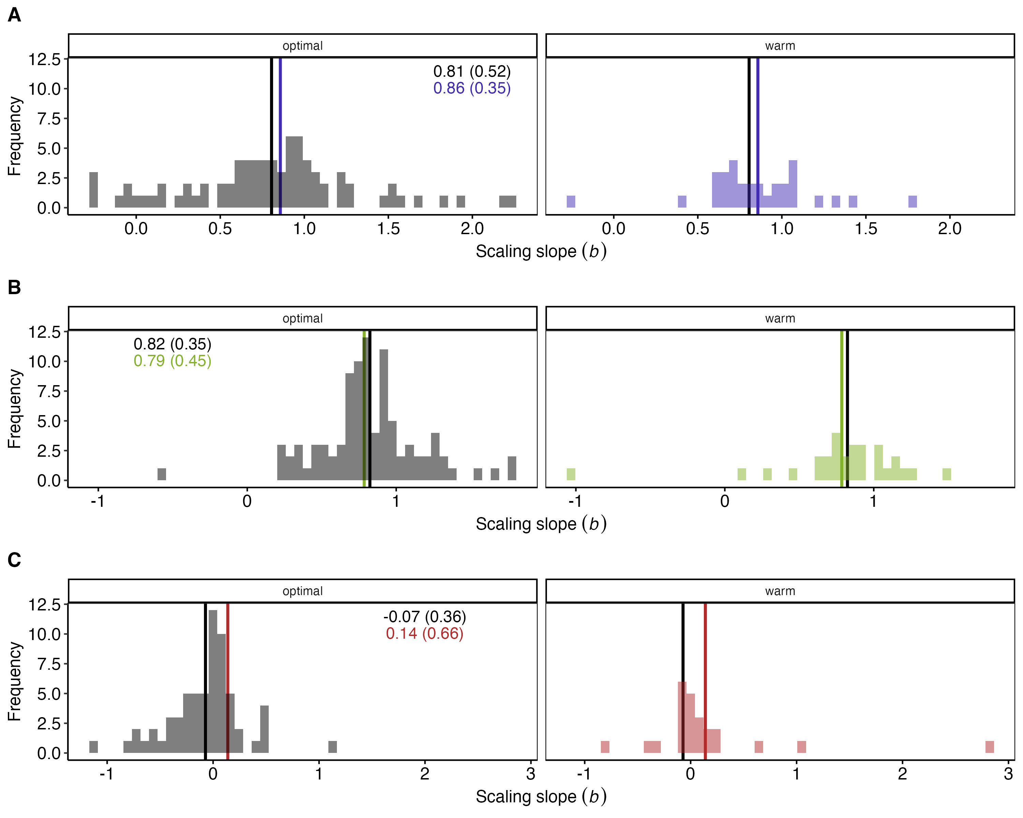

Figure S10. The histogram of all scaling slopes for all fish species included in the dataset. (A) Maximum metabolic rates, (B) resting metabolic rates, (C) factorial aerobic scopes. The vertical lines are the mean of all slopes for each temperature condition (optimal = grey-scale, and warm = colored).

Phylogenetic trees (Inter-specific global scaling models only)
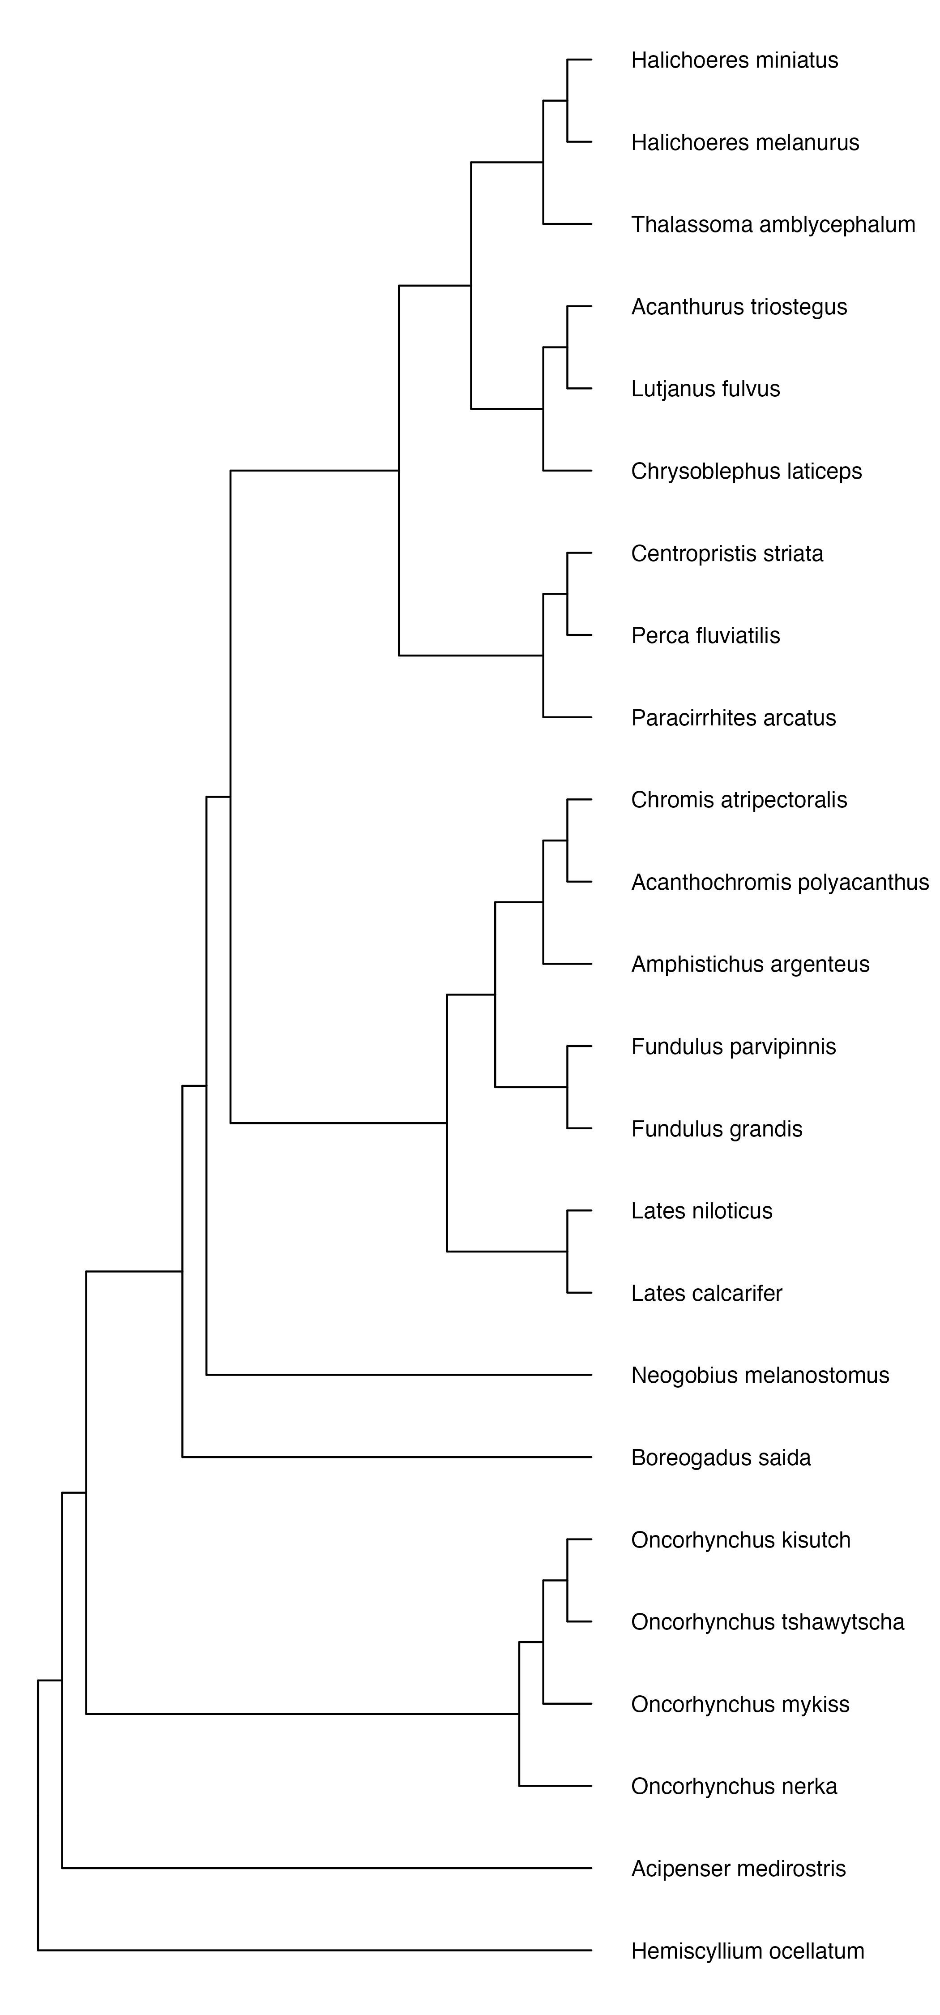

Figure S12.The phylogenetic tree representing species included in the dataset to analyze scaling relationships of factorial aerobic scopes (FAS) in warm temperatures.
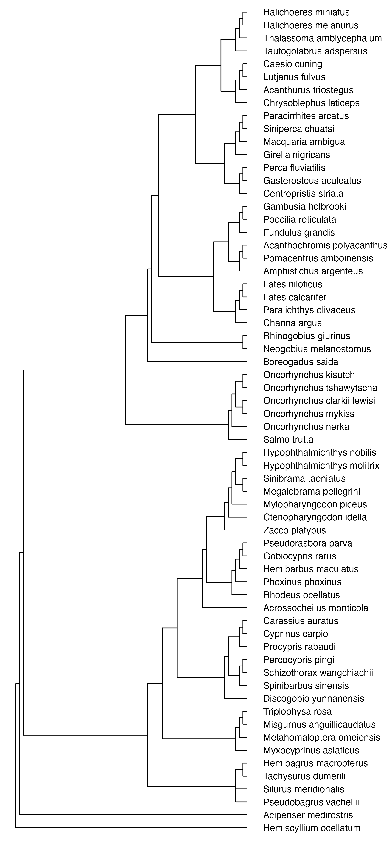

Figure S13. The phylogenetic tree representing species included in the dataset to analyze scaling relationships of factorial aerobic scopes (FAS) in optimal temperatures.


Figure S14. The phylogenetic tree representing species included in the dataset to analyze scaling relationships of aerobic scopes (AS) in warm temperatures.


Figure S15. The phylogenetic tree representing species included in the dataset to analyze scaling relationships of aerobic scopes (AS) in optimal temperatures.
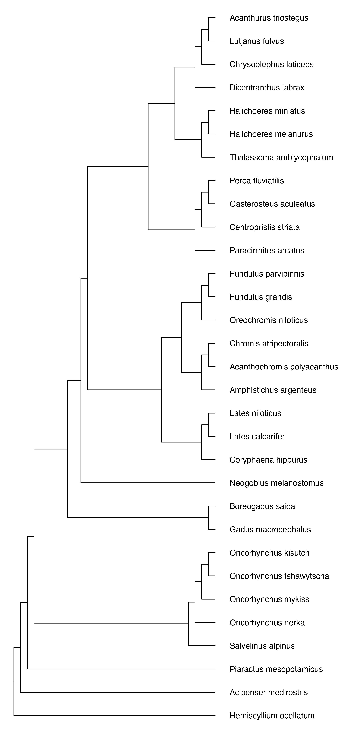

Figure S16. The phylogenetic tree representing species included in the dataset to analyze scaling relationships of maximum metabolic rates (MMR) in warm temperatures.
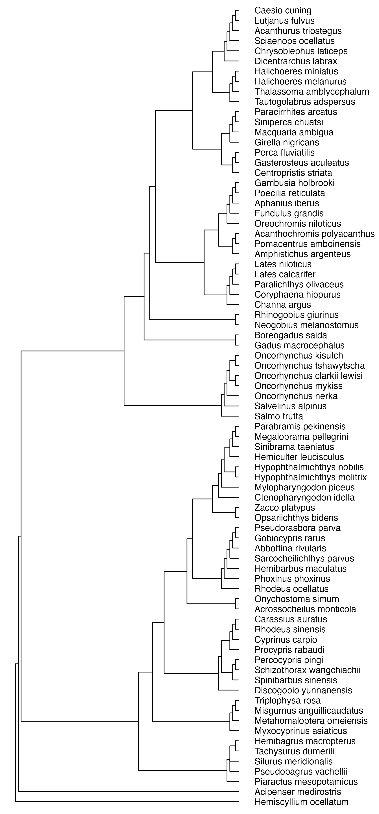

Figure S17. The phylogenetic tree representing species included in the dataset to analyze scaling relationships of maximum metabolic rates (MMR) in optimal temperatures.
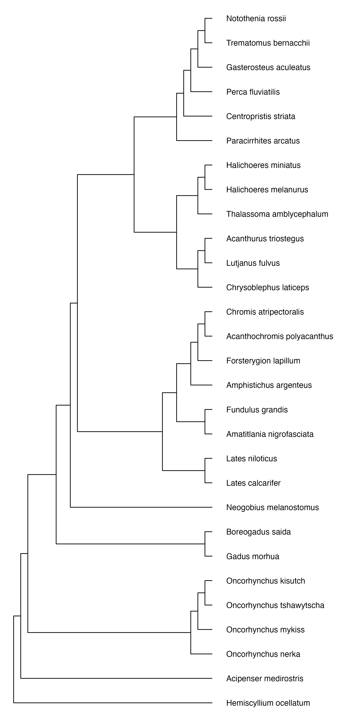

Figure S18. The phylogenetic tree representing species included in the dataset to analyze scaling relationships of resting metabolic rates (RMR) in warm temperatures.
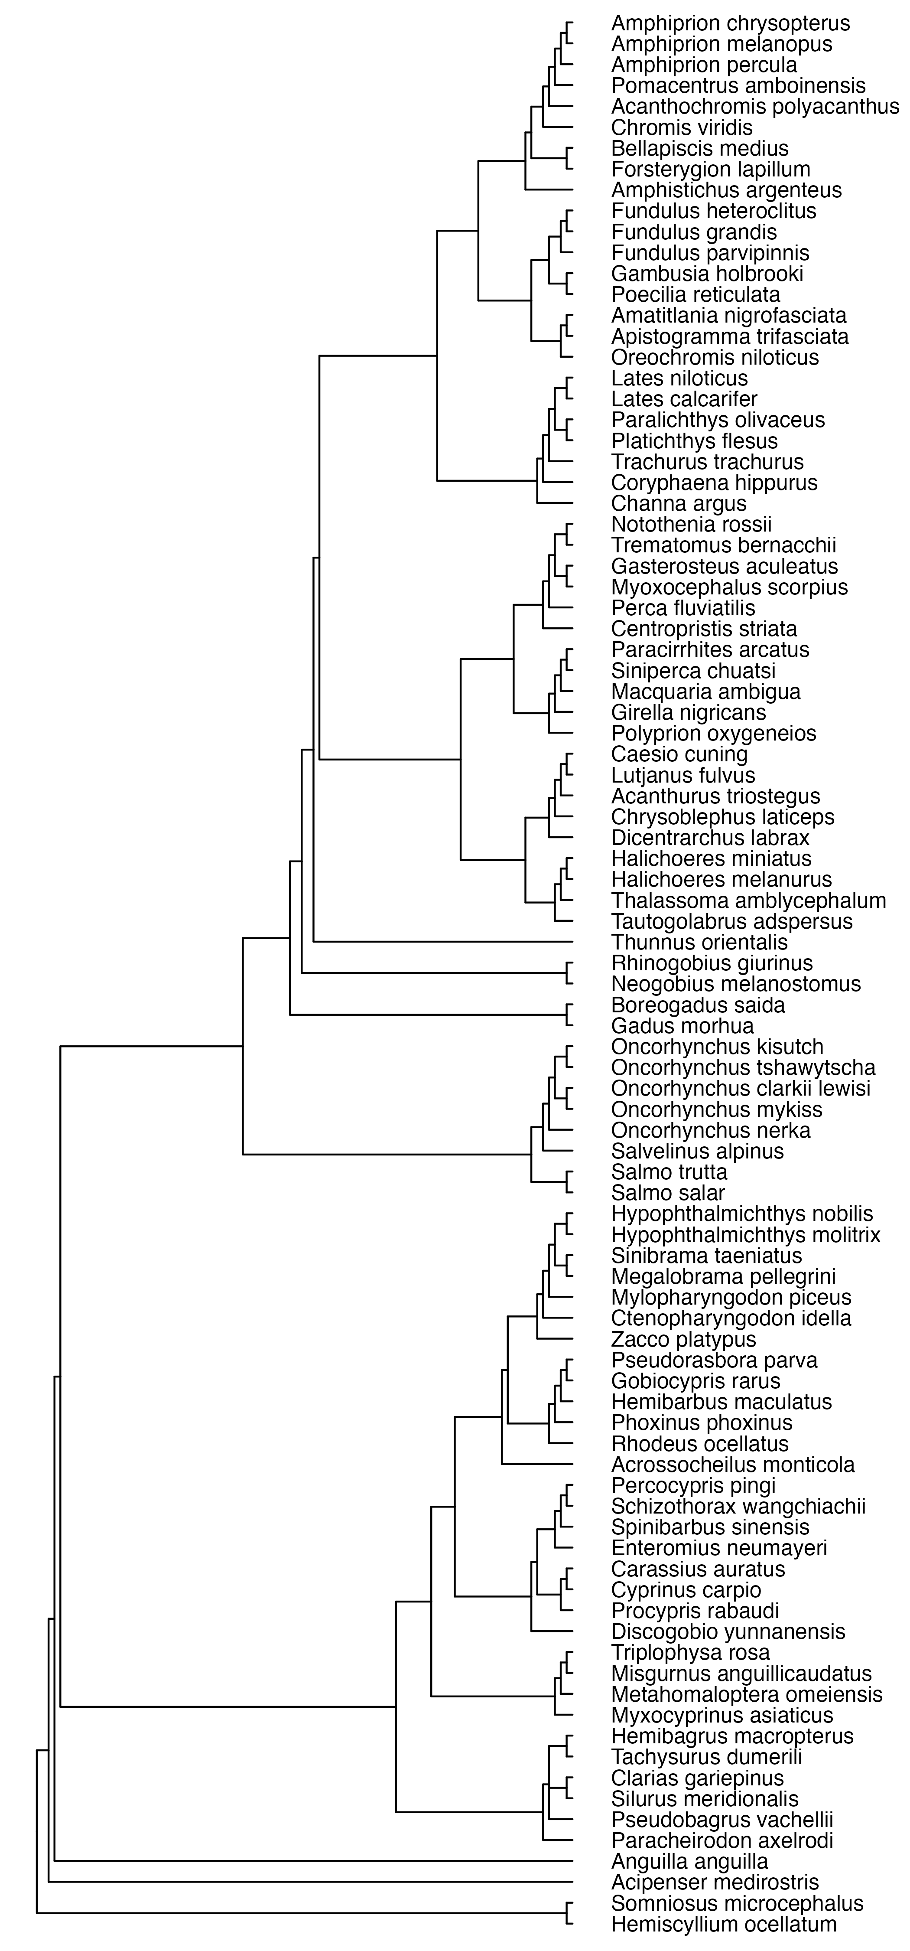

Figure S19. The phylogenetic tree representing species included in the dataset to analyze scaling relationships of resting metabolic rates (RMR) in optimal temperatures.

Detailed reference list of included studies
Ref ID | Full reference | MR terminology (assigned by the author) | MMR | RMR
2 | Auer SK, Salin K, Rudolf AM, Anderson GJ, Metcalfe NB. 2015 The optimal combination of standard metabolic rate and aerobic scope for somatic growth depends on food availability. Funct. Ecol. 29, 479–486. (doi:10.1111/1365-2435.12396) | SMR | - | Y
 | Data: Supplemental Material
3 | Behrens JW, van Deurs M, Christensen EAF. 2017 Evaluating dispersal potential of an invasive fish by the use of aerobic scope and osmoregulation capacity. PLOS ONE 12, e0176038. (doi:10.1371/journal.pone.0176038) | MMR/SMR | Y | Y
 | Data: Supplemental Material
73 | Blasco FR, Esbaugh AJ, Killen SS, Rantin FT, Taylor EW, McKenzie DJ. 2020 Using aerobic exercise to evaluate sub-lethal tolerance of acute warming in fishes. J. Exp. Biol. 223. (doi:10.1242/jeb.218602) | AMR | Y | -
 | Data: McKenzie, David (2020), Using aerobic exercise to evaluate sub-lethal tolerance of acute warming in fishes, Dryad, Dataset, https://doi.org/10.5061/dryad.cjsxksn2v
7 | Boldsen MM, Norin T, Malte H. 2013 Temporal repeatability of metabolic rate and the effect of organ mass and enzyme activity on metabolism in European eel (Anguilla anguilla). Comp. Biochem. Physiol. A. Mol. Integr. Physiol. 165, 22–29. (doi:10.1016/j.cbpa.2013.01.027) | SMR | - | Y
 | Data: Personally received
26 | Bonneaud C, Wilson RS, Seebacher F. 2016 Immune-Challenged Fish Up-Regulate Their Metabolic Scope to Support Locomotion. PLOS ONE 11, e0166028. (doi:10.1371/journal.pone.0166028) | Maximum and resting metabolic rates | Y | Y
 | Data: Bonneaud, Camille; Wilson, Robbie S.; Seebacher, Frank (2017), Data from: Immune-challenged fish up-regulate their metabolic scope to support locomotion, Dryad, Dataset, https://doi.org/10.5061/dryad.km3qd
43 | Chen Z, Farrell AP, Matala A, Narum SR. 2018 Mechanisms of thermal adaptation and evolutionary potential of conspecific populations to changing environments. Mol. Ecol. 27, 659–674. (doi:10.1111/mec.14475) | MMR/RMR | Y | Y
 | Data: Chen, Zhongqi; Farrell, Anthony P.; Matala, Amanda; Narum, Shawn R. (2017), Data from: Mechanisms of thermal adaptation and evolutionary potential of conspecific populations to changing environments, Dryad, Dataset, https://doi.org/10.5061/dryad.s04ng
56 | Christensen EAF, Stieglitz JD, Grosell M, Steffensen JF. 2019 Intra-Specific Difference in the Effect of Salinity on Physiological Performance in European Perch (Perca fluviatilis) and Its Ecological Importance for Fish in Estuaries. Biology 8, 1–17. (doi:10.3390/biology8040089) | MMR | Y | -
 | Data: [dataset] Christensen EAF (2018). Intra-Specific Difference in the Effect of Salinity on Physiological Performance in European Perch (Perca fluviatilis) and Its Ecological Importance for Fish in Estuaries., biostudies, V1. https://www.ebi.ac.uk/biostudies/studies/S-EPMC6956070.
70 | Christensen EAF, Svendsen MBS, Steffensen JF. 2020 The combined effect of body size and temperature on oxygen consumption rates and the size-dependency of preferred temperature in European perch Perca fluviatilis. J. Fish Biol. 97, 794–803. (doi:10.1111/jfb.14435) | MMR/SMR | Y | Y
 | Data: Supplemental material
10 | Collins GM, Clark TD, Carton AG. 2016 Physiological plasticity v. inter-population variability: understanding drivers of hypoxia tolerance in a tropical estuarine fish. Mar. Freshw. Res. 67, 1575. (doi:10.1071/MF15046) | Resting MO₂ | - | Y
 | Data: Collins, G. (2017). Physiological plasticity vs.inter-population variability: understanding drivers of hypoxia tolerance in a tropical estuarine fish. James Cook University. (dataset). http://dx.doi.org/10.4225/28/58c62cb87ebfd
22 | Collins GM, Clark TD, Rummer JL, Carton AG. 2013 Hypoxia tolerance is conserved across genetically distinct sub-populations of an iconic, tropical Australian teleost (Lates calcarifer). Conserv Physiol 1. (doi:10.1093/conphys/cot029) | Resting MO₂ | - | Y
 | Data: Collins, Geoffrey (2017): Hypoxia tolerance is conserved across genetically-distinct sub-populations of an iconic, tropical Australian teleost (Lates calcarifer). James Cook University. https://doi.org/10.4225/28/58be1a4623491
15 | Cooper B, Adriaenssens B, Killen SS. 2018 Individual variation in the compromise between social group membership and exposure to preferred temperatures. Proc. R. Soc. B Biol. Sci. 285, 20180884. (doi:10.1098/rspb.2018.0884) | MMR/SMR | Y | Y
 | Data: Killen, Shaun; Cooper, Ben; Adriaenssens, Bart (2018), “Data for Cooper et al.”, Mendeley Data, V1, doi: 10.17632/34npwr97vn.1
60 | Eliason EJ et al. 2011 Differences in Thermal Tolerance Among Sockeye Salmon Populations. Science 332, 109–112. (doi:10.1126/science.1199158) | MAX/MIN O2 cons | Y | Y
 | Data: Personal data
18 | Eliason EJ, Higgs DA, Farrell AP. 2007 Effect of isoenergetic diets with different protein and lipid content on the growth performance and heat increment of rainbow trout. Aquaculture 272, 723–736. (doi:10.1016/j.aquaculture.2007.09.006) | SMR | - | Y
 | Data: Personal data
27 | Hess S, Prescott LJ, Hoey AS, McMahon SA, Wenger AS, Rummer JL. 2017 Species-specific impacts of suspended sediments on gill structure and function in coral reef fishes. Proc. R. Soc. B Biol. Sci. 284, 20171279. (doi:10.1098/rspb.2017.1279) | MO₂ rest | - | Y
 | Data: Hess, S. (2017). Species-specific impacts of suspended sediments on gill structure and function in coral reef fishes. James Cook University. (dataset). http://dx.doi.org/10.4225/28/59364b00c5bce
31 | Hooker OE, Leeuwen TEV, Adams CE. 2017 The physiological costs of prey switching reinforce foraging specialization. J. Anim. Ecol. 86, 605–614. (doi:10.1111/1365-2656.12632) | SMR | - | Y
 | Data: Hooker, Oliver E.; Van Leeuwen, Travis E.; Adams, Colin E. (2017), Data from: The physiological costs of prey switching reinforce foraging specialization, Dryad, Dataset, https://doi.org/10.5061/dryad.v65m0
42 | Huang Q, Zhang Y, Liu S, Wang W, Luo Y. 2013 Intraspecific Scaling of the Resting and Maximum Metabolic Rates of the Crucian Carp (Carassius auratus). PLoS ONE 8, e82837. (doi:10.1371/journal.pone.0082837) | MMR/RMR | Y | Y
 | Data: Huang, Qingda et al. (2014), Data from: Intraspecific scaling of the resting and maximum metabolic rates of the crucian carp (Carassius auratus), Dryad, Dataset, https://doi.org/10.5061/dryad.cr3p
71 | Huang Y, Fu S, Cooke SJ, Xia J. 2020 Is repeatability of metabolic rate influenced by social separation? A test with a teleost fish. Biol. Lett. 16, 20190825. (doi:10.1098/rsbl.2019.0825) | RMR | - | Y
 | Data: Yan, Huang; Fu, Shijian; Cooke, Steven; Xia, Jigang (2020), Data from: Is repeatability of metabolic rate influenced by social separation? a test with a teleost fish, Dryad, Dataset, https://doi.org/10.5061/dryad.n2z34tmsr
11 | Khan JR, Pether S, Bruce M, Walker SP, Herbert NA. 2014 Optimum temperatures for growth and feed conversion in cultured hapuku (Polyprion oxygeneios) — Is there a link to aerobic metabolic scope and final temperature preference? Aquaculture 430, 107–113. (doi:10.1016/j.aquaculture.2014.03.046) | SMR | - | Y
 | Data: Personally received
14 | Khan JR, Pether S, Bruce M, Walker SP, Herbert NA. 2015 The effect of temperature and ration size on specific dynamic action and production performance in juvenile hapuku (Polyprion oxygeneios). Aquaculture 437, 67–74. (doi:10.1016/j.aquaculture.2014.11.024) | SMR | - | Y
 | Data: Personally received
13 | Khan JR, Johansen D, Skov PV. 2018 The effects of acute and long-term exposure to CO2 on the respiratory physiology and production performance of Atlantic salmon (Salmo salar) in freshwater. Aquaculture 491, 20–27. (doi:10.1016/j.aquaculture.2018.03.010) | SMR | - | Y
 | Data: Personally received
55 | Killen SS, Croft DP, Salin K, Darden SK. 2016 Male sexually coercive behaviour drives increased swimming efficiency in female guppies. Functional Ecology 30, 576–583. (doi:https://doi.org/10.1111/1365-2435.12527) | MMR | Y | -
 | Data: Killen, Shaun S.; Croft, Darren P.; Salin, Karine; Darden, Safi K. (2016), Data from: Male sexually coercive behaviour drives increased swimming efficiency in female guppies, Dryad, Dataset, https://doi.org/10.5061/dryad.vh8v4
28 | Killen SS, Mitchell MD, Rummer JL, Chivers DP, Ferrari MCO, Meekan MG, McCormick MI. 2014 Aerobic scope predicts dominance during early life in a tropical damselfish. Funct. Ecol. 28, 1367–1376. (doi:10.1111/1365-2435.12296) | MMR/RMR | Y | Y
 | Data: Killen, Shaun S. et al. (2015), Data from: Aerobic scope predicts dominance during early life in a tropical damselfish, Dryad, Dataset, https://doi.org/10.5061/dryad.7gc05
4 | Killen SS. 2014 Growth trajectory influences temperature preference in fish through an effect on metabolic rate. J. Anim. Ecol. 83, 1513–1522. (doi:10.1111/1365-2656.12244) | MMR/SMR | Y | Y
 | Data: Killen, Shaun S. et al. (2015), Data from: Aerobic scope predicts dominance during early life in a tropical damselfish, Dryad, Dataset, https://doi.org/10.5061/dryad.7gc05
8 | Kunz KL et al. 2016 New encounters in Arctic waters: a comparison of metabolism and performance of polar cod (Boreogadus saida) and Atlantic cod (Gadus morhua) under ocean acidification and warming. Polar Biol. 39, 1137–1153. (doi:10.1007/s00300-016-1932-z) | Standard metabolic rate (MO₂) | - | Y
 | Data: Kunz, Kristina Lore; Frickenhaus, Stephan; Hardenberg, Silvia; Torild, Johansen; Leo, Elettra; Pörtner, Hans-Otto; Schmidt, Matthias; Windisch, Heidrun Sigrid; Knust, Rainer; Mark, Felix Christopher (2016): New encounters in Arctic waters: a comparison of metabolism and performance of polar cod (Boreogadus saida) and Atlantic cod (Gadus morhua) under ocean acidification and warming. PANGAEA, https://doi.org/10.1594/PANGAEA.870468
8 | Kunz KL, Claireaux G, Pörtner H-O, Knust R, Mark FC. 2018 Aerobic capacities and swimming performance of polar cod (Boreogadus saida) under ocean acidification and warming conditions. Journal of Experimental Biology 221: jeb184473. (doi:10.1242/jeb.184473) | MMR | Y | -
 | Data: Kunz, Kristina Lore; Claireaux, Guy; Pörtner, Hans-Otto; Knust, Rainer; Mark, Felix Christopher (2018): Swimming and respiration data of Polar cod (Boreogadus saida) under ocean acidification and warming conditions. Alfred Wegener Institute, Helmholtz Centre for Polar and Marine Research, Bremerhaven, PANGAEA, https://doi.org/10.1594/PANGAEA.889445
16 | McArley TJ, Hickey AJR, Herbert NA. 2017 Chronic warm exposure impairs growth performance and reduces thermal safety margins in the common triplefin fish (Forsterygion lapillum). J. Exp. Biol. 220, 3527–3535. (doi:10.1242/jeb.162099) | SMR | - | Y
 | Data: Personally received
17 | McArley TJ, Hickey AJR, Herbert NA. 2018 Hyperoxia increases maximum oxygen consumption and aerobic scope of intertidal fish facing acutely high temperatures. J. Exp. Biol., jeb.189993. (doi:10.1242/jeb.189993) | SMR | - | Y
 | Data: Personally received
6 | McLean S, Persson A, Norin T, Killen SS. 2018 Metabolic Costs of Feeding Predictively Alter the Spatial Distribution of Individuals in Fish Schools. Curr. Biol. 28, 1144–1149. (doi:https://doi.org/10.1016/j.cub.2018.02.043) | MMR/SMR | Y | Y
 | Data: Killen, Shaun; McLean, Stephanie; Persson, Anna; Norin, Tommy (2018), “Data for McLean et al Metabolic costs of feeding predictively alter the spatial distribution of individuals in fish schools”, Mendeley Data, V1, doi: 10.17632/8g955t3r9g.1
30 | Morozov S, Leinonen T, Merilä J, McCairns RJS. 2018 Selection on the morphology–physiology-performance nexus: Lessons from freshwater stickleback morphs. Ecol. Evol. 8, 1286–1299. (doi:10.1002/ece3.3644) | SMR | - | Y
 | Data: Morozov, Sergey et al. (2018), Data from: Selection on the morphology-physiology-performance nexus: lessons from freshwater stickleback morphs, Dryad, Dataset, https://doi.org/10.5061/dryad.73kb7
34 | Motson K, Donelson JM. 2017 Limited capacity for developmental thermal acclimation in three tropical wrasses. Coral Reefs 36, 609–621. (doi:10.1007/s00338-017-1546-0) | MO2 rest/MO2max | Y | Y
 | Data: Motson, K. (2017). Limited capacity for developmental thermal acclimation in three tropical wrasses. James Cook University. (dataset). http://dx.doi.org/10.4225/28/586c8ca7f09a5
21 | Nadler LE, Killen SS, McClure EC, Munday PL, McCormick MI. 2016 Shoaling reduces metabolic rate in a gregarious coral reef fish species. J. Exp. Biol. 219, 2802–2805. (doi:10.1242/jeb.139493) | MRmin | - | Y
 | Data: Nadler, L.; Killen, S.; McClure, E.; Munday, P.; McCormick, M. (2016). Shoaling reduces metabolic rate in a gregarious coral reef fish species. James Cook University. (dataset). http://dx.doi.org/10.4225/28/5745456AD6433
19 | Norin T, Malte H. 2011 Repeatability of standard metabolic rate, active metabolic rate and aerobic scope in young brown trout during a period of moderate food availability. J. Exp. Biol. 214, 1668–1675. (doi:10.1242/jeb.054205) | AMR/SMR | Y | Y
 | Data: Personally received
20 | Norin T, Malte H. 2012 Intraspecific Variation in Aerobic Metabolic Rate of Fish: Relations with Organ Size and Enzyme Activity in Brown Trout. Physiol. Biochem. Zool. 85, 645–656. (doi:10.1086/665982) | MMR/SMR | Y | Y
 | Data: Personally received
5 | Norin T, Clark TD. 2017 Fish face a trade-off between ‘eating big’ for growth efficiency and ‘eating small’ to retain aerobic capacity. Biology Letters 13, 20170298. (doi:10.1098/rsbl.2017.0298) | MO2max/MO2min | Y | Y
 | Data: Supplemental material
9 | Norin T, Malte H, Clark TD. 2016 Differential plasticity of metabolic rate phenotypes in a tropical fish facing environmental change. Funct. Ecol. 30, 369–378. (doi:10.1111/1365-2435.12503) | MMR/SMR | Y | Y
 | Data: Supplemental material
1 | Norin T, Gamperl AK. 2018 Metabolic scaling of individuals vs. populations: Evidence for variation in scaling exponents at different hierarchical levels. Funct. Ecol. 32, 379–388. (doi:10.1111/1365-2435.12996) | AMR/SMR | Y | Y
 | Data: Norin, Tommy; Gamperl, A. Kurt (2018), Data from: Metabolic scaling of individuals vs. populations: evidence for variation in scaling exponents at different hierarchical levels, Dryad, Dataset, https://doi.org/10.5061/dryad.fp32k
35 | Nyboer EA, Chapman LJ. 2017 Elevated temperature and acclimation time affect metabolic performance in the heavily exploited Nile perch of Lake Victoria. J. Exp. Biol. 220, 3782–3793. (doi:10.1242/jeb.163022) | MMR/SMR | Y | Y
 | Data: Nyboer, Elizabeth A.; Chapman, Lauren J. (2017), Data from: Elevated temperature and acclimation time affect metabolic performance in the heavily exploited Nile perch of Lake Victoria, Dryad, Dataset, https://doi.org/10.5061/dryad.2s590
33 | Nyboer EA, Chapman LJ. 2018 Cardiac plasticity influences aerobic performance and thermal tolerance in a tropical, freshwater fish at elevated temperatures. J. Exp. Biol. 221, jeb178087. (doi:10.1242/jeb.178087) | MMR/SMR | Y | Y
 | Data: Nyboer, Elizabeth A.; Chapman, Lauren J. (2018), Data from: Cardiac plasticity influences aerobic performance and thermal tolerance in a tropical, freshwater fish at elevated temperatures, Dryad, Dataset, https://doi.org/10.5061/dryad.2k527b8
54 | Pang X, Shao F, Ding S, Fu S, Zhang Y. 2020 Interspecific differences and ecological correlations of energy metabolism traits in freshwater fishes. Funct. Ecol. 34, 616–630. (doi:10.1111/1365-2435.13505) | MMR/RMR | Y | Y
 | Data: Fu, Shi-Jian et al. (2019), Interspecific differences and ecological correlations of energy metabolism traits in freshwater fishes, Dryad, Dataset, https://doi.org/10.5061/dryad.5mkkwh71w
72 | Pilakouta N, Killen SS, Kristjánsson BK, Skúlason S, Lindström J, Metcalfe NB, Parsons KJ. 2020 Multigenerational exposure to elevated temperatures leads to a reduction in standard metabolic rate in the wild. Funct. Ecol. 34, 1205–1214. (doi:10.1111/1365-2435.13538) | MMR/SMR | Y | Y
 | Data: Pilakouta, Natalie et al. (2020), Multigenerational exposure to elevated temperatures leads to a reduction in standard metabolic rate in the wild, Dryad, Dataset, https://doi.org/10.5061/dryad.rfj6q576x
38 | Rodgers GG, Rummer JL, Johnson LK, McCormick MI. 2019 Impacts of increased ocean temperatures on a low-latitude coral reef fish – Processes related to oxygen uptake and delivery. J. Therm. Biol. 79, 95–102. (doi:10.1016/j.jtherbio.2018.12.008) | MO2routine/MO2max | Y | Y
 | Data: Rodgers, G. (2018). Impacts of increased ocean temperatures on a low-latitude coral reef fish – processes related to oxygen uptake and delivery . James Cook University. (dataset). http://dx.doi.org/10.25903/5c0eff685e349
53 | Rupia EJ, Binning SA, Roche DG, Lu W. 2016 Fight-flight or freeze-hide? Personality and metabolic phenotype mediate physiological defense responses in flatfish. J. Anim. Ecol. 85, 927–937. (doi:10.1111/1365-2656.12524) | MMR/SMR | Y | Y
 | Data: Rupia, Emmanuel; Binning, Sandra; Roche, Dominique; Lu, Weiqun (2016): Fight-flight or freeze-hide? Personality and metabolic phenotype mediate physiological defense responses in a benthic fish. figshare. Dataset. https://doi.org/10.6084/m9.figshare.1365473.v7
41 | Sandersfeld T, Davison W, Lamare MD, Knust R, Richter C. 2015 Elevated temperature causes metabolic trade-offs at the whole-organism level in the Antarctic fish Trematomus bernacchii. J. Exp. Biol. 218, 2373–2381. (doi:10.1242/jeb.122804) | RMR | - | Y
 | Data: Supplemental material
75 | Ste-Marie E, Watanabe YY, Semmens JM, Marcoux M, Hussey NE. 2020 A first look at the metabolic rate of Greenland sharks (Somniosus microcephalus) in the Canadian Arctic. Sci. Rep. 10, 19297. (doi:10.1038/s41598-020-76371-0) | Resting routine MR | - | Y
 | Data: Supplemental material
36 | Strobel A, Bennecke S, Leo E, Mintenbeck K, Pörtner HO, Mark FC. 2012 Metabolic shifts in the Antarctic fish Notothenia rossii in response to rising temperature and PCO₂. Front. Zool. 9, 28. (doi:10.1186/1742-9994-9-28) | Routine metabolic rate | - | Y
 | Data: Strobel, Anneli; Bennecke, Swaantje; Leo, Elettra; Mintenbeck, Katja; Pörtner, Hans-Otto; Mark, Felix Christopher (2014): Experiment: Metabolic shifts in the Antarctic fish Notothenia rossii in response to rising temperature and PCO2. PANGAEA, https://doi.org/10.1594/PANGAEA.829830, Supplement to: Strobel, A et al. (2012): Metabolic shifts in the Antarctic fish Notothenia rossii in response to rising temperature and PCO2. Frontiers in Zoology, 9(1), 28, https://doi.org/10.1186/1742-9994-9-28
24 | Zhang Y, Timmerhaus G, Anttila K, Mauduit F, Jørgensen SM, Kristensen T, Claireaux G, Takle H, Farrell AP. 2016 Domestication compromises athleticism and respiratory plasticity in response to aerobic exercise training in Atlantic salmon (Salmo salar). Aquaculture 463, 79–88. (doi:10.1016/j.aquaculture.2016.05.015) | SMR | - | Y
 | Data: Personally received
23 | Zhang Y, Mauduit F, Farrell AP, Chabot D, Ollivier H, Rio-Cabello A, Le Floch S, Claireaux G. 2017 Exposure of European sea bass (Dicentrarchus labrax) to chemically dispersed oil has a chronic residual effect on hypoxia tolerance but not aerobic scope. Aquat. Toxicol. 191, 95–104. (doi:10.1016/j.aquatox.2017.07.020) | SMR | - | Y
 | Data: Personally received
51 | Pope EC et al. 2014 European sea bass, Dicentrarchus labrax, in a changing ocean. Biogeosciences 11, 2519–2530. (doi:https://doi.org/10.5194/bg-11-2519-2014) | MMR /RMR | Y | -
 | Data: Pope, E C; Ellis, Robert P; Scolamacchia, M; Scolding, J W S; Keay, A; Chingombe, P; Shields, R J; Wilcox, R; Speirs, Douglas C; Wilson, R W; Lewis, Ceri N; Flynn, K J (2014): European sea bass, Dicentrarchus labrax, in a changing ocean. PANGAEA, https://doi.org/10.1594/PANGAEA.835574
52 | Yan G-J, He X-K, Cao Z-D, Fu S-J. 2013 An interspecific comparison between morphology and swimming performance in cyprinids. J. Evol. Biol. 26, 1802–1815. (doi:10.1111/jeb.12182) | MMR | Y | -
 | Data: Yan, Guan-Jie et al. (2013), Data from: An interspecific comparison between morphology and swimming performance in cyprinids, Dryad, Dataset, https://doi.org/10.5061/dryad.vk820
62 | Van Wert, J. C., Hendriks, B., Ekström, A., Patterson, D. A., Cooke, S. J., Hinch, S. G., & Eliason, E. J. (2023). Population variability in thermal performance of pre-spawning adult Chinook salmon. Conservation Physiology, 11(1). https://doi.org/10.1093/conphys/coad022 | MMR/RMR | Y | Y
 | Data: Personally received
61 | Kraskura K*, Hardison EA*, Little AG, Dressler T, Prystay TS, Hendriks B, Farrell AP, Cooke SJ, Patterson DA, Hinch SG, and Eliason EJ. Sex-specific differences in swimming, aerobic metabolism, and recovery from exercise in adult coho salmon (Oncorhynchus kisutch) across ecologically relevant temperatures. Conservation Physiology. Volume 9: 10.1093/conphys/coab016 | MMR/RMR | Y | Y
 | Data: Personal data
203 | Auer, S.K., Salin, K., Rudolf, A.M., Anderson, G.J. & Metcalfe, N.B. 2016. Differential effects of food availability on minimum and maximum rates of metabolism. Biology Letters, 12, 20160586. | MMR/SMR | Y | Y
 | Data: Auer, S.K., Salin, K., Rudolf, A.M., Anderson, G.J. & Metcalfe, N.B. 2016. Data from: Differential effects of food availability on minimum and maximum rates of metabolism. http://datadryad.org/stash/dataset/doi:10.5061/dryad.g0q0q
77 | Lv X, Xie H, Xia D, Shen C, Li J, Luo Y. 2018 Mass scaling of the resting and maximum metabolic rates of the black carp. J Comp Physiol B 188, 591–598. (doi:10.1007/s00360-018-1154-5) | RMR/MMR | Y | Y
 | Data: Supplemental material
204 | Andersson ML, Sundberg F, Eklöv P. 2020 Chasing away accurate results: exhaustive chase protocols underestimate maximum metabolic rate estimates in European perch Perca fluviatilis. Journal of Fish Biology 97, 1644–1650. (doi:https://doi.org/10.1111/jfb.14519) | MMR/SMR | Y | Y
 | Data: Andersson M. 2020 Data for: Chasing away accurate results: exhaustive chase protocols underestimate maximum metabolic rate estimates in European perch Perca fluviatilis. (doi:10.5281/zenodo.3873396)
79 | Killen, S.S., Esbaugh, A.J., Martins, N.F., Rantin, F.T. & McKenzie, D.J. (2018b). Aggression supersedes individual oxygen demand to drive group air-breathing in a social catfish. Journal of Animal Ecology, 87, 223–234. | SMR | - | Y
 | Data: Killen, S.S., Esbaugh, A.J., Martins, N., Rantin, F.T., McKenzie, D.J., F. Martins, N., et al. (2018). Data from: Aggression supersedes individual oxygen demand to drive group air-breathing in a social catfish. https://doi.org/10.1111/1365-2656.12758
78 | Shi, C., Yao, M., Lv, X., Zhao, Q., Peng, Z. & Luo, Y. (2018). Body and organ metabolic rates of a cave fish, Triplophysa rosa: influence of light and Inter-specific global variation. J Comp Physiol B, 188, 947–955. https://doi.org/10.1007/s00360-018-1178-x | Resting MO₂ | - | Y
 | Data: Supplemental material
76 | Li, Q., Zhu, X., Xiong, W., Zhu, Y., Zhang, J., Djiba, P.K., et al. (2020). Effects of temperature on metabolic scaling in black carp. PeerJ, 8, e9242. https://peerj.com/articles/9242 | RMR | - | Y
 | Data: Supplemental material
301 | Binning, S. A., Ros, A. F. H., Nusbaumer, D. and Roche, D. G. (2015). Physiological Plasticity to Water Flow Habitat in the Damselfish, Acanthochromis polyacanthus: Linking Phenotype to Performance. PLOS ONE 10, e0121983. | MO₂max (swimming MO₂) | Y | -
 | Data: Binning, S., 2015. Data from “Physiological plasticity to water flow habitat in the damselfish, Acanthochromis polyacanthus: linking phenotype to performance.” https://doi.org/10.6084/m9.figshare.923561.v6
302 | Christensen, Emil A. F., Norin, T., Tabak, I., van Deurs, M., Behrens, J.W., 2021. Effects of temperature on physiological performance and behavioral thermoregulation in an invasive fish, the round goby. Journal of Experimental Biology 224. https://doi.org/10.1242/jeb.237669 | MMR/SMR | Y | Y
 | Data: Christensen, Emil A F, Norin, T., Behrens, J.W., 2021. Data and R script for: Effects of temperature on physiological performance and behavioral thermoregulation in an invasive fish, the round goby. Figshare. https://doi.org/10.6084/m9.figshare.13204841.v1
303 | Cooper, C.J., Kristan, W.B., Eme, J., 2021. Thermal tolerance and routine oxygen consumption of convict cichlid, Archocentrus nigrofasciatus, acclimated to constant temperatures (20 °C and 30 °C) and a daily temperature cycle (20 °C → 30 °C). J Comp Physiol B 191, 479–491. https://doi.org/10.1007/s00360-021-01341-5 | MO₂ | - | Y
 | Data: Cooper, C.J., Thermal tolerance and routine oxygen consumption of convict cichlid, Archocentrus nigrofasciatus, acclimated to constant temperatures (20°C and 30°C) and a daily temperature cycle (20°C→30°C). Dryad. https://datadryad.org/stash/share/sMIFBjzyNmhCGD6STtHbgpt5gOxgqCwjAx4RWlFBkPo (accessed 5.28.21).
304 | Cortese, D., Norin, T., Beldade, R., Crespel, A., Killen, S. S. and Mills, S. C. (2021). Physiological and behavioural effects of anemone bleaching on symbiont anemonefish in the wild. Functional Ecology 35, 663–674. | SMR | - | Y
 | Data: Cortese, D., Norin, T., Beldade, R., Crespel, A., Killen, S.S., Mills, S.C., 2020. Physiological and behavioural effects of anemone bleaching on symbiont anemonefish in the wild. https://doi.org/10.5281/zenodo.4167473
305 | Johansen, J.L., Esbaugh, A.J., 2017. Sustained impairment of respiratory function and swim performance following acute oil exposure in a coastal marine fish. Aquatic Toxicology 187, 82–89. https://doi.org/10.1016/j.aquatox.2017.04.002 | MMR (swimming) | Y | -
 | Data: Johansen, Jacob; Esbaugh, Andrew, 2017. Injury and recovery of respiratory performance and swimming performance of red drum following acute oil exposure. https://doi.org/10.7266/N74M92M5
306 | Killen, S.S., Nadler, L.E., Grazioso, K., Cox, A., McCormick, M.I., 2021. The effect of metabolic phenotype on sociability and social group size preference in a coral reef fish. Ecology and Evolution 11, 8585–8594. https://doi.org/10.1002/ece3.7672 | MMR/SMR | Y | Y
 | Data: Killen, Shaun; Nadler, Lauren; Grazioso, Kathryn; Cox, Amy; McCormick, Mark (2021), “Data for Killen et al The Effect of Metabolic Phenotype on Sociability and Social Group Size Preference in a Coral Reef Fish”, Mendeley Data, V1, doi: 10.17632/4x5k9hsfrf.1
309 | Reemeyer, J.E., Rees, B.B., 2020b. Plasticity, repeatability and phenotypic correlations of aerobic metabolic traits in a small estuarine fish. Journal of Experimental Biology 223. https://doi.org/10.1242/jeb.228098 | MMR/SMR | Y | Y
 | Data: Reemeyer, J.E., Rees, B.B., 2020. Data from Reemeyer and Rees, 2020. https://doi.org/10.6084/m9.figshare.12431813.v1
310 | Slesinger, E., Andres, A., Young, R., Seibel, B., Saba, V., Phelan, B., Rosendale, J., Wieczorek, D., Saba, G., 2019. The effect of ocean warming on black sea bass (Centropristis striata) aerobic scope and hypoxia tolerance. PLOS ONE 14, e0218390. https://doi.org/10.1371/journal.pone.0218390 | MMR/SMR | Y | Y
 | Data: Slesinger, E., 2019. The effect of ocean warming on black sea bass (Centropristis striata) aerobic scope and hypoxia tolerance. https://doi.org/10.1371/journal.pone.0218390
311 | Wheeler, C.R., Rummer, J.L., Bailey, B., Lockwood, J., Vance, S., Mandelman, J.W., 2021. Future thermal regimes for epaulette sharks (Hemiscyllium ocellatum): growth and metabolic performance cease to be optimal. Scientific Reports 11, 454. https://doi.org/10.1038/s41598-020-79953-0 | MO2rest/ MO2max | Y | Y
 | Wheeler, C., 2021. Future thermal regimes for epaulette sharks (Hemiscyllium ocellatum): growth and metabolic performance cease to be optimal. https://doi.org/10.25903/YTXC-N035
313 | Zhu, Y., Xiong, W., Xu, Y., Zhang, P., Zhang, J., Luo, Y., 2021. Comparison of metabolic scaling between triploid and diploid common carp. J Comp Physiol B. https://doi.org/10.1007/s00360-021-01365-x | RMR | - | Y
 | Data: Zhu, Y., 2021. Metabolic scaling of triploid and diploid common carp. Figshare. https://doi.org/10.6084/m9.figshare.13621544.v1
315 | Ye, X., Lu, L., Jiang, M., Jia, J., Li, W., Wu, H., Liao, Y., Li, J., 2021. Metabolic scaling: individual versus intraspecific scaling of Nile tilapia (Oreochromis niloticus). J Comp Physiol B. 191, 721–729. https://doi.org/10.1007/s00360-021-01376-8 | RMR | - | Y
 | Data: Electronic supplement
316 | Li, G., Lv, X., Zhou, J., Shen, C., Xia, D., Xie, H., Luo, Y., 2018. Are the surface areas of the gills and body involved with changing metabolic scaling with temperature? Journal of Experimental Biology 221 (8): jeb174474 https://doi.org/10.1242/jeb.174474 | RMR | - | Y
 | Li, X., 2018. Data for “Are the surface areas of gill and body involved with changing metabolic scaling with temperature?”. Figshare. https://doi.org/10.6084/m9.figshare.5844930.v1
317 | Clark, T.D., Brandt, W.T., Nogueira, J., Rodriguez, L.E., Price, M., Farwell, C.J., Block, B.A., 2010. Postprandial metabolism of Pacific bluefin tuna (Thunnus orientalis). Journal of Experimental Biology 213, 2379–2385. https://doi.org/10.1242/jeb.043455 | RMR | - | Y
 | Data: Table embedded within the original article
315-1 | Metadata article: Scheuffele, H., Jutfelt, F., Clark, T.D., 2021. Investigating the gill-oxygen limitation hypothesis in fishes: intraspecific scaling relationships of metabolic rate and gill surface area. Conservation Physiology 9. https://doi.org/10.1093/conphys/coab040 | RMR | - | Y
 | Metadata article - data: supplementary material
 | Original publication: Li, G., Xie, H., He, D., Luo, Y., 2016. Effects of body chemical components on the allometric scaling of the resting metabolic rate in four species of cyprinids. Fish Physiol Biochem 42, 295–301. https://doi.org/10.1007/s10695-015-0137-7
315-2 | Metadata article: Metadata article: Scheuffele, H., Jutfelt, F., Clark, T.D., 2021. Investigating the gill-oxygen limitation hypothesis in fishes: intraspecific scaling relationships of metabolic rate and gill surface area. Conservation Physiology 9. https://doi.org/10.1093/conphys/coab040 | Standard O₂ consumption | - | Y
 | Metadata article - data: supplementary material
 | Original publication: Duthie, G.G., 1982. The respiratory metabolism of temperature-adapted flatfish at rest and during swimming activity and the use of anaerobic metabolism at moderate swimming speeds. J Exp Biol 97, 359–373.
315-3 | Metadata article: Scheuffele, H., Jutfelt, F., Clark, T.D., 2021. Investigating the gill-oxygen limitation hypothesis in fishes: intraspecific scaling relationships of metabolic rate and gill surface area. Conservation Physiology 9. https://doi.org/10.1093/conphys/coab040 | Standard (R_{S}) and routine metabolism (R_{R}) | - | Y
 | Metadata article - data: supplementary material
 | Original publication: Herrmann, J.-P., Enders, E.C., 2000. Effect of body size on the standard metabolism of horse mackerel. Journal of Fish Biology 57, 746–760. https://doi.org/10.1111/j.1095-8649.2000.tb00272.x
403 | Drown, M.K., DeLiberto, A.N., Ehrlich, M.A., Crawford, D.L., Oleksiak, M.F., 2021. Interindividual plasticity in metabolic and thermal tolerance traits from populations subjected to recent anthropogenic heating. Royal Society Open Science 8, 210440. https://doi.org/10.1098/rsos.210440 | WAM (whole animal metabolism) | - | Y
 | Data: Drown, Melissa et al. (2021), Interindividual plasticity in metabolic and thermal tolerance traits from populations subjected to recent anthropogenic heating, Dryad, Dataset, https://doi.org/10.5061/dryad.0gb5mkm0w
405 | Hardison, E.A., Kraskura, K., Van Wert, J., Nguyen, T., Eliason, E.J., 2021. Diet mediates thermal performance traits: implications for marine ectotherms. Journal of Experimental Biology 224, jeb242846. https://doi.org/10.1242/jeb.242846 | MMR/ SMR | Y | Y
 | Data: Hardison, E., Hardison, E.A., Kraskura, K., Wert, J.V., Nguyen, T., Eliason, E.J., 2021. Diet mediates thermal performance traits: implications for marine ectotherms. https://doi.org/10.25349/D98P66
407 | Heuer, R.M., Stieglitz, J.D., Pasparakis, C., Enochs, I.C., Benetti, D.D., Grosell, M., 2021. The Effects of Temperature Acclimation on Swimming Performance in the Pelagic Mahi-Mahi (Coryphaena hippurus). Frontiers in Marine Science 8. | MMR | Y | -
 | Data: Heuer, R., Stieglitz, J.D., Pasparakis, C., Enochs, I., Benetti, D., Grosell, M., 2020. Effects of temperature on swim performance of mahi-mahi (Coryphaena hippurus). https://doi.org/10.7266/N7-XD7P-YJ29. https://data.gulfresearchinitiative.org/data/R6.x804.000:0008
410 | Nadler, L.E., Bengston, E., Eliason, E.J., Hassibi, C., Helland-Riise, S.H., Johansen, I.B., Kwan, G.T., Tresguerres, M., Turner, A.V., Weinersmith, K.L., Øverli, Ø., Hechinger, R.F., 2021. A brain-infecting parasite impacts host metabolism both during exposure and after infection is established. Functional Ecology 35, 105–116. https://doi.org/10.1111/1365-2435.13695 | MMR/SMR | Y | Y
 | Data: Nadler, L., Bengston, E., Eliason, E., Hassibi, C., Helland-Riise, S., Johansen, I., Kwan, G., Tresguerres, M., Turner, A., Weinersmith, K., Øverli, Ø., Hechinger, R., 2020. A brain-infecting parasite impacts host metabolism both during exposure and after infection is established. Marine & Environmental Sciences Faculty Datasets.
412 | Scheuffele, H., Rubio-Gracia, F., Clark, T.D., 2021. Thermal performance curves for aerobic scope in a tropical fish (Lates calcarifer): flexible in amplitude but not breadth. Journal of Experimental Biology 224, jeb243504. https://doi.org/10.1242/jeb.243504 | MMR/SMR | Y | Y
 | Data: Scheuffele, H., Clark, T., Rubio-Gracia, F. (2021): Data and supplementary material associated with Scheuffele et al. (2021) Thermal performance curves for aerobic scope in a tropical fish (Lates calcarifer): flexible in amplitude but not breadth. Journal of Experimental Biology. figshare. Dataset. https://doi.org/10.6084/m9.figshare.16624978.v3
404 | Gilbert, M.J.H., Tierney, K.B., 2018. Warm northern river temperatures increase post-exercise fatigue in an Arctic migratory salmonid but not in a temperate relative. Functional Ecology 32, 687–700. https://doi.org/10.1111/1365-2435.13006 | MO₂max | Y | -
 | Data: orcid.org/0000-0002-8342-3783 (2017): Data for "Warm northern river temperatures increase post-exercise fatigue in an Arctic migratory salmonid but not in a temperate relative". figshare. Dataset. https://doi.org/10.6084/m9.figshare.5386882.v1
413 | Sundell, E., Morgenroth, D., Ekström, A., Brijs, J., Axelsson, M., Gräns, A., Sandblom, E., 2021. Energetic savings and cardiovascular dynamics of a marine euryhaline fish (Myoxocephalus scorpius) in reduced salinity. J Comp Physiol B 191, 301–311. https://doi.org/10.1007/s00360-020-01336-8 | SMR | - | Y
 | Data: supplementary material
414 | Xiong, W., Zhu, Y., Zhang, P., Xu, Y., Zhou, J., Zhang, J., Luo, Y., 2022. Effects of temperature on metabolic scaling in silver carp. Journal of Experimental Zoology Part A: Ecological and Integrative Physiology 337, 141–149. https://doi.org/10.1002/jez.2542 | RMR | - | Y
 | Data: Luo, Y. (2021): Effects of temperature on scaling of routine metabolic rate, gill surface area, ventilation frequency, cell size and cell metabolic rate in silver carp. figshare. Dataset. https://doi.org/10.6084/m9.figshare.14604255.v1
415 | Wootton, H.F., Morrongiello, J.R., Schmitt, T., Audzijonyte, A., 2022 Smaller adult fish size in warmer water is not explained by elevated metabolism. Ecology Letters. https://doi.org/10.1111/ele.13989 | SMR (MMR not used) | - | Y
 | Data: Wootton, H.F, Morrongliello, J., Audzijonyte, A., Schmidt, T. (2022): Code and data for Wootton et al. (2022) in Ecology Letters. "Smaller adult fish size in warmer water is not explained by elevated metabolism". University of Melbourne. Online resource. https://doi.org/10.26188/6201f08988bdd
37 | Ern, R., Johansen, J.L., Rummer, J.L., Esbaugh, A.J., 2017. Effects of hypoxia and ocean acidification on the upper thermal niche boundaries of coral reef fishes. Biology Letters 13, 20170135. https://doi.org/10.1098/rsbl.2017.0135 | MMR/ SMR | Y | Y
 | Data: supplementary material
1002 | Masó, G., García-Berthou, E., Merciai, R., Latorre, D. & Vila-Gispert, A. (2025) Effects of captive-breeding conditions on metabolic and performance traits in an endangered, endemic cyprinidontiform fish. Current Zoology, 71, 14–24. | MMR | Y | -
 | Data: Masó, Guillem; García-Berthou, Emili; Merciai, Roberto; Latorre, Dani; Vila-Gispert, Anna (2023). Data from: Effects of captive-breeding conditions on metabolic and performance traits in an endangered, endemic cyprinidontiform fish. figshare. Dataset. https://doi.org/10.6084/m9.figshare.23455955.v1
1004 | Godin, J.-G.J., Le Roy, A., Burns, A.L., Seebacher, F. & Ward, A.J.W. (2022) Pace-of-life syndrome: linking personality, metabolism and colour ornamentation in male guppies. Animal Behaviour, 194, 13–33. | MMR /RMR | Y | Y
 | Data:Godin, Jean-Guy; Le Roy, Amélie; Burns, Alicia et al. (2022). Pace-of-life syndrome: linking personality, metabolism and colour ornamentation in male guppies [Dataset]. Dryad. https://doi.org/10.5061/dryad.m37pvmd5h
1005 | Tran, L.L. & Johansen, J.L. (2023) Seasonal variability in resilience of a coral reef fish to marine heatwaves and hypoxia. Global Change Biology, 29, 2522–2535. | MMR/SMR | Y | Y
 | Data: Tran, Leon; Johansen, Jacob (2023). Data for: Seasonal variability in resilience of a coral reef fish to marine heatwaves and hypoxia [Dataset]. Dryad. https://doi.org/10.5061/dryad.kh18932b5
1006 | Brijs, J., Moore, C., Schakmann, M., Souza, T., Grellman, K., Tran, L.L., Patton, P.T. & Johansen, J.L. (2025) Eat more, often: The capacity of piscivores to meet increased energy demands in warming oceans. Science of The Total Environment, 973, 179105. | MMR/SMR | Y | Y
 | Data: Brijs, Jeroen; Moore, Chloe; Schakmann, Mathias et al. (2025). Data from: Eat more, often: The capacity of piscivores to meet increased energy demands in warming oceans [Dataset]. Dryad. https://doi.org/10.5061/dryad.j3tx95xp8
1007 | Zillig, K.W., FitzGerald, A.M., Lusardi, R.A., Cocherell, D.E. & Fangue, N.A. (2023) Intraspecific variation among Chinook Salmon populations indicates physiological adaptation to local environmental conditions. Conservation Physiology, 11, coad044. | MMR /RMR | Y | Y
 | Data: Zillig, Kenneth; FitzGerald, Alyssa; Robert, Lusardi et al. (2024). Intraspecific variation among Chinook salmon populations indicates physiological adaptation to local environmental conditions [Dataset]. Dryad. https://doi.org/10.25338/B8P63W
1010 | Cominassi, L., Ressel, K.N., Brooking, A.A., Marbacher, P., Ransdell-Green, E.C. & O’Brien, K.M. (2022) Metabolic rate increases with acclimation temperature and is associated with mitochondrial function in some tissues of threespine stickleback. Journal of Experimental Biology, 225, jeb244659. | MMR/SMR | Y | Y
 | Data: Cominassi, Louise; Ressel, Kirsten N; Brooking, Allison A et al. (2022). Metabolic rate increases with thermal acclimation and is associated with mitochondrial function in some tissues of threespine stickleback [Dataset]. Dryad. https://doi.org/10.5061/dryad.hdr7sqvmw
1011 | Thoral, E., Dargère, L., Medina-Suárez, I., Clair, A., Averty, L., Sigaud, J., Morales, A., Salin, K. & Teulier, L. (2024) Non-lethal sampling for assessment of mitochondrial function does not affect metabolic rate and swimming performance. Philosophical Transactions of the Royal Society B: Biological Sciences, 379, 20220483. | MMR/SMR | Y | Y
 | Data:Thoral, Elisa; Dargère, Laureliane; Médina Suarez, Ione et al. (2024). Data from: Non-lethal sampling for assessment of mitochondrial function does not affect metabolic rate and swimming performance [Dataset]. Dryad. https://doi.org/10.5061/dryad.2v6wwpzvn
1012 | Davis, B.E., Flynn, E.E., Miller, N.A., Nelson, F.A., Fangue, N.A. & Todgham, A.E. (2018) Antarctic emerald rockcod have the capacity to compensate for warming when uncoupled from CO2-acidification. Global Change Biology, 24, e655–e670. | metabolic rate ( MO2) | - | Y
 | Data: Miller, Nathan, & Todgham, Anne. (2017). Antarctic emerald rockcod have the capacity to compensate for warming when uncoupled from CO2-acidification. US Antarctic Program Data Center. doi:10.15784/601039, version: sha256:3becd574606730722b6ff99f0912ae0b6371f664ae510ebc443473844ef49ae8.
1013 | Zillig, K.W., Hannan, K.D., Baird, S.E., Cocherell, D.E., Poletto, J.B. & Fangue, N.A. (2024) Effects of acclimation temperature and feed restriction on the metabolic performance of green sturgeon. Conservation Physiology, 12, coae021. | MMR /RMR | Y | Y
 | Data: Zillig, Kenneth; Hannan, Kelly; Baird, Sarah et al. (2024). Effects of acclimation temperature and feed restriction on the metabolic performance of Green Sturgeon [Dataset]. Dryad. https://doi.org/10.25338/B8HS83
1015 | Ross, Z.A., Marshall, J., Prior, A., Franklin, C.E., Hipsey, M. & Cramp, R.L. (2025) Physiological and behavioural plasticity improves resilience to chronic hypoxia and warming in a dryland river fish. Science of The Total Environment, 1004, 180809. | MMR/SMR | Y | Y
 | Data: Zoe A.Ross, Jonathan Marshall, AndreaPrior, Craig E.Franklin, MatthewHipsey, and Rebecca L.Cramp(2025). Datasets for "Physiological and behavioural plasticity improves resilience to chronic hypoxia and warming in a dryland river fish". The University of Queensland. Data Collection.https://doi.org/10.48610/8a33dfa
1016 | Fu, C., Cortese, D., Ojelade, O., Munson, A., Gao, L., Fu, S., Nadler, L.E. & Killen, S.S. (2025) Not all company is comforting: metabolic consequences of conspecific presence depend on species’ social system in fish. Behavioral Ecology and Sociobiology, 79, 120. | SMR | - | Y
 | Data: Fu, Cheng; Cortese, Daphne; Ojelade, Oluwaseun; Munson, Amelia; Gao, Le; Fu, Shijian; et al. (2025). Not all company is comforting: metabolic consequences of conspecific presence depend on species’ social system in fish. figshare. Dataset. https://doi.org/10.6084/m9.figshare.28578914.v3
1017 | Luongo, S.M., Wegner, N.C., Skelton, Z.R., Ortega-Garcia, S., Rodriguez-Sanchez, R., Fenix, H., Lake, M., O’Sullivan, J.B., Furukawa, S., Kawabe, R. & Papastamatiou, Y.P. (2025) Vertical energy seascapes and diving behaviour modulate metabolic scope in a pelagic predator. Proceedings of the Royal Society B: Biological Sciences, 292, 20250200. | RMR | - | Y
 | Data: Luongo, Sarah (2025). Data from: Vertical energy seascapes and diving behavior modulate metabolic scope in a pelagic predator [Dataset]. Dryad. https://doi.org/10.5061/dryad.t4b8gtjcs
1019 | Bailey, L.A., Childs, A.R., James, N.C., Duncan, M.I., Pringle, B.A. & Potts, W.M. (2025) Assessing individual physiological variability and future performance phenotypes is essential for predicting the resilience of fish populations to anthropogenic climate change. Conservation Physiology, 13, coaf043. | MMR/SMR | Y | Y
 | Data: Supplemental material
1020 | Enders, E.C. & Durhack, T.C. (2022) Metabolic rate and critical thermal maximum CTmax estimates for westslope cutthroat trout, Oncorhynchus clarkii lewisi. Conservation Physiology, 10, coac071. | MMR/SMR | Y | Y
 | Data: Enders, Eva, 2022, "Data for the paper entitled "Metabolic rate and critical thermal maximum CTmax estimates for Westslope Cutthroat Trout, Oncorhynchus clarkii lewisi"", https://doi.org/10.5683/SP3/LFJ5NZ, Borealis, V2, UNF:6:AB+38OuC+BCZd6AYyKXRPw== [fileUNF]
1023 | Thalmann, H.L., Laurel, B., Hicks, M.B.R., Slesinger, E. & Miller, J.A. (2025) Pacific Cod metabolism and swimming performance are similar across temperatures following prolonged thermal acclimation. Conservation Physiology, 13, coaf031. | MMR | Y | -
 | Data: On Github https://github.com/hthalmann/Thalmann_et_al_Pacific_Cod_Thermal_Metabolic_Variation
1025 | Van Wert, J.C., Birnie-Gauvin, K., Gallagher, J., Hardison, E.A., Landfield, K., Burkepile, D.E. & Eliason, E.J. (2024) Despite plasticity, heatwaves are costly for a coral reef fish. Scientific Reports, 14, 13320. | MMR/SMR | Y | Y
 | Data: Van Wert, Jacey; Birnie-Gauvin, Kim; Gallagher, Jordan et al. (2024). Despite plasticity, heatwaves are costly for a coral reef fish [Dataset]. Dryad. https://doi.org/10.5061/dryad.wdbrv15vm
1026 | Kraskura, K., Hardison, E.A. & Eliason, E.J. (2023) Body size and temperature affect metabolic and cardiac thermal tolerance in fish. Scientific Reports, 13, 17900. | MMR /RMR | Y | Y
 | Data: On GitHub https://github.com/kraskura/KK_etal_perch_scaling_temp.

