**STANDARD OPERATING PROCEDURES FOR FISH AND SHELLFISH COLLECTION, ANALYSIS, DATA MANAGEMENT, AND QA/QC**

**MARYLAND DEPARTMENT OF ENVIRONMENT**

**Water and Science Administration**

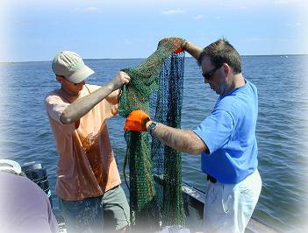



|  |  |  |
| --- | --- | --- |
| **Document #FCA01** | **Title:**  **Fish Tissue Data Management SOP and QA/QC** | **Date:**  **07/21/2020** |
| **Revision #1.0** | **Prepared By:**  **Amy Laliberte** | **Date Prepared: 07/21/2020** |
| **Effective Date:**  **[Date]** | **Reviewed By:**  **[Reviewer’s Name]** | **Date Reviewed:**  **[Date]** |

Contents

Acronyms 3

1.0 INTRODUCTION 4

2.0 SAFETY PROGRAM 4

3.0 STUDY PLANS 4

3.1 Study Design 4

4.0 FISH AND SHELLFISH COLLECTION AND HANDLING IN THE FIELD 6

4.1 Sample Collection 6

4.1.1 Monitoring Network Design and Rationale 7

4.1.2 Sampling Procedure 8

4.1.3 Documentation, Reporting and Audits 11

4.2 Sample Preparation in the Field 11

4.2.1 Sample measurements 11

4.2.2 Scaling or skinning 11

4.2.3 Filleting 12

4.2.4 Removal of edible tissue from shellfish 16

4.2.5 Sex determination (Optional) 16

4.2.6 Assessment of morphological abnormalities (Optional) 16

4.2.7 Field storage and shipping of samples 17

4.2.8 Chain of custody 17

5.0 FISH AND SHELLFISH HANDLING IN THE LABORATORY 20

6.0 ANALYSIS OF FISH AND SHELLFISH TISSUE 21

7.0 QUALITY ASSURANCE/QUALITY CONTROL 21

8.0 DATA ANALYSIS AND REPORTING 21

8.1 Field Data 21

8.2 AWQMS Database 22

9.0 REFERENCES 23

APPENDIX A: Fish Tissue Survey Information 25

APPENDIX B: Fish Sampling Locations 27

APPENDIX C: FISH AND SHELLFISH HANDLING IN THE LABORATORY 31

APPENDIX D: ANALYSIS OF FISH AND SHELLFISH TISSUE 39

APPENDIX E: Procedures for Methyl Mercury 48

APPENDIX F: Procedures for PCB’s 53

# Tables and Figures

Table 4.1: Target species and size ranges for fish tissue monitoring program 10

Table 8.1: Sample of AWQMS Import Configuration 22

Figure 4.1: Fish Fileting for Analytical Laboratory 12

Figure 4.2: Illustration of basic fish filleting procedure (USEPA, 1991). 15

Figure 4.3: Sample Label 15

Figure 4.4: Sample Chain-of-Custody (COC) 19

# 

# comAcronyms

CCV

COC

CWMP

DQO

EA/IRMS

GC/MS

GLP

HPLC

LOQ

MDE

MDL

NIST

NPDES

PACs

PCBs

PDA

POPs

PTFE

QA

QAP

QC

RSD

SOP

SRMs

TLC/FID

TMDL

WSA

continuing calibration verification

Chain of Custody

core water monitoring program

data quality objectives

elemental analyzer/-isotopic ratio mass spectrometer

gas chromatography/mass spectrometry

good laboratory practices

high-performance liquid chromatography

lower limit of quantitation

Maryland Department of the Environment

method detection limit

National Institute of Standards and Technology

National Pollutant Discharge Elimination System

polycyclic aromatic compounds

polychlorinated biphenyls

Photo Diode Array

persistent organic pollutants

polytetrafluoroethylene

quality assurance

Quality Assurance Plan

quality control

relative standard deviation

Standard Operating Procedure

Standard Reference Materials

thin-layer chromatograph-flame ionization detector

Total Maximum Daily Load

Water and Science Administration

# 1.0 INTRODUCTION

The purpose of this manual is to provide detailed information on standard operating procedures (SOP) of the Maryland Department of the Environment’s (MDE) Water and Science Administration (WSA) for the collection and analysis of fish and shellfish tissue. Consistency in collection and analysis is the cornerstone for developing fish consumption advisories and related activities. The procedures provided in this manual are a synthesis of (and in some places taken directly from) widely used methodsas well as methods developed from the experience of personnel within WSA. This manual is to be used in conjunction with the *Technical Support Document for Establishing Fish and Shellfish Advisories in Maryland* (MDE,2009).

This manual will be reviewed regularly and revised as necessary. All current employees and new employees within WSA will be provided with this manual which serves as a guideline of WSA's activities, methods, and procedures for fish/shellfish sampling, analysis, data management, and QA/QC.

Revisions of this manual will be provided to each employee and it will be the responsibility of the employee to keep his or her manual current. The SOPs and quality control (QC) procedures in this manual will be the basis for all fish and shellfish tissue monitoring conducted by MDE in the waters of Maryland. Deviations from these procedures for unusual sampling situations shall be documented in the appropriate report or memorandum.

# 2.0 SAFETY PROGRAM

Personnel are required to collect fish and shellfish throughout Maryland at times and places where medical facilities may not be readily available. It is imperative that all employees are instructed in - and follow - safety precautions when using sampling equipment and hazardous materials. All personnel involved in electrofishing activities should be trained in standard electrofishing safety procedures and boat safety.

Personnel safety is the prime objective especially when field conditions such as high flows, wind, or thunderstorms arise. Long days combined with strenuous effort increase the likelihood of accidents. "Safety first" must always be the rule. Accordingly, Personal Flotation Devices, fire extinguishers, and first aid kits are required equipment on all vessels.

Employees should promptly report on-the-job accidents to their supervisor. If an accident occurs during field operations, the first responsibility of the team leader is to get first aid treatment for the injured employee; their second responsibility is to promptly notify their supervisor.

# 3.0 STUDY PLANS

## 3.1 Study Design

These include protocols established previously by several state and federal agencies, for example, by the US Environmental Protection Agency (USEPA 2000), California Department of Fish and Games (<http://www.cdpr.ca.gov/docs/specproj/tribal/appdixh.pdf>), National Oceanic and Atmospheric Administration (Sloan et al., 2006), the State of Ohio (2005), the North Carolina Department of Environment and Natural Resources (2006) and references within these documents.

A detailed sampling plan should be developed by the primary researcher and approved by the WSA Program Manager for these activities prior to initiating any studies. A study may involve a two-tiered approach:

* Screening, or Tier I studies, should identify sites where commonly consumed fish species are contaminated with target analytes and may pose a risk to human health.
* Intensive, or Tier II, studies should characterize the magnitude and geographical extent of contamination in harvestable fish at sites identified in Tier I studies. Tier II studies should also be designed to verify results of Tier I screening studies.

Further information on study objectives and sampling design may be found in USEPA (2000). The description of a specific study is to be provided before the analyses begin in order to ensure that the project requirements are known and can be met. All investigations conducted by the WSA will follow a written study plan including but not limited to the following sections:

* **Introduction**– The plan will identify the nature and history of the area beinginvestigated, the names of the principal investigator(s), and the name(s) of the persons requesting the study.
* **Objectives** – The plan will include a description of the purpose of the investigation,questions, issues, and expected accomplishments.
* **Sampling Location Selection**- Locating sampling points is of extreme importance inthe initiation of fish tissue monitoring. The variables in watersheds are many and should be considered in as much detail as possible before sites are selected to monitor any body of water. Land use (e.g., urban, rural, forested, agricultural, industrial) should be considered when locating sample sites, because man-made activities significantly affect the amount of sedimentation, nutrients, and organic or inorganic compounds entering a given segment of a river, lake, or stream. The location of permitted dischargers should be reviewed, using the database provided by MDE’s National Pollutant Discharge Elimination System (NPDES) Unit. Discussion of the proposed study with regional office personnel can also provide additional information useful for determining sampling locations. Pre-study planning of this nature will enhance data interpretation once collections and analyses begin.
* **Methods** - Sampling techniques should be listed with reference to those described inthis manual. Any deviation from these standard methods must be noted and described.
* **Analytical Requirements**– The plan should describe the type, quantity, and quality ofanalyses required.
* **Data Reporting** – The plan should include a description of how the results are to beformatted and reported.
* **Logistics**– The plan will include estimates of manpower requirements, equipmentneeded, time requirements, methods of sample transport to laboratories, timeframe for receipt of samples, analyses, and data delivery. The study plan must be submitted and approved by the Program Manager for these activities prior to conducting the investigation.
* **Use of Study Results** – The plan will include information on who will use the data, andwhat decision(s) will be made from the information obtained.

A study is complete when a written memorandum is sent to and approved by the appropriate level of management within WSA. Each memorandum should contain these sections: an **Introduction or Background**, **Sampling Sites**, **Methods**, **Results and Discussion,** and **Summary or Recommendations**. Any figures, maps, and photographs needed to allow areader to easily locate the sampling sites should also be included. The report or memorandum is filed in a Projects File that is organized by waterbody.

# 4.0 FISH AND SHELLFISH COLLECTION AND HANDLING IN THE FIELD

Fish and shellfish incorporate chemicals from the aquatic environment into their body tissues. Contamination of aquatic resources has been documented for heavy metals, pesticides, and other complex organic compounds. Once these contaminants reach surface waters and sediments, they may be available for bioaccumulation, either directly or through aquatic food webs, and may accumulate in fish and shellfish tissues. Results from fish tissue monitoring can serve as an important indicator of further contamination of sediments and surface water. The data can be used to determine long-term trends of contaminant levels in Maryland’s surface waters.

The following procedure is used by the WSA to collect and process fish tissue samples to be analyzed for chemical contaminants. These procedures are generally based on established guidelines described in USEPA (2000).

## 4.1 Sample Collection

Fish samples are collected annually during the Fall (September through November) when fish are generally healthiest (fattest) and flows are generally low. In most cases the WSA will employ electrofishing as the primary means of fish collection. Collections on lakes and non-wadeable streams are usually accomplished using a boat-mounted electrofisher powered by a 3.5 or 5.0 Kilowatt generator. Collections on wadeable streams are accomplished using backpack electrofishing techniques.

Sampling is conducted until the required numbers of fish are collected. **All personnel involved** **should be familiar with standard electrofishing operational and safety procedures** (Reynolds, 1996).

In certain cases electrofishing may not be effective, especially in deep or estuarine waters or when targeting Ictalurids (catfishes) and other benthic species. In these cases, an otter trawl, baited trot lines, traps, hook and line, or gillnets may be used (Hubert, 1996).

Certain studies may require that fish be collected by other agencies or that fish be purchased from commercial fishermen. Division personnel should provide quality control measures necessary to ensure that samples are collected and handled properly with minimal contamination and that sampling sites are verified.

At each sampling station personnel should fill out a Fish Tissue Survey Form (Appendix A) to provide additional information regarding the site visit. The form allows field staff to document access conditions, all species observed, water quality measurements, disease information, and any comments about the station.

Generally, fillet composite samples are collected at each sampling location. Fillet composite samples usually consist of one fillet from each of three to five fish of the same species. The minimum wet weight composite necessary for analyses is 10 grams. The minimum number of fish comprising a composite sample is three fish. More than a five fish composite may be used to meet the minimum 10-gram sample weight requirement if the fish being collected from the site are small and are an important or priority species for monitoring. Under certain conditions, one or two large, single fish fillets can be analyzed if no other fish for that species is available. For all samples, the smallest fish in the sample must be within seventy-five percent of the total length of the largest fish in the composite sample. Ideally, more than 150 grams of sample should be collected and submitted for analyses.

### 4.1.1 Monitoring Network Design and Rationale

The fish tissue sampling network utilizes some of the core water monitoring program (CWMP) stations to form a “Core Fish Tissue Monitoring Network.” Additional stations have been added to better reflect fishing and consumption habits in the state. The CWMP stations were selected in 1976 for water quality assessment through monthly sampling for physical and chemical water quality parameters. Thirty-three of Maryland’s historical 37 CWMP stations are routinely sampled for fish tissue analysis. The remaining four CWMP stations are not suitable for fish sampling. Since its inception in 1977, the fish tissue sampling program has expanded and the core fish tissue sites currently number 58. A list of the core fish tissue stations and other sampling locations used by MDE is included in Appendix B.

The overall design of the monitoring station network was originally selected with the aid of recommended station sighting criteria (USEPA, 1976) which included paired configurations (i.e., upstream and downstream of representative land use areas such as municipal/industrial and agricultural/rural) and proximity to potential areas of development. Selected stations include both “problem” areas and “clean” areas of interest. When possible, stations were cited where historical data were available. Many single stations were located in sub-basins which included surface water intakes, recreational areas and commercial fishing and shell fishing areas. Stations were also sighted within major rivers, significant tributaries, and in estuaries and bays.

The fish tissue sampling program was expanded in 1988 to achieve more efficient statewide coverage. The fish tissue network was divided into three regions, each to be sampled in successive years. The cycle was designed to be completed every third year. The three sample regions were assigned as follows: 1) Western Maryland Watersheds 2) Chesapeake Bay Watersheds and 3) Baltimore/Washington Urban Watersheds (DC Metro Area and Baltimore Area Harbors and Bay). Additional stations were added as necessary to meet new management needs. In 2008, the three-year region rotation cycle was increased to five years to maintain a slightly reduced yearly core network and allow room for new stations to be added. Additional stations become necessary when data gaps are found, when a public safety issue emerges, or when intensive data for Total Maximum Daily Load (TMDL) implementation or 303(d) listing purposes are required. This expansion of the cycle means that, in a given year, 60% of stations at which fish are collected are core sites and 40% are sites not from the core list of sites, but from sites that require attention for specific reasons.

### 4.1.2 Sampling Procedure

At each sampling site, game and bottom feeding accumulator fish are collected for tissue analysis. The protocol for sample collection is given here.

Electrofishing is a fish sampling method that utilizes alternating (AC) or direct (DC) electrical current introduced in the water to produce sufficient electrical stimulus to induce forced swimming (electrotaxis) near the anode, allowing easy capture.

Two electrode fishing devices are available for MDE use: a boat-mounted Coffelt electrofishing array and a SMITH-ROOT 24Volt backpack electrofisher, both of which employ pulsating DC current. The boat- mounted system consists of a 3’ diameter stainless steel “Wisconsin Ring” anode suspended off the bow of an 18’ aluminum boat hull. The hull acts as the cathode. An on-board generator powers the electronics console allowing the users to generate and adjust an electric field in the water near the bow of the boat. A foot switch on the bow allows the operator to switch the electric field on and off as prescribed. This equipment is used in navigable water with two- or three-person teams. The boat is generally maneuvered over structures where fish tend to concentrate, and the unit is energized. Shocked fish are captured with dip nets and placed in a live well or coolers filled with ambient water. Netted fish are transferred to buckets filled with ambient water to allow them to recover until the final samples (i.e., the fish that are needed to comprise the composite and/or individual samples) are determined. Unneeded fish are returned alive to the waterbody.

The backpack shocker is used in wadeable water. It is used in two-person teams and consists of an adjustable, battery powered backpack electronic console, a pole-mounted anode ring, and a trailing steel cable cathode. When energized by a thumb switch on the pole, the unit generates an electric field near the cathode that disorients and stuns fish. The users move and shock systematically along a stream bank or along features where fish tend to shelter or congregate. The users, wearing water-proof chest-high waders and elbow-length gloves, employ dip nets to collect fish. Sunglasses with polarized lenses aid dippers in seeing fish through water surface glare caused by the sun.

Fish are identified, counted, measured, weighed, and recorded; fish not required for analysis are released. For purposes of fish community assessment, specimens which cannot be positively identified in the field are preserved in labeled containers with 10 percent formalin and returned to the taxonomic laboratory.

Two samples - each composed of five similarly sized fish of target species (Table 4.1) - are collected from each site. One sample is to be of the target game species (both fillets of five fish), while the other is to be comprised of fillets from an accumulator species. When neither targeted

species is available, substitutions with related species are appropriate. A composite sample is to consist of five fish of the same species and within a specific size class. Should five fish not be available, four or three fish are acceptable. If there are fewer than three fish, then the fish are to be discarded. A composite sample of fish in the same size class is determined by first removing the fish from live wells, holding tanks, or buckets, and rinsing in ambient water to remove foreign matter. The fish are then placed on a contaminant-free surface for sorting by species. After sorting, each fish is weighed to the nearest 0.1 gram and measured to the nearest 0.5 cm. The results are entered into the field sheets. The composite size class is determined by first identifying the largest fish and then selecting additional fish of the same species that are within 75% of its length.

Each composite is to have a unique Identifier (ID). In addition, each individual fish making up the composite has its own identifier. The naming convention of the composite ID is as follows:

* First 4 characters are the year during which the fish were collected followed by “FTC” (abbreviation for Fish Tissue Composite).
* An underscore is used after the FTC followed by 3 to 5 alphabetical characters that best indicate the body of water from which the fish were collected.
* An underscore is used after the water body designation, followed by a letter of the alphabet starting with A for the first composite, B for the second etc (see Table 4.4).

The naming convention of the unique ID of the individual fish is as follows:

* The number of the month during which the fish was collected followed by an underscore and the year. Month with single digits are to be written as 01, 02, 03, etc.
* After the year and without a space or underscore, enter three letters descriptive of the body of water in which the fish was collected.
* Lastly, an underscore followed by a number starting with “01” and continuing sequentially with each additional fish for the particular sampling station (see Table 4.4).

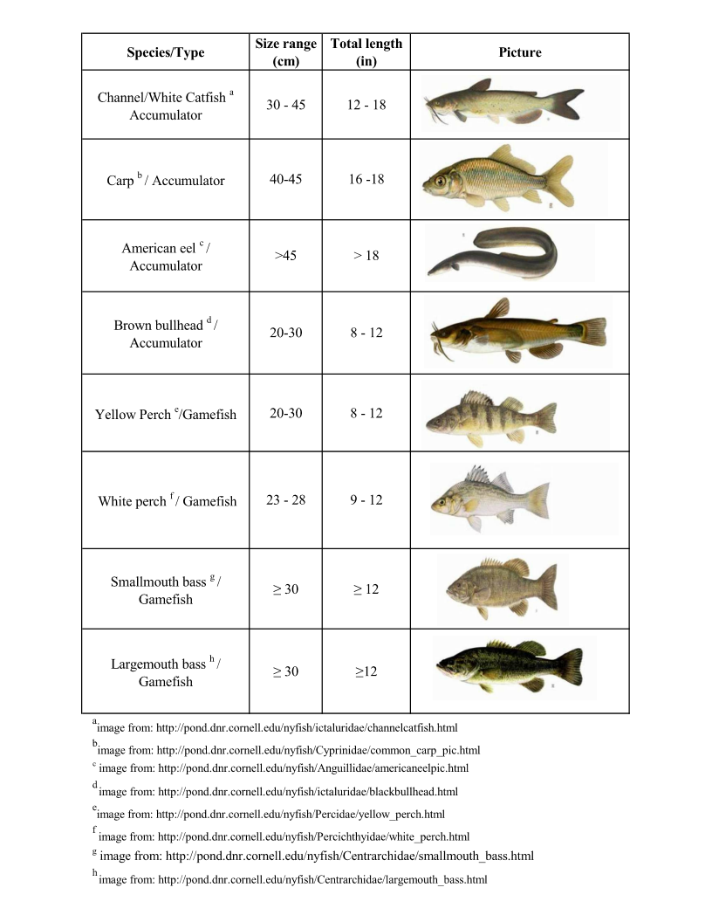

Table 4.1: Target species and size ranges for fish tissue monitoring program

### 4.1.3 Documentation, Reporting and Audits

Field notebooks are maintained by and stored with the MDE Field Evaluation Division, Fish Kill Investigation Section. In these notebooks, all aspects of sample collection are noted.

## 4.2 Sample Preparation in the Field

This section provides detailed guidance on field procedures for scaling or skinning, filleting, removal of edible shellfish tissue, sex determination, assessment of morphological abnormalities, field storage and shipping, and chain of custody (COC). The principal goal of this guidance is to prevent decomposition or contamination of fish and shellfish samples during handling and shipping to the laboratory and to ensure correct identification of samples.

Fish are removed from live wells, holding tanks, or buckets, rinsed with ambient water to remove foreign matter, and placed on a contaminant-free surface for sorting. Skins on fish selected for analysis are examined for breaks or lacerations from sampling gear – a possible source of contamination. The lacerated sections are not included in the sample. Fish are sorted by species before weighing, measuring, and processing.

### 4.2.1 Sample measurements

Wet weight is determined for each fish in the field, to the nearest 0.1 gram and recorded on the Chain of Custody (COC) form. A total length is determined for each fish in the field to the nearest half centimeter (millimeter for fish less than 15 cm) using a length board such as the Wildco® Model 118 and recorded on the COC form.

Edible tissue from all shellfish in a composite sample (3 to 50 individuals) is placed in an appropriate preweighed and labeled noncontaminating container. The weight of the empty container (tare weight) is recorded to the nearest gram on the sample processing record. All fluids accumulated during removal of edible tissue is retained as part of the sample. As the edible portion of each shellfish is placed in the container, it is noted on the sample processing record. When the edible tissue has been removed from all shellfish in the composite, the container is reweighed and the weight recorded to the nearest gram on the sample processing record. The total composite weight is approximately 200 g for screening studies. If the number of target analytes is significantly reduced in intensive studies, a smaller composite homogenate sample may suffice. At this point, the composite sample may be processed for analysis or frozen and stored at -20°C.

### 4.2.2 Scaling or skinning

Fish that require scaling prior to keeping the fillet with skin and rib cage attached are scaled and any adhering slime removed prior to filleting. Fish without scales (e.g., catfish) are skinned after filleting.

### 

### 4.2.3 Filleting

Filleting should be conducted only by or under the supervision of an experienced fisheries biologist. Fish are generally filleted in the field using modified EPA-Clean Techniques, as described below. When samples are filleted in the field, the following procedures will be followed to minimize risk of cross-contamination: Prior to processing, the fish are to be rinsed in ambient water, weighed, and measured. Two types of fillets are prepared, depending on the fish species. Certain fish are filleted and submitted to the laboratory with skin and ribs; these require scaling (see Fig 4.1). Others are submitted skinned and without ribs.

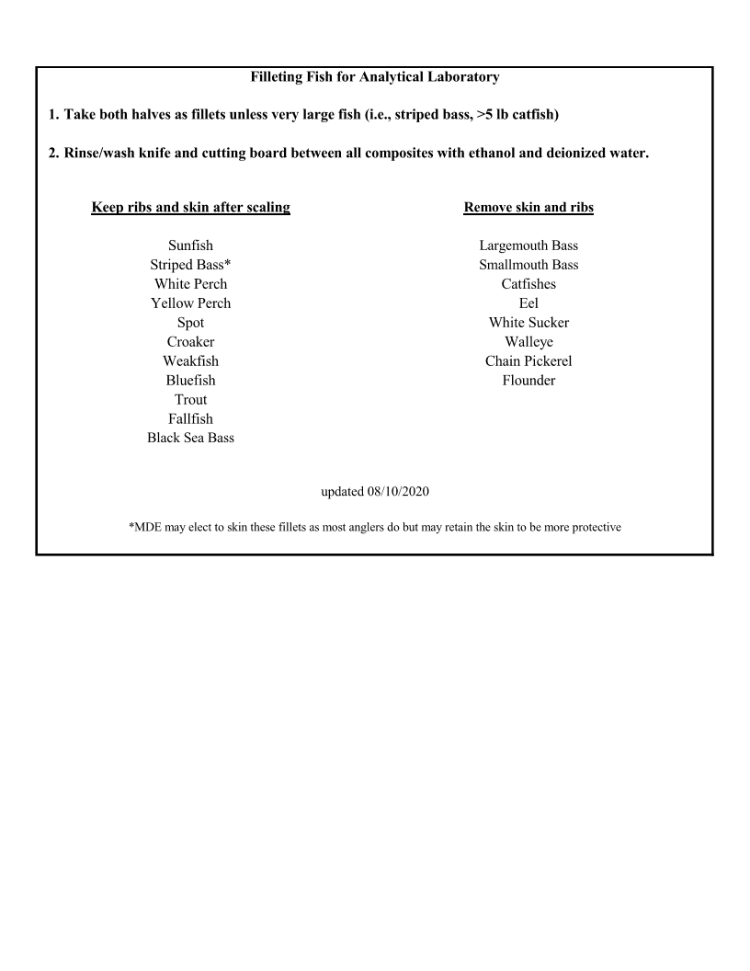

Figure 4.1: Fish Fileting for Analytical Laboratory

* Fillets from the following species are submitted to the laboratory *with* skin and ribs attached: Trout species, Striped Bass, White Perch, Yellow Perch, Spot, Black Seabass, Atlantic Croaker, Weakfish, Fallfish and Bluefish and all sunfish species except Largemouth and Smallmouth Bass.
* Fillets from the following species are submitted to the laboratory *without* skin or ribs: Largemouth Bass, Smallmouth Bass, Catfishes, American Eel, White Sucker, Walleye, Flounder and Chain Pickerel.

When multiple species are to be filleted, the species likely to have the lowest contaminant levels (based on position in the food chain and feeding niche) are processed first (e.g., Sunfish before Largemouth bass and before catfish; smaller fish before larger fish). All fish of the same species are to be weighed and measured to determine which fish fall into composite groups.

Prior to filleting, each fish is rinsed with contaminate-free deionized water. Specimens should come into contact with non-contaminating surfaces only. Fish are filleted on aluminum foil-covered PTFE (polytetrafluoroethylene) cutting boards that are cleaned in the laboratory prior to each sampling trip with soap and water and rinsed with deionized water. Aluminum foil is rinsed with deionized water between fish from the same station and changed completely between composites and at each station. The cutting board is also rinsed with ethanol between fish composites and between stations. Filleting is performed using cleaned (with soap) and rinsed bare hands or talc- and dust-free disposable gloves. Hands or gloves are rinsed between samples to prevent cross contamination. Fillets are resected using clean, high grade stainless steel, ceramic, or titanium utensils cleaned as follows: knives are rinsed with deionized water and ethanol between fish from the same station and recleaned or changed between stations.

If the fillet tissue is contaminated by materials released from the inadvertent puncture of the internal organs during resection, MDE personnel may eliminate the fillet tissue as a sample or, alternatively, the fillet tissue should be rinsed in contaminant- free, deionized distilled water and blotted dry. Regardless of the procedure selected, a notation is made in the sample processing record.

A fish is scaled by laying it flat on a clean glass, stainless steel, or PTFE cutting board covered with heavy duty aluminum foil. Remove the scales and adhering slime by scraping from the tail to the head using the blade edge of a clean knife or scaler. Cross-contamination is controlled by rinsing the cutting board and knife with contaminant- free distilled water between each composite. Aluminum foil is changed between each composite.

The fish samples that will comprise a composite are to be filleted on a clean PTFE cutting board covered in heavy duty aluminum foil using a clean stainless-steel knife. Individual fish fillets are rinsed with deionized water, wrapped in aluminum foil (dull side against the fish tissue), and labeled with a unique identifier. After each set of fish comprising a composite is filleted, the used foil is removed from the cutting board and the cutting board is first washed with deionized water, followed by a rinse with 95% ethanol, then rinsed again with deionized water. The cutting board is then re- wrapped in clean heavy-duty aluminum foil. The knife is rinsed with deionized water, wiped off with a clean paper towel, then rinsed with 95% ethanol, followed by deionized water prior to processing the next composite.

The standard fillet is that portion of the fish bounded anteriorly by the pectoral fin, posteriorly by the caudal fin and from the mid- dorsal line to the midventral line, either including the ribcage and belly flap or not (as above).

Any dark muscle tissue in the vicinity of the lateral line is not separated from the light muscle tissue that constitutes the rest of the muscle tissue mass. If both fillets are removed from a fish, they can be (i) combined, (ii) kept separate for duplicate QC analysis, (iii) kept for analysis of different analytes, or (iv) archived (one fillet). Fillets are weighed (either individually or combined, depending on the analytical requirements) by the contract laboratory and the weight(s) recorded to the nearest tenth of a gram on the sample processing record. Fat is not trimmed from the fillet samples. The percent lipid is reported for all fish tissue samples.

1. skin-on "Standard Fillet" is prepared using the following procedure (Figure 4.2). A shallow cut is made through the skin on either side of the dorsal fin from the base of the head to the tail. A second cut is made along the entire length of the gill cover cutting through skin and flesh to the bone. A third cut is made along the belly (includes the belly flap) from the base of the pectoral fin to the tail and along the side of the anus and the fin directly behind. The skin-on fillet is removed, and major bones are removed. When samples are to be taken with ribs, the visceral wall is necessarily cut. In this case, care is taken not to puncture the exposed organs. In either case, the fillets are rinsed with deionized water prior to wrapping them in foil.

Skin-off fillets are prepared differently because ribs are excluded in skin-off fillets. In this case, a shallow cut is made through the skin on either side of the dorsal fin from the base of the head to the tail. This incision is deepened paralleling the dorsal spines until it reaches the backbone. A second cut is made along the length of the gill cover from the dorsum to a point intersecting the spine. Care is taken not to puncture the visceral cavity. The exposed flap is lifted and removed from the fish, taking with it the top of the fillet and a portion of the rib meat. In larger fish, the rib meat is largely removed with the fillet by running the knife against the ribs repeatedly until the fillet is removed from the ribs to their ends. In smaller fish, because the rib meat is very thin in the belly area, little rib meat stays with the fillet. Fish are skinned after filleting by placing them on a cutting board skin side down and using the knife to separate the skin from the tissue. This is done by pushing the blade of the knife against the skin and moving in a posterior to anterior movement while holding onto the posterior most flap of skin. When samples are to be taken without ribs, care is taken not to puncture the visceral lining.

Fillets from each fish are wrapped in aluminum foil, dull side touching the fish tissue, and uniquely labeled (Figure 4.3). The label contains the project name, sample identification number, the sample type (e.g., "F" for fillet), the species, length (cm) and weight (g) of the fish, and the date and location of the collection. If composite homogenates are to be prepared from only a single fillet from each fish, fillets are wrapped and labeled separately. Otherwise, the individual fillets from each fish are kept together. All fillets from a collecting station should be placed in a plastic bag labeled with the composite identification number, the individual sample identification numbers, and the date and location of sampling. Paper labels with the sample number will be affixed with masking tape. Extra labels will be available. Should more labels be required, they will be prepared with a permanent marking pen in the field. Plastic trash bags used to carry samples will be labeled by writing appropriate identification directly on the bag or a paper affixed with masking tape.

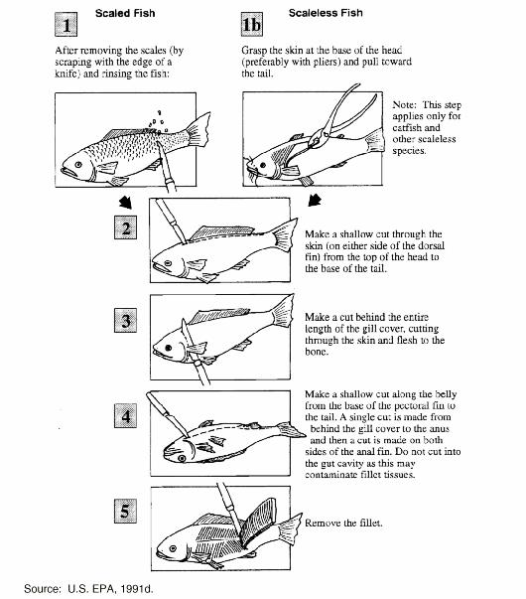

Figure 4.2: Illustration of basic fish filleting procedure (USEPA, 1991).

|  |  |  |  |
| --- | --- | --- | --- |
| MDE-Fish Toxics Monitoring – 2009 Fall | | Sample Station ID: |  |
|  |  |
|  |  |  |  |
| Field ID Number |  | Sample Site Description: | |
|  |  |  |  |
| Date Sampled (m/d/y): | Time Sampled (24hr): |  |  |
| Sample Type |  |
| **/ /** |  |  |
|  |  |  |
|  |  | e.g., Fillet w /Skin and Ribs | |
|  |  |  |  |
| Species Name: |  |  |  |
|  |  | Length (mm) | Weight (g / lbs.) |
|  |  |  |  |

Figure 4.3: Sample Label

### 4.2.4 Removal of edible tissue from shellfish

Edible portions of shellfish should consist only of those tissues that the population of concern might reasonably be expected to eat. Edible tissues should be clearly defined in site-specific sample processing protocols. A brief description of the edible portions used should also be provided on the sample processing record.

Thawing of frozen shellfish samples is kept to a minimum during tissue removal to avoid loss of liquids. Shellfish are rinsed well with organics- and metal-free water prior to tissue removal to remove any loose external debris.

Bivalve mollusks (oysters, clams, mussels, and scallops) typically are prepared by severing the adductor muscle, prying open the shell, and removing the soft tissue. The soft tissue includes viscera, meat, and body fluids. Byssal threads from mussels should be removed with a knife before shucking and are not included in the composite sample.

Edible tissue for crabs typically includes all leg and claw meat, back fin meat, and body cavity meat. Internal organs generally are removed. Inclusion of the hepatopancreas should be determined by the eating habits of the local population or subpopulations of concern. Hard- and soft-shelled crabs must not be combined in the same composite.

### 4.2.5 Sex determination (Optional)

The sex of a fish is determined after filleting. Ovaries appear whitish to greenish to golden brown and have a granular texture. Testes appear creamy white and have a smooth texture. The sex of each fish should be recorded on the sample processing form.

The determination of sex in shellfish species is impractical if large numbers of individuals of the target species are required for each composite sample. For bivalves, determination of sex is a time-consuming procedure that must be performed after shucking but prior to removal of the edible tissues. Once the bivalve is shucked, a small amount of gonadal material can be removed using a Pasteur pipette. The gonadal tissue must then be examined under a microscope to identify egg or sperm cells. For crustaceans, sex also should be determined before removal of the edible tissues. For many species, sex determination can be accomplished by visual inspection. Sexual dimorphism is particularly striking in many species of decapods. In the blue crab, *Callinectes sapidus*, the female has a broad abdomen suited for retaining the maturing egg mass or sponge, while the abdomen of the male is greatly reduced in width. Investigators interested in determining the sex of shellfish should consult taxonomic keys for specific information on each target species.

### 4.2.6 Assessment of morphological abnormalities (Optional)

Assessment of gross morphological abnormalities in finfish is optional. This assessment may be conducted in the field. Space is provided on the COC record (Figure 4.4) for brief summaries of anomalies found on fish.

### 4.2.7 Field storage and shipping of samples

All samples will be stored and transported in a manner designed to minimize bulk loss, analyte loss, contamination, or biological degradation.

All processed fish tissue samples are wrapped in clean aluminum foil with the dull side of the foil against the fish tissue. Wrapped samples are then placed in tagged polyethylene bags. All fish samples are transported to the MDE Field Office in coolers on ice. From there, they are frozen in a standard freezer and remain frozen until and during shipment to the appropriate contract laboratory. Frozen samples will be kept frozen during shipment through the use of wet ice. The sampling team will have a sufficient number of ice chests and frozen coolants to assure that samples remain frozen. Ice chests are cleaned with water and stored uncovered at the end of each day of use.

The samples received at the laboratory will be kept in secured refrigerators or freezers. Refrigerators will be kept at 4°C, and freezers will be kept at -20°C or cooler. Storage will be in an environment where the sample identification numbers will remain attached. Mechanical refrigerant units shall be used. The use of ice as a refrigerant for sample storage is not allowed. The tissue samples must be frozen to prevent degradation or volatilization.

When field filleted fish samples are delivered to the laboratory, they should be shipped from the field on wet ice within 24 hours of collection. Alternatively, they can be frozen by collectors within 24 hours and then shipped frozen and on wet ice. Field filleted fish must be frozen at -20°C or homogenized within 48 hours of collection. Recommendations for the storage of fish tissue are variable and conservative. MDE follows a conservative approach until further studies or data can be amassed to support a different approach.

### Chain of custody

A Fish Sample Chain-of-Custody Record (Figure 4.4) is filled out prior to submission of samples to any contract laboratory. The person responsible for sample collection must originate the COC record. The COC contains discrete sample identifier numbers for the composite samples and individual fish within composite samples (i.e., each field sample is assigned a unique identification number and will have a separate entry on the COC record). It also contains information on sample location, date, personnel, and length and weights of the fish sampled. In general, the COC record must be signed each time the samples change hands for preparation

and analysis. The COC accompanies the samples from MDE through the contract laboratory until results are reported back to MDE. COC records will be electronically filled out using an excel template, then printed out for signatures.

An electronic copy of the COC also is provided to the Public Health Section, EASP (which receives the results from the contract laboratories) prior to sample delivery to the laboratory. The Fish Consumption Advisory Program Project Leader in the Public Health Section reconciles the COCs with laboratory results in accordance with the study plan. Final validation is the responsibility of the Project Leader and is performed during the preparation of yearly data reports.

MDE will usually hand carry the samples and transport time takes approximately 0.5 to 2.5 hours. The samples will be delivered during normal work hours with time to allow for inspections. When custody is transferred from the field to the sample processing laboratory, the following procedure is used:

1. Samples are kept in the custody of the designated sampling or field personnel or both until shipment. Any transfer or movement of samples will use COC procedures. Samples will be properly packaged for shipment near the sampling area and dispatched to the appropriate party. The original signed and dated COC paper record will accompany the sample(s); a copy of the COC record is retained by the sample shipper. All shipments will comply with Department of Transportation regulations (49 CFR, parts 172 and 173). Immediately upon receipt of samples, the recipient will review the shipment for sample condition and consistency with the accompanying COC record before signing and dating the COC record. Sample condition(s) will be noted on the original COC sheet at this time. If there are any discrepancies between the COC record and the sample shipment, the recipient will contact the sample shipper immediately. Any discrepancy will be noted on the COC. Any attempt to correct a discrepancy will also be noted on the COC (e.g., replacing a misplaced fillet at a future time or date).
2. The information from the label (Figure 4.3) is also entered on COC record along with information concerning the sample type, the analyses to be performed and the personnel collecting the sample. The individual collecting the samples will be responsible for the custody of the samples until they are transferred or properly dispatched. If samples are hand-carried to laboratory personnel, custody of samples will be transferred to the laboratory sample custodian. Samples transported by commercial carrier will have the COC record accompany the samples when transported to the laboratory. The COC record will be placed inside a ziplock bag and transmitted along with the samples. Each subsequent custodian of the sample(s) must complete a new line on the COC record and enter the date of receipt.
3. Frozen, filleted fish and shellfish samples are brought or shipped to the sample processing laboratory in sealed bags accompanied by a copy of the COC record with field records. Each time custody of a processed sample or set of samples is transferred, the Personnel Custody Record of the COC record must be completed and signed by both parties. Corrections to the COC record should be made in indelible ink by drawing a single line through the original entry, entering the correct information and the reason for the change, and initialing and dating the correction. The original entry should never be obscured.

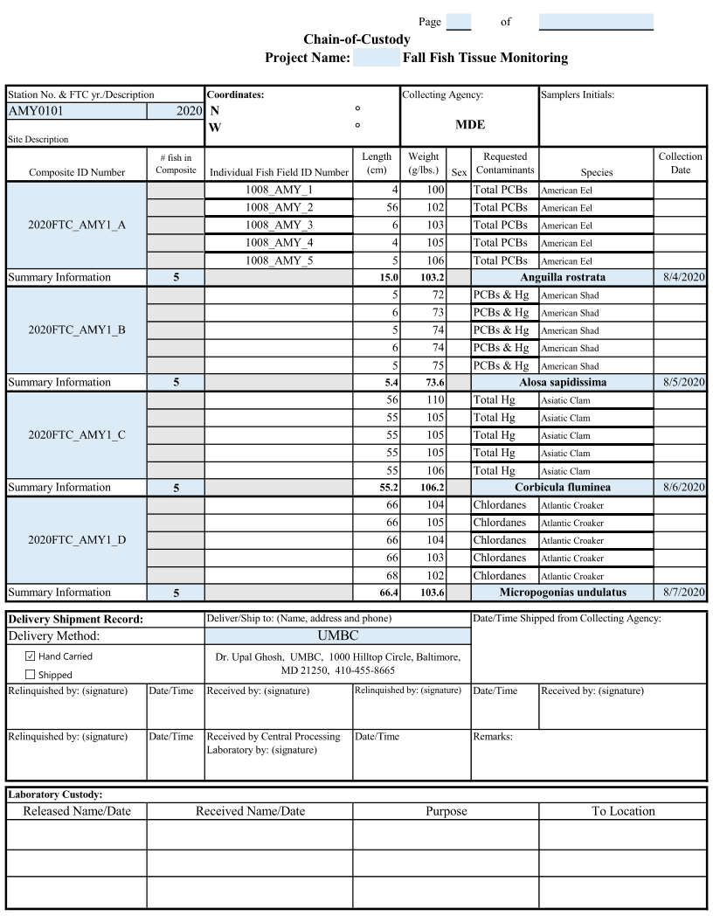

Figure 4.4: Sample Chain-of-Custody (COC)

The sample custodian at the laboratory will carefully inspect each sample for COC documentation, sample labeling, packing lists, and for the condition of the sample. Any discrepancies or problems associated with sample shipment will be documented on the COC record. The following steps should be taken on receipt of the samples by the laboratory:

* Note the shipping time and delivery times.
* Check that each shipping container has arrived undamaged and that the seal is intact.
* Open each shipping container and remove the copy of the COC record, and any accompanying field records, if included.
* Note the general condition of the shipping container (samples iced properly with no leaks, etc.) and the accompanying documentation (dry, legible, etc.).
* Locate individual field fillets in each composite sample listed on the COC record and note the condition of their packaging. Individual specimens should be properly wrapped and labeled. Note any problems (container punctured, illegible labels, etc.) on the COC record.
* If individuals in a composite are packaged together, check the contents of each composite sample bag against the field record for that sample to ensure that the individual specimens are properly wrapped and labeled. Note any discrepancies or missing information on the COC record.
* Initial the COC record and record the date and time of sample receipt.

After inspection, the samples will be entered into a permanent laboratory record book and, if applicable, a computer database. The following information shall be included when samples are logged in:

* required analysis
* sample location
* sample matrix
* sample identification number
* composite ID number
* Receipt date (use format YYYYMMDD)
* Sampling date (use format YYYYMMDD)
* Sampling site (name and/or identification number)
* Fish and shellfish species (scientific name)
* Total length of each fish or size of each shellfish (mm)

The sample custodian will ensure that the samples are either retained in secure storage or are in the possession of the authorized analyst during the time in which the samples are in the laboratory. The COC record will accompany the samples through analysis. The completed COC record will retained as a permanent part of the project record. An accurate written custody record must be maintained so that possession and treatment of each sample can be traced from the time of collection through analysis and final disposition.

# 5.0 FISH AND SHELLFISH HANDLING IN THE LABORATORY

The guidance on laboratory procedures for sample receipt, chain of custody, processing, distribution, analysis, and archiving can be found in Appendix C. Planning, documentation, and quality assurance and quality control of all laboratory activities are emphasized to ensure that (1) sample integrity is preserved during all phases of sample handling and analysis, and (2) chemical analyses are performed cost-effectively and meet program data quality objectives. Laboratory-specific SOP information for mercury and PCBs are given in Appendices E and F, respectively.

**\*\*The contract between MDE and the laboratory will stipulate a deadline for completion of laboratory analysis and data reporting. As fish are typically delivered to the laboratory in the fall, MDE will expect that final data reports to be delivered to MDE by June of the following year. \*\***

# 6.0 ANALYSIS OF FISH AND SHELLFISH TISSUE

The laboratory will provide to MDE a list of analytes for which lab has demonstrated capabilities, documented methods, method detection limits (MDLs), and SOPs (see Appendices E, F, and G for SOPs for mercury ,PCBs, and PFAS analyses). This information can be found in Appendix D.

# 7.0 QUALITY ASSURANCE/QUALITY CONTROL

For a given fish monitoring program year, and for special projects, MDE will contract with one or more laboratories for fish sample analysis. Each laboratory must provide the name of the individual (and contact information) responsible for ensuring that the analytical data quality objectives (DQOs) for the project are met and that staff resources are available to fulfill laboratory analytical requirements. Each laboratory must also provide the name of the individual (and contact information) responsible for ensuring that the analytical results meet QA criteria and the stated objectives.

To assess total variability, duplicate samples will be prepared from at least 10% of the fish samples. Duplicates are prepared using tissue from the same fillet or composite homogenate. Duplicates are assigned a "dummy" sample identification which is recorded in the processing laboratory log. The analytical laboratory does not receive this information.

During intensive or Tier 2 studies, portions of at least 10% of the prepared homogenates will be frozen at -20°C and archived at the laboratory for a period of at least 6 months after completion of the study. This is done in case of analytical problems or the need for future references.

# 8.0 DATA ANALYSIS AND REPORTING

## 8.1 Field Data

The Bioregulatory Monitoring and Response Division collects fish samples for contaminant analysis. When fish tissue samples are collected, data is transcribed from the field notebook to an electronic field Chain of Custody (utilizing a template provided by the Fish Consumption Advisory Program). Electronic field Chain of Custodies (COCs) contain sample length, weight, sample ID, collection date, and species and are submitted to the Public Health Section as soon as possible and prior to delivery to the lab. The electronic Chain of Custodies (COCs) are printed out, and the paper copies travel with the samples to the laboratory for signature. Signed (hard copies) of COC’s will be retained by the Bioregulatory Monitoring and Response Division. The electronic COC’s are used to make an excel file (called the AWQMS Import Configuration) containing field results and all analysis information (except results and Laboratory Detection limits). The information in the COCs are compiled into an import configuration file by the Public Health Section and sent to the specific lab to be used as the data entry template. If samples are sent to two different laboratories for separate analysis, COC’s should be sent twice, indicating a different laboratory on the COC. Note: All samples collected by the Bioregulatory Monitoring and Response Division will follow the same protocol, electronic COCs are sent to the Public Health Section prior to delivery to the lab in order to create the data import configuration file even if the contract is not managed by the Public Health Section.

Table 8.1: Sample of AWQMS Import Configuration

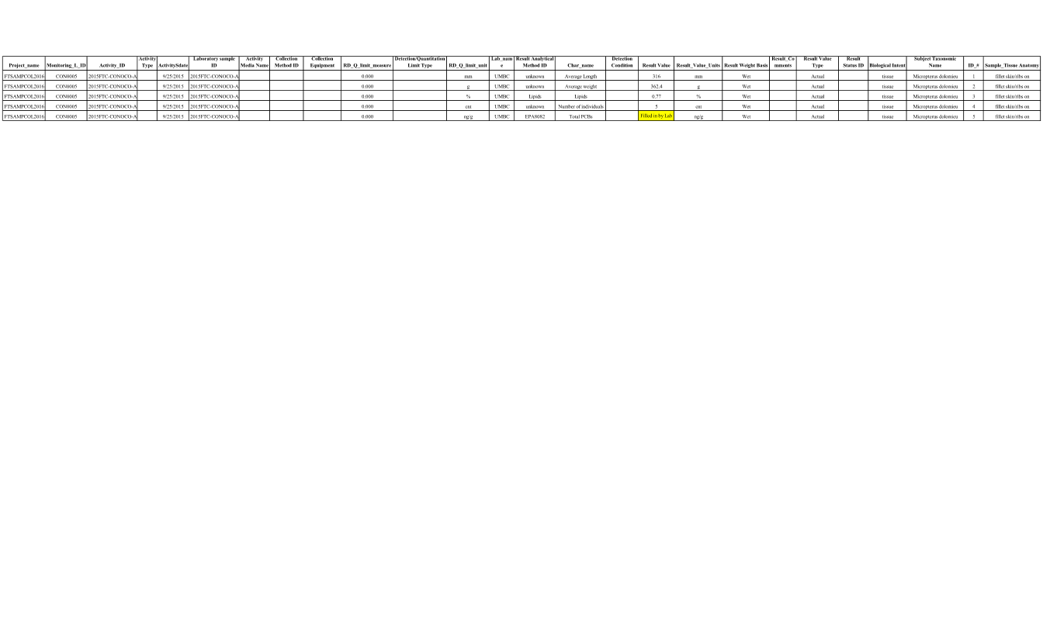

## 8.2 AWQMS Database

Analytical results received from the lab will be visually cross-checked for accuracy between the import configuration file and the final Chain of Custodies by the Public Health Section. Any discrepancies or errors will be noted and corrected. Once the result data is satisfactorily reconciled, the import configuration will be sent to the Quantitative Analysis Section for another cross check. Any errors are then resolved and uploaded into the AQWMS database. Fish tissue data entered into AQWMS has additional QA/QC generated automatically by AWQMS including a check against the master station file and range checks. This process, beginning with the receipt of data from the laboratory, will be completed within three months, unless specifically requested by a stakeholder.

Figure 8.1: Fish Tissue Data Flow Chart

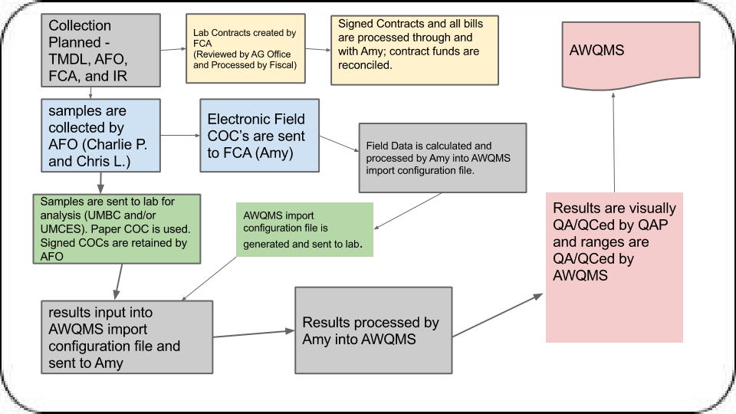

# 9.0 REFERENCES

Allison JT, Butler WL. 1984. Basic Water Monitoring Program report of Fish tissue analysis 1981 & 1982. Office of Environmental Programs, Maryland Department of Health and Mental

Hygiene, Baltimore Maryland.

California Department of Fish and Games. Appendix H. California Department of Fish and

Games Procedure for Fish Tissue Sample Collection, Laboratory Methods and Fish Tissue

Quality Control Results. http://www.cdpr.ca.gov/docs/specproj/tribal/appdixh.pdf

Harman GH. 1980. Basic Water Monitoring Program report of fish tissue analysis 1977, 1978, &

1979. Water Resources Admin., Maryland Dept. of Natural Resources, Annapolis, Maryland.

Hubert W. 1996. Passive capture techniques. Pp. 157-192.in Fish techniques. 2nd Ed. (B.

Murphy and D. Willis, eds.). Am. Fish. Soc., Bethesda, MD.

MDE (Maryland Department of the Environment). 2008. The 2008 Integrated Report of Surface

Water Quality in Maryland. Submitted in Accordance with Sections 303(d), 305(b) and 314 of the Clean Water pg 73-74. Acthttp://www.mde.state.md.us/assets/document/2008_IR_Parts_A_thru_E(1).pdf

MDE (Maryland Department of the Environment). 2009. Technical Support Document for

Establishing Fish and Shellfish Advisories in Maryland. L:\Env_Health_and_Risk\Fish

Consumption Advisories\Technical Support Document for Fish Consumption Advisories\MDE

Fish Consumption Advisory Technical Support Document 2009.pdf

Muir D, Sverko E. 2006. Analytical methods for PCBs and organochlorine pesticides in

environmental monitoring and surveillance: A critical appraisal. Anal. Bioanal. Chem., Advances in Analytical Techniques for Environmental Analyses: Special Edition. 386:769-789.

Murphy DL. 1986. Basic Water Monitoring Program report of fish tissue analysis 1983 and 1984. Office of Environmental Programs, Maryland Dept. of Health and Mental Hygiene, Baltimore, Maryland.

Murphy DL. 1987. Basic Water Monitoring Program report of fish tissue analysis 1985. Office of Environmental Programs, Maryland Department of Health and Mental Hygiene, Baltimore,

Maryland.

North Carolina Department of Environment and Natural Resources. Standard Operating

Procedures - Fish Tissue Assessments. Division of Water Quality Environmental Sciences Section, Biological Assessment Unit. June 2006. http://h2o.enr.state.nc.us/esb/BAUwww/FinalNewSOPv2.pdf

Peterson SA, Peck DV, Van Sickle J, Hughes RM. 2007. Arch Environ Contam Toxicol. Mercury concentration in frozen whole-fish homogenates is insensitive to holding time. 53(3):411-7.

Reynolds JB. 1996. Electrofishing. Pages 221-253 in B. R. Murphy and D. W. Willis, editors.

Fisheries techniques, 2nd edition. American Fisheries Society, Bethesda, Maryland.

Sloan CA, Brown DW, Ylitalo GM, Buzitis J, Herman DP, Burrows DG, Yanagida G, Pearce

RW, Bolton JL, Boyer RH, Krahn MM. 2006. Quality assurance plan for analyses of

environmental samples for polycyclic aromatic compounds, persistent organic pollutants, fatty

acids, stable isotope ratios, lipid classes, and metabolites of polycyclic aromatic compounds.

U.S. Dept. Commer., NOAA Tech. Memo. NMFS-NWFSC-77, 30 p.

http://www.nwfsc.noaa.gov/assets/25/6540_08082006_115623_QAPlanTM77Final.pdf

State of Ohio Cooperative Fish Tissue Monitoring Program Fish Tissue Environmental

Assessment Program. Final. June 2005.

http://www.epa.state.oh.us/dsw/fishadvisory/FishTissueEnvAssessProg05v2.pdf

USEPA (US Environmental Protection Agency). 1976. Basic Water Monitoring Program. U.S.

Environmental Protection Agency Report No EPA 440/9-76-025.

USEPA (US Environmental Protection Agency). 1991. Environmental Monitoring and

Assessment Program (EMAP) Near Coastal Program Laboratory Methods for Filleting and

Compositing Fish for Organic and Inorganic Contaminant Analyses. Draft. Office of Research

and Development, Environmental Research Laboratory, Narragansett, RI.

USEPA (US Environmental Protection Agency). 2000. National Guidance for Assessing

Chemical Contaminant Data for Use in Fish Advisories. Volume 1: Fish Sampling and Analysis,

Third Edition. Office of Water. EPA 823-B-00-007

http://www.epa.gov/waterscience/fish/advice/volume1/index.html

# APPENDIX A: Fish Tissue Survey Information

**Location**

Waterbody________________________________

Location___________________________________

Latitude __________________Longitude____________________

County___________________________ Subasin_________________

Nearest City/Town,Landmark________________________

Tributaries:__________________________________________

**Survey**

Date/Time______________________________

Survey Duration:

Hours________Min._________

Staff: _______________________________________

**Survey Method**

Big boatSmall Boat Back Pack Other

Describe:_______________________________

|  |  |  |  |  |  |
| --- | --- | --- | --- | --- | --- |
|  | **Ramp Info** |  |  |  |  |
|  | Wildlife | Marina | Public | Private | Other |
|  | Describe:____________________________________ | | | |  |
|  |  |  |  |  |  |
|  | **Ramp Condition** | |  |  |  |
|  | Paved | Sand | Gravel | Earth | Slide in |

Comments:____________________

**Site Measurements**

Width:________ Depth:_________

Temperature:__________pH:______ D.O.: _______ Cond:_________Salinity:_____________

**Species caught/observed:**

__ AMERICAN EEL__ REDBREAST SUNFISHOTHER SPECIES:__ BLACK BULLHEAD__

REDEAR SUNFISH__ BLACK CRAPPIE__ REDFIN PICKEREL__ BLUEGILL SUNFISH__

REDHORSE SUCKER__ BLUE CATFISH__ GOLDEN REDHORSE__ BLUEHEAD CHUB__

NOTCHLIP REDHORSE__ BOWFIN__SHORTHEADREDHORSE__ BROOK TROUT__ ROCK

BASS__ BROWN BULLHEAD__ SMALLMOUTH BASS__ BROWN TROUT__

SMALLMOUTHBUFFALO__ CARP__ SNAIL BULLHEAD__ CHAIN PICKEREL__ SPOTTED

BASS__ CHANNEL CATFISH__ SPOTTED SUCKER__ CREEK CHUBSUCKER__ SPOTTED

SUNFISH__ FLAT BULLHEAD__ STRIPED BASS__ FLATHEAD CATFISH__ STRIPED

KILLIFISH__ FLIER__ STRIPED MULLET__ GIZZARD SHAD__ WALLEYE__ GOLDEN

SHINER__ WARMOUTH__ GREEN SUNFISH__ WHITE BASS__ LARGEMOUTH BASS__

WHITE CATFISH__ LONGNOSE GAR__ WHITE CRAPPIE__ NORTHERN HOG SUCKER__

WHITE PERCH__ PINFISH__ WHITE SUCKER__ PUMPKINSEED__ YELLOW BULLHEAD__

QUILLBACK__ YELLOW PERCH__ RAINBOW TROUT __Others

List:_____________,______________,________________,___________________,_________

|  |  |  |  |  |  |  |
| --- | --- | --- | --- | --- | --- | --- |
|  | **Disease Observed**: Lesions/Sores [ ] | | | Injuries [ ] | Flared Gills [ ] | Excessive |
|  | mucus [ ] | Tumors [ ] | Visible Parasites [ ] Other[ ] | | |  |

Describe_____________________________________________________________________

___________________________________________________________________________

# APPENDIX B: Fish Sampling Locations

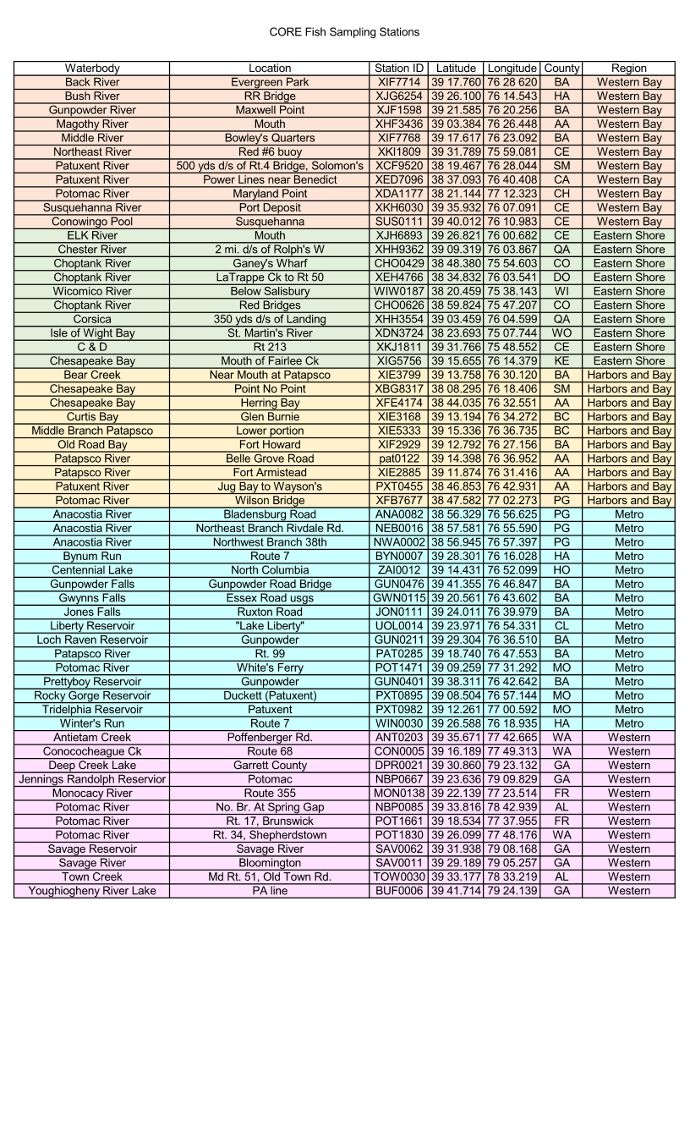

Historical Listing for CORE Sampling Stations

**Core Sampling Sites Visited on a 5 Year Cycle**

|  |  |  |  |  |  |
| --- | --- | --- | --- | --- | --- |
| **Site_Name** | **DNR_site** | **Latitude** | **Longitude** |  | **Description** |
| ARBR | ANA0082 | 38.938800 | -76.943800 | Anacostia River at Bladensburg Road | |
| BCL | XIE3799 | 39.229283 | -76.501983 | Lower Bear Creek | |
|  |  |  |  | Rt. 213 Bridge over the C&D Canal by | |
| Bdg213 | XKJ1811 | 39.529437 | -75.809204 | Chesapeake City | |
| BRSEP | XIF7714 | 39.296000 | -76.477000 | Back River, South of Evergreen Park | |
| BRU | XIF7714 | 39.295556 | -76.476111 | Upper Back River | |
| BuR | XJG6254 | 39.435000 | -76.243611 | Bush River |  |
| ByR | BYN0007 | 39.471389 | -76.266120 | Bynum Run |  |
| CentLk | ZAI0012 | 39.240520 | -76.868300 | Centennial Lake | |
| ChBayHB | XFE4174 | 38.733923 | -76.542524 | Chesapeake Bay @ Herring Bay | |
| CheR | XHH9362 | 39.155278 | -76.064444 | Chester River |  |
| ChopR | CHO0429 | 38.806339 | -75.910047 | Choptank River @ Ganey's Wharf | |
| ChR | XEH4766 | 38.580278 | -76.060278 | Choptank River |  |
|  |  |  |  | 350 YDS Downstream of Centreville | |
| CRUS | XHH3554 | 39.057657 | -76.076649 | Landing 7.5 FT Depth | |
| CtR | CHO0429 | 38.806333 | -75.910050 | Choptank River @ Ganeys Wharf | |
| CuB | XIE3168 | 39.219883 | -76.571183 | Curtis Bay |  |
| CuB2 | XIE3168 | 39.218426 | -76.551796 | Curtis Bay |  |
| DCL2 | DPR0021 | 39.514330 | -79.385540 | Deep Creek Lake | |
| ElRL | XJH6893 | 39.446667 | -76.011389 | Low/Mouth of Elk River | |
| FC | XIG5756 | 39.260900 | -76.239700 | Mouth of Fairlee Creek | |
|  |  |  |  | Old Road Bay, Sparrows Point to the west | |
| FH | XIF2929 | 39.213200 | -76.452583 | Near Ft. Howard to the east | |
|  |  |  |  | Gwynns Falls, South of Fort McHenryTunnel | |
| GFSFMT | XIE5333 | 39.257000 | -76.616000 | (Middle Branch Patapsco) | |
| GpR3 | XJF1598 | 39.359800 | -76.337607 | Gunpowder River @ Maxwell Point | |
|  |  |  |  | 0.1 Miles downstream of Merryman's Bridge | |
| GUN0211 | GUN0211 | 39.488511 | -76.608196 | Loch Raven Fish Tissue Sta. | |
| IWBNCP | XDN3724 | 38.394883 | -75.129050 | Isle of Wight Bay, North of Cedar Point | |
| JRRes | NBP0667 | 39.393933 | -79.163818 | Jennings Randolph Reservoir | |
| LLi | UOL0014 | 39.399517 | -76.905517 | Liberty Reservoir | |
| MagRa | XHF3436 | 39.056503 | -76.440475 | Magothy River at Mouth | |
| MR355 | MON0138 | 39.368617 | -77.390033 | Monocacy at Rt. 355 | |
| MRBQ | XIF7768 | 39.293700 | -76.384545 | Middle River@Bowley's Quarters | |
|  |  |  |  | Northeast Branch of Anacostia River, | |
| NEBAR | NEB0016 | 38.959683 | -76.926500 | Near Route 1 Bridge | |
| NER | XKI1809 | 39.530000 | -75.984700 | Northeast River |  |
|  |  |  |  | Northwest Branch of the Anacostia, 38th | |
| NWBAR | NWA0002 | 38.949067 | -76.957400 | Ave. crossing |  |
| PaRM | XIE2885 | 39.197850 | -76.523600 | Mid Patapsco |  |
| pat0122 | N/A | 39.239967 | -76.615867 | Just under East Patapsco Ave. overpass. | |
| PaxR | XCF9520 | 38.324454 | -76.467399 | Patuxent River 500yds. d/s of bridge | |

|  |  |  |  |  |  |  |  |
| --- | --- | --- | --- | --- | --- | --- | --- |
|  |  |  | **Core Sampling Sites Visited on a 5 Year Cycle** | | | | |
|  | **Site_Name** | **DNR_site** |  | **Latitude** | **Longitude** |  | **Description** |
|  | PaxR2 | XED7096 |  | 38.618331 | -76.673145 | Under power cable crossing 19 ft depth | |
|  |  |  |  |  |  | Midchannel at the railroad bridge ruins just below | |
|  | PaxR5 | PXT0455 |  | 38.780995 | -76.715202 | Western Branch |  |
|  | PB04 | GUN0401 |  | 39.628276 | -76.715705 | Pretty Boy Resevior | |
|  | PoRMCMP | XDA1177 |  | 38.352900 | -77.191133 | Potomac River Main Channel at Maryland Point | |
|  | PoRMDP | XDA1177 |  | 38.351900 | -77.205400 | Potomac@MD Point | |
|  | PoRNBBR | SAV0011 |  | 39.485900 | -79.083583 | N. Br. Potomac R.below Res. | |
|  | PoRNBJRR | NBP0667 |  | 39.405300 | -79.148100 | N. Br. Potomac R.Jenn. Rand. Res. | |
|  | PoRNBSG | NBP0085 |  | 39.564050 | -78.719300 | N. Br. Potomac R.Spring Gap | |
|  | PoRNBSRR | SAV0062 |  | 39.513117 | -79.138533 | N. Br. Potomac R.Savage R. Res. | |
|  | PoRSR | SAV0011 |  | 39.486482 | -79.087623 | Savage River |  |
|  | PoRSRes | SAV0062 |  | 39.532300 | -79.136140 | Savage Resevoir |  |
|  | PoRUAC | ANT0203 |  | 39.594167 | -77.711111 | Upper Potomac R.Ant Crk @ Poff Rd | |
|  | PoRUCC68 | CON0005 |  | 39.602778 | -77.821944 | Upper Potomac R.Con Crk @ MD 68 | |
|  | PoRUS | POT1830 |  | 39.434722 | -77.803056 | Upper Potomac R.Shepherdstown | |
|  | PoRWB | XFB7677 |  | 38.793028 | -77.037891 | Potomac River @ Wilson Bridge | |
|  | PRE287B | POT1661 |  | 39.308900 | -77.632583 | Potomac River, East of 287 Bridge | |
|  | PREC | PAT0285 |  | 39.312445 | -76.792242 | Patapsco River, North of Ellicott City, Catonsville | |
|  |  |  |  |  |  | Potomac River, South of Harper's Ferry, Near Rt | |
|  | PRSHE | POT1471 |  | 39.154317 | -77.521533 | 9 Bridge |  |
|  |  |  |  |  |  | 0.95 Miles upstream of dam in shallow area on | |
|  | PRSTR | PXT0982 |  | 39.204350 | -77.009867 | left side - fish tissue | |
|  |  |  |  |  |  | 1.1 Miles downstream of Ednor Rd.T.H. Duchett | |
|  | PXT0895 | PXT0895 |  | 39.141844 | -76.952102 | Res. Fish Tissue |  |
|  |  |  |  |  |  | Susquehanna River at Conowingo Pool, North of | |
|  | SRCP | SUS0111 |  | 39.666867 | -76.183050 | Rt 1 Bridge |  |
|  | SuR3 | SUS0111 |  | 39.666870 | -76.183053 | Susquehanna River @Conwigo Pool | |
|  | UPaR | XIE2885 |  | 39.216667 | -76.516667 | Upper Patapsco |  |
|  | WinR | WIN0030 |  | 39.443100 | -76.315500 | Winter's Run |  |
|  | YRL | BUF0006 |  | 39.725450 | -79.389550 | Youghiogheny R. Lake | |
|  | YRL2 | BUF0006 |  | 39.695240 | -79.402330 | Youghiogheny River Lake | |
|  |  |  |  |  |  | 1450 Yards East of Point No Point. Water depth | |
|  | XBG8317 | XBG8317 |  | 38.138372 | -76.306430 | 18 feet. |  |
|  | JON0111 | JON0111 |  | 39.400286 | -76.666010 | Falls Rd. at Old Court Rd. | |
|  | WIW0187 | WIW0187 |  | 38.341108 | -75.635372 | Gumby landing at buoy FL-53 | |
|  |  |  |  |  |  | 550 Yards due south of Port Deposit and 1100 | |
|  | XKH6030 | XKH6030 |  | 39.598978 | -76.117863 | Yards east of Lapidum. | |
|  |  |  |  |  |  | |
|  |  |  |  |  |  | |

# APPENDIX C: FISH AND SHELLFISH HANDLING IN THE LABORATORY

\

**1.1 Sample Inspection**

All laboratory personnel performing sample processing procedures should be trained or supervised by an experienced laboratory technician. Received fish fillets should be inspected carefully to ensure that they have not been compromised in any way (i.e., not properly preserved during shipment). Any specimen deemed unsuitable for further processing and analysis should be discarded and identified on the sample processing record (Figure 1-1).

**1.2 Fish/shellfish Tissue Holding Times**

If fillets or edible tissue portions have been shipped frozen on dry or wet ice, they may be distributed immediately to the technician for processing or stored in a freezer at -20°C for later processing. Once processed, tissue homogenates of fish or shellfish should be stored at -20°C. Samples will be stored frozen for no longer than the maximum holding times: six months for metals, one year for PCBs.

Note: Holding times in Table 1-1 are maximum times recommended for holding samples from the time they are received at the laboratory until they are analyzed. These holding times are based on guidance that is sometimes administrative rather than technical in nature; there are no promulgated holding time criteria for tissues. If the laboratory chooses to use longer holding times than six months for metals or one year for PCBs, it must demonstrate and document the stability of the target analyte residues over the extended holding times.

*Table 1-1. Recommendations for container materials, preservation, and holding*

*times for fish and shellfish tissues from receipt at sample processing laboratory to analysis*

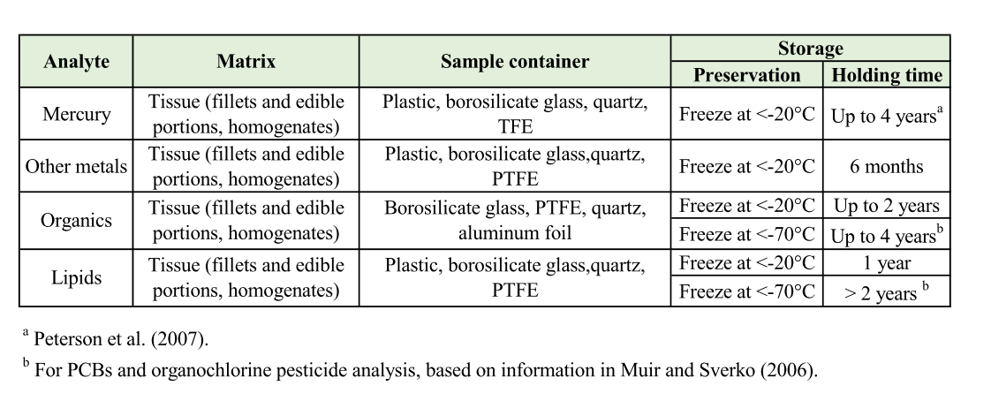

**1.3 Intra-laboratory sample transfer**

The laboratory analysts will maintain a laboratory sample-tracking record in a laboratory notebook, similar to the COC record that will follow each sample through all stages of laboratory processing. The sample- tracking record will show the date of sample extraction or preparation and sample analysis, as well as the names or initials of individuals responsible for each procedure.

**1.4 Preparation of homogenates**

Fillets are ground and homogenized prior to analysis to ensure equal distribution of contaminants throughout the sample. This section includes recommended procedures for preparing homogenate samples of fish fillets and edible portions of shellfish as required in screening and intensive studies. Detailed information follows; the general sequence is:

1. Unwrap and inspect individual fillet
2. If the size of the fillet is big, cut into small pieces to fit in a blender
3. Homogenize fillets
4. Divide homogenized sample into quarters, mix opposite quarters, and then mix halves
5. Composite equal weights (g) of homogenized fillet tissues from the selected number of fish (200-g)
6. Seal and label (200-g) composite homogenate in appropriate container(s) and store at ≤-20°C until analysis
7. Log in fish samples using chain of custody procedures

**1.4.1 Processing equipment**

Care must be taken during sample processing to avoid contaminating samples. Potential sources of contamination include dust, instruments, utensils, work surfaces, and containers that may contact the samples. All sample processing (i.e., homogenizing, compositing) should be done in an appropriate laboratory facility under clean conditions. Periodic wipe tests should be conducted in clean areas to verify the absence of significant levels of metal and organic contaminants. All instruments, work surfaces, and containers used to process samples must be of materials that can be cleaned easily and that are not themselves potential sources of contamination.

To avoid cross-contamination, all equipment used in sample processing (i.e., dissecting, homogenizing, and compositing) should be cleaned thoroughly before each composite sample is prepared. Verification of the efficacy of cleaning procedures should be documented through the analysis of processing blanks or rinsates. Because sources of organic and metal contaminants differ, it is recommended that duplicate samples be collected, if time and funding permit, when analyses of both organics and metals are required (e.g., for screening studies). One sample can then be processed and analyzed for organics and the other can be processed independently and analyzed for metals. If fish are of adequate size, separate composites of individual fillets may be prepared and analyzed independently for metals and organics. If only one composite sample is prepared for the analyses of metals and organics, the processing equipment must be chosen and cleaned carefully to avoid contamination by both organics and metals. Suggested processing equipment and cleaning procedures by analysis type are discussed here, but other procedures may be used if it can be demonstrated, through the analysis of appropriate blanks, that no contamination is introduced.

Sample processing procedures are discussed in the following sections. Data from each procedure should be recorded directly in a bound laboratory notebook or on forms that can be secured in the laboratory notebook. A sample processing record for fish fillet composites is shown in Figure 1-1.

**1.4.2 Samples for organics analysis**

Equipment used in processing samples for organics analysis should be of stainless steel, anodized aluminum, borosilicate glass, PTFE, ceramic, or quartz. Polypropylene and

polyethylene (plastic) surfaces, implements, gloves, and containers are a potential source of contamination by organics and should not be used. If a laboratory chooses to use these materials, there should be clear documentation that they are not a source of contamination. Filleting should be done on PTFE cutting boards that are cleaned properly between fish or on cutting boards covered with heavy duty aluminum foil that is changed after each filleting. Tissue should be removed and handled with clean, high quality, corrosion- resistant stainless steel or quartz instruments. Fillets or tissue homogenates may be stored in borosilicate glass, quartz, or PTFE containers with PTFE-lined lids or in heavy duty aluminum foil. Prior to preparing each composite sample, utensils and containers should be washed with detergent solution, rinsed with tap water, soaked in pesticide-grade ethanol, and rinsed with deionized water. Work surfaces should be cleaned with pesticide-grade isopropanol or acetone, washed with distilled water, and allowed to dry completely. Knives, fish scalers, measurement boards, etc., should be cleaned with pesticide-grade isopropanol or acetone followed by a rinse with contaminant-free distilled water between each fish sample.

**1.4.3 Samples for metals analysis**

Equipment used in processing samples for metals analyses should be of quartz, PTFE, ceramic, polypropylene, or polyethylene. The predominant metal contaminants from stainless steel are chromium and nickel. If these metals are not of concern, the use of high-quality, corrosion-resistant stainless steel for sample processing equipment is acceptable. Quartz utensils are ideal but expensive. For bench liners and bottles, borosilicate glass is preferred over plastic. Knives with titanium blades and PTFE handles are recommended for performing tissue resections. Borosilicate glass bench liners are recommended. Filleting may be done on glass or PTFE cutting boards that are cleaned properly between fish or on cutting boards covered with heavy duty aluminum foil that is rinsed after each fish. Foil is changed after each composite is processed (i.e., after the five fish intended to comprise one composite sample are filleted). Fillets or tissue homogenates may be stored in plastic, borosilicate glass, quartz, or PTFE containers. Prior to preparing each composite sample, utensils and containers should be cleaned thoroughly with a detergent solution, rinsed with tap water, soaked in acid, and then rinsed with metal -free water. Quartz, PTFE, glass, or plastic containers should be soaked in 50 percent HN03 for 12 to 24 hours at room temperature.

Note: Chromic acid should not be used for cleaning any materials. Acids used should be at least reagent grade. Stainless steel parts may be cleaned as stated for glass or plastic, omitting the acid soaking step.

**1.4.4 Preparing individual homogenates**

To ensure even distribution of contaminants throughout tissue samples and to facilitate extraction and digestion of samples, the fillets from individual fish must be ground and homogenized prior to analysis. The fillets from an individual fish may be ground and homogenized separately or combined, depending on the analytical requirements and the sample size. Fish fillets should be ground and homogenized using an automatic grinder or highspeed blender or homogenizer. Large fillets may be cut into 2.5-cm cubes with high-quality stainless steel or titanium knives or with a food service band saw prior to homogenization. For metal analysis, parts of the blender or homogenizer used to grind the tissue (i.e., blades, probes) should be made of tantalum or titanium rather than stainless steel. Stainless steel blades and/or probes have been found to be a potential source of nickel and chromium contamination (due to abrasion at high speeds) and should be avoided.

Grinding and homogenization of tissue is easier when it is partially frozen. Chilling the grinder/blender briefly with a few chips of dry ice can help keep the tissue from sticking to it. The

fillet sample should be ground until it appears to be homogeneous. The ground sample should then be divided into quarters, opposite quarters mixed together by hand, and the two halves mixed together. If chunks of tissue are present at this point, the grinding and homogenization should be repeated.

Note: Skin-on fillets of some finfish species are especially difficult to homogenize completely. No chunks of tissue or skin should remain in the sample homogenate because these may not be extracted or digested efficiently and could bias the analytical results. If complete homogenization of skin-on fillets for a particular target species is a chronic problem or if local consumers are likely to prepare skinless fillets of the species, the state should consider analyzing skinless fillet samples. If the sample is to be analyzed for metals only, the ground tissue may be mixed by hand in a polyethylene bag. The preparation of each individual homogenate should be noted (marked with a check) on the sample processing record. At this time, individual homogenates may be either processed further to prepare composite homogenates or frozen separately and stored at -20°C.

**1.4.5 Preparing composite homogenates**

Composite samples are prepared from at least five but no more than 10 individuals of the same species and should be of the same general size class. Individuals of different species are never mixed to form composite samples.

Composite homogenates should be prepared from equal weights of individual homogenates. The same type of individual homogenate (i.e., either single fillet or combined fillet) should always be used in a given composite sample. If individual homogenates have been frozen, they should be thawed partially and rehomogenized prior to weighing and compositing. Any associated liquid should be kept as a part of the sample. The weight of each individual homogenate used in the composite homogenate should be recorded, to the nearest 0.1 gram, on the sample processing record (Figure 1-1). Each composite homogenate should be blended as described for individual homogenates. The composite homogenate may be processed immediately for analysis or frozen and stored at -20°C. The remainder of each individual homogenate should be archived at -20°C with the designation "Archive" and the expiration date recorded on the sample label. The location of the archived samples should be indicated on the sample processing record under “Notes”. It is essential that the weights of individual homogenates yield a composite homogenate of adequate size to perform all neceWSAry analyses. The total composite weight required for intensive studies may be less than that for screening studies if the number of target analytes is reduced significantly. The recommended sample size of 200 g for screening studies is intended to provide sufficient sample material to analyze for all recommended target analytes at appropriate detection limits; (2) meet minimum QC requirements for the analyses of laboratory duplicate, matrix spike, and matrix spike duplicate samples; and (3) allow for reanalysis if the QC control limits are not met or if the sample is lost. However, sample size requirements may vary among laboratories and the analytical methods used. Each program manager must consult with the analytical laboratory supervisor to determine the actual weights of composite homogenates required to analyze for all selected target analytes at appropriate detection limits.

It is recommended that separate composite homogenates be prepared for the analysis of metals and organics if resources allow.

Shellfish samples should be shipped or brought to the sample processing laboratory either on wet or blue ice (if next-day delivery is assured) or on dry ice. Shellfish samples arriving on wet ice or blue ice should have edible tissue removed and should be frozen to -20°C within 48 hours after collection. Shellfish samples that arrive frozen (i.e., on dry ice) at the processing laboratory

should be placed in a -20°C freezer for storage until edible tissue is removed. Composite samples of the edible portions of shellfish should be homogenized in a grinder, blender, or homogenizer that has been cooled briefly with dry ice. For metals analysis, tissue may be homogenized in 4 -oz polyethylene jars using a Polytron equipped with a titanium generator. If the tissue is to be analyzed for organics only, or if chromium and nickel contamination are not of concern, a commercial food processor with stainless steel blades and glass container may be used. The composite should be homogenized to a paste- like consistency. Larger samples may be cut into 2.5 -cm cubes with high-quality stainless steel or titanium knives before grinding. If samples were frozen after dissection, they can be cut without thawing with either a knife-and-mallet or a clean bandsaw. The ground samples should be divided into quarters, opposite quarters mixed together by hand, and the two halves mixed together. No chunks should remain in the sample because these may not be extracted or digested efficiently. At this point, the composite homogenates may be processed for analysis or frozen and stored at -20°C.

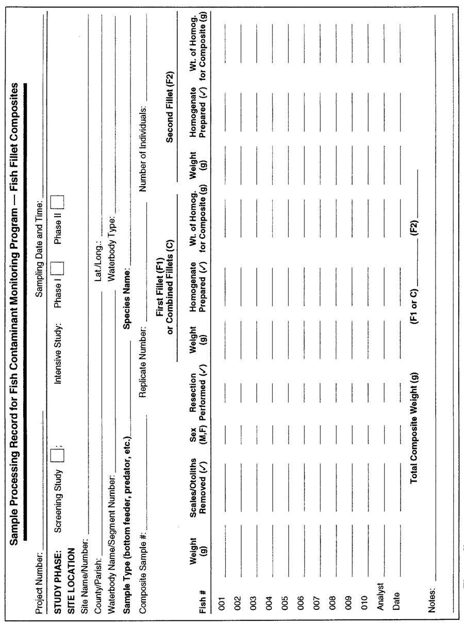

*Fig 1-1. Sample processing record for fish contaminant monitoring program (fish fillet composites).*

**1.5 Sample distribution**

The sample processing laboratory should prepare aliquots of the composite homogenates for analysis, distribute the aliquots to the appropriate laboratory (or laboratories), and archive the remainder of each composite homogenate.

Note: Because lipid material tends to migrate during freezing, frozen composite homogenates must be thawed and rehomogenized before aliquots are prepared. Samples may be thawed overnight in an insulated cooler or refrigerator and then homogenized. The actual sample size required will depend on the analytical method used and the laboratory performing the analysis. Therefore, the exact sample size required for each type of analysis should be determined in consultation with the analytical laboratory supervisor.

The exact quantity of tissue required for each digestion or extraction and analysis should be weighed and placed in an appropriate container that has been labeled with the aliquot identification number, sample weight (to the nearest 0.1 g), and the date aliquots were prepared. The analytical laboratory can then recover the entire sample, including any liquid from thawing, by rinsing the container directly into the digestion or extraction vessel with the appropriate solvent. It is also the responsibility of the processing laboratory to provide a sufficient number of aliquots for laboratory duplicates, matrix spikes, and matrix spike duplicates so that the QC requirements of the program can be met, and to provide extra aliquots to allow for reanalysis if the sample is lost or if QC control limits are not met.

It is essential that accurate records be maintained in a laboratory notebook when aliquots are prepared for analysis. The composite sample identification number, as assigned by MDE at the time of collection and delivery to the lab, should be carried through sample processing. The aliquot identification number should indicate the analyte class (e.g., MT for metals, OR for organics) and the sample type (e.g., R for routine sample; RS or a routine sample that is split for analysis by a second laboratory; MS1 and MS2 for sample pairs, one of which will be prepared as a matrix spike).

Laboratory duplicates should be introduced by preparing two separate aliquots of the same composite homogenate and labeling one aliquot with a "dummy" composite sample identification. The duplicate samples will be analyzed in the laboratory along with the regular samples.

*Final Sample:* The final individual or composite samples should be composed of at least 20 g oftissue to ensure an adequate amount of material for analysis. Metals samples are placed in foil cups with foil-lined lids and labeled. Organics samples are wrapped in aluminum foil, dull side against the tissue, then wrapped in plastic to prevent desiccation. All samples are then analyzed or frozen immediately and stored at -20°C for later analysis.

# APPENDIX D: ANALYSIS OF FISH AND SHELLFISH TISSUE

The laboratory will provide to MDE a list of analytes for which lab has demonstrated capabilities, documented methods, method detection limits (MDLs), and SOPs (see Appendices E and F for SOPs for mercury and PCBs analyses).

**1.1 Laboratory Records**

Laboratory log books will be maintained for each of the following:

* sample preparation,
* use and maintenance of the accelerated solvent extractors,
* use and maintenance of the high-performance liquid chromatograph (HPLC),
* use and maintenance of the gas chromatograph/mass spectrometer (GC/MS),
* use and maintenance of the elemental analyzer/-isotopic ratio mass spectrometer (EA/IRMS), and
* use and maintenance of the thin-layer chromatograph-flame ionization detector (TLC/FID).

Final analytical results will be generated and maintained in electronic database files with frequent backup and storage on permanent media.

**1.2 Data and Data Documentation**

The laboratory will provide data tables and quality assurance (QA) documentation suitable for QA assessment. All original data and data documentation developed by the laboratory for a given data package will be kept by the laboratory for at least one year after the data have been validated and reported; and if requested, the data will be stored in the collection format for up to five years.

**1.3 Assessment of Data Quality**

The overall QA objectives are to ensure development of analytical data of known and acceptable quality. The quality of data required is specified in qualitative and quantitative data quality objectives (DQOs). These objectives usually are expressed in terms of precision, accuracy, representativeness, comparability, completeness, and sensitivity. Data quality is assessed by applying the specific acceptance criteria to QA elements.

**1.3.1 Precision**

Precision is the degree of agreement among individual measurements of the same property under prescribed similar conditions (e.g., replicate measurements of a particular analyte in one sample). Laboratory precision is evaluated using laboratory replicates of field samples and Standard Reference Materials (SRMs) when available. The use of SRMs allows for the long-term measurement of precision, whereas replicates of field samples can indicate the precision for a particular group of samples. Precision will be expressed as the relative standard deviation (RSD) for repeated measurements. The RSD is an estimate of the average standard error in a measurement; this estimate generally improves with increasing number of replicates. Reproducibility is affected by sample collection procedures and matrix variations, as well as the extraction and analytical procedures used. It is recognized that, typically, precision erodes as the limit of detection is approached.

**1.3.2 Accuracy**

Accuracy is the degree of agreement of a measurement with an accepted (e.g., certified or published) value. Laboratory accuracy will be evaluated through the use of SRMs when available. For a particular SRM, accuracy for an analyte will be assessed by comparing the measured value to a value accepted (i.e., certified or published) by the certifying agency (i.e., the National Institute of Standards and Technology [NIST]).

**1.3.3 Representativeness**

Representativeness expresses the degree to which data accurately and precisely represent a defined or particular characteristic of a population, parameter variations at a sampling point, a processed condition, or an environmental condition. Representativeness is a qualitative parameter that is dependent upon the proper design of the sampling program (as addressed in a sampling plan) and proper laboratory protocol. Evaluation of the data for reference materials and replicate field samples may provide an assessment of the representativeness of the analyte measurements for field samples.

**1.3.4 Comparability**

Comparability is a qualitative parameter expressing the confidence with which one data set can be compared to another, as well as the potential for combining the data with that generated outside of the present project. Comparability of the analytical data is established using the following:

* program-defined analytical methodology, quantitation limits, reporting units, and quality assurance measurements,
* NIST-traceable (or other) calibration standards and SRMs, when available, and
* participation in interlaboratory comparison exercises.

**1.3.5 Completeness**

Completeness is defined as the percentage of measured data that meet the DQOs as determined by the QA review process. A typical analytical completeness goal for a project is 90% (i.e., no more than 10% of the analytical data will be qualified as unreliable, meaning they do not meet the DQOs). Data qualified as estimated as a result of QA criteria not being met will be considered usable.

**1.3.6 Sensitivity**

Sensitivity refers to the capability of a method to measure the analytes at low levels. For each method, criteria are established for the minimum concentrations that can be measured with known and acceptable quality.

**1.4 Quality Assurance Procedures**

Prior to the analysis of samples, the laboratory will specify written protocols for the analytical methods to be used and will identify the analytes to be quantified. If a method is significantly modified, the written analytical protocol will be amended. QA procedures are presented with each analytical method and are applied to each batch (i.e., group of field samples and QA

samples analyzed concurrently). The laboratory also must demonstrate its continued proficiency by participation in refereed intercomparison exercises, as available.

**1.4.1 Laboratory operations**

The laboratory will have the appropriate facilities to store and prepare samples and the appropriate instrumentation and staff to provide data of the required quality within the time period indicated. The laboratory is expected to conduct operations using good laboratory practices (GLP), including:

* performing scheduled maintenance of analytical balances, laboratory equipment, and instrumentation,
* validating instrument calibration standards, and
* recording pertinent analytical data in logbooks with each entry signed and dated by the analyst.

Personnel should be well versed in GLP, including standard safety procedures. It is the responsibility of the laboratory project manager to ensure that mandatory safety training is completed by all laboratory personnel. The laboratory is responsible for maintaining a current safety manual in compliance with the Occupational Safety and Health Administration or equivalent state or local regulations. Proper procedures for safe storage, handling, and disposal of chemicals should be followed at all times; each chemical should be treated appropriately based on its potential health hazard.

**1.4.2 Quality Assurance Documentation**

All participants in a project must have the current version of the Quality Assurance Plan (QAP). In addition, the following documents and information must be current and available to all laboratory personnel participating in the processing of samples:

* laboratory SOPs—the detailed instructions for performing routine laboratory procedures,
* instrument performance information—for example, information on instrument calibration, range of response and stability, and
* QA information—QA tables will be developed and maintained throughout the project for all appropriate analyses and measurements.

The SOPs used in the analyses of samples depend on the project and the analytes to be determined. All analytical methods will be in accordance with this SOP unless a modification is required. In that case, an addendum to the SOP will be prepared and provided to MDE.

**1.4.3 Participation in intercomparison exercises**

The analytical laboratory is required to participate, whenever possible, in the intercomparison exercises managed by the NIST or the International Atomic Energy Agency (IAEA). A variety of samples including accuracy-based solutions, sample extracts, and representative matrices (e.g.,

tissue samples) is used in these exercises, which typically take place once a year. Upon review of the results, if the laboratory fails to achieve acceptable performance, it will be required to undertake appropriate corrective actions.

**1.4.4 Quantitation range**

For each GC/MS method (for polycyclic aromatic compounds and POPs), the lower limit of quantitation (LOQ) for a given analyte in a specific sample is the concentration that would be calculated if that analyte had a GC/MS response area equal to its area in the lowest level calibration standard used in the calibration. When an analyte is not detected in a sample or it has a response area that is smaller than its area in the lowest level calibration standard used, the concentration of the analyte in that sample is reported to be less than the value of its lower LOQ. When a specific analyte in a particular sample has a GC/MS response area that is larger than its area in the highest level calibration standard used in the calibration, the analyte amount is calculated using the relative response factor of that analyte in the highest level calibration standard used; the concentration is footnoted as exceeding the calibration range and is therefore an estimate.

For the HPLC/ Photo Diode Array (PDA) method, the lower LOQ for a given analyte in a sample is the concentration that would be calculated if the analyte had a PDA response area equal to the minimum area needed to positively identify that analyte using the PDA spectral library. When an analyte is not detected in a sample or it has an area that is smaller than its minimum area, the concentration of the analyte in that sample is reported to be less than the value of its lower LOQ.

For the TLC/FID method, a linear relationship between the amount of lipid spotted on a Chromarod and the FID response is needed for accurate lipid quantitation. Suitable ranges of the lipid amounts have been determined to be as follows: 0.30–7.5 microgram (μg) for sterol/wax esters, 0.30–7.5 μg for triglycerides, 0.25–10 μg for free fatty acids, 0.050–0.70 μg for cholesterol/sterols, and 0.050–1.0 μg for phospholipids/other polar lipids. In order for the amount of lipid to fall within the linear range of each lipid class, the volumes of the extracts are routinely adjusted as necessary, depending on the matrix, by diluting or concentrating the extracts and then reanalyzing the sample. If a lipid class is not detected in a sample (i.e., no signal above the baseline), a value of zero is reported for the proportion of that lipid class. For the semiquantitative HPLC/fluorescence method, the amplitude of each analyte peak must remain on scale. If a peak amplitude goes “off scale” (i.e., recognized when the top of the peak is flat), the bile sample is diluted and reanalyzed. If an analyte peak is not detected in a sample (i.e., no signal above baseline), a value of zero is reported.

**1.4.5 Quality assurance criteria for the analytical measurements**

QA elements are included in the analyses of every batch of samples. The results for the various QA elements are reviewed by laboratory personnel immediately following the analysis of each sample batch. These results are then used to determine when acceptance criteria have not been met and which corrective actions are required before analyses may proceed.

**1.4.6 Calibration**

Calibration for all methods is established before or during sample analyses and documentation is archived with the sample data. The GC/MS and TLC/FID methods require at least four

concentration levels of calibration standards for analyte quantitation. The HPLC/PDA method uses at least four concentration levels of calibration standards to demonstrate the linearity of the detector’s response and a single level for analyte quantitation. The HPLC/fluorescence method uses a single calibration point based on the average of the responses for repeated analyses of the calibration standard.

**1.4.7 Continuing calibration verification**

Continuing calibration verification (CCV) standards will be analyzed at the specified frequency, including at the beginning and end of every batch of samples. If CCV results do not meet specified criteria, then the entire batch and calibration standards must be reanalyzed. For the GC/MS and HPLC/PDA methods, the CCV standards’ RSD of the analyte responses relative to the internal standard must be less than or equal to 15% for the repetitions.

For the TLC/FID method, the measured values for the CCV standards must be plus or minus 15% of the expected values. For the HPLC/fluorescence method, the RSD of the responses for the standard must be less than or equal to 10% for the repetitions.

**1.4.8 Reference materials**

At least one SRM from NIST, if available, is analyzed with every batch of field samples for quality assurance. The data resulting from the analyses of SRMs are reported in the same manner as field samples and are used to document the estimated accuracy of the associated field sample data. If the SRM results exceed the control limit criteria, then the entire batch of samples is to be considered suspect. The source of the error must be identified and corrected, and the samples may need to be reanalyzed, depending on the project requirements.

The laboratory’s performance for polycyclic aromatic compounds (PACs) or POPs by the GC/MS method is considered acceptable if greater than or equal to 70% of reported values are within their control limits:

* Upper control limit = [1.3 × (certified concentration + uncertainty value for 95% confidence)].
* Lower control limit = [0.7 × (certified concentration – uncertainty value for 95% confidence)].

For all GC/MS methods, acceptance criteria do not apply to analytes that:

1. have a lower LOQ that is above the lower control limit,
2. that coelute with other compounds, or
3. do not have calibration standards available.

The laboratory’s performance for POPs by the HPLC/PDA method is considered acceptable if greater than or equal to 70% of reported values are within their control limits:

* Upper control limit = [1.35 × (certified concentration + uncertainty value for 95% confidence)].
* Lower control limit = [0.65 × (certified concentration – uncertainty value for 95% confidence)].

These criteria apply only to those congeners that are greater than 10 times the lower LOQ and those that are free from coeluting substances.

There are no tissue SRMs certified for lipid classes.

**1.4.9 Surrogate (internal standard) recovery**

All samples analyzed for PACs and POPs will be spiked with appropriate extraction surrogates (internal standards) as described in the laboratory SOPs. If a percent recovery does not meet the specified criteria, the sample will be re-extracted and reanalyzed if possible (i.e., if the sample is still available); otherwise the corresponding data will be qualified as being an estimate. For the GC/MS analyses, the measured percent recovery of the surrogates must be 60–130%; for the HPLC/PDA analyses, the measured percent recovery of the surrogates must be 60–120%.

**1.4.10 Method (reagent) blanks**

Method blanks are laboratory-derived samples that are subjected to the same analytical protocols as are the field samples. Failure to meet acceptance criteria requires definitive corrective action to identify and eliminate the source(s) of contamination before the subsequent re-extraction or reanalysis of the batch of samples or both.

For the GC/MS methods, no more than five analytes in a method blank may exceed two times the value of the lower LOQ. For the HPLC/PDA method, no more than four analytes in a method blank may exceed four times the value of the lower LOQ, unless the analyte is not detected in any of the field samples in the batch.

For the TLC/FID method, no peaks may be detected in a method blank. For the HPLC/fluorescence method, PAC equivalents in the blank must be less than 10% of the lowest concentration in any field sample in the analytical sample batch.

**1.4.11 Sample replicates**

Field samples will be analyzed in replicate at the specified frequency to help ascertain whether samples are analytically homogeneous and to indicate whether other problems with reproducibility occurred during analysis. The reproducibility of the SRM results can indicate the precision for all analyses in the project.

For GC/MS analyses, replicate (i.e., duplicate or triplicate) samples are analyzed with approximately every 20 field samples, as sample amounts allow. RSDs are to be less than or equal to 15% (equivalent to relative percent difference ≤ 30% for duplicates) for greater than or equal to 90% of the analytes. For PACs and POPs, this applies only to those analytes that have concentrations greater than or equal to 1 ng/g.

For HPLC/PDA and HPLC/fluorescence analyses, duplicate samples will be analyzed approximately every 20 field samples. The RSDs are to be less than or equal to 30% (relative percent difference ≤ 60% for duplicates) for greater than or equal to 80% of analytes detected.

For lipid classes by TLC/FID, duplicate samples will be analyzed at every 28 or fewer field samples. The RSDs are to be less than or equal to 25% (relative percent difference ≤ 50% for duplicates).

**1.5 Laboratory Qualification of Data**

Sample results that did not meet the quality assurance acceptance criteria or that presented analytical difficulties are footnoted by the laboratory so that the data user is aware of the potential limitations of the data. These footnotes are summarized and presented in text (e.g., a report or case narrative) accompanying the data.

**1.6 Data Reduction**

Data reduction is the process whereby raw data (analytical measurements) are converted or reduced to usable results that are reported in the format specified for the project, including QA data. Primary data reduction is the responsibility of the analyst(s) conducting the analytical measurements, and is subject to further review by laboratory staff, the project leader, and the project manager(s).

Primary data reduction requires accounting for specific sample preparations, sample volume or weight analyzed, and any concentrations or dilutions required. All data reduction procedures are described in the laboratory’s SOPs.

**1.6.1 Reported results**

In general, results are reported as follows:

* For GC/MS and HPLC/PDA analyses for PACs and POPs, analytes in tissues are reported as ng/g wet weight.
* To two (or, if requested, three) significant figures for polycyclic aromatic compounds and POPs, and to one figure following the decimal point for percent lipid (by TLC/FID).
* For GC/MS and HPLC/PDA analyses, the analyte concentrations are calculated based on the surrogate compounds spiked into the sample prior to extraction.
* For GC/MS and HPLC/PDA analyses, percent recoveries of surrogate standards are reported.
* Results for analytes in method blanks are reported on the same basis as those for the samples being analyzed. The average of the sample weights for the field samples comprising a batch is used in the calculations for the method blank.
* For PACs and POPs, the lower LOQ is reported instead of a concentration when an analyte is below the quantitation range.
* If a lipid class is not detected in a sample, a value of zero is reported for the proportion of that lipid class.
* Replicate sample data are summarized as the mean plus or minus RSD.

**1.6.2 Data review**

Data review is an internal process during which the data are reviewed and evaluated by laboratory personnel. This review is undertaken by analysts who are responsible for ensuring that the analytical data are correct and complete, the appropriate SOPs have been followed, and the QA results meet the acceptance criteria. It is the project manager’s responsibility to ensure that all analyses performed by the laboratory are correct, complete, and meet project DQOs. The project leader has final review authority.

**1.6.3 Laboratory data deliverables**

The laboratory reports any difficulties encountered during sample preparation and analysis, as well as any limitations to the use of the data. In addition, the following specific information will be provided as requested:

* COC/sample receipt checklist,
* procedure modifications,
* calibration summaries (initial calibration data, correlation coefficients for HPLC/PDA method, continuing calibration data),
* data tables for field samples,
* QA data (surrogate recoveries, method blanks, SRMs, replicate field samples), as applicable, and
* corrective actions that were necessary.

**1.7 Corrective Action/Procedure Alteration**

The laboratory is required to adhere to the SOPs specified for the project unless procedure alterations are necessary to correct unforeseen analytical problems. Laboratory personnel are alerted that corrective action is necessary when QA data do not meet the acceptance criteria. Because most of the corrective actions are handled at the laboratory level, it is the immediate responsibility of the analyst to identify and correct the situation before continuing with sample analysis. If the problem persists or cannot be identified, the matter is referred to the project leader or project manager for further investigation. Once resolved, a narrative describing 1) the problem, 2) the steps taken to identify and correct the problem, and 3) the action taken to remedy the problem in the relevant sample batches, must be prepared and submitted with the relevant data package. If the action involves a change from the accepted SOP, the SOP must be revised as appropriate.

**1.8 Sample Archival**

All unanalyzed samples and unused sample aliquots or extracts will be held by the laboratory in a manner to preserve sample integrity (e.g., at -20°C to -80°C) for at least one year or a

specified time period after the data have been validated, as agreed upon by the project leader and the principal investigator(s).

# APPENDIX E: Procedures for Methyl Mercury

**Standard Operating Procedures for the Collection, Processing and**

**Determinations of the Total Mercury Concentrations in Fish Fillets**

|  |
| --- |
|  |
|  |

**Overview**

This report is divided into four main topics: 1) field collection, sample preparation and transfer of fish samples to the Appalachian Laboratory (Lab), 2) selected laboratory work at Lab, 3) quality assurance and quality control (QAQC) procedures, and 4) summary of material in our data reports. Some of the main topics are subdivided into sections devoted to issues associated with the main topic. Topic two describes the protocols used to prepare the individual and composite homogenized fish samples and our total mercury analysis method. Topic three describes the protocols used to calibrate our Tekran 2600 Mercury Analyzer and protocols necessary to determine the precision and accuracy of our results.

**1) Collection, Preparation and Transfer of Fish to the Appalachian Laboratory (Lab)**

The sampling team will determine the fish species and size of fish collected at each location. The length and weight of each individual fish will be measured before the fish are filleted by the sampling team. The sex of each fish could also be determined, if needed. The sampling team will determine the method used to fillet each fish (e.g. with or without skin and/or ribs). *If needed, whole fresh fish can be delivered to Lab on the day of collection. Immediately upon arrival at Lab, trained personnel will fillet each fish. A few days of advanced notice are needed to make this happen.* Each fish fillet should will be wrapped separately in aluminum foil and labeled with appropriate identifying information. All fish fillets from the same location should be placed in a single plastic bag and stored in a cooler with wet, blue or dry ice. The preapproved Chain of Custody (COC) form should be completed by the field supervisor. An accurate COC must accompany each fish sample throughout the entire process, from sample collection to final storage of analyzed samples.

Transfer of fish fillets to Lab should be coordinated by the sampling team supervisor and the laboratory supervisor at Lab. It is best to hand carry the frozen fish fillets to the Lab or have personnel from Lab pick up the frozen fish fillets from the shipper. During the transfer, personnel from Lab will locate and inspect every individual fish listed on the COC and note their condition. Individual fish should be properly wrapped, labeled, and frozen. If the COC matches the data for each individual fish, then the COC will be signed by personnel from Lab and the sampling team. If there are problems with the COC or the fish are not frozen, these problems must be resolved and recorded on the COC before fish are transferred to Lab. After the transfer, the fish fillets will be stored at -21oC in a freezer equipped with a temperature alarm that calls Dr. Castro when the temperature rises above -21oC. At Lab, data from the COC will be entered into a laboratory record book and/or a computer database. Lab will store copies of the COC, laboratory record book and/or computer database for at least three years.

**2) Selected Laboratory Work**

* Individual Homogenates

The homogenization procedure works best if the fish fillets are partially frozen. First, each fish fillet is carefully weighed and recorded on a data sheet. Next, each individual fish fillet is ground and homogenized using separate ultra cleaned high speed choppers. Large fillets may be cut into 2.5-cm cubes with high-quality stainless steel knives before homogenization. The choppers are made of stainless steel and polycarbonate, which will not contaminate the fish samples. The homogenized individual fillets are then processed to make a composite sample for the total mercury analyses, as described in the next section. The homogenized individual fish samples not used in the composite are placed in two sealed ultra-clean plastic bags and stored at -21oC. Both plastic bags are labeled with appropriate identifying information and current date.

* Composite Homogenates

Composite samples will be made from five individually homogenized fish. Fish for each composite sample have lengths within 75% of each other. These lengths are listed on the COC form. After the five fish for each composite sample are determined, we measure and record the weight of each homogenized fish sample. *We try to prepare a 100 gram composite homogenate sample using equal weights from all five individual fish homogenates. This 100 gram composite sample is more than sufficient to meet our QAQC requirements and for reanalysis, if necessary. However, the weight of the smallest fish in each composite is the limiting factor. For example, if our smallest fish weighed 15 grams than we would use a 10 grams of each of individual to prepare a 50 gram composite sample*. After the target weight for each individual is determined, this target weight of homogenized fish tissue is carefully weighed and added to an ultra clean chopper. After equal weights of all five individuals are added to the chopper, the fish in the chopper are thoroughly homogenized to create a well mixed composite sample. Each composite sample is placed in an ultra clean I-Chem bottle. The bottles are labeled with the appropriate composite identification and current date. These bottles are placed in two sealed plastic bags and then stored at -21o C freezer. The outside bag is appropriately labeled.

* Total Mercury Determinations

First, one to three grams of the homogenized composite or homogenized individual samples will be digested in a 5 ml solution of sulfuric (70%) and nitric (30%) acid in 30 ml pre-cleaned Teflon bottles. The Teflon bottles are appropriately labeled, double bagged and heated for at least 4 hours at 60oC. After the fish tissue is completely digested, the solution is cooled to room temperature and 25 to 50 ul of the digested fish-acid solution and 0.25 ml BrCl are added to 50 ml of D.I. (distilled deionized) water in a 60 ml ultra clean Teflon vial. Approximately 24 hours later, samples are pre-reduced with NH2OH-HCL and further reduced with SnCl2 and analyzed with a Tekran Model 2600 cold vapor atomic fluorescence spectrometric (CVAFS) system using EPA Method 1631.

**3) Quality Assurance and Quality Control (QAQC)**

During each total mercury analysis, we will analyze about 25 fish samples. All fish samples from each location will be analyzed on the same analysis date. On each analysis date, we accurately calibrate our Terkan 2600 total mercury analyzer (described below). We will also analyze several laboratory blanks, reagent solutions, acid wash and acid digestion solutions. Each analysis includes several assessments of our analytical precision and accuracy.

* Instrument Calibration

Our Tekran 2600 will be calibrated with standards that are expected to bracket the total mercury concentration in the fish samples. All samples must give instrument responses (area counts and/or concentrations) between our lowest and highest standard concentrations. If a fish sample is outside this range then it is not valid, and will be reanalyzed following dilution(s) or other adjustments. We analyze each standard concentration twice, which is a measure of the analyst’s precision. We calculate the response factor for all standard concentrations. The response factor is the area counts divided by the standard concentration. The average coefficient of variation of all response factors must be less than 10% to move on to the analysis of blank solutions. We also check the accuracy of our calibration with check solutions of know concentration, made using materials not used to make our standards. From past work, our 2.0 ng/L instrument check solution had an average total mercury concentration of 1.98 ng/L, ranging from 1.8 to 2.2 ng/L (n = 65).

* Blank Solutions

We use a strong acid solution to rinse our Tekran 2600 between fish samples. We measure the total mercury concentrations in this acid solution several times during each analysis. In addition, we measure the total mercury in D.I water, reagents blanks and the acid solution used to digest the fish tissue. Total mercury concentrations in our D.I. water typically ranges from below detection limits (BDL) to 0.03 ng/L. Total mercury in acid digestion blanks are typically (n = 25) BDL. Total mercury concentrations in reagents blanks are typically very low to BDL. Detectable total mercury concentrations, if present, in our reagent blanks and acid digestion solutions will be subtracted for the sample concentrations.

* Precision and Accuracy Assessments

During each analysis, we will assess the precision and accuracy of our total mercury concentrations. We propose to make triplicate measurements of the total mercury concentration in three randomly selected fish composites. Each of the selected triplicates will be separately digested and analyzed on each analysis date. We will also make triplicate measurement of the total mercury concentration in the same digested composite fish sample. These two approaches will give us information about our homogenization protocol and analytical precision.

To determine the accuracy of our results, we will measure total mercury concentrations in certified reference material and determine the recovery of mercury added to composite fish samples. In the past, we measured the total mercury concentration in DORM 2, dogfish muscle tissue, purchased from the National Research Council of Canada. We typically measured total mercury concentrations between 4.34 to 5.13 ug/g with an average of 4.69 ug/g. The certified reference concentrations for DORM-2 range from 4.38 to 4.90. For this project, we propose to measure the total mercury concentration in DORM-3 from the National Research Council of Canada. DORM-3 contains 0.382 + 0.06 ug/g of total mercury, which is closer to the expected mercury concentration in the fish samples. We will analyze triplicate DORM-3 samples with each set of fish samples. We will also randomly spike selected fish samples with known amounts of total mercury to determine the recovery efficiency. We propose to spike three different fish samples for each analysis date. From several past studies, recovery of matrix spikes (n = 10) ranged from 85 to 105 %, with an average of 97.5 %.

* Sample Storage

All fish samples: unprocessed fillets, homogenized individual fillets and homogenized composite fillets will be stored at -21oC. These samples will be appropriately labeled and sealed inside plastic bags to minimize exposure to ambient air. We propose to analysis all samples within a couple of months of field collection. According to studies conducted at the Chesapeake Biological Laboratory, fish samples for total mercury determinations can be stored for at least one year without affecting the total mercury concentration in the fish tissue.

**4) Data Reports**

Data from each set of fish samples will be described in a brief data report. This report will summarize important sampling, processing, transferring, COC and analytical issues. This report will detail the results of our QAQC program and summarize of the total mercury concentration data. The results of the analysis will be placed in the AWQMS Import Configuration excel file, originating with Amy Laliberte, and then emailed to Amy Laliberte with results and any pertinent Detection limits needed for Data Collection.

# APPENDIX F: Procedures for PCB’s

**Measurement of PCBs in Fish samples collected by MDE**

Project summary:

The Maryland Department of Environment collects fish samples from Maryland waters annually to help develop and update fish consumption advisories. The samples are collected and processed in the field every Fall and have to be analyzed for target contaminants such as polychlorinated biphenyl congeners (PCBs) and pesticides. The proposed work at UMBC involves measurement of the concentration of PCBs in fish tissue samples. Additionally some of the samples will be analyzed for pesticides as requested by MDE and described below.

Sample collection and transport from the field. MDE personnel will be responsible for field collection of fish samples. The samples will be processed in the field to produce composite fillet samples that will be labeled and transported to UMBC in a cooler with proper custody sheets.

Sample processing and storage at UMBC.

The composite fish samples received from MDE will be stored in a -20 oC freezer in a room dedicated for the fish sample storage and processing. The samples will be analyzed for PCBs within a period of 6 months of receiving. The fish samples will be thawed in a refrigerator at 4oC and homogenized in the laboratory in a clean blender (Osterizer 16 speed blender). The homogenized tissue will be divided into 10g portions and stored in 2 oz glass jars with Teflon lined caps and frozen at -20 oC until analysis. The blender will be cleaned with soap water, isopropanol rinse, and DI water rinse between samples.

Equipment used in processing samples for organics analysis should be of stainless steel, anodized aluminum, borosilicate glass, polytetrafluoroethylene (PTFE), ceramic, or quartz. Polypropylene and polyethylene (plastic) surfaces, implements, gloves, and containers are a potential source of contamination by organics and should not be used. If a laboratory chooses to use these materials, there should be clear documentation that they are not a source of contamination. Filleting should be done on glass or PTFE cutting boards that are cleaned properly between fish or on cutting boards covered with heavy duty aluminum foil that is changed after each filleting. Tissue should be removed with clean, high quality, corrosion-resistant stainless steel or quartz instruments or with knives with titanium blades and PTFE handles. Fillets or tissue homogenates may be stored in borosilicate glass, quartz, or PTFE containers with PTFE-lined lids or in heavy duty aluminum foil. Prior to preparing each composite sample, utensils and containers should be washed with detergent solution, rinsed with tap water, soaked in pesticide-grade isopropanol or acetone, and rinsed with organic-free, distilled, deionized water. Work surfaces should be cleaned with pesticide-grade isopropanol or acetone, washed with distilled water, and allowed to dry completely. Knives, fish scalers, measurement boards, etc., should be cleaned with pesticide-grade isopropanol or acetone followed by a rinse with contaminant-free distilled water between each fish sample.

Composite homogenates should be prepared from equal weights of individual homogenates. The same type of individual homogenate (i.e., either single fillet or combined fillet) should always be used in a given composite sample. If individual homogenates have been frozen, they should be thawed partially and rehomogenized prior to weighing and compositing. Any associated liquid should be kept as a part of the sample. The weight of each individual homogenate used in the composite homogenate should be recorded, to the nearest gram, on the sample processing record (Figure 5-10.) Each composite homogenate should be blended as described for individual homogenates. The composite homogenate may be processed immediately for analysis or frozen and stored at -20 ○C. The remainder of each individual homogenate should be archived at -20 ○C with the designation "Archive" and the expiration date recorded on the sample label. The location of the archived samples should be indicated on the sample processing record under “Notes”. It is essential that the weights of individual homogenates yield a composite homogenate of adequate size to perform all necessary analyses. The total composite weight required for intensive studies may be less than that for screening studies if the number of target analytes is reduced significantly. The recommended sample size of 200 g for screening studies is intended to provide sufficient sample material to (1) analyze for all recommended target analytes at appropriate detection limits; (2) meet minimum QC requirements for the analyses of laboratory duplicate, matrix spike, and matrix spike duplicate samples; and (3) allow for reanalysis if the QC control limits are not met or if the sample is lost. However, sample size requirements may vary among laboratories and the analytical methods used. Each program manager must consult with the analytical laboratory supervisor to determine the actual weights of composite homogenates required to analyze for all selected target analytes at appropriate detection limits.

PCB extraction and cleanup in the laboratory.

Ten grams of homogenized fish sample will be used for extraction. The tissue sample will be thawed and dried using 50 g anhydrous sodium sulfate. The mixture will be transferred to a 150 ml glass beaker and surrogate PCB #14, 65, and 166 will be added and and Soxhlet extracted for 24 hours using 1:1 hexane: acetone. The extract will be concentrated to approximately 5 ml using a Buchi Rotavapor R-200 and a nitrogen evaporator, followed by solvent exchange to hexane. Concentrated sulfuric acid will be used for removal of lipids. 5 ml of concentrated sulfuric acid will be added to the sample and vortexed for 1 min and then allowed to stand for at least 1 min for phase separation. If the hexane layer remains colored another treatment with 5 ml of concentrated sulfuric acid will be performed. Two additional volumes of 2 ml of hexane each will be added to the vial and vortexed to ensure quantitative transfer of the PCBs. The pooled volume of hexane will be reduced to 1ml under a gentle stream of nitrogen and then treated with activated copper (EPA SW846 Method 3660B) for removal of sulfur. Further clean-up of the sample will be done using deactivated Florisil.

Florisil (60-100 mesh size) will be activated by baking at 550°C in a shallow borosilicate container for at least 4 hours and then deactivated by adding 2.5% by mass deionized water and placed on a roller overnight. A 1cm diameter chromatography column will be plugged with glass wool and 8g of deactivated Florisil will be poured on top. The Florisil layer will be capped with a 1 inch layer of anhydrous sodium sulfate. After quantitative transfer of the sample to the column, the PCB fraction will be eluted with 30 ml of hexane. The volume of hexane will be concentrated to approximately 1 ml for analysis.

Fish PCB analysis.

PCB congener specific analysis is performed using a modified EPA Method 8082. An Agilent gas chromatograph (model 6890) with a fused silica capillary column (HP-5, 60 m x 0.25 mm inner diameter) and an electron capture detector is used for analysis. PCB standards for calibration are obtained from the EPA's National Health and Environmental Effects Research Laboratory in Grosse Ile, Michigan and also from Ultra Scientific. A 4-level PCB calibration table is prepared using a known PCB mixture containing 250 mg/L of Aroclor 1232, 180 mg/L of Aroclor 1248 and 180 mg/L of Aroclor 1262 yielding a total PCB concentration of 610 mg/L. Concentrations of individual PCB congeners in the mixture are obtained from Mullin (1994). Two internal standards are used: PCB 30 (2,4,6-trichlorobiphenyl) and PCB 204 (2,2’,3,4,4’,5,6,6’-octachloro biphenyl), which are not present in commercial Aroclor mixtures. Using this protocol, 92 PCB congeners or congener groups can be identified and quantified. With this analytical method, there are some coeluting PCB peaks in the analysis. Where this occurs, coeluting peaks are calibrated as sum of congeners. Details of the PCB extraction, cleanup, analysis, calibration, and QAQC plan are provided later in this document.

**Analytical QA/QC**

(See attached UMBC PCB analysis QA/QC document)**1. QUALITY OBJECTIVES AND CRITERIA FOR MEASUREMENT DATA**

This project will have the following critical measurements: PCB concen­trations in soil and soil fractions, total organic carbon, and soil moisture content. The precision and accuracy of these critical measurements will be verified. Section 14 explains the acceptance criteria for data quality objectives of the different measurements. For analysis of PCBs, analytical precision will be verified through the analysis of sample duplicates and accuracy will be assessed through the analysis of laboratory blank samples, surrogate PCB spike samples, and matrix spike samples. Section 14 provides the details of the QA/QC plans.

**2. SPECIAL TRAINING NEEDS/CERTIFICATION**

All research personnel working in the laboratory will undergo safety training from the UMBC Environmental Health and Safety. General laboratory safety guidelines will be followed by all researchers in the laboratory. Laboratory personnel handling PCB/PAH containing solids or liquids will use protection equipment such as nitrile gloves and safety goggles. Work using organic solvents will always be conducted inside certified fume hoods. Solid and liquid wastes produced during the research will be stored in marked containers and disposed according to the guidelines of the UMBC Environmental Health and Safety. Proper logs will be kept for all PCB and PAH containing materials used in the laboratory. All analysts performing PCB analysis will be directly trained and supervised by the PI. The analyst should be able to analyze and quantify a multi-point calibration and quantitate a known PCB concentration within established limits.

**3. DOCUMENTS AND RECORDS**

This Quality Assurance Project plan after approval will form the basis for all experimental and analytical work carried out in this research project. Copies of the plan will be provided to the graduate and undergraduate students who will carry out the research in the laboratory. The PI will take the responsibility to make sure that the student research assistants have carefully read this document and are following the document in carrying out the research project.

All experiments and analytical work carried out in the project will be documented in detail in bound laboratory notebooks regularly checked by the project principal investigator. In addition, chromatographic data from all PCB analysis will be stored in the computer hard disk and in backup copies in compact disks. PCB quantification data will be stored in a spreadsheet file for further evaluation and calculations. In addition to test files and QC data, the spreadsheet data report will include the identification of outliers, details regarding the corrective actions taken, and discus­sion of any necessary deviation from the protocols established in the referenced methods. All hard copy documents and computer data records will be stored and archived by the principal investigator till at least 5 years after the completion of the project.

**4. SAMPLING METHODS, HANDLING, AND CUSTODY**

There are no field sampling planned for this study. Fish samples collected by others and preserved at -20 oC will be used for laboratory measurements. The chain-of-custody record will remain with the sample from the time of arrival through analysis, experimentation, and final disposition. Upon arrival, the sample custodian will log in the samples, check for and resolve any discrepancies, and provide unique laboratory identifica­tions. Samples will be stored at or below -20 °C upon arrival.

PCB containing organic solvent samples will be stored in glass vials with Teflon-lined caps at or below 4°C in darkness until analysis. Holding time will be less than 2 months for all samples generated in the laboratory. All PCB waste materials generated in the analytical sample processing will be disposed through the UMBC Environmental Health and Safety department.

**5. ANALYTICAL METHODS**

The overall PCB analytical method is briefly described below:

1) Sediment PCBs will be extracted following EPA method 3550B using three volumes of 100 mL each of acetone-hexane mixture (1:1) and sonicating the slurry for 6 minutes (pulsing for 15 seconds on and 15 seconds off).

2) PCB cleanup is based on EPA SW846 Methods 3630C (Silica gel cleanup), 3665A (sulfuric acid cleanup) and 3660B (Sulfur removal with copper). In the silica gel cleanup process, the dried and concentrated extracts are passed through a 3% deactivated silica gel column for the removal of organic interferences and to separate the PCBs and PAHs. Silica gel (chromatographic grade, 100-200 mesh, Fisher Scientific, Fair Lawn, NJ) is activated by heating at 130°C for 16 hours, then deactivated by gradually adding 3% by weight deionized water and rotating on a roller at approximately 2 rpm overnight.

3) PCB congener specific analysis will be performed using a modified EPA SW846 Method 8082. An Agilent gas chromatograph (model 6890) with a fused silica capillary column (HP-5, 60 m x 0.25 mm inner diameter), and an electron capture detector is used for analysis.

4) Congener-level PCB calibration is based on Mullin (1994). A multi-level calibration table has been prepared using dilutions of a PCB mixture containing 250 mg/L of Aroclor 1232, 180 mg/L of Aroclor 1248 and 180 mg/L of Aroclor 1262 yielding a total PCB concentration of 610 mg/L. Concentrations of individual PCB congeners in the mixture were obtained from the EPA's National Health and Environmental Effects Research Laboratory in Grosse Ile, Michigan (Mullin M.). The two internal standards used are 2,4,6-trichlorobiphenyl and 2,2’,3,4,4’,5,6,6’-octachloro biphenyl, which are not present in commercial Aroclor mixtures. Using this protocol, 91 PCB congeners or congener groups could be identified and quantified (see Table A1 in UMBC-SOP presented in the appendix). Co-eluting peaks are calibrated as sum of congeners.

**6. QUALITY CONTROL**

**6.1 Quality Assurance/Quality Control Plan**

A quality control plan has been implemented to assure that PCB analyses performed on the GC-ECD are accurate. The plan consists of several assurances: initial four point-PCB calibration using an internal standard method, continuing calibration checks, method detection limit checks, lab reagent blanks, matrix spikes, and surrogate spikes. A description of each assurance is given below. Tables 14.1 and 14.2 outline assurance frequencies, acceptance criteria, and actions to take if criteria are not met.

**6.2 Assurance Descriptions**

*Detection Limit Determinations*

The Limit of Detection is defined as the signal that is equal to three standard deviations of the baseline noise. The annual four-point calibration curve will be constructed and extrapolated to determine the y-axis intercept. This intercept will be considered the Instrument Detection Limit (IDL). The Method Detection Limit (MDL) for each homolog series will be determined once during the annual calibration using a standard congener mixture from Ultra Scientific containing congeners: 001, 006, 029, 049, 101, 141, 180, 194, 206, and 209. The mean and standard deviation of each congener in the Ultra Scientific mixture will be calculated from seven spikes. The MDL obtained for each homolog will be proportioned against each congener’s relative response factors within a homolog to establish a congener specific MDL. The relative response factors for each congener will be obtained from PCB calibration standards run on the GC at the same time as the MDL spike samples. These MDLs will be reported along with PCB data.

*Lab Reagent Blank*

For every set of PCB analyses, two laboratory blanks of hexane will be analyzed at the beginning and end of sample batch to check GC for contamination from other sources. If there are peaks in the baseline above the LOD, the data obtained should be flagged and reanalyzed after the source of the contamination is eliminated.

*Surrogate Spike (PCBs -14, -65, -166)*

A spike of the PCBs 14, 65, 166 will be added to all samples before extraction to check recovery after a given extraction/cleanup method. An appropriate spike amount will be added to produce a concentration similar to that of the internal standards in the GC vial. The acceptable recovery range is 60% - 130%.

*Matrix Spikes (Mullins Mix)*

For each sediment samples, the Mullins Mix (1994) solution will be added to result in a concentration within a factor of 5 for the sample of interest. The percent recovery for 70% of the congeners will have to be between 60 – 130%. If this is not achieved, the associated sample data will be flagged.

*Internal Standards (PCBs –30 and-204)*

Two internal standards are used: PCB -30 (2,4,6-trichlorobiphenyl) and PCB -204 (2,2’,3,4,4’,5,6,6’-octachloro biphenyl), which are not present in commercial Aroclor mixtures. These are spiked into the GC vial to obtain a concentration of 4mg/L for each PCB.

*Retention Times and Integration*

All peaks are identified using the relative retention times of the two internal standards. Each calibration standard run at the beginning of a sample set is used to establish retention time windows. Once identified, the peaks are integrated using the HP Chemstation software. Each PCB peak is then checked manually for correct identification and integration. Any incorrect identification or integration is corrected manually.

*Sample analysis sequence*

Samples will be analyzed in sets that will include blank hexane and standards as follows:

Vial 1: Hexane

Vial 2: Lab reagent blank sample

Vial 3: PCB standard sample

Vial 4-11: Experimental Samples

Vial 12: PCB matrix spike sample

Vial 13: Lab reagent blank sample

Vial 14: PCB standard sample

Vial 15-22: Experimental Samples

Vial 23: PCB matrix spike sample

Vial 24: Lab reagent blank sample

**6.3. Quality Objectives and Criteria for Measurement Data**

As shown in Table 6.1, this project will have the following critical measurements: PCB concen­trations in soil and soil fractions, total organic carbon, and sediment moisture content. The precision and accuracy of these critical measurements will be verified. Table 6.2 outlines the acceptance criteria for data quality objectives of PCB analysis. For analysis of PCBs, analytical precision will be verified through the analysis of sample duplicates and accuracy will be assessed through the analysis of laboratory blank samples, surrogate PCB spike samples, and matrix spike samples.

**Table 6.1. QA Objectives for MDLs, Precision, and Accuracy**

|  |  |  |  |  |  |
| --- | --- | --- | --- | --- | --- |
| **Measurement** | **Matrix** | **Units** | **MDL** | **Precision** | **Accuracy** |
| PCBs | Sediment | ng PCBs/g sediment | 0.1 to 0.2 | Dupl analysis % diff <20% | See Table 6.2 |
| PCBs | Water | ng PCBs/L water | 0.2 to 0.5 | Dupl analysis % diff <20% | See Table 6.2 |
| PCBs | SPMD | ng PCB/ SPMD | 0.1 to 0.2 | Dupl analysis % diff <20% | See Table 6.2 |
| PCBs | Tenax | ng PCB/g Tenax | 0.1 to 0.2 | Dupl analysis % diff <20% | See Table 6.2 |
| Total Organic Carbon | sediment | % carbon dry weight | 0.04% | Dupl analysis % diff <20% | Carbon QC-check sample (90-110%) |
| Moisture Content | Sediment | g water/g wet sediment | Sensitivity: 0.0001g | Dupl analysis % diff <20% | Professionally calibrated balance |

**Table 6.2. PCB Analysis Assurance Frequencies, Acceptance Criteria, and Actions**

|  |  |  |  |
| --- | --- | --- | --- |
| **Assurance** | **Frequency** | **Acceptance Criteria** | **Failure Action** |
| Five-Point PCB Calibration | 1/year | r2>0.95 for linear regression of each analyte | redo calibration |
| Calibration Check | 1/sample batch | % diff. < 10% (PCBs 53, 91, 153, 174, 180, 201) | 1) bake column  2) redo calibration |
| Method Detection Limit Check | 1/half year | 0.1 to 0.2 ng/g | Increase sample amount, redo MDL check, |
| Lab Reagent Blank | 2/sample batch | no peaks above LOD | flag data, bake column use fresh reagent |
| Surrogate PCB Spike (PCBs –14, –65, –166) | spike every sample before extraction | recovery is 60–130% | flag data, check extraction and cleanup procedures for errors. |
| Internal Standards (PCBs –30 and –204) | spike every sample before GC analysis | Relative ratio change < 10% | Check for contamination and fix problem |
| Retention Times and Manual Integration | every sample | use relative retention times of internal standards to correctly identity PCB peaks | Redo sample calibration or reinject sample after correcting problem |
| Matrix PCB spike | 1 sample for each sediment type | recovery is 60–130% | Investigate problems, evaluate data for usability, reanalyze matrix spike. |

**7. INSTRUMENT/EQUIPMENT TESTING, INSPECTION, AND MAINTENANCE**

**Table 7.1: Maintenance Schedule for GC and Ancillary Equipment**

|  |  |  |
| --- | --- | --- |
| Equipment | Frequency | Action |
| GC Septa | Before each set of runs | Check for signs of deterioration, leaks, time since last replacement, and number of samples analyzed since last replacement. Replace if deterioration is obvious, more than 1 month since last replacement, or more than 50 samples have been injected. |
| GC inlet liner | Once/month | Replace inlet liner |
| Gas Traps | Every 20th cylinder | Replace trap. |
| Gas cylinders | Before each run | Check cylinder pressure gauge, replace if pressure is below 300 psi |
| GC computer | Before each run | Enter sample information in the GC logbook. |
| Extraction Sonicators | Once/month | Retune to correct specifications. |
| Balance | Every 1 year | Calibrate balance |

**8. INSTRUMENT/EQUIPMENT CALIBRATION AND FREQUENCY**

*Four-point PCB calibration of GC-ECD*

A five-point PCB calibration table is prepared using a known PCB mixture containing 250 mg/L of Aroclor 1232, 180 mg/L of Aroclor 1248 and 180 mg/L of Aroclor 1262 yielding a total PCB concentration of 610 mg/L. The known PCB calibration mixture is obtained from the EPA's National Health and Environmental Effects Research Laboratory in Grosse Ile, Michigan. Concentrations of individual PCB congeners in the mixture were obtained from Mullin (1994). Two internal standards are used: PCB 30 (2,4,6-trichlorobiphenyl) and PCB 204 (2,2’,3,4,4’,5,6,6’-octachloro biphenyl), which are not present in commercial Aroclor mixtures. Using this protocol, 92 PCB congeners or congener groups are identified and quantified. With this analytical method, there are some coeluting PCB peaks in the analysis. Where this occurs, coeluting peaks are calibrated as sum of congeners.

*Quantitation*

PCB quantitation will be congener-specific and done by the internal standard method. This method prevents errors from variations in sample injection and is independent of final extract volume. The internal standards will be added before sample injection, thus will not correct for analytical loss of PCBs. A 4-level calibration is prepared ranging 1.5 orders of magnitude in PCB concentrations. For samples where majority of the congeners fall outside the calibration range, the sample has to be either concentrated or diluted and re-run. HP Chemstation software is used for preparing the internal calibration for all the congeners. The linear calibration plots the response ratio vs. the amount ratio of each PCB congener to the internal standard. Example calibration plots for PCB congener 28 and 183 are shown in Appendix F Figure A2.

Congener masses are calculated from the known congener composition of the calibration standard (Mullin 1994). The relative ratio of the areas of the internal standards in a given sample should be consistent among samples. Deviations greater than 10% may indicate that an interfering compound is coeluting with one of the internal standards. When this occurs, steps should be taken to clean the sample to remove the interfering compound or quantitation of all congeners should be done relative to the uncontaminated standard.

*Calibration Check*

Inject the “610 ppb” Lake Michigan Mass Balance (LMMB) standard. For PCBs -180, -201, -174, and –153 (large area peaks), the % difference between initial calibration concentration and continuing calibration concentration must be <5%. For PCBs –53 and –91 (small area peaks), the % difference between initial calibration concentration and continuing calibration concentration must be <10%.

% difference = (CAI – CA)/CAI x 100%

where: CAI = concentration of analyte from initial calibration

CA = concentration of analyte from continuing calibration check

**9. INSPECTION/ACCEPTANCE OF SUPPLIES AND CONSUMABLES**

All solvents used for extraction and sample processing will be pesticide grade. Clean, deionized water will be used in experiments. Laboratory blanks of solvents and deionized water will be analyzed with each batch of analytical samples to check for any contamination. All glassware will be cleaned using, detergent, 10% nitric acid, and deionized water, and baked at 150 oC in a oven overnight before use.

**10. DATA MANAGEMENT**

**10.1 Data Reduction**

The PI will be responsible for preparing a data report that will include a description of the experimental methods, any observations, and the analytical data resulting from all of the analyses described in the plan. The analytical data will be presented in tabular form. Data will be reported on a dry weight basis. Laboratory replicates will be reported individually. All the QC data will be reported with the data quality statistics. The completeness and validity of the data with respect to the quantitative QA objectives will be discussed. Data validation process will be carried out by the graduate student with oversight from the project PI. The validation process will involve adhering to the Assurance Frequencies, Criteria, and Actions outlined in Table 6.1. Invalid data or data reported below the MDL will be flagged and the implications discussed in the accompanying text. Units reported will be consistent with those defined in Table 6.1. If contamination (unexplained values of the parameters measured) is discovered in the blanks, the implications will be discussed in the data report. However, data will not be blank-corrected. Data analysis and reduction process related to each task is discussed in the following sections.

Statistical analysis will be carried out using the one way analysis of variance of the treatment effects. Null hypotheses will be rejected at the level P ≤ 0.05. All statistical analyses will be performed using SigmaStat 3.0 (SPSS Inc, Chicago, IL, USA).

10.2 Data Validation

Data validation is the process of evaluating data and accepting or rejecting it on the basis of the data quality objectives shown in Table 8.1 and Table 6.1. The PI and graduate student will use the data quality criteria outlined in Section 8. Validation procedures will accomplish the following:

Ensure close adherence to the specified sampling, preparation, and analysis procedures

Ensure the use of properly calibrated and maintained equipment and analytical instrumentation

Examine the precision, accuracy, and other QC aspects of the data generated during the project.

Records will be maintained of all data, even those judged to be “outlying” or of spurious value. The persons validating the data will have adequate knowledge of the technical work to identify questionable values.

Analytical data generated in this project will be considered useful if the QC data for spiked and duplicate samples achieve the precision and accuracy goals stated in this QAPP and if the sample is analyzed within the maximum holding time (1 month for solid and liquid samples stored at 4 oC in the dark). If the precision and accuracy goals established in the QA objectives are not achieved, then these data will be flagged and the impact of not meeting the QA objectives will be delineated.

10.3 Calculation of Data Quality Indicators

Data quality will be calculated according to precision and accuracy as described below.

*Precision.*

Precision of analytical duplicates will be calculated as the Relative Percent Difference (RPD). Precision measurements with three or more replicates will be calculated as the Relative Standard Deviation (RSD). These indicators of precision will be calculated with the following two equations:



where RPD = relative percent difference

C1 = larger of two observed values

C2 = smaller of two observed values.



where RSD = relative standard deviation

S = standard deviation

m = mean of replicate analyses.

*Accuracy.*

The accuracy of matrix spikes will be determined using the following equation for recovery:



**11. ASSESSMENTS AND RESPONSE ACTIONS**

The main purpose of this assessment is to ensure strict adherence to the quality assurance project plan throughout the project period. The following audits will be performed to ensure that QAPP is being implemented as approved:

During laboratory analysis, the PI will review the laboratory notebooks on a regular basis to ensure that all activities are carried out according to the QAPP. After the laboratory sampling is complete, the PI will review conformance with the analytical procedures described in the QAPP.

The PI will review the validity of all analyses, including laboratory notebooks, instrumentation, calibration records, precision, and accuracy for compliance with the QA/QC objectives in the QAPP.

Technical systems audits will be conducted on a quarterly basis to assess compliance with established quality assurance procedures and standard operating procedures. These audits will be conducted by the student research assistants and the results will be reported in an audit report to the PI.

**12. REPORTS TO MANAGEMENT**

Semi-annual reports will be prepared by the principal investigator with the help of student research assistants and submitted to the project manager. At the termination of the project a final report will be submitted to the project manager that will contain a fully interpreted data report from the project. Reports, presentations, and peer-reviewed papers produced based on the results of this research will be submitted to the project manager. Records of raw data, QC checks, problems encountered, and QAPP modifications if any will be maintained by UMBC and reported to the project manager. Any changes or deviations to the methods presented in the QAPP will be documented in the final report.

**UMBC-SOP-3**

**PCB congener analysis using GC-ECD**

PCB congener specific analysis will be performed based on EPA publication SW-846 (Test Methods for Evaluating Solid Waste, Physical/Chemical Methods) EPA SW846 Method 8082.

The URL of the online publication of method 8082 is provided below.

<http://www.epa.gov/epaoswer/hazwaste/test/pdfs/8082.pdf>

The modification to EPA method 8082 involves the use of a congener-level PCB calibration based on Mullin (1994). Any changes or deviations beyond those listed here will be documented in the final report. A multi-level calibration table has been prepared using dilutions of a PCB standard mixture containing 250 g/L of Aroclor 1232, 180 g/L of Aroclor 1248 and 180 g/L of Aroclor 1262 yielding a total PCB concentration of 610 g/L. Concentrated stock solution of this standard mixture and concentrations of individual PCB congeners in the standard mixture have been obtained from the EPA's National Health and Environmental Effects Research Laboratory in Grosse Ile, Michigan (Mullin M., 1994). Serial dilutions of this standard have been used to prepare calibration standards. The two internal standards used are 2,4,6-trichlorobiphenyl and 2,2’,3,4,4’,5,6,6’-octachloro biphenyl, which are not present in commercial Aroclor mixtures. Using this protocol, 91 PCB congeners or congener groups could be identified and quantified as shown in Table A1 and Figures A1 and A2. Co-eluting peaks are calibrated as sum of congeners. Congener identification is performed based on comparison of a standard chromatogram with a sample chromatogram obtained from Mullin, M. and based on congener relative retention times.

Sample preparation protocol:

After PCB extraction and cleanup, place 1 ml of the cleaned sample in a 2 ml autosampler vial with Teflon-lined septa. The sample may need to be concentrated or diluted prior to placement in the autosampler vial for injection. Decision to concentrate or dilute the sample will be based on expected concentration range of the sample and the concentration range of the calibration curve. Concentration will be carried out using nitrogen evaporation apparatus (N-evap model 11155-DA) and ultra pure nitrogen gas.

Remove the internal standards from the freezer, and equilibrate to ambient temperature for approximately 1 hr before addition. Add 10 microliters of the internal standard solution (containing 400 g/L of the two internal standards) using a 25 microliter glass syringe to the autosampler vials containing PCB samples in hexane. This will result in a final concentration of about 4 g/L of each internal standard. The sample vials will be labeled using a permanent marker and placed on the autosampler tray.

Instrument:

An Agilent gas chromatograph (model 6890N) with a fused silica capillary column (HP-5, 60 m x 0.25 mm inner diameter), and a micro electron capture detector will be used for analysis. An Agilent 7683 autoinjector module will be used or sample injection. To start the GC analyses follow these steps:

1. Make sure the GC has been turned on for at least an hour
2. Make sure the autosampler tower is placed over the front inlet for PCB analysis.
3. Ensure sufficient carrier gas (ultrapure grade helium) and make-up gas (ECD grade argon/methane mixture P5) are in the cylinders to complete the runs.
4. Change inlet septum if more than 1 month has passed since last replacement or more than 50 samples have been injected.
5. Change the solvents in the autosampler wash vials, and empty out and clean the autosampler waste vial.
6. Load the method “PCB3” and check to make sure that the method parameters match those listed under “INSTRUMENT CONTROL PARAMETERS” in the SOP.
7. Start a new sequence table and give it a name with the date of analysis (e.g. PCB-Dec25-04).
8. Enter the sample names. Samples will be analyzed in sets that will include blank hexane, standards, and QC samples as follows:

Vial 1: Hexane

Vial 2: Lab reagent blank sample

Vial 3: PCB standard sample

Vial 4-11: Experimental Samples

Vial 12: PCB matrix spike sample

Vial 13: Lab reagent blank sample

Vial 14: PCB standard sample

Vial 15-22: Experimental Samples

Vial 23: PCB matrix spike sample

Vial 24: Lab reagent blank sample

1. Place the sample vials in the correct spots in the autosampler tray.
2. Verify that the correct method name has been entered in the sample log table for each vial.
3. Save the sample sequence.
4. Start the sequence.
5. Check to make sure that the first sample injection operates smoothly.
6. After the sequence is complete, check to make sure that all sample vials have been run. Check for needle puncture marks in the autosampler vial septa.
7. Proceed to PCB data analysis.

**References:**

Mullin, M. PCB Congener Quantification for Lake Michigan Mass Balance Study. EPA National Health and Environmental Effects Research Laboratory, Grosse Ile, MI, 1994.

Safety:

Some of the analytes used in this method have been tentatively classified as known or suspected human or mammalian carcinogens. Pure standard materials and stock standard solutions of these compounds should be handled with suitable protection to skin, eyes, etc.

Researchers working in the laboratory should follow UMBC laboratory Safety guidelines with attention to the following:

1. A lab coat is necessary when working in the lab.
2. Eye protection with splash resistant safety glasses or safety goggles is required.
3. Nitrile gloves should be used while handling samples or standards.
4. Special solvent resistant gloves should be used while handling large amount of solvents.
5. All solvent work should be done in working and certified fume hoods.
6. Full-length trousers and covered shoes are required in the laboratory.
7. Avoid working alone in the laboratory. If work must be performed after hours or in the weekend inform the supervisor or other staff so that your presence is known and will be accounted for in case of an emergency.
8. Store chemicals and solvents under the hoods in flame-proof cabinets. Acids must be separated from bases.
9. A rubber bucket is required to transport any chemical.
10. Gas cylinders should be well secured at all times.
11. Discard disposable gloves and wash hands well after work.
12. No food or drinks are allowed in the laboratory.
13. In case of a minor spillage, use spillage kit to clean the area. A major spill requires the UMBC Environmental Health and Safety and Fire Department to be contacted and the working area evacuated.
14. MSDS sheets should be stored in the laboratory and easily accessible to the researchers.
15. All chemicals and standards must be labeled with chemical name, date, and initials of person to contact.
16. All chemicals and standards will be entered in the laboratory chemicals inventory.
17. Empty chemical bottles should be flushed out with water, or, in case of liquid, allowed to evaporate under a hood before discarding.
18. Label waste solvent containers as `chlorinated waste' and `non-chlorinated waste'. Glass bottles used for waste are placed under hoods for convenience. When full, call UMBC Environmental Health and Safety for hazardous waste disposal.

**INSTRUMENT CONTROL PARAMETERS**

=============================================================

6890 GC METHOD “PCB3.M”

=============================================================

**OVEN**

Initial temp: 100 'C (On) Maximum temp: 350 'C

Initial time: 0.00 min Equilibration time: 3.00 min

Ramps:

# Rate Final temp Final time

1 2.00 280 0.00

2 10.00 300 6.00

3 0.0(Off)

Post temp: 100 'C

Post time: 0.00 min

Run time: 98.00 min

**FRONT INLET (SPLIT/SPLITLESS)** BACK INLET (SPLIT/SPLITLESS)

**(used for PCB analysis)**

Mode: Splitless Mode: Splitless

Initial temp: 225 'C (On) Initial temp: 200 'C (On)

Pressure: 23.84 psi (On) Pressure: 10.48 psi (On)

Purge flow: 40.0 mL/min Purge flow: 49.9 mL/min

Purge time: 0.75 min Purge time: 0.75 min

Total flow: 43.3 mL/min Total flow: 53.2 mL/min

Gas saver: On Gas saver: On

Saver flow: 20.0 mL/min Saver flow: 20.0 mL/min

Saver time: 2.00 min Saver time: 2.00 min

Gas type: Helium Gas type: Helium

COLUMN 1 **COLUMN 2 (Used for PCB analysis)**

Capillary Column Capillary Column

Model Number: Agilent 19091S-433 Model Number: Agilent 19091S-436

HP-5MS, 0.25mm * 30m * 0.25um HP-5MS, 0.25mm * 60m * 0.25um

Max temperature: 350 'C Max temperature: 350 'C

Nominal length: 30.0 m Nominal length: 60.0 m

Nominal diameter: 250.00 um Nominal diameter: 250.00 um

Nominal film thickness: 0.25 um Nominal film thickness: 0.25 um

Mode: constant flow Mode: constant flow

Initial flow: 1.0 mL/min Initial flow: 1.0 mL/min

Nominal init pressure: 10.48 psi Nominal init pressure: 23.84 psi

Average velocity: 37 cm/sec Average velocity: 22 cm/sec

Inlet: Back Inlet Inlet: Front Inlet

Outlet: MSD Outlet: Front Detector

Outlet pressure: vacuum Outlet pressure: ambient

**FRONT DETECTOR (µECD)** BACK DETECTOR (NO DET)

Temperature: 300 'C (On)

Mode: Constant makeup flow

Makeup flow: 60.0 mL/min (On)

Makeup Gas Type: Argon methane 5%

Electrometer: On

**SIGNAL 1** SIGNAL 2

Data rate: 10 Hz Data rate: 20 Hz

Type: front detector Type: front detector

Save Data: On Save Data: Off

Zero: 0.0 (Off) Zero: 0.0 (Off)

Range: 0 Range: 0

Fast Peaks: Off Fast Peaks: Off

Attenuation: 0 Attenuation: 0

**7673 Injector**

**Front Injector:**

Sample Washes 1

Sample Pumps 2

Injection Volume 2.0 microliters

Syringe Size 10.0 microliters

PostInj Solvent A Washes 2

PostInj Solvent B Washes 2

Viscosity Delay 0 seconds

Plunger Speed Fast

PreInjection Dwell 0.00 minutes

PostInjection Dwell 0.00 minutes

**Back Injector:**

No parameters specified

**Table A1. List of PCB Congeners Quantified**

|  |  |  |  |  |
| --- | --- | --- | --- | --- |
| **BZ number** | **Chlorine position** |  | **BZ number** | **Chlorine position** |
| (1) | 2 |  | (136) | 22'33'66' |
| (3) | 4 |  | (77+110) | 33'44' 233'4'6 |
| (4+10) | 22' 26 |  | (82) | 22'33'4 |
| (7+9) | 24 25 |  | (151) | 22'355'6 |
| (6) | 23' |  | (135+144+147+124) | 22'33'56' 22'345'6 22'34'56 2'3455' |
| (8+5) | 24' 23 |  | (107) | 233'4'5 |
| (30) ISTD | 246 |  | (123+149) | 2344'5 22'34'5'6 |
| (12+13) | 34 34' |  | (118) | 23'44'5 |
| (18) | 22'5 |  | (134) | 22'33'56 |
| (15+17) | 22'4 |  | (114+131) | 2344'5 22'33'46 |
| (24+27) | 236 23'6 |  | (146) | 22'34'55' |
| (16+32) | 22'3 24'6 |  | (153) | 22'44'55' |
| (26) | 23'5 |  | (132) | 22'33'46' |
| (25) | 23'4 |  | (105) | 233'44' |
| (31) | 24'5 |  | (141) | 22'3455' |
| (28) | 244' |  | (137+176+130) | 22'344'5 22'33'466' 22'33'45' |
| (21+33) | 234 2'34 |  | (163+138) | 233'4'56 22'344'5' |
| (53) | 22'56' |  | (158) | 233'44'6 |
| (51) | 22'46' |  | (178+129) | 22'33'55'6 22'33'45 |
| (22) | 234' |  | (175) | 22'33'45'6 |
| (45) | 22'36 |  | (187+182+175) | 22'34'55'6 22'344'56' 22'33'45'6 |
| (46) | 22'36' |  | (183) | 22'344'5'6 |
| (52+43) | 22'55' 22'35 |  | (128) | 22'33'44' |
| (49) | 22'45' |  | (185) | 22'3455'6 |
| (47) | 22'44' |  | (174) | 22'33'456' |
| (48) | 22'45 |  | (177) | 22'33'4'56 |
| (44) | 22'35' |  | (202+171+156) | 22'33'55'66' 22'33'44'6 233'44'5 |
| (37+42) | 344' 22'34' |  | (157+200) | 233'44'5' 22'33'45'66' |
| (41+71) | 22'34 23'4'6 |  | (204) ISTD | 22'344'566' |
| (64) | 234'6 |  | (172) | 22'33'455' |
| (40) | 22'33' |  | (197) | 22'33'44'66' |
| (100) | 22'44'6 |  | (180) | 22'344'55' |
| (63) | 234'5 |  | (193) | 233'4'55'6 |
| (74) | 244'5 |  | (191) | 233'44'5'6 |
| (70+76) | 23'4'5 2'345 |  | (199) | 22'33'4566' |
| (66) | 23'44' |  | (170+190) | 22'33'44'5 233'44'56 |
| (95) | 22'35'6 |  | (198) | 22'33'455'6 |
| (91) | 22'34'6 |  | (201) | 22'33'4'55'6 |
| (56+60) | 233'4' 2344' |  | (203+196) | 22'344'55'6 22'33'44'56' |
| (92+84+89) | 22'355' 22'33'6 22'346' |  | (189) | 233'44'55' |
| (101) | 22'455' |  | (208+195) | 22'33'455'66' 22'33'44'56 |
| (99) | 22'44'5 |  | (207) | 22'33'44'566' |
| (119) | 23'44'6 |  | (194) | 22'33'44'55' |
| (83) | 22'33'5 |  | (205) | 233'44'55'6 |
| (97) | 22'3'45 |  | (206) | 22'33'44'55'6 |
| (81+87) | 344'5 22'345' |  | (209) | deca |
| (85) | 22'344' |  |  |  |

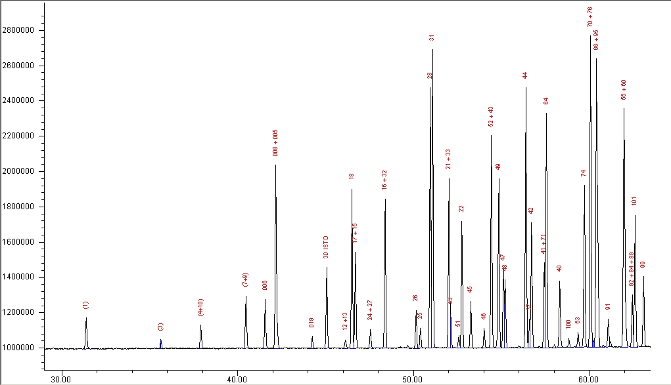

**Figure A1. GC-ECD chromatogram of PCB standard mixture showing identified peaks (congeners 1-99). Injection amount = 1uL of 610 g/L of total PCBs.**

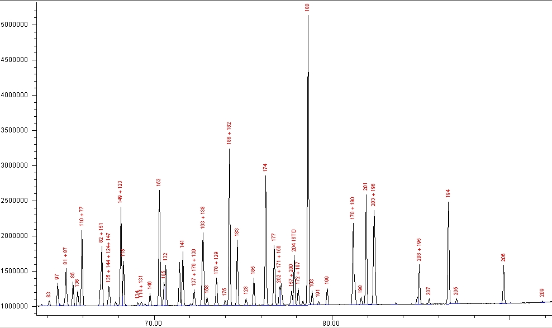

**Figure A2. GC-ECD chromatogram of PCB standard mixture showing identified peaks (congeners 83-209). Injection amount = 1uL of 610 g/L of total PCBs.**

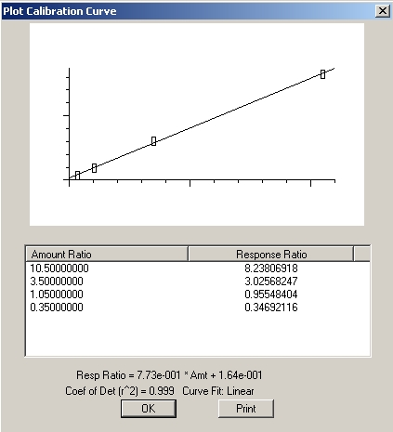 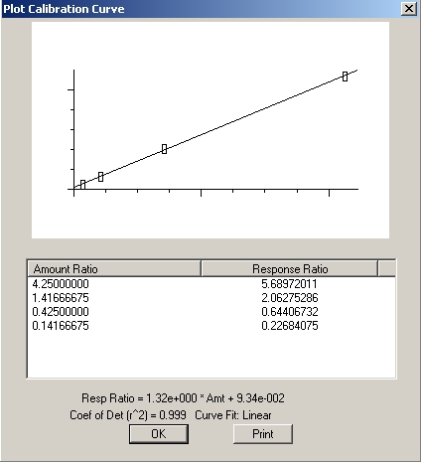

**Figure A3. PCB congener internal calibration plots showing good linear fit of the 4-level calibration data for congeners 28 (left) and 183 (right).**