R markdown - intro and some basics

Krista

2024-02-05

## Getting started:

R markdown can nicely combine writing and executing R script and making extensive notes.

### 1. Examples of text formatting:

# Header 1

## Header 2

### Header 3

#### Header 4

##### Header 5

###### Header 6

* 6 level headers, serve as internal ouline links (toc)
* *italics*
* **bold**
* code
* another bullet point
  + second level bullet point
* [links](https://rmarkdown.rstudio.com/lesson-15.HTML)

### 2. Code Chunks:

## here() starts at /Users/kristakraskura/Github_repositories/biol601_spring2024_dealing_w_data

## OPTION 1 (be sure to add eval = FALSE if not running this)  
  
# using library "here"  
here::here() # sets the root directory   
# can resest it with:  
here::i_am("w2/w2_intro_RMarkdown.Rmd")  
  
data <- read.csv(here("w2","dfexample.csv")) # read in data, inside 'here()' we write the path to our data from the root directory (e.g., w1 is a folder that holds the csv file)  
  
# to see the parent folder:  
here()

## OPTION 2 (be sure to add eval = FALSE if not running this)  
  
# rename it to match your working directory  
setwd("/Users/kristakraskura/Github_repositories/biol601_spring2024_dealing_w_data/w2/")  
  
data <- read.csv("dfexample.csv") # read in data

Some useful settings for the code chunks:

* include = FALSE prevents code and results from appearing in the finished file. R Markdown still runs the code in the chunk, and the results can be used by other chunks.
* echo = FALSE prevents code, but not the results from appearing in the finished file.
* results = 'hide' or FALSE prevents the results to be shown. Useful when
* message = FALSE prevents messages that are generated by code from appearing in the finished file.
* warning = FALSE prevents warnings that are generated by code from appearing in the finished.
* fig.width = the width of the printed figure, in inches
* fig.height = the height of the printed figure, in inches

(click tab in the section to see all the options)

### 3. Images (not figures):

* Use knitr::include_graphics()

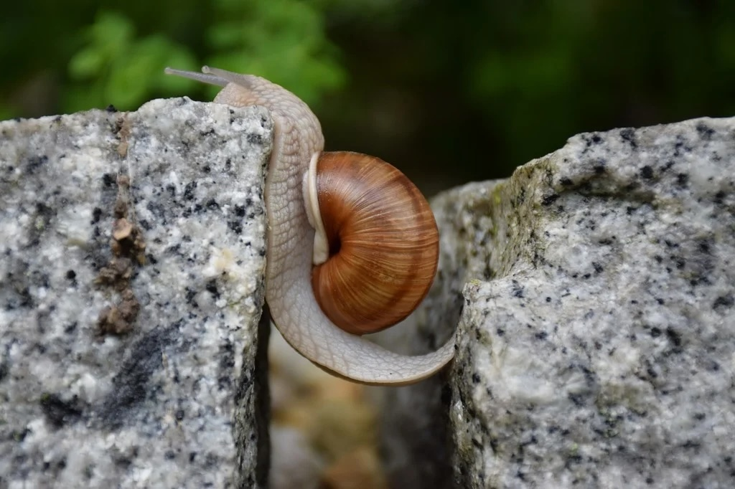

### 4. Tables:

kable in knitr works well for html, pdf, and word document outputs.

knitr::kable(data, # data frame  
 digits = 2, # round to 2 digits   
 col.names = gsub("[.]", " ", names(data)),# format column names, substitute the dots with spaces  
 align = "c", # alignment center   
 longtable = TRUE) # formats tables that span multiple pages

| X | transect position | dist from transect | substrate type | snail size | snail weight | snail aggressiveness | snail color |
| --- | --- | --- | --- | --- | --- | --- | --- |
| 1 | 1.00 | 0.42 | C | 11.78 | 0.36 | 1 | yellow |
| 2 | 1.66 | -0.40 | A | 11.80 | 0.36 | 1 | yellow |
| 3 | 2.31 | -1.53 | A | 13.70 | 0.74 | 1 | yellow |
| 4 | 2.97 | 0.26 | B | 13.77 | 0.75 | 1 | pink |
| 5 | 3.62 | 0.11 | C | 13.08 | 0.62 | 1 | blue |
| 6 | 4.28 | -0.54 | A | 14.48 | 0.90 | 1 | yellow |
| 7 | 4.93 | 0.16 | C | 17.13 | 1.43 | 1 | pink |
| 8 | 5.59 | -0.40 | B | 14.91 | 0.98 | 1 | yellow |
| 9 | 6.24 | -0.21 | A | 18.02 | 1.60 | 2 | pink |
| 10 | 6.90 | -1.68 | C | 17.32 | 1.46 | 2 | blue |
| 11 | 7.55 | -1.76 | A | 21.88 | 2.38 | 2 | blue |
| 12 | 8.21 | -2.16 | A | 20.32 | 2.06 | 2 | yellow |
| 13 | 8.86 | 2.10 | B | 24.01 | 2.80 | 3 | blue |
| 14 | 9.52 | 0.00 | A | 23.59 | 2.72 | 3 | orange |
| 15 | 10.17 | 0.37 | B | 21.78 | 2.36 | 2 | pink |
| 16 | 10.83 | 0.54 | A | 20.01 | 2.00 | 2 | blue |
| 17 | 11.48 | -1.14 | C | 22.90 | 2.58 | 3 | yellow |
| 18 | 12.14 | -0.24 | C | 24.82 | 2.96 | 3 | yellow |
| 19 | 12.79 | -0.35 | C | 27.82 | 3.56 | 4 | yellow |
| 20 | 13.45 | -1.46 | A | 25.48 | 3.10 | 3 | yellow |
| 21 | 14.10 | -1.46 | C | 26.53 | 3.31 | 4 | pink |
| 22 | 14.76 | -1.24 | B | 31.53 | 4.31 | 5 | pink |
| 23 | 15.41 | 1.17 | C | 24.11 | 2.82 | 3 | orange |
| 24 | 16.07 | -0.49 | C | 26.22 | 3.24 | 3 | yellow |
| 25 | 16.72 | 0.90 | B | 29.90 | 3.98 | 4 | blue |
| 26 | 17.38 | 0.26 | A | 29.43 | 3.89 | 4 | yellow |
| 27 | 18.03 | -0.93 | A | 28.87 | 3.77 | 4 | pink |
| 28 | 18.69 | 1.08 | A | 30.81 | 4.16 | 5 | pink |
| 29 | 19.34 | 1.04 | B | 31.69 | 4.34 | 5 | blue |
| 30 | 20.00 | -0.96 | C | 30.05 | 4.01 | 5 | yellow |

### 5. Figures made using imbedded script:

# plot code from week 1:  
 ggplot(data = data, aes(x = transect.position, y = snail.size)) +  
 geom_point(aes(col = substrate.type)) +  
 theme(panel.background = element_blank(),  
 axis.line = element_line(color = "black"),  
 text = element_text(size = 20)) +  
 scale_x_continuous(name = "Transect position (m)", breaks = seq(-10, 20, by =2)) +  
 scale_y_continuous(name = "Snail size (mm)", breaks = seq(-10, 40, by = 5))

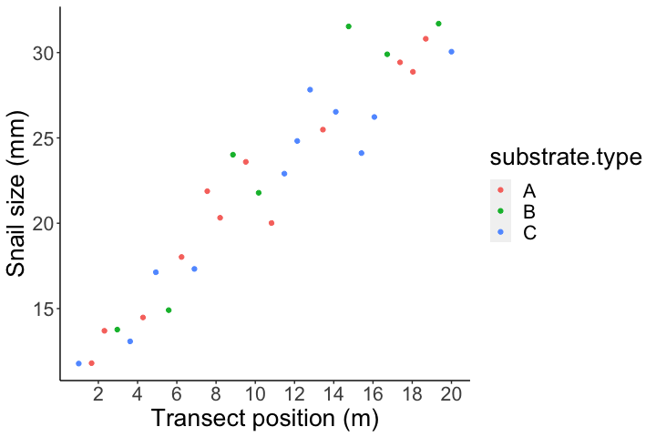

Figure 1. Snail body sizes along the transect position

### Rendering and customization of the file

* pick a theme, or stick with a default
* render to PDF or html (some themes will not work to PDF)
* html (most common)
* table of contents
* execute the code in R markdown and show out put in R markdown is the default. To change that go to ‘settings’ (next to the knit) and select ‘chunk output in Console’

### Resources:

* [Rmarkdown cheatsheet, pdf](https://rmarkdown.rstudio.com/lesson-15.HTML)
* [Rmarkdown cheatsheet, web](https://rstudio.github.io/cheatsheets/html/rmarkdown.html)
* [themes](https://rpubs.com/ranydc/rmarkdown_themes) [R markdown book](https://rmarkdown.rstudio.com/lesson-1.html)