Introduction

Name - Kratant Jain
Enrolment no - 151308
Batch - B3
Project Name - Post Office Agent Software

The project requires Tkinter, tkmessagebox and Sqlite3 module.
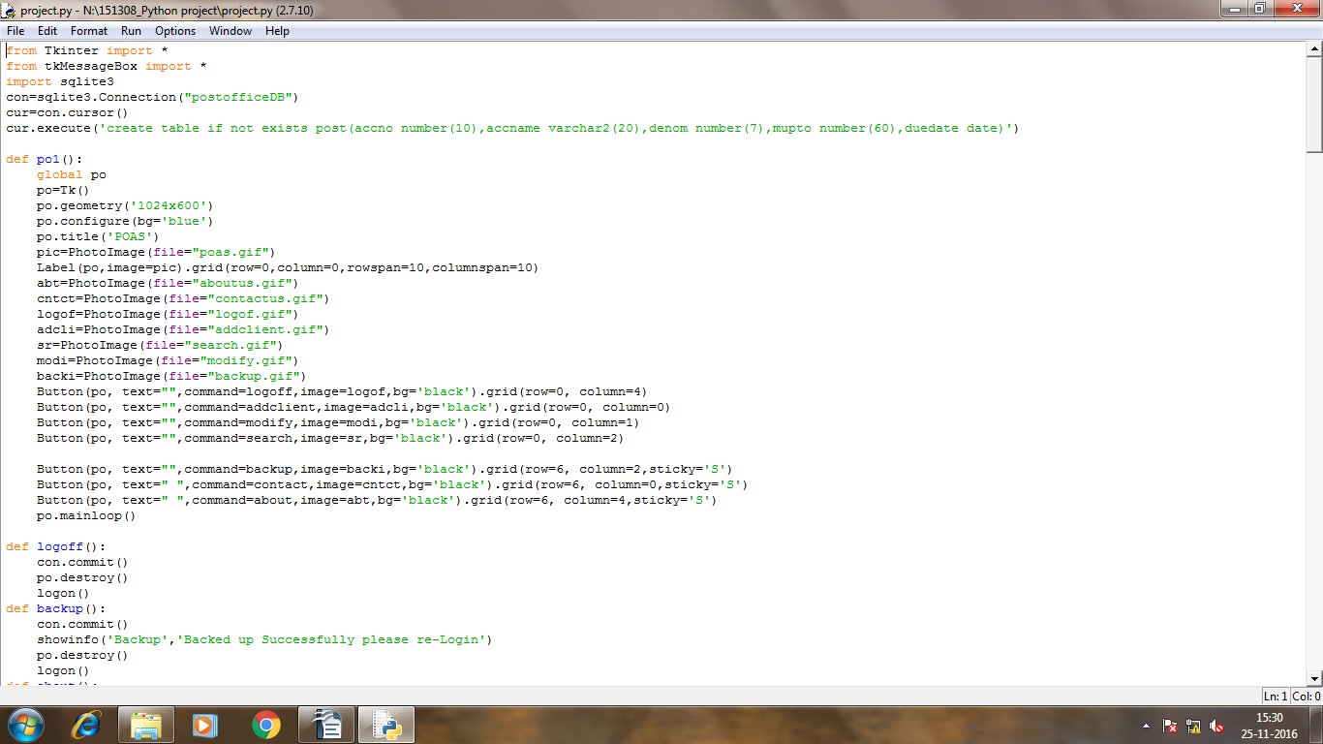

Here, Database is named as postofficeDB

Now, reviewing the program at runtime and its explanation given below

Running Program:-
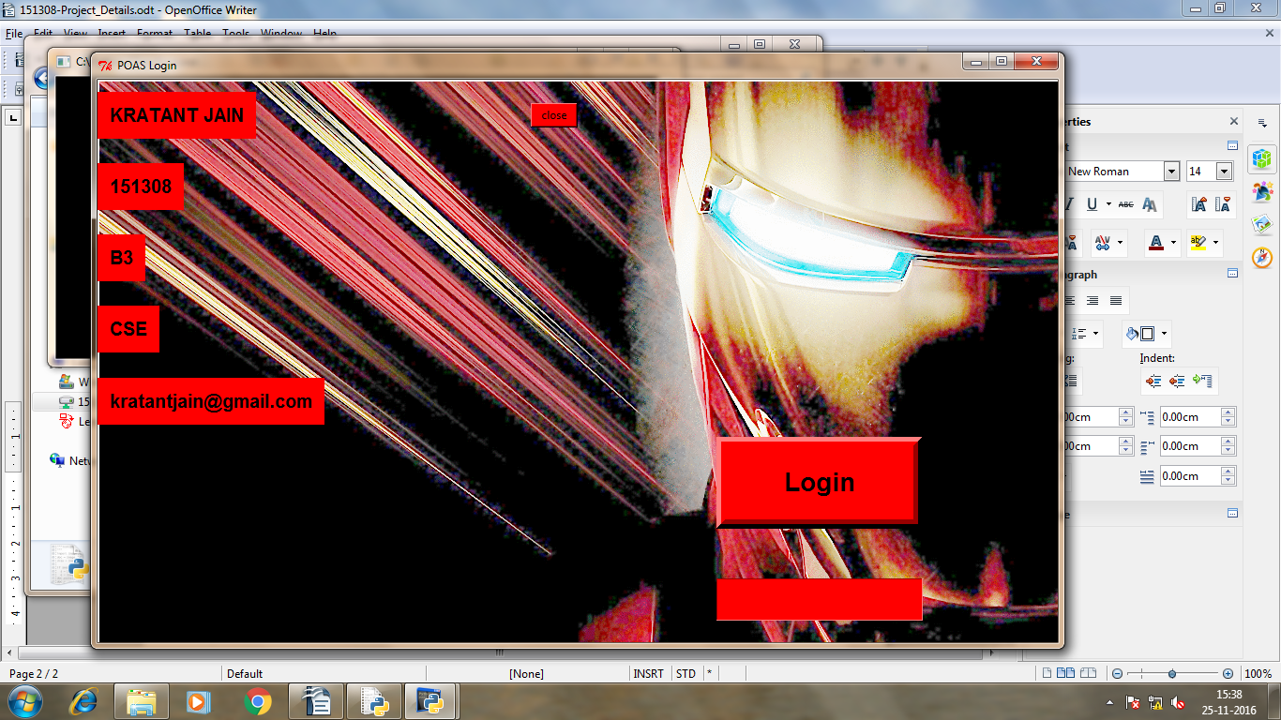
*Password is kratant
It is the first Gui:-
It has 5 Labels- Kratant Jain, 151308, B3, CSE, Kratantjain@gmail.com
2 Buttons-Login and close
1 Entry(just below login Button to take passwords)
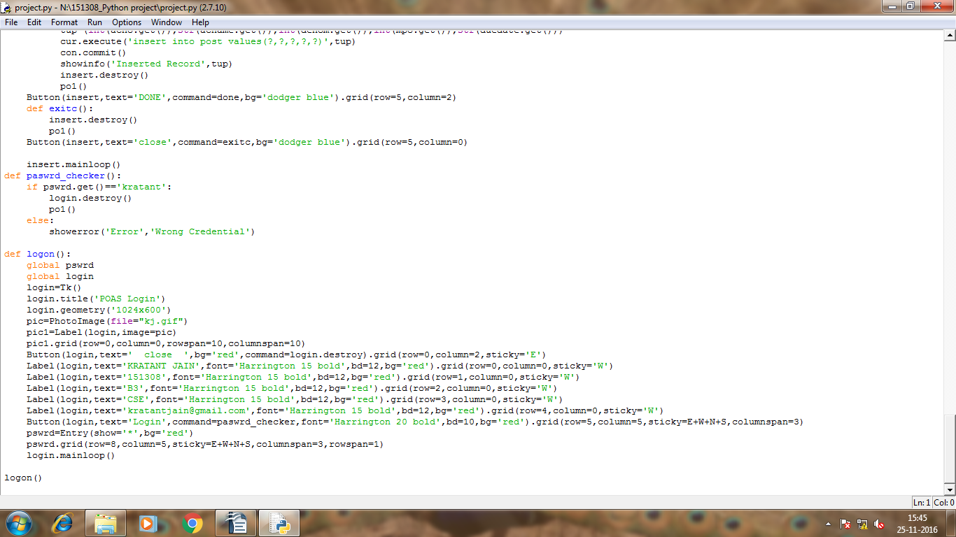
here Logon() is the function which invokes the first GUI which is login
in login gui there is button which invokes psswrd_checker function which gets the input from gui and check the password. If psswrd results true the PO1 function will invoke otherwise it will show error Wrong credentials.
Shown below:-
if wrong
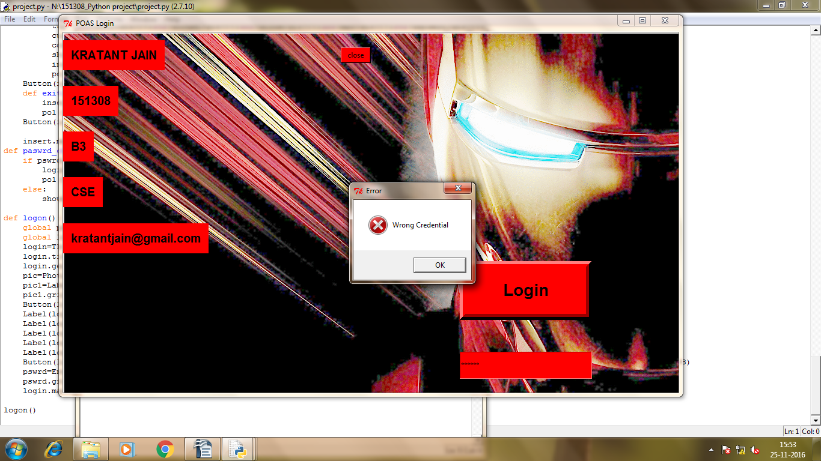
if right-

2nd Gui will open i.e. 'po'

It has 6 Buttons:-
Add client(This Buttons invokes function addclient)
Modify(This Buttons invokes function modify)
Search(This Buttons invokes function search)
Logoff(This Button invoke function logoff)
Contact us(This Button invoke function contact)
Backup(This Button invoke function backup)
About(This Button invoke function about)
If Addclient Button is pressed thn:-
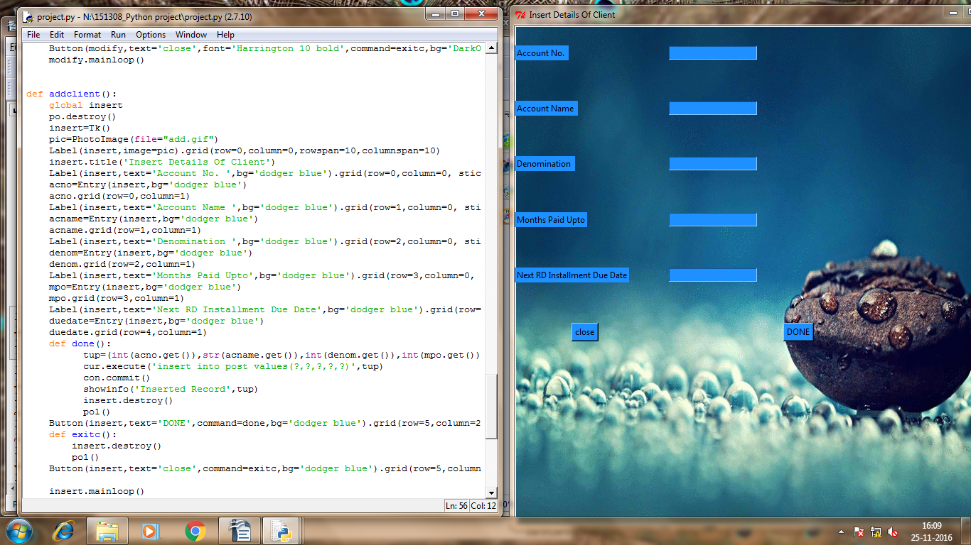
po gui will destroy and new gui will be opened which is named as insert
it has 5 labels And their respective entry boxes
and have two buttons close and done close button will close this gui and reopen the po gui by calling po1 function and by filling all entries when done button is pressed it will save all the details in database postofficeDB and a information message box will be shown which tells the successful completion and all filled entries
Things Tobe noted While filling Entries
Account no should be a number of not more than 10digits
Account name should not exceed 20 characters
denominations should be in number without decimal value
months paid up to should be no of months a person has paid.
Next rd Installment due date should be in format dd/mm/yyyy
on pressing done Following things will appear:-
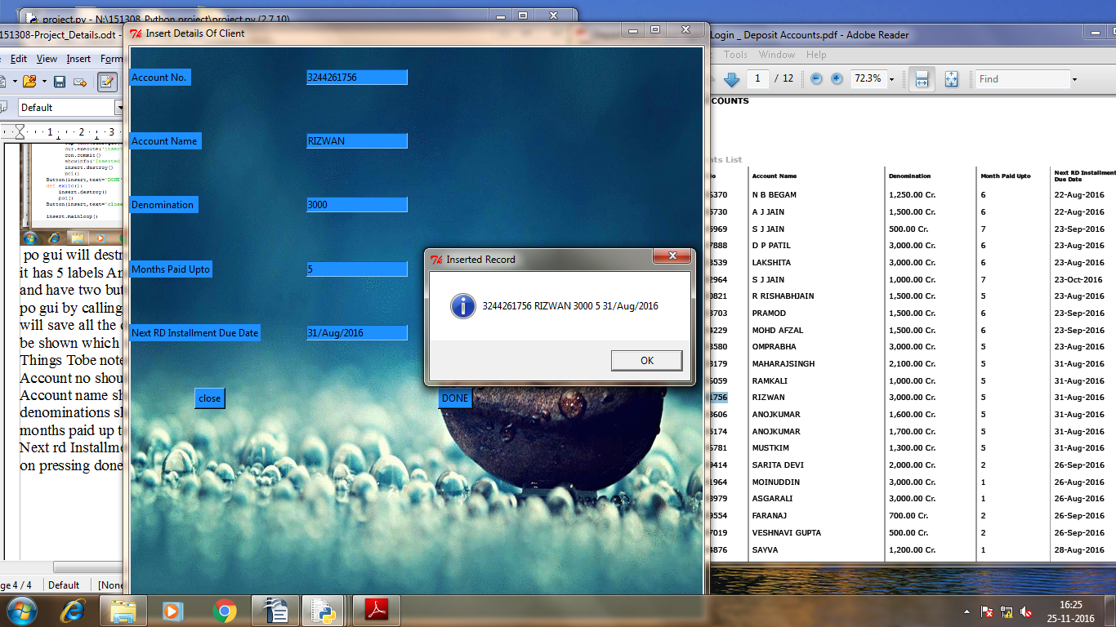
on pressing ok Insert gui will close and po gui will reopen again to take further commands.
On pressing Search Button:
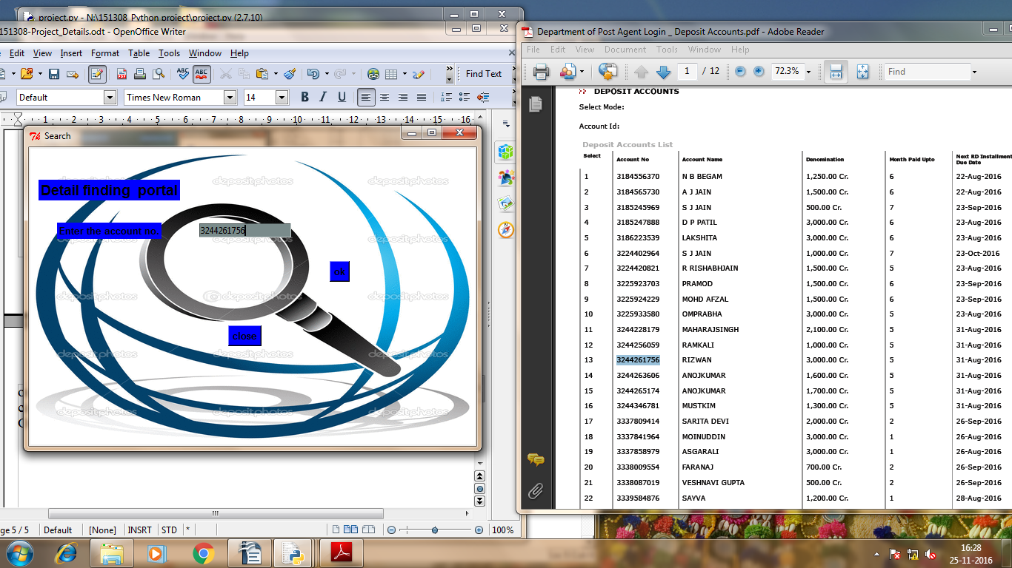
in this there is 1 label enter the Account no. Followed by the entry
and Two buttons one is ok and second is close
ok button will search the database for given account no and display the details.
As Following-
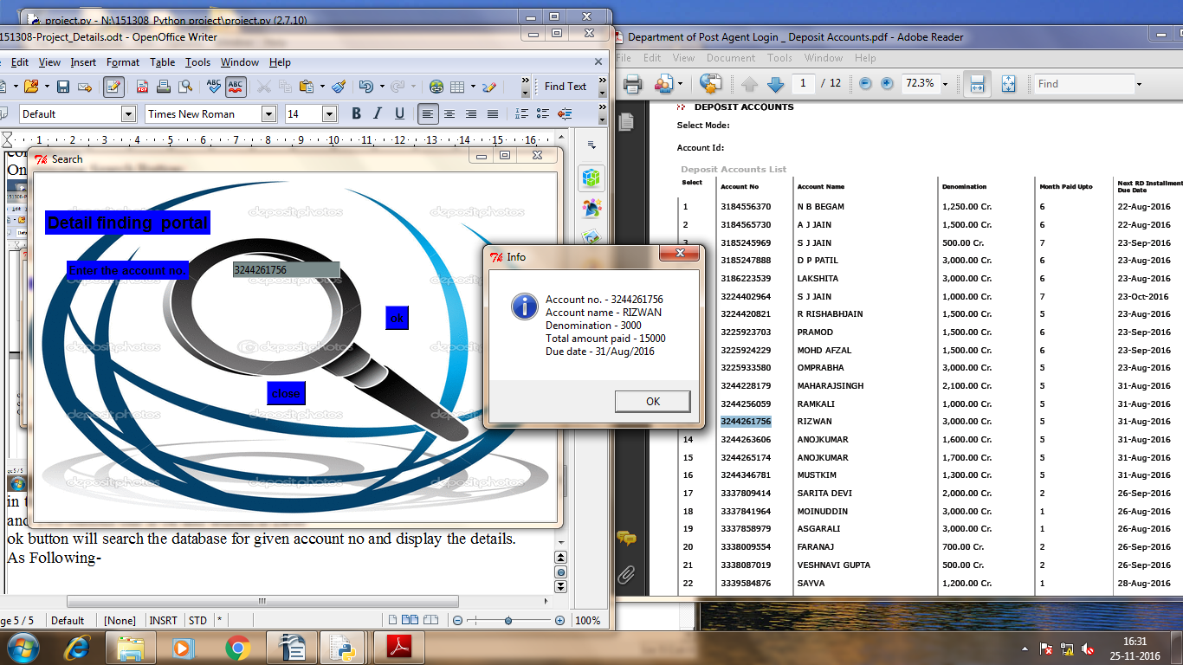
from going back to po window press close button
Logoff Button:-
this button will save the database and then destroy the current root and invoke the first root which is the login one.
Modify Button-
on Pressing Modify Button the new gui will open which is modify and po gui will be destroyed
modify Gui look like-
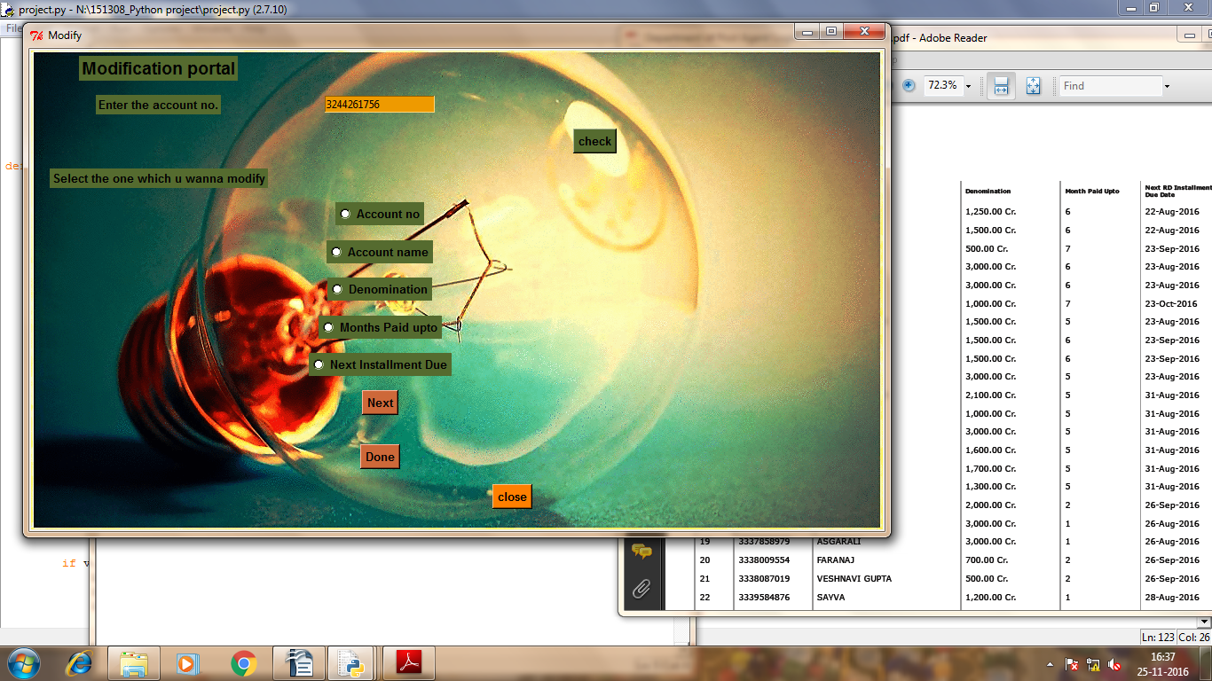
in this the check button will check this account no with database
and further u can make modification on this account no by given below raido buttons
check button will invoke function of search which is find to give details about the enetered account no. C below
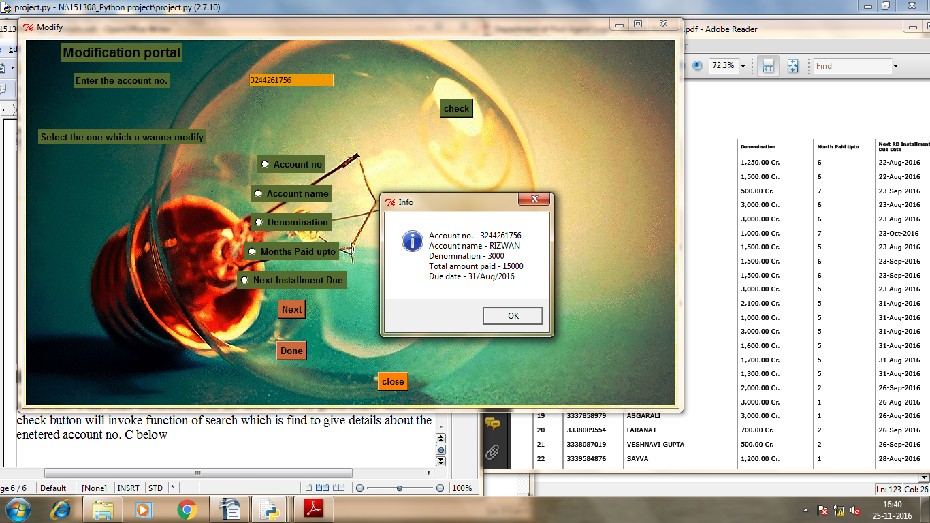
if u want to make changes to this account no select one the parameters which u want to modify see further more images to have clear idea
images below -
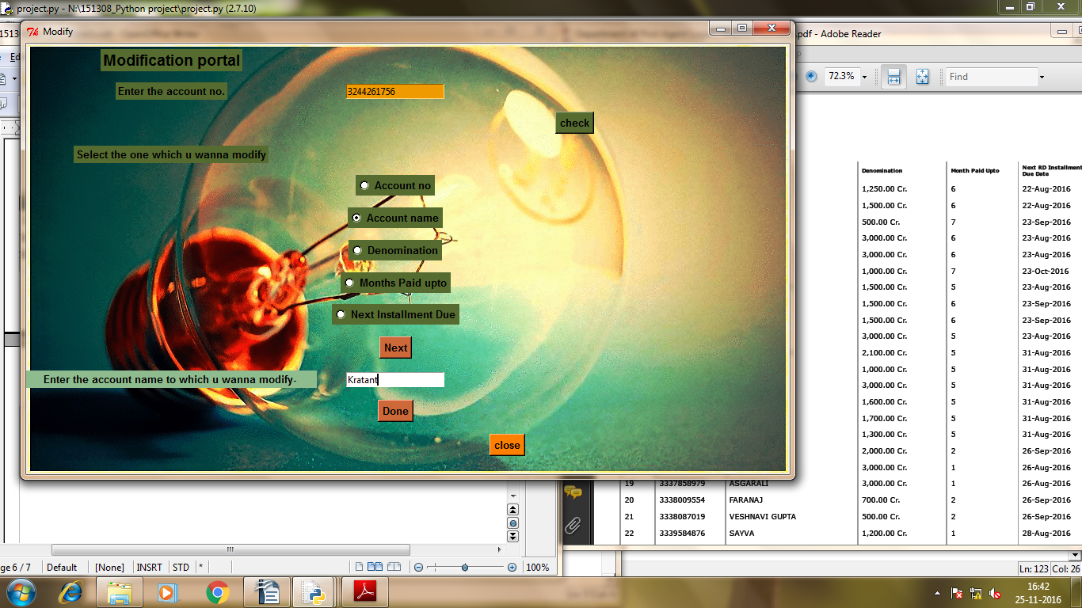
when the done button is pressed the modifaction is done see the message
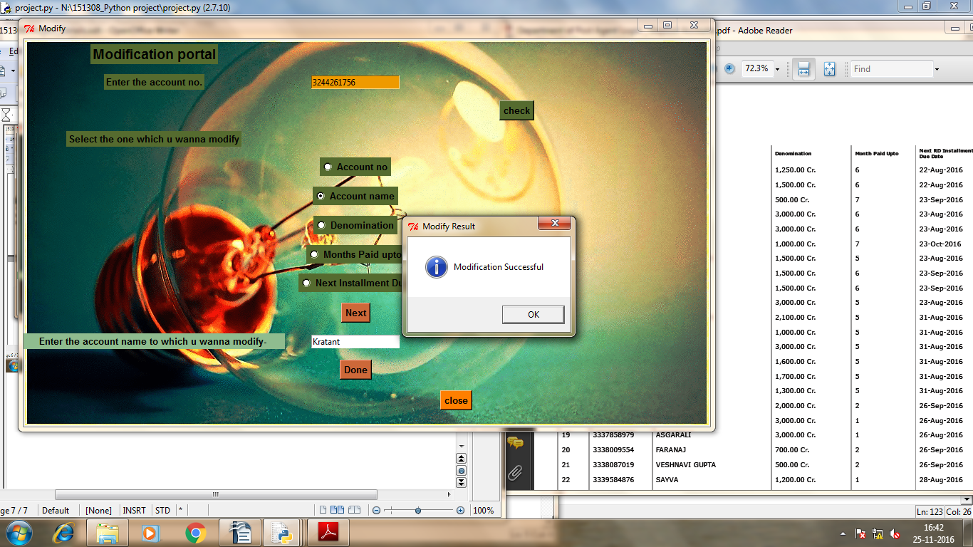

now in the give below image u can see when i pressde on search name has been changed to kratant all the radiobuttons and modification are working fine.
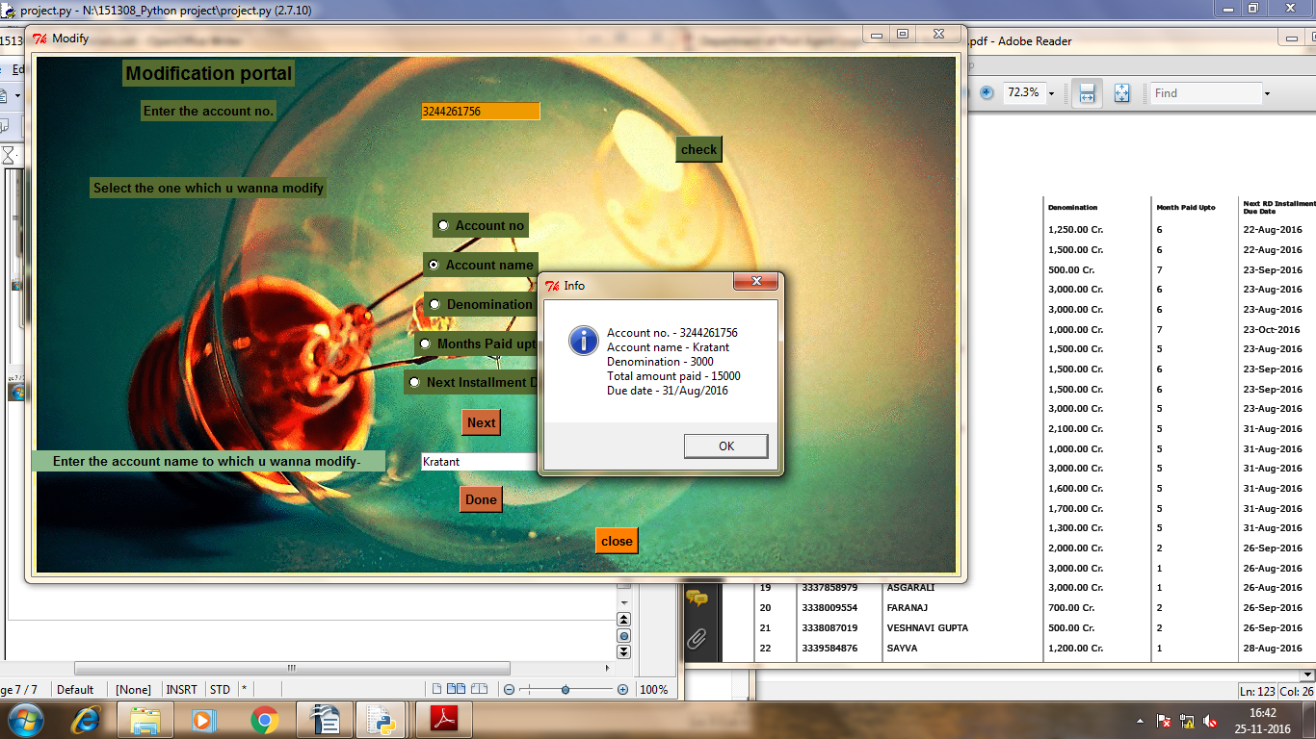
Now closing it .
Po will appear again
going to conatct us button:
when pressed it will show-

close button will take u back to po gui
next Button is About us:
Images are below juist a informative gui
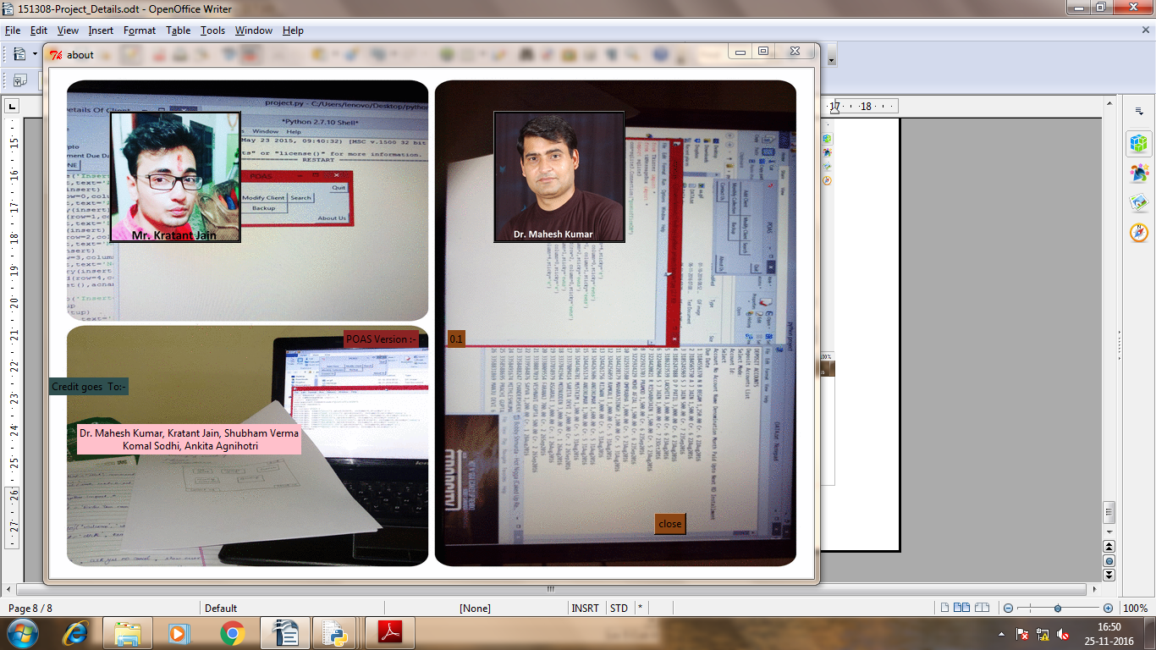
these images are on button when pressed it will show the following.

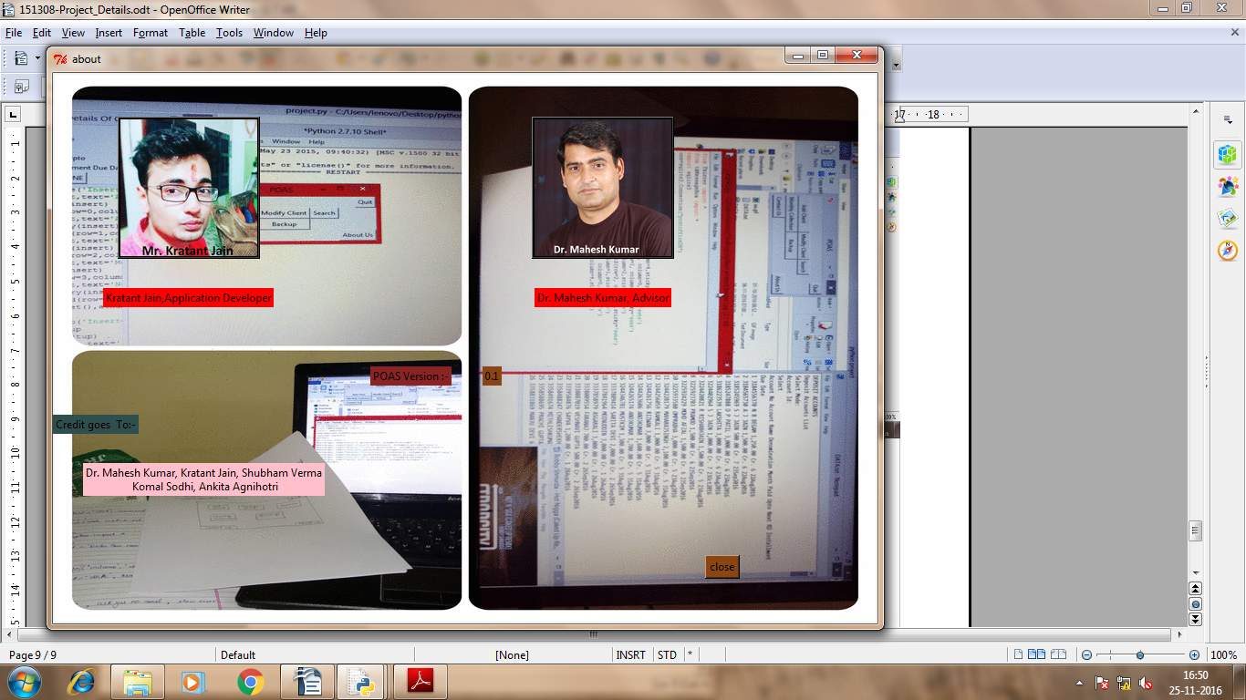
And last left is backup Button_
its main function is to save all data to database
and then ask user to relogin
c below
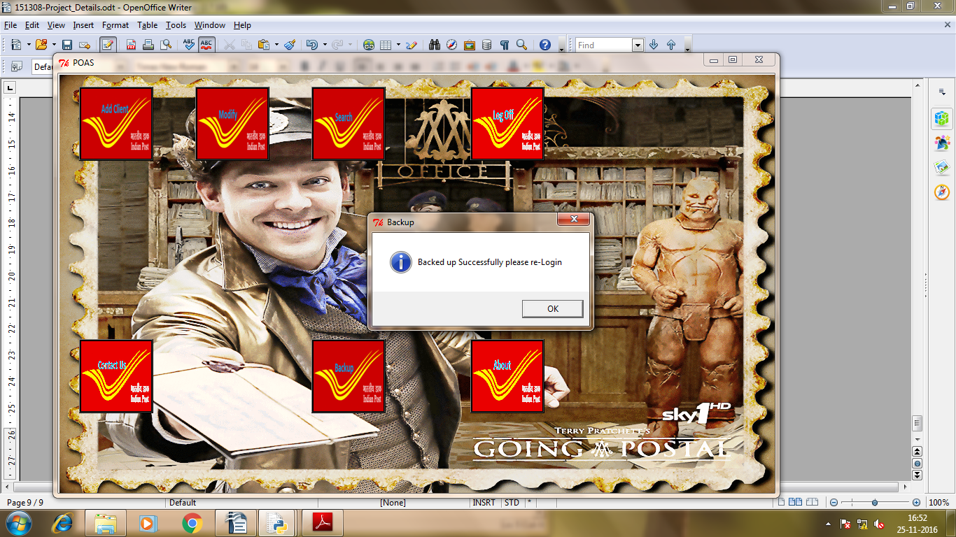

That's All
Thank You
Kratant Jain

