Financial Dashboard for a Company

Power BI Implementation

Presented by: [KRATI CHOURASIA]

INTRODUCTION:

In today’s business environment, financial tracking is crucial for decision-making.

A well-structured financial dashboard provides insights into revenue, expenses, and profit trends.

Power BI helps visualize and analyze financial data effectively.

This presentation outlines the development and key components of a financial dashboard.

OBJECTIVE:

The Power BI Sales & Profit Analysis Dashboard provides real-time insights into business performance by tracking total sales, profit, and quantity across various dimensions, including time, product categories, regions, and customer segments. It automates reporting, enhances decision-making, and helps identify trends, high-performing areas, and opportunities for growth while minimizing manual effort and errors.

Sample Datasets:

Revenue Data: Includes Date, Revenue Amount, and Region to track income sources.

Expenses Data: Contains Date, Expense Category, and Expense Amount to analyze spending.

Profit Data: Shows Date and Profit Amount for measuring financial performance.

These datasets form the foundation of the financial dashboard.

Data Preparation:

Importing Data: Bringing revenue, expenses, and profit data into Power BI.

Data Cleaning: Removing inconsistencies, handling missing values, and standardizing date formats.

Preprocessing: Ensuring data is structured for analysis and visualization.

Importance: Clean data leads to more accurate insights and better decision-making.

Visualization Components:

Time-Series Chart: Tracks revenue, expenses, and profit over months.

Pie Chart: Displays expense distribution across different categories.

Clustered Bar Chart: Compares quarterly revenue, expenses, and profit.

KPI Cards: Show key financial indicators like total revenue, total expenses, and net profit.

Visualizations make it easier to interpret complex financial data.

DASHBOARD:

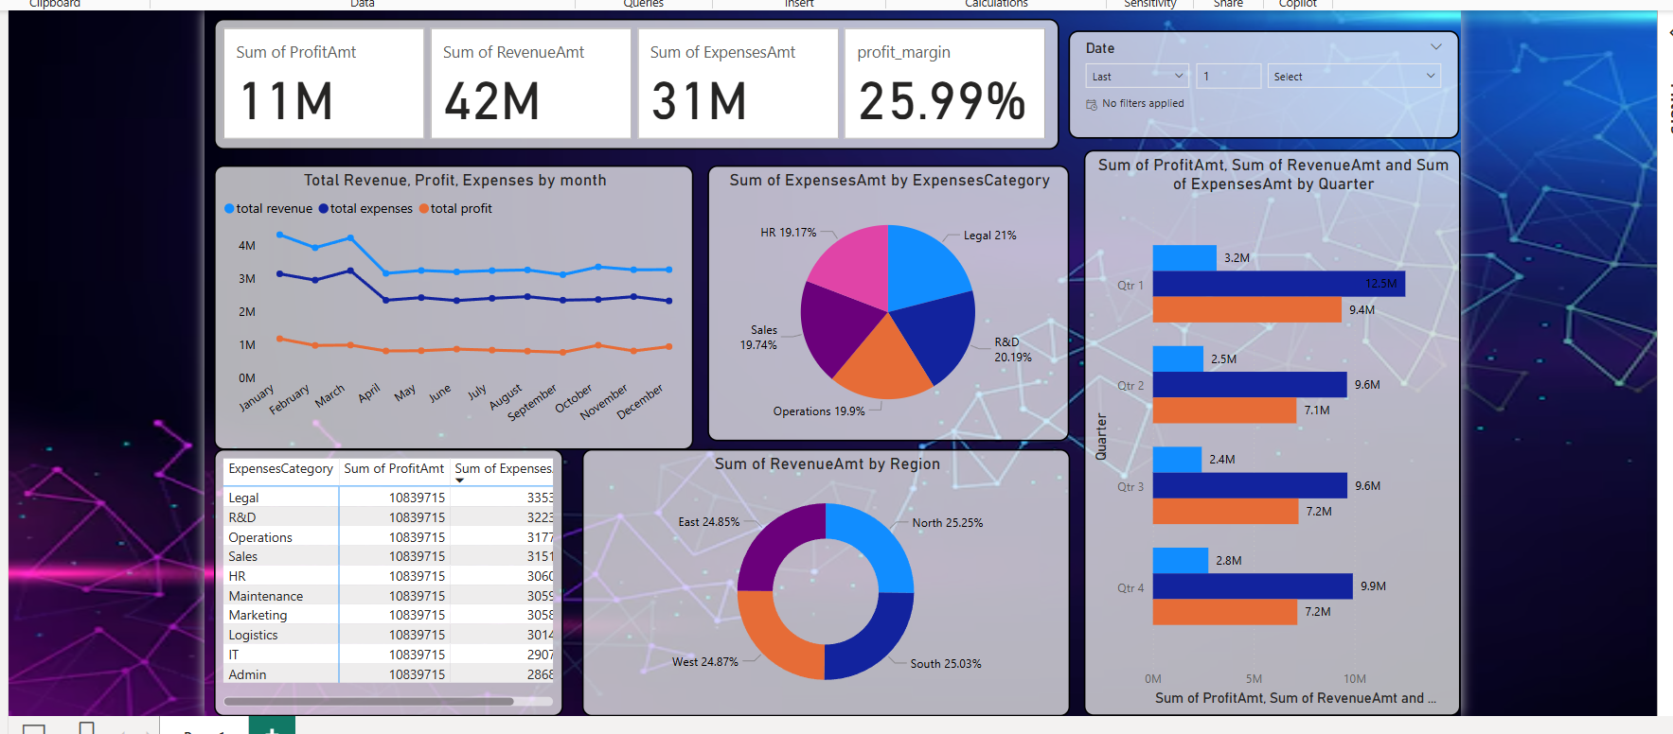

Interactive Features:

Slicers: Enable filtering by year and month for better analysis.

Waterfall Chart: Breaks down expenses into key contributing factors.

Drill-through Functionality: Allows deeper insights into specific financial aspects.

Interactive features improve user experience and decision-making.

Financial Insights:

Top Expense Categories: Identifying the biggest cost drivers.

Profitability Analysis: Evaluating how expenses impact overall profit.

Financial Health Indicators:

Revenue Growth Rate

Cost-to-Revenue Ratio

Net Profit Trends

These insights help stakeholders make data-driven financial decisions.

Conclusion:

A well-designed financial dashboard provides actionable insights.

Proper data modeling and visualization enhance financial tracking.

Security measures ensure that financial data is protected.

Future improvements may include advanced predictive analytics.

Power BI empowers finance teams with real-time, interactive dashboards.

THANK YOU!!