PROJECT REPORT
CLASSROOM MCQ QUIZ SYSTEM
A Multi-Client, Socket-Based Classroom Quiz Management Application Built with Python Socket Programming
Submitted By
Kratika Yadav
Submitted To
Dr. Aniruddha Singh Kushwaha
Assistant Professor, IIT Indore
Python • TCP Sockets • Multithreading • Tkinter GUI • CSV Storage
Academic Year 2026

Table of Contents
1. Abstract 3
2. Project Overview 3
3. Problem Statement 3
4. Objectives 3
5. Technologies Used 4
6. System Architecture 4
7. Working of the Project 5
8. Randomized Quiz Generation 6
9. Multi-Client Functionality 6
10. Application Interfaces 6
11. Professor Quiz Dashboard 9
12. Live Student Activity 11
13. Completed Quiz Results and Data Storage 13
14. Professor Quiz Creator 14
15. Major Features 14
16. Testing and Results 15
17. Challenges and Solutions 15
18. Advantages 15
19. Limitations 15
20. Future Enhancements 15
21. Conclusion 16
22. References 16

1. Abstract
The Classroom MCQ Quiz System is a network-based application built to conduct multiple-choice quizzes in a classroom setting. It follows a client–server architecture in which a professor manages the quiz through a central server while multiple students connect simultaneously as clients. The system is implemented in Python using TCP socket programming, multithreading, a Tkinter graphical interface, and CSV-based file handling. Each student receives a randomized set of questions, submits answers through a graphical interface, and instantly receives a final score, while the professor monitors live progress, reviews completed results, and manages quiz content through a dedicated dashboard.

2. Project Overview
The Classroom MCQ Quiz System automates one of the most repetitive parts of classroom assessment — distributing questions, collecting answers, grading, and record-keeping. Built around a client–server model, the project pairs a central quiz server (operated by the professor) with a lightweight student client application. Students connect over the network, receive an individually randomized quiz, answer questions through a simple graphical interface, and are scored automatically the moment they finish.
At the same time, the professor works from a dedicated dashboard that shows which students are connected, how far each has progressed, and what scores have already come in — turning quiz administration into something that can be watched and managed in real time rather than tallied by hand afterwards.

3. Problem Statement
Traditional classroom quizzes rely on manual distribution of question papers, manual collection of answers, manual checking, and manual score calculation — a process that is slow, error-prone, and difficult to scale across a full classroom. The Classroom MCQ Quiz System addresses this by providing a centralized digital platform that solves each of these pain points directly:
- Multiple students can attempt the quiz at the same time.
- Every student receives an independently randomized set of questions.
- Answers are checked and scored automatically, with no manual grading.
- Final scores and percentages are calculated instantly.
- The professor can observe student activity as it happens.
- Results are stored permanently for later reference and analysis.

4. Objectives
The core objective of this project is to build a multi-client, network-based quiz application that demonstrates practical socket programming while doubling as a genuinely useful classroom assessment tool. The specific objectives are:
- Establish reliable communication between students and a central server using TCP sockets.
- Support multiple students at the same time using multithreading.
- Generate an individually randomized quiz for every student.
- Assign a unique Quiz ID to every quiz attempt for tracking.
- Provide an intuitive graphical interface for students.
- Provide a separate management dashboard for the professor.
- Automatically calculate scores and percentages.
- Monitor student quiz progress live.
- Persist completed quiz results in a CSV file.
- Allow professors to author new questions through a graphical interface, without editing code.

5. Technologies Used
The project combines a compact but complete set of Python tools — each chosen for a specific role in the system:
Technology | Purpose
Python | Core programming language used throughout the project.
Socket Programming | Enables communication between the server and connected clients.
TCP Protocol | Guarantees reliable, ordered delivery of quiz data.
Multithreading | Allows the server to handle many students at once.
Tkinter | Provides the graphical interfaces for students and the professor.
CSV | Provides permanent storage for completed quiz results.
Random Module | Powers randomized selection of quiz questions.
File Handling | Manages the question bank and results on disk.

6. System Architecture
The project is organized around a classic client–server architecture, split into three cooperating roles.

Professor Side
The professor controls the entire quiz session through the Professor Quiz Dashboard, and can:
- Start and stop the quiz server.
- Check whether the server is online or offline.
- Monitor connected students in real time.
- View live quiz progress.
- View completed results.
- Check the class average and highest score.
- Open the results CSV file directly.
- Create new quiz questions.

Server Side
The server is the central nervous system of the application, responsible for:
- Listening for incoming student connections.
- Accepting and managing multiple simultaneous clients.
- Creating an independent session for each student.
- Generating a randomized quiz per student.
- Generating a unique Quiz ID per attempt.
- Receiving and validating student answers.
- Calculating final scores.
- Saving results to disk.
- Keeping the professor dashboard updated.

Student Side
Students interact with the system through the Classroom MCQ Quiz Client, which lets them:
- Enter their name.
- Connect to the quiz server.
- Receive a randomized quiz.
- Select answers for each MCQ.
- Submit answers.
- Complete the quiz.
- View their final score and percentage.

7. Working of the Project
End to end, a single quiz session unfolds as follows:
- The professor opens the Professor Quiz Dashboard.
- The professor starts the quiz server.
- The server becomes ONLINE and begins listening for student connections.
- A student opens the Classroom MCQ Quiz application.
- The student enters their name and clicks Connect & Start Quiz.
- The student client establishes a TCP connection with the server.
- The server creates an independent quiz session for that student.
- A randomized set of questions is selected from the question bank.
- A unique Quiz ID is generated for the attempt.
- Questions are displayed to the student one at a time.
- The student selects and submits an answer for each question.
- The student's progress becomes visible on the professor dashboard.
- Once all questions are answered, the responses are processed.
- The final score and percentage are calculated automatically.
- The result is saved to quiz_results.csv.
- The student sees a quiz completion screen with their result.
- The professor dashboard updates to show the completed result.

8. Randomized Quiz Generation
A core feature of the project is randomized quiz generation. The server maintains a question bank — for example, 10 questions in the bank, with 5 questions drawn per student. When a student connects, the server randomly selects a fresh combination of questions from that bank, so different students are unlikely to see the same sequence of questions — an important property for classroom-style assessment.
Every quiz attempt is also tagged with a unique Quiz ID (for example, 003945074773), which allows each individual attempt to be identified and tracked separately, even across many simultaneous students.

9. Multi-Client Functionality
The system is designed from the ground up as a multi-client application. Rather than serving one student at a time, the server uses multithreading so that several students can take the quiz simultaneously:
- The server accepts an incoming connection.
- A dedicated thread is spun up to handle that student's quiz session.
- The main server thread continues listening for additional students.
Based on the current server configuration, the system can be scaled to support up to 50 concurrent clients.

10. Application Interfaces

10.1 Student Login Screen
The student enters their name and connects to the server using the Connect & Start Quiz button.

10.2 Quiz Screen
The quiz screen presents the student's name, a random Quiz ID, the current question number out of the total, the question text, four answer options, and a Submit Answer button. For example:
Question 1/5 — A socket is best described as:
1. A physical network cable 2. An interface between the application and transport layer
3. A routing protocol 4. A network switch

10.3 Quiz Completion Screen
Once all questions are completed, the student sees their name, Quiz ID, score, and percentage, for example: Student: B — Score: 1/5 — Percentage: 20%.
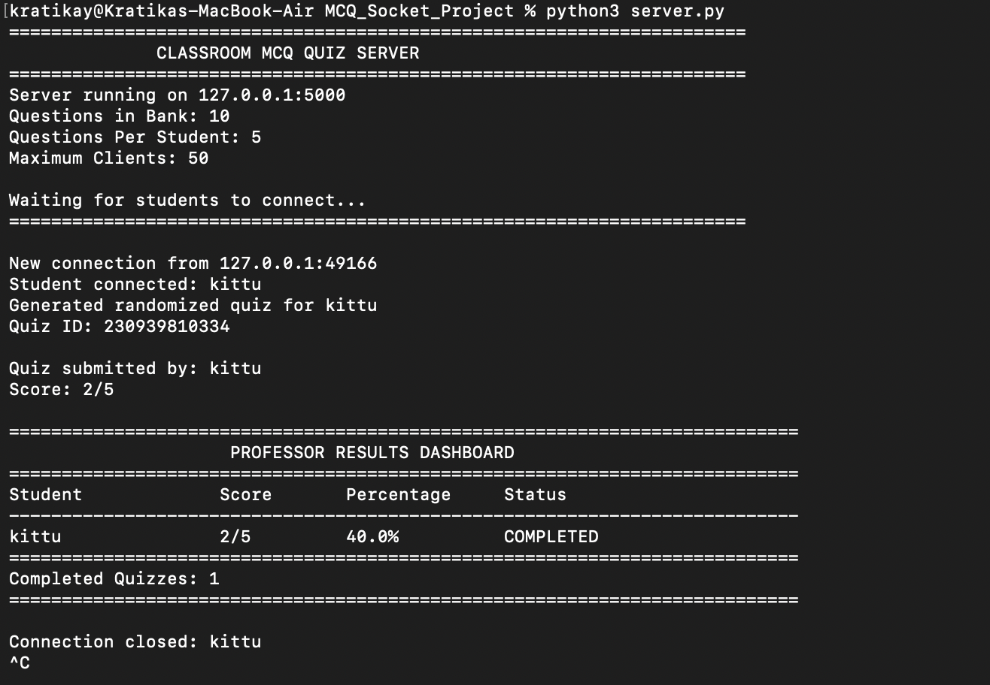
Figure 1. Student login interface.
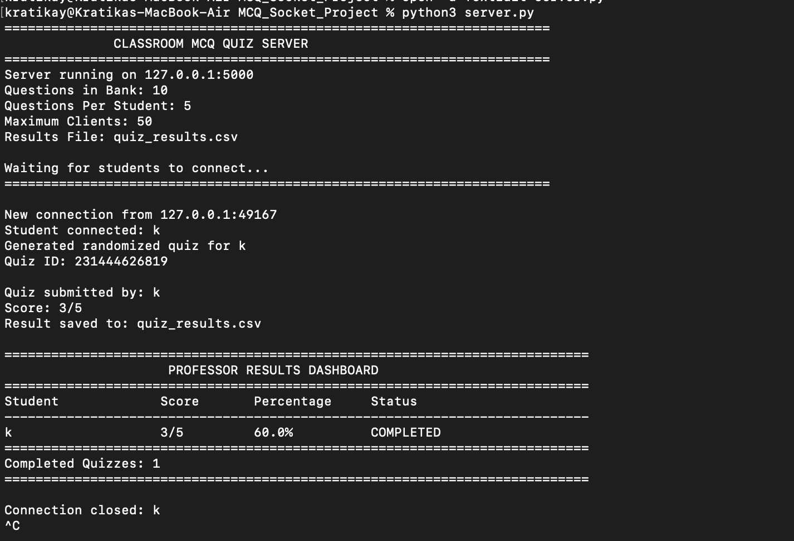
Figure 2. Graphical student MCQ interface.
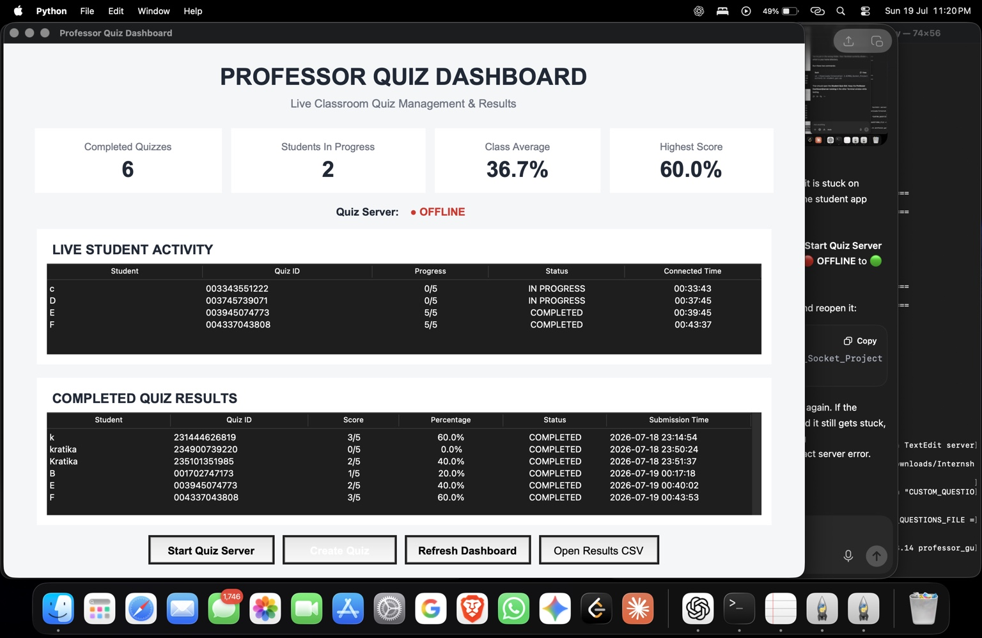
Figure 3. Randomized student quiz showing a unique Quiz ID.
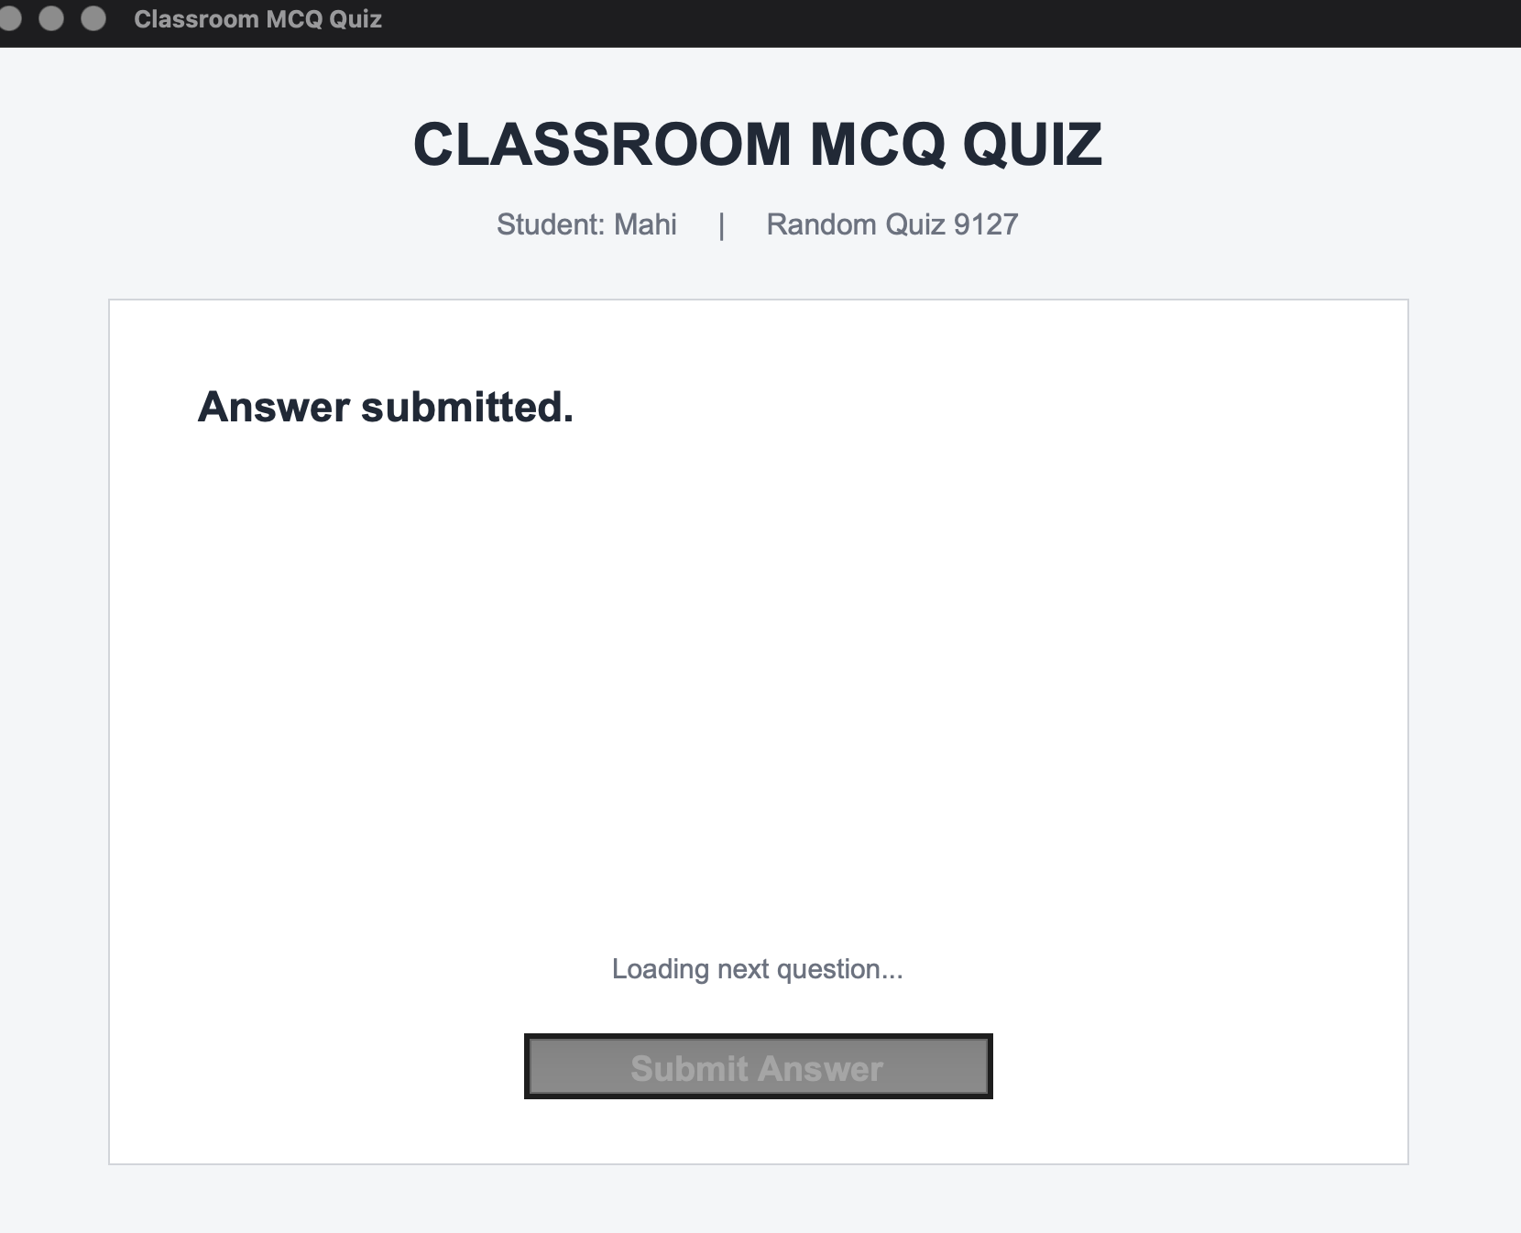
Figure 4. Quiz completion screen showing score and percentage.

11. Professor Quiz Dashboard
The Professor Quiz Dashboard is the main administrative interface, surfacing the statistics that matter most during a live session:
Dashboard Element | What It Shows
Completed Quizzes | Total number of quizzes submitted by students.
Students in Progress | Number of students currently attempting the quiz.
Class Average | Automatically calculated average score of completed quizzes.
Highest Score | Highest percentage obtained so far.
Quiz Server Status | Whether the server is currently ONLINE or OFFLINE.
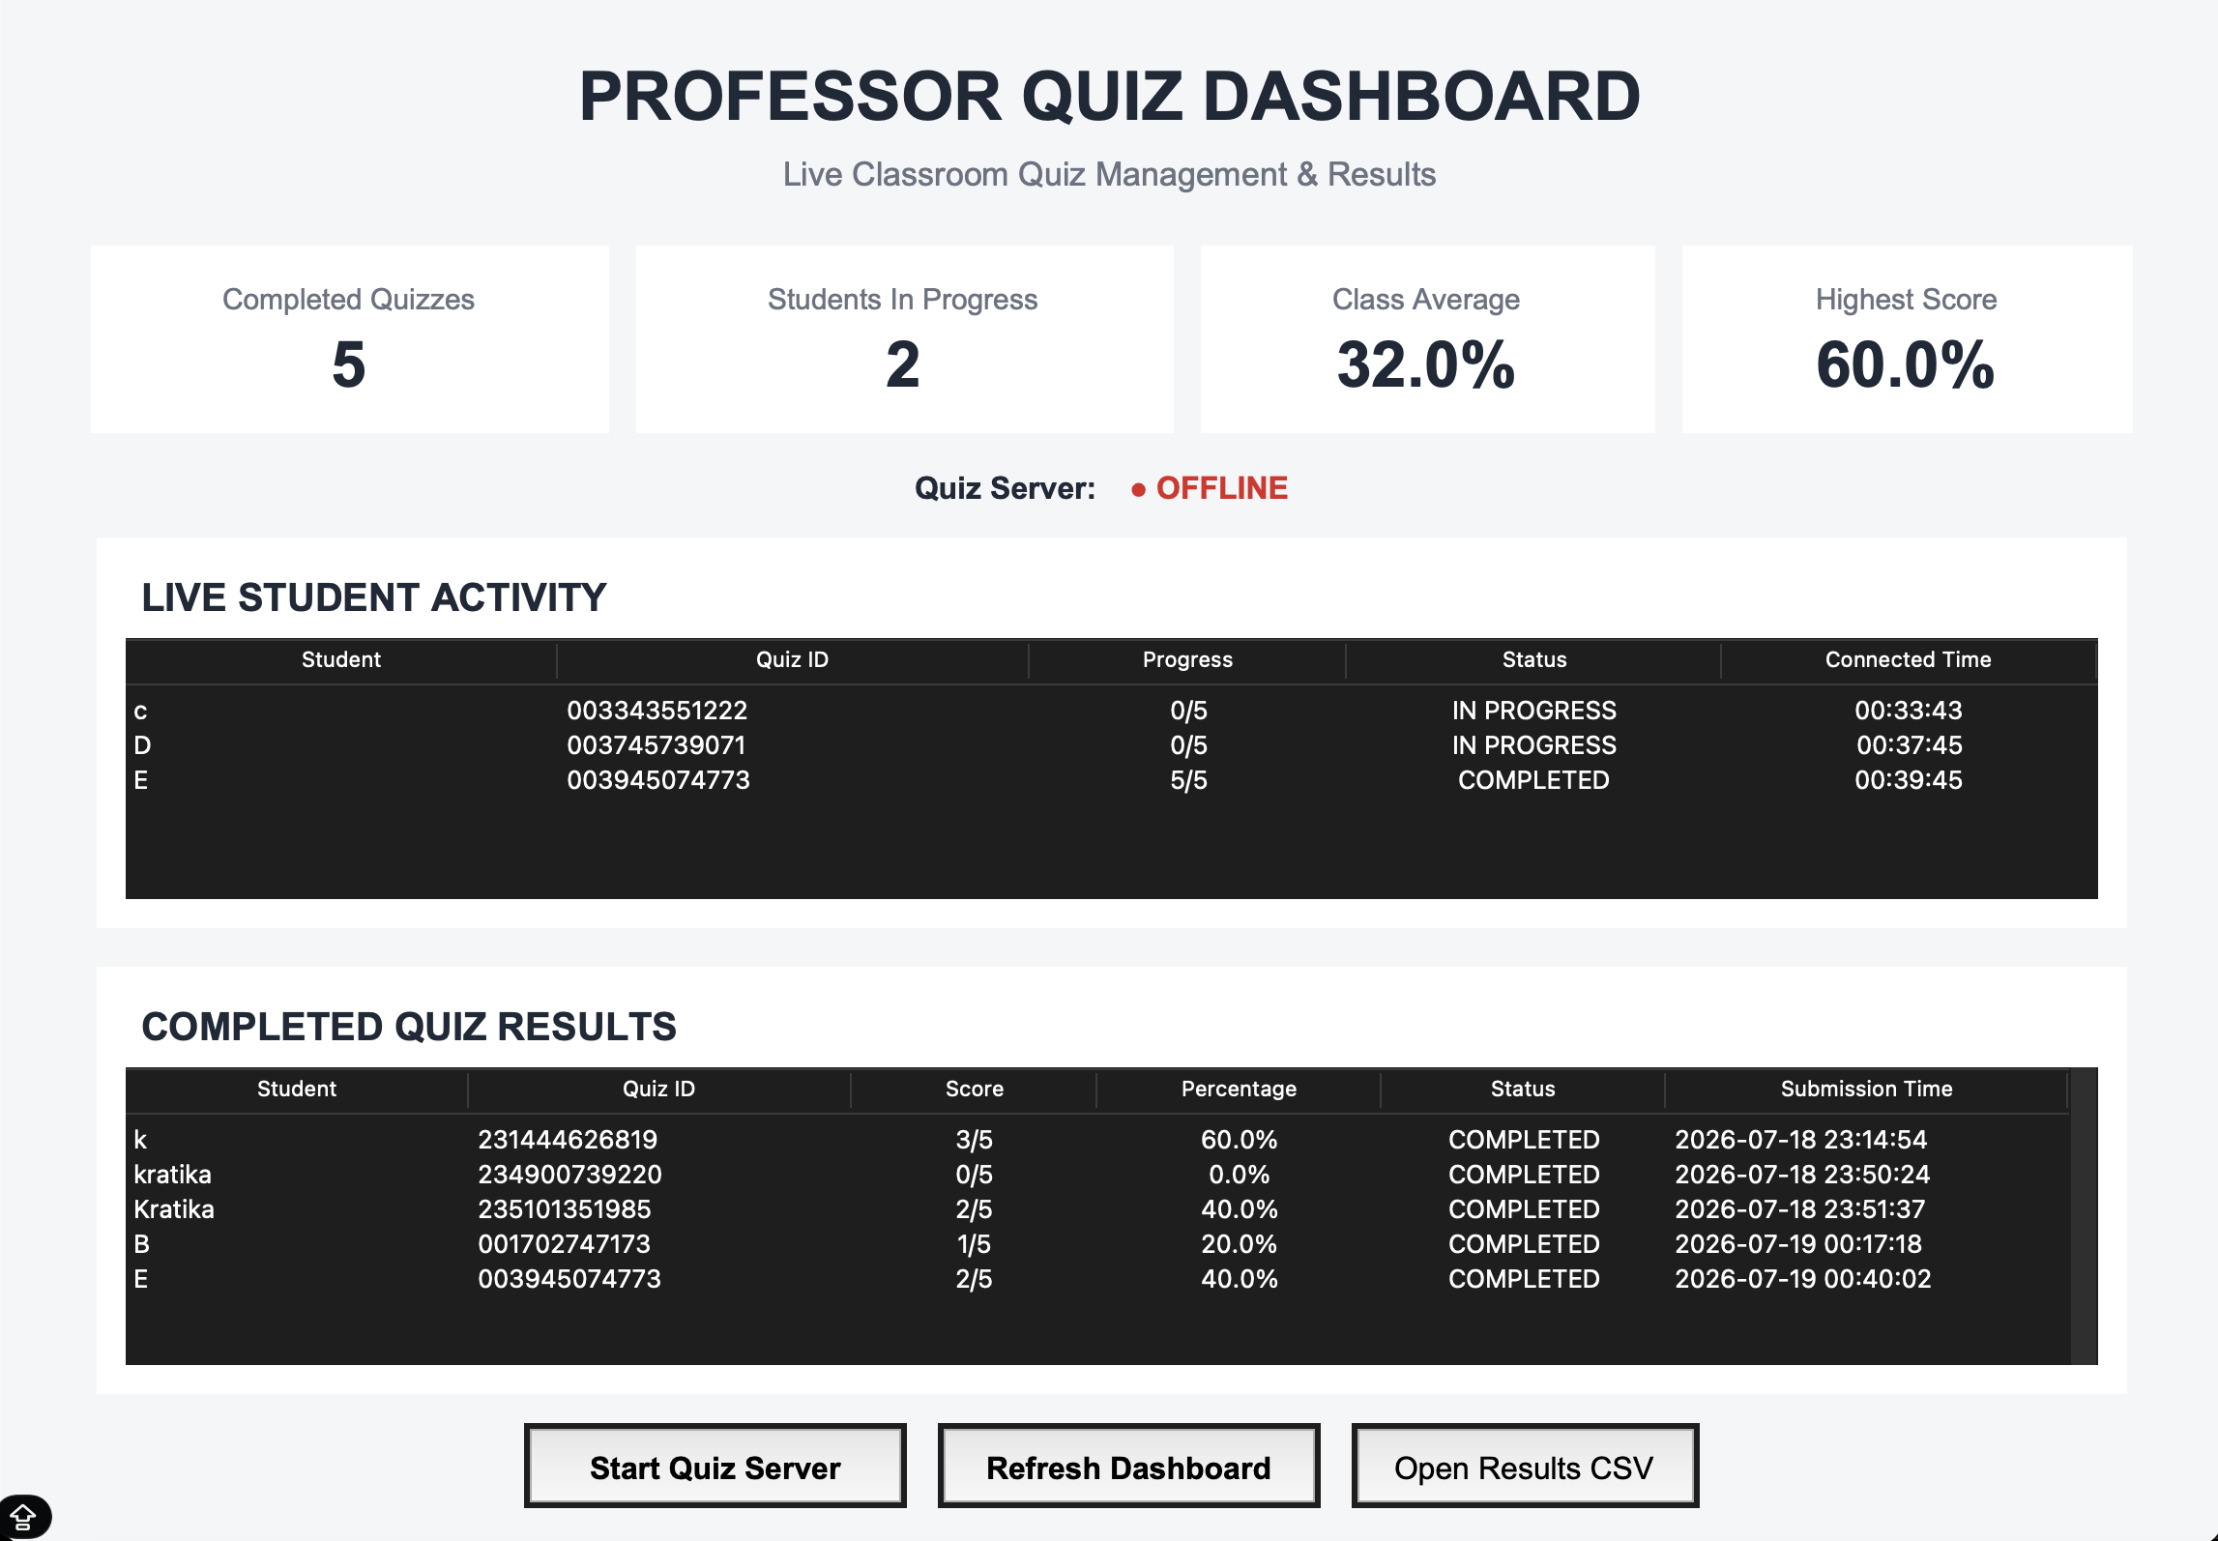
Figure 5. Professor dashboard showing stored quiz results.
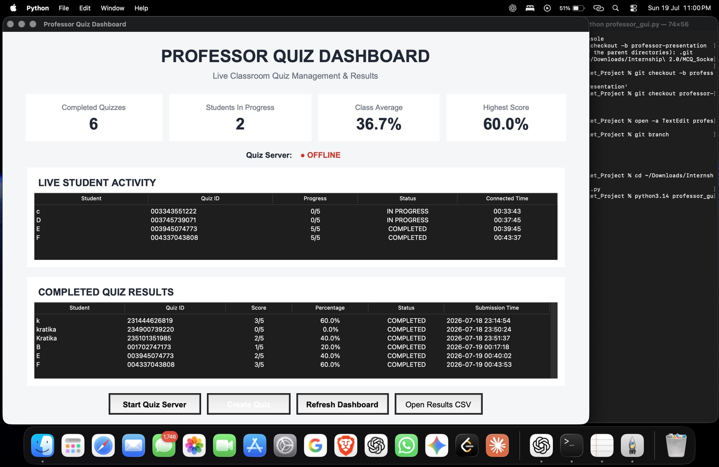
Figure 6. Enhanced dashboard with live student activity.
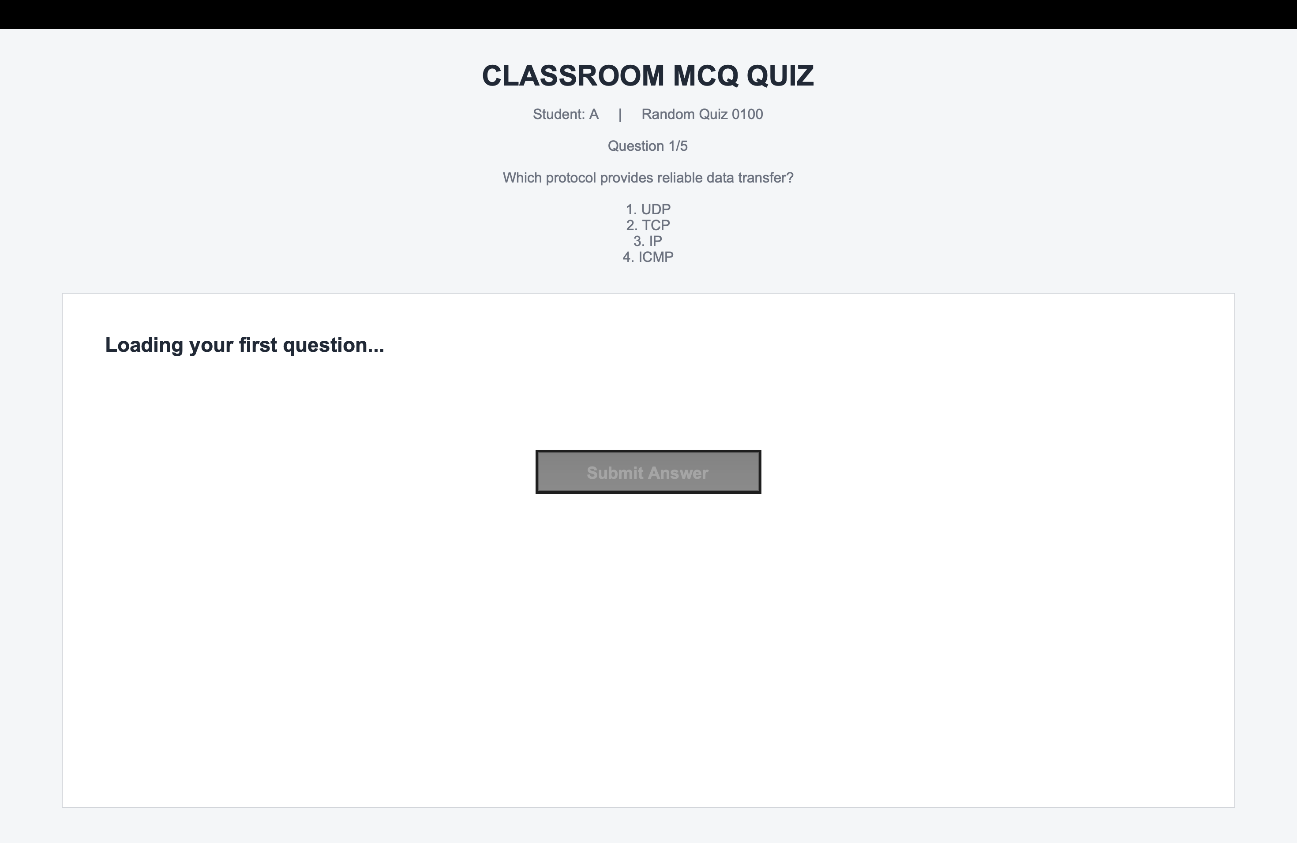
Figure 7. Professor dashboard with the server online.

12. Live Student Activity
The Live Student Activity panel lets the professor monitor every connected student in real time, showing student name, Quiz ID, progress, status, and connected time. For example:
Student | Quiz ID | Progress | Status
C | 003343551222 | 0/5 | IN PROGRESS
D | 003745739071 | 0/5 | IN PROGRESS
E | 003945074773 | 5/5 | COMPLETED
This gives the professor a real-time, at-a-glance view of classroom quiz activity as it unfolds.
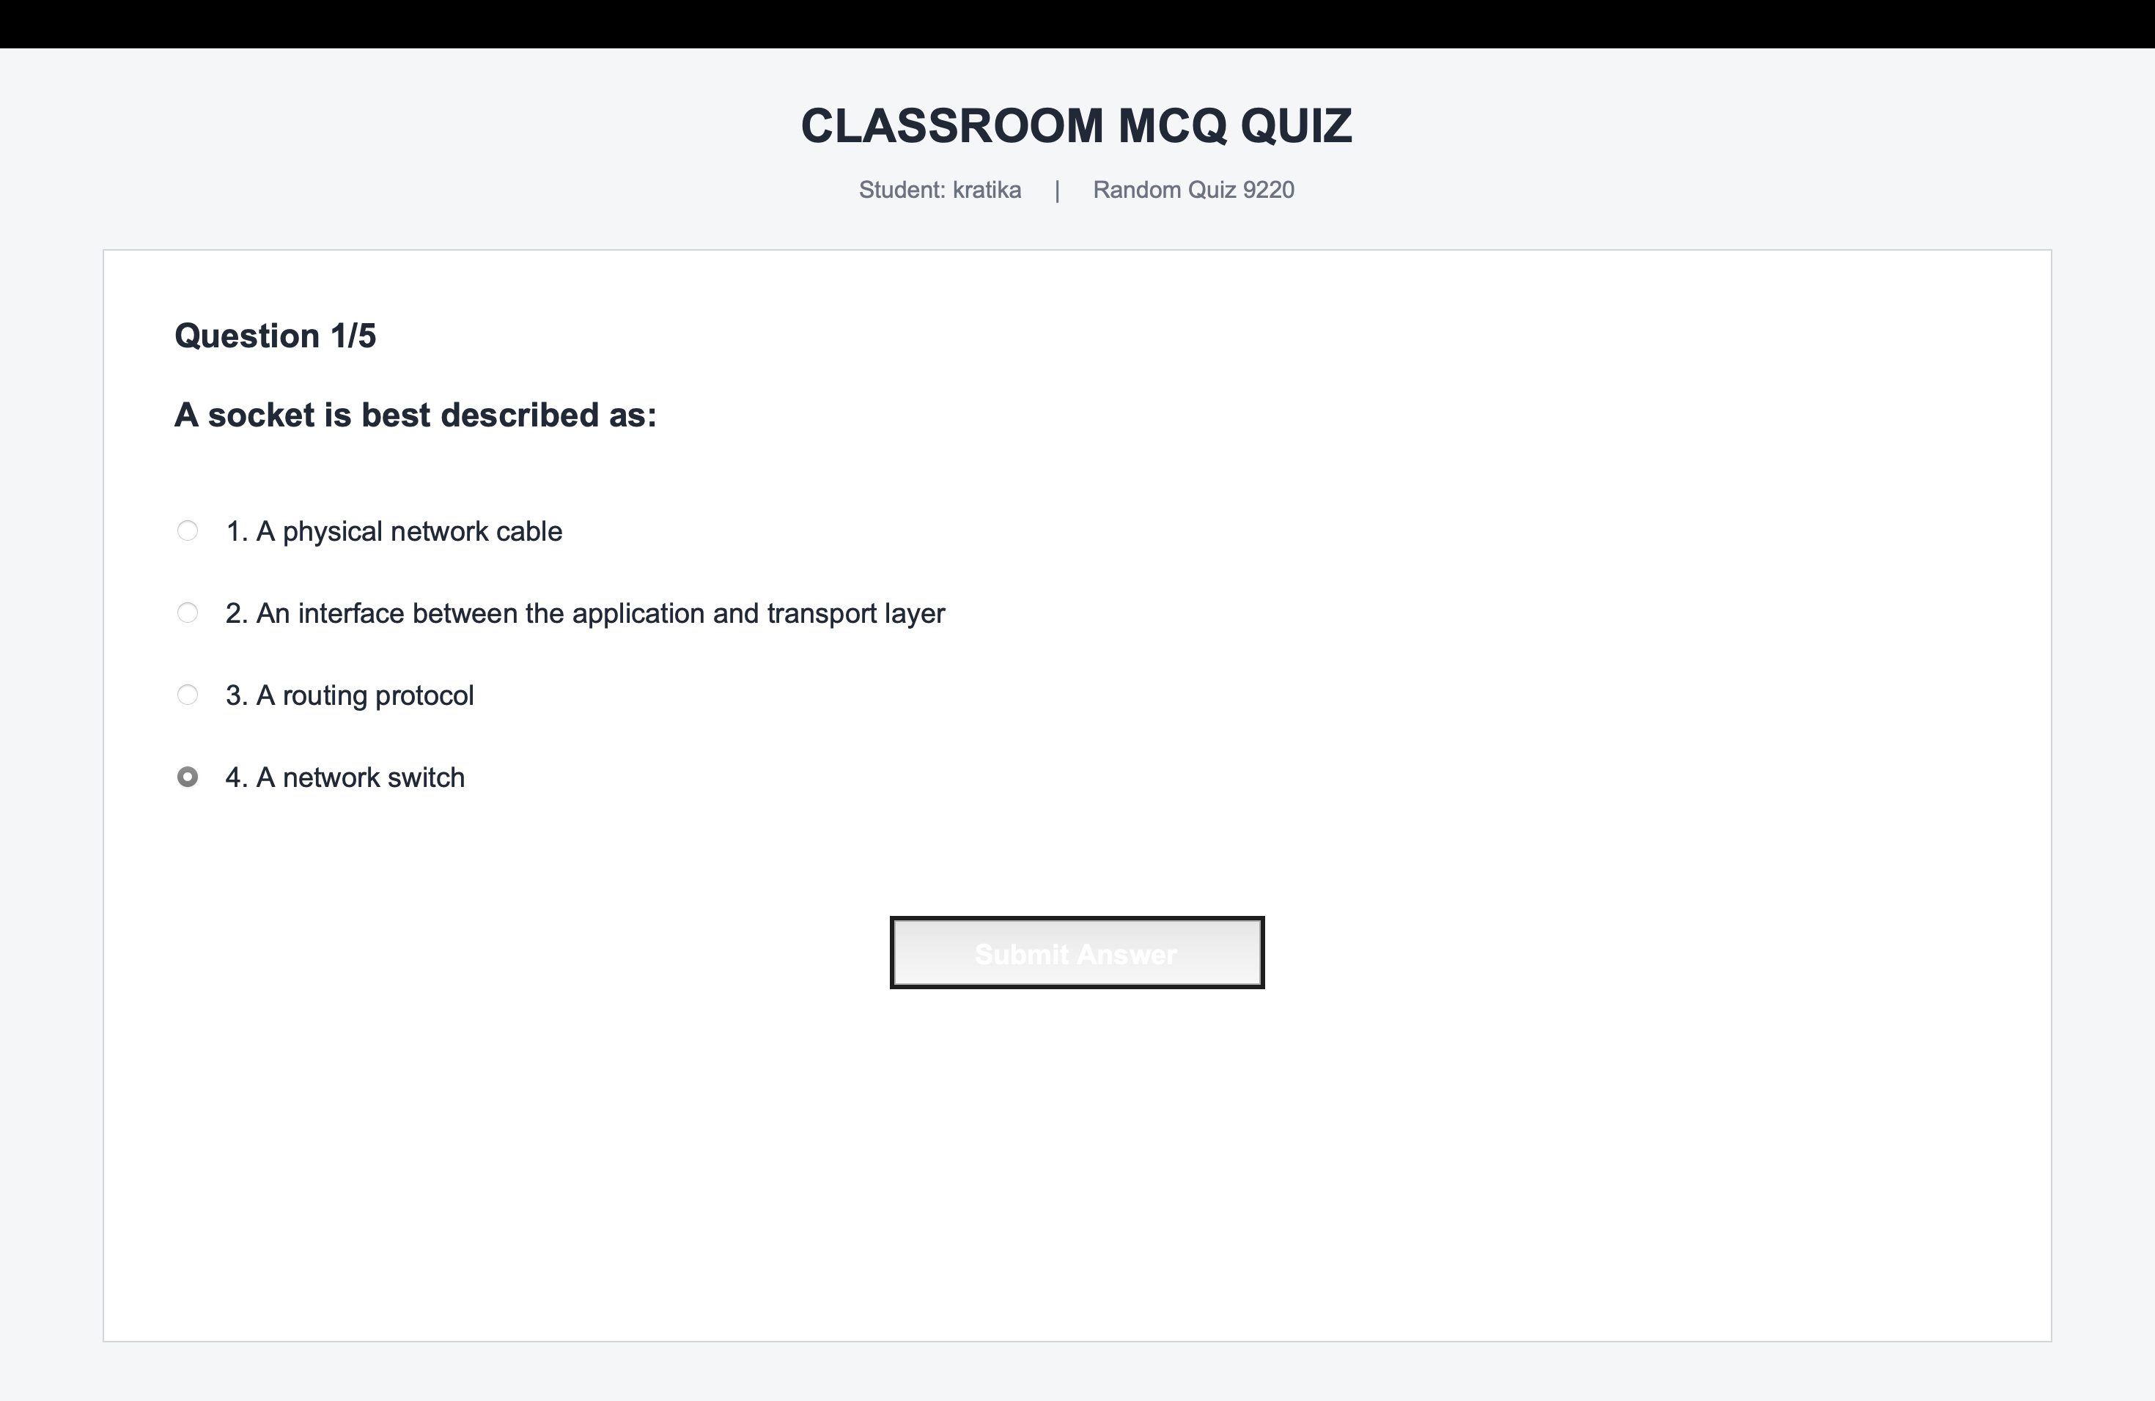
Figure 8. Server configuration and randomized quiz generation.
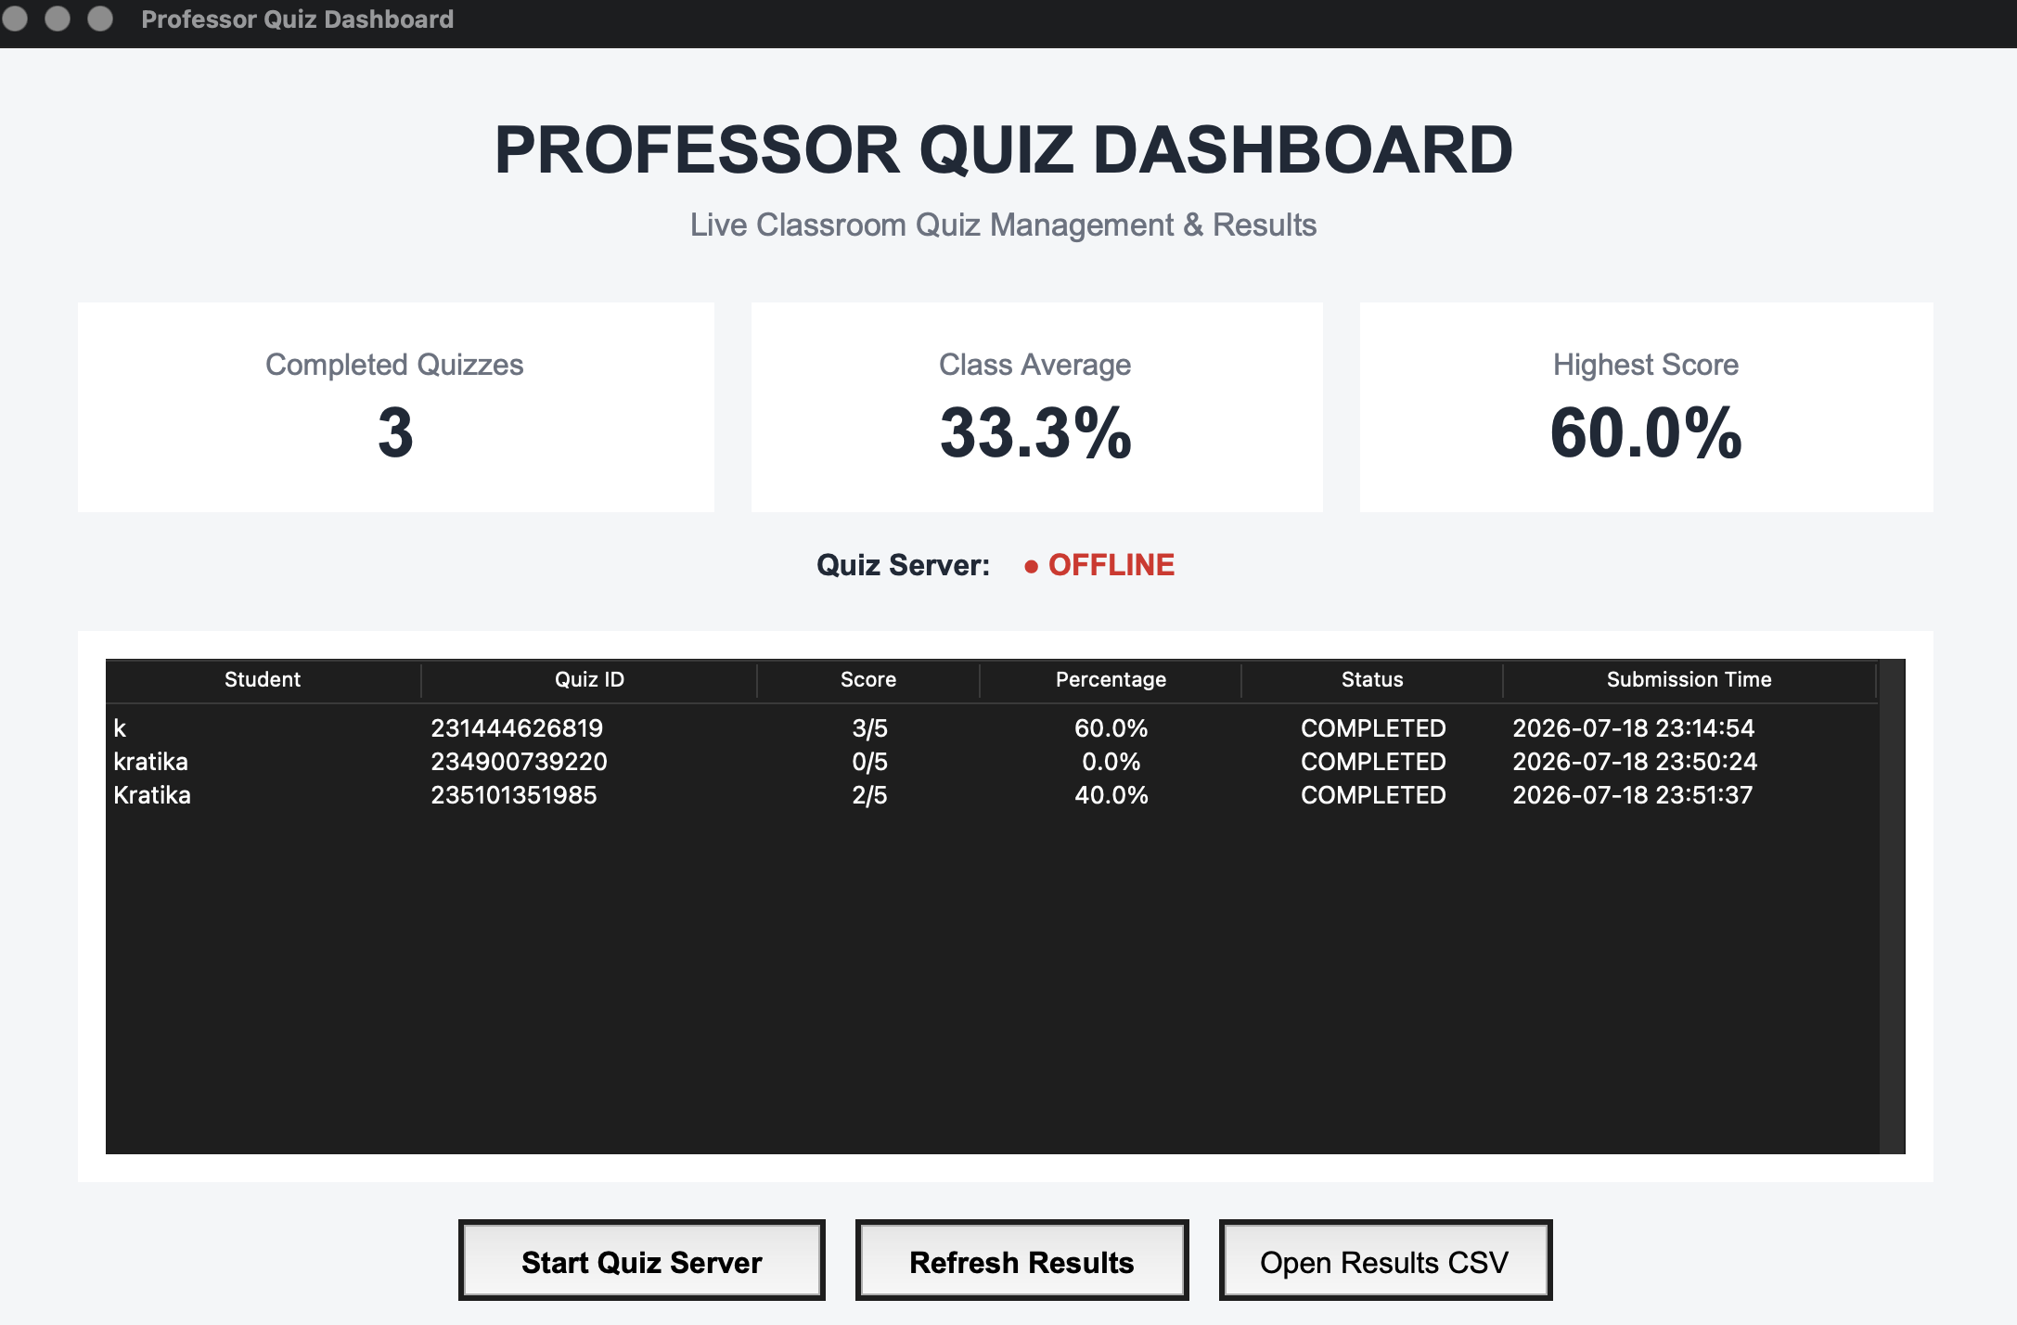
Figure 9. Server console processing multiple completed quizzes.
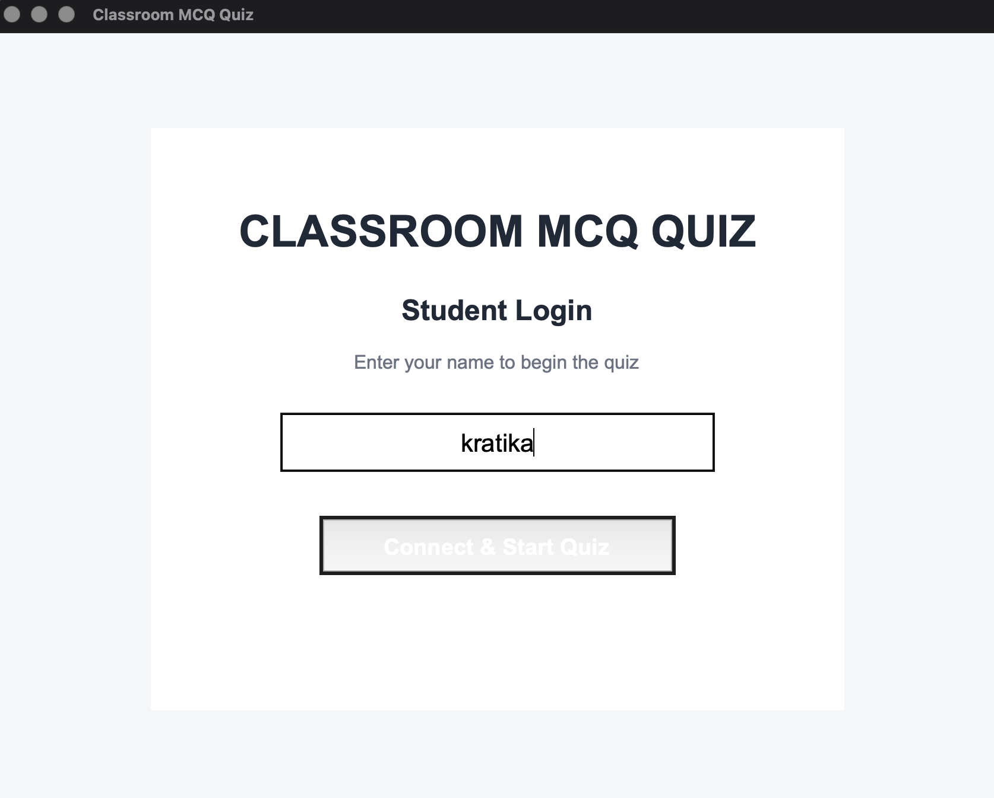
Figure 10. Server-side score calculation and result storage.

13. Completed Quiz Results and Data Storage
Alongside live activity, the professor dashboard maintains a dedicated section for completed attempts, recording student name, Quiz ID, score, percentage, completion status, and submission time. Because these records are written to quiz_results.csv, they remain available even after the quiz session ends — and after the application itself is restarted — giving the professor persistent, reviewable records of every attempt.
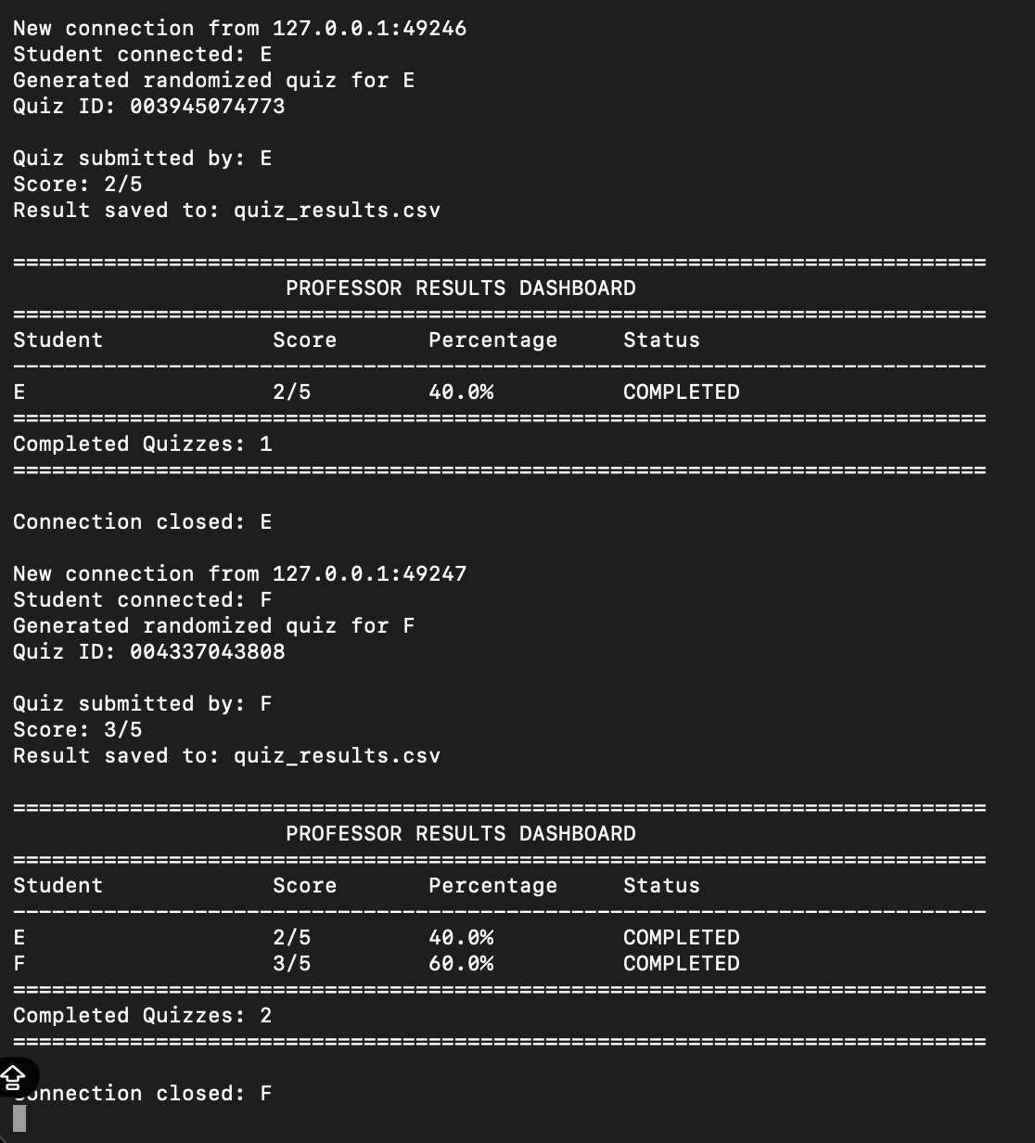
Figure 11. Professor results dashboard during testing.

14. Professor Quiz Creator
The Create Classroom Quiz interface lets the professor author new questions — entering the question text, four answer options, and the correct answer — without ever touching the underlying Python source code. Submitted questions are added directly to the question bank used by the quiz application.
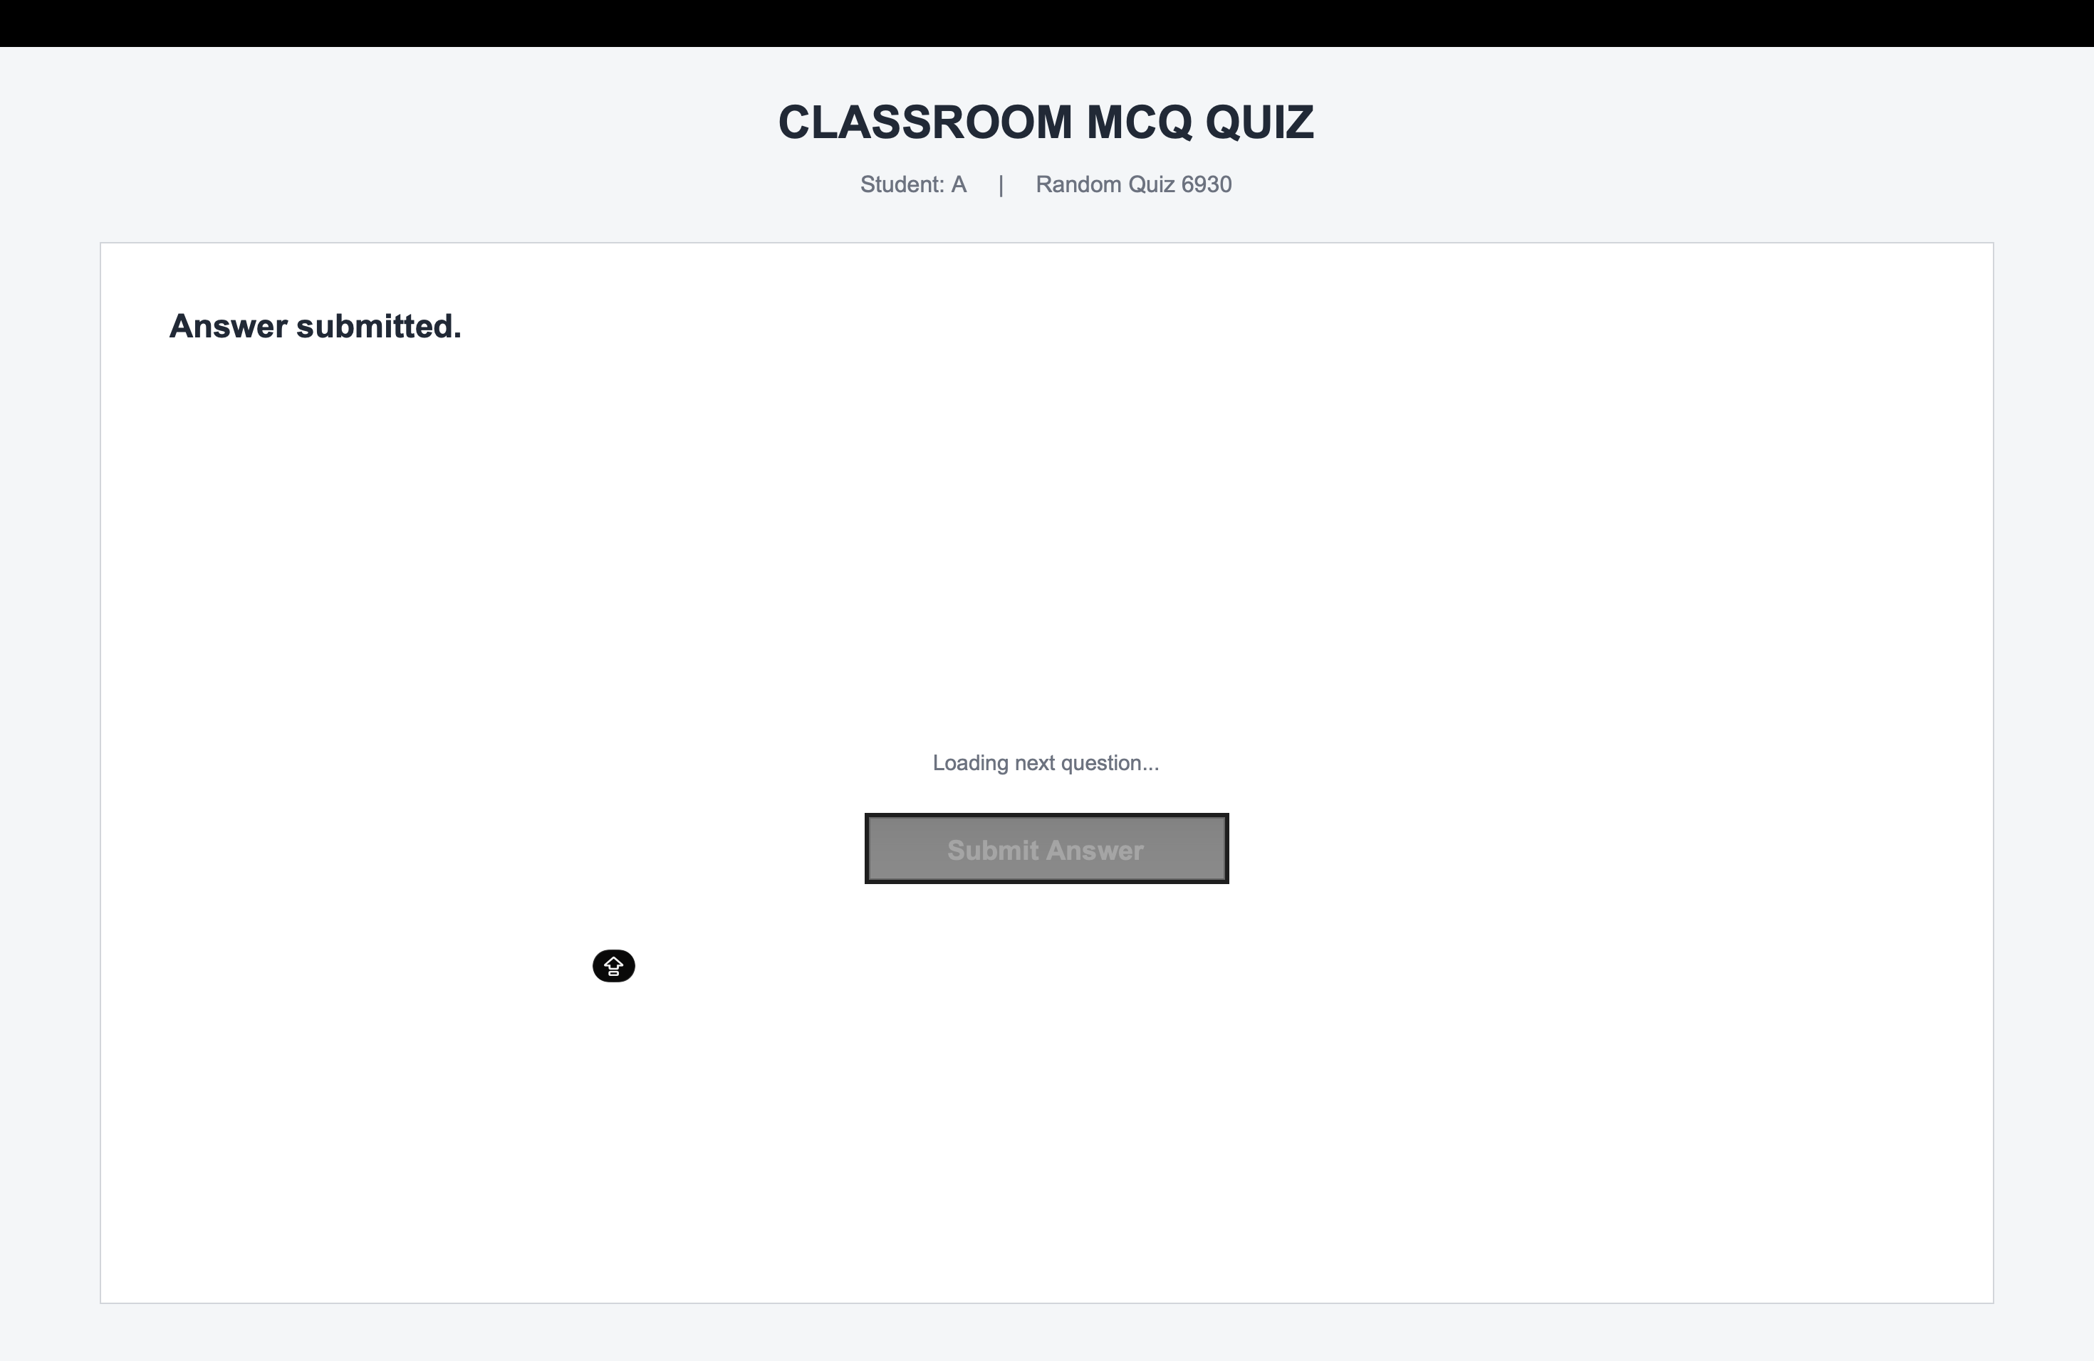
Figure 12. Professor Quiz Creator interface.

15. Major Features
- Client-server architecture with reliable TCP socket communication
- Multi-client support through multithreading
- Randomized, individualized question generation
- Unique Quiz IDs for tracking every attempt
- Graphical student interface built with Tkinter
- Graphical professor dashboard
- Live student activity monitoring
- Automatic score and percentage calculation
- Class average and highest-score calculation
- Online / offline server status indication
- Persistent CSV-based result storage
- Graphical quiz creation interface for professors

16. Testing and Results
The system was tested through repeated student connections and multiple simultaneous quiz attempts. Testing confirmed successful client connection, randomized quiz creation, unique ID generation, question delivery, answer submission, score calculation, result persistence, and professor-side monitoring. The final dashboard correctly reflects completed quizzes, students in progress, class average, highest score, live activity, and full submission history.

17. Challenges and Solutions
Challenge | Solution Implemented
Handling concurrent student connections | Used a dedicated server thread per connected client.
Avoiding repeated quiz sequences | Introduced randomized question selection from the question bank.
Tracking individual attempts | Assigned a unique Quiz ID to every quiz session.
Preserving results after restarts | Persisted every completed attempt to a CSV results file.
Improving usability over a terminal interface | Replaced command-line interaction with Tkinter GUIs.
Giving the professor visibility into the class | Added dedicated live-activity and completed-results dashboard sections.

18. Advantages
By automating distribution, evaluation, and record-keeping, the system removes most of the manual overhead of running a classroom quiz. It calculates results instantly, lets many students participate at once, keeps centralized and durable records, and gives the professor real-time visibility into how the class is doing — while randomized questions reduce the chance that students see an identical sequence.

19. Limitations
The project is currently demonstrated over a local network or localhost environment, and does not yet include formal student authentication or database-backed storage. For deployment at a larger institution, CSV storage would ideally be replaced with a proper database, and additional network security measures would need to be added.

20. Future Enhancements
- Student and professor login authentication
- SQLite or MySQL database integration
- Quiz timer with automatic submission
- Support for multiple subjects and categories
- Configurable question difficulty levels
- Negative marking
- Detailed student performance analytics
- Graphs and charts for result visualization
- Downloadable PDF result reports
- Secure, encrypted network communication
- LAN and internet deployment
- Web-based student interface
- Mobile application support

21. Conclusion
The Classroom MCQ Quiz System is a complete implementation of a multi-client network application built on Python socket programming. It demonstrates how core networking concepts — TCP communication, client-server architecture, sockets, and multithreading — can be applied to solve a genuine classroom problem.
Over the course of development, the project evolved from a basic terminal-based client-server quiz into a full graphical system: a student quiz application, randomized quiz generation, live student monitoring, automatic evaluation, persistent result storage, a professor dashboard, and a quiz creation interface. Taken together, it brings computer networking, GUI programming, concurrent programming, and data management into a single, functional classroom assessment platform.

22. References
- Python documentation — socket module.
- Python documentation — threading module.
- Python documentation — Tkinter GUI toolkit.
- Python documentation — csv module.

