Proposed additions for the revised manuscript (higher-tier submission)
All numbers below come from the re-implemented pipeline in the public repository (ChEMBL 37, 50 pairs). That pipeline reproduces the manuscript closely (scaffold R2 0.54 vs 0.56; publication hold-out 0.26 vs 0.21; within-series 0.04 vs 0.05; between-publication share 65% (54 to 76%); leakage 92%). Because the new analyses use the re-implemented pipeline, we recommend reporting its values throughout the revised paper for internal consistency, or stating clearly which pipeline each number comes from.

Abstract: replace the final results and conclusion sentences with
A cross-publication noise ceiling, estimated from compounds measured in several publications, bounds the achievable R2 on a new publication at a median of 0.63; publication-held-out models reach about 55% of it and never exceed it, whereas scaffold-split R2 exceeds the ceiling in 6 of 26 pairs. A chronological split was harsher still (median R2 0.07). An empirical-Bayes calibration that shrinks the offset estimated from a few measured anchors towards the training mean, with the between-publication variance estimated by nested publication-level cross-validation, raised pooled R2 from 0.18 to 0.34 with one anchor per new series (better in 46 of 47 pairs). We recommend publication-level and chronological hold-out, reporting performance relative to the noise ceiling, and calibration with one or two anchors.

Methods: new subsections
Noise ceiling. For each pair, the selectivity Delta of a compound measured in at least two documents was compared across documents. Because compound-specific selectivity cancels, the within-compound variance across documents (Vx) measures the protocol offset plus measurement error per measurement. The ceiling on R2 for predicting a held-out publication is 1 - Vx/Vtot, where Vtot is the variance of same-document Delta. Compounds were resampled 500 times for 95% intervals. Ceilings were summarised over pairs with at least 20 repeat compounds (30 pairs).
Chronological split. Publications with at least five matched compounds were ordered by ChEMBL document year; those after the 75th-percentile year (median 2017) formed the test set and any compound occurring in them was removed from training.
Empirical-Bayes anchor calibration. For a new publication with m measured anchors, the plain method adds the mean residual of the anchors to all predictions. The calibrated method adds mu + w(r - mu), where r is the anchor mean residual, mu the mean publication offset in the training data, w = tau2/(tau2 + sigma2/m), tau2 the between-publication variance of offsets and sigma2 the within-publication residual variance. tau2 and sigma2 were estimated from out-of-fold residuals of a three-fold, publication-grouped cross-validation on the training set, with compounds shared with the held-out fold removed. Residuals from out-of-bag predictions were tried first and failed because they retain same-publication information.
Additional learners and strata. Gradient boosting and a two-layer perceptron were compared with the random forest under identical publication splits (three splits, training capped at 2,500 compounds). The between-publication variance share was recomputed for equilibrium (Ki, Kd) and functional (IC50) data separately.

Results: new subsections
Noise ceiling. Across 30 pairs the median ceiling was 0.63 (IQR 0.37 to 0.71); four pairs (BRD4/BRD2, EGFR/ERBB2, CDK2/CDK1, CA2/CA1) had ceilings at or below zero. Among 26 pairs with a ceiling above 0.05, publication-held-out R2 was a median 55% of the ceiling and never exceeded it, whereas scaffold-split R2 exceeded it in 6 pairs, which a model without leakage cannot do. The ceiling predicted publication-held-out R2 across pairs (Spearman rho 0.73, p = 5e-6; Figure 5a). About 57% of the between-publication variance was protocol offset or noise, leaving a chemical-series component of about 27% of the total variance.
Chronological split. Median R2 was 0.07 across 45 pairs and within-series R2 was 0.02, lower than under publication hold-out.
Anchor calibration. In an independent validation (four new splits, training capped at 6,000 compounds, 47 pairs), pooled R2 for plain and empirical-Bayes calibration was 0.18 vs 0.34 with one anchor, 0.38 vs 0.46 with two, 0.44 vs 0.47 with three and 0.49 vs 0.50 with five (Table 3, Figure 5b). The calibrated version was better in 46, 41, 41 and 36 of 47 pairs (Wilcoxon p = 2e-12, 1e-6, 9e-7, 1e-5). One calibrated anchor therefore recovers about as much as two plain anchors. A first run with different splits gave the same ordering (0.26 vs 0.41 with one anchor).
Anchors | Plain offset R2 | Empirical-Bayes R2 | Pairs improved (of 47)
1 | 0.18 | 0.34 | 46
2 | 0.38 | 0.46 | 41
3 | 0.44 | 0.47 | 41
5 | 0.49 | 0.50 | 36
Table 3. Few-anchor calibration, leave-publication-out, median over 47 pairs.
Other learners and strata. Gradient boosting (pooled R2 0.17, within-series -0.13), the perceptron (0.17, -0.11) and a three-model mean (0.27, 0.00) did not outperform the random forest (0.27, 0.03); a series-centred forest gave -0.03 pooled and 0.02 within-series. The between-publication share was 0.56 for equilibrium data (37 pairs) and 0.66 for functional data (45 pairs).
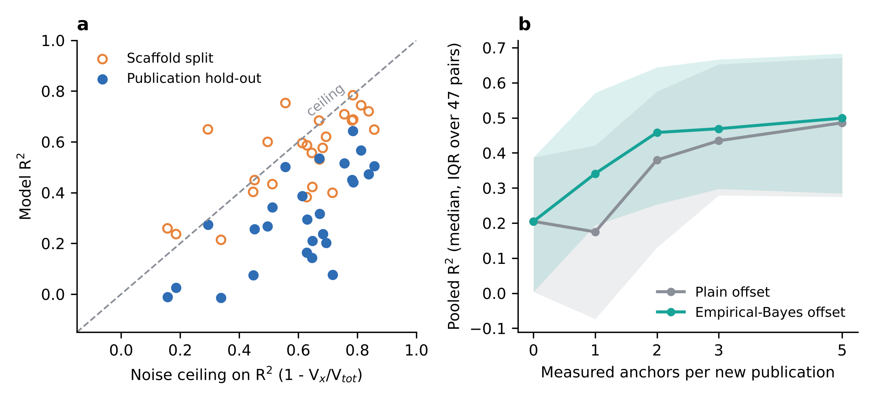
Figure 5. (a) Model R2 against the cross-publication noise ceiling for 26 pairs; points above the dashed line exceed the achievable maximum. (b) Pooled R2 against the number of measured anchors per new publication for the plain and empirical-Bayes offsets (median and IQR over 47 pairs).

Discussion and limitations: sentences to add
The noise ceiling provides a reference for interpreting any selectivity benchmark: a score above it signals leakage, and a score far below it signals room for improvement. The ceiling is estimated from repeat compounds, which are mostly reference compounds, so it may not describe typical series compounds; it cannot separate laboratory offsets from random error without assay descriptors; and the pairs are curated, not random. Calibration results rest on a re-implemented pipeline with capped training sets, publications as a proxy for laboratories, and no prospective or experimental validation.

Data availability: replace with
Code, curated tables and results are in a public repository: [GitHub URL to be added]; an archived DOI (for example via Zenodo) will be provided on acceptance. Source data: ChEMBL 37 (2026-05-01).

