Step 1:

* Import necessary libraries
* Indicate where training and validation data are located
* Specify the size of the images (in pixels)
* Import data into the training dataset

Step 2:

* Import data into validation dataset

Step 3:

* Display some of the images of each classification set
* This is to ensure that they are labeled correctly and can be accessed

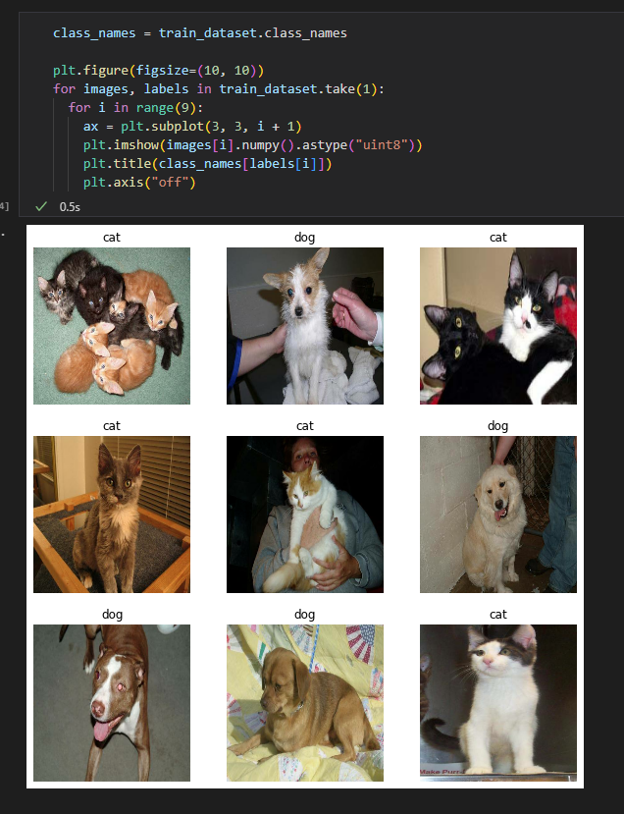

Step 4:

* Divide the data up to create a test dataset for later use

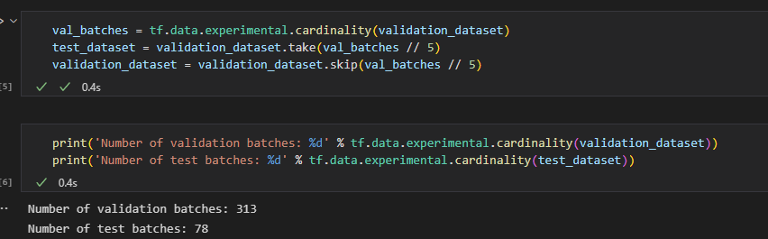

Step 5:

* Autotune automatically determines how much data needs to be prefetched

Step 6:

* Augment data through flipping, rotation, and translation. This creates a larger variety of data

Step 7:

* Adjust the size of the images to be compatible with the base model about to be imported

Step 8:

* Import the base model used for transfer learning

Step 9:

* Convert each image to a 5x5x1280 block of features

Step 10:

* Freeze the layers of the base model to ensure weights don’t change with further training

Step 11:

* Generate predictions from the base model and augmentation

Step 12:

* Create a prediction per layer

Step 13:

* Create a model by combining the base model, augmentation, and rescaling

Step 14:

* Compiling the model

Step 15:

* Train the model

Step 16:

* Display the training and validation accuracy/loss

Step 17:

* Unlock the base model to allow changes

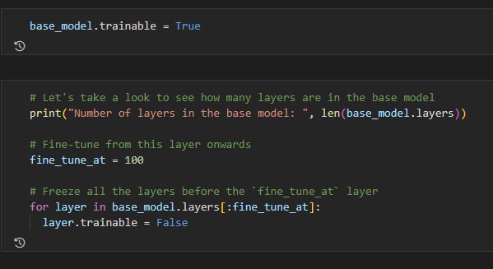

Step 18:

* Adjust the model to allow further training

Step 19:

* Increase accuracty with further training

Step 20:

* Show loss/accuracy curve for additional training done to base model

Step 21:

* Verify performance on test data

