Some issues were encountered while setting up this assignment. Originally, I attempted to run it locally on my machine. However, some of the dependencies required for detectron2 stated that they could only be installed on a UNIX system. I attempted to run this on a virtual machine, but it did not have enough resources available to even run a pre-trained detectron2 model.

From here I started developing this assignment using Google Colab, which allowed me to have access to more resources. At first, several issues were encountered with installing detectron and its dependencies. Once those were fixed, I was able to use detectron on individual images. To gain access to the webcam within Colab required JavaScript. With the JavaScript The first cell of the colab code is used to install detectron2 to the host.

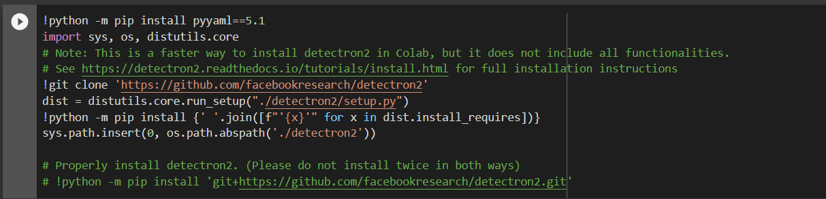

After installing detectron2 we check the version of other dependencies needed.

Import all necessary libraries

Setup a function that will allow us to access the webcam.

Take a picture and display it to ensure the webcam is working correctly.

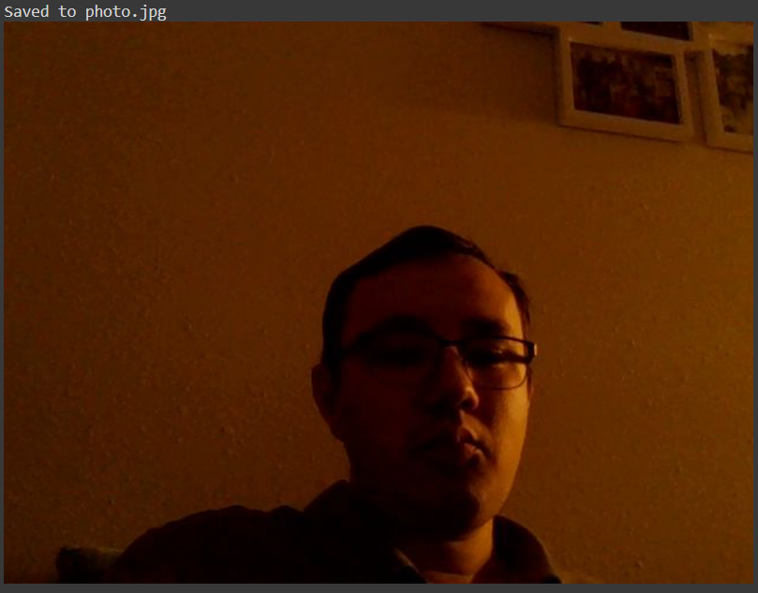

Run a loop to take a picture, analyze it, and display it with bounding boxes, masks, and confidences. This is repeated until the program is interrupted

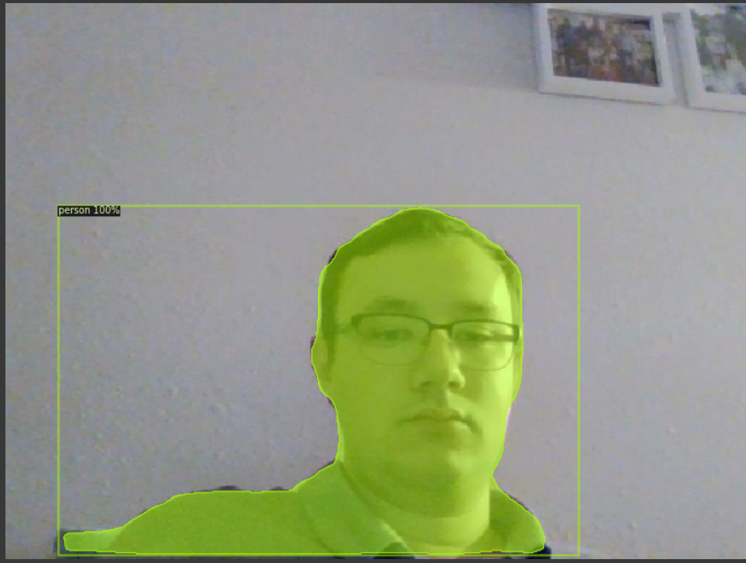

I was able to take pictures and have them be analyzed by detectron. Unfortunately, it did not allow me to analyze live footage.

The first cell of the colab code is used to install detectron2 to the host.



After installing detectron2 we check the version of other dependencies needed.

Import all necessary libraries

Setup a function that will allow us to access the webcam.

Take a picture and display it to ensure the webcam is working correctly.



Run a loop to take a picture, analyze it, and display it with bounding boxes, masks, and confidences. This is repeated until the program is interrupted

