Dustan Kraus

Advanced Mechanisms Robotics

**Homework 7**

Problem 1

I designed a PD controller with gravity compensation. Below are the plots of the performance for two different configurations.

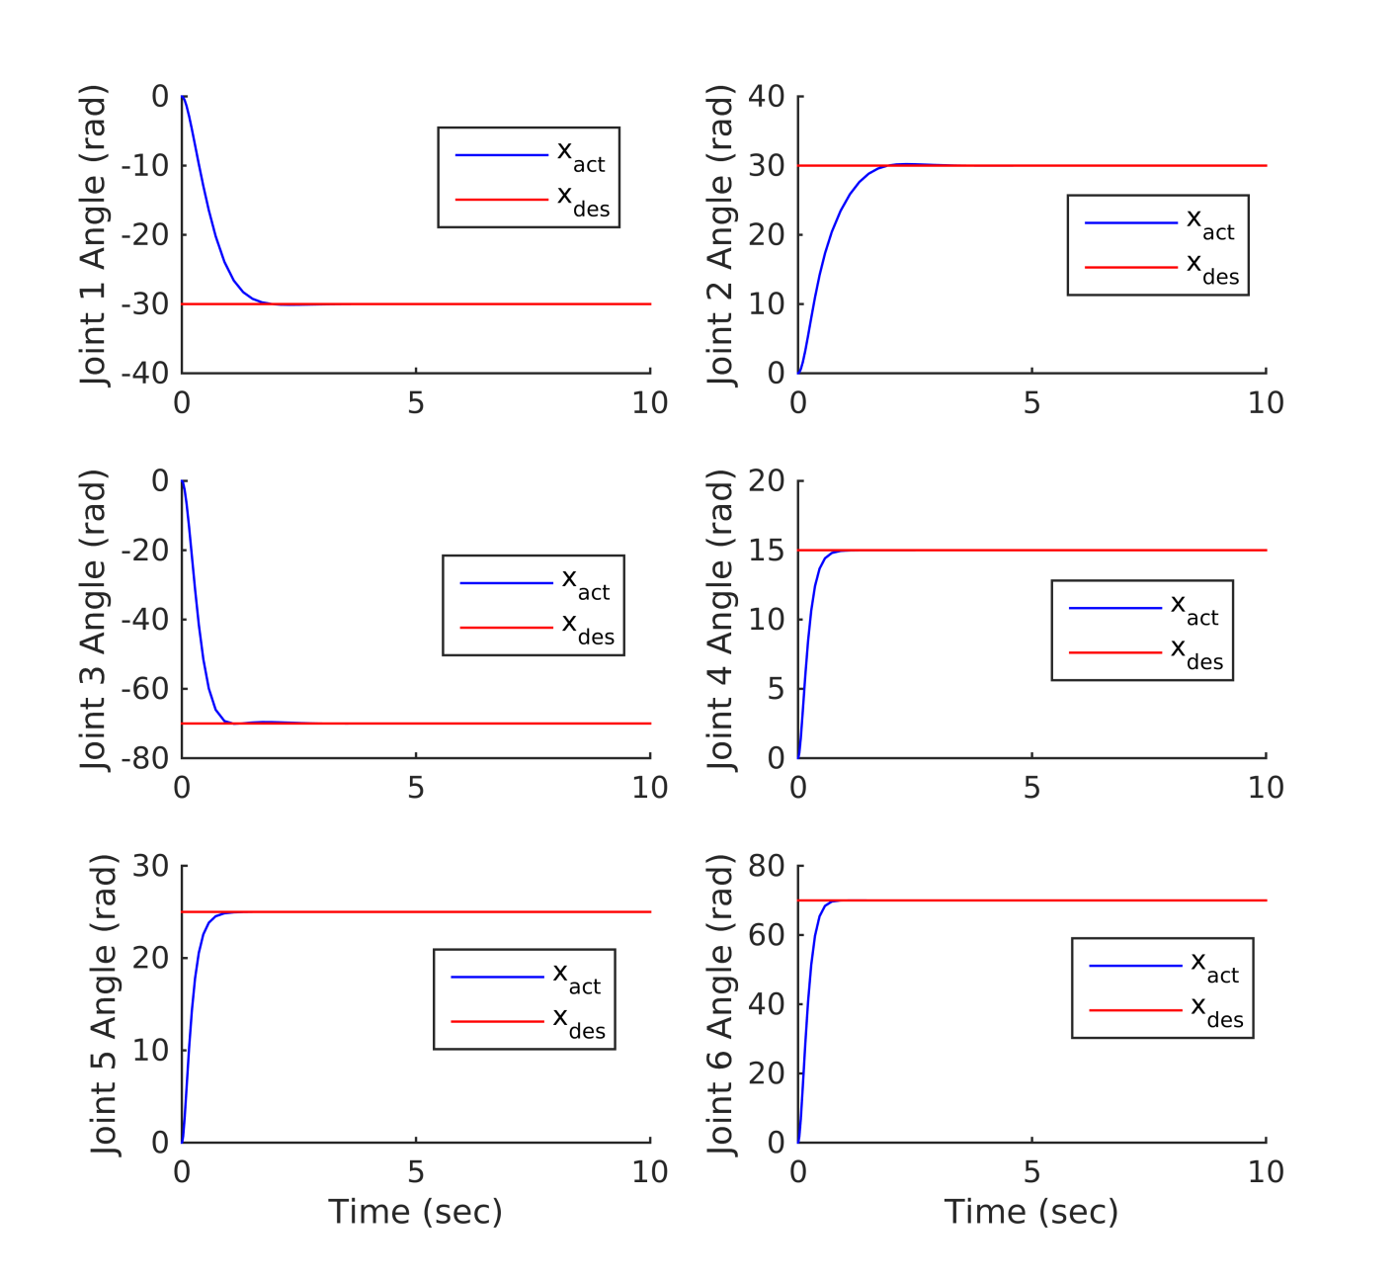

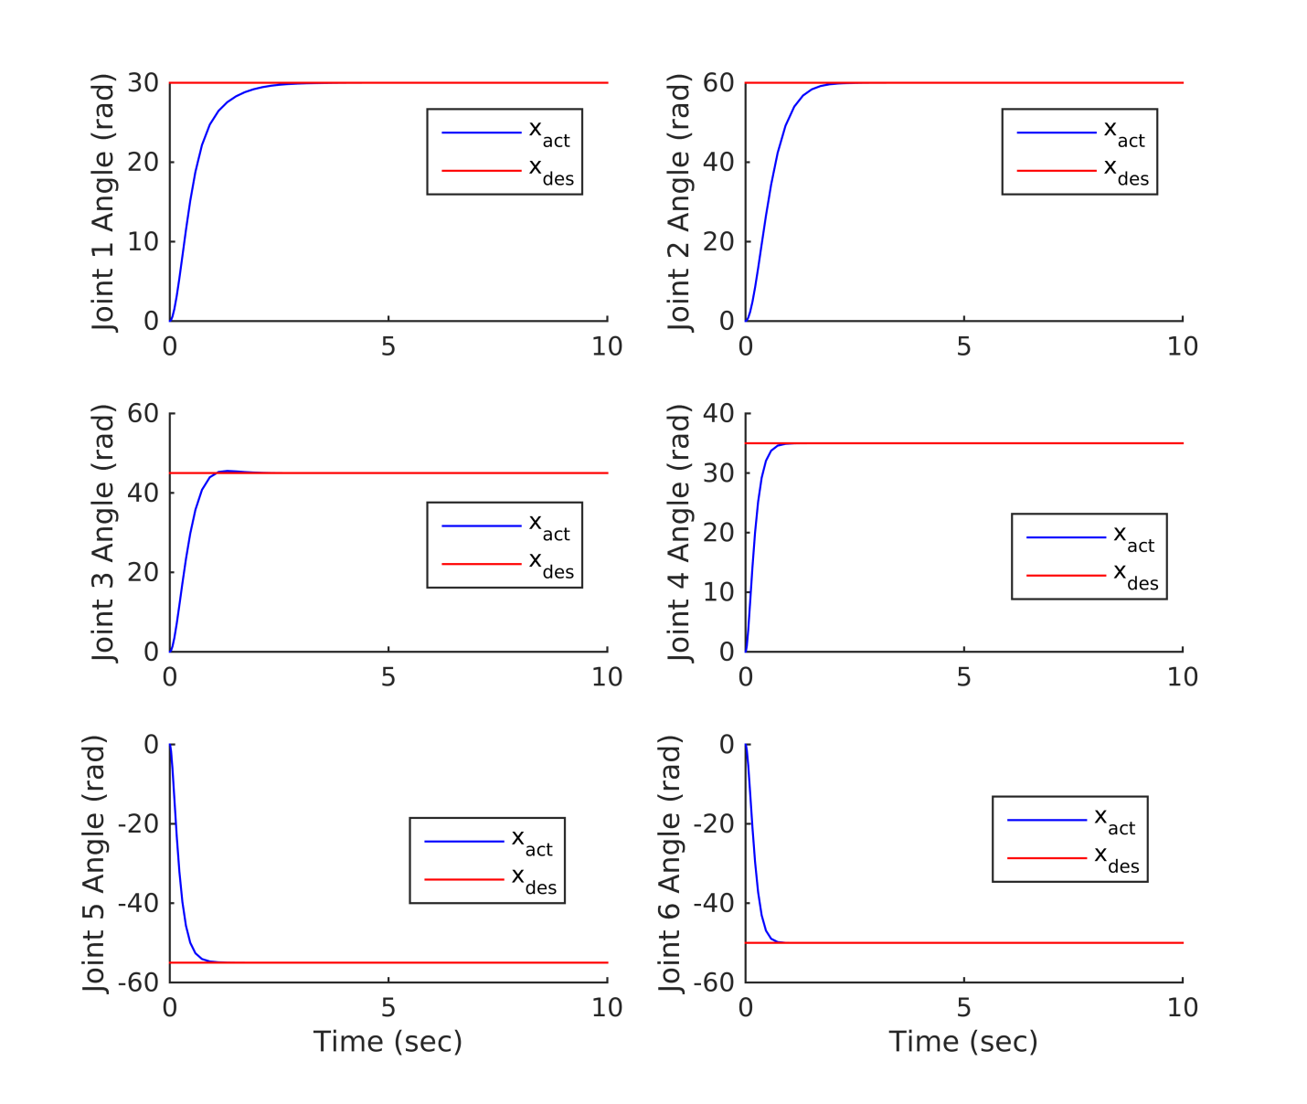

The Kp and Kd gain matrices I used are below:

P.kp = diag([40 40 20 15 15 15])*eye(6);

P.kd = diag([18 14 3 3 3 3])*eye(6);

Problem 2

Computed Torque:

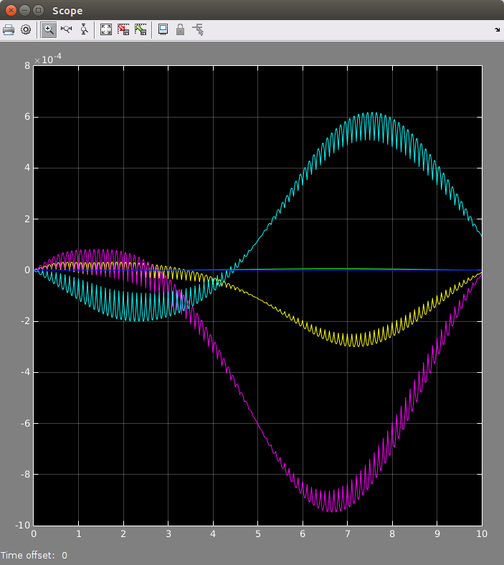

Computed Torque No Change

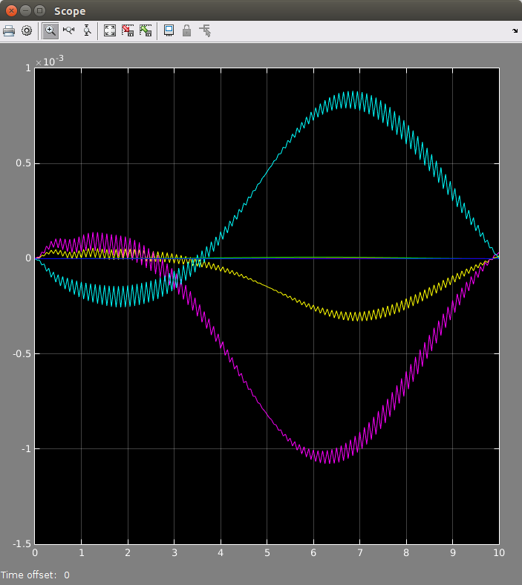

Computed Torque with Higher kp

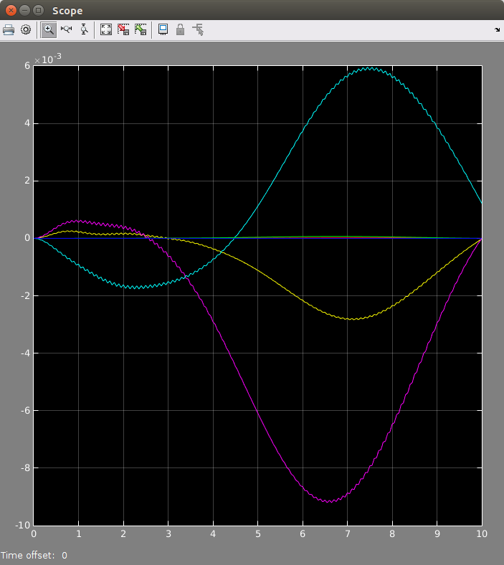

Computed Torque with a slower sample rate

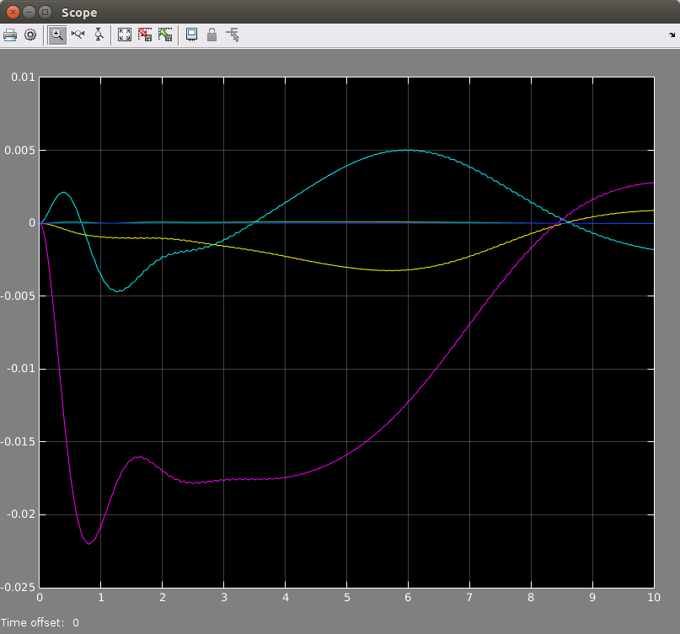

Computed Torque with Perturbation added

Feed Forward Torque:

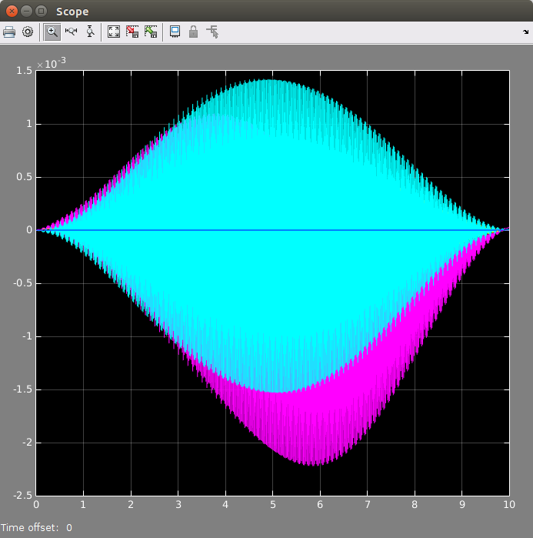

Feed Forward Torque with No change

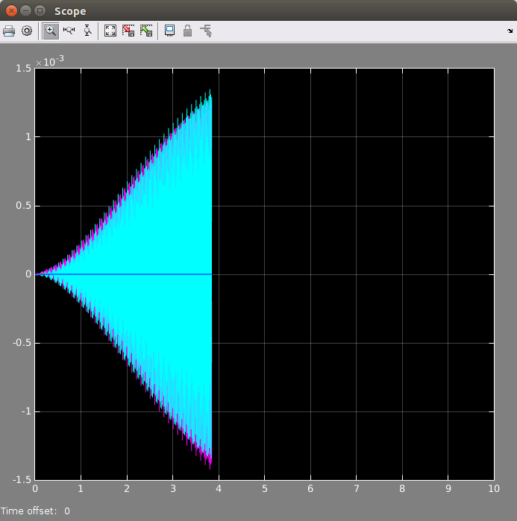

Feed forward torque with bigger gains

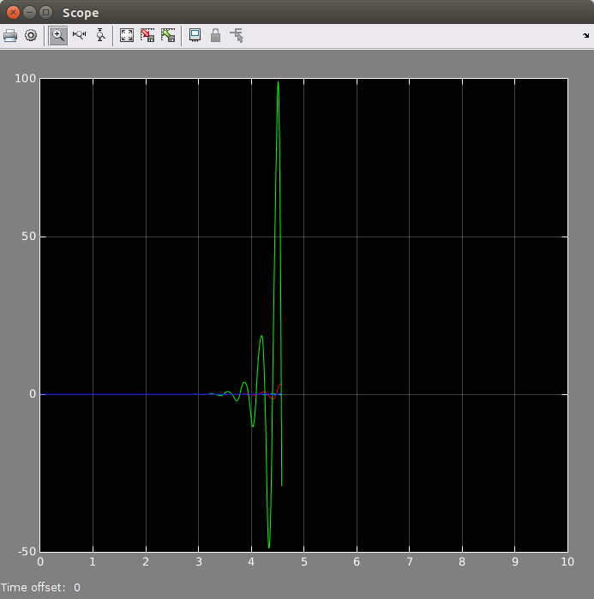

Feed Forward Torque with Slower Sampling (clearly unstable)

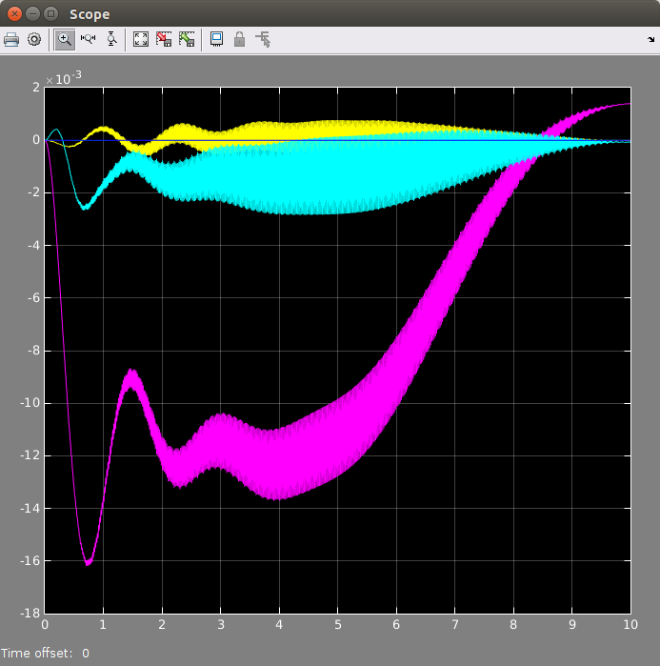

Feed Forward Torque with a perturbation

Problem 3:

For this problem, I plotted the points and the projected points in pixel space to verify that the transformation matrices I found were accurate.

(a): T1_est =

0.9801 -0.0000 0.1987 -0.0000

-0.0198 0.9950 0.0978 -0.0000

-0.1977 -0.0998 0.9752 0.5000

0 0 0 1.0000

(b)

T2_est =

1.0000 -0.0000 -0.0000 0.0000

0.0000 1.0000 -0.0000 0.1000

0.0000 0.0000 1.0000 -0.0000

0 0 0 1.0000

(c)

T3_est =

0.9801 -0.1987 -0.0000 0.1000

0.1977 0.9752 0.0998 0.0000

-0.0198 -0.0978 0.9950 0.0000

0 0 0 1.0000

Problem 4:

clear all

clc

% Make sure that you source the two startup files for the robotics toolbox

% and for the machine vision toolbox

% run ~/Desktop/vision-3.4/startup_rvc.m

% run ~/Desktop/rvctools/startup_rvc.m

%define the robotics toolbox Puma 560 arm

mdl_puma560;

%set the Coulomb friction terms to zero to help with numerical simulation

p560 = p560.nofriction;

%define desired robot pose

q_des = pi/180*[45,45,-135,0,-90,0];

Tcdes_0 = p560.fkine(q_des); %camera is at end effector

Tp_0 = [1 0 0 0; 0 1 0 0; 0 0 1 0; 0 0 0 1];

% Define object position in base frame

obj_pos = Tcdes_0(1:3,4);

obj_pos(3) = 0;

Tp_0(1:3,4) = obj_pos;

obj = [...

-0.1000 -0.1000 0.1000 0.1000 -0.1000 -0.1000 0.1000 0.1000;...

-0.1000 0.1000 0.1000 -0.1000 -0.1000 0.1000 0.1000 -0.1000;...

-0.1000 -0.1000 -0.1000 -0.1000 0.1000 0.1000 0.1000 0.1000];

obj = obj*0.5;

obj(1,:) = obj(1,:) + obj_pos(1);

obj(2,:) = obj(2,:) + obj_pos(2);

obj(3,:) = obj(3,:) + obj_pos(3);

scatter3(obj(1,:),obj(2,:), obj(3,:))

p560.plot(q_des)

cam = CentralCamera('default');

cam = cam.move(Tcdes_0);

pixels = cam.project(obj);

%cam.plot(obj);

%cam.plot(pixels);

Tp_c = cam.estpose(obj, pixels)

Tcdes_p = inv(Tp_0)*Tcdes_0;

inv(Tcdes_p)

cam.plot_camera

%P = [0.3, 0.4, 3.0]';

%cam.project(P);

%cam.project(P, 'Tcam', transl(-0.5, 0, 0));

I never could quite get problem 4 figured out. I spent a good amount of time trying to figure out why the cam.estpose() function wasn’t working for me, but couldn’t quite get it. So I never even got to the servoing part because I spent a good amount of time trying to figure this out.

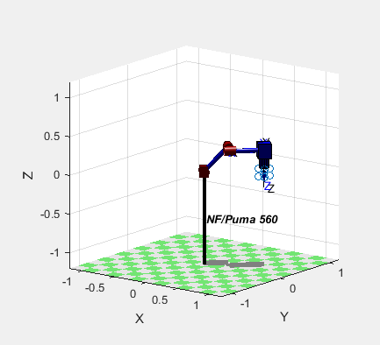

This shows the camera and shape I generated.

Problem 5:

Because I didn’t finish problem 4, I couldn’t compare my results with problem 4. But I did open and run sl_arm_ibvs. It was very cool to see servoing work properly.

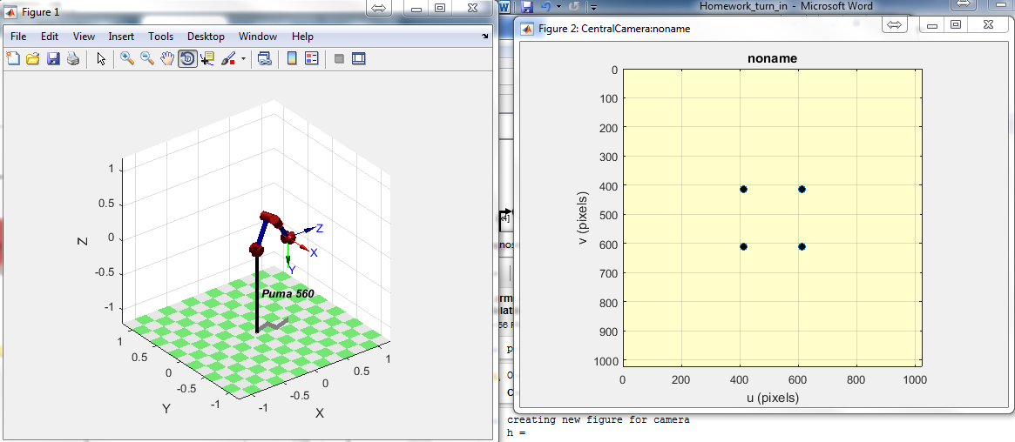

Problem 6:

Again, because I didn’t finish problem 4, I can’t use my implementation from it. But If I had finished it, I would use the Simulink roblocks to create the robot model.