MEEN 537 Lab 1

By: Dustan Kraus, Nathan Day, and Erich Mielke

# Part 1

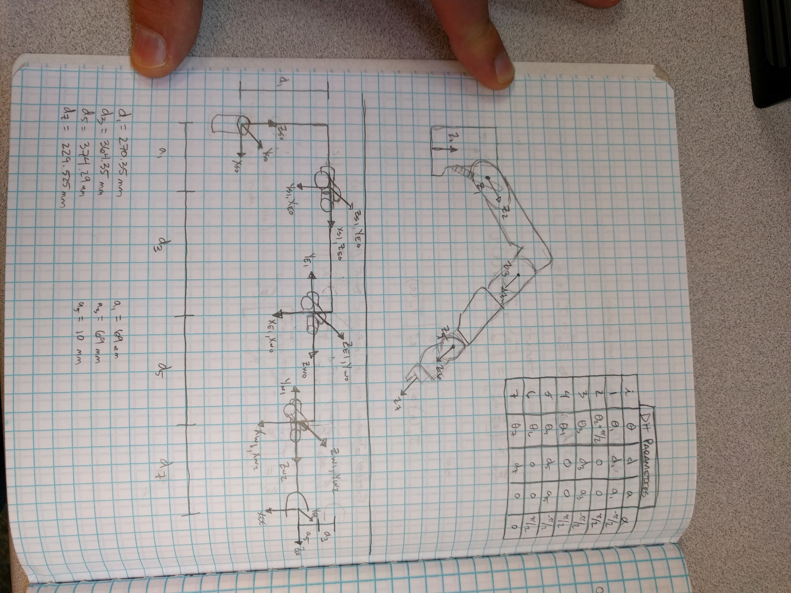

Figure 1: DH Parameters for Baxter

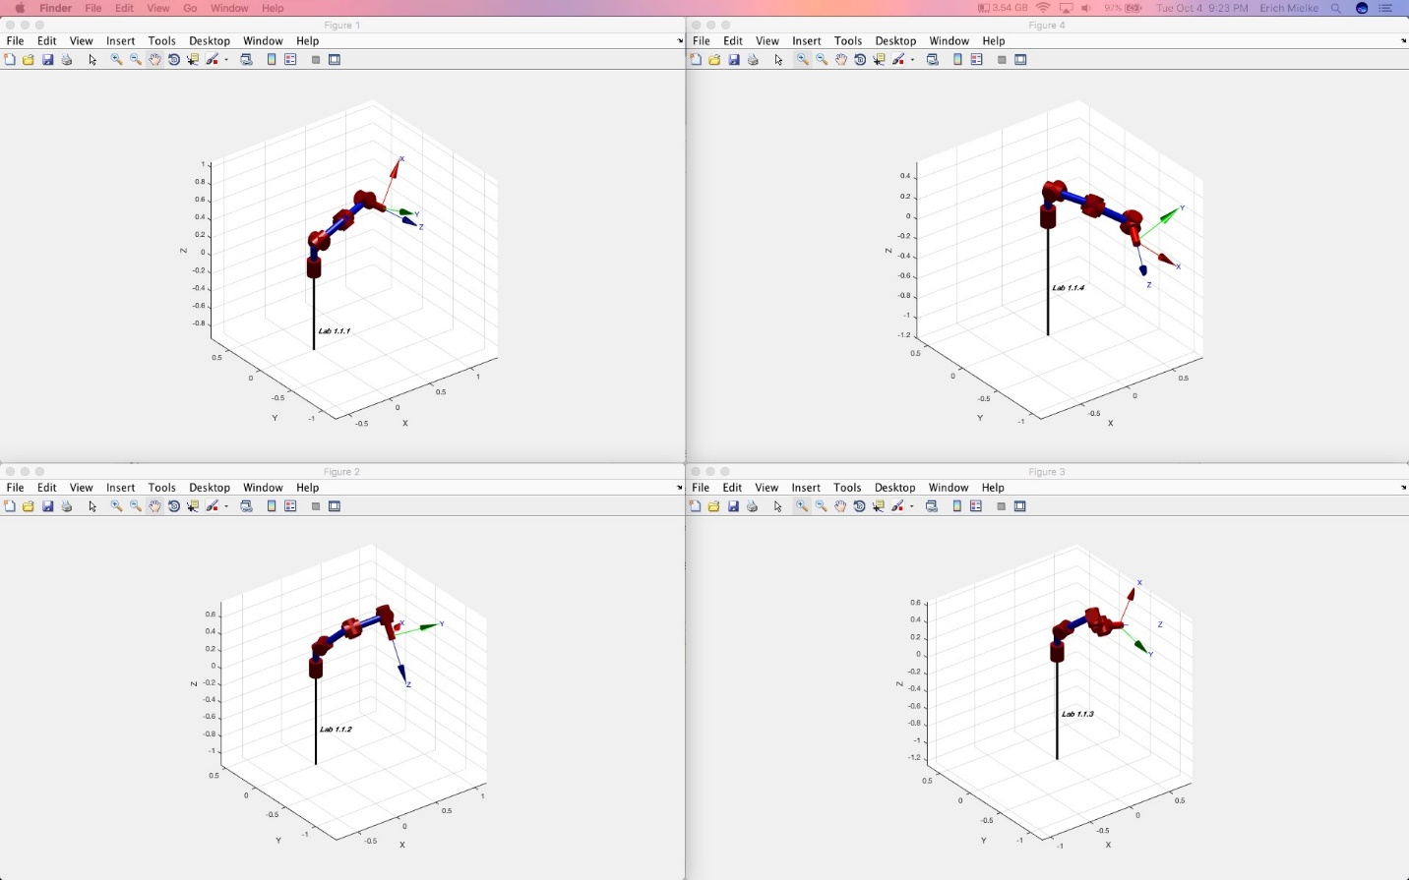

Figure 2 Four Commanded Positions

|  |  |  |  |  |
| --- | --- | --- | --- | --- |
| **Number** | **Code Position** | **Estimated Position** | **Code Orientation** | **Estimated Orientation** |
| 1 | (.625, 1.05, .379) | (.627,1.046,.392) |  |  |
| 2 | (.821, .398, .470) | (.821,.396,.423) |  |  |
| 3 | (.641, .619, .259) | (.642,.619,.272) |  |  |
| 4 | (.879, -.038, .098) | (.878,-.040,.110) |  |  |

Table 1: A Table with the four positions and orientations we estimated vs. the ones we got from the code

* The positions and orientations obtained from our DH parameters and forward kinematics were very close to the positions from the given code. The slight discrepancy between the code and our estimated positions and orientations may be due to the fact our DH parameters are slightly different than the DH parameters used internally by Baxter. This could be due to a number of factors (measurement error on our part for example).

# Part 2

* We measured the vertical distance to be 93cm and 150cm respectively for every single movement; however, we were using a measuring tape and eyeballing it, so we may not have been super precise in our measurement. Realistically, the error was probably around 93cm/150cm +/- 0.5cm.
* Any error could be due to imprecise encoders, or the control method (as it’s an underdamped system). For example, if the model of the system is not precise, and the control does not use an integrator, it will not command precisely to the same position (having some steady state error).
* For our two cases, the repeatability and precision seemed to be the same. With other poses; however, the repeatability and precision could be affected by near singularities in the workspace.

# Part 3

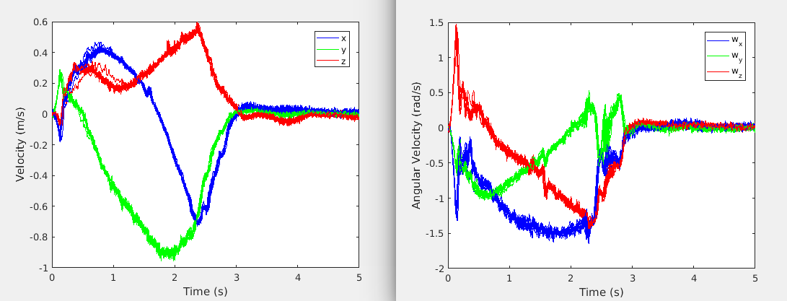

Figure 3: Plot of the end effector linear and angular velocities in the base frame

* If Baxter was using inverse kinematics, he may have found a slightly different answer each time which would result in different joint and task space velocities. Additionally, the controller would then respond differently to a different commanded input.
* We have attached a video with the animation of Baxter for one of the 10 movements.