Dustan Kraus
Nathan Day

MEEN 537 Advanced Mechanisms Robotics

Project Proposal

Soft robot task space accuracy and repeatability are affected by dynamic and kinematic model error. Previous researchers in the RaD Lab have designed a joint space controller that can accurately command joint angles. We will use inverse kinematics libraries – like TRAC-IK in the Robot Operating System–to compute desired joint angles for this controller; however, this control method alone will not result in accurate task space positions due to dynamic and kinematic modeling error. A common control technique to close error is visual servoing. Our first approach to this problem will be to create a hybrid controller using the RaD Lab’s high-precision motion capture system for servoing to close the position error and improve repeatability. A more mobile solution will incorporate an HTC Vive virtual reality system with sub millimeter tracking accuracy. This system tracks targets which, when attached to the end effectors, should provide task space position/orientation feedback. If we have time, we will use the Vive for position feedback rather than the motion capture system.
Our controller will be of the form shown below.
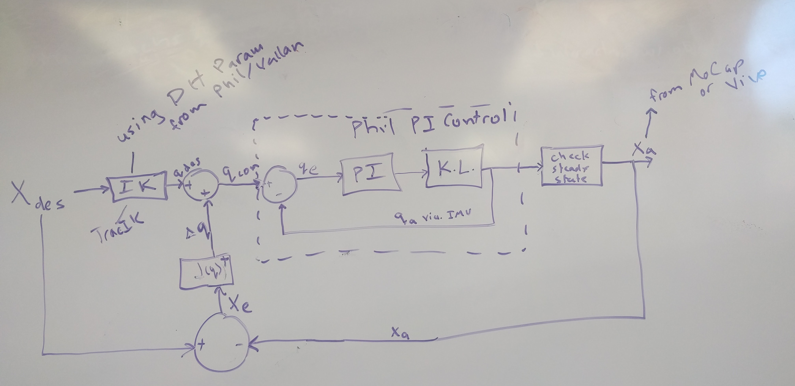
In this figure, Xdes is the desired task space position, qdes is the original joint angles computed from inverse kinematics, qcom is the actual commanded joint angles and is equal to qdes plus delta q where delta q is equal to a the pseudoinverse of the Jacobian multiplied by the position error. This will act like the numerical inverse kinematics we learned in class, but the delta q at each time step is actually moving the arm a small amount.

