# Personal Statement

## Preparation and Potential for Space Technology Research

During my early education, I learned of the major impact space technology like satellites has on our personal lives. The researchers who developed this technology changed the world, and I yearned to make similar impactful contributions to space technology. This desire led me to pursue a degree in mechanical engineering. During my undergraduate studies, I discovered that I had an aptitude for and love of controls and robotics, and I found that the best way to get involved with robotics research that would benefit society was to pursue a graduate degree. Nelson Mandela said, “Education is the most powerful weapon which you can use to change the world”. My education will empower me to have a career where I can perform cutting edge research, provide for my family, and benefit society. The following sections highlight a few of the most prominent experiences that have prepared me to push forward the frontiers of space technology research in controls and robotics.

### Los Alamos Dynamic Summer School – 2014

Los Alamos National Laboratory (LANL) was my first exposure to the world of research. In a disaster scenario, humans on foot can take a long time to navigate unsafe terrain to locate people who need help. Unmanned aerial vehicles (UAVs) are one of the most promising technologies in the effort to improve this response time as they could quickly locate survivors and direct responders accordingly. In many disaster scenarios, UAVs would need to fly indoors to find people. One of the challenges in flying a UAV indoors via onboard visual feedback is encountering reflective and transparent barriers. Glass office partitions, windows, and mirrors can confuse the operator (or autonomous navigation system), reducing the ability to accurately identify the location of people who need rescue. During this nine-week fellowship, I worked with two other students to design a multimodal sensing system capable of determining 1) whether a barrier was transparent, reflective, or opaque and 2) the distance and angle of approach to that barrier. I personally came up with the system architecture we ultimately chose to use, headed the mechanical design of our prototype, and designed and implemented the algorithms for determining the distance and angle of approach to the barriers.

By the end of the fellowship, we had built and tested a successful prototype. We also published our research in an SPIE conference paper [1], and I had the opportunity to individually travel to the conference to present our results. Working as a researcher at LANL left me amazed by the depth of knowledge my mentors possessed. They were able to guide us to the most viable solutions of our difficult research problems while performing impactful research of their own. During this experience, I developed a strong desire to become a technical expert so that I too could help younger researchers while contributing to the solutions of difficult problems.

### BYU Tactile Sensor Development – 2015

After my experience at LANL, I sought out more research opportunities at Brigham Young University (BYU). Being particularly interested in dynamics and control, I decided to get involved with the BYU Robotics and Dynamics (RaD) Lab under the direction of Marc Killpack. Before joining the lab, I was required to have a certain skill level in Python, Linux, and other third party robotics software libraries. To compensate for my lack of knowledge in these areas, I spent much of my time outside of class and work completing tutorials and developing the necessary skills. As a result, I was able to join the lab and gain valuable research experience. This demonstrates my drive to succeed and ability to overcome obstacles in my path, both skills that will continue to benefit me as a researcher. At the RaD Lab, we work with pneumatically actuated soft robots. These soft robots are inherently safer around humans than traditional robots with high gear ratios and have significant space technology applicability (weighing an order of magnitude less than Robonaut 2). I led a team of three other undergraduate students to develop a fabric tactile sensor that wrapped around the inflatable robots to provide force feedback for control implementation. I wrote both the microcontroller code to collect data from the sensor, as well as the Python code to implement the sensor with the robots in the lab. This sensor has now been implemented with a soft robot to perform movements while keeping the contact forces below a certain threshold. Now, these robots (already inherently safe) will now be able to operate even more safely around humans (in the International Space Station for example).

### The Aerospace Corporation - 2016

This past summer, I worked at a second federally funded research and development center, The Aerospace Corporation. While there, I worked primarily on three projects. First, I designed, built, and calibrated a testing setup to measure the thrust generation of a new type of UAV in Martian atmosphere. This included selecting vacuum compatible load cells, designing all of the mounting hardware, and writing the LabVIEW code to collect the data. Second, I was responsible for determining the heat transfer rate of new thermoelectric cooling modules. The Aerospace Corporation was researching these modules as a potential replacement for cyrocoolers on satellites. I designed a test plan and wrote a thermal PID controller in LabVIEW that controlled the temperature difference across the module. My LabVIEW code completely automated the data collection saving weeks of engineering time. To tune the PID controller, I performed system identification to create a first order model and simulated its response in Simulink. Third, I wrote a gradient based optimization in MATLAB to orient six accelerometers on a reaction wheel jitter test stand.

This internship reinforced my love of working in a research based environment with real hardware. I want the algorithms I develop during my graduate research to influence the lives of real people. This means that they will need to be implemented on real hardware. This experience in working with control system design on real hardware has been invaluable in preparing me for graduate research in controls and robotics.

## Space Technology Research, and Career Goals

Through my internships at The Aerospace Corporation and Los Alamos National Laboratory, I learned that I will greatly enhance my potential to benefit society through cutting edge research by obtaining a graduate degree. I fully intend to do similar research throughout my career. In fact, my research and experimentation at The Aerospace Corporation was received well enough that they kept me on as a temporary employee while working on my graduate degree. This means I have the option of returning there after the completion of my degree to contribute to the nation’s scientific understanding of dynamics and control in space applications.

## How My Proposed Course of Study and Research will Help Me Achieve These Goals

I am pursuing my master’s degree in the RaD Lab at BYU where I will research multi-arm manipulation with soft, pneumatically actuated robots. As a part of this research, I will develop advanced dynamic models, write and implement controllers, and work with a variety of robots. This experience in solving open ended problems will be priceless for my future career. I will also have the opportunity to present my research at multiple conferences where I will collaborate with other researchers in my field. My graduate degree will enable me to work shoulder-to-shoulder with other experts to address some of the nation’s most difficult challenges.

# Project Narrative

## Introduction and Motivation

Robots revolutionized the manufacturing industry 30 years ago, but human-robot interaction is still minimal. Imagine a robot that could gently help a disabled person into their wheelchair, lift a survivor to safety in a disaster scenario, or even work alongside an astronaut in space. Industrial robots, though highly precise and capable, have a relatively high inertia which severely limits how quickly and safely they can move when operating in close proximity to humans to avoid unexpected collisions and high impact forces.[2] Current robots for space missions (like Robonaut 2), mainly rely on rigid links with compliance at the joints. One of the purposes of Robonaut 2 is to provide performance data about how a robot may work side-by-side with astronauts.[3] Despite having compliance at the joints, Robonaut 2 still has relatively high inertia which limits how quickly it can move around delicate equipment or human collaborators. The footprint and weight of robots used in space are also critically important, and the current robots used are often comparatively large and heavy. My research will focus on inflatable, pneumatically actuated (soft) robots – like the one in *Figure 1* – which will use comparatively less payload (weighing an order of magnitude less than Robonaut 2 and occupying significantly less volume when deflated). Because these robots have soft links with low inertia, they are *inherently* safer around people and equipment, even when moving at higher speeds, than traditional space robotics. In short, development of these soft robotics has significant merit in space technology and human-robot interaction.

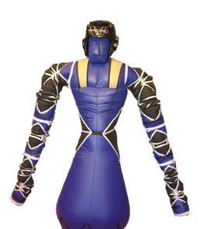

*Figure 1: Five degree of freedom soft robot developed by Pneubotics*

One important feature in robotics capable of working around humans, or mimicking human dexterity, is the ability to use two (or more) arms. Many tasks such as lifting heavy/bulky objects or service and assembly tasks are difficult, if not impossible, with only one arm. This problem has sparked a large amount of research into multi-arm manipulation. My research will focused on coordinated, multi-arm manipulation using inflatable, pneumatically actuated (soft) robots like the one in *Figure 1.*

## Background

Multi-arm manipulation does not have a specific agreed-upon definition. It could be many fingers on a hand manipulating a small object, or many arms manipulating a large object. In fact, both of these scenarios could use the same control principles. Furthermore, multi-arm manipulation can be categorized by un-coordinated and coordinated tasks. Un-coordinated manipulation tasks are those in which the arms are performing tasks that do not require interaction (for example: one arm is moving parts while another arm is performing an unrelated assembly task). Tasks which require two or more robotic arms to physically interact with the same object are classified as coordinated manipulation tasks. [4] My research will be focused on coordinated, multi-arm manipulation tasks.

One difficulty in coordinated, multi-arm manipulation with traditional robots is that small deviations in end effector position or orientation from any of the arms while holding a rigid object can result in large stresses on both the object and internally on the arm. To compensate, many researchers have proposed hybrid force/position control schemes which seek to control the position of an object being grasped by several manipulators while either keeping the forces below a certain threshold or maintaining a certain force.[5, 6, 7, 8, 9] A challenge with this approach is the coordination of high bandwidth centralized controllers. Additionally, if the software or hardware malfunctions and the force control stops working, traditional robots could either exert a dangerous amount of force on the object being manipulated, themselves, humans, or other delicate equipment around the robots.

An alternative and novel approach is to mitigate buildup of high forces by using a robot with flexible links and joints. Because soft robots are inherently compliant, deviations in object position result in significantly lower buildup of forces; thus, they lend themselves nicely to tasks involving several arms. Even tasks with one rigid arm and multiple soft arms become simpler as the whole system is forgiving of end effector deviations due to compliance of the soft arms. Therefore, one of the major concerns with successful implementation of coordinated, multi-arm manipulation is eliminated. Additionally, because these robots are soft and inherently compliant, they are very safe around humans and delicate equipment (even if something malfunctions). On the other hand, compliant links and joints introduce new challenges (addressed below) into the control paradigm, and currently do not have as high of performance as state of the art torque controlled robots like Robonaut 2.

## Hypothesis

I propose that coordinated multi-arm manipulation can realistically (and usefully) be implemented with an inflatable, pneumatically actuated robot. My goals are to (1) implement coordinated control for impact tasks with rigid objects (like sweeping off a solar panel, assembly of construction materials that require impact for insertion, or hammering) and (2) implement coordinated control for soft object manipulation tasks (like moving a tarp or a flexible solar array). Here are the underlying questions to address:

* A key challenge with soft robots is repeatability. The dynamics of the arm can change with a variety of different stimuli such as temperature change, pressure loss through bladder punctures, and actuation hysteresis. Additionally, the fabric does not fold on itself the same way with each movement and the bladders often reseat themselves. What type of control scheme will result in the highest task space accuracy and repeatability?
* There are many different types of control schemes for coordinated multi-arm manipulation presented in the literature. Which type of control scheme will be most effective in coordinated manipulation tasks?
* Some tasks require more stiffness than a single soft arm has. I propose that such tasks could become more feasible by grasping one arm with the other (increasing the rigidity by forming a closed kinematic chain). This type of task would not be feasible with a rigid robot. How will the control scheme need to be altered to accurately control this system?

To answer these research questions, there are many intermediate steps I will work on which are described in the following section.

## Research Plan

*Manipulability Improvement:* After spending the last year in the RaD Lab, I am familiar with the challenges of accurately controlling soft robots. Recent design changes have left the robot in *Figure 1* with only four degrees of freedom per arm. To perform multi-arm manipulation tasks, each end effector needs to accurately be controllable in at least six degrees of freedom. I have already enlisted the help of two interested undergraduate students to help add at least two additional degrees of freedom to improve manipulability. Another researcher in the RaD lab recently submitted a paper to ICRA 2017 on rigorous design optimization of soft robots. I will build on this work in selecting which degrees of freedom to add and how they should be mounted.

*Single Arm* *Hybrid Controller Development:* Task space accuracy and repeatability are affected by dynamic and kinematic model error (it is difficult to get accurate Denavit-Hartenberg parameters for the robot in *Figure 1*).Previous researchers in the RaD Lab have designed an algorithm using model predictive control (MPC) that can fairly accurately command a single arm in joint space.[10] I will use inverse kinematics libraries – like TRAC-IK in the Robot Operating System (ROS) – to compute desired joint angles for this controller; however, this control method alone will not result in accurate task space positions and orientations due to dynamic and kinematic error. A common control technique to close error is visual servoing.[11, 12] My first approach to this problem will be to create a hybrid controller using the RaD Lab’s high-precision motion capture system for servoing to close the task space position error and improve repeatability. A more mobile solution will incorporate an HTC Vive virtual reality system with sub millimeter tracking accuracy. This system tracks targets which, when attached to the end effectors, should provide task space position/orientation feedback. This controller will be of the form:

$$q_{cmd}= q_{des}+ ∆q$$

$$q_{des}=IK({\left[\begin{matrix}\begin{matrix}x_{des} & y_{des} & z_{des}\end{matrix} & \begin{matrix}θ_{des} & ϕ_{des} & ψ_{des}\end{matrix}\end{matrix}\right]}^{T})$$

∆q is the result of an optimization defined by:

minimize: $‖Δx-JΔq‖$

with respect to: ∆q

subject to: *Joint Limit Constraints*

Where qdes is the original joint angle commands (from inverse kinematics) sent to the MPC controller, qcmd is the updated joint angle commands, ∆q is the change in the joint angle commands, ∆x is the task space position and orientation error, and J is the Jacobian. It should be noted that the objective function for the optimization relies on an approximation which is only valid for small ∆x and ∆q.

*Coordinated, Multi-Arm Controller Development:* My first approach at coordinated multi-arm manipulation will be to design and implement an object level model predictive controller with each arm acting as force/torque inputs on the object. This controller will determine the optimal force/torque for each arm to apply at every time step and be of the form shown in *Figure 2*. 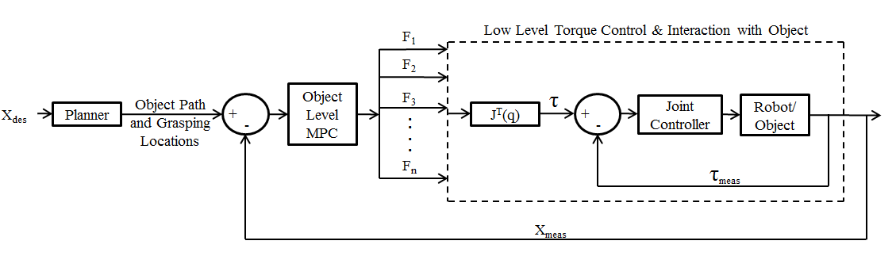

*Figure 2: Proposed object level control scheme*

One of my first steps in designing this controller will be to design a path planner which will have two main objectives. First, it will output an optimal object path which avoids obstacles when given a desired object position and orientation. A student in the RaD lab has already worked extensively on this problem for a single arm, and I will build on his work. Second, the path planner will determine the optimal location on the object for each arm to grip in order to maximize the force manipulability ellipsoid over the course of the path. Maximizing the force manipulability ellipsoid will enable each arm to better compensate for disturbances/deviations over the course of the path. I have already taken a graduate optimization course during my bachelor’s degree which will help me design and solve this optimization problem.

I plan to initially manipulate objects using the two arms on the robot in *Figure 1* and then utilize more soft arms, and even a more traditional torque controlled Baxter Research Robot Arm (see *Figure 3*) to demonstrate the applicability of my algorithms to systems that include multiple soft robots and a rigid robots.

*Closed Kinematic Chain Modeling:* To address my last research question, I will begin by modelling the gripping of one arm by the other as a closed kinematic chain. Previous students in the RaD Lab researched and successfully implemented simultaneous joint angle and stiffness control for an inflatable robot.[13] I will build upon this research by developing a controller for the closed kinematic chain with two additional tuning parameters (the stiffness of the gripping arm and the gripping location) which can be optimized for a given task.

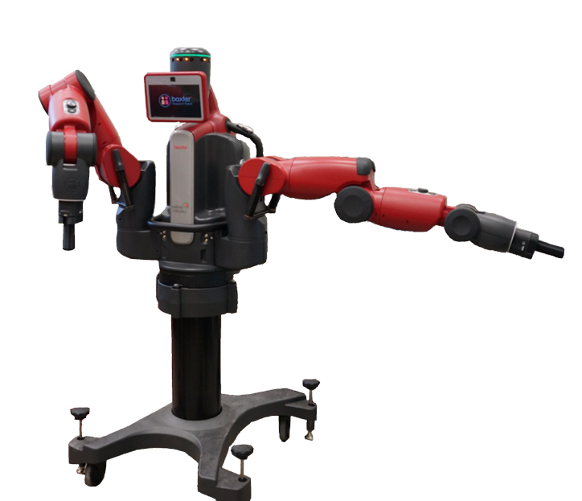

*Figure 3: A Baxter Research Robot*

As part of a NASA Early Career Faculty Space Technology Research (ECF) Grant, BYU already has almost all of the hardware I will need to complete my research. With less time and money spent procuring and setting up hardware, I can focus my efforts on developing useful dynamic models and control algorithms.

## Application to the NASA Technology Roadmaps

TA 4.3.5: Collaborative Manipulation states, “For collaborative manipulation, the required technical capability is to provide a teamed approach for multiple robots or teams of humans and robots working with objects, equipment, or samples.” This collaboration includes coordinated manipulation tasks (where multiple robot manipulators are physically connected together in tasks like handling a common load). My graduate research directly impacts these goals. I will be researching and implementing control methods for coordinated multi-arm manipulation tasks with soft, pneumatically actuated robots. Furthermore, TA 4.3.5 lists robust safety system development as a goal. TA 4.7.5: Safety and Trust expands on this by setting the goal of having a crew “be able to work next to a robotic assistant, within a one-meter proximity in a controlled and safe manner, without being physically attached to it.” The soft robotic platforms I will be using for my research are *inherently* safe for operation around humans and delicate equipment due to their inflatable structure and low inertia. The algorithms I develop will help these robots have performance on par with state of the art torque controlled robots so that they will work more robustly and safely in close proximity to humans.

More generally, the sub-goal listed in TA 4.3: Manipulation is to “Increase Manipulator dexterity and reactivity to external forces and conditions while reducing overall mass and launch volume and increasing power efficiency.” Providing structures developed from lightweight materials for robotic arm design is listed as a goal of TA 4.3.1.2: Lightweight Structures.[14] The soft robots I will be researching are an order of magnitude lighter than current space robotic technology like Robonaut 2, and occupy 10 times less volume when deflated. Though I will not be focusing on the manufacturing or mechanical design of the lightweight structures that make up soft robots, my research on control algorithms for multi-arm manipulation with these robots will contribute to making lightweight, inflatable robotic arms feasible in space. A single soft robot may not have the power output of the current generation of torque controlled robots, but soft robots have such a low weight and volume that it would still drastically reduce the overall mass and launch volume to send two or more of these soft robots at a time on space missions. My research will make this feasible by enabling multiple soft robots to collaborate with each other or even humans on the same manipulation task.

## Impact of Visiting Technologist Experience

I chose to pursue graduate research largely because I want to create technology that is truly capable of changing the world. Coordinated multi-arm manipulation with soft robots has many space applications as mentioned above, and I view the visiting technologist experience as an opportunity to collaborate with subject matter experts in integrating this promising technology in space specific applications. The research knowledge and skills I develop during the visiting technologist experience will also greatly benefit the research I will be completing at BYU.

Additionally, my career ambition is to be involved in space technology research and development. This collaboration with NASA scientists would both expose me to the research culture of NASA and help me become more familiar with current cutting edge space technology developments. An understanding of the current developments and needs of an industry is critical in performing contributing research. In short, this experience would be invaluable in my career goal of performing research critical to our nation’s space industry, and I believe that my graduate research will have a broad impact on robotic manipulation for future space missions.

## References

1. Acevedo, I., Kleine, R. K., Kraus, D., & Mascareñas, D. (2015, April). Multimodal sensing strategies for detecting transparent barriers indoors from a mobile platform. In SPIE Smart Structures and Materials+ Nondestructive Evaluation and Health Monitoring (pp. 94310V-94310V). International Society for Optics and Photonics.
2. Haddadin, S., Albu-Schäffer, A., & Hirzinger, G. (2010). Safe physical human-robot interaction: measurements, analysis and new insights. In Robotics research (pp. 395-407). Springer Berlin Heidelberg.
3. Diftler, M. A., Ahlstrom, T. D., Ambrose, R. O., Radford, N. A., Joyce, C. A., De La Pena, N., Parsons, A.H., & Noblitt, A. L. (2012, March). Robonaut 2—initial activities on-board the ISS. In Aerospace Conference, 2012 IEEE (pp. 1-12). IEEE.
4. Smith, C., Karayiannidis, Y., Nalpantidis, L., Gratal, X., Qi, P., Dimarogonas, D. V., & Kragic, D. (2012). Dual arm manipulation—A survey. Robotics and Autonomous systems, 60(10), 1340-1353.
5. Sakaino, S., Sato, T., & Ohnishi, K. (2011). Precise position/force hybrid control with modal mass decoupling and bilateral communication between different structures. IEEE Trans. on Industrial Informatics, 7(2), 266-276.
6. Alberts, T. E., & Soloway, D. I. (1988, April). Force control of a multi-arm robot system. In Robotics and Automation, 1988. Proceedings., 1988 IEEE International Conference on (pp. 1490-1496). IEEE.
7. Hayati, S. (1986, April). Hybrid position/force control of multi-arm cooperating robots. In Robotics and Automation. Proceedings. 1986 IEEE International Conference on (Vol. 3, pp. 82-89). IEEE.
8. Yoshikawa, T., & Zheng, X. Z. (1993). Coordinated dynamic hybrid position/force control for multiple robot manipulators handling one constrained object. The International Journal of Robotics Research, 12(3), 219-230.
9. Uchiyama, M., & Dauchez, P. (1988, April). A symmetric hybrid position/force control scheme for the coordination of two robots. In Robotics and Automation, 1988. Proceedings., 1988 IEEE International Conference on (pp. 350-356). IEEE.
10. Best, C. M., et al. (2016). A New Soft Robot Control Method: Using Model Predictive Control for a Pneumatically Actuated Humanoid. IEEE Robotics & Automation Magazine, 23(3), 75-84.
11. Wang, H., Yang, B., Liu, Y., Chen, W., Liang, X., & Pfeifer, R. Visual Servoing of Soft Robot Manipulator in Constrained Environments with an Adaptive Controller. IEEE/ASME Transactions on Mechatronics.
12. Vahrenkamp, N., Böge, C., Welke, K., Asfour, T., Walter, J., & Dillmann, R. (2009, December). Visual servoing for dual arm motions on a humanoid robot. In 2009 9th IEEE-RAS International Conference on Humanoid Robots (pp. 208-214). IEEE.
13. Gillespie, M. T., Best, C. M., & Killpack, M. D. (2016, May). Simultaneous position and stiffness control for an inflatable soft robot. In Robotics and Automation (ICRA), 2016 IEEE International Conference on (pp. 1095-1101). IEEE.
14. NASA. (2015, July). NASA Technology Roadmaps TA 4: Robotics and Autonomous Systems. From: http://www.nasa.gov/sites/default/files/atoms/files/2015_nasa_technology_roadmaps_ta_4_robotics_and_autonomous_systems_final.pdf

# Degree Program Schedule

# CV

# Transcript

# GRE Scores