LABORATORY EXERCISE 1
Getting Started with Python for AI
(Topic: AI Overview, Tools & Frameworks)
Name: |  | Date:
Course & Year: | BSIT3-1 | Score: | / 50

LEARNING OBJECTIVES
- Set up and verify a Python development environment for AI programming.
- Install and import key AI libraries: NumPy, Pandas, Matplotlib, and Scikit-Learn.
- Write a basic Python script to demonstrate AI readiness.
- Recognize the role of Python and its libraries in AI development.

BACKGROUND / THEORY
Python is the most popular programming language for Artificial Intelligence because of its simple syntax, large ecosystem of libraries, and strong community support. Key Python libraries used in AI include:
- NumPy – Provides support for multi-dimensional arrays and mathematical operations.
- Pandas – Offers data structures (DataFrames) for data manipulation and analysis.

# Python Code

import numpy as np

import pandas as pd

import matplotlib.pyplot as plt

from sklearn.datasets import load_iris

- Matplotlib / Seaborn – Used for data visualization (graphs, charts, heatmaps).
- Scikit-Learn – A machine learning library providing algorithms for classification, regression, and clustering.
- TensorFlow / Keras – Used for building and training deep learning models.
- NLTK / spaCy – Libraries for natural language processing.

MATERIALS AND REQUIREMENTS
- Computer with Python 3.9 or later installed.
- Anaconda Navigator / Jupyter Notebook or any Python IDE.
- Internet connection for package installation.
- Installed packages: numpy, pandas, matplotlib, scikit-learn.

PROCEDURES
- Open Anaconda Navigator / Jupyter Notebook / Google Colab. Create a new file named lab01_ai_intro.py.
- Install required packages. Open the terminal and type:
# Python Code
pip install numpy pandas matplotlib scikit-learn
- Write the following Python script to verify your environment:
# Load the Iris Dataset

iris = load_iris()

df = pd.DataFrame(iris.data, columns=iris.feature_names)

df['species'] = iris.target

# Display basic info

print('Dataset Shape:', df.shape)

print(df.head())

# Plot a histogram of sepal length

plt.hist(df['sepal length (cm)'], bins=15, color='green',
edgecolor='black')

plt.title('Distribution of Sepal Length')

plt.xlabel('Sepal Length (cm)')

plt.ylabel('Frequency')

plt.show()

- Run the script. Observe the output in the terminal and the plotted histogram.
- Modify the script to plot petal width instead of sepal length.

QUESTIONS / ANALYSIS

1. What output did you observe when running print(df.head())? Paste a screenshot and describe it.
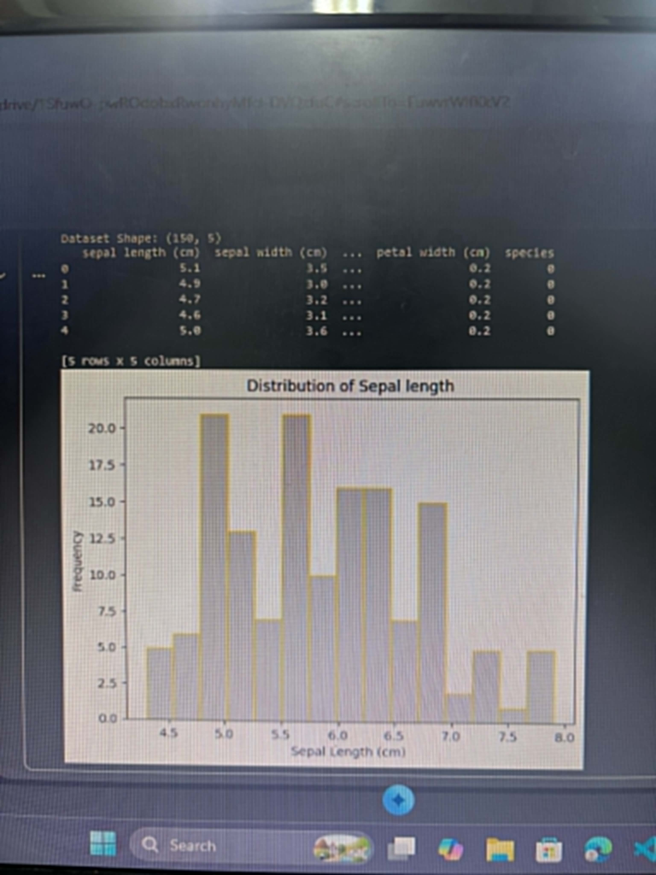

2. What is the shape of the Iris dataset? What do the rows and columns represent?

3. Describe the histogram you generated. What does the distribution tell you about the data?

4. Why is Python preferred for AI development compared to other languages? List at least 3 reasons.

SCORING RUBRIC
Criterion | Description | Points
Environment Setup | Python and all packages correctly installed and running. | /10
Code Execution | Script runs without errors; correct output produced. | /15
Modification Task | Successfully modified script to plot petal width. | /10
Question Responses | Complete, accurate, and thoughtful answers. | /15
TOTAL |  | /50

