**Shortest Job First Output**

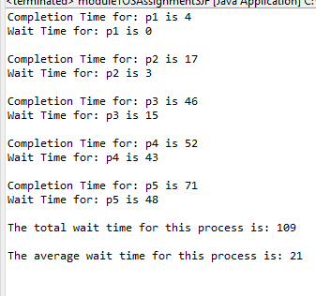

**First Come First Served Output**

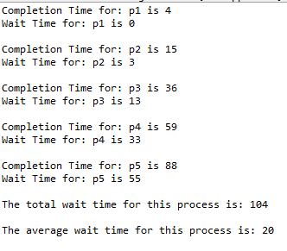

I created two separate Java programs to show how the First Come First Serve process works versus the Shortest Job First process works. The average wait time was less in the First Come First Served Process. I also noticed that the total wait time for the First Come First Served Process was less.

Completion and wait times for P1 were similar in both processes. The differences came when P2 through P5 were running. Overall, in this example the averages were pretty close. That may not always be the case.

|  |  |  |  |  |
| --- | --- | --- | --- | --- |
| Process | AT | BT | CT(FCFS) | CT(SJF) |
| P1 | 0 | 4 | 4 | 4 |
| P2 | 1 | 7 | 11 | 13 |
| P3 | 2 | 10 | 21 | 29 |
| P4 | 3 | 2 | 23 | 6 |
| P5 | 4 | 6 | 29 | 19 |