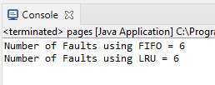

In this program I wrote code for the FIFO and LRU algorithms. For the FIFO program I created an arrayList to hold all of the numbers in the pages string. I also set the frame size to 4. I looped through the pages arrayList finding the faults and counted them at the end.

The LRU code was similar only in that it used an ArrayList to find the least recently used integers. I used the count function to count all of the faults occurring. I found that FIFO and LRU have the same number of faults for this example.