APPENDIX I

Table A.1: Left- and Right-wing Populist Parties

|  |  |  |  |
| --- | --- | --- | --- |
| **Country** |  | **Party** | **Left-/Right-Populist** |
| Austria | BZÖ | Alliance for the Future of Austria | R |
|  | FPÖ | Party of Freedom | R |
| Belgium | VB | Flemish Interest | R |
| Bulgaria | Ataka | Attack | R |
|  | GERB | Citizens for European Development of Bulgaria | R |
| Czech Republic | ANO | ANO 2011 | R |
| Denmark | DF | Danish People’s Party | R |
| Croatia | HDSSB | Croatian Democratic Assembly of Slavonia and Baranja | R |
|  | HL-SR | Croatian Labourists – Labour Party | L |
|  | HSP AS | Croatian Party of Rights | R |
| Finland | PS | True Finns | R |
| France | FN | National Front | R |
| Germany | AfD | Alternative for Germany | R |
|  | Linke | The Left | L |
| Greece | Syriza | Coalition of the Radical Left | L |
|  | ANEL | Independent Greeks | R |
| Ireland | SF | Ourselves Alone | L |
| Hungary | Fidesz | Fidesz | R |
|  | Jobbik | Jobbik | R |
| Italy | MCS | Five Star Movement | L |
|  | FI | Go Italy | R |
|  | LN | Northern League | R |
| Latvia | TB/LNNK | For Fatherland and Freedom – National Independence Mov. | R |
| Lithuania | DP | Labour Party | L |
|  | TT | Order and Justice | R |
| Luxemburg | ADR | Alternative Democratic Reform Party | R |
| Netherlands | PVV | Party for Freedom | R |
|  | SP | Socialist Party | L |
| Poland | PiS | Law and Justice | R |
| Romania | PP-DD | People’s Party – Dan Dianconescu | L |
|  | PRM | Greater Romania Party | R |
| Slovakia | Smer | Direction – Social Democracy | L |
|  | OĽaNO | Ordinary People and Independent Personalities | R |
| Spain | Podemos | Podemos (We Can) | L |
| Sweden | SD | Sweden Democrats | R |
| United Kingdom | UKIP | United Kingdom Independence Party | R |

We tested whether alternative specifications of the standard errors affects our empirical results substantially. First, we followed Lewis and Linzer’s (2005) idea of an estimated variable regression strategy more closely and employed a weighted least squares approach in order to account for differences across contexts in the standard deviations of the coefficients in the first stage of the analysis. As indicated by the first model in Table 2, the effect size of populist party establishment remains—once again—stable, while the standard error is reduced. In the case of the two further covariates, standard errors increase, but the effects remain statistically significant. In the second model of table 2, we repeated the calculation of the main model but did not employ clustered standard errors. In the case of small cluster sizes, standard errors could drastically rise and, hence, cause type-I errors. This is not the case since the standard error of the establishment measure decreases in our test. The effects of the two control variables remain equally significant although the corresponding standard errors increase. In the third model, we used the centered inverted standard errors of the estimates for external efficacy of the first step as weights for the second step regression to account for differences in the reliability of the first step coefficients. Again, the results remain stable.

Table A.2: Alternative Specifications - Standard Errors

|  |  |  |  |
| --- | --- | --- | --- |
|  | (1) | (2) | (3) |
|  | Lewis/ Linzer (2005) | w/o clustered SEs | Weights (1/SE) |
|  |  |  |  |
| Establishment | -.173*** | -.173*** | -.170** |
|  | (.049) | (.050) | (.066) |
| Eastern Europe | -.336** | -.328** | -.344** |
|  | (.130) | (.131) | (.123) |
| Multiple Pop. Parties | -.298** | -.303** | -.294** |
|  | (.134) | (.134) | (.122) |
| Right-Wing Populist |  |  |  |
|  |  |  |  |
| Radicalism |  |  |  |
|  |  |  |  |
| Constant | .271** | .275** | .267*** |
|  | (.112) | (.110) | (.087) |
|  |  |  |  |
| Observations | 36 | 36 | 36 |
| Adjusted R-squared | .478 | .476 | .474 |

Note: Standard errors in parentheses. *** p<.01, ** p<.05, * p<.1.

Table A.3: Multilevel Models

|  |  |  |
| --- | --- | --- |
|  | (1) | (2) |
|  | DV: PTVs | DV: Vote Choice |
|  |  |  |
| No external efficacy | .499*** | .583*** |
|  | (.153) | (.105) |
| Establishment | .917*** | .414** |
|  | (.234) | (.186) |
| No external efficacy X Establishment | -.200*** | -.051 |
|  | (.068) | (.044) |
| Eastern Europe | 1.421** | 1.383*** |
|  | (.621) | (.495) |
| No external efficacy X Eastern Europe | -.540*** | -.572*** |
|  | (.179) | (.118) |
| Multiple populist parties | .387 | 1.440*** |
|  | (.635) | (.510) |
| No external efficacy X Multiple populist parties | -.372** | -.301** |
|  | (.184) | (.123) |
| No internal efficacy | .075*** | .014 |
|  | (.021) | (.017) |
| Eval. economy (prospective) = same | .122** | .016 |
|  | (.052) | (.046) |
| Eval. economy (prospective) = worse | .032 | .034 |
|  | (.064) | (.055) |
| Eval. economy (retrospective) = same | .057 | .049 |
|  | (.055) | (.049) |
| Eval. economy (retrospective) = worse | .056 | .089 |
|  | (.065) | (.057) |
| Eval. EU membership = good | -.372*** | -.111*** |
|  | (.046) | (.038) |
| Eval. EU membership = bad | .219*** | .283*** |
|  | (.064) | (.049) |
| Against more power of the EU | .031*** | .039*** |
|  | (.007) | (.006) |
| Pro redistribution | -.015** | .017*** |
|  | (.007) | (.006) |
| Pro higher taxes | -.028*** | -.007 |
|  | (.008) | (.006) |
| Against same-sex marriage | .036*** | .012** |
|  | (.006) | (.005) |
| Against immigration | .062*** | .037*** |
|  | (.006) | (.005) |
| Education: 16–19 | -.023 | .095* |
|  | (.060) | (.049) |
| Education: 20+ | -.256*** | .068 |
|  | (.064) | (.054) |
| Education: still studying | -.272** | .100 |
|  | (.111) | (.094) |
| Unemployed | .064 | .103* |
|  | (.069) | (.056) |
| Age | -.016*** | -.003** |
|  | (.001) | (.001) |
| Female | -.108*** | -.125*** |
|  | (.039) | (.033) |
| Observations | 27,941 | 29,756 |
| Number of groups | 36 | 36 |
| Log Likelihood | -71863 | -12643 |

Standard errors in parentheses. *** p < .01, ** p < .05, * p < .1.

Note: Model 1 = multilevel model with PTVs for the respective populist party as the dependent variable; Model 2 = multilevel model with vote intention (next national election) for the respective populist party as the dependent variable; lower level = individuals, higher level = populist parties.

Figure A.1: *Marginal Effects of No External Efficacy, Dependent Variable: PTV and National Vote Intention (Table A.2)*

1. *Marginal Effects of No External Efficacy, Dependent Variable: PTV (Model 1)*

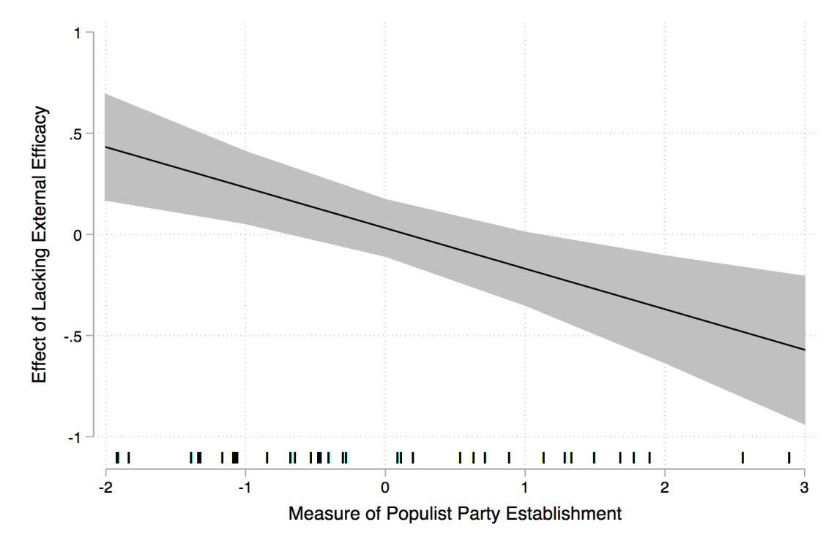

1. *Marginal Effects of No External Efficacy, Dependent Variable: National Vote Intention (Model 2)*

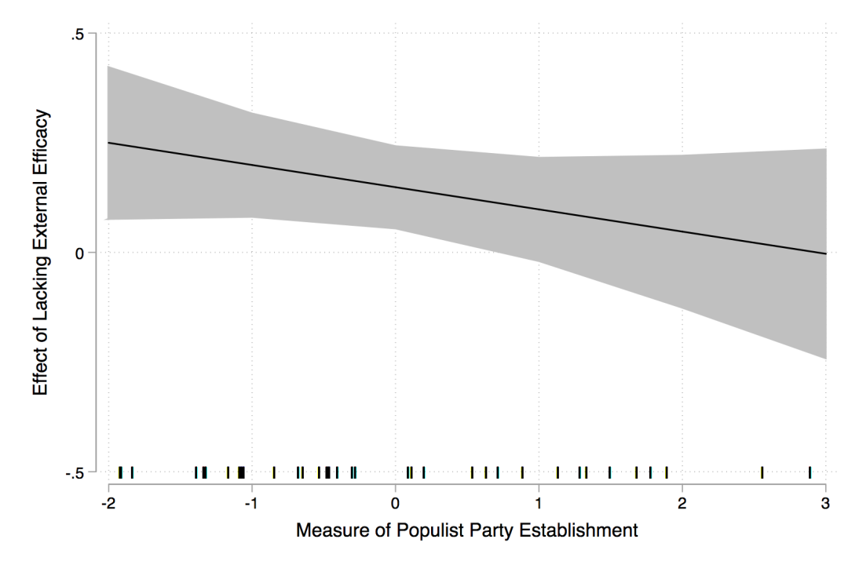

# APPENDIX II: FURTHER DETERMINANTS OF POPULIST PARTY SUPPORT AT THE INDIVIDUAL LEVEL

To disentangle the effect of external efficacy, we need to control for alternative sources of support for populist parties. For this purpose, we refer to a wider range of the literature on electoral behavior and on populist-party support. We include internal efficacy as a first control variable on the individual level. Concerning political self-assurance or awareness of their own political competence, we assume that people who feel overwhelmed by the complexity of the political world are particularly likely to support populist parties whose dichotomous solutions should be attractive to them.

Second, the criticism of elites articulated by populist parties should not only be examined in relation to national elites. Although the degree of Euro-skepticism in populist parties varies across countries (Arzheimer 2015, 537), the European Union is a particular focus of criticism. Targeting the technocratic culture and weak ‘accountability’ of European institutions, populist parties claim that Europeanization has opened a growing gap between the interests of national populations and the decisions of the European political elites. Furthermore, the fundamental non-finality of the idea of European unification together with the EU’s institutional structure involving laborious negotiation and compromise is diametrically opposed to the populist idea of politics as the execution of a supposedly clear popular will. Another common motive for populist voting behavior is therefore seen in the rejection or negative evaluation of European institutions (Taggart 1998; Hooghe, Marks, and Wilson 2002; de Vries and Edwards 2009).

Third, past research has found an important explanatory factor for populist-party support in the evaluation of the economy. Spier (2010), for example, shows that losers of modernization are more likely to vote for right-wing populist parties. Those individuals that have experienced or are fearing job loss and material deterioration as a consequence of economic decline are—according to this perspective—likely to blame certain groups, often foreigners or ‘the ruling class,’ for these developments. Hence, voters who perceive or expect a downturn in the past or future development of the economy are likely to turn to populist parties.

Whereas internal efficacy, attitudes concerning the EU, and the evaluation of the economy should explain party support for left- and right-wing populist parties, there are party family-specific aspects, too. As we have seen, populist electoral programs find support only in combination with a core ideology. It is the ideological coupling with criticism of elites that gives meaning to the antithetically paired concepts of people and elite. In this regard, the argumentation patterns of right- and left-wing populists are based on different ’host ideologies’. Whereas criticism of elites among the former is grounded in the protection of a culturally defined homogeneity against multicultural societal designs, left-wing populists back their criticism with reference to the ideal of social equality (March 2007; Mudde 2007).

Right-wing populist parties frame anti-establishment and elite-critical attitudes with a discourse addressing ethnic and/or cultural homogeneity (nativism). For the majority of current right-wing populist parties ethnopluralist concerns constitute their programmatic cornerstone. From this point of view, non-native groups are incompatible with the values and norms of the majority society by reason of cultural differences. Ultimately, immigration is construed to be a threat to the life and cultural integrity of this majority society (Betz and Johnson 2004, 318). Right-wing populist parties accordingly benefit from the increasing politicization of the policy areas immigration and integration and, in the eyes of some scholars, have contributed to the establishment of a new cultural cleavage (see, e.g., Kitschelt 1995; Pellikaan, de Lange, and van der Meer 2007). The concept of ’the people’ is defined with reference to national values and culture; it is set up against an elite allegedly ignoring the interests of ‘the people’ in favor of immigrants and other non-native persons. Therefore, we include the two political issues of negative attitudes towards immigrants and same-sex marriage. Proximity on these issues between a citizen and a party should increase the popularity of right-wing populist parties.

As far as their fundamental ideological paradigms are concerned, left-wing populist parties can be described as an alternative variant of a democratic socialism. With their polar left-wing positions, they can at times fill the gap in the programmatic party spectrum seemingly opened up in recent decades by a social democracy shifting more strongly towards the center. In contrast to their counterparts on the right fringe of the party spectrum, the programmatic focus of left-wing populists is on socio-economic issues (March 2007). From this perspective, national and transnational elites are seen as responsible for economic and political inequality. The people, in this case the wage-earning population, are perceived as a group oppressed by minorities that control politics and resources (Stavrakakis and Katsambekis 2014). Consequently, we control for attitudes concerning redistribution and increased taxation that should be positively associated with left-wing populist party support.

Table A.4: *First-Stage Regression Results—Left-Wing Populist Parties*

|  |  |  |  |  |  |  |  |  |  |  |
| --- | --- | --- | --- | --- | --- | --- | --- | --- | --- | --- |
|  | Linke  (DE) | Podemos  (ES) | Syriza  (GR) | HL  (HR) | SF  (IE) | M5S  (IT) | DP  (LT) | SP  (NL) | PP-DD  (RO) | Smer  (SK) |
|  |  |  |  |  |  |  |  |  |  |  |
| No external efficacy | .476*** | .378** | .107 | -.261** | .259 | -.241 | -.158 | -.003 | -.159 | -1.605*** |
|  | (.136) | (.173) | (.175) | (.132) | (.161) | (.184) | (.197) | (.149) | (.138) | (.151) |
| No internal efficacy | .169 | -.088 | -.023 | -.047 | .086 | .025 | .198 | .127 | .252** | -.261** |
|  | (.104) | (.136) | (.132) | (.106) | (.134) | (.142) | (.144) | (.104) | (.116) | (.133) |
| Eval. economy (prospective) = same | -.169 | .594* | .362 | .234 | .373 | 1.194** | -.200 | .415* | .721** | -.207 |
|  | (.220) | (.341) | (.430) | (.326) | (.327) | (.485) | (.370) | (.251) | (.282) | (.333) |
| Eval. economy (prospective) = worse | -.370 | 1.029** | .190 | -.014 | -.145 | .910* | -.382 | -.397 | .462 | -.327 |
|  | (.323) | (.467) | (.471) | (.337) | (.508) | (.504) | (.409) | (.399) | (.320) | (.415) |
| Eval. economy (retrospective) = same | .550*** | .757** | .826 | -.162 | -.336 | -1.120 | 1.167*** | -.202 | -.315 | -.223 |
|  | (.207) | (.385) | (.505) | (.478) | (.340) | (.816) | (.346) | (.242) | (.305) | (.406) |
| Eval. economy (retrospective) = worse | -.063 | .384 | .756 | -.037 | .464 | -1.122 | .544 | .660* | -.148 | -.778* |
|  | (.335) | (.426) | (.539) | (.449) | (.445) | (.805) | (.434) | (.344) | (.330) | (.451) |
| Eval. EU membership = neither/nor | .175 | -.356 | .091 | .335 | .339 | .670** | 1.218*** | .487* | .181 | .287 |
|  | (.221) | (.333) | (.314) | (.242) | (.352) | (.315) | (.333) | (.257) | (.270) | (.260) |
| Eval. EU membership = bad | -.131 | .114 | -.380 | .122 | 1.050*** | .582 | .667 | .001 | .712* | .370 |
|  | (.349) | (.404) | (.358) | (.302) | (.386) | (.367) | (.521) | (.369) | (.371) | (.464) |
| Against more power of the EU | -.091*** | .081* | .013 | -.090*** | .032 | -.025 | -.025 | -.059 | -.041 | .052 |
|  | (.030) | (.043) | (.052) | (.034) | (.044) | (.047) | (.048) | (.042) | (.029) | (.041) |
| Pro redistribution | .267*** | .422*** | .155*** | -.077** | .108** | -.072 | .051 | .298*** | -.111*** | .099** |
|  | (.033) | (.053) | (.053) | (.035) | (.048) | (.048) | (.039) | (.041) | (.032) | (.041) |
| Pro higher taxes | .152*** | .093* | .096* | -.005 | -.032 | -.053 | -.228*** | .186*** | .009 | .136*** |
|  | (.036) | (.053) | (.058) | (.040) | (.051) | (.057) | (.056) | (.047) | (.036) | (.045) |
| Education | .454*** | .085 | .453** | .230 | -.789*** | -.477*** | -.400* | -.225 | -.368** | -.425** |
|  | (.120) | (.177) | (.181) | (.160) | (.189) | (.172) | (.216) | (.165) | (.147) | (.200) |
| Unemployed | -.136 | .042 | -.505 | -.015 | .380 | -.991* | .196 | 1.158*** | .231 | .140 |
|  | (.364) | (.329) | (.366) | (.295) | (.389) | (.516) | (.435) | (.403) | (.377) | (.385) |
| Age | -.009* | -.033*** | -.005 | -.000 | -.062*** | -.059*** | -.027*** | -.016** | -.009 | .027*** |
|  | (.006) | (.010) | (.009) | (.007) | (.009) | (.009) | (.009) | (.007) | (.007) | (.008) |
| Female | -.423** | -.184 | .667** | .389* | -.337 | -.247 | -.173 | .459** | .693*** | .039 |
|  | (.177) | (.264) | (.258) | (.216) | (.254) | (.257) | (.274) | (.198) | (.217) | (.238) |
| Constant | -.359 | .558 | 1.235 | 4.652*** | 7.589*** | 9.652*** | 6.691*** | 3.609*** | 4.053*** | 8.408*** |
|  | (.753) | (1.157) | (1.183) | (.932) | (1.097) | (1.409) | (1.145) | (.917) | (.902) | (1.070) |
|  |  |  |  |  |  |  |  |  |  |  |
| Observations | 1,227 | 678 | 799 | 726 | 767 | 629 | 721 | 964 | 647 | 804 |
| Adjusted R-squared | .121 | .164 | .034 | .018 | .115 | .066 | .076 | .105 | .053 | .217 |

Standard errors in parentheses. *** p < .01, ** p < .05, * p < .1.

Table A.5: *First-Stage Regression Results—Right-Wing Populist Parties—Part 1*

|  |  |  |  |  |  |  |  |  |  |  |
| --- | --- | --- | --- | --- | --- | --- | --- | --- | --- | --- |
|  | BZÖ  (AT) | FPÖ  (AT) | VB  (BE-VLG) | Ataka (BG) | GERB (BG) | ANO  (CZ) | AfD (DE) | DF  (DK) | PS  (FI) | FN  (FR) |
|  |  |  |  |  |  |  |  |  |  |  |
| No external efficacy | -.231** | -.057 | .741*** | -.246** | .167 | -.125 | .409*** | .336** | .323* | .314* |
|  | (.104) | (.161) | (.189) | (.120) | (.193) | (.156) | (.127) | (.158) | (.173) | (.169) |
| No internal efficacy | .073 | -.141 | -.111 | -.213** | -.162 | -.041 | -.044 | .283** | -.038 | .209* |
|  | (.084) | (.129) | (.137) | (.090) | (.149) | (.120) | (.093) | (.115) | (.135) | (.116) |
| Eval. economy (prospective) = same | -.187 | -.134 | .112 | -.330 | -1.154** | -.550* | -.040 | .611** | .077 | -.266 |
|  | (.199) | (.305) | (.295) | (.278) | (.458) | (.303) | (.205) | (.294) | (.266) | (.358) |
| Eval. economy (prospective) = worse | -.534** | -.247 | -.063 | -.554* | -1.910*** | -.955** | .202 | 1.365** | -.198 | .182 |
|  | (.239) | (.367) | (.411) | (.316) | (.519) | (.405) | (.299) | (.590) | (.309) | (.398) |
| Eval. economy (retrospective) = same | .009 | .387 | -.391 | -.270 | 2.147*** | -.388 | -.133 | .279 | -.125 | .587 |
|  | (.207) | (.320) | (.287) | (.391) | (.645) | (.307) | (.190) | (.282) | (.402) | (.577) |
| Eval. economy (retrospective) = worse | .400* | .578 | -.453 | -.495 | 2.455*** | -.695* | -.240 | .889 | -.266 | .624 |
|  | (.232) | (.356) | (.410) | (.403) | (.663) | (.397) | (.317) | (.548) | (.407) | (.575) |
| Eval. EU membership = neither/nor | .285 | 1.456*** | .832** | .146 | -2.011*** | -.549* | .948*** | 1.509*** | .843*** | 1.523*** |
|  | (.180) | (.278) | (.335) | (.209) | (.342) | (.292) | (.209) | (.277) | (.252) | (.296) |
| Eval. EU membership = bad | .660*** | 2.324*** | 1.612*** | .239 | -2.995*** | -1.677*** | 1.613*** | 1.097*** | 1.679*** | 1.939*** |
|  | (.223) | (.341) | (.484) | (.352) | (.581) | (.368) | (.326) | (.334) | (.337) | (.368) |
| Against more power of the EU | -.025 | .122*** | .120** | .032 | .044 | -.031 | .069** | .293*** | .183*** | .145*** |
|  | (.028) | (.043) | (.049) | (.032) | (.053) | (.041) | (.028) | (.051) | (.046) | (.043) |
| Against same-sex marriage | .103*** | .162*** | .129*** | .030 | -.029 | -.018 | .079*** | .168*** | .006 | .095*** |
|  | (.022) | (.034) | (.040) | (.033) | (.055) | (.034) | (.025) | (.039) | (.031) | (.033) |
| Against immigration | .005 | .025 | .232*** | .032 | -.052 | -.113*** | .080*** | .372*** | .227*** | .265*** |
|  | (.024) | (.037) | (.046) | (.034) | (.056) | (.037) | (.027) | (.037) | (.039) | (.040) |
| Education | -.238** | -.555*** | -.112 | -.021 | -.473* | -.180 | .290*** | -.098 | .026 | -.320* |
|  | (.097) | (.149) | (.195) | (.145) | (.241) | (.205) | (.109) | (.168) | (.151) | (.191) |
| Unemployed | .242 | .158 | 1.104** | .450 | -.312 | -.474 | -.760** | -.589 | -.538 | .465 |
|  | (.352) | (.542) | (.439) | (.356) | (.571) | (.407) | (.336) | (.470) | (.372) | (.448) |
| Age | -.033*** | -.048*** | -.022*** | -.016** | -.039*** | -.007 | -.009* | -.012* | -.024*** | -.043*** |
|  | (.005) | (.007) | (.008) | (.006) | (.010) | (.008) | (.005) | (.007) | (.007) | (.008) |
| Female | -.024 | -.185 | -.324 | -.102 | .180 | .467* | -.333** | -1.356*** | -1.096*** | -.562** |
|  | (.147) | (.226) | (.249) | (.194) | (.318) | (.239) | (.163) | (.215) | (.214) | (.246) |
| Constant | 4.505*** | 5.636*** | .263 | 4.252*** | 7.165*** | 9.073*** | .527 | -.683 | 2.313** | .969 |
|  | (.577) | (.894) | (1.052) | (.844) | (1.379) | (1.058) | (.661) | (.885) | (.931) | (1.157) |
|  |  |  |  |  |  |  |  |  |  |  |
| Observations | 768 | 813 | 495 | 526 | 522 | 892 | 1,125 | 938 | 887 | 737 |
| Adjusted R-squared | .0921 | .189 | .171 | .027 | .138 | .076 | .108 | .333 | .160 | .266 |

Standard errors in parentheses. *** p < .01, ** p < .05, * p < .1.

Table A.5: *First-Stage Regression Results—Right-Wing Populist Parties—Part 2*

|  |  |  |  |  |  |  |  |  |  |  |
| --- | --- | --- | --- | --- | --- | --- | --- | --- | --- | --- |
|  | UKIP  (GB) | ANEL  (GR) | HDS  (HR) | HSP  (HR) | Fidesz  (HU) | Jobbik (HU) | FI  (IT) | LN  (IT) | TT  (LT) | ADR (LU) |
|  |  |  |  |  |  |  |  |  |  |  |
| No external efficacy | -.007 | -.021 | -.088 | -.147 | -1.581*** | -.111 | -.442** | -.771*** | -.045 | .494** |
|  | (.145) | (.122) | (.117) | (.122) | (.150) | (.154) | (.189) | (.168) | (.185) | (.229) |
| No internal efficacy | .228* | .158* | .046 | .081 | -.123 | .008 | .209 | -.020 | .505*** | -.016 |
|  | (.117) | (.092) | (.097) | (.101) | (.134) | (.138) | (.142) | (.127) | (.136) | (.166) |
| Eval. economy (prospective) = same | .646** | .904*** | .365 | -.224 | -1.532*** | -.744** | .745 | .974** | -.034 | -.077 |
|  | (.281) | (.299) | (.289) | (.305) | (.366) | (.377) | (.482) | (.429) | (.355) | (.404) |
| Eval. economy (prospective) = worse | .240 | .572* | -.074 | -.354 | -2.540*** | -.705 | 1.138** | .762* | -.001 | -.528 |
|  | (.387) | (.328) | (.297) | (.314) | (.487) | (.501) | (.505) | (.451) | (.391) | (.457) |
| Eval. economy (retrospective) = same | -.543* | .156 | -.147 | .023 | .005 | .611 | .094 | -.492 | .043 | .383 |
|  | (.290) | (.350) | (.416) | (.439) | (.375) | (.388) | (.834) | (.741) | (.331) | (.421) |
| Eval. economy (retrospective) = worse | .658* | -.286 | -.110 | .198 | -.901* | 1.170** | -.006 | -.255 | .257 | -.014 |
|  | (.369) | (.376) | (.386) | (.410) | (.465) | (.480) | (.826) | (.734) | (.423) | (.449) |
| Eval. EU membership = neither/nor | 1.356*** | -.148 | .188 | -.113 | -.333 | .612** | .612* | .189 | 1.022*** | .686 |
|  | (.285) | (.218) | (.222) | (.229) | (.274) | (.282) | (.321) | (.285) | (.324) | (.454) |
| Eval. EU membership = bad | 2.525*** | -.558** | -.086 | .084 | .088 | 1.131** | .223 | .636* | .941* | .777 |
|  | (.307) | (.247) | (.280) | (.291) | (.439) | (.456) | (.376) | (.337) | (.505) | (.780) |
| Against more power of the EU | .055 | -.042 | -.025 | -.063* | .064 | .059 | .060 | .114*** | .010 | -.026 |
|  | (.045) | (.035) | (.031) | (.033) | (.043) | (.044) | (.047) | (.042) | (.046) | (.059) |
| Against same-sex marriage | .024 | .020 | .104*** | .127*** | .085** | .115*** | .168*** | .065* | .112** | .084* |
|  | (.031) | (.029) | (.027) | (.028) | (.040) | (.041) | (.042) | (.038) | (.054) | (.043) |
| Against immigration | .211*** | .047 | .022 | .007 | -.066 | .073* | .024 | .121*** | -.026 | .295*** |
|  | (.039) | (.034) | (.033) | (.034) | (.040) | (.042) | (.048) | (.043) | (.038) | (.060) |
| Education | -.158 | -.300** | -.124 | .146 | -.045 | .251 | .022 | .064 | .087 | -.016 |
|  | (.172) | (.128) | (.151) | (.156) | (.190) | (.197) | (.171) | (.154) | (.205) | (.206) |
| Unemployed | 1.066** | -.419* | -.523** | .310 | -.359 | -.132 | -.790 | .388 | .732* | 1.625** |
|  | (.451) | (.253) | (.264) | (.273) | (.400) | (.412) | (.513) | (.461) | (.422) | (.704) |
| Age | -.015** | -.017*** | -.014** | -.006 | -.003 | -.018** | -.004 | .009 | -.005 | -.011 |
|  | (.007) | (.006) | (.007) | (.007) | (.008) | (.009) | (.010) | (.009) | (.008) | (.010) |
| Female | -.604*** | .143 | .075 | .058 | .415 | -.333 | .437* | .140 | -.175 | .379 |
|  | (.229) | (.182) | (.198) | (.205) | (.253) | (.261) | (.261) | (.233) | (.264) | (.315) |
| Constant | 1.115 | 3.928*** | 2.947*** | 2.474*** | 11.434*** | 2.779** | 2.103 | 2.658** | 2.231** | .484 |
|  | (.957) | (.837) | (.833) | (.869) | (1.080) | (1.114) | (1.319) | (1.175) | (1.077) | (1.148) |
|  |  |  |  |  |  |  |  |  |  |  |
| Observations | 883 | 825 | 653 | 691 | 774 | 771 | 644 | 642 | 751 | 295 |
| Adjusted R-squared | .231 | .035 | .021 | .020 | .319 | .045 | .054 | .065 | .035 | .159 |

Standard errors in parentheses. *** p < .01, ** p < .05, * p < .1.

Table A.5: First-Stage Regression Results - Right-Wing Populist Parties - Part 3

|  |  |  |  |  |  |  |
| --- | --- | --- | --- | --- | --- | --- |
|  | NA  (LV) | PVV  (NL) | PiS  (PL) | PRM  (RO) | SD  (SE) | OL’aNO  (SK) |
|  |  |  |  |  |  |  |
| No external efficacy | -.479*** | .454*** | -.309* | -.345** | .598*** | -.241* |
|  | (.167) | (.123) | (.179) | (.141) | (.133) | (.134) |
| No internal efficacy | .064 | -.084 | -.157 | .167 | -.112 | -.212* |
|  | (.126) | (.088) | (.141) | (.122) | (.095) | (.120) |
| Eval. economy (prospective) = same | -.432 | -.190 | .366 | .796*** | -.408** | .551* |
|  | (.295) | (.210) | (.398) | (.294) | (.197) | (.292) |
| Eval. economy (prospective) = worse | -.506 | -.717** | .140 | .817** | .102 | .532 |
|  | (.383) | (.325) | (.490) | (.337) | (.252) | (.366) |
| Eval. economy (retrospective) = same | -.624** | .518** | -.274 | -.570* | -.035 | -.395 |
|  | (.302) | (.204) | (.429) | (.317) | (.199) | (.364) |
| Eval. economy (retrospective) = worse | -1.072*** | .408 | .288 | -.661* | .482* | -.116 |
|  | (.369) | (.289) | (.489) | (.343) | (.251) | (.397) |
| Eval. EU membership = neither/nor | -1.185*** | 1.623*** | .276 | .260 | -.442** | .044 |
|  | (.260) | (.219) | (.316) | (.283) | (.210) | (.233) |
| Eval. EU membership = bad | -1.910*** | 3.196*** | -.544 | .732* | .962*** | .027 |
|  | (.401) | (.304) | (.565) | (.380) | (.251) | (.427) |
| Against more power of the EU | -.029 | .152*** | .039 | -.026 | -.053 | -.035 |
|  | (.045) | (.036) | (.049) | (.029) | (.039) | (.037) |
| Against same-sex marriage | .045 | -.024 | .180*** | .009 | .129*** | -.005 |
|  | (.044) | (.030) | (.049) | (.038) | (.031) | (.031) |
| Against immigration | .067* | .288*** | .027 | .041 | .484*** | -.018 |
|  | (.036) | (.034) | (.049) | (.031) | (.031) | (.038) |
| Education | -.074 | -.181 | -.296 | .182 | .186 | -.047 |
|  | (.182) | (.140) | (.204) | (.158) | (.134) | (.180) |
| Unemployed | .362 | -.472 | .278 | -.238 | .140 | -.406 |
|  | (.400) | (.329) | (.498) | (.382) | (.413) | (.347) |
| Age | -.014* | -.021*** | .004 | -.008 | -.016*** | -.041*** |
|  | (.008) | (.006) | (.009) | (.007) | (.006) | (.007) |
| Female | -.097 | -.404** | -.013 | .326 | -.183 | .416* |
|  | (.237) | (.169) | (.270) | (.228) | (.178) | (.212) |
| Constant | 7.945*** | .541 | 4.480*** | 3.064*** | -.058 | 7.108*** |
|  | (1.047) | (.735) | (1.160) | (.943) | (.695) | (.942) |
|  |  |  |  |  |  |  |
| Observations | 736 | 991 | 716 | 584 | 933 | 775 |
| Adjusted R-squared | .119 | .377 | .026 | .025 | .376 | .043 |

Standard errors in parentheses. *** p < .01, ** p < .05, * p < .1.