WEEK 2 INTERNSHIP REPORT
Cyber Security Incident Response Plan Development
Junior Cyber Security Analyst – E-Governance & Digital Services
YuvaIntern Internship Programme
Prepared by: Raushan Kumar
Week 2 Submission
Date: 21 August 2026
Scope Note
This is a generalized, internship-oriented plan. It does not authorize testing or access to real government systems.

1. Executive Summary
This Incident Response Plan (IRP) provides a practical framework for detecting, analyzing, containing, eradicating, and recovering from cybersecurity incidents affecting e-governance digital services. It is designed for citizen portals, mobile applications, APIs, identity systems, payment services, databases, cloud infrastructure, and supporting administrative systems.
The plan follows the current NIST incident-response direction in SP 800-61 Rev. 3, finalized in April 2025, which integrates incident response with cybersecurity risk management and supersedes Rev. 2. It also considers the Indian context through CERT-In directions and guidance for government entities.
The plan emphasizes service continuity, protection of sensitive information, evidence preservation, clear ownership, timely escalation, and post-incident improvement. It uses six operational phases: preparation; detection and analysis; containment; eradication; recovery; and post-incident activity.

2. Objectives
- Create a repeatable response process.
- Define severity levels and escalation thresholds.
- Assign clear roles and responsibilities.
- Provide scenario-specific response actions.
- Establish communication and reporting procedures.
- Support evidence preservation and auditability.
- Reduce recurrence through lessons learned.

3. Scope and Governance
The plan applies to security incidents affecting public-facing and supporting digital services, including web applications, APIs, mobile services, authentication systems, databases, cloud resources, networks, endpoints, and third-party integrations.

3.1 Governance Principles
- Use only authorized response actions and follow applicable law and policy.
- Prioritize citizen safety, essential services, and reduction of harm.
- Maintain one incident record and one accountable incident lead.
- Record facts, assumptions, decisions, and timestamps.
- Preserve evidence before destructive remediation where practical.
- Use least privilege for responders.
- Escalate when legal, regulatory, contractual, or national-level coordination applies.

3.2 India-Specific Reporting
CERT-In's Directions under Section 70B of the Information Technology Act include mandatory reporting of specified cyber incidents within six hours of noticing them or being brought to notice, subject to the Directions and applicable scope. The organization should maintain a workflow that can quickly determine reportability and the authorized reporting officer. Government environments may also require coordination with NIC-CERT, sectoral CSIRTs, regulators, or other relevant stakeholders.

4. Incident Classification
Level | Typical Criteria | Examples | Initial Response | Escalation
SEV-1 Critical | Major public-service outage, broad data compromise, privileged compromise, destructive/ransomware event. | Core portal unavailable; large-scale exfiltration. | Full IR activation; immediate containment. | Senior leadership and relevant authorities.
SEV-2 High | Significant but contained compromise or service degradation. | Admin account compromise; active API exploitation. | Urgent containment and investigation. | Management, legal/privacy, relevant external parties.
SEV-3 Moderate | Limited event with manageable impact. | Single endpoint malware; suspicious login. | Security/SOC investigation and remediation. | Security manager/service owner.
SEV-4 Low | Low-impact event with no material compromise identified. | Benign suspicious email. | Record, monitor, close after validation. | Routine reporting.

4.1 Severity Factors
- Confidentiality impact
- Integrity impact
- Availability/service impact
- Number of affected systems or users
- Privilege level involved
- Persistence and active attacker access
- Legal, privacy, contractual, or regulatory impact

5. Roles and Responsibilities
Role | Key Responsibilities
Incident Response Lead | Own coordination, severity, task assignment, decisions, timeline, and status updates.
SOC/Security Analyst | Validate alerts, correlate logs, identify indicators and affected assets.
System/Network Team | Implement isolation, blocking, segmentation, and infrastructure controls.
Application/API Owner | Assess application impact, support containment and recovery, validate service integrity.
IAM Team | Secure accounts, revoke sessions, reset credentials, review privileged access.
Legal/Privacy | Assess reporting, notification, evidence, contractual, and privacy obligations.
Communications | Prepare approved internal and public service communications.
Management | Provide authority, priorities, risk decisions, and business continuity direction.
Vendor/Third-Party Contact | Coordinate supplier investigation, logs, technical support, and contractual actions.

5.1 Responsibility Principle
Every major action should have one accountable owner, a named performer, and clearly identified consulted or informed stakeholders. The Incident Response Lead maintains the master action list to avoid conflicting instructions.

6. Incident Escalation and Response Flow
The flow below represents the standard response path. Critical incidents may be escalated immediately after initial validation.
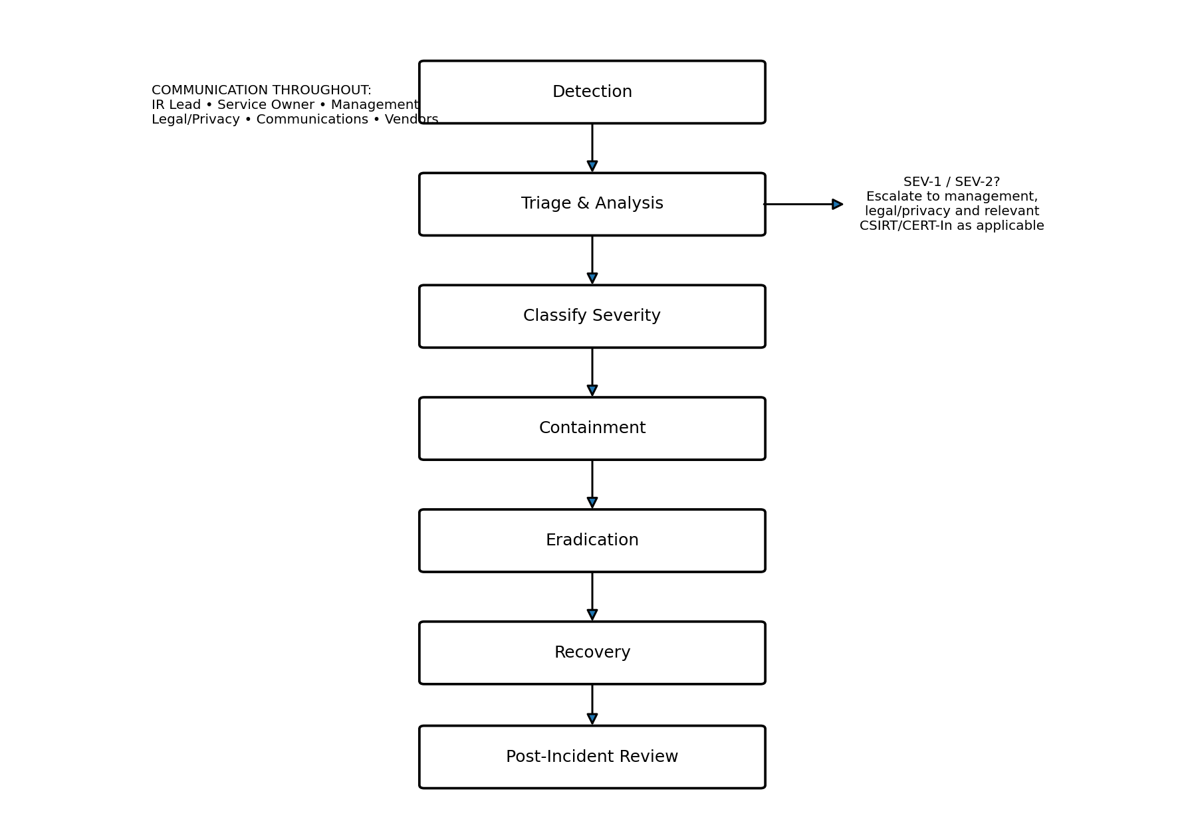
Figure 1. High-level incident response and escalation flow.

6.1 Escalation Rules
- Escalate immediately for privileged-account compromise, core-service impact, sensitive-data exposure, or multi-system compromise.
- Escalate when containment could materially affect public services.
- Escalate when the incident crosses organizational or vendor boundaries.
- Escalate when reporting or external coordination may be required.
- Do not release technical details externally until authorized review is complete.

7. Detailed Response Procedure

7.1 Preparation
- Maintain asset, service, dependency, owner, and contact inventories.
- Define severity, escalation thresholds, and authority for disruptive actions.
- Maintain secure access to logs, monitoring, backups, and incident records.
- Test backups and recovery priorities.
- Conduct tabletop exercises for ransomware, data breach, DDoS, credential compromise, and third-party incidents.

7.2 Detection and Analysis
- Create an incident record when an alert/report is received.
- Validate the event and determine whether it is a security incident.
- Identify affected accounts, systems, applications, data, and time window.
- Preserve relevant logs and evidence where authorized.
- Assign initial severity and incident owner.
- Keep facts, hypotheses, and uncertainties clearly separated.

7.3 Containment
- Revoke compromised credentials and sessions when authorized.
- Isolate compromised systems when safe and appropriate.
- Block malicious indicators using suitable controls.
- Rate-limit or temporarily disable affected functions if active exploitation continues.
- Segment affected systems when lateral movement is suspected.
- Document every containment action, time, owner, and reason.

7.4 Eradication
- Remove malware, unauthorized accounts, persistence, and malicious rules.
- Patch or mitigate the exploited weakness.
- Rotate exposed credentials, secrets, tokens, or certificates.
- Check related systems for the same weakness or indicators.
- Validate removal of attacker access.

7.5 Recovery
- Restore from trusted systems or verified backups.
- Validate integrity, configuration, authentication, and monitoring.
- Perform functional tests with the service owner.
- Restore in stages when risk warrants it.
- Increase monitoring after recovery.
- Document residual risk and recovery approval.

7.6 Post-Incident Review
- Prepare a final report and timeline.
- Identify root cause and control failures.
- Create corrective actions with owners and deadlines.
- Update playbooks, detections, access controls, training, architecture, and vendor requirements.
- Track actions to closure.

8. Communication and Reporting
Audience | Trigger | Owner | Content | Timing
IR Team | Confirmed/suspected incident | IR Lead | Facts, scope, tasks, actions | Immediately after validation
Management/Service Owner | SEV-1/SEV-2 or material service impact | IR Lead | Impact, decisions, status | Rapidly and at defined intervals
Legal/Privacy | Potential personal-data or legal impact | IR Lead/Privacy | Data scope, evidence, obligations | As soon as credible impact is known
External Authorities/CSIRT | Reportable or required coordination | Authorized Officer | Required incident details | Within applicable timeframe
Citizens/Public | Material service impact | Authorized Communications | Service status and safe guidance | When approved and necessary
Vendor/Partner | Third-party dependency affected | Vendor Manager | Facts and requested actions | Promptly after validation

8.1 Communication Rules
- Do not speculate about attacker identity or cause.
- Do not share passwords, tokens, keys, or unnecessary personal data.
- Use approved secure channels for sensitive information.
- Record important verbal decisions in the incident timeline.
- Keep status updates consistent during prolonged incidents.

9. Scenario Playbooks

9.1 Ransomware
- Isolate affected systems where safe.
- Secure compromised accounts and remote access.
- Preserve evidence and identify initial access.
- Assess backup integrity and prevent further backup compromise.
- Eradicate persistence and patch the root cause.
- Restore from verified backups and monitor closely.

9.2 Data Breach
- Identify data potentially accessed, changed, or exfiltrated.
- Contain the access path and preserve evidence.
- Determine affected systems, records, accounts, and timeframe.
- Engage legal/privacy teams for notification assessment.
- Reset credentials and rotate secrets as necessary.
- Monitor for misuse and complete corrective actions.

9.3 DDoS / Service Disruption
- Validate malicious traffic versus infrastructure failure.
- Engage upstream DDoS/CDN/network protection.
- Apply rate limits and protect critical APIs.
- Prioritize essential citizen functions.
- Monitor traffic and service health.
- Document characteristics and improve defenses after recovery.

9.4 Privileged Account Compromise
- Treat as high/critical until scope is known.
- Revoke sessions/tokens and secure the account.
- Review administrative activity and accessed systems.
- Check for persistence, new accounts, configuration changes, and data access.
- Rotate credentials and strengthen authentication.
- Review other privileged accounts.

9.5 Web/API Exploitation
- Identify vulnerable endpoint/function/authorization weakness.
- Apply temporary WAF, rate-limit, or service controls where appropriate.
- Determine whether unauthorized access occurred.
- Fix and test the root cause.
- Review logs and related API versions/endpoints.
- Restore normal service only after validation.

10. Evidence Handling and Incident Records
Evidence may include authentication logs, application logs, endpoint telemetry, network records, alerts, configuration snapshots, screenshots, and relevant timestamps. Evidence handling should preserve integrity, provenance, access control, and applicable chain-of-custody requirements.
- Record who collected evidence, when, from which system, and by what authorized method.
- Avoid unnecessary alteration of original evidence.
- Store evidence in access-controlled locations.
- Use hashes where appropriate to support integrity verification.
- Maintain a synchronized incident timeline.
- Retain evidence according to applicable legal, regulatory, policy, and investigation requirements.

10.1 Minimum Incident Record
- Incident ID and opening time
- Reporter/source
- Category and severity
- Affected services and owners
- Indicators and evidence locations
- Initial impact
- Containment actions and approvals
- Eradication/recovery actions
- External reporting status
- Root cause and lessons learned
- Corrective actions and deadlines
- Closure approval

11. Incident Response Metrics
Metric | Definition | Purpose
MTTD | Time from malicious activity/event to detection. | Measures monitoring effectiveness.
MTTC | Time from validation to effective containment. | Measures response speed.
MTTR | Time from incident to trusted service restoration. | Measures resilience.
Reporting Timeliness | Time to complete required external reporting after reportability is determined. | Measures compliance readiness.
Exercise Completion | Planned versus completed response exercises. | Measures preparedness.
Corrective Action Closure | Percentage of post-incident actions completed by due date. | Measures improvement.

12. Tabletop Exercise
Scenario: At 10:00, the SOC detects repeated authentication failures followed by a successful privileged login from an unusual location. At 10:15, an API configuration changes unexpectedly. At 10:30, the citizen portal begins returning errors.
- Create the incident record and assign the IR Lead.
- Classify as at least SEV-2 pending scope analysis.
- Secure the privileged account and revoke suspicious sessions.
- Review authentication, API, administrative, and network logs.
- Assess unauthorized configuration changes and data access.
- Contain affected API functions or infrastructure if exploitation is confirmed.
- Engage management, service owner, legal/privacy, and relevant external stakeholders as applicable.
- Remove persistence, restore trusted configuration, and validate the service.
- Monitor after recovery and conduct the lessons-learned review.

13. Conclusion
An e-governance IRP must combine cybersecurity operations with public-service continuity, privacy, legal compliance, and clear decision-making. The document is useful only when the organization can execute it under pressure. Regular exercises, current contacts, tested backups, reliable logging, clear authority, and measurable corrective actions are therefore essential.
This plan provides a practical framework for preparation, detection and analysis, containment, eradication, recovery, and post-incident improvement. It should be reviewed after major incidents, major architecture changes, changes in legal requirements, and scheduled exercises.

14. References
1. NIST SP 800-61 Rev. 3 – Incident Response Recommendations and Considerations for Cybersecurity Risk Management: A CSF 2.0 Community Profile.
https://csrc.nist.gov/pubs/sp/800/61/r3/final
2. NIST Cybersecurity Framework (CSF) 2.0.
https://www.nist.gov/cyberframework
3. CERT-In – Directions under Section 70B of the Information Technology Act, 2000.
https://www.cert-in.org.in/Directions70B.jsp
4. CERT-In – Guidelines on Information Security Practices for Government Entities.
https://www.cert-in.org.in/s2cMainServlet?pageid=GUIDLNVIEW02&refcode=CISG-2023-01
5. CERT-In – Cyber Crisis Management Plan.
https://www.cert-in.org.in/s2cMainServlet?pageid=CCMP
6. CISA – Cybersecurity Incident & Vulnerability Response Playbooks.
https://www.cisa.gov/topics/cyber-threats-and-advisories/cybersecurity-incident-vulnerability-response-playbooks

Appendix A – Quick Response Checklist
- Create incident record and assign IR Lead.
- Validate and classify the incident.
- Identify affected systems, accounts, services, and data.
- Preserve relevant evidence.
- Contain active compromise using authorized controls.
- Notify required stakeholders.
- Eradicate root cause and rotate compromised secrets.
- Recover from trusted systems/backups and validate integrity.
- Monitor closely after recovery.
- Complete final report, lessons learned, and corrective actions.

