OPP Playfield Rewire
Getting Started

(Project: PlayfieldRewire)

Project # : Not applicable
P/N: Not applicable
Rev 0.1

This program is free software: you can redistribute it and/or modify it under the terms of the GNU General Public License as published by the Free Software Foundation, either version 3 of the License, or (at your option) any later version.

This program is distributed in the hope that it will be useful, but WITHOUT ANY WARRANTY; without even the implied warranty of MERCHANTABILITY or FITNESS FOR A PARTICULAR PURPOSE. See the GNU General Public License for more details.

You should have received a copy of the GNU General Public License along with this program. If not, see <http://www.gnu.org/licenses/>.

 | PREPARED: | APPROVAL:  LEAD ENGINEER | APPROVAL:  ENGINEERING MANAGER
NAME | Hugh Spahr
DATE

Revision History
Version | Primary Author(s) | Description of Version | Date Completed
0.1 | Hugh Spahr | Initial version | 08/30/14

Table of Contents
1Purpose 5
2Applicable Documents 5
3Terms, Definitions & Acronyms 5
4Communications 6
4.1Solenoid/Input Board Communication 6
4.2Incandescent Board Communication 6
5Board Descriptions 7
5.1Solenoid Driver Board (Product ID 1001) 7
5.1.1Board Image 7
5.1.2Description 7
5.1.3Configuration/Communications 8
5.1.4Known Issues 8
5.2Input Board (Product ID 1003) 8
5.2.1Board Image 8
5.2.2Description 8
5.2.3Configuration/Communications 9
5.2.4Known Issues 9
5.3RS232 Interface (Product ID 1006) 9
5.3.1Board Image 9
5.3.2Description 9
5.3.3Known Issues 9
5.4Max Power Board (Product ID 1009) 10
5.4.1Board Image 10
5.4.2Description 10
5.4.3Playfield Power Supply Connector Pinout 11
5.5Incandescent Driver Board (Product ID 1011) 11
5.5.1Board Image 11
5.5.2Description 11
6Instructions for Rewiring a Playfield 11
6.1Flippers and End Of Stroke switches 13
7Pictures 14
7.1Power/Debug Header 14
7.2Playfield Power Connector 14
7.3Pop Bumper Wiring 15
7.4Drop Target Wiring 15
7.5Closeup of Switch Wiring 16
7.6Closeup of Solenoid Card 16
7.7Closeup of Input Card 17
7.8Closeup of Comm Cable 20
Appendix A – Solenoid Wiring 21

Purpose
The OPP Playfield Rewire document provides a description of how to retheme a playfield using OPP cards. This retheme document describes how to take an existing playfield and change the wiring so that the OPP cards can drive the solenoids, feature lights, and read inputs from the from all the switches. If you are interested in instructions for sanding down a playfield, and applying new graphics, clear coating a playfield, you are on your own at this point. This document will describe how to install and wire the following cards:
- Solenoid Driver Board (Product ID 1001)
- Input Board (Product ID 1003)
- RS232 Interface (Product ID 1006)
- Max Power Board (Product ID 1009)
- Incandescent Driver Board (Product ID 1011)

Applicable Documents
brdIntf.odt – Board interface documentation

Terms, Definitions & Acronyms
OPP Open Pinball Project

Communications

Solenoid/Input Board Communication
Each board has two four pin connectors at the bottom of the card are for communication to the main controller. The four pins on the connector are +5V, Gnd, Tx, and Rx. The board's processor is powered using the +5V and Gnd. One connector is marked as “In” and this is the input of the board. It should be connected to the RS232 interface card, or the next card closest to the RS232 interface card. The “Out” connection should be connected to the next solenoid/input board, or if the last board, the Tx/Rx pin should be jumpered together.
Communications is similar to token ring or FDDI. Information is transmitted from one card to the next card. If a message is destined for a card, it can either strip the information (such as configuration information), or fill out the information (such as reading the input bits). If the message is a broadcast message, the card will simply pass it on and may add information at the end (such as the inventory message). If the information is for a different card, it is passed to the next card unaltered. This requires that each board either knows the length of each message, or each message has the length embedded in it at a well known location. To minimize command length and latency on the communication bus, it was decided that each board will know the length of each command. For more information on the communications format and commands, see the board interface document.
Communications travel from one board (either solenoid or input) to the next board. The master controller transmits to the first card which receives the information and then transmits it to the next board. The next board receives information from the first board, and transmits it to the next board. The transmit from one board is attached to the receive of the next board until the last board. The last board connects the Tx/Rx of the output connector. The last cards Tx signal travels back through all of the cards and ends at the Rx of the master controller. One of the features of this scheme is that connections between boards are all the same.

Incandescent Board Communication
The incandescent driver boards use a six pin 100 mil spaced connector. The connector includes SCLK, MOSI, SS*, Gnd, +5V, +12V. The SCLK, MOSI, and SS* support the SPI bus. +5V and ground power serial to parallel register chip. The register chip has open collector outputs. Each register output is pulled up 12V using a 10K resistor. A separate MOSFET is used as a low side switch to turn on and off the incandescent bulbs. When a register bit is set to 1 (pull the output low or to ground), the MOSFET switch is open (i.e. the light bulb is off) since the MOSFETs gate voltage is below the threshold voltage for the MOSFET. When a register bit is set to 0 (float the output of the register chip to 12V), the MOSFET switch is closed (i.e. the light bulb is on). This means when sending data bits to turn lights on and off, 0 means the light is on, and 1 means the light is off, or bits are active low.

Board Descriptions

Solenoid Driver Board (Product ID 1001)

Board Image
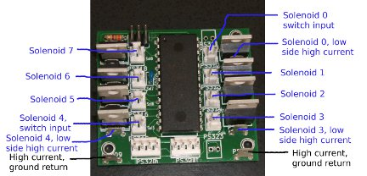

Description
The solenoid driver supports eight solenoids. The MOSFETs are configured as low side switches which means that the MOSFET opens and closes the connection to ground to turn on and off the solenoid.
Each solenoid in the pinball machine requires a diode across it to dissipate the fly-back voltage. The arrow on the diode points from the low voltage side of the solenoid to the high voltage side of the solenoid. The high voltage side of the solenoid is attached to the high voltage power supply. The low voltage side of the solenoid is attached to the spade terminal next to the MOSFET on the driver board. (marked low side high current in the above picture).
The MOSFET opens and closes a switch from the spade terminal of the MOSFET to the ground plane. The ground plane returns the current using the spade terminals marked high current ground return in the above picture.
The high voltage line to the high voltage side of the solenoids is usually bused. That means that it goes from the power supply and is attached to the first solenoid. From that solenoid, it is attached to the high voltage side of the next solenoid, and continues until all of the solenoids are attached.
If a fuse is desired, it tends to be between the high voltage pin from the power supply to the high voltage side of the first solenoid on the bus. With Sharp Shooter 2, there are three high voltage circuits. Two circuits for the lower current solenoids (upper and lower playfield), and a third circuit just for the flippers since they have the highest current draw.
The two four pin 100 mil spaced connectors on the bottom of the board are the communication headers. The connector on the left is the “In” connector, and the connector on the right is the “Out” connector.
The switch input connectors provide a signal input to the processor, and a ground. The processor has a weak pull-up on each of its inputs, so shorting the two pins together closes the switch. Normally signal grounds are daisy chained between switches beneath the playfield so only a wire to the signal is needed. If the tab of the connector is on the top, the signal connection is the pin on the right. Note: The 2 pin connectors are populated with different orientations on the left and right side of the card.

Configuration/Communications
Configuration and commmunication information can be found in the brdIntf.odt document.

Known Issues
The 100 mil spaced header connector pins are numbered differently depending on the manufacturer. When assembling the cards, the pictures in this document should be used to insure proper orientation of these connectors.

Input Board (Product ID 1003)

Board Image
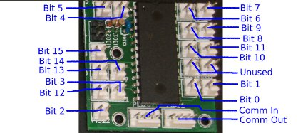

Description
The switch input card supports sixteen switch inputs. The microprocessor debounces these inputs. Depending on configuration the input card can report on rising edges, falling edges, or simply report the current state. If using edge detection, the get status command will only return the edge occurred bit once until the edge occurs another time.
The switch input connectors provide a signal input to the processor, and a ground. The processor has a weak pull-up on each of its inputs, so shorting the two pins together closes the switch. Normally signal grounds are daisy chained between switches beneath the playfield so only a wire to the signal is needed. Since the tab of the connectors is always oriented on the bottom, the signal connection is the pin on the left.

Configuration/Communications
Configuration and commmunication information can be found in the brdIntf.odt document.

Known Issues
The 100 mil spaced header connector pins are numbered differently depending on the manufacturer. When assembling the cards, the pictures in this document should be used to insure proper orientation of these connectors.

RS232 Interface (Product ID 1006)

Board Image
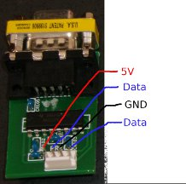

Description
The RS232 interface card converts from RS232 level Tx and Rx signals to either 5V or 3.3V level signals, depending on the voltage supplied to the 4 pin 100 mil spaced header. The card is used to connect the solenoid and input cards to a standard RS232 output from a PC.

Known Issues
The RS232 interface card is pinned out as pin 1, +5V, pin 2, TxD (data sent to solenoid and input cards), pin 3, ground, and pin 4, RxD (data returned from solenoid and input cards).
The solenoid and input cards are pinned out as pin 1, RxD (data returned from solenoid and input cards), pin 2, TxD (data sent to solenoid and input cards), pin 3, ground, and pin 4, +5V.
Since the RS232 interface and solenoid/input cards are pinned out differently, it can be corrected in two ways: changing the cable to swap pins 2 and 4, or modify the RS232 interface card to swap the two pins.

Max Power Board (Product ID 1009)

Board Image
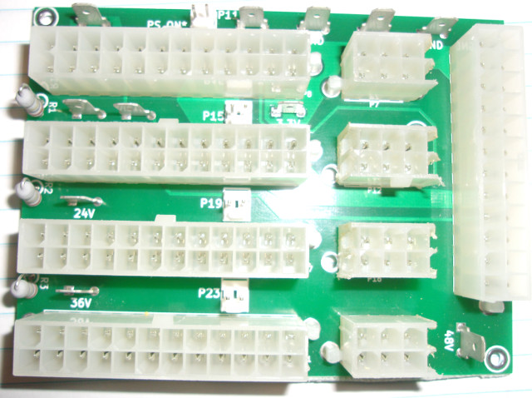

Description
The Max Power board uses four PC power supplies (each providing 12V) and combines them serially to make a 48V power supply. The Max Power board uses the 24 pin motherboard connector, and the extra 4 pin ATX 12V power cable. The first PC power supply is grounded, while the other three PC power supplies to a different potential. The second power supply is at 12V potential, so its ground is 12V and its 12V output is 24V. This same setup occurs so that the first power supply is outputting 48V.
Since the grounds on PC power supplies are attached to earth ground for safety, this connection needs to be removed for the second, third and fourth power supplies. The easiest way to do this is to buy a power splitter, and remove the ground connection (round conductor in a three pin outlet). By removing it for the power splitter, it removes the ground connection from the three power supplies that are floating. Below is a picture of a power splitter that can easily by modified. If the ground is not removed for the floating power supplies, the power supplies will burn up, and smoke, and might cause a fire.
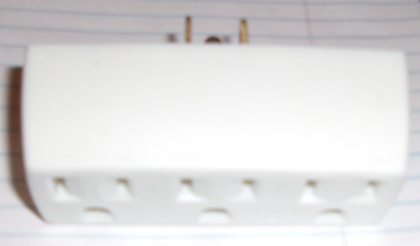
The above picture shows four 24 pin motherboard connectors on the left side, and a 24 pin connector on the right side. The connector on the top left is the connector from the grounded power supply. The remaining three 24 pin connectors are for the floating power supply motherboard connectors. The 6 pin connectors are for the extra 12V power connectors from each power supply.
The connector on the right is a 24 pin connector use for voltages going to the playfield. See the below picture for the pinout. The 48V signals are towards the bottom of the above picture, while the grounds are toward the top of the picture of the card. The PS_ON* signal can be driven from through the playfield power connector, or through the separate 2 pin 100 mil header at the top of the card. The three 2 pin 100 mil headers between the 24 pin connectors enable the three power supplies supplying higher voltages. There are normally shunts connecting these pins together.

Playfield Power Supply Connector Pinout
Note: The pinout in the below picture is rotated with respect to the picture of the card above. In the picture of the card above, the ground pins are at the top, and the 48V connections are at the bottom. (Essentially the schematic below should be rotated 180 degrees with respect to the picture of the card above.)
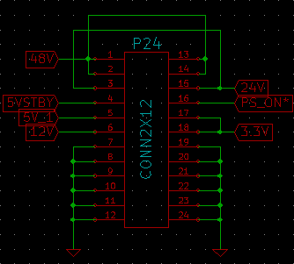

Incandescent Driver Board (Product ID 1011)

Board Image

Description

Instructions for Rewiring a Playfield
So you've just received your cards, or just built assembled your cards and had them programmed. You also have a playfield that has been sitting in the basement for a couple of years, saying “Help me!” It is time to rewire the playfield. This document will not discuss how to write a new set of rules for the playfield, but simply how to wire the OPP cards to an existing playfield.
- Cut wires off the playfield - Remove all the old wires from the playfield. This does not include the grounding straps beneath the playfield. The wire strap should remain connected to the incandescent bulbs. The cut off wire can be re-used to rewire the playfield. If the old wire has cloth insulation, throw it out (recycle it). Stripping wires with cloth insulation is a PIA, and it is easier to get new wire. I also re-use the wire holders that are on the playfield, and try to run the wires using the existing holders. The wire holders are typically placed in locations where the wire won't interfere with the solenoid operation or the feature lights.
- Desolder wire bits – Remove the remaining wire bits from the switches, bulb holders, and solenoids. If the switches have a diode across the switch, the diode can be removed since it isn't needed. The solenoids also have diodes across them which should not be removed. When removing the extra solder, it is usually easy to remove enough solder to open up the holes where the wires were soldered. Doing this all at once will make your life much simpler.
- Choose wire colors for the major voltages – Look at the cut off wires. There are usually two different gauges of wire. Thicker wire can carry more current, so choose one of the thicker types of wire carry higher current. The categories of voltages that I chose included the following: 48V (three separate wires were run for upper solenoids, lower solenoids, and flippers, all thick gauge wire), 5V Light Bulb voltage (two separate wires were run for GI lights, and feature lights, all thick gauge wire), 5VSB to power Microprocessors (thin gauge wire), Gnd (three thick gauge wires for returning the 48V current, two thick gauge wires for returning the light bulb current, and one thin gauge wire for ground for all the switches). By making them different colors, it makes it easier to look at a wire and know the voltage, purpose, and where it should start and end.
- Run 48V to high side of all the solenoids – If using three 48V circuits (upper solenoids, lower solenoids, flippers), take the three longest wires of the correct color and route each of them to a solenoid on each of the circuits. (The arrow of the diode points to the high side of the solenoid.) These wires should be thicker gauge high current wires. Make sure that you have at least 1 or 2 feet of wire left over at the top of the playfield where the wire will be crimped into the playfield power connector from the Max Power board. Next route wires from the solenoids to the next closest solenoid in the circuit. Continue doing this until eventually all of the solenoids are connected to one of the wires going to the playfield power connector. At this point, there should be no loops in the wire since each of the circuits are completely separate.
- Position the solenoid driver/input boards – Keep them as close to the solenoids they are driving as possible. The shorter the wires, the less loss due to resistance, and the more kick your solenoids will have. Attach the boards on the back side of the playfield. Next position the input boards. It is less important where these are positioned. They should be placed near the highest density of switches to minimize the amount of wire used.
- Run a wire from the low side of each solenoid to the spade terminals on the solenoid driver card marked low side high current. (Refer to the solenoid driver card picture above). These wires should be thicker gauge high current wire.
- Run a high current return wire to each of the solenoid driver boards. This wire should be the thicker gauge high current wire and the color of the high current ground wire. Make sure there is at least 1 or 2 feet of extra wire at the top of the playfield where the wire will be crimped into the playfield power connector in one of the ground positions.
- Run a signal ground wire from the playfield power connector to a switch at the top of the playfield. Make sure there is at least 1 or 2 feet of extra wire at the top of the playfield where the wire will be crimped into the playfield power connector in one of the ground positions. Daisy chain a wire from one side of each switch to another switch until all the switches are connected. This includes normal switches, and switches for solenoids.
- Route wires from the other side of the leaf switches to the appropriate input pin. I tend to take a bunch of wires and crimp one end and install the crimp in a 2 pin 100 mil housing. I then put the housing on the input pin, and route the wire to the switch. At that point, I cut the wire to length, strip the end, and solder it to the switch.
- Create communications/power wiring for the boards. Figure out the length of the wires needed to go between the cards. The communication should start at the card closest to the top of the playfield, and then move from card to card in a daisy chain. The “Out” connector of one card goes to the “In” connector of the next card. At the last card in the chain pins 3 needs to be tied to pin 4. This wraps the Tx signal to the Rx signal. Another option is to build a debug cable which connects a 5V wall wart to the proper signals and ties the Tx and Rx pins together. See the picture section of this document.
- Run a 5V wire from the playfield power connector to the first GI light bulb. Use wire to daisy chain all the remaining GI light bulbs. The GI lights provide a good visual indication that the power supplies are on if you are using a wall wart to power the solenoid and input cards. Do not use the 5VSB because that voltage is powered even if the power supply is off. (It also doesn't supply enough current for the GI lights if using incandescent bulbs.)
- That's it except for wiring the feature lights. They are wired the same as solenoids (without the switch aspect).

Flippers and End Of Stroke switches
End of stroke switches aren't needed since the flipper is controlled using timing and PWM to support the hold function. Remove the wires, and make sure when connecting to the solenoid, the strong coil is connected.

Pictures

Power/Debug Header
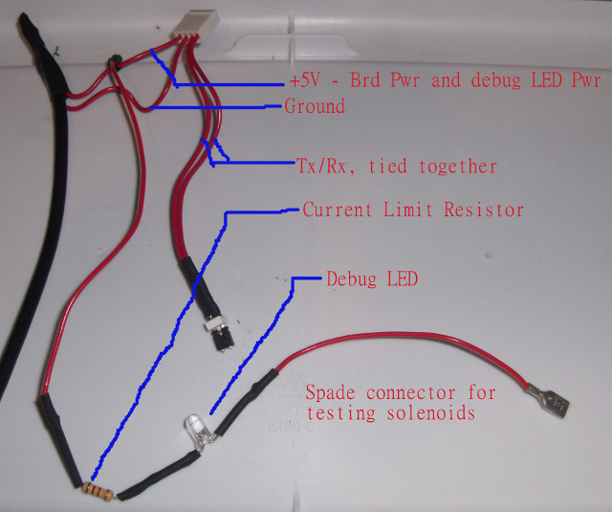
Above is a picture of a debug header. It uses a 5V wall wart to supply 5V and ground to the solenoid/input cards. It splits 5V to supply power to the boards, and to a debugging LED with a current limiting resistor and a spade connector on the end. A second debugging tool is a normally open switch with two wires attached to a 2 pin 100 mil spaced header. By plugging the header into the switch input of the solenoid driver card, and the LED plugged into the spade terminal, the FET can be tested. By looking at the brightness of the LED, the length of the initial kick, and if the FET is configured as a flipper can easily be seen.

Playfield Power Connector
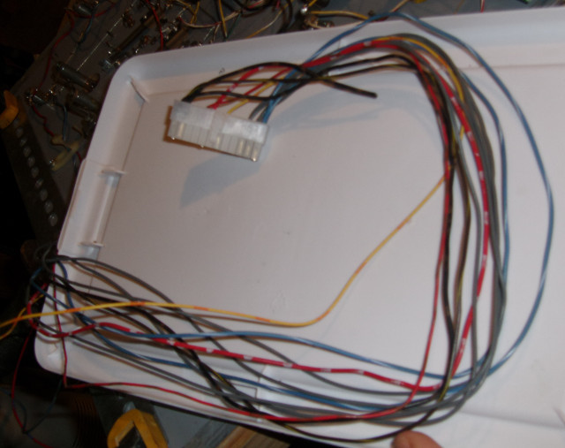
Make sure to have enough wire as a service loop for the playfield power connector. Approximately two feet is a nice length. For SS2, red is +5V, gray is high current ground returns, black is 48V, blue is ground return of lights, and yellow is signal ground for all the switches.

Pop Bumper Wiring
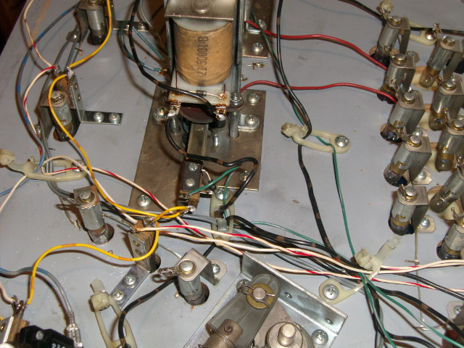
This is a picture of a pop bumper. The high voltage side of the solenoid (brown and black wire) is on the right. Note the diode band is towards the right indicating the high voltage side. The low voltage side (on the left) is also a brown and black wire, and this wire goes to a spade terminal on the solenoid driver card. The ground for all the switches is a yellow wire, and it is daisy chained from one switch to another switch. The green wire from the pop bumper switch goes to the solenoid card's switch input for the pop bumper MOSFET. The red and white wires are switch inputs that go to an input card. On the right side near the feature light bulbs, you can see the ground braid that was left on the playfield after cutting off all the wires. That will be reused to ground one side of the lightbulbs. The gray wires are the high current returns from the solenoid driver cards. They go from the solenoid cards directly to the playfield power connector.

Drop Target Wiring
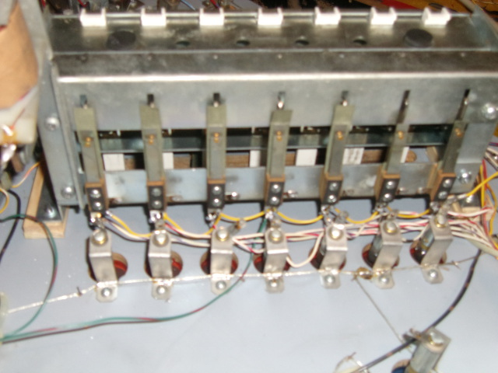
Here is a picture of the drop bank targets. You can see the yellow wire which is daisy chained to all the switches to provide the ground. An individual red and white wire goes to the input card switch input. There is an extra green wire attached to the center switch that is attached as the switch input to the solenoid. If the center target is hit, the drop targets will be reset. When the rules are programmed, depending on the mode, a different number of drop targets will be used to reset the bank.

Closeup of Switch Wiring
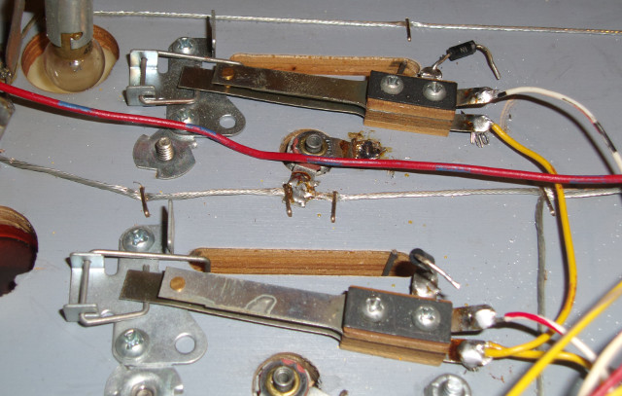
Closeup of switch wiring with the yellow wiring daisy chained between switches. (Note the top switch is the end of the chain). The white wires end at the switch input card.

Closeup of Solenoid Card
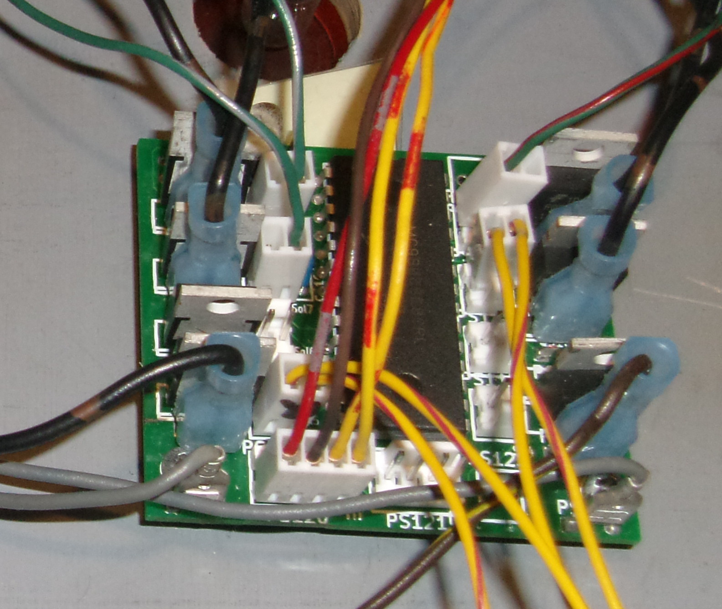
Closeup of the solenoid card. Many of the switches only have one gray wire. (Top two MOSFETs on the left). With the flippers (bottom left MOSFET and second from the top MOSFET on the right) two wires were used. One of the wires is ground, while the other one is the signal pin. I made up a couple test switches that go to 2 pin 100 mil headers which I use for flipper buttons. Note that the headers on the left side and the right side are oriented differently. If the locking tab of the header is on the bottom the signal pin is on the left. The signal pin is always in the same location within the housing.

Closeup of Input Card
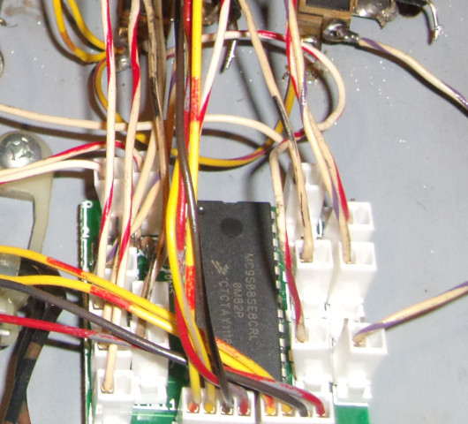
Closeup of input card. Note that all the headers only have a single wire going to them for the input signal.

Closeup of Comm Cable
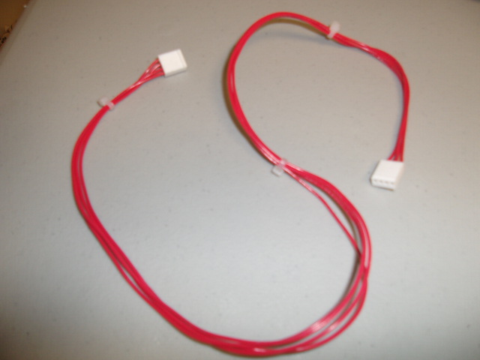
Closeup of the communication cable. It contains four wires (+5V, gnd, Tx, Rx). It is a straight through cable so pin 1 goes to pin 1, etc.

Appendix A – Solenoid Wiring
