OPP Populate Gen2 Boards
Assembly Document

(Project: Populate Gen2 Boards)

Project # : Not applicable
P/N: Not applicable
Rev 0.3

This program is free software: you can redistribute it and/or modify it under the terms of the GNU General Public License as published by the Free Software Foundation, either version 3 of the License, or (at your option) any later version.

This program is distributed in the hope that it will be useful, but WITHOUT ANY WARRANTY; without even the implied warranty of MERCHANTABILITY or FITNESS FOR A PARTICULAR PURPOSE. See the GNU General Public License for more details.

You should have received a copy of the GNU General Public License along with this program. If not, see <http://www.gnu.org/licenses/>.

 | PREPARED: | APPROVAL:  LEAD ENGINEER | APPROVAL:  ENGINEERING MANAGER
NAME | Hugh Spahr
DATE

Revision History
Version | Primary Author(s) | Description of Version | Date Completed
0.1 | Hugh Spahr | Initial version | 03/08/16
0.2 | Hugh Spahr | Fixed solenoid board pinout | 03/29/16
0.3 | Hugh Spahr | Added surface mount incandescent info, new version of interface board | 04/22/16

Table of Contents
1Purpose 4
2Product Overview 4
3Applicable Documents 4
4Terms, Definitions & Acronyms 4
5Assembly Overview 4
6Board Assembly Pictures 5
6.1Microprocessor Board 5
6.2Assembled Example 6
6.34 Pin Voltage Connectors 6
6.4Solenoid Wing 7
6.4.1Unpopulated Solenoid Board 8
6.4.2Populated Solenoid Board 8
6.4.3Used 4 pin voltage connector pins 9
6.4.4Order to populate components 9
6.5Interface Board (New version) 10
6.5.1Unpopulated board 10
6.5.2Populated board 11
6.5.3Used 4 pin voltage connector pins 11
6.5.4Order to populate components 11
6.6Surface Mount Incandescent Board 12
6.6.1Unpopulated board 12
6.6.2Populated High Side board 13
6.6.2.1Front 13
6.6.2.2Back 14
6.6.2.3Used 4 pin voltage connector pins 14
6.6.2.4Order to populate components 14
6.6.3Populated Low Side board 15
6.6.3.1Used 4 pin voltage connector pins 15
6.6.3.2Order to populate components 15
6.7Input connectors 16
6.8Incandescent Wing (Through-hole) 17
6.9Interface Board (Old version) 18
6.9.1Unpopulated board 18
6.9.2Populated board 18
6.9.3Used 4 pin voltage connector pins 19
6.10Input/Neo Wing 20
6.11RS232 Interface 21

Purpose
The OPP Populate Gen2 Boards provides a description of how to populate Gen2 boards, and how to connect them to the PSoC 4200 microprocessor board. The populate document includes the following wing boards:
- Gen2 Solenoid Driver Wing (Product ID 1013)
- Gen2 Incandescent Wing (Product ID 1014 and1017) (Future)
- Gen2 Input/Neo Wing for support of Neopixels (Product ID 1015) (Future)
- Gen2 Interface Wing (Product ID 1016)

Product Overview
Populate Gen2 Boards contains the assembly instructions for OPP boards. This document describes the assembling the wing cards, and connecting them to the microprocessor board.

Applicable Documents
None

Terms, Definitions & Acronyms
OPP Open Pinball Project

Assembly Overview
An OPP assembly contains a PSoC 4200 microprocessor board and up to four wing cards. Each wing board. This document will describe how to assemble the wing cards and then solder the wing cards to the processor board.

Board Assembly Pictures

Microprocessor Board
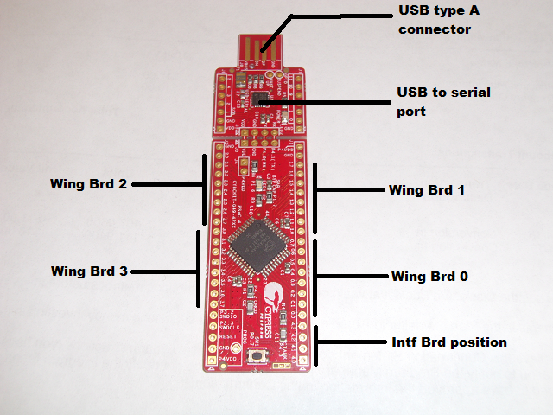

Assembled Example
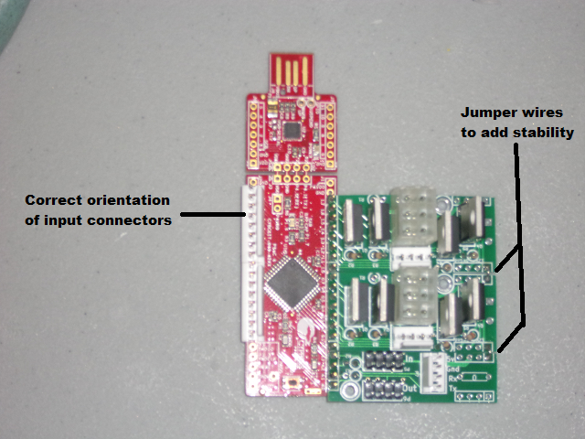
Note: The input connectors are always oriented so the plastic friction lock is closest to the microprocessor (the large square chip on the red PSoC 4200 development board).

Getting Voltage from Intf Card to Processor
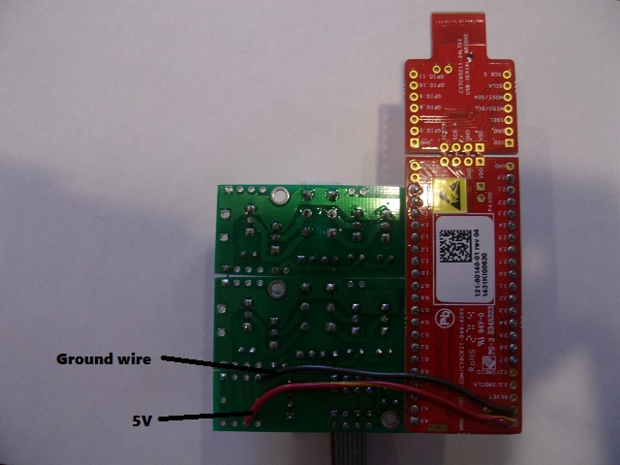
Voltage is distributed using the ribbon cables between cards. This only brings the voltage to the interface card. That voltage must then be wired to the processor board itself. This picture illustrates the wires needed to be 5V and ground to the processor card.

First card in Chain
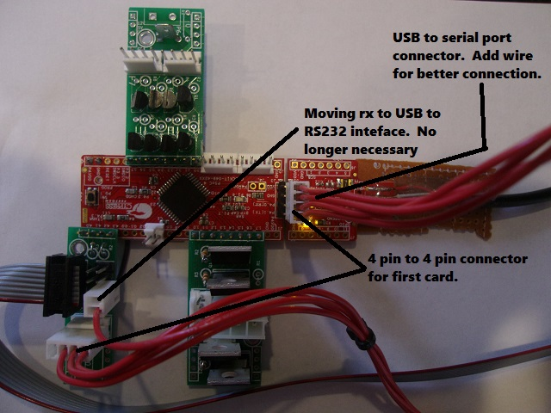

4 Pin Voltage Connectors
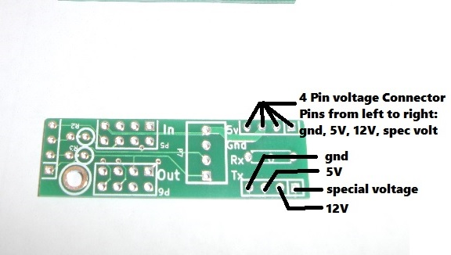
Each wing board has two 4 pin voltage connectors. These provide supplemental voltages to the wing cards including ground, 5V, 12V, and a special voltage. The 4 pin voltage connectors are placed so that jumper wires can easily be added between wing cards which provides voltages, and mechanical stability. The special voltage is used for different purposes depending on the type of card. In most cases it is connected to the high current ground (solenoid and low side switched incandescent boards). In a high side switched incandescent board, it is attached to the bulb voltage. Note: Attaching the bulb voltage to ground will short the power supply and cause issues.

Solenoid Wing
The solenoid wing board supports 4 solenoids. The card acts as a low side switch, so each solenoid can be powered with a different voltage.

Unpopulated Solenoid Board
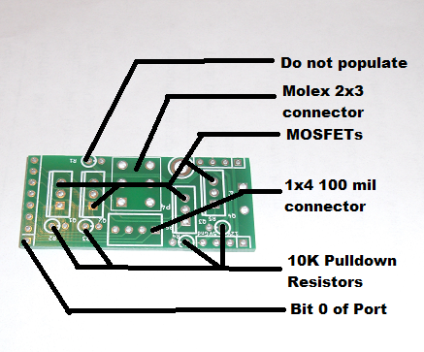

Populated Solenoid Board
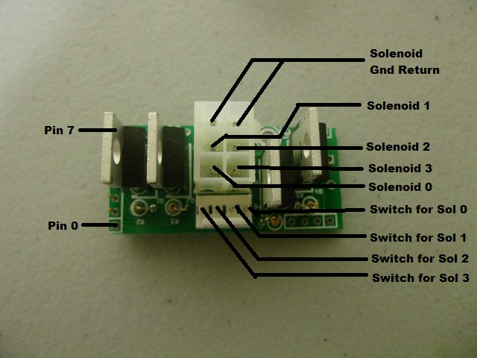
Note 1: Molex connectors have rectangular holes, and holes with the top corners of the rectangles filled in to insure connectors aren't plugged in incorrectly. The picture above shows the molex connector with the flat part (or bottom) of the connector to the right. (An example of a rectangle with the top corners can be seen on the bottom right pin.) Make sure the orientation is correct for the connector.

Note 2: The four pin connector, should be oriented with the friction lock towards the bottom of the card.

Used 4 pin voltage connector pins
The ground on the 4 pin voltage connector is used to provide a weak pull down resistor so solenoids don't fire when the is not booted. The special voltage on the 4 pin voltage connector is connected to the solenoid high current ground.

Order to populate components
When populating this board, it is easiest to first populate shortest components, and then move onto taller components. First populate the pull down resistors. Next populate the 4 pin 100 mil spaced connector. Next populate the 2x3 pin Molex connector. Finally populate the MOSFETs.

Interface Board (New version)

Unpopulated board
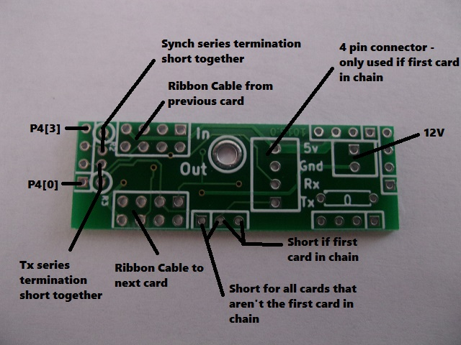

Populated board
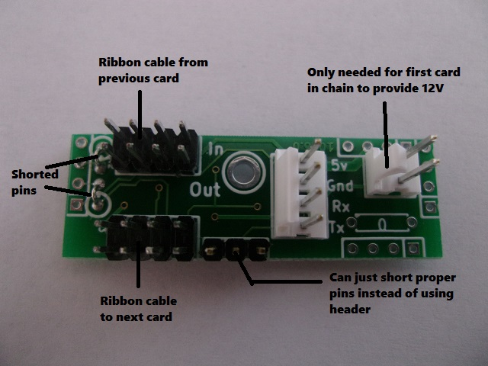

Note: The four pin connector, should be oriented with the friction lock towards the left side (processor side) of the card.

Used 4 pin voltage connector pins
Ground and 5V are usually provided by the ribbon cable, or the 1x4 pin 100 mil header if this is the first card in the chain. 12V is only needed if using incandescent boards configured as high side switches. 12V is either provided by the ribbon cable, or should be provided by adding a locking header to the first card in the chain. The special voltage on the 4 pin voltage connector is connected is not used on this card.

Order to populate components
When populating this board, it is easiest to first populate shortest components, and then move onto taller components. First populate the shorted pins. The rest of the components can then easily be populated all at once. (Place components in board, then, using a piece of card board, flip the board upside down, and solder all the through hole pins).

Surface Mount Incandescent Board
The surface mount incandescent board can be populated in two different ways: as a high side switch, or a low side switch.
When populated as a high side switch, the card connects or disconnects the bulb voltage (up to 9V) from the bulb. The other lead from the bulb is always connected to ground to complete the circuit. To wire a bulb in the high side configuration, the bulb voltage is connected to the 2 pin Molex connector on the incandescent card. Each of the 8 pin 100 mil connections are attached to one connection of the bulb, and the second connection of the bulb is attached to the bulb ground. When populated as a high side switch 16 MOSFETs must be populated, and the 8 resistors on the back must be populated. Note: pinball machines that use a common ground braid for the bulbs must use this configuration of the card.
When populated as a low side switch, the card connects or disconnects the ground from the bulb. The other lead from the bulb is always connected to the bulb voltage (up to 12V). To wire a bulb in the low side configuration, the bulb voltage is connected to one side of each of the bulbs. The other side of the bulb is connected to the 8 pin 100 mil connection. In this configuration, the 2 pin Molex connector becomes the bulb ground. When populated as a low side switch, only 8 MOSFETS are populated. Note: most white woods would use this configuration of the card.

Unpopulated board
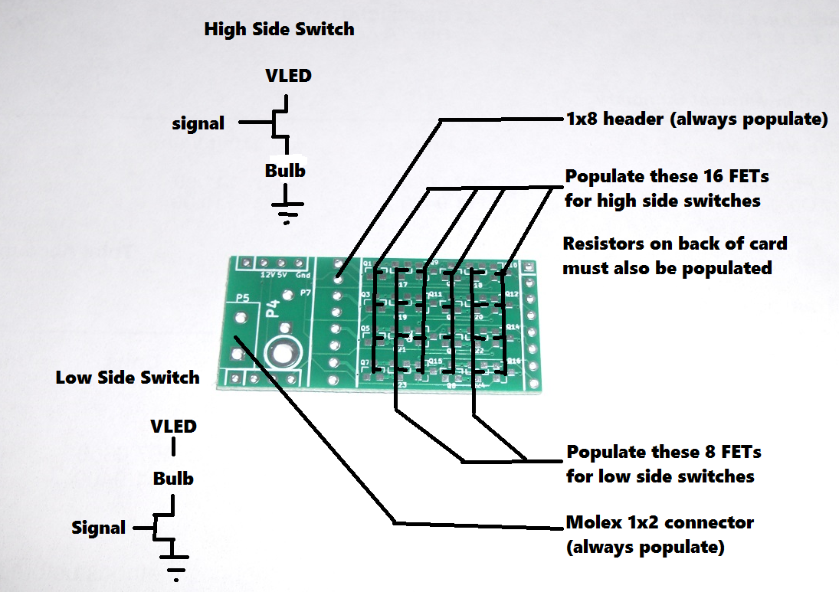

Populated High Side board

Front
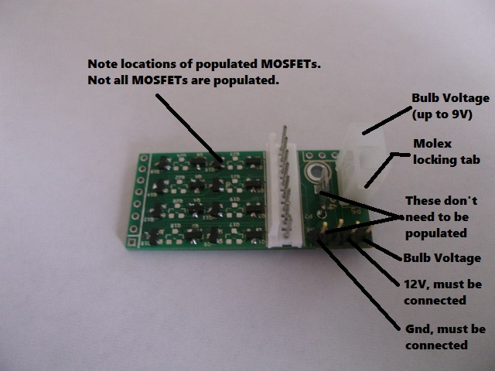

Back
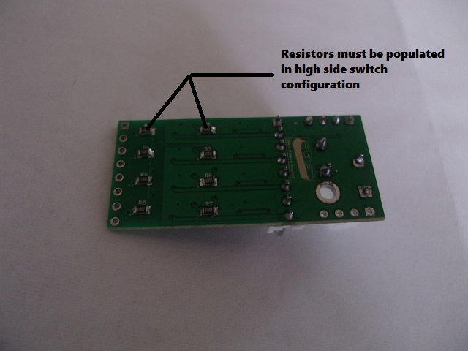

Used 4 pin voltage connector pins
The ground and 12V on the 4 pin voltage connector are used to control the MOSFETs. The special voltage on the 4 pin voltage connector is connected to the bulb voltage.

Order to populate components
When populating this board, it is easiest to first populate shortest components, and then move onto taller components. First populate the surface mount components. Next populate the 1x8 pin 100 mil connector. Finally populate the 1x2 pin Molex connector.

Populated Low Side board
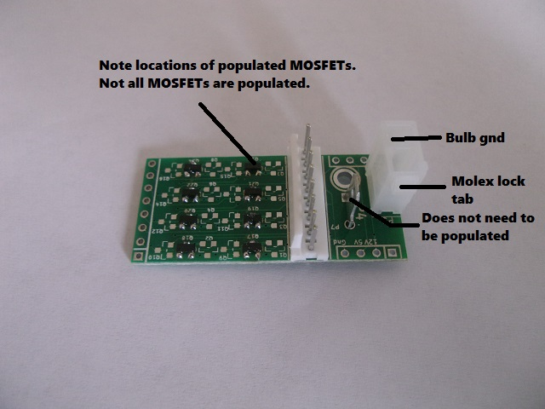

Used 4 pin voltage connector pins
The special voltage on the 4 pin voltage connector is connected to the bulb ground. No other pins are used.

Order to populate components
When populating this board, it is easiest to first populate shortest components, and then move onto taller components. First populate the surface mount components. Next populate the 1x8 pin 100 mil connector. Finally populate the 1x2 pin Molex connector.

Input connectors

Note: The input connectors are always oriented so the plastic friction lock is closest to the microprocessor (the large square chip on the red PSoC 4200 development board).

Incandescent Wing (Through-hole)
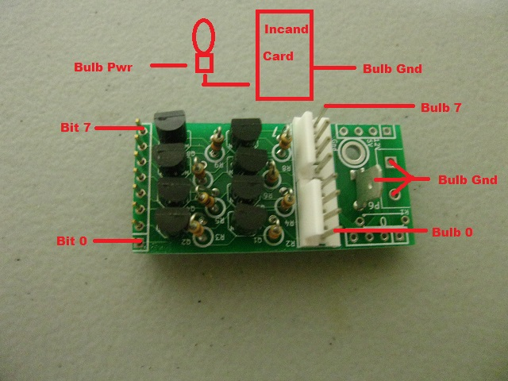
Note: This version of the incandescent card can only be used as a low side switch. (Low side switch means that the MOSFET connecting one side of the bulb to ground so that current can flow). Many pinball machines have a common ground braid. In that case, a high side switch must be used.

Interface Board (Old version)

Unpopulated board
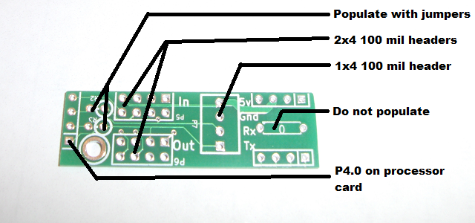

Populated board
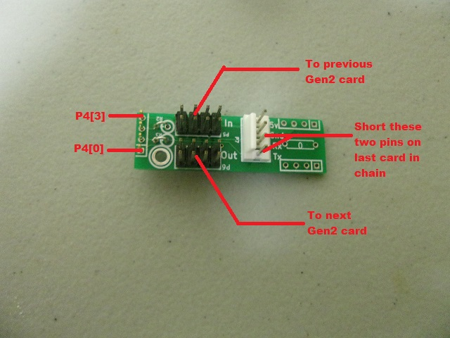
Note: The four pin connector, should be oriented with the friction lock towards the left side (processor side) of the card.

Used 4 pin voltage connector pins
Ground and 5V are usually provided by the ribbon cable, or the 1x4 pin 100 mil header if this is the first card in the chain. 12V is only needed if using incandescent boards configured as high side switches. 12V is either provided by the ribbon cable, or should be provided by adding a locking header to the first card in the chain. The special voltage on the 4 pin voltage connector is connected is not used on this card.

Input/Neo Wing
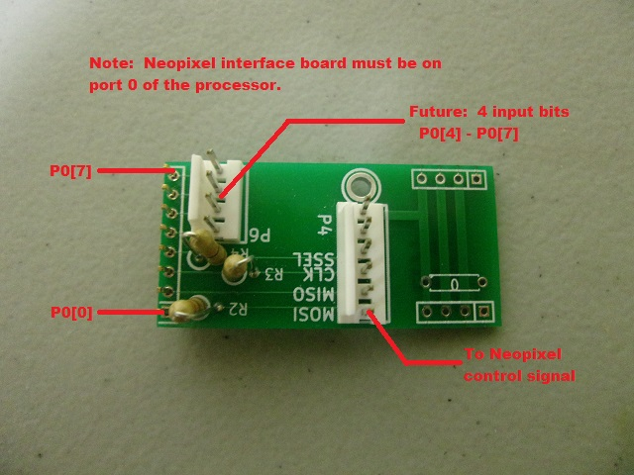

RS232 Interface
