OPP Board Serial Interface
Interface Document

(Project: BrdSerIntf)

Project # : Not applicable
P/N: Not applicable
Rev 0.11

This program is free software: you can redistribute it and/or modify it under the terms of the GNU General Public License as published by the Free Software Foundation, either version 3 of the License, or (at your option) any later version.

This program is distributed in the hope that it will be useful, but WITHOUT ANY WARRANTY; without even the implied warranty of MERCHANTABILITY or FITNESS FOR A PARTICULAR PURPOSE. See the GNU General Public License for more details.

You should have received a copy of the GNU General Public License along with this program. If not, see <http://www.gnu.org/licenses/>.

 | PREPARED: | APPROVAL:  LEAD ENGINEER | APPROVAL:  ENGINEERING MANAGER
NAME | Hugh Spahr
DATE

Revision History
Version | Primary Author(s) | Description of Version | Date Completed
0.1 | Hugh Spahr | Initial version | 11/08/13
0.2 | Hugh Spahr | Added save/erase configuration | 12/21/13
0.3 | Hugh Spahr | Added pictures of cards to locate headers. Added wiring diagram for solenoid card. | 01/04/14
0.4 | Hugh Spahr | Added new commands for Gen2 hardware | 09/28/15
0.5 | Hugh Spahr | Removed CRC from Inventory command | 11/19/15
0.6 | Hugh Spahr | Added Incandescent commands. Added num pixels to set neopixel color table command. | 12/04/15
0.7 | Hugh Spahr | Removed first OPP hardware commands to make the document more readable. (If need to see those commands, version 0.6 is the last version that includes them.) Fixed bit position description for Neopixel and incandescent commands to be more logical. Added wing board wiring pictures. | 12/28/15
0.8 | Hugh Spahr | Added INCAND_SET_ON_OFF command. | 01/26/16
0.9 | Hugh Spahr | Added CONFIG_IND_SOL, CONFIG_IND_INP, and SET_IND_NEO | 02/02/16
0.10 | Hugh Spahr | Added ON_OFF_SOL an DLY_KICK_SOL to solenoid configuration. Added SET_SOL_INPUT command. | 08/06/16
0.11 | Hugh Spahr | Fix solenoid wing pinout image | 05/04/17

Table of Contents
1Purpose 5
2Product Overview 5
3Applicable Documents 5
4Terms, Definitions & Acronyms 5
5Serial Interface Overview 5
5.1Addressing 6
6Serintf.h 6
7Commands 8
7.1Get Serial Number, 0x00 9
7.1.1Gen2 example 9
7.2Get Product ID, 0x01 9
7.2.1Gen2 example 9
7.3Get Version, 0x02 9
7.3.1Gen2 example 9
7.4Set Serial Number, 0x03 9
7.4.1Gen2 example 10
7.5Reset, 0x04 10
7.5.1Gen2 example 10
7.6Go Boot, 0x05 10
7.6.1Gen2 example 10
7.7Configure Solenoid Board, 0x06 10
7.7.1Gen2 example 11
7.8Kick Solenoids, 0x07 11
7.8.1Gen2 example 11
7.9Read Gen2 Inputs, 0x08 12
7.9.1Gen2 example 12
7.10Configure Inputs Board, 0x09 12
7.10.1Gen2 example 12
7.11Save Cfg, 0x0b 13
7.11.1Gen2 example 13
7.12Erase Cfg, 0x0c 13
7.12.1Gen2 example 13
7.13Get Gen2 Cfg, 0x0d 13
7.14Set Gen2 Cfg, 0x0e 13
7.15Change Neopixel Cmd, 0x0f 14
7.16Change Neopixel Color, 0x10 14
7.17Change Neopixel Color Table, 0x11 14
7.18Set Neopixel Color Table, 0x12 15
7.19Incandescent Command, 0x13 15
7.20Configure Individual Solenoid, 0x14 16
7.21Configure Individual Input, 0x15 16
7.22Set Individual Neopixel, 0x16 16
7.23Set Solenoid Input, 0x17 17
7.24Inventory Command, 0xf0 17
7.24.1Gen2 example 17
7.25End of Message, 0xff 17
8CRC 8 Generation 17
9Board Connector Positions 20
9.1Solenoid Wing 20
9.2Incandescent Wing 22
9.3Input/Neo Wing 23
9.4Interface Wing 24
9.5RS232 Interface 25
10Wiring 26
10.1Solenoid Card Wiring 26
10.2Input Card Wiring 26

Purpose
The OPP Board Serial Interface provides a description of the serial interface for the Open Pinball Project board serial interface. The serial interface document includes the following wing boards:
- Gen2 Solenoid Driver Wing (Product ID 1013)
- Gen2 Incandescent Wing (Product ID 1014 and1017)
- Gen2 Input/Neo Wing for support of Neopixels (Product ID 1015)
- Gen2 Interface Wing (Product ID 1016)

Product Overview
BrdSerIntf contains the serial interface for OPP boards. This document describes the APIs

Applicable Documents
None

Terms, Definitions & Acronyms
API Application Program Interface
EOM End of Message (0xff)
ICD Interface Control Document
OPP Open Pinball Project
PWM Pulse Width Modulation
MPF Mission Pinball Framework

Serial Interface Overview
BrdSerIntf port for second generation cards is 115.2 kbps, 8, N, 1. Since the two generations of cards run at different baud rates, they can not be combined on a single serial chain. During the setup, a command is sent to get an inventory of cards that are on the serial interface chain. The cards are daisy chained together in the same way that FDDI or token ring boards are linked together. The host sends to the first card receiver which transmits to the second card's receiver. This continues until the last card where a jumper is installed so that the transmitter of the last card is connected to the host receiver.

Each card is given an address which is automatically discovered during the setup command. The host uses the address to send individual commands to cards.

All commands use card addresses to indicate the destination of the command, and EOM to indicate the end of the command. The exception to this is the inventory command where cards receive the command, and wait to see the end of message. The card then inserts its address before the transmitting the EOM.

After the inventory command is run, the cards are configured. The host then sends a Get Gen2 Cfg message to discover the wing board configuration for each card. The configuration of the boards is saved in non-volatile memory so they operate independently of the host. The cards do all of the real time processing themselves without the intervention of the host. The host only polls the cards to get status, such as if a solenoid input switch was activated.

Gen2 commands append a CRC8 to the end of transfers which matches the CCITT-CRC8. The generator polynomial is x^8+x^2+x+1 with an initial value of 0xff. This is true for all commands except for the initial inventory command.

Addressing
The most significant four bits of the address indicate card type, while the least significant four bits of the address byte indicate the instance of the card. The first card starts from 0, and each card increases its address by one.

Gen2 cards have the most significant bits set to 2 (CARD_ID_GEN2_CARD).

Examples:
First Gen2 card: 0x20
Third G3n2 card: 0x22

Serintf.h
The serial interface file contains the structures used to interface with the solenoid driver boards and input boards. If programming using the C programming language, this file can be included to get the necessary defines.
/* Each command starts with the Card ID except for inventory and EOM. Next comes
* the command, then any data.
*/
typedef enum
{
RS232I_GET_SER_NUM = 0x00,
RS232I_GET_PROD_ID = 0x01,
RS232I_GET_VERS = 0x02,
RS232I_SET_SER_NUM = 0x03,
RS232I_RESET = 0x04,
RS232I_GO_BOOT = 0x05,
RS232I_CONFIG_SOL = 0x06, /* For each solenoid, CFG_SOL_TYPE,
* Initial kick, and Duty Cycle.
*/
RS232I_KICK_SOL = 0x07, /* Value, mask */
RS232I_READ_SOL_INP = 0x08, /* Data */
RS232I_CONFIG_INP = 0x09, /* For each input, CFG_INP_TYPE */
RS232I_GEN2_UNUSED = 0x0a, /* Data, data */
RS232I_SAVE_CFG = 0x0b,
RS232I_ERASE_CFG = 0x0c,
RS232I_GET_GEN2_CFG = 0x0d, /* For each wing, GEN2_WING_TYPE */
RS232I_SET_GEN2_CFG = 0x0e, /* For each wing, GEN2_WING_TYPE */
RS232I_CHNG_NEO_CMD = 0x0f,
RS232I_CHNG_NEO_COLOR = 0x10,
RS232I_CHNG_NEO_COLOR_TBL = 0x11,
RS232I_SET_NEO_COLOR_TBL = 0x12,
RS232I_INCAND_CMD = 0x13,
RS232I_CONFIG_IND_SOL = 0x14,
RS232I_CONFIG_IND_INP = 0x15,
RS232I_SET_IND_NEO = 0x16,
RS232I_SET_SOL_INPUT = 0x17,
RS232I_NUM_CMDS,

RS232I_INVENTORY = 0xf0, /* Each card adds byte for card type */
RS232I_EOM = 0xff,
} __attribute__((packed)) RS232I_CMD_E;

#ifndef RS232I_INSTANTIATE
extern
#endif
const U8 CMD_LEN[RS232I_NUM_CMDS]
#ifdef RS232I_INSTANTIATE
={ 4, /* RS232I_GET_SER_NUM */ 4, /* RS232I_GET_PROD_ID */
4, /* RS232I_GET_VERS */ 4, /* RS232I_SET_SER_NUM */
0, /* RS232I_RESET */ 0, /* RS232I_GO_BOOT */
48, /* RS232I_CONFIG_SOL */ 4, /* RS232I_KICK_SOL */
4, /* RS232I_READ_SOL_INP */ 32, /* RS232I_CONFIG_INP */
2, /* RS232I_GEN2_UNUSED */ 0, /* RS232I_SAVE_CFG */
0, /* RS232I_ERASE_CFG */ 4, /* RS232I_GET_GEN2_CFG */
4, /* RS232I_SET_GEN2_CFG */ 6, /* RS232I_CHNG_NEO_CMD */
6, /* RS232I_CHNG_NEO_COLOR */ 4, /* RS232I_CHNG_NEO_COLOR_TBL */
97, /* RS232I_SET_NEO_COLOR_TBL / 5, /* RS232I_INCAND_CMD */
4, /* RS232I_CONFIG_IND_SOL */ 2, /* RS232I_CONFIG_IND_INP */
2, /* RS232I_SET_IND_NEO */ 2, /* RS232I_SET_SOL_INPUT */
}
#endif
;
/* Note: This is the length of the cmd excluding card ID and cmd at the
* beginning and CRC8 at the end.
*/

typedef enum
{
CARD_ID_CARD_NUM_MASK = 0x0f,

CARD_ID_TYPE_MASK = 0xf0,
CARD_ID_SOL_CARD = 0x00,
CARD_ID_INP_CARD = 0x10,
CARD_ID_GEN2_CARD = 0x20,

} __attribute__((packed)) RS232I_CARD_ID_E;

typedef enum
{
USE_SWITCH = 0x01,
AUTO_CLR = 0x02,
ON_OFF_SOL = 0x04,
DLY_KICK_SOL = 0x08,
} __attribute__((packed)) RS232I_CFG_SOL_TYPE_E;

typedef enum
{
DUTY_CYCLE_MASK = 0x0f, /* lsb 4 bits are duty cycle */
MIN_OFF_MASK = 0x70,
} RS232I_DUTY_E;
/* Min off time is 0-7 times the initial kick time. If initial kick
* is 20 ms and min off is 5, the solenoid will be forced off for 100 ms
*/

typedef enum
{
STATE_INPUT = 0x00,
FALL_EDGE = 0x01,
RISE_EDGE = 0x02,
} __attribute__((packed)) RS232I_CFG_INP_TYPE_E;

typedef enum
{
WING_UNUSED = 0x00,
WING_SOL = 0x01,
WING_INP = 0x02,
WING_INCAND = 0x03,
WING_SW_MATRIX_OUT = 0x04,
WING_SW_MATRIX_IN = 0x05,
WING_NEO = 0x06,
} __attribute__((packed)) RS232I_GEN2_WING_TYPE_E;

typedef enum
{
NEOCMD_BLINK_SLOW = 0x00,
NEOCMD_BLINK_FAST = 0x20,
NEOCMD_FADE_SLOW = 0x40,
NEOCMD_FADE_FAST = 0x60,
NEOCMD_ON = 0x80, /* overrides other cmds */
NEOCMD_MASK = 0xe0,
NEOCMD_COLOR_TBL_MASK = 0x1f,
} __attribute__((packed)) RS232I_GEN2_NEO_CMD_E;

typedef enum
{
INCAND_ROT_LEFT = 0x00,
INCAND_ROT_RIGHT = 0x01,
INCAND_LED_ON = 0x02,
INCAND_LED_OFF = 0x03,
INCAND_LED_BLINK_SLOW = 0x04,
INCAND_LED_BLINK_FAST = 0x05,
INCAND_LED_BLINK_OFF = 0x06,
INCAND_LED_SET_ON_OFF = 0x07,

INCAND_SET = 0x80,
INCAND_SET_ON = 0x01,
INCAND_SET_BLINK_SLOW = 0x02,
INCAND_SET_BLINK_FAST = 0x04,
} __attribute__((packed)) RS232I_GEN2_INCAND_CMD_E;

typedef enum
{
SOL_INP_SOL_MASK = 0x0f,

SOL_INP_CLEAR_SOL = 0x80,
} __attribute__((packed)) RS232I_SET_SOL_INP_E;

Commands
The following section describes all the commands and gives examples. All second generation a CRC8 to the end of the command/response except for the inventory command.

Get Serial Number, 0x00
CardAddr + 0x00 + Serial number (4 bytes) + CRC8

Gen2 example
Example: Host queries the gen2 card (addr 0x22) for its serial number. The card responds with the serial number 0x01234567.

Gen2 Cmd: 0x22 | 0x00 | 0x00 | 0x00 | 0x00 | 0x00 | 0xc6 | 0xff

Gen2 Resp: 0x22 | 0x00 | 0x01 | 0x23 | 0x45 | 0x67 | 0x06 | 0xff

Get Product ID, 0x01
CardAddr + 0x01 + Product ID (4 bytes) + CRC8

Note: Gen2 cards always return the configuration of the wing boards that identifies the capabilities of the board.

Gen2 example
Example: Host queries the first Gen2 card (addr 0x20) for its product ID. Card responds the Port A has a NeoPixel board, Port B is an input board, and Port C and D have Solenoid boards.

Gen2 Cmd: 0x20 | 0x01 | 0x00 | 0x00 | 0x00 | 0x00 | 0xf6 | 0xff

Gen2 Resp: 0x20 | 0x01 | 0x06 | 0x02 | 0x01 | 0x01 | 0x46 | 0xff

Get Version, 0x02
Get the firmware version that is running on a card. The firmware version is broken into a byte representing the major version, minor version, sub version and engineering version.

CardAddr + 0x02 + Firmware Version (4 bytes) + CRC8

Gen2 example
Example: Host queries the third Gen2 card (addr 0x22) for its version number. The card responds that it is running version 1.5.6.0 (major version 1, minor version 5, subversion 6, and engineering version 0).

Command: 0x22 | 0x02 | 0x00 | 0x00 | 0x00 | 0x00 | 0x50 | 0xff

Response: 0x22 | 0x02 | 0x01 | 0x05 | 0x06 | 0x00 | 0xf8 | 0xff.

Set Serial Number, 0x03
CardAddr + 0x03 + Serial number (4 bytes) + CRC8

Gen2 example
Example: Host sets the serial number of the first Gen2 card (addr 0x20) to 32 (0x20 in hex). If the serial number has already been set, the card responds with the current serial number of the card. If the serial number can be programmed, it responds with the serial number found in the command.

Command: 0x20 | 0x03 | 0x00 | 0x00 | 0x00 | 0x20 | 0xd2 | 0xff

Response: 0x20 | 0x03 | 0x00 | 0x00 | 0x00 | 0x20 | 0xd2 | 0xff

Reset, 0x04
CardAddr + 0x04 + CRC8

Gen2 example
Example: Reset the fifth Gen2 card (addr 0x24). This resets the card and an inventory command must be resent to reconfigure the card's address.

Command: 0x24 | 0x04 | 0x31

Response: No response since the card resets

Go Boot, 0x05
CardAddr + 0x05 + CRC8

Gen2 example
Example: Reset the Gen2 card (addr 0x20). This resets the card and keeps the card in the bootloader so that the card firmware can be updated.

Command: 0x20 | 0x05 | 0x62

Response: No response since the card resets. After the reset the card remains in the bootloader. Cards should only be updated when connected directly to a host without any other cards on a chain.

Configure Solenoid Board, 0x06
Each solenoid is configured using three bytes. The first byte is the type of solenoid which is a bit field. (0x01, USE_SWITCH, 0x02, AUTO_CLR, 0x04, ON_OFF_SOL, and 0x08, DLY_KICK_SOL). If the solenoid is configured to use the switch input, when the switch input is closed, the solenoid fires. If the solenoid is configured to auto clear, the host can kick the solenoid using the kick which is automatically cleared, and the solenoid can be kicked another time without sending a command to clear the kick. If the solenoid is configured as an ON/OFF solenoid, it will be driven at 100% when the input is active (used for dual wound flippers).

If a solenoid is configured as a delay kick solenoid, the kicking of the solenoid will be delayed by 4 * hold field (ms). If the hold field is set to 4, the solenoid kick is delay 16 ms after the input is detected. Note: This means that delay kick solenoids can not be PWM'd.

The second byte is the initial kick for the solenoid in milliseconds. If the initial kick is supposed to be 100 ms, the byte should be 0x64.

The third byte is broken into the duty cycle to “hold” the solenoid active, and the minimum off time. The period for the hold is 16 ms. The least significant four bits indicate the amount of “on” time during the 16 ms period. To keep the solenoid on for 50%, during the hold period, the four bits should be set to 0x08. This is 8 ms/16 ms or 50%. For 25% hold, set the value to 0x04. This is 4 ms/16 ms or 25%. The maximum hold strength is 87.5%.

The minimum off time is calculated using the least significant three bits of the most significant nibble of the third byte. ((3rd byte & 0x70) >> 4). These three bits are multiplied by the initial kick time to determine the minimum off time for the solenoid. If the solenoid is using the switch contact, and the initial kick time is 105 ms, and the minimum off time is 315 ms, and the duty cycle is 75%, the configuration bytes would be 0x01 0x69 0x3c.

Note: Unused solenoids should have their parameters configured to 0x00 | 0x00 | 0x00 to disable them. With Gen2, only wing boards configured/populated as solenoids will use the solenoid parameters. Solenoid parameters for wing boards that aren't solenoid wings will be ignored.

Gen2 example
CardAddr + 0x06 + Solenoid Parameters (16 sets of parameters, 3 bytes each or 48 bytes total) + CRC8

Example: Configure the first Gen2 card (addr 0x20). The first four solenoids are configured as flippers, the next four are configured as pop bumpers, the next four are not used, and the last four are configured as VUKs. The flippers are configured with an initial kick of 48 ms and 25% hold. The pop bumpers have initial kicks of 48 ms and no hold. The VUK have initial kicks of 100 ms and no hold.

Command: 0x20 | 0x06 | 0x01 | 0x30 | 0x04 | 0x01 | 0x30 | 0x04 | 0x01 | 0x30 | 0x04 | 0x01 | 0x30 | 0x04 | 0x01 | 0x30 | 0x00 | 0x01 | 0x30 | 0x00 | 0x01 | 0x30 | 0x00 | 0x01 | 0x30 | 0x00 | 0x00 | 0x00 | 0x00 | 0x00 | 0x00 | 0x00 | 0x00 | 0x00 | 0x00 | 0x00 | 0x00 | 0x00 | 0x01 | 0x64 | 0x00 | 0x01 | 0x64 | 0x00 | 0x01 | 0x64 | 0x00 | 0x01 | 0x64 | 0x00 | 0xc4

Response: The card removes the command from the communication stream.

Kick Solenoids, 0x07
Command for the host to kick the solenoids. The solenoid bits are active high. The mask bits allow individual or groups of solenoids to be turned on and off. If the solenoid is configured to auto clear, after the solenoid kicks, the bit is automatically cleared so a second command isn't needed to kick it again. Solenoids to kick bytes and mask are16 bit quantities.

Gen2 example
CardAddr + 0x07 + Solenoids To Kick (2 bytes) + Mask (2 bytes) + CRC8

Example: Kick the third Gen2 card (addr 0x22). Solenoid wing cards are on Port A and Port D. Turn on first and last solenoids for Port A wing card. Turn off second solenoid on Port D wing board.

Command: 0x22 | 0x07 | 0x00 | 0x09 | 0x20 | 0x09 | 0x44

Response: The card removes the command from the communication stream.

Read Gen2 Inputs, 0x08
Gen2 cards use a single command to read inputs. It returns the inputs from both solenoids and input wing boards. Solenoid wing boards only populate the low nibble of the port byte.

Each solenoid card returns a byte listing if any new inputs have occurred since the last read input command. The command contains a blank data byte to be filled out by the card. Bits are numbered from right to left with bit 0 being 0x01.

Gen2 example
CardAddr + 0x08 + Data (4 bytes) + CRC8

Example: Read first Gen2 card (addr 0x20). Card has solenoids on Port A and Port D, and input boards on Port B and Port C. Solenoid or Port A has bits 0, 1, 3, solenoid on Port D has bit 2 set, input card on port B has 0, 1, 4, and 5 set, and input card on port C has 0, 3, 4, and 7 set.

Command: 0x20 | 0x08 | 0x00 | 0x00 | 0x00 | 0x00 | 0x8d

Response: 0x20 | 0x08 | 0x04 | 0x99 | 0x33 | 0x0b | 0xb1

Configure Inputs Board, 0x09
Each input is configured using one byte. Switches are typically active low since the input line has a pull up resistor, and the switch connects the input to ground. STATE_INPUT returns the current value of the input. FALL_EDGE returns a single '1' with the read input board command when the input changes from a high to low value. The '1' is held until the input is read. The next read input will return a '0' unless the input transitions from low to high, then low again. RISE_EDGE returns a single '1' with the read input board command when the input changes from a low to high value. The '1' is held until the input is read. The next read input will return a '0' unless the input transitions from high to low, then high again.

Note: Unused inputs should have their parameters configured to 0x00. With Gen2, only wing boards configured/populated as inputs will use the input parameters. Input parameters for wing boards that aren't input wings will be ignored.

Gen2 example
CardAddr + 0x09 + Input Parameters (32 sets of parameters, 1 byte each or 32 bytes total) + CRC8

Example: Configure the first Gen2 card (addr 0x20) with input wing boards on Port B and Port C. Port B 8 inputs are STATE_INPUTS, and Port C first 4 inputs are FALL_EDGE, and last four inputs are RISE_EDGE.

Command: 0x20 | 0x09 | 0x00 | 0x00 | 0x00 | 0x00 | 0x00 | 0x00 | 0x00 | 0x00 | 0x00 | 0x00 | 0x00 | 0x00 | 0x00 | 0x00 | 0x00 | 0x00 | 0x01 | 0x01 | 0x01 | 0x01 | 0x02 | 0x02 | 0x02 | 0x02 | 0x00 | 0x00 | 0x00 | 0x00 | 0x00 | 0x00 | 0x00 | 0x00 | 0x7f

Response: The card removes the command from the communication stream.

Save Cfg, 0x0b
CardAddr + 0x0b + CRC8

Save the current configuration to the card. The next time the card is powered, it will automatically be configured without need another configuration command.

Gen2 example
Example: Save the configuration to the first Gen2 card (addr 0x20)

Command: 0x20 | 0x0b | 0x48

Response: The card removes the command from the communication stream.

Erase Cfg, 0x0c
CardAddr + 0x0c + [CRC8 (Gen2 only)]

Clear the saved configuration. The next time the card is powered, it will need to be configured. Note: This command does not disable the current configuration.

Gen2 example
Example: Erase the configuration to the first Gen2 card (addr 0x20)

Command: 0x20 | 0x0c | 0x5d

Response: The card removes the command from the communication stream.

Get Gen2 Cfg, 0x0d
CardAddr + 0x0d + 0x00 + 0x00 + 0x00 + 0x00 + 0x49

Get the Gen2 configuration of the wing boards. Note: Wing boards are not discovered, but must be programmed using the Set Gen2 Cfg command. The configuration can be made persistent by using the Save Cfg command.

Example: Get the configuration to the second Gen2 card wing boards (addr 0x21). Card responds the Port A has a NeoPixel board, Port B is an input board, and Port C and D have Solenoid boards.

Command: 0x21 | 0x0d | 0x00 | 0x00 | 0x00 | 0x00 | 0x49

Response: 0x21 | 0x0d | 0x06 | 0x02 | 0x01 | 0x01 | 0xf9

Set Gen2 Cfg, 0x0e
CardAddr + 0x0e + Input Parameters (4 sets of parameters, 1 byte each or 4 bytes total) + CRC8

Set the Gen2 configuration of the wing boards. Note: The configuration can be made persistent by using the Save Cfg command.

Example: Set the configuration to the second Gen2 card wing boards (addr 0x21) with Port A as a NeoPixel board, Port B as an input board, and Port C and D as Solenoid boards.

Command: 0x21 | 0x0e | 0x06 | 0x02 | 0x01 | 0x01 | 0x5f

Response: The card removes the command from the communication stream.

Change Neopixel Cmd, 0x0f
CardAddr + 0x0f + NeoCmd + Offset + Mask (4 bytes) + CRC8

Change the Neopixel command to the masked Neopixels. The offset is the number of Neopixels from the start of the chain to change the command, and the mask can change up to 32 contiguous Neopixels. To change the first 8 Neopixels, the offset equals 0, and the first byte of the mask would be 0x000000ff.

Example: Set the Neopixel command to fast blink (0x20) on the first Gen2 board to light the fifth through fifteenth Neopixel. This command would be written either using an 0 offset and using an offset within the mask, or starting with offset 4, and masking the first ten bits.

Command: 0x20 | 0x0f | 0x20 | 0x00 | 0x00 | 0x00 | 0x7f | 0xf0 | 0xc8 or
0x20 | 0x0f | 0x20 | 0x04 | 0x00 | 0x00 | 0x07 | 0xff | 0x60

Response: The card removes the command from the communication stream.

Change Neopixel Color, 0x10
CardAddr + 0x10 + NeoColor + Offset + Mask (4 bytes) + CRC8

Change the Neopixel color index to the masked Neopixels. Colors are indexed (0-31) into the color table to determine the actual color. The offset is the number of Neopixels from the start of the chain to change the command, and the mask can change up to 32 contiguous Neopixels. To change the first 8 Neopixels, the offset equals 0, and the first byte of the mask would be 0xff.

Example: Set the Neopixel color index to 5 on the first Gen2 board to light the fifth through fifteenth Neopixel. This command would be written either using an 0 offset and using an offset within the mask, or starting with offset 4, and masking the first ten bits.

Command: 0x20 | 0x10 | 0x05 | 0x00 | 0x00 | 0x00 | 0x7f | 0xf0 | 0x54 or
0x20 | 0x10 | 0x05 | 0x04 | 0x00 | 0x00 | 0x07 | 0xff | 0xfc

Response: The card removes the command from the communication stream.

Change Neopixel Color Table, 0x11
CardAddr + 0x11 + Index + ColorBytes (3 bytes) + CRC8

Change a single entry in the Neopixel color table. Neopixels color entries are ordered: green byte, red byte, blue byte.

Example: Change the Neopixel color table entry index 12 to have green full on (0xff), red half on (0x80), and blue quarter on (0x40).

Command: 0x20 | 0x11 | 0x0c | 0xff | 0x80 | 0x40 | 0x76

Response: The card removes the command from the communication stream.

Set Neopixel Color Table, 0x12
CardAddr + 0x12 + ColorBytes (32 sets of parameters, 3 bytes each or 96 bytes total) + numPixels + CRC8

Change all the Neopixel color table entries. I picked random color values that are all different. I have no idea what colors these are except 0x00 0x00 0x00 is off, and 0xff 0xff 0xff is white. The number of pixels is a single byte at the end of the command with 64 pixels set in this command. Note: This command takes nearly 10 ms to send, so it should be used sparingly or probably only when setting up the non-volatile memory configuration.

Command: 0x20 | 0x12 | 0x0c | 0x00 | 0x00 | 0x00 | 0xff | 0xff | 0xff | 0x40 | 0x00 | 0x00 | 0x80 | 0x00 | 0x00 | 0xc0 | 0x00 | 0x00 | 0xff | 0x00 | 0x00 | 0x00 | 0x40 | 0x00 | 0x00 | 0x80 | 0x00 | 0x00 | 0xc0 | 0x00 | 0x00 | 0xff | 0x00 | 0x00 | 0x00 | 0x40 | 0x00 | 0x00 | 0x80 | 0x00 | 0x00 | 0xc0 | 0x00 | 0x00 | 0xff | 0x40 | 0x40 | 0x00 | 0x80 | 0x80 | 0x00 | 0xc0 | 0xc0 | 0x00 | 0xff | 0xff | 0x00 | 0x00 | 0x40 | 0x40 | 0x00 | 0x80 | 0x80 | 0x00 | 0xc0 | 0xc0 | 0x00 | 0xff | 0xff | 0x40 | 0x00 | 0x40 | 0x80 | 0x00 | 0x80 | 0xc0 | 0x00 | 0xc0 | 0xff | 0x00 | 0xff | 0x40 | 0x40 | 0x40 | 0x80 | 0x80 | 0x80 | 0xc0 | 0xc0 | 0xc0 | 0xff | 0x80 | 0x40 | 0x80 | 0x40 | 0xff | 0x40 | 0xff | 0x80 | 0x40 | 0x7d

Response: The card removes the command from the communication stream.

Incandescent Command, 0x13
CardAddr + 0x13 + IncandCmd + Mask (4 bytes) + CRC8

Change the incandescent wing boards to turn on/off bulbs, make them blink slow/fast, or rotate the bulbs that are on. The mask contains the affected bulbs with the first byte received for wing 0. Blinking and on/off are independent so a bulb can be set to blink and on at the same time. The bulb being lit overrides the blinking. The rotate commands allow lane shifting to be easily implemented where all the lanes would be set to blink, and the completed lanes are set to lit. Pushing the flipper button would send a rotate command to rotate the on/off state of the inlane bulbs. The set on/off command clears all blinking masks, and uses the mask to turn bulbs on/off. (A one bit turns a bulb on while a zero bit turns a bulb off. This was implemented so MPF only needs to send a single command to turn set the state (on/off) of all the bulbs.)

The INCAND_SET sub-command sets the state (both the on/off and the blink/no blink) in one command. It uses the INCAND_SET bitfields to configure the bulb settings.

Example: On the first wing board light bulbs 0-3, and on the third wing board, light bulbs 0, 2, 4, 6.

Command: 0x20 | 0x13 | 0x02 | 0x00 | 0x55 | 0x00 | 0x0f | 0x0d

Example: Set all the bulbs on wing 3 to be on and blink rapidly. (In this case the bulbs will appear on, but if the bulb is commanded off using INCAND_LED_OFF, it will start blinking).

Command: 0x20 | 0x13 | 0x85 | 0xff | 0x00 | 0x00 | 0x00 | 0xab

Response: The card removes the command from the communication stream.

Configure Individual Solenoid, 0x14
CardAddr + 0x14 + SolIndex + SolenoidCfg (3 bytes) + CRC8

Change the configuration of a single solenoid. The index contains the index of the solenoid [0-15]. The solenoid configuration uses the same values as the configure solenoid command above.

Example: Configure the first Gen2 card (addr 0x20). Configure the third solenoid (wing 0, last solenoid) as a flipper.

Command: 0x20 | 0x14 | 0x03 | 0x01 | 0x30 | 0x04 | 0x9d

Response: The card removes the command from the communication stream.

Configure Individual Input, 0x15
CardAddr + 0x15 + InputIndex + InputCfg (1 byte) + CRC8

Change the configuration of a single input. The index contains the index of the input [0-31]. The input configuration uses the same values as the configure input command above.

Example: Configure the first Gen2 card (addr 0x20). Configure the ninth input (wing 1, 2nd input, or P1[1]) for falling edges.

Command: 0x20 | 0x15 | 0x08 | 0x01 | 0xd2

Response: The card removes the command from the communication stream.

Set Individual Neopixel, 0x16
CardAddr + 0x15 + PixelIndex + ColorTblIndex (1 byte) + CRC8

Change the color of a single Neopixel. The pixel index is the index of the neopixel. The color table index [0-31] is the index in the color table of the color to set the Neopixel.

Example: Configure the first Gen2 card (addr 0x20). Configure the third neopixel, to use the fifth color table entry.

Command: 0x20 | 0x16 | 0x02 | 0x04 | 0xf6

Response: The card removes the command from the communication stream.

Set Solenoid Input, 0x17
CardAddr + 0x17 + InputIndex + SolIndex (1 byte) + CRC8

Change a solenoid to be triggered or not triggered by an input. The input index contains the index of the input [0-31]. The solenoid index contains the index of the solenoid [0 – 15]. If the msb of the SolIndex is set (0x80), the solenoid will stop using the input switch.

Example: Configure the first Gen2 card (addr 0x20). Configure the sixth solenoid to use the fourth input to trigger the solenoid.

Command: 0x20 | 0x17 | 0x03 | 0x05 | 0x8f

Response: The card removes the command from the communication stream.

Example: Configure the third Gen2 card (addr 0x22). Configure the eighth solenoid [wing 1] to stop using the default input which is the twelfth input.

Command: 0x22 | 0x17 | 0x0b | 0x87 | 0x8c

Response: The card removes the command from the communication stream.

Inventory Command, 0xf0
The inventory command is used to figure out the number of cards and the position of the cards. When a card receives the inventory command, it listens and remembers the card addresses which match its card type. When it receives the end of message, it inserts its card address and increments the last matching card type address that it saw.

Gen2 example
Example: Send the inventory command and find out that there are three Gen2 cards.

Command: 0xf0 | 0xff

Response: 0xf0 | 0x20 | 0x21 | 0x22 | 0xff

End of Message, 0xff
End of message is needed at the end of an inventory command. It can also be used at the end of any command chain.

CRC 8 Generation
Gen2 commands append a CRC8 to the end of transfers which matches the CCITT-CRC8. The generator polynomial is x^8+x^2+x+1 with an initial value of 0xff. The following lists Python code can also be found in the repository at Python\CalcCrc8\CalcCrc8.py

#!/usr/bin/env python
#
#===============================================================================
## @mainpage
#
# OOOO
# OOOOOOOO
# PPPPPPPPPPPPP OOO OOO PPPPPPPPPPPPP
# PPPPPPPPPPPPPP OOO OOO PPPPPPPPPPPPPP
# PPP PPP OOO OOO PPP PPP
# PPP PPP OOO OOO PPP PPP
# PPP PPP OOO OOO PPP PPP
# PPP PPP OOO OOO PPP PPP
# PPP PPP OOO OOO PPP PPP
# PPPPPPPPPPPPPP OOO OOO PPPPPPPPPPPPPP
# PPPPPPPPPPPPP OOO OOO PPP
# PPP OOO OOO PPP
# PPP OOO OOO PPP
# PPP OOO OOO PPP
# PPP OOO OOO PPP
# PPP OOOOOOOO PPP
# PPPPP OOOO PPPPP
#
# This program is free software: you can redistribute it and/or modify
# it under the terms of the GNU General Public License as published by
# the Free Software Foundation, either version 3 of the License, or
# (at your option) any later version.
#
# This program is distributed in the hope that it will be useful,
# but WITHOUT ANY WARRANTY; without even the implied warranty of
# MERCHANTABILITY or FITNESS FOR A PARTICULAR PURPOSE. See the
# GNU General Public License for more details.
#
# You should have received a copy of the GNU General Public License
# along with this program. If not, see <http://www.gnu.org/licenses/>.

#===============================================================================
##
# @file CalcCrc8.py
# @author Hugh Spahr
# @date 6/19/2014
#
# @note Open Pinball Project
# @note Copyright 2015, Hugh Spahr
#
# @brief Calculate the CRC8 of a message. Calculates using nibbles and
# bytes.

#===============================================================================

import sys
import os

## Main
#
# Read passed in arguments.
#
# @param argv [in] Passed in arguments
# @return None
def main(argv=None):

end = False

if argv is None:
argv = sys.argv
for arg in argv:
if arg.startswith('-?'):
print "python CalcCrc8.py [OPTIONS]"
print " -? Options Help"
end = True
if end:
return 0

CRC8Lookup = [0x00, 0x07, 0x0e, 0x09, 0x1c, 0x1b, 0x12, 0x15, \
0x38, 0x3f, 0x36, 0x31, 0x24, 0x23, 0x2a, 0x2d]

CRC8ByteLookup = \
[ 0x00, 0x07, 0x0e, 0x09, 0x1c, 0x1b, 0x12, 0x15, \
0x38, 0x3f, 0x36, 0x31, 0x24, 0x23, 0x2a, 0x2d, \
0x70, 0x77, 0x7e, 0x79, 0x6c, 0x6b, 0x62, 0x65, \
0x48, 0x4f, 0x46, 0x41, 0x54, 0x53, 0x5a, 0x5d, \
0xe0, 0xe7, 0xee, 0xe9, 0xfc, 0xfb, 0xf2, 0xf5, \
0xd8, 0xdf, 0xd6, 0xd1, 0xc4, 0xc3, 0xca, 0xcd, \
0x90, 0x97, 0x9e, 0x99, 0x8c, 0x8b, 0x82, 0x85, \
0xa8, 0xaf, 0xa6, 0xa1, 0xb4, 0xb3, 0xba, 0xbd, \
0xc7, 0xc0, 0xc9, 0xce, 0xdb, 0xdc, 0xd5, 0xd2, \
0xff, 0xf8, 0xf1, 0xf6, 0xe3, 0xe4, 0xed, 0xea, \
0xb7, 0xb0, 0xb9, 0xbe, 0xab, 0xac, 0xa5, 0xa2, \
0x8f, 0x88, 0x81, 0x86, 0x93, 0x94, 0x9d, 0x9a, \
0x27, 0x20, 0x29, 0x2e, 0x3b, 0x3c, 0x35, 0x32, \
0x1f, 0x18, 0x11, 0x16, 0x03, 0x04, 0x0d, 0x0a, \
0x57, 0x50, 0x59, 0x5e, 0x4b, 0x4c, 0x45, 0x42, \
0x6f, 0x68, 0x61, 0x66, 0x73, 0x74, 0x7d, 0x7a, \
0x89, 0x8e, 0x87, 0x80, 0x95, 0x92, 0x9b, 0x9c, \
0xb1, 0xb6, 0xbf, 0xb8, 0xad, 0xaa, 0xa3, 0xa4, \
0xf9, 0xfe, 0xf7, 0xf0, 0xe5, 0xe2, 0xeb, 0xec, \
0xc1, 0xc6, 0xcf, 0xc8, 0xdd, 0xda, 0xd3, 0xd4, \
0x69, 0x6e, 0x67, 0x60, 0x75, 0x72, 0x7b, 0x7c, \
0x51, 0x56, 0x5f, 0x58, 0x4d, 0x4a, 0x43, 0x44, \
0x19, 0x1e, 0x17, 0x10, 0x05, 0x02, 0x0b, 0x0c, \
0x21, 0x26, 0x2f, 0x28, 0x3d, 0x3a, 0x33, 0x34, \
0x4e, 0x49, 0x40, 0x47, 0x52, 0x55, 0x5c, 0x5b, \
0x76, 0x71, 0x78, 0x7f, 0x6a, 0x6d, 0x64, 0x63, \
0x3e, 0x39, 0x30, 0x37, 0x22, 0x25, 0x2c, 0x2b, \
0x06, 0x01, 0x08, 0x0f, 0x1a, 0x1d, 0x14, 0x13, \
0xae, 0xa9, 0xa0, 0xa7, 0xb2, 0xb5, 0xbc, 0xbb, \
0x96, 0x91, 0x98, 0x9f, 0x8a, 0x8d, 0x84, 0x83, \
0xde, 0xd9, 0xd0, 0xd7, 0xc2, 0xc5, 0xcc, 0xcb, \
0xe6, 0xe1, 0xe8, 0xef, 0xfa, 0xfd, 0xf4, 0xf3 ]

while (not end):
print "Enter message [ex: 0x11 0x22 0x33]:"
msg = sys.stdin.readline()
msgBytes = msg.split()
if (len(msgBytes) != 0):
msgInts = []
for indByte in msgBytes:
# If separators used from brdIntf document, ignore them
if indByte != '|':
msgInts.append(int(indByte, 16))
crc8 = 0xff
crc8Byte = 0xff
for indInt in msgInts:
crc8 = (((crc8 << 4) & 0xf0) ^ CRC8Lookup[ \
(((crc8) ^ (indInt)) >> 4) & 0x0f])
crc8 = (((crc8 << 4) & 0xf0) ^ CRC8Lookup[ \
(((crc8 >> 4) & 0x0f) ^ (indInt)) & 0x0f])
crc8Byte = CRC8ByteLookup[crc8Byte ^ indInt];
print "CRC8 = 0x%02x" % crc8
print "CRC8Byte = 0x%02x" % crc8Byte
else:
end = True
return (0)

if __name__ == "__main__":
sys.exit(main())

Board Connector Positions

Solenoid Wing
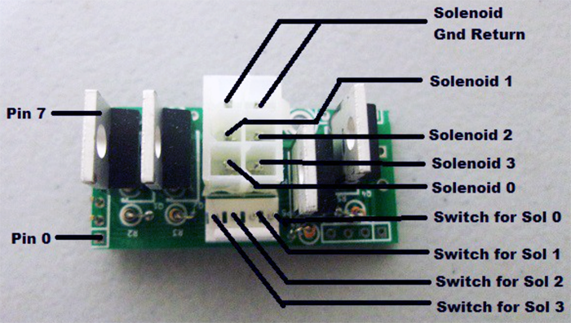

Incandescent Wing
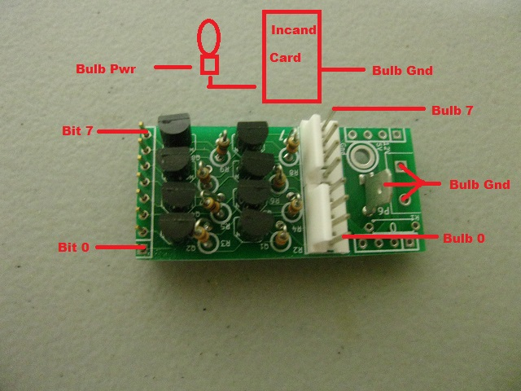

Input/Neo Wing
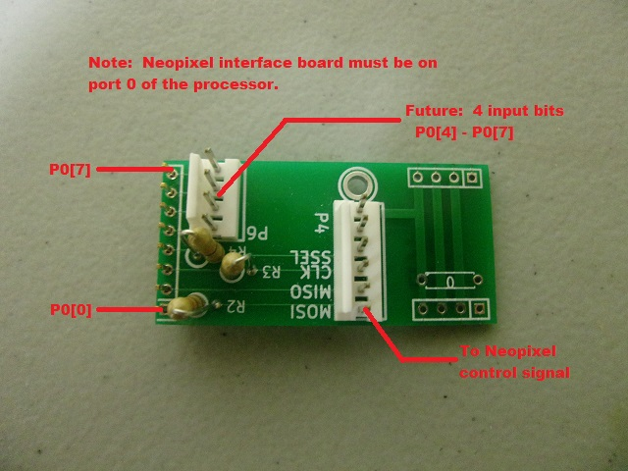

Interface Wing
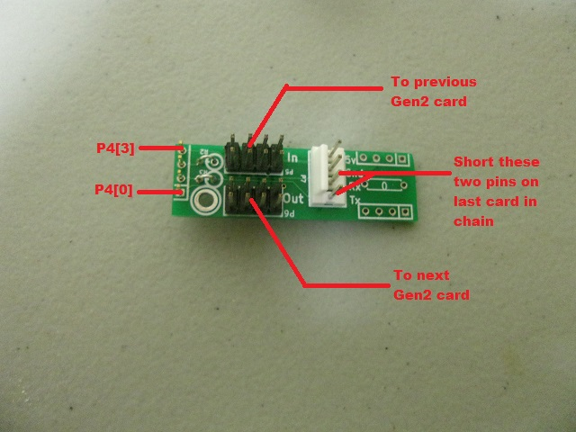

RS232 Interface
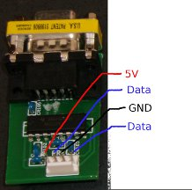

Wiring

Solenoid Card Wiring

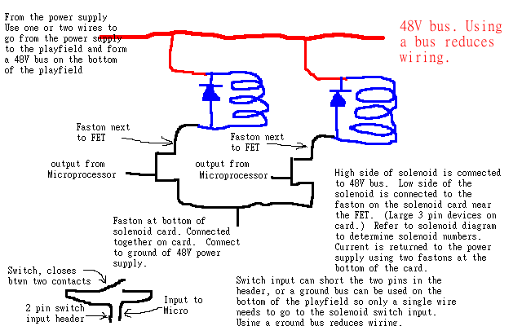

Input Card Wiring
Switch input wiring is the same as the solenoid switch input wiring. Each connector has a ground pin and a pin that is an input to the processor. The processor detects that the switch is closed by looking for a low (grounded) input. The processor has an internal pull up so when the pin is not connected, it is seen as high.

