Inside AI: The Math, Science, and Code Behind Intelligent Tools
A 10th/11th-grade extension to AI, the Brain, and Serviam

LESSON SNAPSHOT
Category | Plan
Course or context | Grades 10 and 11. Computer science, math, science, AI literacy, I.D.E.A. Hub, AP CSP or AP CSA extension.
Length | 15 to 20 minutes. This is a focused supplement, not a full machine learning unit.
Audience | Student-facing upper-school extension, reviewed by school leaders.
Essential question | Can you explain how AI turns language into math, uses patterns, generates a response, and still needs human review?
Core thesis | AI is not magic. It is math trained on patterns. Human wisdom decides whether, when, and how to use it.
Mission fit | Serviam, intellectual curiosity, integrity, purpose, presence, and young women as builders, critics, and leaders of technology.

Learning targets
- I can describe AI as a learned function that maps input to output.
- I can explain how text becomes tokens, token IDs, and vectors.
- I can connect vector similarity, weights, loss, probability, attention, and loops to math and computer science.
- I can describe training as feedback at scale: predict, measure error, adjust, repeat.
- I can explain why AI output is likely, not guaranteed true.
- I can use human judgment to test, verify, and decide whether AI use serves learning and others.

Success criteria
- Students can explain f(x)=y as input, model, and output.
- Students can define token, vector, weight, loss, probability, attention, and loop in student-friendly language.
- Students can complete a short explanation of the AI pipeline from prompt to human review.
- Students can use one worked example: cosine similarity, weighted sum, loss, softmax probability, or generation loop.
- Students can connect model evaluation to accuracy, fairness, privacy, and Serviam.

15 to 20 minute instructional flow
Time | Slides | Teacher move | Student evidence
0:00 to 1:30 | Slides 1 to 2 | Connect Part 2 to Part 1 and ask what happens after pressing Enter. | Students predict hidden steps in the AI pipeline.
1:30 to 3:00 | Slide 3 | Model AI as a learned function: input -> model -> output. | Students connect f(x)=y to functions and methods.
3:00 to 4:45 | Slide 4 | Frame data, training, and testing as scientific modeling. | Students explain why test data matters.
4:45 to 7:30 | Slides 5 to 6 | Show tokens, vectors, and similarity through the Tokens and Similarity simulation. | Students compare related and unrelated terms using the vector map.
7:30 to 11:30 | Slides 7 to 9 | Explain weighted sums, training from error, and probability. | Students follow one weighted sum and one probability example.
11:30 to 15:30 | Slides 10 to 11 | Explain attention and the generation loop. | Students solve the pronoun-reference example and read simple pseudocode.
15:30 to 20:00 | Slide 12 | Use the stronger exit ticket: explain how AI works. | Students write 4 to 5 sentences or a labeled diagram.

Core technical explanation for teacher delivery
Say it simply
When a student presses Enter, the system turns words into tokens, token IDs, and vectors. Those vectors move through layers of weighted math. The model uses attention to weigh relationships in context and probability to generate one token at a time. Training improves the model by measuring error and adjusting weights. The output can still be wrong, biased, incomplete, or unsafe, so human review remains essential.

Worked examples that match the 12-slide deck
Concept | Example | Teacher explanation
Function | f(x)=y | Prompt -> model -> response. In code: def model(prompt): return response
Token to vector | robot -> [0.12, -0.44, 0.81, ...] | Text must become numbers before a model can calculate with it.
Vector similarity | A=[3,4], B=[4,3], cos(theta)=24/25=0.96 | Related vectors point in similar directions. Similarity is calculated, not felt.
Weighted sum | z = w1*x1 + w2*x2 + b | Weights decide which signals matter more. Training changes the weights.
Loss | If p(Paris)=0.90, loss is low. If p(Paris)=0.01, loss is high. | Loss measures error. Training tries to reduce it.
Softmax | robot 0.61, sensor 0.32, toaster 0.07 | Scores become probabilities that sum to 1.
Attention | it -> gear, gear has highest attention weight | Attention weights relationships in context.
Loop | predict -> sample -> append -> continue | Generation is step by step, not magic.

Simulation integration
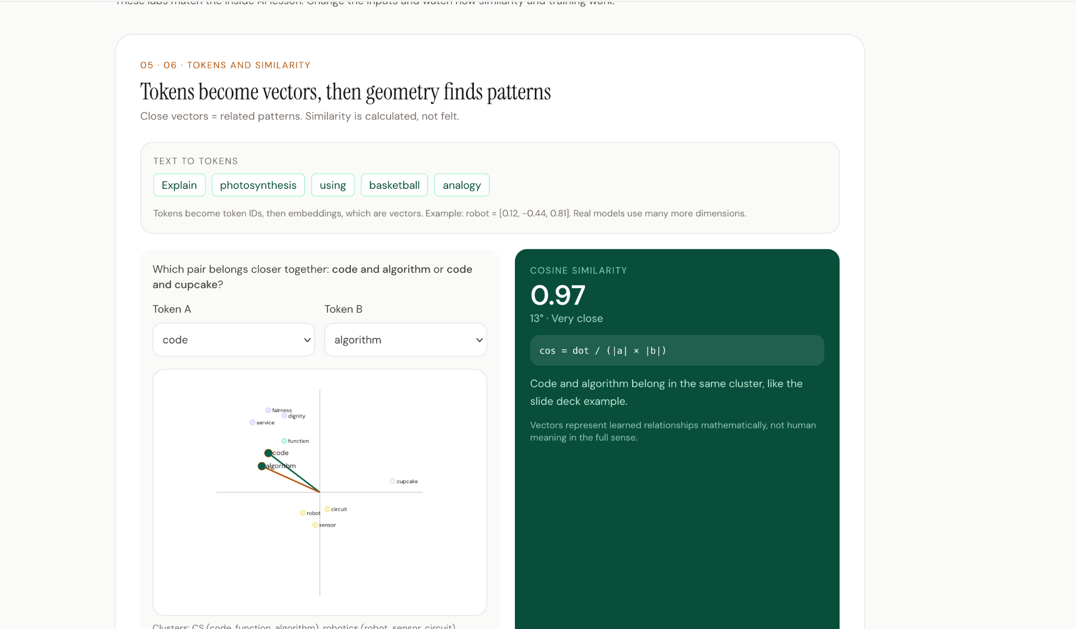
Simulation 1: Tokens and Similarity. Students compare token pairs and observe cosine similarity and clusters.
Simulation 1 teacher move: Ask students to compare code and algorithm, then code and cupcake. They should notice that related terms cluster closer and produce a higher cosine similarity. The key idea is that vectors represent learned relationships mathematically, not human meaning in the full sense.
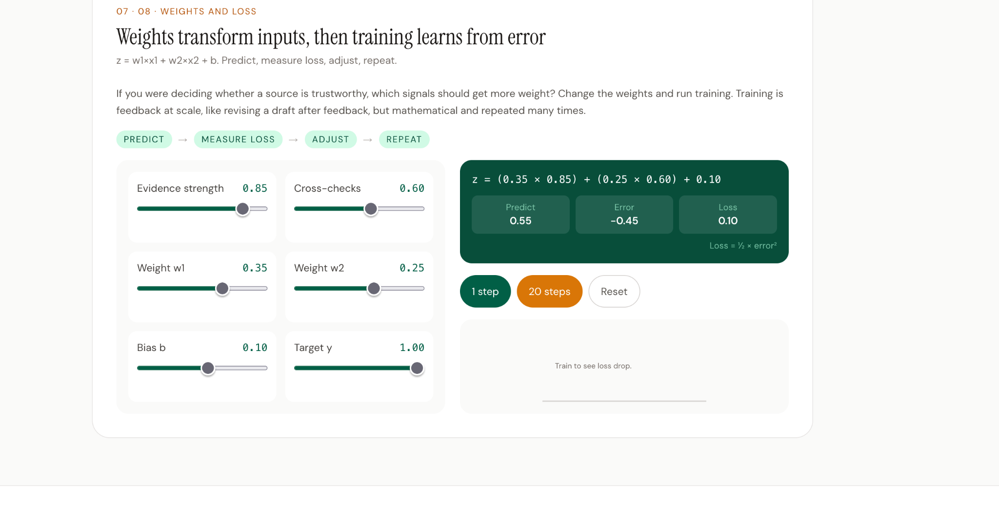
Simulation 2: Weights and Loss. Students adjust inputs and weights, then observe prediction, error, and loss.
Simulation 2 teacher move: Ask students to predict what happens when evidence strength is high but a weight is negative. Then run one step and twenty steps. The key idea is that training adjusts weights to reduce loss, much like revision improves a draft, but mathematically and at scale.

Student exit ticket
Explain how AI works
In 4 to 5 sentences or a labeled diagram, explain how AI creates a response. Include one math idea, one computer science idea, one science or testing idea, and one reason human review still matters.

Differentiation
Group | Adjustment
Students needing support | Use the pathway, definitions, and diagrams. Skip formulas except f(x)=y and the weighted sum as a visual.
Grade 10 baseline | Use all 12 slides and both simulations. Keep formulas as intuition and focus on explanation.
Grade 11 extension | Add cosine similarity, loss example, and pseudocode. Ask students to annotate which step is math, CS, science, or human judgment.
AP extension | Add dot product, softmax formula, attention formula, and Java-style arrays in speaker notes only.

Best-practice design notes
- Prediction before explanation activates prior knowledge and curiosity.
- Visual models and simulations reduce cognitive load and make abstract ideas visible.
- Short worked examples make the math and code concrete without turning the lesson into a college lecture.
- Students produce visible evidence of learning through the exit explanation.
- UDL is supported through diagrams, formulas, written prompts, speaking opportunities, and simulation-based exploration.
- Serviam connects technical skill to responsible use, testing, fairness, privacy, and human oversight.

